Research in Contex- Essay

Can Graphic Design really save your life?
Explore the association of wellbeing and personal growth in Design in your discussion.
Student Name: Agnes Olah
P Number: 2014497
Programme of Study: BA Graphic Design
Module: ADAD5003
Research in Contex Lecturer’s Name: Donna Williams
Word count: 2540

Can Graphic Design Save Your Life? A powerful and ground-breaking exhibition from 2017, hosted by Wellcome Collection and curated by Lucienne Roberts and Rebecca Wright emphasised how graphic design can have an effect on our health by influencing, informing or inspiring us. “If graphic design can save your life, it is eminently capable of killing you, too.” (Wainwright,2017) Wainwright’s statement about the exhibition, highlights the responsibilities of graphic designers and their complex position balancing between creating sales for companies or raising awareness to save lives. (Wainwright,2017)
Graphic design is all around us, in a form of product packaging, advertisement, signs, infographics, the list is endless. Communicating to us through illustrations, photographs, and typography. Sometimes they blend into our surroundings, other times they there to shock us, but without a doubt they have a huge impact on our society and our everyday of life.
Through the years, graphic designers’ responsibilities have become more intricate. Creating just a visually pleasing design is no longer enough. Designs should be inclusive, created with meaning, social awareness and taking human interactions into account without biases.
This essay will explore how graphic designers around the world have addressed certain issues. For instance: encouraging people to donate blood, presenting statistical analysis through infographics to show us causes and their effects, or help us to navigate through pandemics. Saving lives with their creations, directly or indirectly by raising awareness or empower acts to do that. Drawing comparison between the past and present days.
Blood Donation
In modern medicine blood transfusion has become a common practice to save lives. It can be used as part of a cancer treatment or to treat other conditions that effect the functions of the red blood cells and most frequently used to replace lost blood caused by severe bleeding following serious accidents, during surgery or childbirth. (National Health Service, 2021)
Essentially the discovery of blood types in 1901 by Karl Landsteiner and by Jan Jansky who identified the four key blood groups later on, led to establish the modern transfusion. In 1915 Captain O.H Robertson from the Harvard Medical School created the transfusion bottle and the universal donor blood. Also, he showed success in saving lives by demonstrating how blood could save wounded soldiers. Despite showing early success, due to disbelieve of medical professionals, blood fusion did not receive their approval during the First World War. Large scale of blood transfusion only become reality during the Spanish Civil War, when a blood transfusion service was established in 1936 in Barcelona by Frederick Durán-Jordà and Henry Norman Bethune. [Figure 1.] Duran- Jordà during his exile in the United Kingdom worked at Hammersmith Hospital with Janet Vaughan. She later on became a key member of the Medical Research Council during the Second World War, establishing blood donor centres, bringing blood to the front-line, saving countless civilians and soldiers during Dunkirk and the Blitz. (McCann, 2018)
As part of the war effort, the Army Bureau of Current Affairs (ABCA) started propaganda campaigns with the support of a series of posters. They realised the persuasive power of graphic design. [Figure 2.] While preceding to the war, graphic design was initially just an art form, mainly used commercially for selling luxury items. It soon became an essential tool to encourage and inspire both civilians and soldiers. The Army Bureau of Current Affairs changed the objective of posters. These posters were no longer designed for the selling of goods, they were designed to inspire patriotism or for recruitment along many other things. It encouraged to avoid waste, maintain fighting fitness and to give blood to save lives.
The War Office Public Relations Department recruited Abram Games in 1941. He believed that the designers have a responsibility to create consciously, taking human interest into account. As he said: “I prefer working for causes and ideas rather than for selling goods”. Games later become known as the only ‘Official War Poster Artist’ who created over 100 designs to convey the War Office’s messages into widely accessible visuals. These messages included patriotism, educational, instructional, training, housing, and health topics. The posters created in his trademark simplified, symbolic design style, became one of the most influential in his century. (National Army Museum)
He created many health care related campaigns, not only giving out medical and dental care information, but also encouraged the nation to do blood donations. [Figure 3.] [Figure 4.] [Figure 5.]
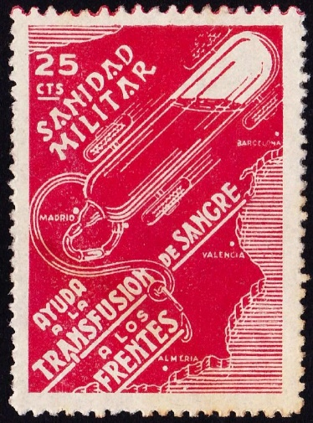
Figure 1. Spain (1937) ‘Cinderella’ stamp during the Spanish Civil War

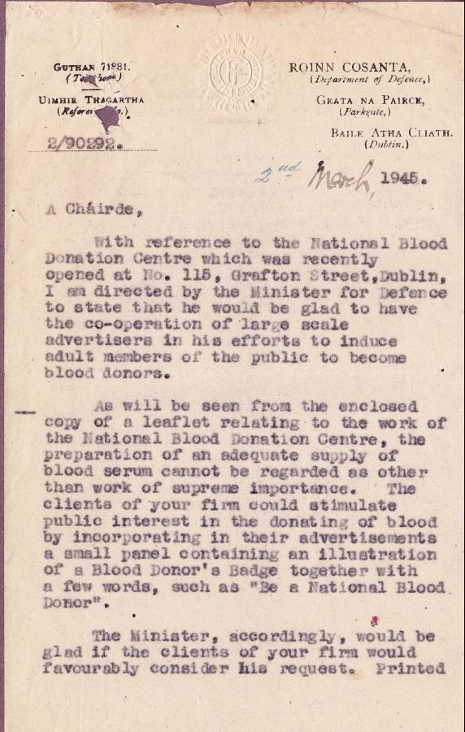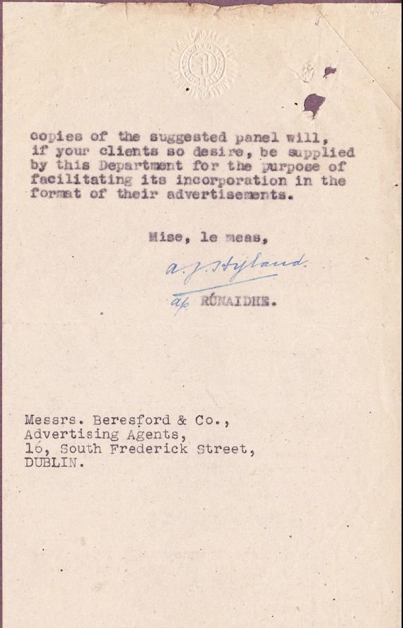

Figure 2. Minister of Defence of Ireland (1945) [letter]to an Advertising Agency


Figure 3. Abram Games, (1943) 'Blood Donors. If He Should Fall Is Your Blood There To Save Him?'[Colour offset lithography]


Figure 4. Abram Games (ca.1941-1945), ‘Blood Donors Now. 30 Minutes Of Your Time A Lifetime To Somebody Else’. '[Colour offset lithography]


Figure 5. Abram Games (1941-1946) 'Blood Donors are needed urgently to save these lives'. [Colour lithograph]

During the passing time, the need for blood transfusion has not changed but the way we approach campaigns has. New technology is developed, and existing technology is evolved every day. The changing technology and lifestyle have brought new platforms to influence people’s behaviour. In the past, posters were the most assessable way to reach a wide audience. In our modern-day social media has taken over, becoming the most important stage to get through to the masses.
The National Health Service Blood and Transplant (NHSBT) recognised this and with the Engine Group, they created a blood donation campaign being fit for the modern needs. The ‘Missing Type’ campaign (2015) was aimed to recruit new blood donors through social media branding. The Editor of PR Week, John Harrington said: “Missing Type blew the PR industry away in 2015 for its originality, creativity and effectiveness. It is still cited as a superb example of how the power of social media can be used to influence public behaviour for an important cause if the idea is strong enough.” (NHSBT,2019) Many agreed with his opinion, as the missing Type became named as the ‘Campaign of The Decade’.
During the campaign, over 1,000 organisations and big brands joined in, removing A, O and B from their signage to raise awareness for the need of a new group of young blood donors to help save lives. [Figure 6.] [Figure 7.] The result was unprecedented, the #MissingType took over Instagram, Twitter and Facebook. Just during the first week NHSBT was donated eight times more blood than their average week and by the end of the first week 30,000 new donors had registered. The successes did not end there, as the follow up campaign a year later got joined by many others around the world. [Figure 8.] (National Health Service Blood and Transplant,2019)
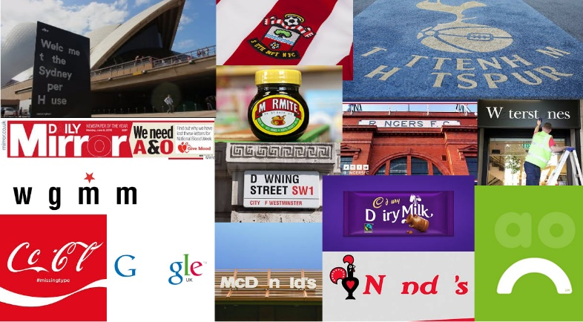
Figure 6. Engine Group ‘Missing Type’ blood donation campaign

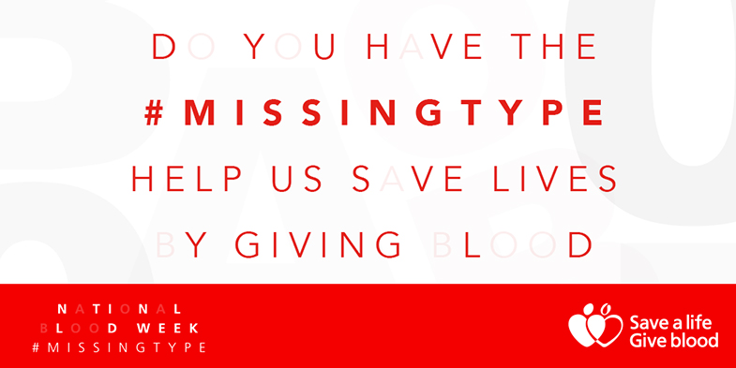
Figure 7. Engine Group ‘Missing Type’ blood donation campaign

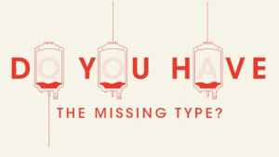
Figure 8. South African National Blood Service (2018) 'Missing Type' campaign

Infographic
We can see infographics surrounding us all the time. They can take on many forms from charts, graphs, diagrams, icons, and symbols. It can be a way to visualise data for a quick and easy understanding. Infographic helps to turn complex information into an easily digestible visual form, quite often with or without a minimum use of text. They can compare, inform, show a process, statistics and a timeline or using a combination of them. (Nediger,2021) We are visual creatures by nature as half of our brain is programmed for processing visual information. The amount of information we are exposed during a daytime has been increased tremendously in the last few decades due to technical revolution. While infographic is widespread, some of them are more important than others. They can shape the world around us and while doing it they can save lives. (Lile, 2017)
There are some perfect examples to show how a detailed statistical analysis turned into an infographic, can help to understand a previously unknown cause and effect to enable future generations to save lives.
One of the early examples is a Cholera Map by Doctor John Snow from 1854. [Figure 9.] In the early nineteen century, nobody really understood germs and how diseases were spread where it was widely thought that illnesses were caused by ‘bad air’. Until the cholera outbreak in London, when Snow displayed his collected data on a map. For each death’s location, he placed a bar on a map creating a thorough statistical analysis. Examining his map, he realised that the mostly affected area appeared in the Broad streets’ water pump’s surrounding. He also noticed that some of the local places a workhouse and a brewery stayed mostly unaffected, but all these had their own independent water supply. Later, it had been discovered that the Broad streets’ pump was polluted by a cholera infected baby’s diaper, demystifying the spread of cholera. Thanks to his map and his data analyses he changed the way we understand how diseases are spread. (Rogers,2013)
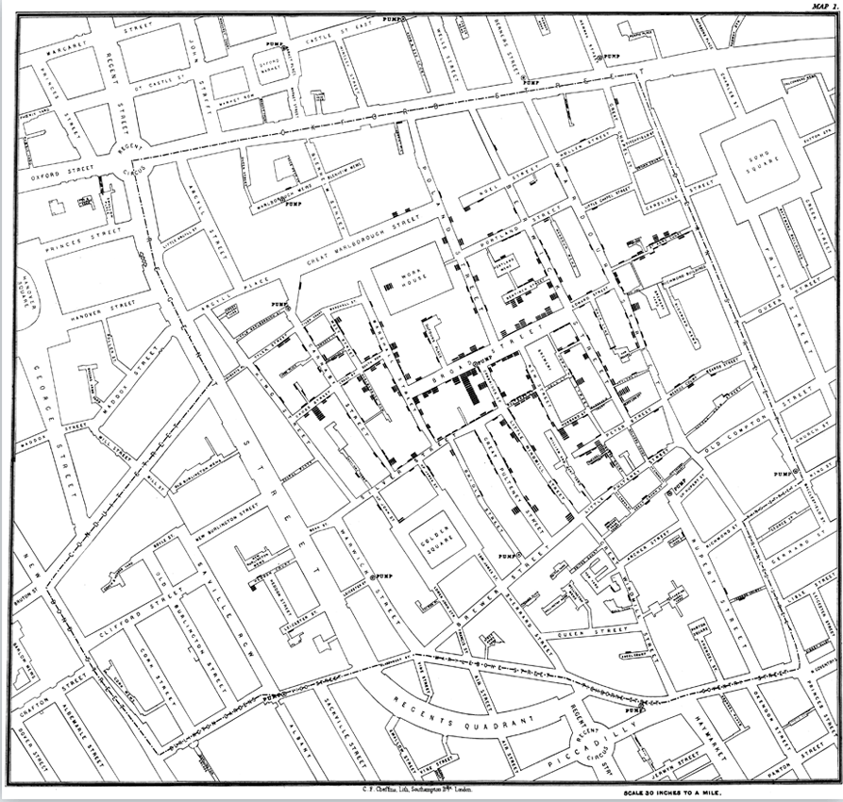
Figure 9. Doctor John Snow (1854) 'Cholera Map'

However, knowing how diseases are spread is only one of the first step to save lives, the next step is to prevent them in the first place even before they could start. In the last 200 years many vaccines have been created to help beat certain illnesses.
While some of the deadliest diseases from the past like smallpox and polio have been completely eliminated since the vaccines being first made, there is still a huge debate around them. In the last few years’ measles had a rise in a number of cases, as more and more people are turning against vaccinations as a result to anti-vax groups and their theories. Although many do not believe that vaccines can save lives, according to some of the biggest health organizations the facts show otherwise. According to UNICEF around 5 million lives are saved in a year around the world by vaccines. Also, about 15.6 million lives were saved with the measles vaccine alone between 2000 and 2016 according to World Health Organization (WHO). (Health Alliance, 2015)
In 2011 Leon Farran created a ‘Vaccine Infographic’ [Figure 10.] to show the impact of vaccines and their power in the 20th and 21st century using data from the Centres for Disease Control and Prevention (CDC), designing an infographic comparison between Pre-vaccine era and the then current estimated morbidity. (Health Alliance, 2015)
His infographics has been used by many health organizations since, to raise awareness and highlight the importance of vaccinations.
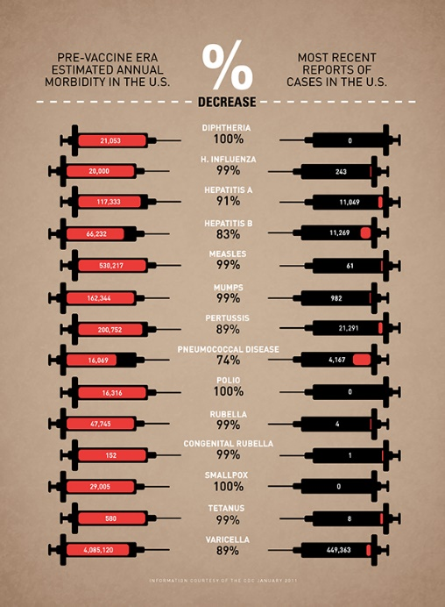
Figure 10. Leon Farrant (2011) 'Vaccine Infographic'

Pandemics
One of the most covered heath topics by graphic design in recent times is related to pandemics due to the recent Covid-19 outbreak. While Covid is a relatively new cause, humanity has been challenged by countless different outbreaks for centuries before. The increasing number of people combined with the constantly advancing transportation and the increased stress on the ecosystem, caused and spread many of them. From the Plague, leprosy, malaria, tuberculosis, smallpox, Spanish-flu to the ones more relatable in modern days, diseases like Ebola, HIV, SARS. While in ancient societies illnesses were thought to be caused by gods and spirits, or later in the 19th century by ‘bad air’. Thanks to people like John Snow also seen in the ‘infographic’ as the designer of the cholera map in 1854, humanity has a much better understanding of the spread of these diseases. Furthermore, the improvement in healthcare like the introduction of vaccines has highly improved our chances of survival of a pandemic. (LePan,2020)
The way society and graphic design attempt to spread information and awareness during pandemics, have remained the same as they handled the ‘Blood transfusion’ crisis in the past and present.
Before technology, the fundamental medium were posters, flyers, bulletins and manuals. Contributed to the crowd by being plastered over the walls on the streets, printed in the newspapers or handed out in manuals. While in modern days the delivery changed and has more focused on the vast variety of social media outlets like Television, Instagram, Facebook or Twitter. The message remained the same, trying to be informative and sometimes shocking to raise awareness. Using psychological strategies through visual interpretations to influence public behaviour. (Cheng, 2020)
During the Spanish flu between 1918 and 1920 approximately one third of inhabitants were affected around the world. The poor conditions caused by the war magnified the lethality of the disease. All over the world, governments had to address the issue. One of the many responses was a manual being released by the Japanese Government’s Central Sanitary Bureau. [Figure 11.] The manual included detailed information about the flu, described the symptoms and also the number of infected were displayed on charts. The 455 paged booklet also included tips on how to deal with the illness. Some of the advice highly resonate with the modern day’s messages during Covid-19. For example: stay away, cover your mouth and nose, get vaccinated etc. (Waldman,2020)
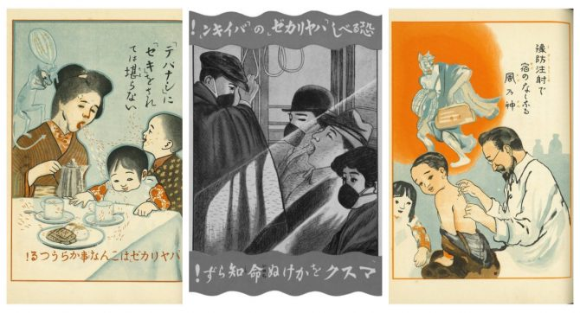
Figure 11. Central Sanitary Bureau (1918) 'Influenza' manual
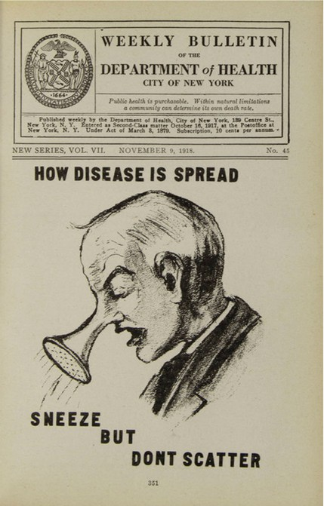
Figure 12. Department of Health City of New York (19 October 1918) Weekly Bulletin

At the beginning of the Covid-19 pandemic, designers had to face new challenges. They had to create powerful, informative national campaigns in an extremely short timescale. Designing and creating a basic design that was easily transferable for many different media and still remaining consistent throughout. Moreover, able to evolve with the changing emotions following the development of the virus. Each country took a different approach, some focused more on the purpose of the campaign, others on the audience. Some campaigns where criticised, others were praised. The most successful ones used visuals that were someway already familiar and related their nation’s culture and to the audience, creating a sense of unity, care and safety to influence public behaviour.
One of the most praised campaign drafts was designed in a short two days by Brigid Alkema creative director of Clemenger BBDO Wellington agency and her team, commissioned by the government of New Zealand. [Figure 13.] Their campaign focused on human interactions and the portrayal of people in their home environment instead of the virus, to create trust to inspire people. As Alkema explained “A human tone of voice is incredibly important for helping to dissipate fear and make dense information accessible and approachable”. The campaign included illustrations, infographics, and a series of films. [Figure 14.] (Khandwala,2021)

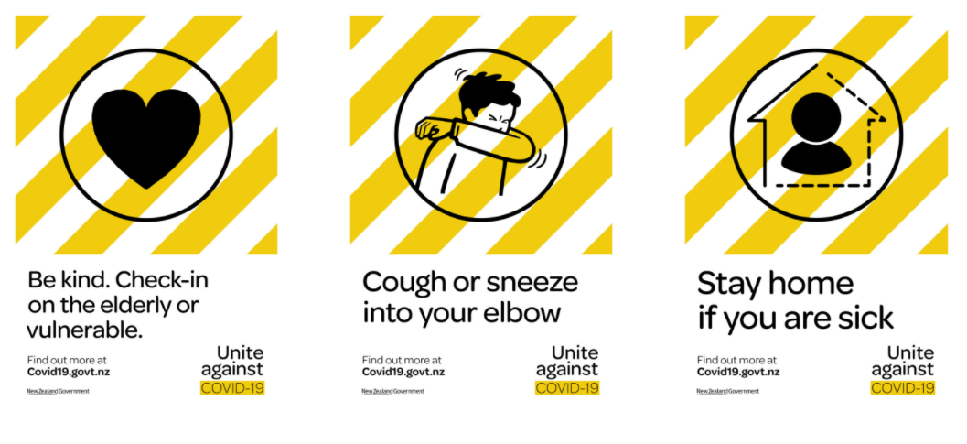
Figure 13. Clemenger BBDO Wellington (2019) ‘Unite Against Covid-19’ campaign

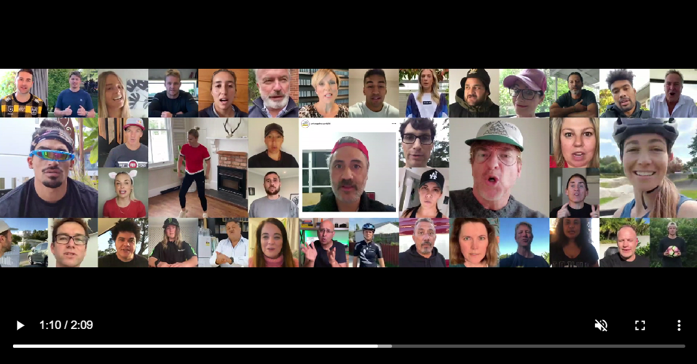

Figure 14. Clemenger BBDO Wellington (2019) ‘Unite Against Covid-19’ campaign film (still)

On the other hand, Vietnam approached their campaign in a very different tone. It was a declaration of war against Covid-19. In a country where propaganda posters are part of everyday life, focusing on patriotism using propaganda aesthetics to raise awareness was an obvious choice. Using strong symbolism like clenched fists to show resistance and defiance against the virus, turning healthcare workers into heroic figures similar to previous political campaigns [Figure 15.], was a reflection on the nation’s cultural background. The National campaign included posters, stamps [Figure 16.] and propaganda songs to encourage handwashing. (Humphrey,2020)

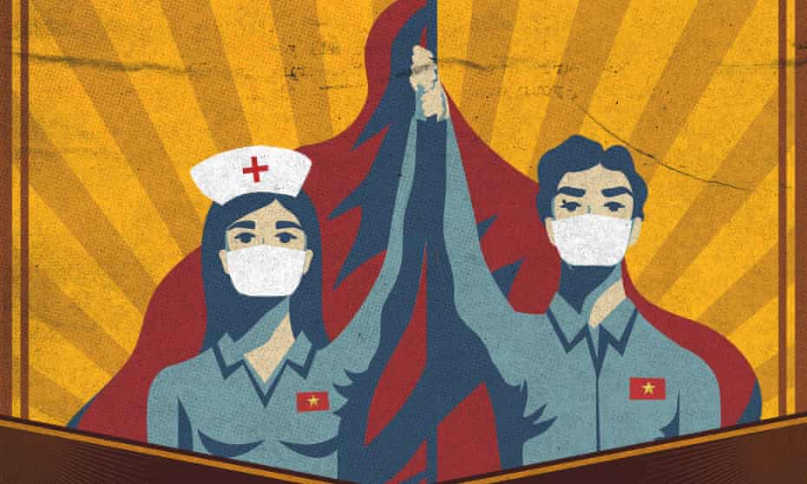
Figure 15. Le Duc Hiep (2019) ‘To stay at home is to love your country’

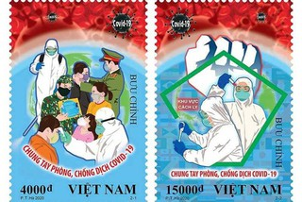

Figure 16. Pham Trung Ha (2020) '#TogetherWeWillWin' [stamp]

Despite the fact that each country addressed the challenge caused by the virus differently, they are equally realised and utilized the power of graphic design.
But the question still remains. Can graphic design really save your life?
Just a graphic design by itself maybe cannot save lives, as human interaction is essential to do that. However, in conclusion after examining the topics presented through this essay, it became obvious that graphic design has an enormous power to influence people’s behaviour. It can inspire and encourage not just individuals but whole societies to take action to save lives. While the way graphic designers address certain issues around the world in present times or in the past may change, their responsibilities remain the same. Create with meaning with social awareness without biases to raise awareness and inspire to save lives.
I believe after completing this research, I have become more aware of the power of graphic design and the obligations which are required to create expressive graphic design pieces. Being aware of these responsibilities will inevitably have a huge impact on my future graphic design career. Knowing my designs could make a difference and a positive impact on others life, I want to create meaningful designs with value and social awareness to create a better future.

Reference
Cheng, A. Y. (2020) ‘Don’t Spit! Pandemic Posters Through the Years’ The Atlantic 19 April, Available at: https://www.theatlantic.com/health/archive/2020/04/dont-spit-pandemic-posters-through-the-years/609589/ (Accessed: 17 November 2021)

Health Alliance, (2015) ‘The Importance of Vaccines: Myths vs. Facts’ Health Alliance [Blog] 25 February, Available at: https://blog.healthalliance.org/tag/leon-farrant/ (Accessed: 17 November 2021)

Humphrey, C. (2020)’ 'In a war, we draw': Vietnam's artists join fight against Covid-19’ The Guardian 9 April, Available at: https://www.theguardian.com/global-development/2020/apr/09/in-a-war-we-draw-vietnams-artists-join-fight-against-covid-19 (Accessed: 18 November 2021)

Khandwala, A. (2021) ‘Stay Home, Save Lives: The Design Secrets of Covid-19 Health Campaigns’ Elephant 18, Available at: March https://elephant.art/stay-home-save-lives-what-the-graphic-design-of-public-health-warnings-reveal-18032021/ (Accessed:18 November 2021)

LePan, N. (2020) ‘Visualizing the History of Pandemics’ Visual Capitalist, 14 March, Available at: https://www.visualcapitalist.com/history-of-pandemics-deadliest/ (Accessed: 17 November 2021)

Lile, S. (2017) ‘12 Groundbreaking Infographics That Changed the World’ Visme [Blog] 18 April, Available at: https://visme.co/blog/interesting-infographics/ (Accessed: 10 November 2021)

McCann, S. (2018) ‘All’s Fair in Blood and War’, History Today Volume 68 Issue 1 January, Available at: https://www.historytoday.com/history-matters/all%E2%80%99s-fair-blood-and-war (Accessed: 10 November 2021).

National Army Museum, ‘Abram Games, ABCA and the fight for post-war change’ Available at: https://www.nam.ac.uk/explore/abram-games-abca-and-fight-post-war-change (Accessed: 10 November 2021).
National Health Service (2021) Blood transfusion, Available at: https://www.nhs.uk/conditions/blood-transfusion/ (Accessed: 10 November 2021).

National Health Service Blood and Transplant (2019) ‘Missing Type’ blood donation campaign named campaign of the decade’, NHS Blood and Transplant 17 December Available at: https://www.nhsbt.nhs.uk/news/missing-type-blood-donation-campaign-named-campaign-of-the-decade/ (Accessed: 10 November 2021).

Nediger, M. (2021) ‘What is an Infographic? Examples, Templates & Design Tips’ Venngage [Blog]19 October, Available at: https://venngage.com/blog/what-is-an-infographic/ (Accessed: 10 November 2021).

Rogers, S. (2013) ‘John Snow's data journalism: the cholera map that changed the world’ The Guardian, 15 March, Available at: https://www.theguardian.com/news/datablog/2013/mar/15/john-snow-cholera-map (Accessed: 17 November 2021)

Waldman, J. (2020) ‘Posters From Japan’s 100-Year Old Pandemic Manual’ Spoon and Tamago [Blog] 25 April, Available at: https://www.spoon-tamago.com/2020/04/25/japan-spanish-flu-pandemic-manual/ (Accessed: 17 November 2021)
Wainwright, O. (2017) ‘Can Graphic Design Save your Life? Review – thrills, pills and big pharma’, The Guardian, 7 September. Available at: https://www.theguardian.com/artanddesign/2017/sep/07/can-graphic-design-save-your-life-review-wellcome-collection-london (Accessed: 03 November 2021).

List of Figures:
Figure 1.
Spain (1937) ‘Cinderella’ stamp during the Spanish Civil War, Available at: https://www.stampboards.com/viewtopic.php?p=6112331 (Accessed: 26 November 2021)
Figure 2.
Minister of Defence of Ireland (1945) [letter]to an Advertising Agency, Available at: https://www.stampboards.com/viewtopic.php?p=6112331 (Accessed: 26 November 2021)
Figure 3.
Abram Games, (1943) 'Blood Donors. If He Should Fall Is Your Blood There To Save Him?'[Colour offset lithography] Available at: https://collections.vam.ac.uk/item/O1034422/blood-donors-if-he-should-poster-games-abram/ ( Accessed: 10 November 2021)
Figure 4.
Abram Games (ca.1941-1945), ‘Blood Donors Now. 30 Minutes Of Your Time A Lifetime To Somebody Else’. '[Colour offset lithography] Available at: https://collections.vam.ac.uk/item/O1224091/blood-donors-now-poster-games-abram/ ( Accessed: 10 November 2021)
Figure 5.
Abram Games (1941-1946) 'Blood Donors are needed urgently to save these lives'. [Colour lithograph] Available at: https://collections.vam.ac.uk/item/O540495/blood-donors-are-needed-urgently-poster-games-abram/ ( Accessed: 10 November 2021)
Figure 6.
Engine Group (2015) ‘Missing Type’ blood donation campaign, Available at: http://katienelson.co.uk/nhs-give-blood-missing-type-campaign/ (Accessed: 10 November 2021)
Figure 7.
Engine Group ‘Missing Type’ blood donation campaign, Available at: http://projectrising.in/2015/07/missingtype/ (Accessed: 10 November 2021)
Figure 8.
South African National Blood Service (2018) 'Missing Type' campaign Available at : https://www.mediaupdate.co.za/publicity/144078/sanbs-aims-to-steal-brands-letters-for-the-missing-type-campaign (Accessed: 10 November 2021)
Figure 9.
Doctor John Snow (1854) 'Cholera Map' Available at: https://visme.co/blog/interesting-infographics/ (Accessed: 17 November 2021)
Figure 10.
Leon Farrant (2011) 'Vaccine Infographic' Available at: https://www.behance.net/gallery/2878481/Vaccine-Infographic (Accessed: 17 November 2021)
Figure 11.
Central Sanitary Bureau (1918) 'Influenza' Available at: https://www.spoon-tamago.com/2020/04/25/japan-spanish-flu-pandemic-manual/ (Accessed: 17 November 2021)
Figure 12.
Department of Health City of New York (19 October 1918) Weekly Bulletin Available at: https://www.theatlantic.com/health/archive/2020/04/dont-spit-pandemic-posters-through-the-years/609589/ (Accessed: 18 November 2021)
Figure 13.
Clemenger BBDO Wellington (2019) ‘Unite Against Covid-19’ campaign Available at: https://www.dandad.org/awards/professional/2021/234098/unite-against-covid-19/ (Accessed: 18 November 2021)
Figure 14.
Clemenger BBDO Wellington (2019) ‘Unite Against Covid-19’ campaign film Available at: https://www.dandad.org/awards/professional/2021/234098/unite-against-covid-19/ (Accessed: 18 November 2021)
Figure 15.
Le Duc Hiep (2019) ‘To stay at home is to love your country’ Available at: https://www.theguardian.com/global-development/2020/apr/09/in-a-war-we-draw-vietnams-artists-join-fight-against-covid-19 (Accessed:18 November 2021)
Figure 16.
Pham Trung Ha (2020) '#TogetherWeWillWin' [stamp] Available at: https://www.theguardian.com/global-development/2020/apr/09/in-a-war-we-draw-vietnams-artists-join-fight-against-covid-19 (Accessed:18 November 2021)

