BA (Hons) International Hotel Management
Module Handbook Autumn Term 2025

Hotel Placement – Managing Guest Service Operations
BMIH6003

Level 6

Student Name:Daniela-Elena Zota
Student ID:2240973

Table of Contents
Introduction 3
Department Reflection: Management Styles and the Guest Experience 3
Overview of Leadership Practice in the Maintenance Department 4
Theoretical Analysis: Applying Management and Organisational Behaviour Concepts 4
Linking Leadership to Service Culture and Guest Experience 5
Observations on Safety, Communication, and Organisational Culture 6
Significance of the Issue 6
References 8

Introduction
The best western hotels place me in the Maintenance Department of Chilworth Manor Hotel Southampton, a four star establishment, during my placement. The hotel is well known because of its combination of modern aspects and traditional architecture that includes leisure club, conference suites and gardens. Maintenance Department is critical to the smooth operation of the hotel infrastructure plumbing, electrical, and guest room maintenance, as well as emergency repairs (Zhukova, 2022). I collaborated with the Maintenance Manager, Steve Whitmore, and the Assistant Supervisor, James Connolly, and learned how the leadership styles directly affected the workflow performance, employee morale, and, eventually, the satisfaction of the guests. The work of the team went further than normal checks to the activities of the rapid response which required cooperation with the other departments, including Housekeeping and Front Office. This learning log takes a critical look at the style of management used in the Maintenance Department and how it influenced the motivation of the employees, how it influenced the coordination of the employees and how it influenced service delivery. Using theoretical backgrounds of Management and Organisational Behaviour, I relate theoretical knowledge to practical management and offer an improvement strategy to improve the performance of the team and the overall outcome of the guest service.

Department Reflection: Management Styles and the Guest Experience
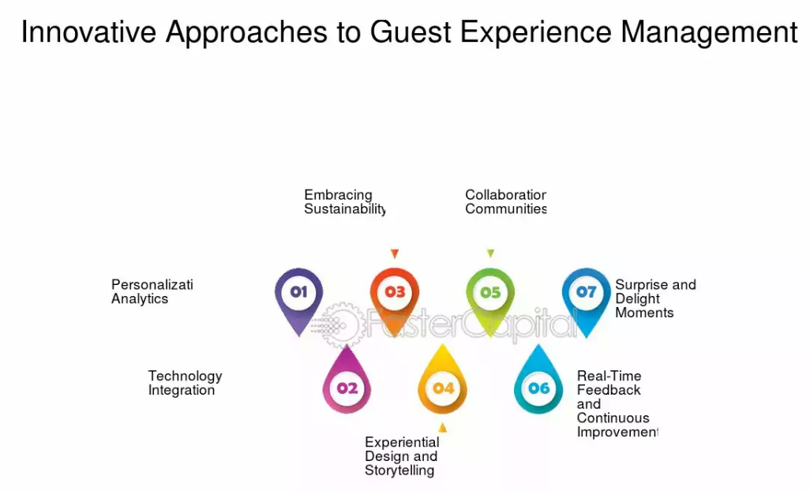
Figure 1: Management Styles and the Guest Experience
(FasterCapital, 2025)

Overview of Leadership Practice in the Maintenance Department
My first few weeks in Chilworth Manor Hotel revealed that the Maintenance Department was operated on a transactional style of management. The Maintenance Manager, Steve Whitmore was very strict in his task allocation, he emphasised on sticking to the hotel standards and he would always check on staff performance by using checklists and reporting forms. This hierarchy guaranteed conformity and uniformity, yet it sometimes restricted candid communication and creativity among the staff members. According to the description given by Burns (1978), transactional leadership model emphasizes on execution of tasks, reward, and penalty. In this context, motivation is an act of external reinforcement as opposed to internal involvement (Bass and Riggio, 2006). I could see this in the day-to-day activities where the instructions were dictatorial and performance was measured by speed of completion as the main factors. As much as this ensured discipline, it at times led to tension in cases of high pressure like when there were cases of urgent repair and at the same time the guests complaining. As an example, in one of the weekends, the air conditioning system of the conference hall broke down. The Maintenance Manager also focused on immediate repair to prevent inconvenience, but failed to engage the technicians in the planning process. As a result, misunderstanding was created and a short delay and dissatisfaction of guests were experienced.

Theoretical Analysis: Applying Management and Organisational Behaviour Concepts
Conversely, using the Management and Organisational Behaviour theories that were undertaken in Level 5, the good leadership style must respond to the situational needs. The Situational Leadership Theory developed by Hersey and Blanchard suggests that the behaviour of a leader should change between the controlling and supportive based on the maturity and competency of the team (Felce, 2019). At Chilworth Manor, the management team was very strict, but the maintenance team was very proficient and their autonomy and expertise in their job was not fully exploited. During reflective observation, I realised that the team engagement could be enhanced using a more transformational approach to leadership. Transformational leaders motivate workers through illustrating a clear vision, inviting their engagement, and promoting intrinsic motivation (Northouse, 2021).

Linking Leadership to Service Culture and Guest Experience
Based on the idea of service culture introduced by Wood, (2013), hospitality leadership should go beyond the internal processes; it has a direct impact on the experience of guests. The de-motivated maintenance team also has the likelihood of executing their duties in a robotic manner without regard to the emotional satisfaction of the guest. On the other hand, a team with empowerment is able to foresee problems, communicate efficiently with Front Office employees and solve problems in advance. This change was also observed by me personally when I was encouraged by James Connolly who was the Assistant Supervisor to suggest a new maintenance tracking sheet to track recurrent faults.
The difference in the styles of management between the two supervisors offered a good learning experience. Steve Whitmore was a transactional manager who believed in compliance by structure whereas James Connolly was oriented towards transformational practice where he provided motivation by use of mentorship and inclusion. This two-fold exposure enabled me to contrast practical relevance of the leadership theory taught in the classroom, specifically Theory X and Theory Y created by McGregor (Walker, 2021). The style of the Maintenance Manager was associated with Theory X assumptions as it presupposes an employee that should be controlled strictly. Conversely, the Assistant Supervisor was a Theory Y, who believed that the staff were self-driven and self-directed. This affirmed Johnston et al. (2012) postulation that managing service operations requires employee participation and internal co-ordination.
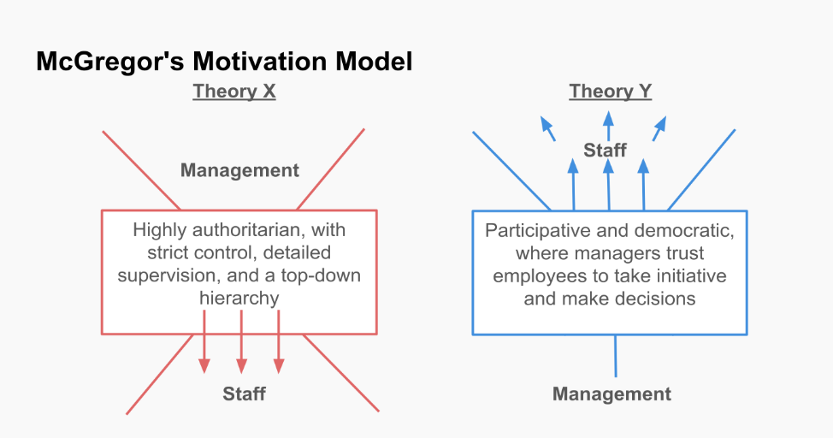
Figure 2: McGregor’s Theory X and Theory Y
(Planyway, 2024)

Observations on Safety, Communication, and Organisational Culture
Moreover, I got to know that the styles of leadership do not only affect the motivation, but also safety culture which is an essential part of maintenance operations. The strict chain of command can lead to the workers failing to report safety issues early. I noticed that some technicians were reluctant to mention defective equipment during a weekly health and safety audit because they were afraid of being criticized. This experience helped me to solidify the fact that leadership within the hospitality industry should be authoritative and yet empathetic and communicative. Leadership is, therefore, a mediator between organisational culture and guest satisfaction. According to Rughubalan (2009), operations reliability and impression of quality of services to guests is directly influenced by managerial behaviour.

Significance of the Issue
The style of leadership plays a major role in the performance of the hotel guest service activities. In the maintenance situation whereby some of the tasks are typically behind the scenes but the leadership of the time is time sensitive; how quickly and safely a problem is solved is a matter of concern. This experience at Chilworth Manor proved that a lack of consistency in leadership styles may cause confusion and decrease the level of efficiency, which eventually may affect the scores in terms of guest satisfaction. This observation correlates with Hagg (2013) who points out that during an internship, one can use theoretical knowledge to solve real-life problems and develop a professional identity.

Three-Step Improvement Plan
- Implement Participative Briefings
Hold brief meetings every morning by each department headed by the Maintenance Manager, to get suggestions on how to prioritise and allocate the work to be done. This goes in line with transformational leadership concepts and promotes each other to understand the daily goals.
- Introduce Recognition Systems
Introduce a monthly reward of maintenance excellence award to shows initiative and problem solving. Bardi (2010) claims that recognition boosts motivation and lowers the staff turnover in the hospitality operations.
- Leadership Development Training
Suggest supervisor management training seminars on adaptive intelligence-based and emotional intelligence-based leadership. This coincides with Felce (2019), who emphasizes that the learning of the manager is a crucial element in the context of quality improvements in the sphere of services.

Conclusion
My experience with the Chilworth Manor Hotel Southampton has enabled me to reflect on how management styles influence the efficiency of operations and employee motivation within hospitality settings. Comparing the leadership styles in the Maintenance Department, it was observed that transactional leadership styles ensure organization, but also suppress initiative and that transformational leadership styles also promote cooperation, innovation, and motivation. Based on Management and Organisational Behaviour theories, I have learned that the best leaders will change their style to match situational requirements and maturity of employees. It was also an experience that emphasized the role of emotional intelligence, communication, and recognition in motivating and maintaining service quality. In the future, I would like to create a leadership approach that would be both directive and empowering in terms of encouraging open communication, appreciating input in a team, and ensuring that operational objectives are aligned with the hotel service culture.

References
Bardi, J. (2010) Hotel Front Office Management. 5th ed. London: Wiley.
Bass, B.M. and Riggio, R.E. (2006) Transformational Leadership. 2nd ed. Mahwah, NJ: Lawrence Erlbaum.
FasterCapital. (2025) Hospitality and tourism leadership and management: Driving innovation in hospitality – A leadership perspective. Available at: https://fastercapital.com/content/Hospitality-and-tourism-leadership-and-management-Driving-Innovation-in-Hospitality--A-Leadership-Perspective.html (Accessed: 12 October 2025).
Felce, A. (2019) ‘Managing the quality of higher education in apprenticeships’, Higher Education, Skills and Work-Based Learning, 9(2), pp. 141–148.
Hagg, E. (2013) Internship Guide: Work Placements Step by Step. 5th ed. The Hague: Eleven International Publishing.
Johnston, R., Clark, G. and Shulver, M. (2012) Service Operations Management. London: Pearson.
Northouse, P.G. (2021) Leadership: Theory and Practice. 9th ed. Thousand Oaks: Sage.
Planyway. (2024) ‘McGregor’s Theory X and Theory Y: A Comprehensive Exploration’. Planyway Blog. Available at: https://planyway.com/blog/mcgregor-theory-x-and-y (Accessed: 12 October 2025).
Rughubalan, G. (2009) Hotel Housekeeping: Operations and Management. Oxford: Higher Education Press.
Walker, J.R. (2021) Introduction to Hospitality. 8th Global Edition. Harlow: Pearson.
Wood, R.C. (2013) Key Concepts in Hospitality Management. London: SAGE Publications Ltd.
Zhukova, V.I., 2022. Management Styles. Инновационная наука, (12-2), pp.154-158.

