Assignment on Marketing Plan for Travelodge Hotel

Name: Zakia Sultana
ID: 2018895
Module: BMIH4005
Module Tutor: Luciana Suardi

The Travelodge refers to several hotel chains located around the world, including the United Kingdom, Spain, and Ireland. First and foremost, the chosen hotel firm Travelodge from group B will be addressed in terms of pushing a new marketing plan based on the geographical region of the United Kingdom and Ireland. The hotel was founded in 1973 and its headquarter is in Thames. Travelodge runs almost 510 hotels across the UK, 11 hotels in Ireland, and 5 hotels in Spain. Staggering 11000 employees are currently working at Travelodge hotel. Travelodge provides a variety of hotel tiers ranging from low-cost lodgings to full-service high-rise hotels. However, to discuss the existing marketing plan of Travelodge, the company is promoting the brand through the digital platform of social media. Besides having several marketing strategies, there are still some areas that can be targeted for improvement, gathering new ideas, and new customer acquisitions. Nevertheless, investing in search engine marketing and meta-search, broadening reach with influencer marketing, showcasing property with augmented reality (AR), and turning the guests into brand ambassadors would be some effective marketing methods that will draw in more consumers, increase profit margin, boost customer satisfaction, build goodwill and public reputation for the proposed hotel company. And lastly, to add new marketing strategies include expanding Travelodge's digital marketing efforts and growing the brand globally, particularly in tourist areas, which can make more customer acquisitions for Travelodge. (Smart Insights, 2019)

From the very beginning, Travelodge’s main mission is to provide affordable travel for everyone and they have a vision that they’ll be the ultimate affordable accommodation for adventure seekers of all ages. They always put three values as their key focus area: Building Competence, Teamwork, and Innovation. Their pricing strategy is keeping the price as affordable as possible and providing minimal service but giving the best output within that. Now, let’s do a brief situational analysis of Travelodge hotel and for that, if we follow Porter’s 5 laws of competitive position analysis, they are really in an ultra-competitive, price-sensitive market. As their main selling point is affordable pricing, there are lots of existing hotels already with this concept like Premier Inn, Best Western, etc, and more, that are coming regularly. Customers can easily take any of the solutions as each one will be a pocket-friendly solution for them. (Katerina, 2022)
Again, as most of their customers are looking for just an overnight stay, they have collaborated with many renowned companies like taxibboking.com, tastecard, holiday extras, etc so that together they can give a better value to the customers within the budget limit. Covid-19 and Brexit were the most recent big threats to their business.

To begin analyzing Travelodge's strengths, weaknesses, opportunities, and threats, it is necessary to note that they consistently provide new discounts while offering reasonable rates. They also provide a highly user-friendly booking system, which is of tremendous value to the consumer and of course exposes the strengths of Travelodge. (Kotler et al., 2017)
Additionally, frequent discounts and promotions as well as unique premium service cards for travelers in business classes demonstrate additional services for the client. Moreover, Travelodge's future growth opportunities include a presence in all popular tourist destinations throughout the globe, company expansion into other nations, partnerships with other businesses, and high levels of digitalization. On the other hand, Travelodge's weaknesses to date include offering inadequate customer service in comparison to other competitive hospitality businesses, inability to host large events, and lack of luxurious facilities. As a result, there is a considerable likelihood that these vulnerabilities might become threats in this fiercely competitive market for the hospitality industry if other hotel chains offer similar services at a lower cost or if guests decide to stay in upscale accommodations. (Sfgate, 2020)

The PESTLE analysis illustrates the favorable and unfavorable effects of Travelodge's many environmental regions to determine the macro-environmental elements that influence it. In the current political turmoil, Travelodge as a private hotel industry is regulated under strict government rules and laws. Even more, different political parties have also influenced the hospitality market which is a challenge for Travelodge. Though London has strong consumer demand, there is fierce rivalry among the same types of affordable hotels. (Bradford, 2022)
The present price hike market and keeping the price reasonable can influence Travelodges's economic environment. In addition, they are making use of social occasions like the Olympics, Commonwealth Games, and other such events to serve more people and keep updated with the social and environmental elements. However, Travelodge had to incur significant costs to keep up with the technical demands of the current advancement. Besides, the Travelodge hotel industry's legal academics are in charge of overseeing the legal matters that have an impact on the organization’s legal environment. And lastly, to illustrate the environmental frameworks of Travelodge, it has taken responsibility for sustainable living by establishing the “Better Future Plan” besides regulating its business plan. (Chen, 2022)

However, if we try to set marketing plan objectives for Travelodge, we can focus on several areas like Increasing the Number of Bookings, Increasing our Brand Presence, Increasing our Brand Loyalty, Increasing the number of repetitive guest numbers, and Engaging more target areas for the audience. Now, let’s put a SMART target for this marketing objective. We need to set Measurable metrics for achieving the plan. While doing intensive situation analysis we’ve already set Realistic and Achievable targets within a limited time frame which will discuss in later part of Gannt Chart discussion area. Again, to discuss the other areas of Travelodge’s marketing strategies, the 4Ps marketing mix is the essential method where they are used to analyze the hotel's major distinguishing qualities and establish Travelodge's placement. For visitors, Travelodge provides lodging options and related services. They provide completely equipped double and family rooms together with a constrained number of facilities including Wifi, reception, and room services. Its framework is typical for a cheap hotel and appropriate for short stays. Moreover, Travelodge stated that its hotels were conveniently situated in or close to downtown areas, making it easy to access cafes, theaters, restaurants, churches, malls, and tourist sites. Targeting low-income and casual visitors, Travelodge is dedicated to offering the greatest services at the lowest costs. Additionally, it operates additional marketing initiatives, such as early booking discounts and other unique offerings. This also reduces Travelodge's costs and raises customer expectations. Lastly, with the growth of the Internet and globalization, digital marketing is the strongest marketing medium, reaching consumers all over the world for Travelodge. We’ll use all possible marketing channels from Content Marketing, SEO, Social Media Marketing, PR, Email Marketing, and PPC to establish a proper marketing mix and make our campaign a successful one. We have set a few key performance metrics to evaluate our campaign success. Like in content marketing we’ll measure traffic source, how much time they are spending here; in SEO we’ll measure the number of organic traffic, CTR; in PR marketing we’ll measure media coverage, and brand impact; in social media marketing we’ll look for engagement rate; in email marketing, we’ll count conversion rate; in PPC we’ll measure impression shares, etc. These are a few of our performance measuring metrics. Again we’ve set a year-long target to achieve our marketing targets in Gantt chart. From Jan we’ll start our concept generation, and doing all other procurements and preparations we’ll run our campaign from May to Sep afterwards our Sales Team and other supply chain members we’ll come forward to carry the success from this marketing campaign.

Conclusion
This marketing plan can be summarized in 4 words; Customers are the priority. With all the economic instabilities, it is increasingly becoming tough to do business. We want to make sure our existing customer base doesn’t decrease. We’ll be working on our brand presence and recognition which will come in handy during the business’s profit period.

References.
- WU, S.Y., 2021. A STUDY ON PROMOTION STRATEGIES AND PURCHASE INTENTION DURING THE EPIDEMIC SITUATION-IN THE TRAVELODGE INDUSTRY.
- BOWIE, D., BUTTLE, F., BROOKES, M. AND MARIUSSEN, A., 2016. HOSPITALITY MARKETING. ROUTLEDGE.
- HOGAN, J.J., 1992. TURNOVER AND WHAT TO DO ABOUT IT. CORNELL HOTEL AND RESTAURANT ADMINISTRATION QUARTERLY, 33(1), PP.40-45.
- WHITTAKER, C., 2008. HOTEL OPERATOR MOTIVES IN UK SALE AND LEASEBACK/MANAGEMENT-BACK TRANSACTIONS. INTERNATIONAL JOURNAL OF HOSPITALITY MANAGEMENT, 27(4), PP.641-648.
- CONNELL, J., 1992. BRANDING HOTEL PORTFOLIOS. INTERNATIONAL JOURNAL OF CONTEMPORARY HOSPITALITY MANAGEMENT.
- IMRIE, R. AND FYALL, A., 2001. INDEPENDENT MID-MARKET UK HOTELS: MARKETING STRATEGIES FOR AN INCREASINGLY COMPETITIVE ENVIRONMENT. JOURNAL OF VACATION MARKETING, 7(1), PP.63-74.
- POTTORFF, S.M. AND NEAL, D.D.M., 1994. MARKETING IMPLICATIONS FOR POST-DISASTER TOURISM DESTINATIONS. JOURNAL OF TRAVEL & TOURISM MARKETING, 3(1), PP.115-122.
- LAŠKARIN, M., 2012. WEB COMMUNICATION MANAGEMENT IN HOTEL MARKETING. INFORMATOLOGIA, 45(4), PP.314-322.
- Travel Industry Example Marketing Plan (2019) Smart Insights. Smart Insights. AVAILABLE AT: HTTPS://WWW.SMARTINSIGHTS.COM/GUIDES/TRAVEL-INDUSTRY-EXAMPLE-MARKETING-PLAN/
- Chen, J. (2022) What is a marketing plan? types and how to write one, Investopedia. Investopedia. Available at: https://www.investopedia.com/terms/m/marketing-plan.asp
- “The strategic marketing plan” (2010) Strategic Marketing, pp. 257–268.
- Travel and tourism marketing: The ultimate guide (2020) Travel and Tourism Marketing: The Ultimate Guide. Available at: https://marketing.sfgate.com/resources/travel-marketing-guide
- Bradford, J. (2022) Council post: How to write a marketing plan, Forbes. Forbes Magazine. Available at: https://www.forbes.com/sites/forbesagencycouncil/2021/08/05/how-to-write-a-marketing-plan/ (Accessed: December 9, 2022).
- Katerina (2022) 10 Luxury Hotel &amp; Resort Marketing Strategies + Marketing Plan, Proven Partners. Proven Partners. Available at: https://www.proven.partners/blog/luxury-hotel-resort-marketing (Accessed: December 9, 2022).
- Kotler, P. et al. (2017) Marketing for hospitality and tourism. Harlow, Essex, England: Pearson Education Limited.

Presentation Slides

Presentation Slides are attached below:

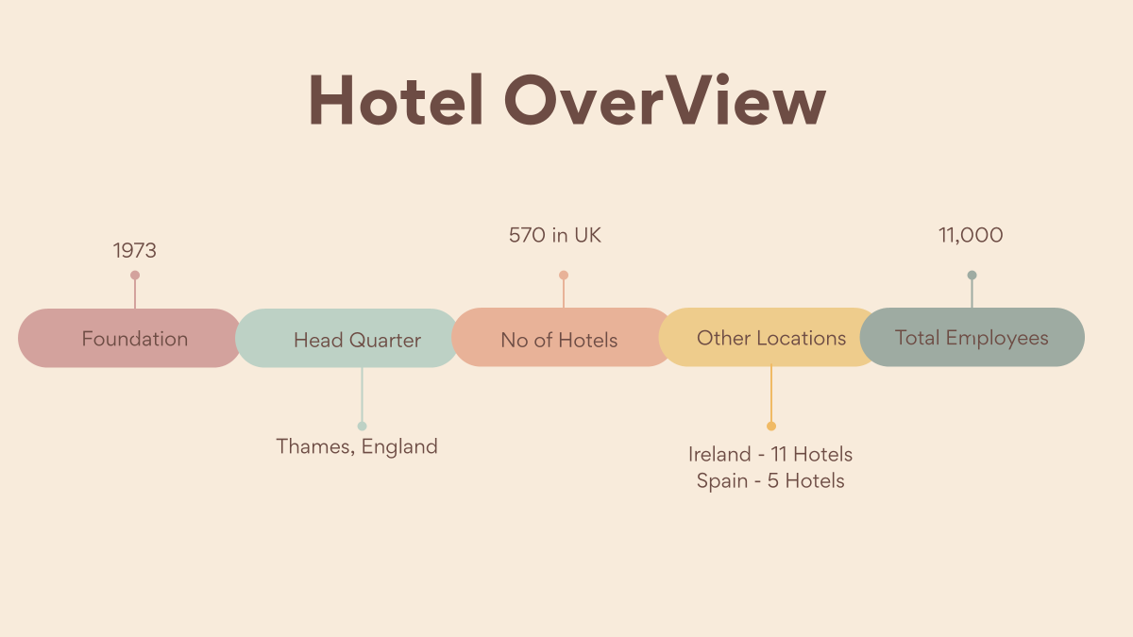

3.
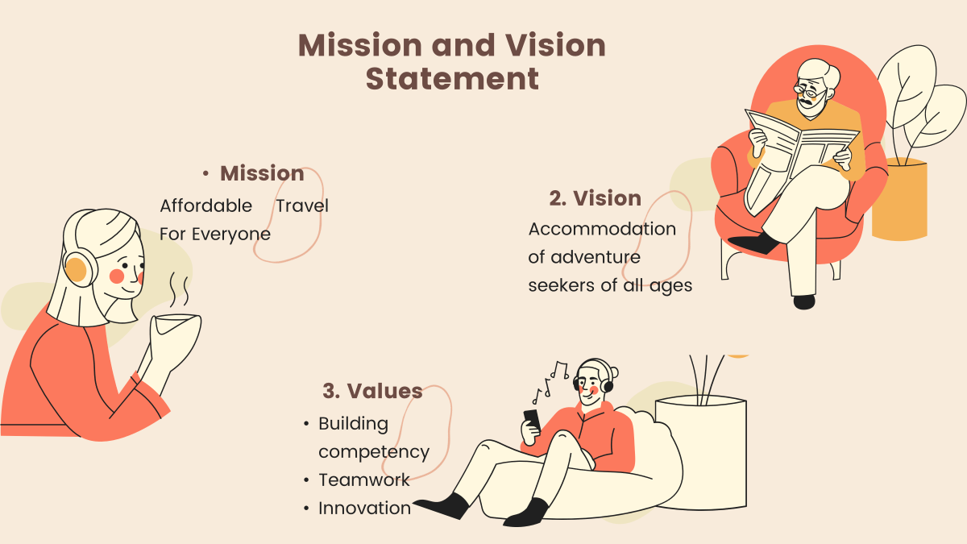
4.
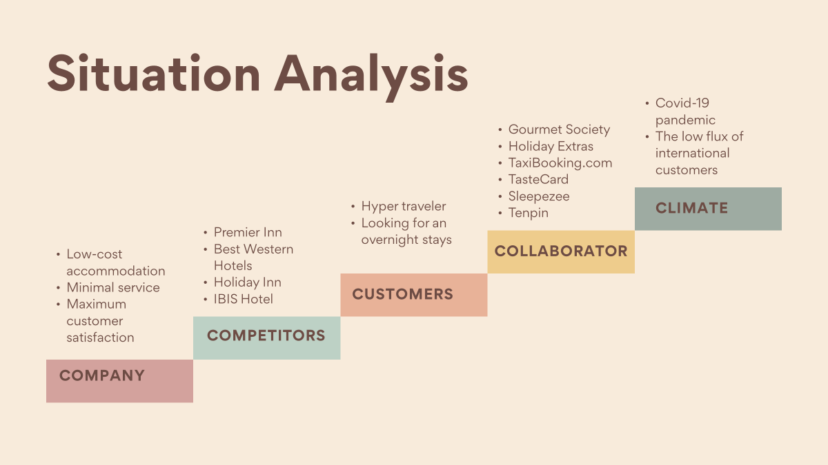
5.
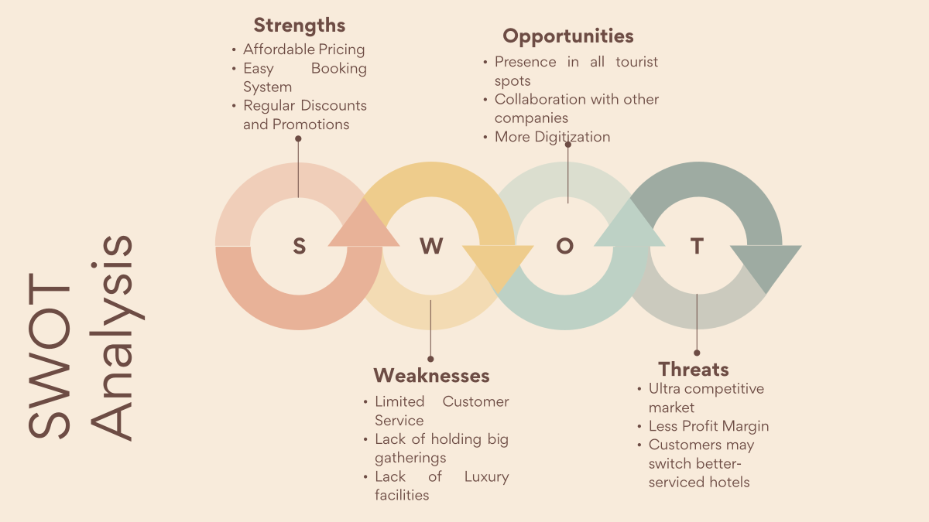

6.
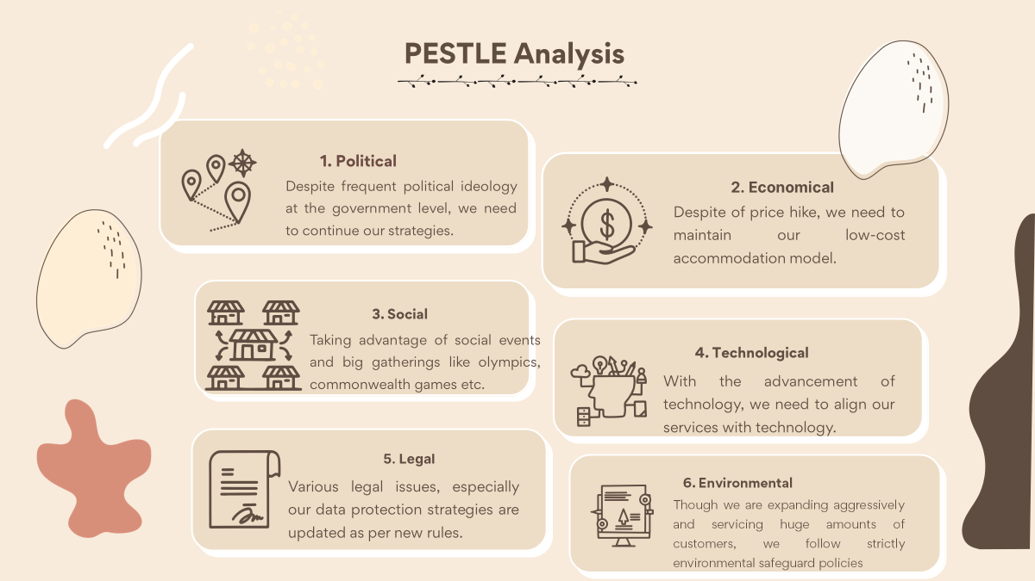

7.
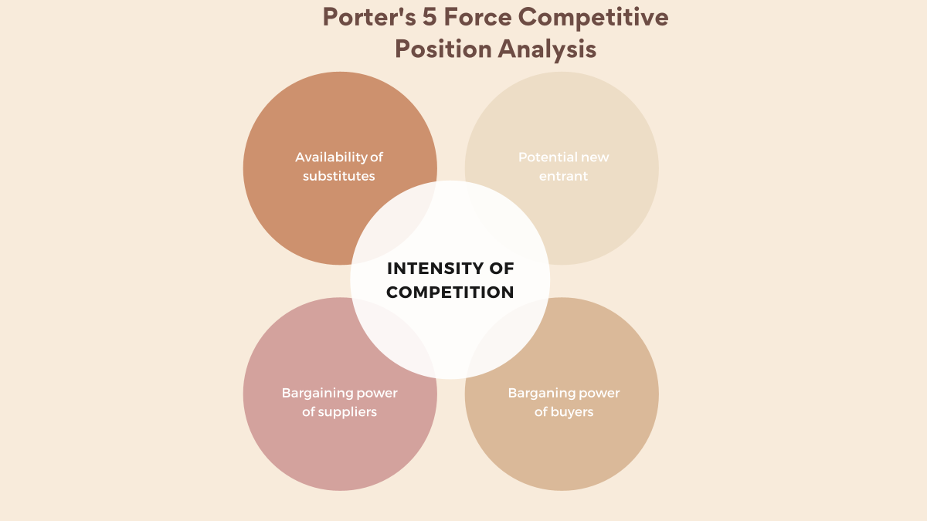
8.
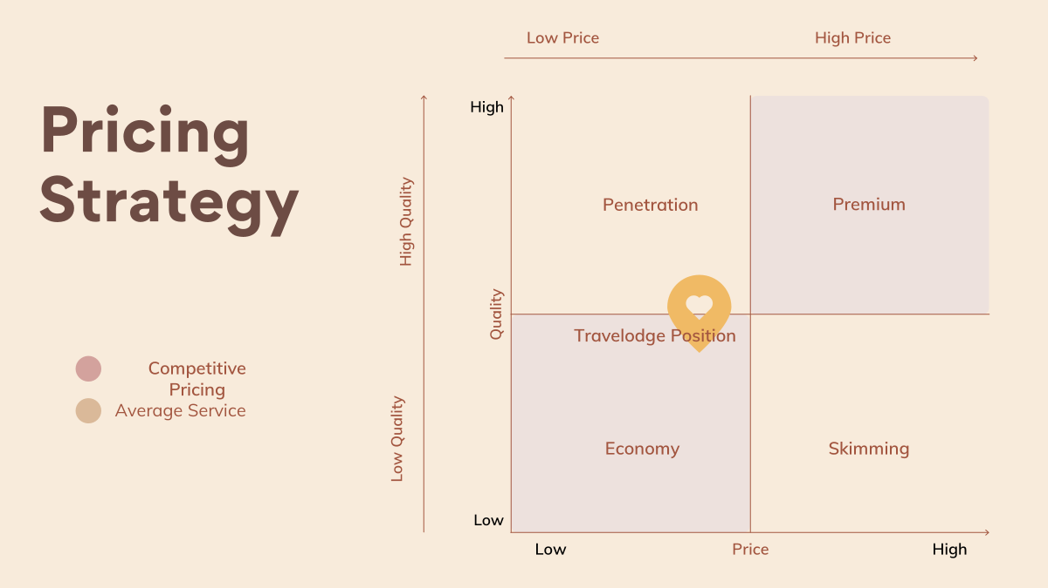
9.
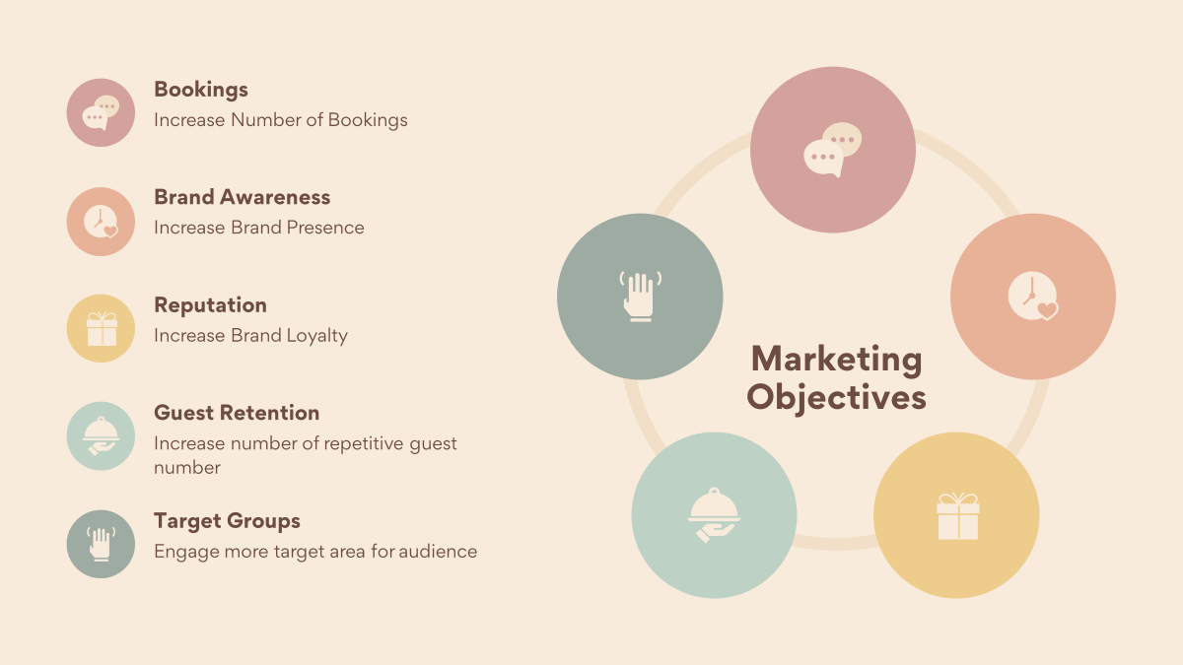
10.
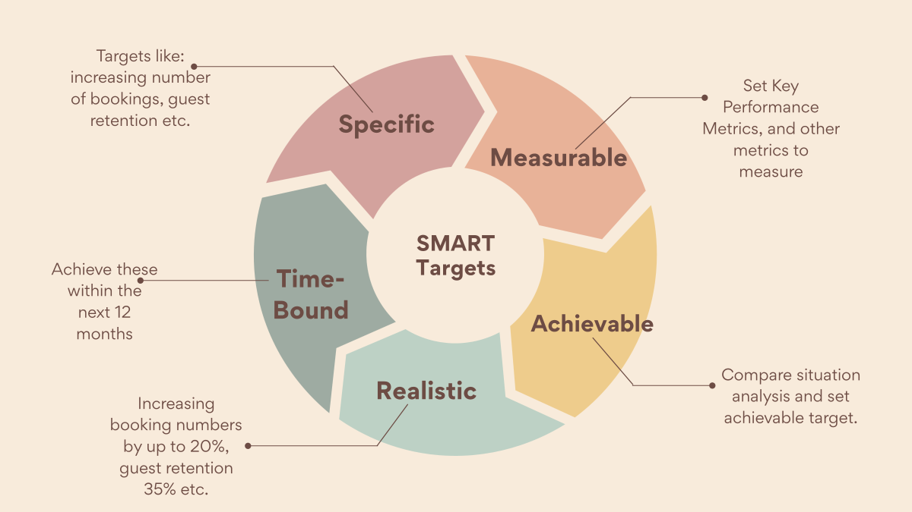
11.
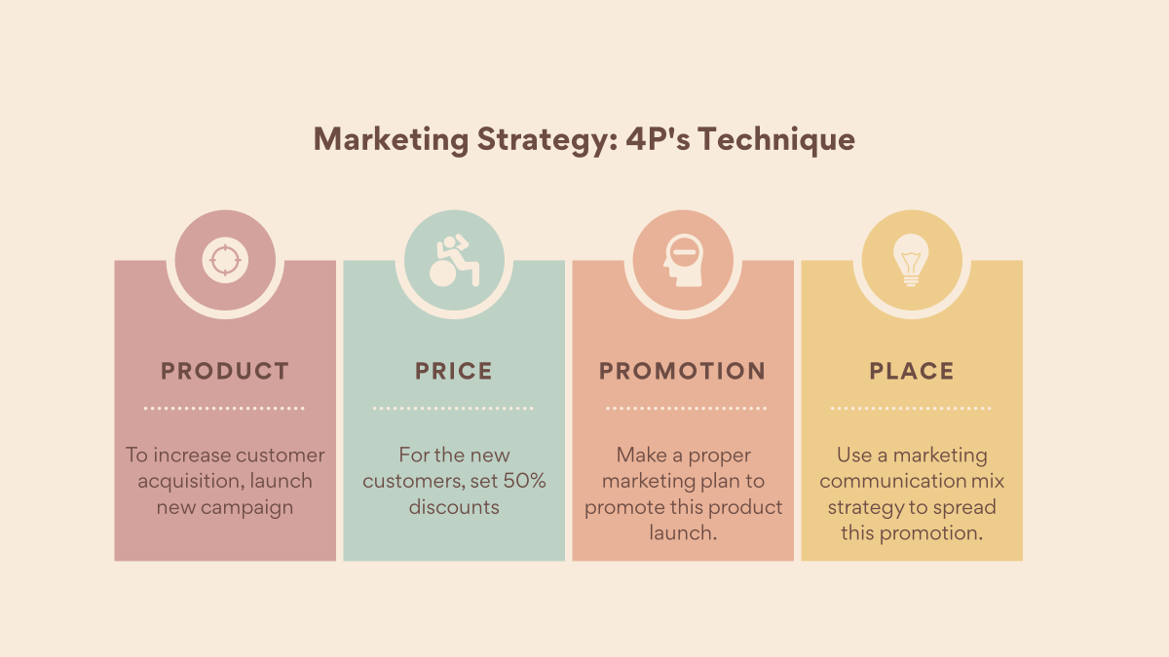
12.
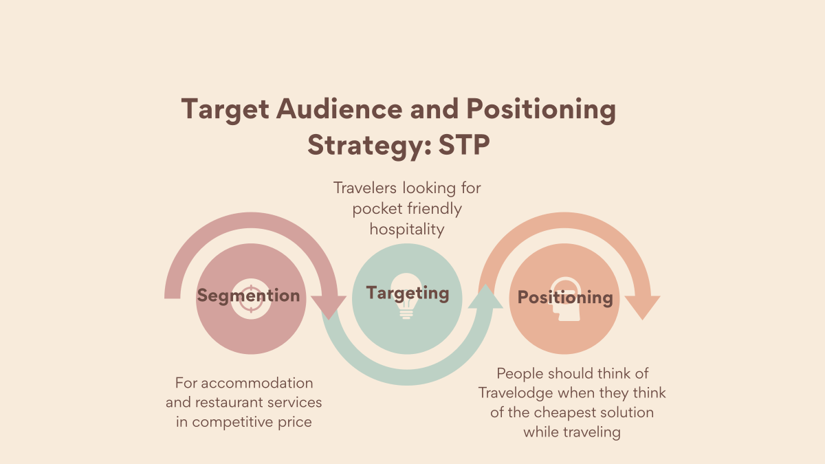
13.
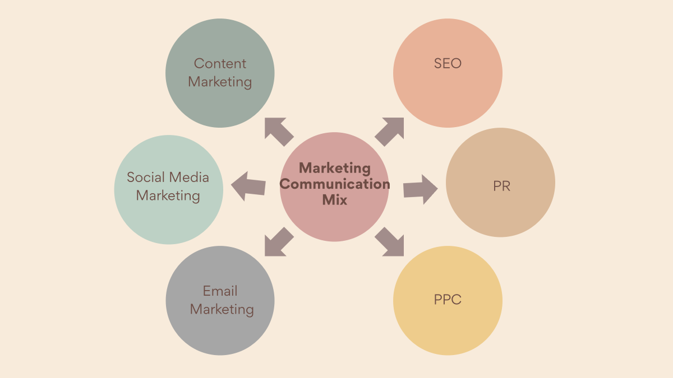
14.
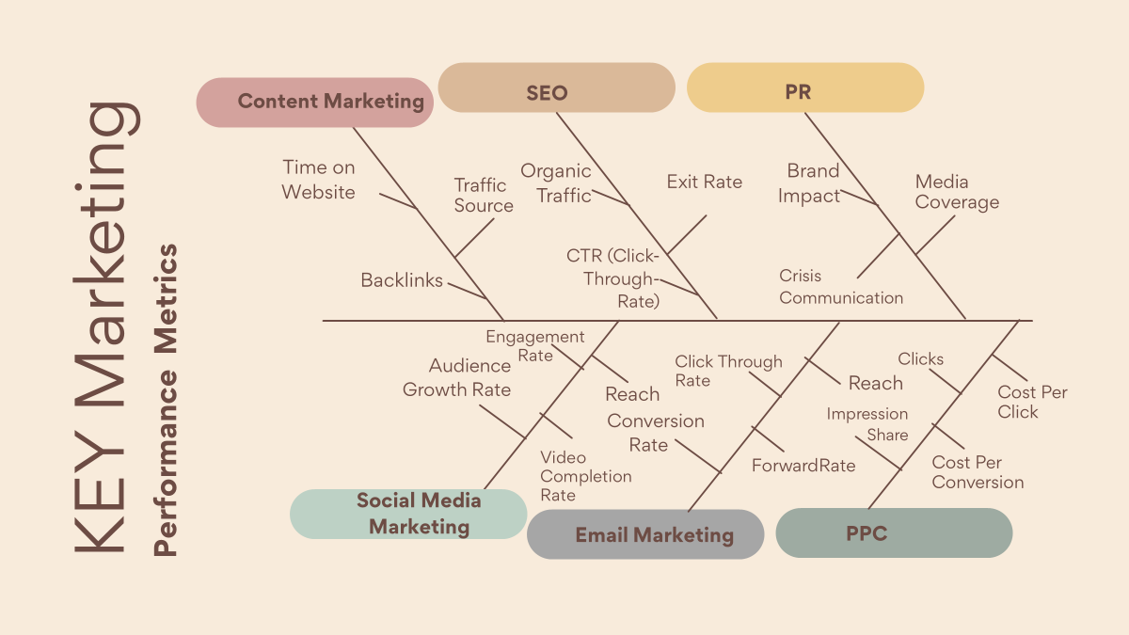
15.
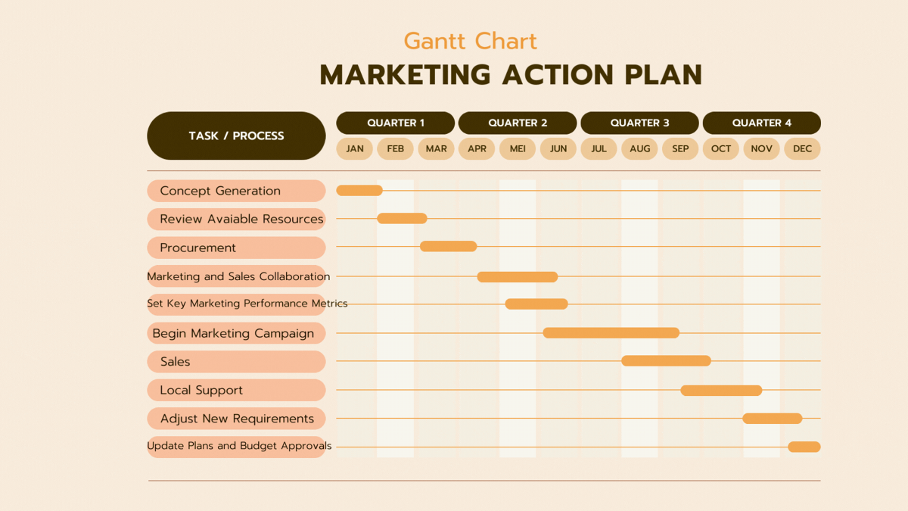
16.


