

Postgraduate/Distance Learning
Assignment coversheet & feedback form

THIS SHEET MUST BE THE FIRST PAGE OF THE ASSIGNMENT YOU ARE SUBMITTING (DO NOT SEND AS A SEPARATE FILE)

For completion by the student:
Student Name: Krystyna Cap

Student University Email: 2123816@student.uwtsd.ac.uk
Module code:  HPCA7015  Module title:  Foundations in Cultural Astronomy and Astrology | Student ID number:  2123816 |  |  | Educational support needs:  No
Assignment title:
‘Essay based on a Sky Journal’

Assignment due date: 1 December 2022
This assignment is for the 1st 2nd 3rd 4th 5th 6th module of the degree
I confirm that this is my original work and that I have adhered to the University policy on plagiarism.
Signed ……………………………………………………………
Email submission: if you are submitting this form via email, please tick this box x
(as a substitute for your signature) to confirm that you agree to the above declaration.
Assignment Mark
1st Marker’s Provisional mark
2nd Marker’s/Moderator’s provisional mark
External Examiner’s mark (if relevant)
Final Mark

NB. All marks are provisional until confirmed by the Final Examination Board.

For completion by Marker 1 :
Comments:

Marker’s signature: |  |  | Date:
For completion by Marker 2/Moderator:

Comments:

Marker’s Signature: |  | Date:
External Examiner’s comments (if relevant)

External Examiner’s Signature: |  | Date:

Krystyna Cap – HPCA7015 – Essay 2
1 December 2022

Essay based on a Sky Journal:
Observing Clouds in Toronto, Canada
Word Count: 2100

In Weatherland: Writers and Artists Under English Skies, Alexandra Harris examined how writers and painters engaged with meteorological and climate phenomena in Britain. In a chapter on clouds, Harris cited both the German landscape painter Caspar David Friedrich, and the English poet John Keats, for whom mist was ‘an accurate figuration of all mental life’, leading Harris to conclude that ‘to think is to walk among clouds’.
This essay will reflect on Harris’ statement within the context of personal sky journal observations kept between October 17, and November 17, 2022. Viewing clouds daily between approximately 9:45 and 10:15 a.m. local time in Toronto, Canada, a combination of drawings, photographs and written descriptions will be used to consider Harris’ statement. In contemplating the relationship between thought and clouds, this essay will discuss three themes: the language of cloud observation, the concept of the sky as an ‘organ of sentiment’, and the extent to which different media can accurately depict the observer’s experience.

The Language of Cloud Observation

Harris posited that the ‘provisionality’ of clouds, lacking a ‘single authoritative version’, allowed them to serve as creative inspiration for writers and artists. ‘Clouds give out the merest hint of shape’, wrote Harris, arguing that the observer adds detail in order to ‘fill out […] whatever the observer thinks he sees’. This may be one reason that definitions of the word ‘cloud’ appear to avoid referring to a specific visual appearance. An 1823 definition considered a cloud to be ‘a visible aggregate of minute particles of water suspended in the atmosphere’, while a more recent definition considers it ‘an agglomeration or amassing of materials, whether of stone, water vapor, or data’.
The seeming fluidity of clouds reflects my own observations. Despite expressing anxiety around an ‘embarrassing lack of knowledge’ of various cloud types (October 21), my entries often communicated what I saw through language, including metaphor and simile. According to my observations, clouds were alternatively ‘cotton candy swirls’ (October 25, Figure 1), a ‘sea of cotton balls’ (November 6) ‘billowy tufts’ (October 27), ‘celestial wave[s] on which Zeus might “hang ten”’ (October 30), and ‘bursts of silky, cascading ribbons […] ascending like jellyfish from the depths of the ocean’ (October 28, Figure 2). This language reflects Lorraine Daston’s conclusion that ‘cloud description is drenched in metaphor’—a metaphor that, she argued, was ‘deliberately deadened’ when scientific description was first applied to clouds.

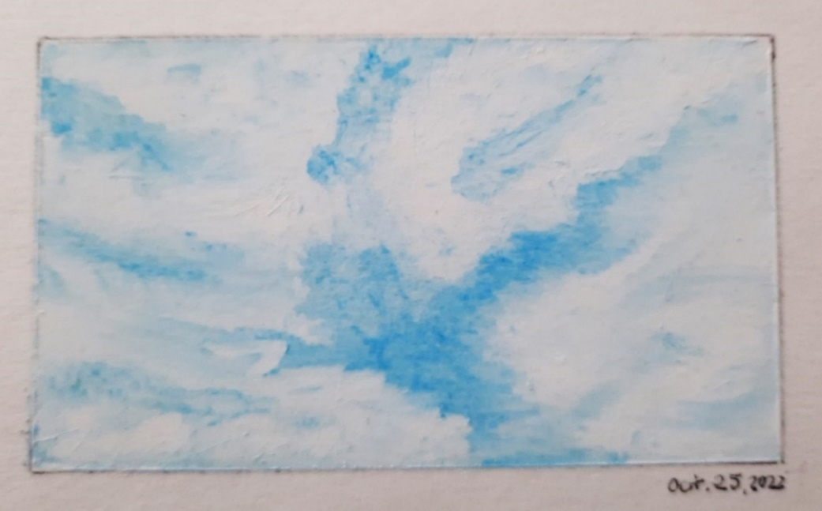

Figure 1, Krystyna Cap, Sky Journal – October 25, 2022 – ‘Cotton Candy Swirls, 314˚ N’, oil pastel on paper, 9 cm x 5.4 cm, Toronto, Ontario, Canada.

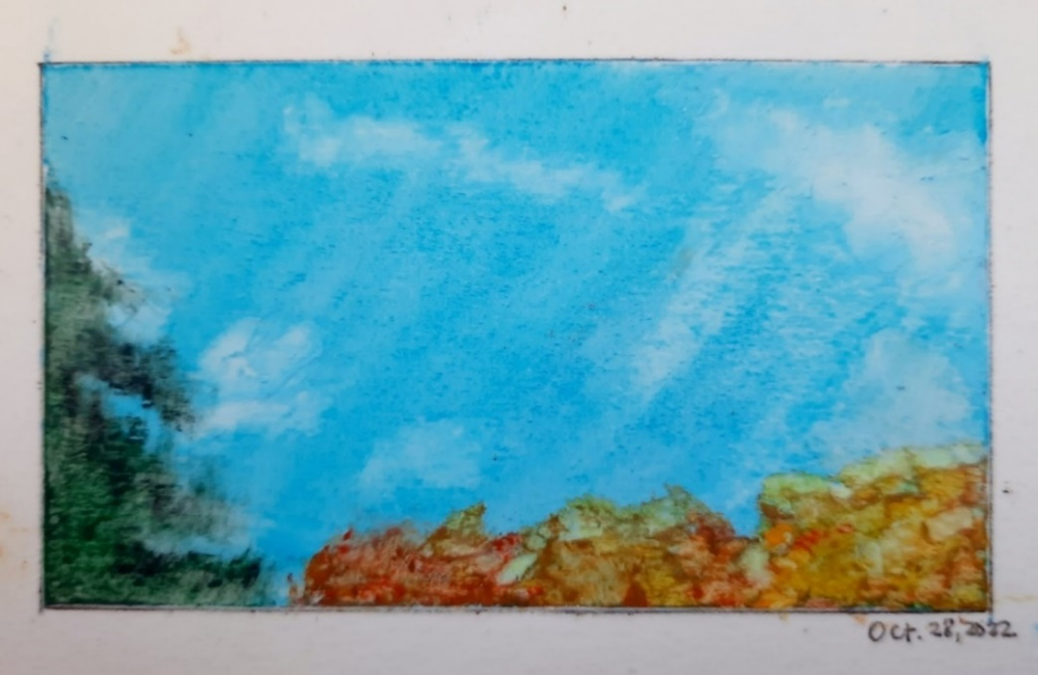

Figure 2, Krystyna Cap, Sky Journal – October 28, 2022 – ‘Jellyfish Clouds, 260˚ W’, oil pastel on paper, 9 cm x 5.4 cm, Toronto, Ontario, Canada.
Evidence for Daston’s position may be sought in the seminal text on cloud taxonomy written by Luke Howard in 1803. Howard posited that clouds could be categorized according to their ‘variations of the atmosphere’. In introducing a ‘methodical nomenclature’, he believed that viewing clouds would no longer be ‘consigned only to the memory of the possessor, in a confused mass of simple aphorisms’.
It is, however, the ‘memory of the possessor’ and the ‘simple aphorisms’ that appear to have inspired the poetic imagination. For Harris, the intersection between thoughts and clouds was confined to the literary and artistic realms where images were ‘created from […] human imagination and language’. An entry from my sky journal is worth quoting at length, demonstrating how, in Harris’ estimation, the perceiver not only adds detail according to what they imagine they see, but also communicates this through language:

The clouds are extremely slow-moving today—if we can measure speed by rolls and drifts and creeps and crawls, then this, by far, is the most languid crawl the sky has yet to produce. These clouds are also gauzy, but thinner, more transparent, like little shreds of tulle scattered across the atmosphere.
In the western corner [of my field of vision] is a different kind of cloud—a complex sea-foamy mass with tendrils emerging, almost like indecisive curlicues, yet very decisive atmospheric agents scooping backwards in the sky. Then, towards the north side, there is an expanse of white, not unlike the product of a thick paint-laden brush being dragged across the sky in one a long stroke. (November 9)

While these descriptions lack the ‘order’ that Howard’s typology introduced over two hundred years ago, they demonstrate the metaphor that Daston contended scientific language supplanted and capture the provisionality that Harris argued made clouds such ‘fertile creative sources’. These examples also illustrate how the mind fashions images from nature—a question that Harris posed rhetorically when she asked, ‘how much is “there” […] and how much is made by our shape-imposing minds?’
For the untrained observer, it appears that the mind cannot help but perceive shapes and attempt to translate them into descriptive language. However, language is only one level of potential perceptual experience. The next section will consider how perception and language can ally with feeling to produce evocative images of clouds.

Organ of Perception, ‘Organ of Sentiment’: Mind, Sky and Feeling

In discussing the English painter John Constable, Harris wrote that he appeared most concerned with learning ‘the mood-language of weather’, citing a letter in which Constable called the sky an ‘organ of sentiment’. Although Harris believed that Constable may have ‘[imagined] the landscape as a living being’, she nevertheless concluded that ‘sentiments’ belong to ‘the perceiver’. This conclusion may overlook an opportunity to make stronger connections between the observer and the natural world—a world that David Abram has argued is ‘an open and dynamic landscape subject to its own moods and metamorphoses’.
Influenced by the phenomenological perspectives of Edmund Husserl and Maurice Merleau-Ponty, Abram has argued that our engagement with the world is not only ‘charged with subjective, emotional, and intuitive content’, but also commingles and communicates with natural phenomena. Paraphrasing Merleau-Ponty, Abram wrote that when ‘we conceptually immobilize or objectify the phenomenon’, we ‘[forget] or [repress] our sensuous involvement with it’. However, when we engage in a ‘reciprocal encounter’ in which we avoid ‘repressing our direct experience’, we can engage with a phenomenon ‘as an active, animate entity’. This framework provides greater context for Constable’s statement, demonstrating his potential ‘reciprocal encounter’ with the sky.
In my own observations, feelings were as much a part of my entries as the perceived shape and qualities of the clouds themselves. For example, a stretch of rain brought ‘heaviness’ and ‘disappointment’ (October 18), while a subsequent entry conveyed a deeper engagement with the sky, approaching the ‘reciprocal encounter’ of which Abram wrote:

The clouds feel quite low on the horizon and a bit closer to earth, like they are enveloping me…closing in. Intimate. […] [This cloud] is a bit brighter today with more white, rather than the depressing shade of autumnal grey that seems to have descended upon us. […] The overlay of an elongated grey tuft in the foreground lends the sky a feeling of foreboding. Perhaps bad weather is coming? (October 19, Figure 3)

In the presence of better weather, my sky journal reflects shifts in mood. On a cloudless day, I remarked that ‘there is something that feels very lovely, light and untroubled about a blue sky’ (October 22), and its ‘worry-free’ quality makes clear why the phrase ‘blue skies ahead’ conveys a positive outlook for the future (October 23).
In lacking a capable meteorological and technical vocabulary, I was thus able to avoid a certain degree of objectification of clouds that could have repressed my more ‘sensuous involvement’ with them. In these excerpts, I was emotionally moved by the changing sky and engaged with clouds on a level outside of the more ‘deliberately [deadening]’ effects of scientific language, as Daston had argued.
Harris identified at least one instance where Constable, despite achieving meteorological accuracy in cloud painting, allowed ‘the expression of mood [to usurp] the precise recording of nature’, leading one meteorological viewer to remark, ‘The sky is wrong […] But it is magnificent’. This anecdote underscores the important connection that observers can feel with a sky that is constantly changing, evoking powerful emotions when permitted to step outside of an objective framework. At the same time, however, the depiction of clouds on canvas raises questions that will be discussed in the following section around whether specific media impact the accuracy of cloud images and whether accuracy even matters within an observational context.

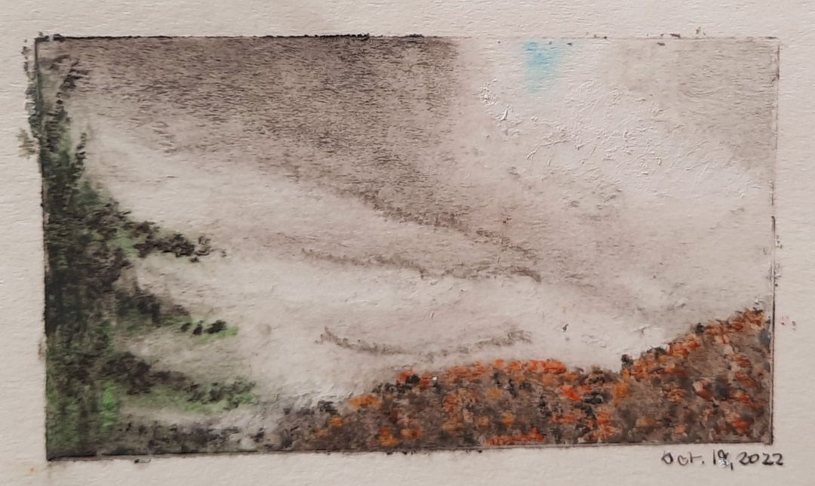

Figure 3, Krystyna Cap, Sky Journal – October 19, 2022 – ‘Monolith, 260˚ W’, oil pastel on paper, 9 cm x 5.4 cm, Toronto, Ontario, Canada.

The Mind, Clouds and the Medium

Harris observed that accurate cloud painting posed certain challenges for artists. ‘For one thing, the cloud-model kept moving’, she wrote, and for artists like Constable, painting clouds required committing the cloud to memory so that they ‘could keep painting after it had changed beyond recognition’.
In my own attempts to capture clouds, I encountered similar problems. When clouds were ‘creeping at a snail’s pace’ (October 26), I was able to make a crude sketch to facilitate production of a handmade picture after the clouds had dissipated (Figure 4); however, on other days when clouds were swift-moving, I took digital photographs to capture what I saw. Upon inspection, the latter often revealed a misalignment between the image as I perceived it and what I noted during my observations. In an addendum on November 9, I commented: ‘This [photograph] is not how I saw it. These clouds appear to be dissipating […] but the cluster at the bottom-right was converging [when I observed it]’ (Figure 5). This raises a question around what is more accurate: a photograph or a handmade picture. While Harris has noted Constable’s achievement of a high degree of technical accuracy, Daston has shown that the first scientific atlas of clouds, published in 1896, used photographs as one of its contributors ‘considered drawings to be “too inexact”’ and subject to ‘human intervention’.
The tension between human intervention and representational accuracy has been taken up by scholars of film and photography. For example, Robert Hopkins has argued that, in contrast to handmade pictures which are subject to the artist’s perception, photographs are ‘factive’: they are ‘guaranteed to reflect the facts’. Jiri Benovsky has countered this, suggesting that ‘no depiction of the world is ever totally realist’, not even visual perception. Benovsky’s critique rests on the argument that photographers make various ‘necessary decisions’ whenever they take a photograph, modifying aperture, shutter speed and focal length to capture their subjects based on their ‘intentions, beliefs, and decisions’.

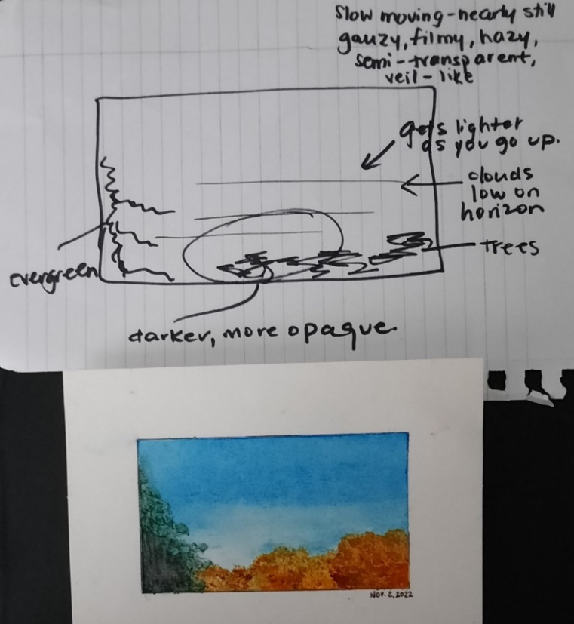

Figure 4, Krystyna Cap, Sky Journal – November 2, 2022 – ‘Morning Mist, 260˚ W’, oil pastel on paper, 9 cm x 5.4 cm, Toronto, Ontario, Canada, pictured with rough sketch.

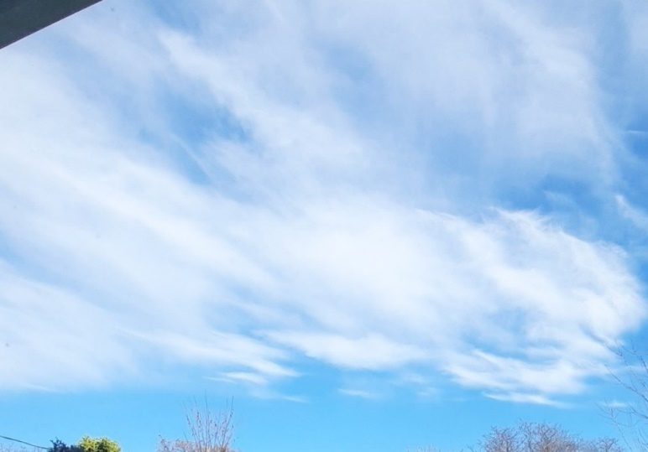

Figure 5, Krystyna Cap, Sky Journal – November 9, 2022 – Photograph, 260˚ W, digital camera phone photograph, Toronto, Ontario, Canada.

While my photographs were taken with a digital camera phone, the device appeared to make certain ‘necessary decisions’ for me, such as auto-focusing to compensate for environmental and lighting constraints. This could suggest that my photographs may not be factive according to Hopkins’ definition, given the ‘intervention’ of the device’s technology. While Hopkins has argued that digital and traditional photographs are equally factive, he has acknowledged criticism from those contending that digital photographs are ‘closer to handmade pictures’ as they can be manipulated by the photographer or by the device’s technology.
My own experiences indicate that photographs only appeared accurate under certain conditions, such as when ‘the morning sun [was] unobstructed’ (November 3). However, during a patch of fog on November 4, the photograph ‘failed to distinguish variations in the sky’ that I was still able to observe with the naked eye. By contrast, while my handmade pictures would not be considered factive according to Hopkins’ definition, they nevertheless appeared characteristically accurate of my perceived experience, closely mirroring the words and feelings I noted during my observations. This could approach the middle-ground that Benovsky has suggested: both paintings and photographs ‘can communicate to us some features’ of their subjects, making both ‘at least partially realist, to a degree’.
Constable may, therefore, be a highly instructive example for considering the kind of realism that Benovsky has articulated. Constable appeared to marry technical accuracy with the emotional experience of the moment, echoing a conclusion that Merleau-Ponty drew concerning landscape painters: their aim is ‘to recapture the feel of perceptual experience itself’. In my own journal, the feelings associated with perceptual experience seemed almost more important to achieve than technical accuracy in the images rendered. Instead, the factivity of the image resided in the extent to which the handmade picture or photograph most closely reflected the totality of my perceptual experience.

Conclusion

This essay has sought to contextualize personal sky journal observations within Alexandra Harris’ statement, ‘to think is to walk among clouds’. It has attempted to demonstrate that the act of thinking is a more complex exercise than simply imagining clouds. From the descriptive metaphor that the language of cloud observation can invite, to the emotional-relational experience between a changing sky and the observer, and the extent to which one might consider a handmade picture factive, it is apparent that, like Wordsworth, ‘clouds, in the end, could only guide [the] imagination so far’. If anything, this essay has intended to show that ‘to think’ is not only ‘to walk among clouds’, but to immerse oneself in a totality of experience with them, which includes both visual perception and emotional experience.

Bibliography
Primary Sources
Forster, Thomas, Researches about Atmospheric Phaenomena, 3rd edn (London: Harding, Mavor and Lepard, 1823)
Howard, Luke, Essay on the Modifications of Clouds, 3rd ed. (London: John Churchill & Sons, 1865)
Secondary Sources
Abram, David, The Spell of the Sensuous: Perception and Language in a More Than Human World (New York: Vintage Books, 1997) <https://projects.iq.harvard.edu/files/retreat/files/ abram_the_spell _of_the_sensuous_perception.pdf> [accessed 18 November 2022]
Benovsky, Jiri, ‘Three Kinds of Realism About Photographs’, The Journal of Speculative Philosophy 25.4 (2011), 375-395 <https://www.jstor.org/stable/10.5325/ jspecphil.25.4.0375> [accessed 17 November 2022]
Daston, Lorraine, ‘Cloud Physiognomy’, Representation 135 (Summer 2016), 45-71 <https://www.jstor.org/stable/10.2307/26520565> [accessed 9 November 2022]
Harris, Alexandra, Weatherland: Writers and Artists Under English Skies (London: Thames & Hudson, p. 2016)
Hopkins, Robert, ‘Factive Pictorial Experience: What’s Special About Photographs?’, Noûs 46.4 (December 2012), 709-731 < https://www.jstor.org/stable/41682693> [accessed 18 November, 2022]
Merleau-Ponty, Maurice, The World of Perception (London and New York: Routledge, 2002)
Peters, John Durham, ‘Cloud’, in Digital Keywords: A Vocabulary of Information Society and Culture, ed. by Benjamin Peters (Princeton: Princeton University Press, 2016), pp. 54-62 <https://www.jstor.org/stable/j.ctvct0023.9> [accessed 8 November 2022]

Alexandra Harris, Weatherland: Writers and Artists Under English Skies (London: Thames & Hudson, p. 2016), p. 247.
Harris, Weatherland, p. 237.
Harris, Weatherland, p. 237.
Thomas Forster, Researches about Atmospheric Phaenomena, 3rd edn (London: Harding, Mavor and Lepard, 1823), p. B.
John Durham Peters, ‘Cloud’, in Digital Keywords: A Vocabulary of Information Society and Culture, ed. by Benjamin Peters (Princeton: Princeton University Press, 2016), pp. 54-62 (p. 55) <https://www.jstor.org/stable/j.ctvct0023.9> [accessed 8 November 2022].
Lorraine Daston, ‘Cloud Physiognomy’, Representation 135 (Summer 2016), 45-71 (p. 50) <https://www.jstor.org/stable/10.2307/26520565> [accessed 9 November 2022].
Luke Howard, Essay on the Modifications of Clouds, 3rd ed. (London: John Churchill & Sons, 1865), p. 1.
Howard, Essay on the Modification of Clouds, p. 2.
Harris, Weatherland, p. 239.
Harris, Weatherland, p. 244.
Harris, Weatherland, p. 237.
Harris, Weatherland, p. 239.
Harris, Weatherland, p. 245.
Harris, Weatherland, p. 245.
David Abram, The Spell of the Sensuous: Perception and Language in a More Than Human World (New York: Vintage Books, 1997), p. 29 <https://projects.iq.harvard.edu/files/retreat/files/abram_the_spell _of_the_sensuous_perception.pdf> [accessed 18 November 2022].
Abram, The Spell of the Sensuous, pp. 30, 43.
Abram, The Spell of the Sensuous, p. 43.
Abram, The Spell of the Sensuous, p. 43.
Harris, Weatherland, p. 246.
Harris, Weatherland, p. 243.
Harris, Weatherland, p. 243.
Daston, ‘Cloud Physiognomy’, p. 57.
Robert Hopkins, ‘Factive Pictorial Experience: What’s Special About Photographs?’, Noûs 46.4 (December 2012), 709-731 (pp.722-724) <https://www.jstor.org/stable/41682693> [accessed 18 November, 2022].
Jiri Benovsky, ‘Three Kinds of Realism About Photographs’, The Journal of Speculative Philosophy 25.4 (2011), 375-395 (p. 376) <https://www.jstor.org/stable/10.5325/jspecphil.25.4.0375> [accessed 17 November 2022].
Benovsky, ‘Three Kinds of Realism about Photographs’, pp. 379, 383.
Hopkins, ‘Factive Pictorial Experience’, pp. 710-11, 714-715.
Benovsky, ‘Three Kinds of Realism about Photographs’, p. 377.
Maurice Merleau-Ponty, The World of Perception (London and New York: Routledge, 2002), p. 54.
Harris, Weatherland, p. 249.

