Yaqoob Talukdaar

Student : 2126722
Module Title: Event Strategic Planning and Delivery Considerations for an International Meeting
Module code: BMIH6007
Tutor: Chris Wilkin
Word Count: 2500

I confirm that I have not used any AI tools in the research and creation of this assignment. I confirm that I have not presented any AI generated materials as my own work. I confirm I have copies of my drafts, notes, and other resources I used, which I may be asked to provide in evidence.

Executive Summary
The Birmingham Unity Games serves as a multi-sport competition that will host its events at Alexander Stadium inside Birmingham city. The event will target EDI promotion through sports by focusing on diversification and equal treatment. The event gathers communities and athletes for the purpose of demonstrating how sports create social transformation opportunities through fostering unity among diverse populations. The main objective of Birmingham Unity Games is to advance sports community inclusivity through equality and diversity which enables broad participation across backgrounds among sports athletes. Through collaborations between community members and sports organisations with diversity advocates the event aims to establish long-term changes regarding athletic environment inclusivity. The Birmingham Unity Games will benefit the sports community through cultural consideration while establishing vital standards for upcoming events dedicated to diversity equality and inclusion. Every phase of the planning and delivery process depends on the proper integration of these essential factors to achieve success in the event.

Table of Contents
Executive Summary 2
Introduction 4
The Event Cycle 5
Event Concept 7
Aim and Objectives of the Event 8
Event Management 10
Event Budget 13
Industry Trends, Issues, and Impacts 15
Situational and Cultural Considerations 16
References 19
Appendix 21

Introduction
The Birmingham Unity Games serves as a multi-sport competition that will host its events at Alexander Stadium inside Birmingham city. The event will target EDI promotion through sports by focusing on diversification and equal treatment. The event gathers communities and athletes for the purpose of demonstrating how sports create social transformation opportunities through fostering unity among diverse populations. The event will include sports competitions along with sessions that discuss EDI principles in sports while presenting relevant workshops. This whole event will be carried out by following and promoting the Equality Act 2010. This event will ensure equal opportunities to all participants. This event will ensure an environment free from discrimination. For accommodating athletes and participants with disabilities, the organisers will made reasonable adjustments in the sports.
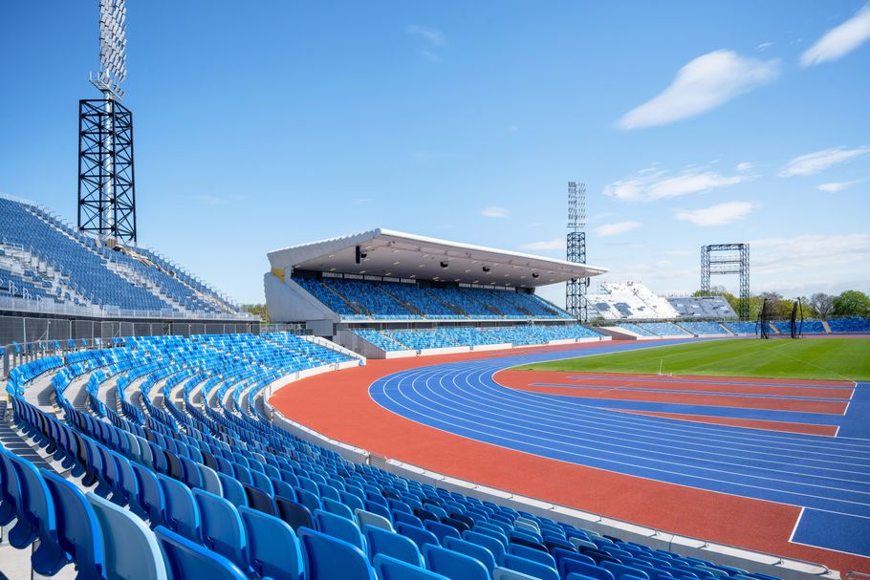
Figure: Alexander Stadium (Doran et al., 2024).
The organisers selected this event to reflect the increasing awareness of universal inclusion that the sports sector specifically needs. According to Supovitz and Goldwater (2024), people from various societal backgrounds traditionally come together through sports events. All population groups have not received equal accessibility or been equally represented. By fostering participation in the Birmingham Unity Games, the event will challenge traditional barriers because its main objective includes recruiting minorities along with women and disabled athletes and LGBTQ+ individuals.
Alexander Stadium will serve as an optimal choice because it stands as a popular historic venue that suits this occasion. This stadium offers a convenient location combined with superior facilities and room to accommodate big crowds which makes it an outstanding venue for this type of event. This event will target Birmingham residents along with sports enthusiasts alongside community associations and all persons who support inclusive sports (Rotchild, 2024). The event works to promote understanding of sports equality together with diversity as it establishes places where any individual can both participate and watch competitions.

The Event Cycle
The event Cycle represents an organisational framework that directs event planners throughout the planning execution and evaluation process. The Event Cycle serves an essential purpose since it helps event planners organise their thoughts to effectively meet their goals. Fundamentally the Cycle contains three distinctive stages which begin with Pre-Event then move through Event and finish with Post-Event (Getz, 2023).

Figure: Event Cycle (Holmes and Ali-Knight, 2022).
Pre-Event
The planning stage occurs during this phase by making essential event decisions. During the Birmingham Unity Games’ planning stage, the organisers focus on developing the event theme targeting equality, diversity, and inclusion goals. Event planning will begin with securing Alexander Stadium as the venue after which the selection of sports and panel discussions takes place while obtaining sponsorships from community partners. The event's promotion will commence using social media platforms also the city will experience local outreach while partnering with diversity-focused organisations (Holmes and Ali-Knight, 2022). The project will attract support from stakeholders who include local administration together with sports organisations and funding partners. A wheelchair basketball competition with 8 mixed teams comprised of non-disabled and disabled athletes will be organised during the event. The teams will consist of five players where two members need to be wheelchair athletes in order to support sports inclusivity.
Event
During this stage, all elements integrate for the final execution. The Birmingham Unity Games will emphasise operating with efficiency and delivering excellent visitor services during its main event day. The scheduled activities at the event consist of sports tournaments alongside football matches workshops and panel discussion programs. The panel session about LGBTQ+ inclusivity in sports will include 5 well-known LGBTQ+ athletes who will analyse how sports can create an all-embracing atmosphere for gender-identity diversity. During the event, volunteers will handle registration processes while assisting visitors and providing accessibility support (Parent and Ruetsch, 2022). A total of 100 youth athletes from minority communities will participate through the mentorship initiative at the event. A mentoring programme pairs 100 inexperienced athletes with 20 experienced athletes who will guide them toward sport participation. In addition to scholarships the programme will offer five complete educational opportunities for youth trainees from diverse communities who want to attend camps and sports competitions.
Post-Event
Evaluation and feedback collection will become the main priority following the conclusion of the event. It is essential to evaluate performance in this phase because it helps determine success metrics for upcoming events. The evaluation process will gather information from participants along with guests and sponsors through survey and interview methods. The success of the event will depend on reaching the established goals to grow diverse sports engagement and strengthen community alliances (Parent and Ruetsch, 2022).

Event Concept
The Birmingham Unity Games provides a distinct experience for everyone through sports competitions and community involvement alongside meaningful talks about equality diversity and inclusion (EDI). Participants and delegates at the event can enjoy numerous activities during the occasion which include sports competitions along with workshops and panel discussions that emphasise inclusive practises in sports (Aversa and Dickinson, 2022).
Guest Experience
The event will start with a welcome opening ceremony featuring important speeches from sports representatives and EDI champions with local community leaders. The inaugural ceremony will establish the main purpose of the event by emphasising inclusivity's value within sporting activities. Participation and observation of sports tournaments will be available during this event as different teams representing different communities engage in friendly competitions. A main attraction of the event will be a football match where Birmingham City FC will challenge Aston Villa FC to demonstrate the power of sport in forging unity between fans of different city areas (Zhang and Pitts, 2022).
Itinerary
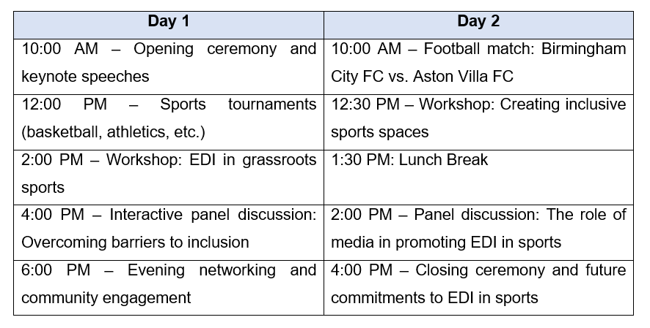
Figure: Itinerary (Lawrence et al., 2024).

Aim and Objectives of the Event
The main objective of Birmingham Unity Games is to advance sports community inclusivity through equality and diversity which enables broad participation across backgrounds among sports athletes. Through collaborations between community members and sports organisations with diversity advocates the event aims to establish long-term changes regarding athletic environment inclusivity (Aversa and Dickinson, 2022).
SMART Objectives
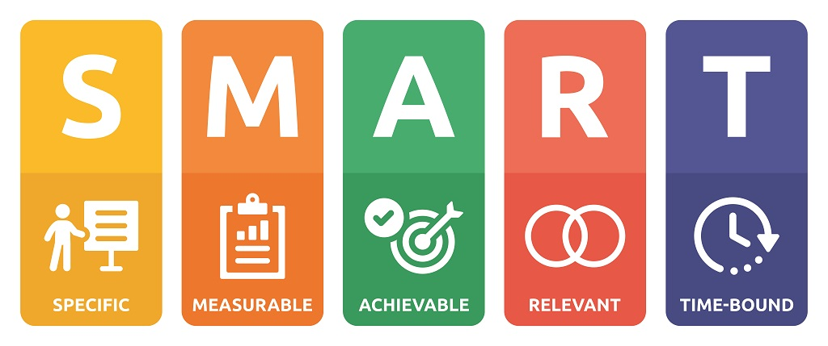
Figure: SMART Objectives (Greenwell, et al., 2024).
Objective 1: To raise marginalised community participation levels by 20% before its conclusion.
Specific | The specific goal focuses on raising marginal community participation in all sports initiatives including ethnic minorities and their subgroups along with women LGBTQ+ and people with disabilities (Zhang and Pitts, 2022). At least 8 athletes will be from diverse backgrounds.
Measurable | Registration data will show the number of participants from marginalised communities with results compared to previous event participant counts (Greenwell, et al., 2024). In the previous event 5 participants were from marginalised backgrounds. And it will increase to 8.
Achievable | Through strategic outreach campaigns combined with open sports organisations there is a high chance of reaching a 20% growth in participant numbers.
Relevant | The purpose of promoting equality along with sports inclusion makes this initiative completely relevant to the event's core objectives (Staurowsky and Hart, 2022).
Time-bound | The required increase in attendance should be finalised during the specific period of two event days.

Objective 2: To obtain 5 specific sponsorships from businesses that support diversity as well as inclusion prior to the first day of operation.
Specific | The organisation needs to secure sponsorship agreements with stakeholders who focus on supporting sports-based diversity programmes (Lawrence et al., 2024).
Measurable | The number of sponsors who have both agreed and finalised contracts will serve as an important measurable outcome (Greenwell, et al., 2024).
Achievable | The EDI-aligned values of the event along with its tailored offerings to organisations will make this target easily achievable because it draws relevant sponsorships (Zhang and Pitts, 2022).
Relevant | The event's success depends on securing sponsorships because it will provide funding along with increased promotion of EDI awareness (Doran et al., 2024).
Time-bound | The organisation needs to finalise all five sponsorship agreements two months prior to the event day (Emery, 2022).  Operators will focus on reaching this goal through the 3-month promotional effort before the scheduled event.

Event Management
According to Lawrence et al. (2024), event management success depends on different skills and resources that help deliver coherent planning for successful execution. Successful execution of the Birmingham Unity Games depends on obtaining the necessary resources and skills.
Skills Required

Figure: Skills required in Event Management (Emery, 2022).
Project Management: Project Management involves complete oversight of event development through execution which maintains a seamless connection between plans and time-based objectives (Greenwell, et al., 2024). Trello or Asana together with project management software helps organisations monitor their tasks along with deadlines while tracking milestones during execution (Emery, 2022).
Stakeholder Coordination: A person must have strong interpersonal abilities to connect with sponsors local officials sports organisations and partners and stakeholders. Belbin’s team roles model will be used to delegate roles and responsibilities among the linked stakeholders. Organisations need to collaborate with multiple stakeholders to obtain necessary support while accessing funds and securing required authorizations (Zhang and Pitts, 2022).
Communication: According to Greenwell et al. (2024), the event’s success depends on the existence of clear consistent communication which remains vital throughout the entire process. The communication strategy will address both internal team communication while maintaining external connections with attendees' sponsors and members of the media. Through effective communication, all participants receive updated information which results in proper alignment between them (Emery, 2022).
Resources

Figure: Resources of the event
Operational Resources
Venue Management: The organisers of Alexander Stadium will have to manage the available space effectively for holding sports events alongside workshops and panel discussions. Strategic arrangements of proper signs combined with correct seating configuration and necessary safety procedures need implementation (Lawrence et al., 2024).
Logistics: The event organisers will arrange transportation services along with shuttle routes and parking facilities as well as ensure the implementation of crowd controls and set up first aid facilities for persons with disabilities (Emery, 2022).
Technology: The event experience will be improved through reliable sound and lighting systems and event apps for updates and live streaming equipment (Parent and Ruetsch, 2022).
Planning Resources
Budgeting and Scheduling: A detailed financial plan which fulfills all objectives needs to be established in advance to maintain costs inside the designated budget.
Risk Management: Operational risks like weather disruptions or attendance drops will be managed through effective risk management strategies that establish plans to prevent the event from unexpected events (Parent and Ruetsch, 2022).
Marketing Resources
Social Media Strategy: The company will use Instagram Twitter and Facebook as their social media platforms to reach both the neighbourhood residents and people from different areas (Supovitz and Goldwater, 2024).
Partnerships: Local organisations, sports clubs and influential figures will help the event reach more people through partnership collaborations (Lawrence et al., 2024).

Event Budget
A clear and well-structured budget is crucial for ensuring the Birmingham Unity Games is financially viable and aligned with its objectives. Below is a breakdown of the expected income and expenditure for the event.
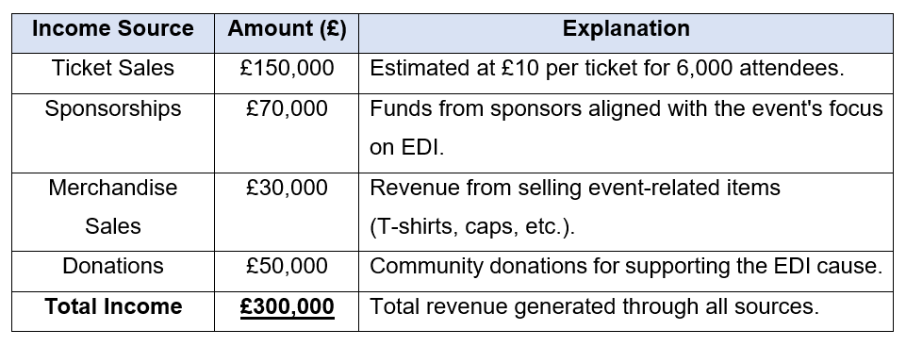

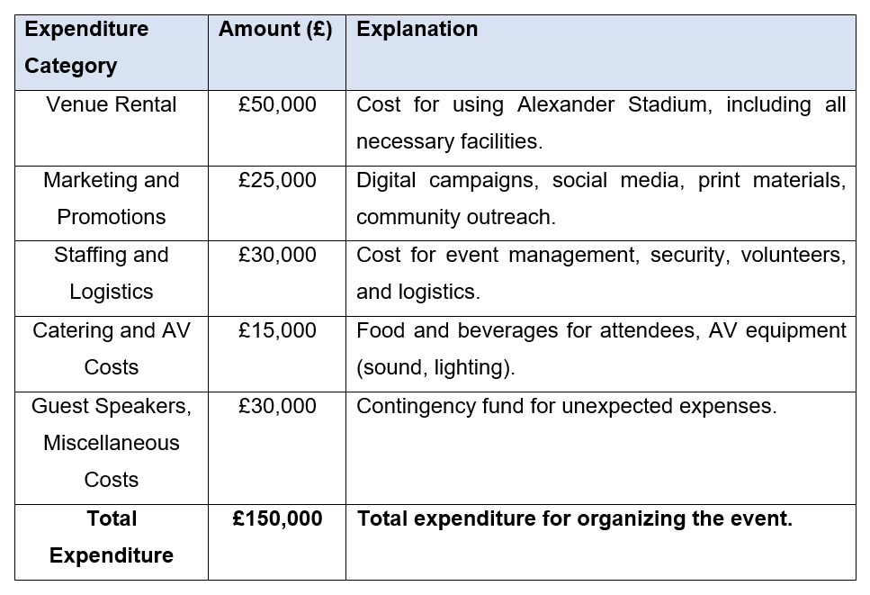
Net Profit: £300,000 - £150,000 = £150,000
Funding Sources:
- Local Government: The social inclusion plans of the event will get support through funding from Birmingham City Council.
- Sponsorships: Sponsors dedicated to EDI initiatives will offer financial assistance while gaining marketing opportunities for their brands.
- Ticket Sales: Ticket revenue will fund most of the various expenses (Supovitz and Goldwater, 2024).
Birmingham Unity Games operations will perform effectively using this budget because it prioritises funding support for activities that help achieve the goal of sports-based inclusiveness.

Industry Trends, Issues, and Impacts
The events industry has experienced substantial changes in recent times.
Trends
Virtual and Hybrid Events: According to Doran et al. (2024), hybrid events have transformed event planning approaches because they have gained extensive popularity in recent years. Remote attendees need technology that will let them participate in live sessions because their numbers continue to grow among those attending both in-person and virtually. The event now draws participants from various locations because of this trend which results in broader audience acquisition (Stavros, 2022).
Diversity and Inclusion Focus: The growing need for inclusive events requires diversity and inclusion (EDI) to be the main focus during event planning People nowadays seek events that embody fairness values along with inclusive representation and total social equality (Emery, 2022). The EDI focus of the Birmingham Unity Games finds direct support in the current event planning trends.
Issues
Event Security: Supovitz and Goldwater (2024) have argued that event safety and security continue to grow as a vital concern thus requiring organisations to adopt strong protective measures. Event security measures should encompass the management of crowds together with health measures and procedures for emergency situations.
Technology Integration: The quick advancements in event technology between virtual streaming capabilities and engagement tools provide simultaneous advantages along with critical problems to be resolved (Lawrence et al., 2024). Organisations must adopt modern accessibility technologies when serving attendees with impairments.
Impact on the Birmingham Unity Games
The Birmingham Unity Games should implement hybrid event models which will allow them to welcome remote participants by enabling virtual participation. As per Aversa and Dickinson (2022), the implementation of EDI standards demands concentrated attention toward designs that are accessible and technological implementation strategies and outreach efforts for participants. The successful achievement of Birmingham Unity Games requires absolute inclusivity for all activities spanning both sports engagement and panel sessions. Decision-making about catering services together with waste management and logistics will prioritise lowering the environmental impact of the event through sustainable practises (Getz, 2023).

Situational and Cultural Considerations
The Birmingham Unity Games will achieve success by implementing approaches to address both cultural diversity aspects and situational variables that might affect the event. The planning and delivery process of the event needs to integrate these considerations to make the event more inclusive while retaining its connection to the local community (Staurowsky and Hart, 2022).
Cultural Considerations
The EDI (Equality Diversity and Inclusion) event needs a detailed understanding of different cultural requirements for all its participants and viewers (Allen et al., 2022). Cultural sensitivity needs to be the fundamental aspect in designing the Birmingham Unity Games. This includes:
- The event will offer various food selections that accurately represent the Birmingham population with its many cultural backgrounds.
- Designing accessible spaces that accommodate people with disabilities, ensuring equal participation in sports and panel discussions.
The event organisation will maintain inclusive practises through its language choices to avoid causing any community marginalisation. The event programme will also provide multilingual signage and translate content for workshops as well as panels (Staurowsky and Hart, 2022). Local community organisations focused on minority groups should actively participate in the event because their involvement ensures proper engagement of marginalised communities.
Situational Factors
- Political Climate: The event organisers need a thorough understanding of political developments both in Birmingham and throughout the UK. The event framework needs to incorporate all existing social justice policies found at local or national levels (Allen et al., 2022). The event should keep strong connexions with local governmental organisations because these partnerships often bring resources and infrastructure support.
- Economic Conditions: The financial outcome of the event depends heavily on how the economy performs in that period. The financial recovery from the pandemic together with income fluctuations among various income levels will affect ticketing revenues mainly within marginalised communities (Staurowsky and Hart, 2022). The decision to provide discounted or affordable tickets for disadvantaged communities stands as an essential factor for consideration.
Business Analysis Tool – SWOT
Elements | Discussion
Strengths | The main strength of the event is its emphasis on equality, diversity and inclusion. It will also arrange high-profile sports matches (Birmingham City vs. Aston Villa). It will also get substantial community support.
Weaknesses | The event may face low attendance numbers because of people's pandemic-related concerns as well as marketing funding constraints (Allen et al., 2022).
Opportunities | The event benefits from strong media interest surrounding diversity projects and builds engagement options through HD event formats that welcome global participation.
Threats | The event has some threats such as security issues, bad weather conditions.

Importance of Consideration
The cultural as well as situational elements determine whether the event achieves its set objectives. Event planners who implement cultural understanding together with political economic analysis and SWOT assessment will successfully overcome challenges and exploit opportunities leading to an impactful and successful Birmingham Unity Games (Allen et al., 2022).
Conclusion
The Birmingham Unity Games functions as an essential occasion that enables the sports community to build stronger diversity as well as inclusive practises and equal opportunities. All planning aspects including marketing and logistics for this event need to base their strategies on cultural sensitivity combined with sustainability principles and equal opportunities and diversity implementations. The integration of successful strategic planning in every aspect including event coordination and stakeholder partnerships alongside financial operations will lead to event triumph. Community support depends heavily on culture-related factors including disability-friendly events and analysis of economic and political situations. The SWOT analysis tool as part of business analysis methodology helps organisations gain complete comprehension of their internal factors and external landscape. The Birmingham Unity Games will benefit the sports community through cultural consideration while establishing vital standards for upcoming events dedicated to diversity equality and inclusion. Every phase of the planning and delivery process depends on the proper integration of these essential factors to achieve success in the event.

References
Allen, J., Harris, R. and Jago, L. (2022) Festival & special event management, essentials edition. 6th ed. Milton, QLD, Australia: John Wiley & Sons.
Aversa, D. and Dickinson, C. (2022) Unity Game Optimization: Enhance and extend the performance of all aspects of your Unity games. Packt Publishing Ltd.
Doran, A.L. et al. (2024) “Planning virtual and hybrid events: steps to improve inclusion and accessibility,” Geoscience Communication, 7(4), pp. 227–244.
Emery, P. (2022) “Past, present, future major sport event management practice: The practitioner perspective,” Sport management review, 13, pp. 158–170.
Getz, D. (2023) “Festivals and special events: life cycle and saturation issues,” in Trends in outdoor recreation, leisure and tourism. UK: CABI Publishing, pp. 175–185.
Greenwell, T.C., Danzey-Bussell, L.A. and Shonk, D.J. (2024) Managing sport events. 3rd ed. Champaign, IL: Human Kinetics.
Holmes, K. and Ali-Knight, J. (2022) “The event and festival life cycle-developing a new model for a new context,” International Journal of Contemporary Hospitality Management, 29(3), pp. 986–1004.
Lawrence, S., Hill, J. and Mowatt, R. (2024) Routledge Handbook of Sport, Leisure, and Social Justice.
Parent, M.M. and Ruetsch, A. (2022) Managing major sports events: Theory and practice.
Rotchild, L. (2024) How We Gather Matters: Sustainable Event Planning for Purpose and Impact. New Society Publishers.
Staurowsky, E. and Hart, A. (eds.) (2022) Diversity, equity, and inclusion in sport: Mastering mindset for peak performance in sport and life. Champaign, IL: Human Kinetics.
Supovitz, F. and Goldwater, R. (2024) The sports event management and marketing playbook. 3rd ed. Nashville, TN: John Wiley & Sons.
Zhang, J.J. and Pitts, B.G. (eds.) (2022) Globalized sport management in diverse cultural contexts. London, England: Routledge.

Appendices
Appendix 1: Event Budget
Net Profit: £300,000 - £150,000 = £150,000

Appendix 2: SWOT Analysis


