

NAME: Josephine Hagan Mantey
Level : 5
Student ID: 1908217
Moodle Code: BMHP5001
Lecturer: Miss Magdalena Wronska
Title: Aromatherapy

Assignment 2.

Table of Content

- Introduction (An overview of complementary therapies and the current systems utilised to regulate the treatments).
- The history, uses, efficacy and contraindications of Aromatherapy and how it compares to more traditional treatments.
- An evaluation of the statutory self-regulation system and the voluntary self-regulation system (membership bodies).
- Ethical considerations
- Recommendations

Introduction
Complementary / Alternative medicine is defined as group of various medical and health systems,practices and products that are not normally regarded as part of conventional medicine ( Balouchi et al.,2018). CAM is split into 5 main divisions namely alternative systems, mind and body interventions, body based manipulation therapies, biologically based interventions ( natural products) and energy/ metaphysical therapy (Balouchi et al.,2018).
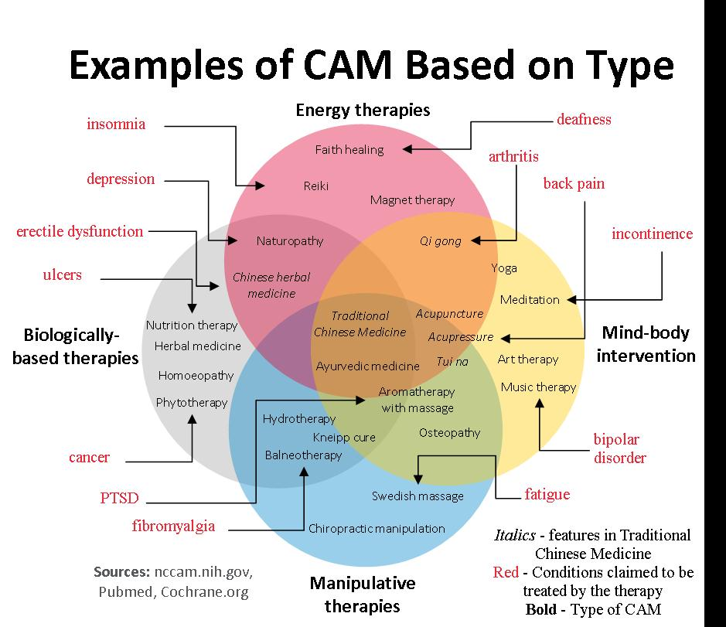
Designed by livewellwithmel.com
For the purpose of this report, we will be focusing on Aromatherapy.

Aromatherapy is a natural plant extracts healing treatment that is holistic and promotes health and well-being of its users. Aromatherapy is also known as essential therapy. It medically uses aromatic essential oils to make better the health of the body, mind and Spirit to enhance both emotional and physical health ( Cronkleton, 2019).
Background
Aromatherapy has been around for over 1000s of years. It was ancient cultures in China, Egypt, India etc who absorbed aromatic plant parts in resins, balms and oils ( Cronkleton, 2019). Though it was used for medical and religious purposes, it has psychological and emotional benefits as well (Cronkleton, 2019). The resolution of uncertainty about essential oil distillery was published around the 16th century in Germany . Physicians in France , recognized in the19th century the latent qualities of essential oils in the treatment of diseases even when medical doctors were established during this time time and were focusing on using chemical drugs ( Cronkleton, 2019)
Aromatherapy was a name which was made up by a French perfumer and chemist Rene- Maurice Gattefosse in a book written and published in 1937 (Cronkleton, 2019). Aromatherapy is also known as Essential oils.
There are four types of essential oil according to Reis and Jones, 2017 which are:
Nature-identical oils or Synthetic :
These are oils produced in the laboratory and often obtained in health food and novelty stores. It can cause harm and has no therapeutic effectiveness.
Natural oils: These are organic certified oil that has met standard testing guidelines however it contains few therapeutic compounds. They are often labeled as “100% pure or natural.”
Extended or altered oils : These are oils which are fragrance quality oils with perfume aroma. It has an essential oil base and enhanced with specifically created laboratory constituents to increase its volume or fragrance.
Therapeutic quality essential oil also known as genuine essential oils or medicinal quality are distilled in order for all desired therapeutic compounds to be maintained.
Current systems that regulate Aromatherapy
The largest aromatherapy professional practitioner organization in UK is the International Federation of Professional Aromatherapists, who supports and improve standards of education and practice in aromatherapy and have now joined the NAHA ( the national association for holistic aromatherapy) ( IFPA,n.d) .
Aromatherapy Council renounce it regulatory role in favour of CNHC( Complementary & Natural Healthcare Council) in 2008, as the Department of Health needed a voluntary self regulators for all complementary therapies due to the fact that most of the aromatherapist practice not only one therapy but more ( aromatherapy council , 2018). This was set up by the government to protect the UK public by providing a voluntary register of complementary therapists . Most of the NHS jobs and opportunities will require CNHC registration (aromatherapy council, 2018). The common law right to medicine in the UK makes it possible for anyone to treat sick even where you do not have training or qualifications to do so. Though there are statutory regulation awards certification , it can not stop anyone making up the methods of the therapy.
A very serious problem was the procedures for disciplining those bodies to have small weight. When a practitioner is hit off one register, he / She can join another and then not all practitioners are well trained and reputable ( publications.parliament uk, 2020).
Uses of Aromatherapy
The study of how essential oils are assimilated and excreted is called Pharmacokinetics . There are different ways of applying essential oils
(Reis and Jones, 2017).
The aim of the use of Aromatherapy is to improve a person mood or health ( Brazier, 2017) and its application includes internal ( gargles ,suppository etc) , oral ( capsules, dilution in honey), topical applications and inhalation (Reis and Jones, 2017).

Inhalation takes place when oils are sprayed or defused in the air or in a steam bath for one to inhale. When inhaling the essential oils, the olfactory system, part of the brain are stimulated. Molecules enter the nose or mouth to the lungs and transport it to other parts of the body ( Braizer, 2017). As the molecules get into the brain, the limbic system which is linked to emotions, heart rate, breathing, memory, stress, and hormone balance are affected. This makes essential oil a subtle but brings a holistic effect on the body ( Brazier, 2017). This is a simple but very effective way to get results in seconds (Reis and Jones, 2017). One of the limitations of the inhalation is that because of the nature of the intervention, the actual dose of the air inhaled cannot be standardized however, those with smaller lung volume can inhale less than those with bigger large lung size ( Schneider, Singer and Singer, 2018).
Tropical application takes effect as the skin absorbs massage oil , bath and skin products that have been applied. For instance this can be done as you massage the area like under the feet , head, the palms of the hands with the essential oil which is diluted with carrier oil ( olive oil or sweet almond oil) to boost circulation and increase absorption ( Brazier, 2017).
Aromatherapy should not be used to replace conventional treatment however research shows how it can be beneficial to one's health which includes ;
- Easing of stress, anxiety and depression
- improving sleep,
- Fight bacteria when been put on the skin ,
- Eases side effects of cancer treatment like vomiting ,nausea and pain ,
- Relieves some pain kidney stone pain and osteoarthritis of the knee,
- Improves quality of life care for dementia patients ( Camille Noe Pagan, 2018).
Effectiveness of Aromatherapy for depression
Currently, it has been estimated that about 350 million of people are suffering from depression and with a major depressive disorder as the highest cause of years lived by 2030 with prolonged disability and aromatherapy is one of the Complementary / Alternative medicine chosen by patient to help with their depressive symptoms in the UK ( Sanchez Vidana et al., 2017). Every year about a million people with dementia committed suicide and it prevalence has dramatically increased globally. About 53.6% of patients suffering from depression uses CAM as adjuvant therapy in the USA ( Sanchez Vidana et al., 2017). In this research, 8 studies was done, total number people who took part were 1226 ( 984 female and 224 male) with ages between 21-73. 5 out of the 8 studies was positive about aromatherapy massage . Massage aromatherapy is massage and aromatherapy been used together and 21% of patients with severe depression are offered this therapy to relieve them of their depressive symptoms ( Sanchez Vidana et al., 2017).
Effectiveness of Essential oil / cancer
Patients with cancer after treatment may be disturbed with pain, insomnia , stress along side with psychological and physiological issues which affects their quality of life. 70% of patients in pain are in the advanced stage of their cancer and 65% of patients in pain are with non cancerous disease. Certain types of essential oils can be used to enhance some drugs’ effectiveness depending on the strength of oil, methods used and the amount of oil applied ( Reis and Jones, 2017).
In a systematic review research, there were twenty studies involving 1, 717 participants, and a meta - analysis of a randomized trial revealed that aromatherapy was proved as an effective intervention for the reduction of anxiety in preoperative adult patients as compared to placebo control, conventional care with no intervention . The three commonly used aroma preparations done were Lavender oil , citrus spices preparation and rose oil with the modes of delivery including inhaling, massage and oral administration were shown as very effective ( Guo et al., 2020) for nausea, vomiting and pain.

Safety use of Aromatherapy
Safety precautionary measures must be taken before using essential oil. Patients must understand the use and guidelines of essential oil before they use them ( Reis and Jones, 2017). Essential oils must be diluted before applying them to the skin as they are very condensed substances, therefore guidelines such as a 2% to 5% solution which has been recommended must follow. Essential oil must be out of reach from children, discontinue if you notice any changes in the skin or an allergic reaction ( Escents USA, n.d).

Contraindications
There are a lot of contraindications for aromatherapy but will mention a few which include epileptic patients, High blood pressure, low blood pressure, pregnancy, babies & children under 5. People under the above categories must be extremely careful when using essential oils. For instance: High blood pressure patients must avoid increased circulation oil intake and adrenaline: hyssop, peppermint sage , thyme etc ( Escents USA, n.d).
Pregnant women should avoid the use of Angelica , carrot seed and Basil for they can cause skin irritation ( Brazier, 2017).
Limitations of aromatherapy
Aromatherapy has been accepted as being effective, some of its limitations include untrained staff, lack of support and lack of more research ( Balouchi et al.,2018).
Ethical considerations
- Failing to know for patients medical history, failing to confirm adequate medical care or supplements before the application of essential oil can cause serious complications. For instance the practitioner not keeping professional note , will not know the health conditions of the clients . Failing to check if your client has got heart condition or high blood pressure before you apply the oil may affect the rhythm of the heart.
- Failing to obtain an informed consent from the client/ patients. Because there are no records stored, the patients/ clients do not get full details of the use of oil, clients later become upset because of lack understanding and more details of what they are getting involved in. They end up complaining to their doctors and even sue for unconventional care ( Smith, 2012).
- Promoting marketing materials, including websites, brochures, public presentations that are not consistent with the Food Standards Agency (UK) ( Smith, 2012) is deceptive and harmful for the patients. For instance a patient died after seeing a brochure of essential oil used to cure cancer. The patient did not accept treatment options offered to her , went on applying the essential oil and later resulted in her death .
Recommendation
Practitioners should get more information from their clients by linking their GPs and hospital notes together before treating them. This means the practitioners must have full understanding about anatomy and the physiology of the body in order for them to have full knowledge of the patient's note . It is one thing to get the patient's note and also another thing to read and understand what it implies.

Reference list

- aromatherapy council. (2018). Regulation. [online] Available at: https://www.aromatherapycouncil.org.uk/regulation
- Balouchi, A., Mahmoudirad, G., Hastings-Tolsma, M., Shorofi, S.A., Shahdadi, H. and Abdollahimohammad, A. (2018). Knowledge, attitude and use of complementary and alternative medicine among nurses: A systematic review. Complementary Therapies in Clinical Practice, [online] 31, pp.146–157. Available at: https://www.sciencedirect.com/science/article/pii/S1744388118300483.
- Brazier, Y. (2017). Aromatherapy: Uses, benefits, oils, and risks. [online] Medical News Today. Available at: https://www.medicalnewstoday.com/articles/10884.
- Camille Noe Pagán (2018). What Is Aromatherapy? [online] WebMD. Available at: https://www.webmd.com/balance/stress-management/aromatherapy-overview#1 [Accessed 30 Aug. 2019].
- Cronkleton, E. (2018). Aromatherapy Uses and Benefits. [online] Healthline. Available at: https://www.healthline.com/health/what-is-aromatherapy.
- Escents USA. (n.d.). Introduction To Essential Oils - Safety And Contraindications. [online] Available at: https://escentsaromatherapy.com/pages/introduction-to-essential-oils-safety-and-contraindications.
- Guo, P., Li, P., Zhang, X., Liu, N., Wang, J., Yang, S., Yu, L. and Zhang, W. (2020). The effectiveness of aromatherapy on preoperative anxiety in adults: A systematic review and meta-analysis of randomized controlled trials. International Journal of Nursing Studies, 111, p.103747.
- IFPA. (n.d.). The International Federation of Professional Aromatherapists (IFPA). [online] Available at: https://ifparoma.org/ [Accessed 25 Apr. 2021].
- Lee, M.S., Choi, J., Posadzki, P. and Ernst, E. (2012). Aromatherapy for health care: An overview of systematic reviews. Maturitas, 71(3), pp.257–260.
- Mayo Clinic. (2017). Aromatherapy: Is it worthwhile? [online] Available at: https://www.mayoclinic.org/healthy-lifestyle/consumer-health/expert-answers/aromatherapy/faq-20058566.
- publications.parliament.uk. (2020). House of Lords - Science and Technology - Sixth Report. [online] Available at: https://publications.parliament.uk/pa/ld199900/ldselect/ldsctech/123/12307.htm [Accessed 29 Apr. 2021].
- Reis, D. and Jones, T. (2017). Aromatherapy: Using Essential Oils as a Supportive Therapy. Clinical Journal of Oncology Nursing, [online] 21(1), pp.16–19. Available at: https://cjon.ons.org/file/29116/download.
- Sánchez-Vidaña, D.I., Ngai, S.P.-C., He, W., Chow, J.K.-W., Lau, B.W.-M. and Tsang, H.W.-H. (2017). The Effectiveness of Aromatherapy for Depressive Symptoms: A Systematic Review. Evidence-Based Complementary and Alternative Medicine, [online] 2017, pp.1–21. Available at: https://www.ncbi.nlm.nih.gov/pmc/articles/PMC5241490/
- Schneider, R., Singer, N. and Singer, T. (2018). Medical aromatherapy revisited—Basic mechanisms, critique, and a new development. Human Psychopharmacology: Clinical and Experimental, p.e2683.
- Smith, L. (2012). ETHICS IN THE PRACTICE OF AROMATHERAPY What Every Aromatherapist Needs to Know. [online] . Available at: http://www.ishafiles.com/eBooks/Ethics_ebook.2012%5B1%5D.pdf

