REFLECTIVE REVIEW ON EMPLOYABILITY SKILLS
Student Name: Andreea Oana Vlasceanu Student ID:2108084
Subject Name: task 2
Course Name: Skills for the Workplace
Module name: academic and employability skills
BMSW4001
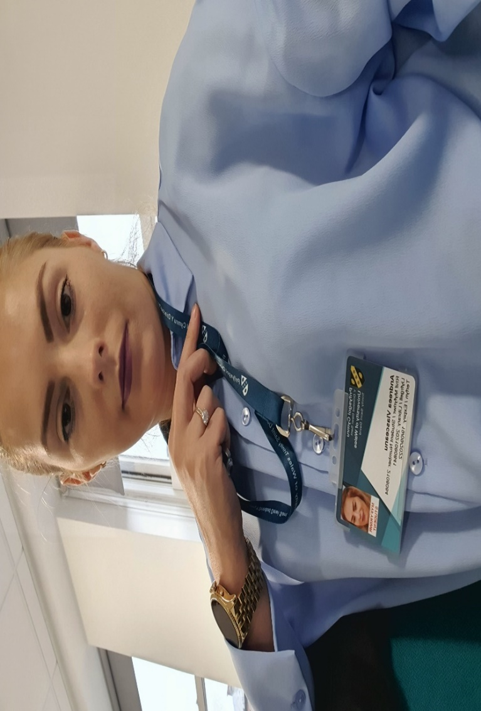

Table of Contents
1. Introduction 3
2. Application of Gibbs Model 3
3. Personal Development Plan 7
4. Conclusion 9
5. References 10

1. Introduction
Employability skills are transitional skills that help to improve personal skills and ability and prepare an individual according to job requirements. It is important to develop employability skills that help to improve personal skills like risk management, personal growth, learning ability, decision-making ability, and mindfulness (Suleman, 2018, p.263). The current report is a self-reflection report based on Gibbs’s reflective model and discusses four major personal development skills, time management, information research, planning and organizing skills, and written communication.

2. Application of Gibbs Model
Gibbs reflective model is one of the most used reflective or cyclic models consisting of six different components that are description, feelings, evaluation, analysis, conclusion, and action plan. The model is a very useful tool for evaluating experience gained from the course work or job role and analysis through personal critical overview and describing learning along with subject objectives and goals (Markkanen et al., 2020, p.46). Although Gibbs is recommended for its usage in recurring situations, the phases and concepts can be applied to singular events as well. The plan of action may grow increasingly general and explore how someone could apply anyone else’s insights in the upcoming lessons (Dhaliwa et al., 2018, p.10).
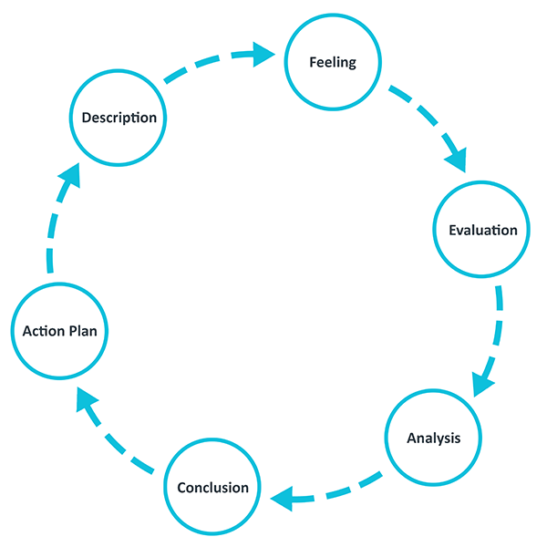
Figure 1: Gibbs reflective model
(Source: Adeani et al., 2020, p.140)
Description
I decided to work on my assignments and continue studying on weekends, but some events and consequences disturbed my whole management. At first, I realized that I don’t have any pen for writing my assignments and I need to submit them within Wednesday. However, there were some major events like softball matches, friends’ outings, and church visiting interrupted my study plan. At last, I realized that I need to go to the clinic and I am 15 minutes late, and in addition, my assignment is not yet completed. The overall events made me realize some employability skills like time management, written communication skills, planning, and organizing skills, along with information research skills. As I understand that the overall situations happen due to a lack of my time management skills.
At first, I lost my pen, and then my friends asked me to go with them and have a softball match. After winning the match we went to the pub for a celebration. After that, I thought about sitting for work after my dinner but it was late on Saturday and then on Sunday morning I went to church to visit my uncle and aunt. After thinking about the job I realized that I don’t have my appropriate notes and I cannot submit my best work on Turnitin between Wednesday. On Monday I forgot to set an alarm and as a result, I woke up late around 8 am and found out that my roommate was already gone to the clinic. However, I didn't have time for breakfast. I rushed towards the bus stand but unfortunately, I missed my bus, and as result, I was 15 minutes late for the clinic.
Feelings
On Friday when I decided to complete my assignment and study hard, I didn’t prepare for all the situations that happened. Moreover, on Monday morning I realized I don’t have any time management skills or other employability skills that can help to balance my personal life and professional life. Before starting my study I realized that I am motivated and organized for completing the work on time with 100% effort, but in the end, I realized I am lacking several skills like time management skills, written communication skills, information research planning, and organizational skills. Considering each event, I realized that if at first, I was a little organized and resourceful along with a time managing person, it would not affect my studying.
At the time of working, I realized that I don’t have my required notes. My studying tools such as pen and copies all disturbed me and decreased my concentration level along with lack of motivation. In addition, while working, I was distracted by other situations like my friend’s invitation for outings, playing with them, sleeping, dinner, and others which reduced my energy level for working on an assignment. An assignment on the health sector needs to have in-depth research and evaluation of the events which can be used in critical case purposes in the future (Scott et al., 2019, p.700). I need to provide extra effort on the assignment and perform my best to meet all the required outputs.
Evaluation
The overall experience I gained from the situations and events that this all is not at all good for me, each event addressing my faults and that impact my study ability. I need to focus on my employability and study skills and brush up my abilities to overcome the situation that will help me in my future to critically overcome harsh conditions. In these events, I realized that the situation was not appropriate according to my plan as I decided to study on weekends and that was good for my study. My planning was quite good at the beginning as I decided to work on my employability skills and study hard to submit my assignment on Wednesday with my best work.
As the assignment need high research and in-depth analysis of the case studies and article reviewing for better accessing the objectives. It was very important to meet all the objectives that were important for the subject analysis and assignment. In this situation, my friends and my uncle aunty were the other contributors. In my view, they all play a positive role as they try to reduce my stress. I was the only contributor who followed the negative role and did not fulfil my requirements. My roommate asks me to play softball with her to reduce my work stress and help me to evaluate the study component more accurately. The planning of my study plan was not going well according to my desired requirements and that was reflected through my situations. Moreover, disturbance in my study planning affects my overall assignments plan and reduces my assignment quality as well.
Analysis
I think my first planning of studying in weakened was a good decision and that can be useful for my study purpose. I need to submit my quality work on Wednesday and after a long week of clinic visits; I have only my weekend to complete my assignments as per requirements. As of Monday, I need to go to the clinic on a daily basis and I could not find time to complete the task. However, my study plan failed due to my lack of time management skills and I could not manage my time schedule for my study. I need to divide my overall weekend into two halves that consist of time for my assignment and the other is for my personal life as I only get free time in my weakened state. The planning failed due to my involvement in other stuff like playing softball, an outing in the pub with friends, and visiting my uncle aunt in church delayed my studying time, but this all was as important as my study.
I need to focus on my employability skills such as time management skills, research skills, planning, and organizing skills along with written communication skills. I did not have many resources for completing the task with quality because I did not take written communication or notes during the class that reduced my ability for submitting the task. It is very important to focus on the study material and take notes along with accurate written communication with the tutor to collect information that is essential for the assignment. In addition, this situation made me realize that I need to work on my personal development skills to increase the employability skills that would help me in my career to find a suitable job role.
Conclusion
I learned from the overall situation that I need to develop my employability skills such as my time management skills, planning, organizing things, information researching for quality work, and written communication skills that will help me connect with my tutor. It is very important to manage time as per job and manage each work in time along with their quality performance. Time management skill is one of the essential skills asked by employers in interviews (Azmi et al., 2018, p.10). I am connected with the health sector which requires multitasking and time management as there are lots of emergency duties we would be assigned at one time.
This situation can be more positive for me if I manage my overall timing for each event and perform as my planning. An important lesson I learned from this overall situation is that it is very important to split works as per their requirement and urgent works need more attention than the others. According to my overall situation, the first priority was to fulfil the assignment in time, I can play softball and go for an outing some other day. That was the importance of time management. In addition, I need to focus on my planning and organizing skills that help me to find my required tools on time along with written communication or notes that help me to meet each requirement in time.
Action Plan
In case of working in the same situation and urgent submitting of assignment, I would prepare as per requirements. Next time I will develop my employability skills such as time management, research information, planning, organizing, and written communication practice. These skills would help me to evaluate each requirement that I need to prepare for the job. I will split my jobs according to their needs, like in case of an urgent assignment or another job I will focus on. In case of urgent submission, I will reduce my other job timing and focus on the assignment requirement that will help me to complete my job on time. Next time I will use different tools like 4D for time management and CRAAP for information research which will help me to evaluate my employability skills.
The 4 Ds of time management, often known as the 4 Ds of efficiency, is a popular method for determining if a task or project is worthwhile. It entails making a snap decision about what to do right now, whether by doing it myself, what to do later, and what to cross off my to-do list (Swallow and Zulu, 2019, p.86).
The abbreviation of CRAAP stands for C=Currency, R=Relevance, A=Authority, A=Accuracy, and P=Purpose. The CRAAP exam evaluates the objective trustworthiness of data sets from a variety of academic areas. As there are many online sources, it can be hard to find which sources are reliable enough to use as research instruments (Liu, 2021, p.75). The CRAAP test does not assist educators or learners in determining the reliability of their sources. Using these skills I can work much better next time and meet all the requirements.

3. Personal Development Plan
Required objectives | Expected outcomes | Needed action plan | Success criteria | Application | Estimated timescale
To develop time management | Overcome my time splitting issue and manage work within a formulated time span. | Use 4D time planning to accurately evaluate time management skills. | Prepare an accurate timetable for each job. | Next time project timings. | 1 - 2 weeks
To develop planning and organizing | Being more organize and finding each required thing on time. | Use life managing skills that will help to organize things.  Use time management skills to develop planning as required | Organize required things and tools.  Plan as per job requirement. | Daily life | 1-3 weeks
To develop written communication skills | Have information accurately about the research and communication with the instructor. | Collect notes, information, and class activity. | More accurately understand project requirements. | Study purpose | 1-4 weeks
Research information | Have in-depth knowledge about the topic. | Gain knowledge and search for required information by using the CRAAP tool. | Accurately use data sources | Research purpose | 1-4 weeks

4. Conclusion
Sometimes despite having the subject knowledge and technical ability of individual, employers ask for some basic objective skills that help to grow and carry out the desired job role. This self-reflection assignment focuses on each required component and essential tools for developing employability skills.

5. References
Adeani, I.S., Febriani, R.B. and Syafryadin, S., 2020. USING GIBBS’REFLECTIVE CYCLE IN MAKING REFLECTIONS OF LITERARY ANALYSIS. Indonesian EFL Journal, 6(2), pp.139-148.
Azmi, I.A.G., Hashim, R.C. and Yusoff, Y.M., 2018. The employability skills of Malaysian university students. International Journal of Modern Trends in Social Sciences, 1(3), pp.1-14.
Dhaliwal, U., Singh, S. and Singh, N., 2018. Reflective student narratives: honing professionalism and empathy. Indian J Med Ethics, 3(1), pp.9-15.
Liu, G., 2021. Moving up the ladder of source assessment: Expanding the CRAAP test with critical thinking and metacognition. College & Research Libraries News, 82(2), p.75.
Markkanen, P., Välimäki, M., Anttila, M. and Kuuskorpi, M., 2020. A reflective cycle: Understanding challenging situations in a school setting. Educational Research, 62(1), pp.46-62.
Scott, F.J., Connell, P., Thomson, L.A. and Willison, D., 2019. Empowering students by enhancing their employability skills. Journal of Further and Higher Education, 43(5), pp.692-707.
Suleman, F., 2018. The employability skills of higher education graduates: insights into conceptual frameworks and methodological options. Higher Education, 76(2), pp.263-278.
Swallow, M. and Zulu, S., 2019. Benefits and barriers to the adoption of 4d modeling for site health and safety management. Frontiers in Built Environment, 4, p.86.

