Name: Serena Bailey
Student ID: 2025320
Module: Health wellbeing and sustainable development
Lecture: Chloe Harris and Joanne
Module code: BMHP6021

Written report

Contents
Introduction 3
Introduction to concepts 4
Goal Two Zero Hunger 6
Identify two strategies, programmes or initiatives to implement this goal. 6
Strategy 1 – free school meals 6
Free school meals 6
Benefits: 6
Challenges and considerations 7
Recommendations 9
Conclusion 9
Strategy or programme number 2: Food banks. 10
Food banks. 10
Benefits 10
Challenges and considerations 11
Recommendations 11
Conclusion 12
Goal Four – Quality Education 12
Identify two strategies, programmes or initiatives to implement this goal. 12
Strategy one – Education for all children, adolescents and adults 12
Benefits 12
Challenges and considerations 13
Recommendations 14
Conclusion 15
Strategy two- Apprenticeships 15
Benefits 15
Challenges and considerations 16
Recommendations 16
Conclusion 17
Reference list 17

Introduction
This report is intended for the National Health Service Chief, to outline the key factors of two chosen sustainable development goals, Zero Hunger and Quality education. This will demonstrate what needs to be achieved and implemented to ensure the NHS Chief is aware of the problems that are occurring. This report will have two sustainable development goals to determine implementations that is required to take place in order to reach the United Nations target goals by 2030.

Introduction to concepts

The following section will outline the four concepts of wellbeing, health, sustainable development and sustainable development goals in detail.

Health
The World Health Organization, (2024) states that health is defined as physical, mental and social wellbeing. Health can be depicted as a state of wellbeing where individuals see their own capabilities, which leads the individual to be able to deal with daily stresses from common daily life on a whole and can work and have contribution to their community (WHO, 2022).
WHO, (2017) state the factors of health include: income, education, physical environment and social support networks.
Income explained
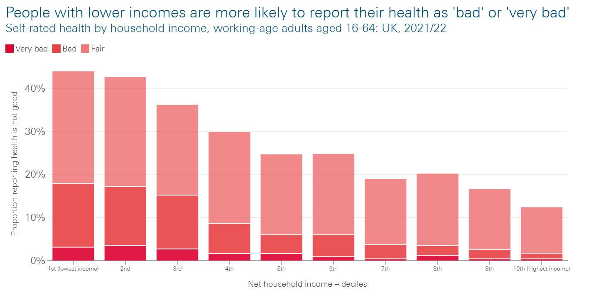(The Health Foundation, 2021)
The image above displays the statistics of how income effects individuals based on lower income and higher income. The Health Foundation, (2024) states that 44% of individuals who are on lower income rated their own health as either ‘fair, bad or very bad’ however, only 12% of individuals on the highest income ranked the same as the 44% of individuals on lower income.

Wellbeing
The Department of Health, (2014) states that there are several aspects to wellbeing;
- Illnesses
- Improving oneself
- Effect of how staff and health provider’s work
- Social, emotional, mental and physical
Each of these areas are integral to overall wellbeing.
The Department of Health, (2014) also defines subjective wellbeing, which is the personal wellbeing of an individual on how the individual feels and thinks about their own wellbeing. MIND, (2020) attest that mental wellbeing is linked to how an individual feels throughout daily life. According to MIND, (2020) it is important to look after mental wellbeing as having poor mental wellbeing create difficulties in daily activities and normal life. The Department of Health, (2014) defines objective wellbeing as adequate food, education and safety.
Why is wellbeing important?
WPA, (2023) argues that wellbeing is important as it is linked to happiness and life satisfaction, having good wellbeing could possibly add more years to your life, and encourage positive health behaviours in adults and children.

Sustainable Development
The United Nations, (2023) state that sustainable development is how we live some of the factors of sustainable development are:
- Economic – As stated by Emas, R, (2015) Economic tries to implement and improve the wellbeing and quality of life to support the wellbeing now and in the future.
- Social – Sivaraman, A (2020) argues that social sustainable development is inclusive societies support poverty reduction and individuals have a voice for the present and future.
- Enviromental – changes are happening such as air pollution and deforestation (Willsher, 2022).
The International Institute for Sustainable Development, (2022) state that sustainable development is to meet the needs of today without compromising.

Sustainable Development Goals
The 17 United Nations goals have been made in 178 countries adopted to the scheme to try and achieve targets for each goal made by 2030 (United Nations 2023). United Nations (2023) state that the 17 goals they have come up with need vital attention, as they are made to provide action to improve the 178 countries, targets where made to implement solutions moving forward to succed in the targets to be completed by 2030.

The following part will lead on to the discussion of the chosen goals.

Goal Two Zero Hunger
Goal two of the 17 United Nations goals was established to develop solutions to be able to end hunger and improve nutrition United Nations (2023). In accordance with the United Nations, (2022) 60% of countries in 2022 faced the severe increase in food prices. According to United Nations, (2023) referring to Goal Two (Zero Hunger) over 600 million people globally will face hunger in 2030, this is because of the recurring hunger issues individuals are not able to have a balanced diet.

Identify two strategies, programmes or initiatives to implement this goal.

Strategy 1 – free school meals

Free school meals
In line with GOV.UK (2020) free school meal scheme was introduced to support low-income families with children in school, this helps as children from low-income backgrounds to have nutritious meals while in school. As reported by Just, D, (2019) free school meals can help by providing nutritious meals which can lead to children having less absences and better behaviour outcomes by schools providing and introducing healthier foods into the children's diet.

Benefits:
Implementing nutrition within schools: Research indicates that Heaths Equals, (2023) are a food charity in which they are trying to push and improve the government food policy to help pupils receive free school meals within the UK, as one of the factors of ill health can be from having a poor diet. Poppendieck, (2021) states that free school meals are designed to meet the food standards criteria of being nutritious, which enables students to eat healthy meals while in school and can then lead students' health to improving from the nutritional food provided by schools.
Reducing stress for low-income families: For families who are financially struggling, having free school meals provided within school helps to relieve stress and anxiety of those from low-income families, as it is one less of a worry (Davis, 2023). In line with the Department for Education, (2022) children just starting school can receive free school meals from reception through to year two. The National Education Union, (2022) launched a campaign in 2022 for its demand to implement ‘Free School Meals for All’ in which 90,000 people have signed their petition for the Prime Minister. This shows suggests that companies and organisations are trying to help families and students in school.
Summer Holiday scheme: Mummybloggernat, (2024) states a variety of cafes and restaurants where in the school holidays children can eat for £1 when an adult spends £10, this could be a great help to families struggling or big families where it is too expensive to go out for a meal. It is important to consider that this source could be biassed due to the credibility of this information. However, ASDA, (2024) have stated on their website that the £1 Kids' Café meal deal will be extended all year round. As stated by GOV.UK, (2022) the holiday activities programme is designed to assist and support low-income households with healthy meals. The sources provided above can be a great assistance for families who receive free school meals at school as it could reduce financial stress.

Challenges and considerations
Food insecurity: Evidence shows that in 2023, Health Equals (2023) found that “21.6% of UK households with children had reported that their children had experienced food insecurity in the past month”. Based on the evidence found this displays that families are struggling to provide adequate food within their household. UK Parliament (2024) states that households living in food insecurity increased by 2.5 million in the year 2022 to 2023. However, because of the change in the UK government as of July 2024 this situation could be alleviated (UK Parliament, 2023).
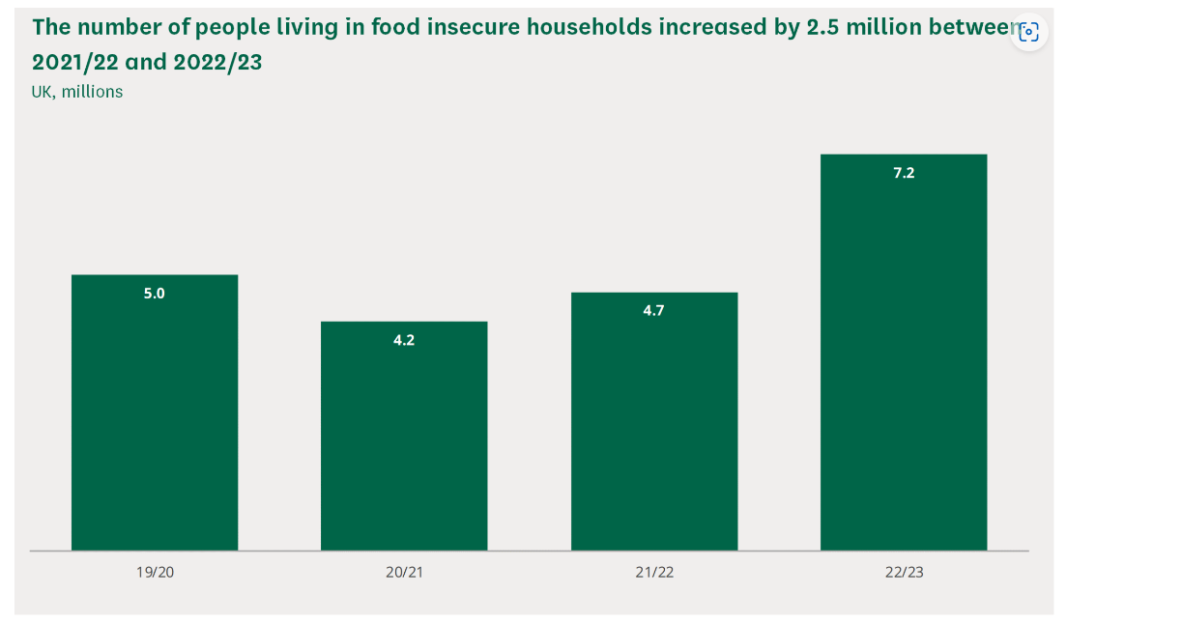
(UK Parliament, 2024)

Funding: Sibieta, L, (2023) identified that schools within the UK had seen a large disconnect in the total number of funding per student since inflation. In accordance with Lewis, A, (2022) 90% of students attested in a recent survey that the cost of living had impacted their mental health negatively, in which caused a downfall in their mental health and wellbeing.
Stigma of free school meals: Lower income income families may feel ghettoised from the stigma of free school meals as they could feel like them out of place within society (Cambridge Dictionary, 2023). The Children's Society (2018) suggets that with the stigma of free school meals, some children go without free school meals in school to reduce their risk of embarrassment from other children.
Health: According to Food Foundation, (2022) obesity had increased by 2.6% between the years 2019 and 2022. Healthy food is three times the number of unhealthy foods, this could be the reason as to why there is an increase in obesity in schools, as lower income families may only be able to afford the cheaper option In foods, students not being able to receive free school meals could impact their health and wellbeing and could lead to medical issues such as diabetes, which would then impact a burden on NHS healthcare services and costs (Food Foundation, 2022).

Recommendations
It could be recommended that chief of the NHS could implement free school meals for every child in schools, as this will reduce the stigma of ‘free school meals is for poor people’. From research found it is important that healthy nutritious can have a great deal of benefits on an individual in line with the Food Foundation, (2022), also free school meals for every child could potentially see a decrease in obesity for children in schools.
Collaboration with the NHS nutritional team in schools could help children to learn about a balanced diet and the positives and negatives that some foods can have on an individual’s body (NHS, 2022).
Increase of healthy start voucher amount up to the age of 16 years old, to be able to buy food and essentials such as toiletries, school supplies, healthy foods which could help to alleviate poverty.

Conclusion
To conclude, free school meals are crucial to the SDG (Zero Hunger) to ensure children are receiving the nutritional meals. Just, D, (2019) stated above having a nutritious school meal can have a good impact of the children’s behaviour in school and could help children have fewer medical issues in the future. However as suggested above there are a variety of positives and negatives based around free school meals. However, one of the most important factors is to implement health and wellbeing of the children at school to ensure their health is up to the standards which will then save the NHS money for long term medical care of those who's health could be affected due to their intake of less healthy food.

The following section of this report will lead onto to the discussion strategy number two which will be on food banks.

Strategy or programme number 2: Food banks.

Food banks.
There is a growing issue of food insecurity which has impacted a lot of communities. Evered, B, (2023) stresses the importance of food banks to help support individuals to ensure that people don’t go hungry.
The Trussell Trust, (2020) suggests that food banks have been increasingly nessasary support system since COVID-19, as it has affected people's daily lives, and has left some people in extreme poverty, during the start of the pandemic more than half of the people using food banks had never needed to use a food bank before.

Benefits

Charity Organisation's: In line with Citizens Advice, (2024) food banks can help to support people who are struggling to afford food, food banks are set up by community organisations to help the communities out. People who are eligible to be referred to food banks can go through Citizens Advice referral scheme to collect their food bank vouchers (Citizens Advice, 2024). Tyler, G, (2021) suggests that 1669 different location in the UK were providing food banks from the Trussell Trust company and 1172 locations of independent food banks were also provided. As most food banks are charities and independent communities helping there is not as much as an issue with funding as they are not government funded.

Alleviating Hunger:
United Nations (2023) created the goal of Zero Hunger to come up with solutions and targets to end hunger by 2023 mainly for people with lower income and the vulnerable. This then links onto The Global Food Banking Network (2022) in which plays a crucial role in ending hunger for the SDG Goal Two where food banks provide access to nutritious healthy meals for anyone in crisis.
Community Support/ Partnerships:
BCPCouncil (2024) provides research on food banks being a positive as some food banks partner up with supermarkets which can help to improve food wastages. According to ASDA corporate (2023) the supermarket introduced a national food drive where customers can donate food to help support people in need, to provide food to their local community food banks.

Challenges and considerations

Stigma: It was indicated that the stigma around food banks were that some people did not think of their vulnerable situation and felt more ashamed of what people would think of them using a food bank according to Dickins,S, (2022). This could deter people away from using food banks.
Demand of food parcels: Wait,S, (2022) argues that with the increase of people using food banks, food banks are struggling to meet the demand of needing more food parcels, as food banks are mostly charity organisations, they rely of the donations off people in order to provide nutritious foods. Bullock,C, (2024) attests that as food banks are struggling due to the demand and running out of some foods, people using food banks must go without. Following from this vulnerable people who are left struggling more and this could impact their mental health and wellbeing.

Recommendations
A recommendation for food banks is that food banks need to improve their accessibility as Citizens Advice (2024) state that food banks are available in their local community, but for people with mobility issues transportation can be hard. However, coming up with a driving food bank service could benefit a lot more people who are struggling.
Improve the universal credit amount for people. GOV.UK, (2012) state that the average monthly allowance for a single person equals to £311.68. Says, F, (2023) argues that on an average the single person spends around £44.70 on a weekly shop, within one month their monthly shop would calculate to £178.80 leaving the individual with £132.88 left over. This need to be improved as having £132.88 left over to pay for bills etc. could lead to more people becoming food insecure.

Conclusion
To conclude, food banks are very common in society today which help a lot of vulnerable people by providing access to sufficient nutritious food. However, there is a gap in society where people are not able to afford foods which needs a change for the UK to get out of people falling reliant on the use of food banks.
The following section of this report will follow onto the next SDG Goal and the discussion.

Goal Four – Quality Education
In line with the United Nations (2024) Goal four is on quality education, which is created to try and achieve inclusive and equitable of education. The following section of this report will be stating information found through a variety of sources based on the benefits and challenges the SDG Goal four with the aim to suggest recommendations for the future which can be of help for the purpose to reach the targets that are set for this goal.

Identify two strategies, programmes or initiatives to implement this goal.

Strategy one – Education for all children, adolescents and adults
In accordance with the World Economic Forum, (2020) 17% which is the equivalent of 258 million children in the whole world did not attend school, the factors which do have an impact on children being able to attend school were: poverty, gender, ethnicity, religion and sexual orientation.

Benefits
School: The Department for Education (2022b) state that children in England from ages 5 to 16 have access to receiving a free school place for education. Gibb, N, (2015) proposes that education is important to allow people to achieve their full potential and reach the highest standards of education. Schools are a great way to deliver quality education and personal development for oneself. It is stated by the UNICEF (2022) that schools can offer an inclusive approach for children in education by not excluding children with disabilities or the minority of children with their first language not being English.
Davies, N.M. et al. (2018) argues that individuals who receive education are normally healthier people, evidence was also found out that there were reduced risks in diabetes from remaining in school.
Adult education: GOV.UK (2017) state that poor mental health can be reduced in adults as receiving quality education can give an individual a sense of purpose in life and fulfilment. OECD (2019) argues that education can implement economic stability as receiving higher education can lead an access of higher paid jobs. Having access to higher paid jobs could possibly result in decline in poverty.

Inclusivity: This strategy can add to diversity and inclusion as Cengage (2020) suggests that those willing to learn gives all individuals the right to contribute to society and has an inclusive approach as it does not exclude individuals no matter their background and provides quality education.

Challenges and considerations

Support: UNICEF (2022) mention some of the support factors for schools as:
- Trained teachers to help meeting the criteria of a child’s needs
- Trained Language teachers to support the minority of children’s other languages
- The needs for an assessable environment for children with disabilities
The table below states young people and adolescents in the UK who were not in education, training or looking for work.

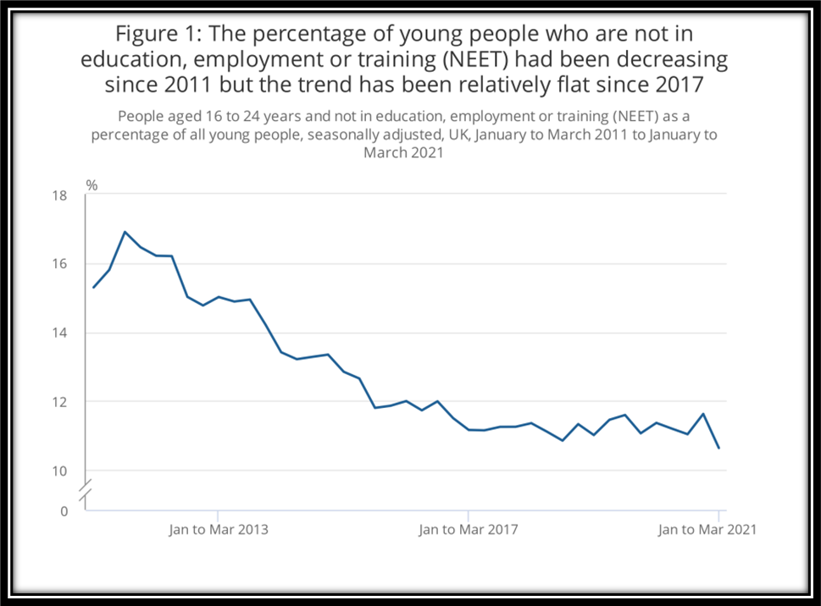
(Office for National Statistics, 2021)
Funding: According to Hubble, S, et al (2021) in line with the UK Parliament, funding for adolescents and adult education scheme has seen a large drop.
Richardson, H, and Lawrie, E, (2021) discuss that funding for children with disabilities and extra needs is inadequate which therefore some of the parents have written to the Prime Minister to demand better provision within school. It is important to understand that the point above may not hold the credibility however it is important to consider some of the problems found in the funding sector.

Recommendations
Schools need to tackle the recurring issue of language barriers within school settings. O’Dwyer, J (2023) attests that children whose first language is not English end up feeling isolated and uncomfortable while trying to learn in school. It is recommended that schools have teacher in place to deal situations like this who specialise in languages to prevent the language barrier from becoming a recurring problem.
Funding for adolescents and adults in education needs to be better in attempt to meet the critical needs of for adolescents and adults trying to better themselves, as Hubble,S, et al (2021) mentioned the large drop in funding for education for ages 19 or older.
Schools need to meet the needs of children with disabilities to alleviate the stigma individuals who may feel different to other children in schools, this can add more inclusivity to the schools to meet the standards of the UNICEF (2022).

Conclusion
All things being considered, through the research found on education for children, adolescents and adults there is a gap in the field of language barriers which needs to see a great deal of attention as this could be the reason why children feel isolated and embarrassed to attend school. It is important that quality and inclusive education for children adults and adolescents is seen intending to provide and meet the expectations of the targets for SDG (Goal Four).

Strategy two- Apprenticeships

Benefits
Hands on: The Education Hub, (2022) provides Indepth research on apprenticeships, apprenticeships are a hands-on experience where colleges collaborate with companies, where individuals who take the apprenticeship route must spend a minimum of six hours a week classroom based to study and gain knowledge for their job.

Career development: (GOV.UK, 2023) state the variety of levels apprenticeships offer in which Indvidual's can apply for, the image below provides details of all levels, which suggest that apprenticeships have inclusivity as all levels are provided from intermediate to obtaining a degree. In line with GOV.UK, (2023) apprenticeships are Nationally recognised through the UK, this gives individuals the opportunity of career development. The image below outlines that individuals can enter a profession from the range of apprenticeships levels.

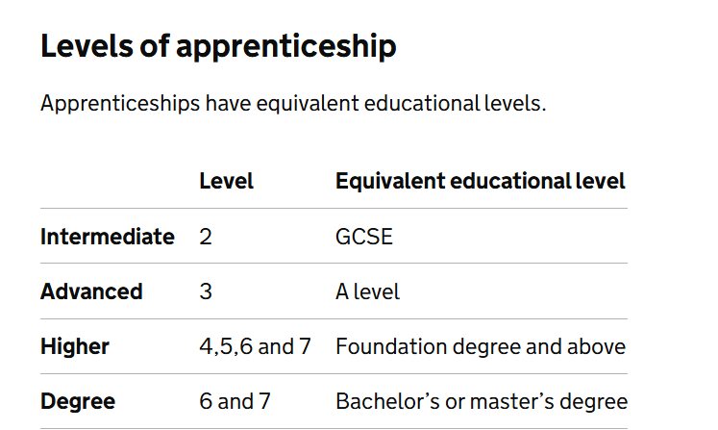(GOV.UK, 2023)
Paid while you learn: Apprenticships.GOV.UK, (No Date) state that one of the benefits of going down the apprenticeship route, is individuals get paid while they learn, so individuals exceed to gain experience of a working environment.

Challenges and considerations

Time commitment: Zambas, J, (2017) suggests that apprenticeships can become time consuming as individuals undergoing the apprentice route have a high workload and complete relevant studies on time for the job, upon completion for individuals to gain a qualification. Following on Zamba, J, (2017) goes onto argue that it can be a lot of added stress for adolescents' wellbeing and can impact their wellbeing negatively.

Low pay salary: GOV.UK, (2024) declares that Apprenticeships offer the National Apprenticeship wage in April 2024 it was confirmed that Apprenticeships rates were £6.40 per hour. While someone in the same line of work as an Apprentice over the age of 21 would be earing £11.44 an hour for the same number of hours as Apprentice.

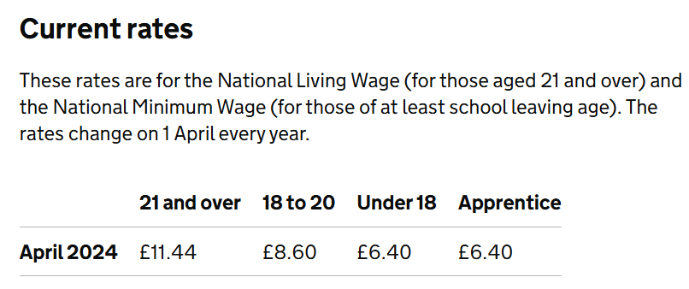

Recommendations
It would be recommended that apprenticeships can benefit individuals especially school leavers aged 16, as finishing school can be stressful not knowing what to do next. Schools should be implementing workshops designed to give young people the opportunity to understand and gain knowledge of the apprenticeship pathways to promte awareness and outreach. This will help to provide more access to young people receiving quality education in line with SDG Goal Four as it can help to decrease the level of targets that need to be met by 2030.
The National Foundation for Educational Research, (2023) explain the Barriers for apprenticeships as:
- GCSEs – companies who offer apprenticeships should offer a programme for individuals to include functional skills Maths and English
- Availability – most apprenticeships are working on a full-time basis. Companies could provide access to part time apprentiships with the duration of time to complete the apprenticeship extended. By doing this it would show the inclusion the company offers for people who are not able to work full time and study. This could improve and increase the quality and inclusivity of education as more people may be willing to gain education this way.

Conclusion

In conclusion, apprenticeships offer an exciting opportunities and pathways. Apprenticeships offer quality and inclusive education for all though a hands-on experience of working and gaining knowledge at the same time. Apprenticeships benefit individuals who are willing to learn and in the completion of an apprenticeship individuals are capable of gaining access to career development. However, it is important to consider the factors of the barriers that can be created through apprenticeships such as balancing the workload and study, relevant GCSEs and availability. It is important to understand that more work needs to be done.

Reference list

Apprenticships.GOV.UK (No Date) What are the benefits of an apprenticeship? www.apprenticeships.gov.uk. Available at: https://www.apprenticeships.gov.uk/apprentices/benefits-apprenticeship#. (Accessed date 27 July 2024)
ASDA (2024) Asda’s popular £1 kids café meal deal extends all year round as it hits 3 million meals ahead of easter. Available at: https://corporate.asda.com/newsroom/2024/20/03/asdas-popular-1-kids-cafe-meal-deal-extends-all-year-round-as-it-hits-over-3-million-meals-ahead-of-easter (Accessed date: 24 July 2024)
ASDA corporate (2023) Asda launches national food drive.Available at: https://corporate.asda.com/newsroom/2022/05/05/asda-launches-national-food-drive. (Accessed date: 25 July 2024)

BCPCouncil (2024) Access to Food Partnership - local food banks and community fridges. Available at: https://www.bcpcouncil.gov.uk/communities/cost-of-living-help/access-to-food-partnership (Accessed 28 July 2024)
Bullock, C. (2024) Bristol food banks say they are struggling to meet demand.BBC News. Available at: https://www.bbc.co.uk/news/articles/ce99r414pr6o (Accessed date: 26 July 2024)

Cambridge Dictionary (2023) ghettoize. Available at: https://dictionary.cambridge.org/dictionary/english/ghettoize. (Accessed date: 25 July 2024)
Cengage (2020) The Importance of Diversity in Adult Learning. Available at: https://blog.cengage.com/the-importance-of-diversity-in-adult-learning-principles (Accessed date: 26 July 2024)
Citizens Advice (2024) Using a food bank. Citizens Advice. Available at: https://www.citizensadvice.org.uk/debt-and-money/food-bank/using-a-food-bank/. (Accessed date: 25 July 2024)
Davies, N.M. et al. (2018) ‘The Causal Effects of Education on Health Outcomes in the UK Biobank’, Nature human behaviour, 2(2) Available at: UWTSD library - https://doi.org/10.1038/s41562-017-0279-y. (Accessed date: 8 July 2024).
Davis, A. (2023) Free school meals boost bond between parents and schools, report says. Evening Standard. Available at: https://www.standard.co.uk/news/uk/free-school-meals-report-child-poverty-action-group-national-education-union-b1126346.html (Accessed date: 20 July 2024)
Department for Education (2022) Free school meals and other support for disadvantaged pupils - here’s what you need to know - The Education Hub. Available at: https://educationhub.blog.gov.uk/2022/05/31/free-school-meals-and-other-support-for-disadvantaged-pupils-heres-what-you-need-to-know/. (Accessed date: 20 July 2024)
Department for Education (2022b) What Is a Free school? Everything You Need to Know - the Education Hub. Available at: https://educationhub.blog.gov.uk/2022/06/10/what-is-a-free-school-everything-you-need-to-know/. (Accessed date: 26 July 2024)
Department of Health (2014) Wellbeing Why it matters to health policy Health is the top thing people say matters to their wellbeing. Available at: https://assets.publishing.service.gov.uk/media/5a7ba1d6ed915d4147621a24/NarrativeJanuary_2014 (Accessed date: 18 June 2024).
Dickins, S. (2022) Cost of living: Food bank shame drives needy away - study. BBC News. Available at: https://www.bbc.co.uk/news/uk-wales-61664584. (Accessed date: 26 July 2024)
Educationhub.blog.gov.uk. (2020) Questions and answers on free school meals - The Education Hub. Available at: https://educationhub.blog.gov.uk/2020/10/19/questions-and-answers-on-free-school-meals/. (Accessed date: 9 July 2024)
Evered, B. (2023) Nourishing Hope: The Importance of Food Banks in Our Communities | THE Agency. Available at: https://www.theagency.org.uk/nourishing-hope-the-importance-of-food-banks-in-our-communities/. (Accessed date: 24 July 2024)
Food Foundation, (2022) The superpowers of free school meals. Available at: https://foodfoundation.org.uk/ (Accessed date: 24 July 2024)
Gibb, N. (2015) The purpose of education. GOV.UK. Available at: https://www.gov.uk/government/speeches/the-purpose-of-education. (Accessed date: 25 July 2024)
GOV.UK (2012) Universal Credit. GOV.UK. Available at: https://www.gov.uk/universal-credit/what-youll-get. (Accessed date: 25 July 2024)
GOV.UK (2017) Skills and lifelong learning: the benefits of adult learning. GOV.UK. Available at: https://www.gov.uk/government/publications/skills-and-lifelong-learning-the-benefits-of-adult-learning. (Accessed date: 25 July 2024)
GOV.UK (2022) Holiday activities and food programme 2024. GOV.UK. Available at: https://www.gov.uk/government/publications/holiday-activities-and-food-programme/holiday-activites-and-food-programme-2024 (Accessed date: 24 July 2024)
GOV.UK (2023) Become an apprentice. GOV.UK. Available at: https://www.gov.uk/become-apprentice. (Accessed date: 27 July 2024)
GOV.UK (2024) National Minimum Wage and National Living Wage rates. GOV.UK. Available at: https://www.gov.uk/national-minimum-wage-rates#apprentices (Accessed date: 27 July 2024)
Heaths Equals (2023) Health Equals – Supporting Free School Meals to reduce health inequalities for children Food Foundation. Available at: https://foodfoundation.org.uk/health-equals-supporting-free-school-meals-reduce-health-inequalities-children. ( Accessed date: 10 July 2024)
Hubble, S, et al (2021) Further Education Funding In England. Available at: https://assets-learning.parliament.uk/uploads/2021/12/Further-Education-Funding-in-England. (Accessed date: 26 July 2024)
International Institute for Sustainable Development (2022) Sustainable Development.Available at: https://www.iisd.org/mission-and-goals/sustainable-development. (Accessed date: 17 July 2024)
Just, D. (2019) 3 Ways Nutrition Influences Student Learning Potential and School Performance – Healthy Food Choices in Schools. Available at: https://healthy-food-choices-in-schools.extension.org/3-ways-nutrition-influences-student-learning-potential-and-school-performance/. (Accessed date: 24 July 2024)
Lewis, A. (2022) How is the rising cost of living affecting students? House of Commons Library. Available at: https://commonslibrary.parliament.uk/how-is-the-rising-cost-of-living-affecting-students (Accessed date: 24 July 2024)
MIND (2020) Wellbeing. Mind.org.uk. Available at: https://www.mind.org.uk/information-support/tips-for-everyday-living/wellbeing/wellbeing/. (Accessed date: 18 June 2024)
Mummybloggernat (2024) ‘Summer Holidays 2024’: 36 restaurants/cafés where kids can eat for FREE or £1 this July and August. Kiddo Adventures. Available at: https://kiddoadventures.com/2024/07/09/restaurants-and-cafes-where-kids-can-eat-free-summer-holidays-july-and-august-2024/ (Accessed date: 24 July 2024)
National Education Union, (2022) The campaign. Available at: https://freeschoolmealsforall.org.uk/about/the-campaign (Accessed date: 24 July 2024)
National Foundation for Educational Research (2023) Barriers to young people accessing intermediate and advanced apprenticeships. Available at: https://www.nfer.ac.uk/media/5zsfwewj/barriers_to_young_people_accessing_intermediate_and_advanced_apprenticeships_perspectives_from_apprenticeship_providers (Accessed date: 27 July 2024)
NHS (2022) Eating a Balanced Diet. nhs.uk. Available at: https://www.nhs.uk/live-well/eat-well/how-to-eat-a-balanced-diet/eating-a-balanced-diet/. (Accessed date: 24 July 2024)
O’Dwyer, J. (2023) Addressing language barriers in UK schools. Available at: https://www.openaccessgovernment.org/addressing-language-barriers-in-uk-schools/171465/. (Accessed date: 27 July 2024)
OECD (2019) The future of work: New evidence on job stability, under-employment and access to good jobs. Available at: https://www.oecd-ilibrary.org/employment/oecd-employment-outlook-2019_59d17791-en (Accessed date 25 July 2024)
Office for National Statistics (2021) Young people not in education, employment or training Available at: https://backup.ons.gov.uk/wp-content/uploads/sites/3/2021/05/Young-people-not-in-education-employment-or-training-NEET-UK-May-2021. (Accessed date: 8 July 2024).
Poppendieck, J. (2021) Top 10 Reasons to Support Free Healthy School Meals for All. Food Research & Action Center. Available at: https://frac.org/blog/top-10-reasons-to-support-free-healthy-school-meals-for-all. (Accessed date: 17 July 2024)
Richardson, H. and Lawrie, E. (2021) Special-needs support beyond crisis, heads say. BBC News Available at: https://www.bbc.co.uk/news/education-58474416. (Accessed date: 27 July 2024)
Says, F. (2023) What Is The Average Weekly Food Bill In The UK (Individuals, Couples & Families) Available at: https://moneysprout.co.uk/average-weekly-food-bill-in-the-uk (Accessed 28 July 2024)
Sibieta, L. (2023). What is happening to school funding and costs in England? Institute for Fiscal Studies. Available at: https://ifs.org.uk/articles/what-happening-school-funding-and-costs-england. (Accessed date: 24 July 2024)
Sivaraman, A. (2020). Five Things You Need to Know About Social Sustainability and Inclusion. Available at: https://www.worldbank.org/en/news/feature/2020/09/02/five-things-about-social-sustainability-and-inclusion. (Accessed date: 20 July 2024)
The Children's Society (2018) The free school meals poverty trap. Available at: https://www.childrenssociety.org.uk/sites/default/files/2020-10/fsm-poverty-trap-tcs-cpag.pdf. (Accessed date: 24 July 2024)
The Education Hub (2022) Five reasons why you should consider an apprenticeship - The Education Hub Available at: https://educationhub.blog.gov.uk/2022/06/29/five-reasons-why-you-should-consider-an-apprenticeship/. (Accessed date: 20 July 2024)
The Global Food Banking Network (2022) How Food Banks Promote Food Security. The Global FoodBanking Network. Available at: https://www.foodbanking.org/promoting-food-security (Accessed 28 July 2024)
The Health Foundation (2021) Relationship between income and health. Available at: https://www.health.org.uk/evidence-hub/money-andresources/income/relationship-between-income-and-health. (Accessed date: 8 July 2024).
The Trussell Trust (2020) New report reveals how coronavirus has affected food bank use. The Trussell Trust. Available at: https://www.trusselltrust.org/2020/09/14/new-report-reveals-how-coronavirus-has-affected-food-bank-use/. (Accessed date: 24 July 2024)
Tyler, G. (2021) Food Banks in the UK. Available at: https://commonslibrary.parliament.uk/research-briefings/cbp-8585/. (Accessed date: 24 July 2024)
UK Parliament (2023) Research Briefings Archive. House of Commons Library. Available at: https://commonslibrary.parliament.uk/research-briefings (Accessed date: 24 July 2024)
UK Parliament (2024) who is experiencing food insecurity in the Uk. Available at: https://commonslibrary.parliament.uk/who-is-experiencing-food-insecurity-in-the-uk/. (Accessed date: 16 July 2024)
UNICEF (2022) Inclusive education. UNICEF. Available at: https://www.unicef.org/education/inclusive-education. (Accessed date: 25 July 2024)
UNICEF (2022a). Article 8 - Awareness-raising | Division for Inclusive Social Development. Available at: https://social.desa.un.org/issues/disability/crpd/article-8-awareness-raising.
United Nations (2022) Article 8 - Awareness-raising Division for Inclusive Social Development Available at: https://social.desa.un.org/issues/disability/crpd/article-8-awareness-raising. (Accessed date: 26 July 2024)
United Nations (2022) Goal 2 | Department of Economic and Social Affairs. sdgs.un.org. Available at: https://sdgs.un.org/goals/goal2. (Accessed date: 8 July 2024)
United Nations (2023) THE 17 GOALS | Sustainable Development. United Nations. Available at: https://sdgs.un.org/goals#history. (Accessed date: 8 July 2024).
United Nations (2023) What is sustainable development? Available at: https://www.un.org/sustainabledevelopment/blog/2023/08/what-is-sustainable-development/. (Accessed date: 17 July 2024)
United Nations (2024) Goal 4 | Ensure Inclusive and Equitable Quality Education and Promote Lifelong Learning Opportunities forAll.Available at: https://sdgs.un.org/goals/goal4. (Accessed date: 27 July 2024)
Wait, S. (2022) Almost 90% of food bank charities worried they cannot meet increased demand. Available at: https://www.civilsociety.co.uk/news/almost-90-of-food-bank-charities-worried-they-cannot-meet-increased-demand.html. (Accessed date: 26 July 2024)
WHO (2017) Determinants of health. World Health Organisation. Available at: https://www.who.int/news-room/questions-and-answers/item/determinants-of-health. (Accessed date: July 5, 2024).
Willsher, I. (2022) What is Sustainable Development and Why Is It Necessary? Available at: https://utopia.org/guide/what-is-sustainable-development-and-why-is-it-necessary/.
World Economic Forum (2020) This is why many young people have no access to proper education. Available at: https://www.weforum.org/agenda/2020/07/unesco-education-inclusion-inequalities/. (Accessed date: 8 July 2024).
World Health Organisation (2022) Health and Well-Being. World Health Organisation. Available at: https://www.who.int/data/gho/data/major-themes/health-and-well-being. (Accessed date: 20 June 2024).
World Health Organization (2024) Constitution of the World Health Organization. World Health Organisation. Available at: https://www.who.int/about/accountability/governance/constitution. (Accessed date: 18 June 2024).
WPA (2023) What is Wellbeing and why is it important? www.wpa.org.uk. Available at: https://www.wpa.org.uk/health-wellbeing/articles/importance-of-wellbeing (Accessed date: 18 June 2024).
Zambas, J. (2017) The Pros and Cons of Apprenticeships.Available at: https://www.careeraddict.com/apprenticeships-pros-cons. (Accessed date: 27 July 2024)

