University of Wales
Trinity Saint David

Scan First

An expiry management system for tracking and controlling the food products expiry dates

Student Name: Claudiu Octavian Albus
Student Number: 1809254

Supervisor Name: Renuga Jayakumar

London
2021


Declaration of Originality

I, Claudiu Octavian Albus declare that I am the sole author of this Project; that all references cited have been consulted; that I have conducted all work of which this is a record, and that the finished work lies within the prescribed word limits.
This work has not previously been accepted as part of any other degree submission.

Signed: Claudiu Octavian Albus
Date: 26.07.2021

Form of Consent

I, Claudiu Octavian Albus hereby consent that my Project, submitted in candidature for the BSc Cloud Computing, degree, if successful, may be made available for inter-library loan or photocopying (subject to the law of copyright), and that the title and abstract may be made available to outside organisations.

Signed: Claudiu Octavian Albus
Date: 26.07.2021

Copyright Acknowledgement
I acknowledge that the copyright of this project report, and any product developed as part of the project, belong to the University of Wales Trinity Saint David.

Abstract

In the recent years, most of the food stores have grown substantially, being able to ensure not only a pleasant shopping experience, but also quality products that are of high standards. The food consumers represent the main concern of each food retailer. To take care of the existing consumers and to attract new potential ones, it is necessary to always offer fresh products, within a good shelf life.
Thus, the shelf life of a food product contains the date until which it can be consumed. Each supermarket has hundreds of products, each of these products having one or more expiration dates. Maintaining an optimal control of these expiration dates is vital and neglecting them can have devastating effects on any food store.
Scan First project has been created as an additional solution in overcoming the expired food products to be sold within the supermarkets or small stores. To prevent this aspect, a new Android application has been developed. Its purpose is to reduce the number of the expired products and to protect the customers from buying products that no longer meet the food standards.
Within this paper will be discussed all the key aspects of this Android application that has been chosen, implemented, and tested.
The Mobile Application Development has become a very competitive sector nowadays. Thus, every single process from a certain field of activity can be transformed into a dedicated mobile application to simplify the process and make it accessible for each potential user.

Acknowledgements

I would like to convey my deepest gratitude to Mrs Renuga Jayakumar, my thesis supervisor, for the valuable support, the guidance and supervision to achieve a successful completion for this project.
At the same time, I would like to express my sincere appreciation to the University of Wales Trinity Saint David for all the support provided during these three years of study, but also for the professional atmosphere during the classes.
Last, but not least, I would like to thank my fiancée and my parents for their moral support without which I would not have succeeded.

Table of Contents

Abstract
Acknowledgements
List of Abbreviations
List of Figures
Chapter 1. Introduction 1
1.1 Project background 1
1.2 Project Objectives 3
Chapter 2. Literature review 4
2.1 Problem Domain 4
2.2 Similar Android applications on the market 5
2.3 Food Checklist - Groceries Expiration and Shopping 6
2.4 Food Checklist and Scan First 8
2.5 Nosh - Food Inventory & Expiry Date Management 9
2.6 Nosh and Scan First 10
2.7 Technologies used to develop Scan First 11
2.8 Xamarin 11
2.9 Android Platform 13
2.10 The architecture of the Android Operating System 14
2.11 The main features of the Android Operating System 15
2.12 Android SDK 16
2.13 iOS Platform 19
2.14 Software Development Lifecycle (SDLC) 19
2.15 Software Development Lifecycle Phases 20
2.16 Methodology 22
The Waterfall Model 22
The Advantages of the Waterfall Methodology 23
The Disadvantages of the Waterfall Methodology 24
2.17 Model View ViewModel (MVVM) 25
Chapter 3. Analysis 28
3.1 Discount scheme 28
3.2 Login access levels 29
3.3 Functional Requirements 30
Admin user – Functionalities 30
Normal user – Functionalities 31
Non-functional Requirements 32
3.4 System requirements 33
Hardware Requirements - Android Platform 33
iOS Platform 34
Microsoft Visual Studio 35
Android Emulator 36
3.5 Risk Analysis 36
Chapter 4. Design 40
4.1 Application Interface 40
The Login Page 40
The Home Page 41
The Menu Page 42
4.2 Database Design 43
Chapter 5. Implementation 45
5.1 The Scan Page 47
5.2 The Food Departments page 48
5.3 The Add Product page 49
5.4 The Add New Employees page 50
5.5 The Discount Page 51
5.6 The Search Page 52
Chapter 6. Testing 53
Test Case 1 - The Login system 53
Test Case 2 - The Add Product feature 54
Test Case 3 – The Add New Employees feature 55
Test Case 4 – The Scanning feature 56
Test Case 5 – The Search feature 57
Test Case 6 – The Discount Products feature 58
Test Case 7 – Adding New Food Departments 59
Chapter 7. Evaluation 60
7.1 The system evaluation and the time management 60
7.2 Future enhancements 61
Conclusions 63
References 64
Appendices 69

List of Abbreviations

API – Application Programming Interface
AVD - Android Virtual Device
BYOD – Bring Your Own Device
C# - C Sharp
DB - Database
GCM - Google Cloud Messaging
HTML – Hyper Text Markup Language
iOS – iPhone Operating System
JIT – Just In Time
MVVM – Model View ViewModel
RDBMS - Relational Database Management Systems
SDK – Software Development Kit
SDLC – Software Development Lifecycle
SQL – Structured Query Language
OS- Operating System

List of Figures

Figure 1 – Software Development Lifecycle Scheme 20
Figure 2 – Waterfall Methodology Scheme 23
Figure 3 – Model View ViewModel Scheme 26
Figure 4 – Pre-implementation Risks 37
Figure 5 - The Landing Page…………………………………………………………………41
Figure 6 - The Login Page 41
Figure 7 – The Home Page 42
Figure 8 - The Menu Button………………………………………………………………….42
Figure 9 - The Menu Page 42
Figure 10 – Database Design Scheme 43
Figure 11 – Scanning a New Product 47
Figure 12 - The Food Departments Page………………………………………………….….48
Figure 13 - Add Food Department Page. 48
Figure 14 – The Add Product Page 49
Figure 15 – The Existing Employees……………………………………...…………………50
Figure 16 – Add New Employees Page 50
Figure 17 – The Discount Page 51
Figure 18 – The Search Page…………………………………………………………………52
Figure 19 – Searching a Food Product 52
Figure 20 – Login Input……………………………………………………………………...53
Figure 21 - Login Output 53
Figure 22 – Missing Name Input…………………………………………………………….54
Figure 23 – Missing Name Output 54
Figure 24 – Wrong Email Input……………………………………………………………...55
Figure 25 – Wrong Email Output 55
Figure 26 – Scan a New Product……………………………………………………………..56
Figure 27 – New Product Captured 56
Figure 28 – The Searching Page…………………………………………………...…………57
Figure 29 – Searching for a Product 57
Figure 30 - Searching the Item……………………………………………………………….58
Figure 31 – Applying the Discount 58
Figure 32 – The Food Departments………………………………………………………….59
Figure 33 – Adding a New Food Department 59

Chapter 1. Introduction

1.1 Project background

Food waste is a global issue which has become increasingly an important matter, politically and socially within the recent years. Throughout the past decade, many high-level political declarations have emphasised the need of combating this problem [2].
Food waste is generated throughout the food chain, namely in the stages of production, processing, marketing, and consumption. Food waste can be described in many ways and there is no single methodology for evaluating this aspect. However, it is generally acknowledged that around 30% of food produced for human consumption is wasted or lost worldwide [1].
This is completely inappropriate in the face of a growing world population. A significant part of these losses is related to inefficient administration during the supply chain operations. This also includes the concept of 'shelf life', which is a general concept that refers to the number of days left for a food product to be of 'good quality' and healthy to eat [2].
Usually, the clients choose a specific supermarket because they trust and believe that the establishment shall always fulfil their demands and expectations, both the expressed and unexpressed ones. They trust that the food products are within the validity period, quality and fresh to eat. Providing safe products is not only important for the consumers and business health, but also mandatory by law.
In the modern society, every individual is dependent on the mobile phone, respectively on mobile applications. The mobile applications provide the largest range of functionalities available to the consumers [3].
Several mobile applications are now accessible for all these smart technologies, and new mobile 'apps' are developed frequently. The mobile devices have eclipsed the desktop computers on the existing market, and those platforms represents the support for most of the future apps that will be developed [4].
Developers must understand the capabilities and the limits of the various technologies available in order to implement proper techniques while designing the mobile applications. This is critical for both parts, which are the users and the developers. Adopting the incorrect approach might become an expensive and time-consuming process [5].
Most of the supermarkets are using dedicated scanners for keeping a better management upon their food products, but this option involves a considerable investment. Another option would be for the users to resort to their own device (BYOD) and use it to keep track of these food products by installing on their smartphone a dedicated application. This BYOD approach can be cost-effective not only for the big retailers, but also for the small stores as well.
Due to its portability and ease, any activities can be carried out with minimal effort by the user. Many mobile applications, such as ‘Food Checklist’ and ‘Nosh’, allow users to manually input and monitor food products from their inventory to help minimize food waste.
Considering that the food industry has a variety of food products, the present project aims to develop an Android mobile application, to track and control the validity terms to prevent the food wastage.

1.2 Project Objectives

- Research specialized books or articles to lay down the foundations of the knowledge that will be used to create the mobile application.
- Analyse the required tools to develop mobile applications and enhance the programming skills required.
- Investigate similar mobile applications to identify the features for the existing application.
- Adopting cross-platform mobile application development, it is possible to create applications that can operate on several platforms using a single code system.
- Develop a user-friendly mobile application using an efficient .NET framework which is involving the Xamarin features that is concentrating on C# language in order to create the code that will underpin the mobile application.
- Design a suitable database for the application, using Microsoft SQL Server Management Studio.

The purpose of this project is to control the validity terms of the products, by creating a proper management system application, that can be used in the food industry. The focus of this project is to examine the current similar applications from the market and to implement new functionalities to increase the productivity.
As mentioned above, this project is designed to help the small and big food retailers to combat the loss of products and, at the same time, to make the daily work of the employees much easier. Developing such an application could have economic, social, and environmental benefits.

Chapter 2. Literature review

2.1 Problem Domain

The food products are supplied using what is known as a supply chain. Those supply chains plan and coordinate the processes necessary to turn the raw elements into the final food products, which form the food supply chain. Supplier-purchaser relationships connect the organisations into a supply chain. However, specific product issues may arise. The source of the problem should then be identified, and the cause should be addressed as quick as possible in terms of food safety. The food companies must track and trace all the products in order to be efficient and successful in controlling them [6].
Tracking and tracing offers to the supply chain organisations is a viable alternative for dealing with the product deficiencies. The companies that are equipped with an effective tracking and tracing system have the ability to control and remove all the items that may be potentially harmful to the customers. Those items could be tracked and traced through the supply chain, forcing the supply chains to act properly and eliminate non-compliant items that may affect the customers health [7].
Most of the food supply chains are using special devices, such as scanners, which also use a dedicated software that controls all food within the supply chain. These devices are already used all over the UK and beyond. In addition to the fact that their price is quite high, it should be taken into consideration the fact that more money will be invested to acquire the dedicated software running for these devices. Thus, the companies will end up spending thousands of pounds on the equipment. That means a cost-effective approach could be investing only into a mobile application that can run on any available smartphone [8].
Each retailer/supermarket should ensure quality standards for all the food products. One of the most important aspects that is considered very important, and which has high priority in the food chain, is the validity term of the product [9].
In order to control all the validity terms as efficiently as possible, it is necessary to use a dedicated system, that offers a set of functionalities, which will facilitate and at the same time increase the employee's performance during the work process.
To solve this existing issue, an expiry date management system has been developed. This system aims to maintain the control over the food products in a very simple and efficient way.
Nowadays there are many types of similar applications for tracking the validity terms of the food products and each type has its own characteristic features. The current application has the function to record the details of the food items. Also, there is a high demand for this kind of system to control the food products more precisely.

2.2 Similar Android applications on the market

In this thesis it will be presented the process of developing a mobile barcode scanning application that can be used by any food retailer. Many similar shopping applications are already competing for the customers attention on the leading smartphone application markets; iTunes App Store for iPhone, Google Play, and the original Android Market, are meant to be used internally by the retailer employees.
Some of the applications are utilising the barcode scanning feature to identify the retail products and to allow the interaction with them. While the initial successful barcode scanning apps were mostly concerned about the price comparison, the new types of barcode scanning apps are also focused on the customers health and sustainability. The applications have started to include social capabilities, allowing users to promote items to friends and followers via prominent social networks, such as: Facebook or Twitter, but this is not the case for the actual context [10].
As the food industry is growing and evolving so fast, the smartphone apps are being used to keep track of the food products. On the market are available already some software that are able to monitor the food products and their specifications, being used only for home purposes.
However, on the existing market there is no application that is used for internal purposes, which means that is used inside of the food supply chain by the workers that are trained on this matter.
Within the food industry, preparing the monthly reports and having the control of the validity terms is a difficult mission to the workers, but the invention of such an application on smartphone, is the kind of achievement that will make a real change. If a problem occurs, the system allows verification of past actions to determine the cause of the occurrence.

2.3 Food Checklist - Groceries Expiration and Shopping

This application enables you to control your personal food supply and also the expiry dates, utilising the shopping list to replace your food stock. The barcode scanner can be used to simplify the process.
This system allows the users to sort the items into categories and provide locations for storage to keep everything in order. There is also the possibility of using the Android devices to access the list that can be shared with other people.
Features:
Includes two tabs, named ‘My Food’ and ‘Shopping List’.
‘My Food’ page contains:
- The possibility to add into the application the food products.
- For each product the expiration date can be introduced in the system.
- The expiration date of each product can be seen on the list, as well as details regarding the expiry dates.
- Any item can be copied from "My Food" list to the "Shopping List" and a certain amount can be set in order to be purchased.

The Shopping List page has:
- The possibility to add items from the ‘Food List’.
- Any item can be transferred from one list to another.
- When moving an item between the lists, the quantity is reduced from ‘Shopping List’ and added to the ‘My Food’ list.

Barcodes
- The phone's camera can be used to capture the barcodes of the items.
- After the barcode was inserted into the system, the product can be just scanned to perform an action instead of inserting the details manually.
- It can be associated one barcode or more for a single food item. The ‘Catalog’ menu item can be used to edit the products.

The Categories and Storage Places have the purpose to:
- Arrange the products into categories.
- Establish storage places to help users to find where the food is placed.
- Customize the view as a normal list with specific items.
- Use colours for the storage locations to simplify the viewing.

Sharing and Syncing are able to:
- Share the lists with the other members.
- Add other member's e-mail address, using the "Users" menu item.
- Allow the user to access all the lists, when the application is installed, and the login is successful.
- Use the right credentials on another gadget, so all data can be synchronized automatically in real-time [11].

2.4 Food Checklist and Scan First

Firstly, as a comparison, the Food Checklist app can be used for home purpose only, when Scan First has been designed for supermarkets and other food stores. However, these two applications have few matching features that are aiming to control the traceability for the food products.
Secondly, apart from the possibility to create a shopping list, Food Checklist app described above, has a few functionalities similar with Scan First. Within Food Checklist app, in the dedicated section for the expired products, it can be observed the products that will expire soon, and the products expired already. On this segment, Scan First is trying to avoid the expiration of the food products by applying a specific discount according to the product expiry date.
Lastly, the storage place feature where all the products details have been captured based on the specific categories is common for both systems. The only difference between them represents the push notifications, which are part of Scan First, and that will notify the user what product will expire soon.

2.5 Nosh - Food Inventory & Expiry Date Management

If a user wanted to check what was left in their fridge while shopping for food, with this app they could track the food inventory and expiry dates or best before dates while they also get recipes suggestions based on the items in their fridge.

The main features of the application are as follows:
- Streamlined Solution - Nosh is the ideal solution for managing all types of food and trash. It makes stock management more transparent and precise than before.
- Smart Inventory Tracking - Keeping track of all foods in a inventory is easy using the 'Stocked' section. Any food additions or removals, expiration dates (best before), remaining stocks, and the quantity of each remaining specific food are all tracked within Nosh app.
- Suggested Recipes – The possibility of receiving a library of high-quality recipes tailored for each user, all accessible through a single touch.
- Smart Shopping List - A personalised shopping list can be created. Using an easy-to-use marking features will make the shopping a delight. Additionally, the users can copy the stocked and the expired items to the shopping list at their convenience with a swipe gesture.

Other Features:
- Easy product registration - To track the food products and to prevent the waste, the users can manually enter the details about the items or use the scan function.
- Easy product categorization – The users can organize their stored items into five categories: fridge, freezer, pantry, medicine, and uncategorized, to keep track of their groceries.
- Manage the stock with scan-receipt feature - Scanning the shopping receipts with a smartphone's camera to automatically input the groceries already purchased within nosh. Tracking users’ grocery bags has never been easier, as it assists users in reducing the food waste.
- Manage the stock with barcodes - Using the camera from the smartphone to easily scan the product's barcode and see its name. There is no need to manually input the food product's name, as the product's expiry date can be simply entered.
- Modern User Interface - The application comes with features such an enhanced User Interface that was meticulously designed to give a superior user experience [12].

2.6 Nosh and Scan First

As its name implies, the possibility to scan the products and to store their details within the database is one of the key features of the Scan First application. This kind of feature can be discovered within the Nosh application, being used to have a better control of stocks and expiry dates.
As mentioned above, Scan First has been developed to be used within supermarkets and food stores. Another important feature is the discount option that can be granted to the user to the food products that will expire soon. Depending on the expiry date displayed on the food package, the discount will be given using the Discount Scheme levels. The purpose of using the discount feature is to prevent the food products to expire, which can lead to food wastage.

2.7 Technologies used to develop Scan First

Mobile applications have become essentials in everyone’s life. It has now become a challenge for the software developers to build smartphone applications that can run on a wide range of operating systems such as iOS, Android, and Windows Phone. One response to this issue is having different code bases and separate development teams on each platform on the same program, which is clearly an expensive solution [13].
The more advantageous solution would be to use a cross-platform mobile device development tool to minimize development effort and costs, while delivering fast distribution to all application markets at once.

2.8 Xamarin

The mobile application industry has grown in the recent years, being divided into three main categories: Google Android, Apple iOS, and Microsoft Windows. To attract as many users as possible to use a mobile application, the developers are conditioned to create applications that can run on the most existing platforms on the market [14].
On the market are several frameworks available, including cross-platform development framework, native application development, or mobile site using HTML5. One of them used within this project is Xamarin, a cross-platform tool for developing mobile applications which can run on any platform, such as Android, iOS, Widows Phone using the C Sharp (C#) language. This framework is described by its founders to be easy to use, fast, efficient, and reliable.
Xamarin is a cross-platform system that includes its own Development Environment that relies on C# within the dotNET (.NET) framework, which enables native applications to be developed. Also, Xamarin applications are created by using native user interface functions. Adopting C# shared codebase, the developers can write native Android, IOS and Windows Phone by using the Xamarin tools [15].
Xamarin provides two distinct methods for the application development: Xamarin.Android/iOS and Xamarin. Forms. The first method enables the developers to create Android layout files and iOS storyboards using Visual Studio capabilities. All native frameworks are easily accessible. While the graphical user interface is different for each platform, the business logic-based code may be used between Android and iOS apps. The second method enables the developer to create the user interface for both platforms simultaneously [16].
This framework allows the creation of platform-specific user interfaces developed in C# that interacts with iOS and Android using the platforms' native APIs. The support for C# language is implemented during development as an abstraction layer. This is feasible due to the fact that Xamarin's bindings provide access to native APIs. Since the native APIs are accessible through C# classes, it is feasible to design applications that share a core library across platforms while maintaining platform-specific user interfaces [17].
Microsoft Visual Studio with the Xamarin plugins or the Xamarin Studio integrated development environment are the IDEs used for Xamarin applications. Along with the requisite tools and plugins, the Xamarin website includes instructions for submitting the created apps to the Apple App Store and Google Play.
There are several code editors on the market, such as Eclipse or Unreal Engine. The most popular one, which is used by the majority of developers, is Microsoft Visual Studio.

2.9 Android Platform

Android is a mobile operating system based on the Linux kernel that was developed initially by Google and then by the commercial group Open Handset Alliance. Android enables developers to create managed Java code that communicates with the device using Google-developed Java libraries. Although applications written in C# and other languages may be developed and executed on ARM machine, Google does not officially support this development approach [18].
Since October 21, 2008, Android is accessible as an open-source platform. Google has made the whole source code accessible for the first time, which was previously available under the Apache license. This process enables manufacturers to incorporate private expansions without making them available to the general public [19].
In order to achieve a better performance, this platform relies on the processor capability of the mobile device. Some other examples of available platforms that are using the mobile environment are: iOS, Windows Phone, RIM Blackberry.

2.10 The architecture of the Android Operating System

The Android operating system's architecture is categorized into five components on four levels: the Linux Kernel, the Libraries, the Android Runtime, the Application Framework, and the Applications [18].
The official version of the Linux Kernel incorporates a number of updates and includes all the drivers for the hardware components such as the camera, keyboard, Wi-Fi, and the audio devices. Additionally, certain Android-specific features have been introduced to the Linux Kernel, including WakeLocks, low-memory killer, binder, and logger [20].
Another component within the architecture is the Android Runtime, which consists of a collection of fundamental libraries that enable users to create mobile apps. These libraries provide access to a device's services, including the calling, messaging, and the packet management. The architecture is built on registers, each of which is equipped with a JIT compiler that enables the modification of the executable acquired on the mobile device [18].
The third component, the Libraries layer, includes a collection of C/C++ libraries that enables direct access to the fundamental kernel functionalities. They are often used by applications within the Application Framework layer to communicate with the Linux kernel and access the data contained on the device [18].
The next component is the Application Framework level, which exposes numerous operating system capabilities to the programmers, which can be incorporated into their applications. This component enables developers to construct complicated and unique applications by allowing them to access hardware, location information, run background services, set alarms, and add status bar alerts [18].
The last component is the Applications Level, which includes both built-in goods like as the camera, music player, contacts manager, and video player, as well as third-party items available through the Play Store [18].

2.11 The main features of the Android Operating System

- Storage - includes the utilisation of SQLite, which represents a relational database engine that maximises the resource usage.
- Connectivity - through a variety of methods, including 3G, Wi-Fi, Bluetooth, WiMAX, GPRS, and EDGE.
- Direct Wi-Fi - which enables high-bandwidth communication between several devices.
- Android Beam - which enables users to instantaneously share content by bringing the smartphones closer together.
- Web browsing - powered by the open source WebKit browser and the Chrome V8 JavaScript engine, which supports HTML5 and CSS3.
- Multimedia - supports a variety of file types, including H.263, MPEG-4, AMR-WEB, AAC, and JPEG.
- Multi-touch - which enables simultaneous interaction across many points.
- Multitasking - GCM (Google Cloud Messaging) enables developers to transfer small data without requiring a proprietary synchronisation method [21].

2.12 Android SDK

The Android SDK includes a collection of development tools, libraries, a troubleshooting system, a device emulator, code samples, and tutorials, all of which are designed to simplify the process of developing mobile applications. The enhancements to the Android SDK make it easier to create apps for earlier versions of the Android platform, allowing the creation of apps for older devices as well [13].
Also, the Android SDK includes all the mechanisms necessary for developing and compiling an Android application. Additionally, the Android SDK includes a phone emulator, code examples, starting tutorials, and troubleshooting tools for developers. Currently supported development platforms include Linux, Mac OS X, and Windows systems [13].
Additionally, the Android SDK enables the development of applications that run on earlier versions of the Android platform. Because the development tools are components that are always available to developers, previous versions of the programme could also be downloaded and used for testing purposes. Each version of Android has an SDK platform that can be used as the target platform for the application [13].

Android SDK includes the following:
- Android API: The Android SDK is built on the Android API libraries, which enable developers to interact with the Android stack. These are the libraries that Google use to create native applications.
- Android SDK provides a variety of development tools that allow developers to build and debug the applications. The Android emulator is an interactive device which emulates the hardware configuration of a smartphone. The emulator allows the user to experiment with how the application will run on an Android smartphone.
- Full documentation: The SDK provides comprehensive documentation, code references, and instructions for utilising the classes, as well as explanations of fundamental Android programming concepts.
- Android Online Support: Due to the open-source platform, a vibrant developer community has grown significantly, where new ideas are constantly explored and where the members can receive all the support.

In order to be more specific, the main technologies used to create Scan First Android application are grouped in different categories, as follows:

Software:
- Microsoft Windows 10 Operating System - Is the operating system environment used to build this program. It is better to build smartphone applications using Windows as an OS, than Linux, since a lot of additional measures need to be taken within Linux.
- Visual Studio 2019 – Is an Integrated Development Environment (IDE), created to support complex operations, that provides all the necessary tools to develop web and mobile applications.
- SQL Server Management Studio – A software used to manage, configure, and administrate the database engines, which is used by the majority of developers around the world.
- Google Chrome – Used for performing the tests and debugging the application.

Hardware:
- Asus ROG Strix GL753VE Gaming Laptop – This laptop comes pre-installed with Microsoft Windows 10, and its 7th-generation Intel Core i7 CPU and the powerful NVIDIA GeForce GTX 1050Ti graphics for incredibly immersive gaming. The Asus ROG Strix GL753VE is designed for gaming and is loaded with a variety of creative features to offer an outstanding experience for any type of user.
- Samsung Galaxy S10 - The Galaxy S10 is a quantum leap forward for the venerable S series. Among the key features are the huge curved-edge screen and the innovative Ultrasonic Fingerprint Scanner, which secures the device via fingerprint. With a front camera and three back cameras, one of which is ultra-wide and another ultra-zoom, it is simple to record every angle of a certain object. Additionally, it has a 3400mAh battery that can be shared with others.

Programming languages:
- . NET – It is a free cross-platform used to build many different types of applications, using multiple programming languages and libraries.
- C-Sharp (C#) – An object-oriented programming language developed by Microsoft and designed to build portable applications.
- Structured Query Language (SQL) – A programming language used to create Relational Database Management Systems (RDBMS).

2.13 iOS Platform

iOS represents the Apple's mobile operating system that was initially named iPhone OS when it was introduced in 2007. It was then renamed in 2010 to reflect the addition of compatibility for additional Apple devices such as the iPad and Apple TV. On the mobile OS sector, some of iOS's competitors are Google's Android OS, Microsoft's Windows Phone 7, and BlackBerry OS. Several difficulties have been highlighted, including the development model and the rigorous approval procedure for launching apps on the App Store. Other developers, on the other hand, believe that a more restricted platform could give further protection.

2.14 Software Development Lifecycle (SDLC)

A software development lifecycle process represents a structure or framework that is utilised for the construction of any software product. There are several models that have been defined. Among these models are the waterfall model, the spiral model, and the prototyping model. A series of actions is used to explain each model. The development processes or activities may differ within the models, although all the models will involve planning, requirements, analysis, design, and so on. The waterfall approach places a greater emphasis on the step-by-step procedure. The spiral model focuses on risk assessment, whereas the prototyping model follows an incremental approach throughout the development process.
A critical component of the development process includes the designing of the product to meet the needs of the user based on several standard development lifecycle models. A well-defined development process is essential. If the development is done progressively, the development lifecycle will be affected. When the customer is involved in the development process, the customer's expectations are better realised towards the completion of the process, that will result in a higher satisfaction for the customer.

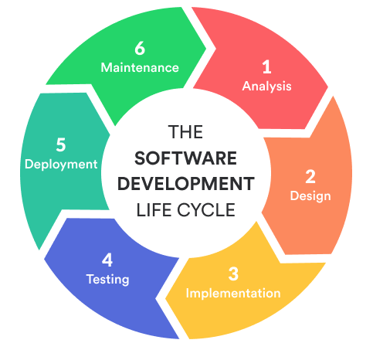

Figure 1 – Software Development Lifecycle Scheme [28]

2.15 Software Development Lifecycle Phases

Analysis Phase – This phase contains a categorized collection of ideas. These ideas can be proposed either by the client or by the developers involved in the project.
In the current context, the chosen idea involves the creation of a mobile application that has the role of preventing the expiration and, at the same time, the waste of food products, as well as of maintaining or raising the profit of the companies from the food industry.
The mobile application Scan First will be able to scan the barcode of food products, recording the most important details such as: product name, price, the department it belongs to and finally the expiration date, as well as the quantity. In the end, these details are recorded in the database, thus making it possible to generate reports showing the period when these products will expire.
Also, the application will have a special feature called Push Notification. This feature will notify the user 4 days before reaching the consumption threshold. In this case, the discount scheme must be adopted in order to be able to eliminate the stock of expiring products. This is beneficial for both parties, both for the grocery store and for the customer, because the store will be able to sell the products and not have food waste and financial losses, and the customers can benefit from quality food at low prices [22].
Design Phase – Based on the main idea behind the mobile application, an initial design is created. The functionality of the application is divided into smaller components, like modules and prototypes. The application's software architecture is now established.
For the project to be feasible, the platform on which the application will be built must be determined. In this case, the platform used is called Microsoft Visual Studio 2019 and represents an integrated development environment that uses special tools, very useful in creating large and small applications.
It is very important to create an outline that represents the central structure of the project to have a better overview. In order to create the layout of the Scan First mobile application, each page has been drawn separately with all the related functionalities.
Alternatively, the platform target is fixed to start the next phase, called the Development Phase [22].
Implementation Phase – At this stage, the code will be generated by the developer. The first step is to develop the code for the core functionalities and then the coding for different structures of the project, such as User Interface functionalities, can be generated in parallel.
Testing Phase – The testing is one of the most essentials steps from any lifecycle production model, being conducted on an emulator followed by a test on a real device. Testing on a real device should be done on different types of the operating system, multiple types of screen sizes. The test cases will be forwarded to the client for feedback.
Within this phase there are two type of tests that will be performed. The first one is Internal Testing, known as the Unit Test and the second one is the Integration Test [22].
Deployment Phase – At this stage, the client will offer the final feedback regarding the mobile application. Now, the application will be ready to be used within a real environment and all the final check-ups will take place accordingly [22].
Maintenance Phase - Maintenance is the final stage of the model and this is a continuous process during the application lifecycle. Through this phase the feedback is received from the users, and the necessary improvements are made to fix the potential bugs or to perform upgrades [22].

2.16 Methodology

The Waterfall Model

The Waterfall model represents the most used SDLC model, which accentuates the analogy between the stages of the software development and cascading steps down an incremental waterfall. In brief, once one phase is complete, the following phase cannot begin until the previous one is completed.
When it comes to teams, each member should be focused on the same stage of the development process within the waterfall alternative, which must be fulfilled before proceeding to the next stage. This process is divided into six critical stages: requirements, analysis, design, implementation, testing, and maintenance.
This type of model is dedicated for the smaller projects, and this is the main reason why it has been adopted within the Scan First project. Also, it is very easy and simple to understand the process by following the specific phases one by one until completion.
Nowadays, waterfall methodologies are being phased out in favour of the agile methodologies. However, the logical character of the waterfall processes cannot be ignored, and it continues to be a prominent design method on the market.
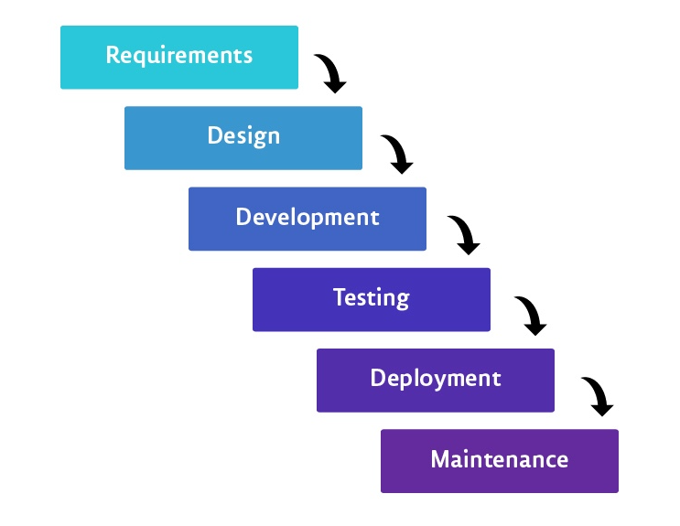

Figure 2 – Waterfall Methodology Scheme [29]

The Advantages of the Waterfall Methodology

- It adapts to changing in regards to the team compositions - The model enables the whole project to retain a comprehensive, resilient scope and design structure as a result of all planning and documentation phases. Therefore, it is ideal for big teams that may see people come and leave during the project's lifecycle.
- The model encourages the organisation to be organised – When creating a waterfall model, it compels the organisation to be very disciplined regarding the design and the structure.
- Early design modifications — The design adjustments may be very challenging, particularly as a project progresses through the development phase. Because of the waterfall model documents specifications, in collaboration with the development team, and the customers at the first phases, these adjustments are possible.
- Convenient for the development milestones — As stated above, the waterfall model is the best choice for the big projects, and also for the organisations or teams that operate on a milestone paradigm [23].

The Disadvantages of the Waterfall Methodology

- Constraints that are not adjustable — The most difficult element of the waterfall model is its intrinsic inability to adjust across all phases of the life cycle. The test phase, which is stage five of the process, has the potential to uncover fundamental faults in the system's architecture.
- Ignoring the potential feedbacks — Because this approach follows a rigorous step-by-step procedure, potential users of the system cannot provide feedback until the very final stages of the product's lifecycle. As a consequence, the late input is frequently unsatisfactory, and it is frequently too late to evaluate and implement desired improvements.
- Testing is being postponed — While most other current techniques strive to incorporate testing as a basic and constant activity throughout the whole development process, the waterfall approach will delay the testing stage.
Although the waterfall model includes specific software testing during the development, particularly during the implementation phase, the testing is sometimes insufficient for the entire lifecycle [23].

2.17 Model View ViewModel (MVVM)

MVVM was created by Microsoft, and it is designed for XAML systems. However, it represents a new concept for the Android platform. This design style is used to isolate the View's state and behaviour, allowing the user interface to be developed independently of the model. The ViewModel can be seen as a mediator to expose the Model's data and to manage the application's logic, while presenting the View.
The Scan First architecture has been developed based on the MVVM model. One of the reasons of choosing this type of architecture is because implies:
- writing clean code that could be much readable and easy to understand by other developers who might work on the same project.
- the possibility to test the code in detail.
- developing the features faster, increasing the speed of the development process.
The MVVM is based on three fundamental components, which are: the Model, The View and the ViewModel. The Model includes the data providers and the logic for obtaining and updating data from a variety of sources, including the REST API, SQLite database, shared preferences, and Firebase.
The View represents the graphical side of the application and is responsible for initiating actions and managing menus, permissions, event listeners, and dialogues, among other things. Using the data binding architecture, the View binds to the observable variables presented by the Viewmodel.
The key difference is the ViewModel being used as a third party between the Model and the View. The ViewModel offers a series of features when it comes to testing and creating applications. It establishes a one-way communication channel with the View by linking itself to the View. It is not associated with the view itself, but rather serves as a model for a view. Also, the ViewModel encapsulates the model and populates it with the observable data required by the View. The View Model is supplied with data by the Model.

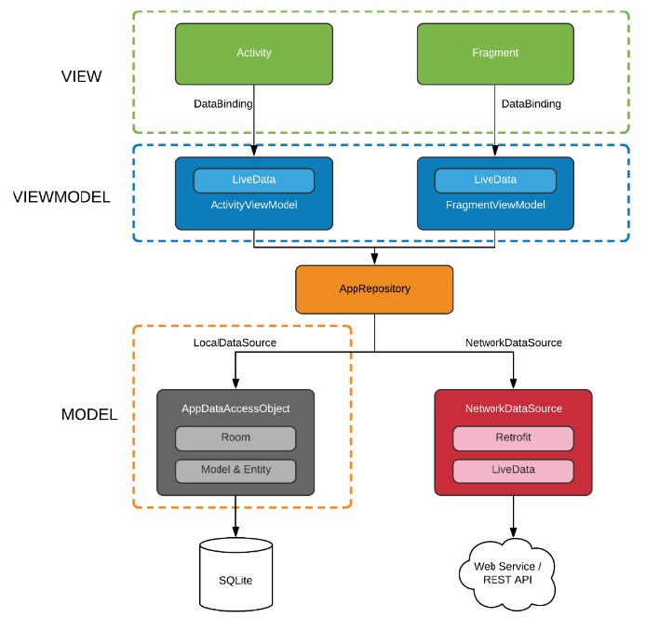

Figure 3 – Model View ViewModel Scheme [30]
The ViewModel is responsible for the following tasks: reveals the date, offers visibility, validation, performs calls within the Model and performs methods within the View.
The MVVM pattern has been widely used in WPF, Silverlight, and JS contexts. However, it has only just begun in Android, and Google has promoted the usage of the MVVM design with the release of the databinding library [24]

Chapter 3. Analysis

The idea of using a mobile application to store the validity terms for the food items has been used in the past. On both Android and iOS platform, an application has already been developed that allows the manual input of the product names and the expiration dates. While these systems are saving the information within a database and incorporate changes, manually entering all the facts takes a longer time and may be time consuming for the active workers [10].
The concept is very simple to understand, and it will be explained as follows; every supermarket has a variety range of food products. Each food product has an expiry date or more, depending on the case. Every single expiry date will be introduced into the system for each food product from each food section by the workers. The scanning feature will be implemented into the application to facilitate the process. Finally, each barcode will be scanned and stored into the database.
Depending on the situation, the discount will be applied to the specific product, in order to help the company not lose profit and to offer products at the best quality level.
The following discount scheme will be applied on the last 4 days before the expiry date of the food item.

3.1 Discount scheme

- 1st day of discount - 30% discount will be applied.
- 2nd day of discount - 50% discount will be applied.
- 3rd day of discount - 70% discount will be applied.
- 4th day of discount - 90% discount will be applied.

In this context, the discount scheme includes four days of price reductions. During this time, the discounts will be granted gradually in order to eliminate the stock of products that are very close to the expiration limit.
When the worker discovers the location and identifies the product, the application will ask him to enter the number of pieces that were found on the shelf and that have the same expiry date. After completing this task, the application will ask the worker to enter for the same product, the other validity terms available in that location.

3.2 Login access levels

The login system consists of two types of users, as follows:
- The Administrator – Has the full control of the Scan First system. This user could be the managing director of the supermarket, or a supervisor.
- The Normal User – Has the access to the basic features. This user could be the normal employee.
When a user account is created within the application, the system will generate a user ID and a password. In this case, only the Admin user is capable to add any new users.

3.3 Functional Requirements

In this section will be presented all the functionalities available for all types of users, such as: the admin user and the normal user.
An administrator has full autonomy and control over all available functions in the application. An account with administrator rights can do anything, from granting the discounts for certain products, to controlling the normal users.
The normal user will be able to do the daily tasks using the application, such as: scanning or adding the expiry dates for the products, search for other items, view the previous items which were scanned previously, etc.

Admin user – Functionalities

- Login or authentication system which is using the specific credentials, such as: Username and Password.
- The possibility to recover the password using the ‘Forgotten password?’ feature, which will send an email to the user’s email address with a link that can be accessed to generate another new password.
- The registration of new users to the system, by creating new profiles for the future employees.
- The scanning of the food products is the main feature around which the application was developed. It allows users to scan the barcode of the products, and then to enter the other important details about the food product, for example: the expiration date, the quantity, as well as the food department or the price.
- The discount scheme is another important element that can be applied when the food products are getting close to the expiration date.
- Adding products represents another useful feature that has the same capabilities as the previous feature. This element was added as a backup in case the barcode might not be readable for certain food products.
- The feature of removing products gives the possibility to the user to remove the food products from the system.
- The search feature was developed for checking the food products details that have been captured before by scanning the items.
- The Food Departments has the role of categorizing the products accordingly, depending on their type.

Normal user – Functionalities

- Login or authentication system which is using the specific credentials, such as: Username and Password.
- The possibility to recover the password using the ‘Forgotten password?’ feature, which will send an email to the user’s email address with a link that can be accessed to generate another new password.
- The scanning of the food products is the main feature around which the application was developed.
- Adding products represents another useful feature that has the same capabilities as the previous feature. This element was added as a backup in case the barcode might not be readable for certain products.
- Remove products feature gives the possibility to the user to remove the food products from the system.
- The Search feature was developed for checking for the food products details that have been captured before by scanning the items.
- The Food Departments has the role of categorizing the food products accordingly, depending on their type.

Non-functional Requirements

This section will describe all the requirements based on how easy to use is the Android mobile application, known as Scan First.

Several examples of non-functional requirements include the following:
- Scalability – Consists in the growth of the network bandwidth usage, which leads to increased response times and load on the client and server systems. There are two ways to increase scalability: vertical scaling and horizontal scaling.
- Reliability – It is a term that refers to the system's capacity to remain operational over time. It is quantified as the chance that a system will execute its intended tasks for a particular time frame.
- Performance - A measure of a system's ability to execute certain activities within a certain time period. However, it must take into the account the elements that have a considerable impact on the system performance. These can be any demand for certain activities and the system's response for those requests, particularly in regards to the communication channels between the client-side application and the web server. The performance optimization requires transferring critical data processing tasks to the web server.
- Security – Represents the system's capacity to minimise the risk of malicious or accidental activities outside of its intended use that will have a big impact on the system, as well as to avoid the unauthorized access or the data loss.
- Manageability – This term refers to the simplicity with which system administrators can manage an application, typically through the availability of adequate and relevant instrumentation, such as: documentation and error logging, introduced for use within the monitoring systems, as well as the debugging and the performance optimization.
- Maintainability - It refers to the system's ability to perform regular maintenance with a relative simplicity. These modifications may have an effect on the components, features, and interfaces when the functionalities of the application are added or changed to correct the mistakes or to satisfy the new business objectives.

3.4 System requirements

Hardware Requirements - Android Platform

Most of the mobile devices are using Android OS version 10 or 11. The remaining are dispersed between older Android platform versions. It is also important to keep in mind the API level of various OS versions. When designing an application, the minimum API level required to operate the application will define the number of phones on which it may run. For example, if an application requires API level 30, it will be unable to install and execute on most Android-enabled devices.
Thus, over time, Android has moved the majority of mobile devices from a situation where the devices had an API level of 29 or below to a condition where they had an API level of 30. Additionally, Google notes that there are smartphones running other versions of Android, but they are not shown since they account for less than 0.1 percent of all devices. While the Android platform have become less fragmented in some ways, since fewer API levels are now used by the most devices, there is a greater scattering of devices on each API level, with 40% of devices utilising an API level of 29 or less.
In the actual context, Scan First is using version 11 of the Android platform, with an API level of 30, which represents the ultimate version available at the moment, until version 12 will be ready to be launched further in 2021.

iOS Platform

Apple provides to the iOS developers a choice of four distinct Developer Programs. The programmes are priced differently and offer different benefits. Apple Developer is known as the base programme. To become a part of any iOS programme, the developers must first register as an Apple Developer. [25].
The iOS SDK includes all the essential tools for designing, developing, debugging, and optimising iOS apps. The list contains both native and web apps, but excludes other forms of code such as drivers, frameworks, and dynamic libraries.
The iOS SDK contains the frameworks, the shared libraries, Xcode Tools, the simulator, and developer library. Xcode is the primary programme used for application development; it is used to manage application projects, edit, compile, execute, and debug. The Interface Builder is used to create the user interface, while Instruments are used for runtime analysis and debugging [25].

The Base SDK specifies which headers and libraries are utilised during compilation, whereas the iOS Deployment Target specifies the minimal iOS version on which the programme will run. By configuring these two parameters, the danger of implementing code that is not supported on an iOS device running an earlier version of iOS is minimised.
Generally, but not always, the iOS SDK is included with the Xcode bundle. This may be verified by accessing the custom install panel of the selected installer. At the moment, the most recent free version of Xcode is version 14, which is accessible for the registered Apple Developers.

Microsoft Visual Studio

Microsoft Visual Studio is a graphical Integrated Development Environment (IDE) created by Microsoft. It is a complex tool that can be used to create computer programmes, websites, and other forms of applications that need any form of coding.
Microsoft Visual Studio sustains a range of programming languages, including C#, Visual Basic, C++, HTML, and JavaScript. Microsoft Visual Studio is mostly used for developing code, although it may also be used for debugging and code analysis.
The coding process using the Microsoft Visual Studio is simplified by the integration of tools such as IntelliSense adaptive code completion, which seeks to accelerate the coding process by decreasing the syntax mistakes. Microsoft Visual Studio has an integrated compiler, which enables developers to create and compile source code prior to deploying it for usage within the applications [26].

Android Emulator

An Android emulator is a graphical representation of an Android smartphone that runs on a computer. The Android emulator replicates all the software and the hardware capabilities of a normal mobile gadget, excepting the ability to perform phone calls. Without utilising a real device, the emulator enables an application developer to test the Android application on various API levels.
A Virtual Device for Android is a device configuration that runs inside the Android emulator. It works in conjunction with the emulator to provide a simulated specific environment in which the Android apps may be installed and launched. The AVD Manager offers a graphical user interface, through which the developer can replicate various Android device configurations that the Android emulator requires [27].

3.5 Risk Analysis

This section presents the risks that can have a direct and practical influence on the project's scope, money, and duration, resulting in a modification from the original agreement of the plan. Those incidents could be diverse as they are unpredictable. There are two categories of risks that could happen during the development process: the pre-implementation risks and the post-implementation risks.

Risks | Risk  Level | Risk Probability | Consequences | Mitigation
System failure | High | Low probability | All the stored data could be lost. | Regular back-ups should be done frequently.
Time management | High | Low probability | Improper time management could lead to delays in completing the project tasks. | Time planning must be effective to achieve the ultimate goal.
Lack of skills required | Medium | High  probability | Developing errors could happen. | Each developer should grow their own skills on long term.
Personal circumstances | Low | Medium probability | Uncertain situations or health problems might occur. | Those potential problems cannot be predicted.

Figure 4 – Pre-implementation Risks

The pre-implementation risks could appear when starting this kind of project. As stated in the table, there are few risks to consider.
Some post-implementation risks may occur when using the Scan First mobile application, and they could be as follows:
- The risk of forgetting the password for the user account.
- The risk that users do not know how to use the application.
- The risk of losing the internet signal while using the mobile application.
- The risk of not being able to scan a product, or several types of products, to be registered in the system.
- The risk of not being able to make updates or check the details of the employee profiles as an Admin user.
- The risk of losing all the reports based on the previous scanning or adding a product to the system.
- The risk of introducing wrong details about the food products in the system.
- The risk that the mobile application will not be able to connect to the database that contains all the vital information for carrying out the daily tasks.
- The risk that employees are offering a high discount from the beginning, when the food products have a few days left until will expire.
- The risk that the current functionalities of the application might not be implemented correctly from the beginning, thus causing to slow the running process of the application.

For all these potential risks listed have been found viable solutions, which will be stated in the same order matching the risks from above. Based on these, the solutions are:
- The possibility to recover the password using the ‘Forgotten password?’ feature.
- The mobile application has a very friendly design that makes the application very easy to understand for everyone. Also, a basic training will be offered by the dedicated trainers for each new employee.
- Depending on the internet provider services and also on the signal coverage, the lost signal might happen. However, the mobile application will notify the user when the signal will be available again.
- In case the barcode is not readable for a certain food product, the user has the possibility to use the ‘Add Product’ feature.
- This kind of problem might be affected by the written code. The developer must check again the code in order to solve the issue.
- The regular backups and using a reliable system to hold and control the data represent the solutions for preventing the occurrence of such events.
- The human error might appear at some point which is normal. To prevent this, all the details that have been entered wrong within the system can be deleted and the employee can add another entry for the product using the right details.
- This issue may occur if software updates have not been made or if there is no internet connection.
- To prevent offering high discounts to the products, a detailed control of all the discounts made will be required.
- Creating an application is very challenging for the entry level developers. Sometimes the implementations might not be right, that means an extra support may be needed to achieve the good results.

Chapter 4. Design

To guarantee that the application is simply accessible and understandable by the potential users, it should be easy to use without any significant explanation or training. This section of the report will explain why the system was developed using certain functions, and why the controls and settings are configured and developed the way they are.
The application's design will strive for simplicity in order to make it as easy as possible to use, and as feasible for the future employees. Essentially, the application is divided into two sections, which are known as the Frontend and the Backend.
The Frontend represents the visual aspects that can be experienced and seen by the users. The Backend represents every single process that is taking place in the background and cannot be seen by the users.

4.1 Application Interface

In this section will be presented the most utilized pages and the design that has been chosen and implemented for the Android mobile application, known as Scan First.

The Login Page

The landing page is the first page that the user will interact with when starting the application. The Login page contains the logo, the textboxes for the username and for the password, as well as the login button. The password will not be displayed as plain text and each character from it will appear as ‘●’.
The Login page is the place where the user can enter their own credentials in order to access their profile. In case the user forgot the password, as it can be observed in the print screen below, the ‘Forgot Password’ option is available to obtain a new password.
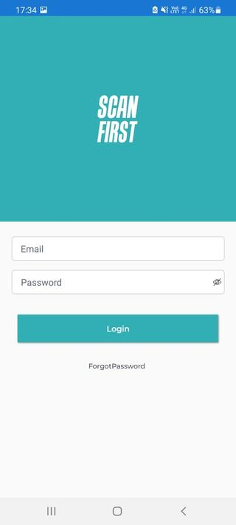
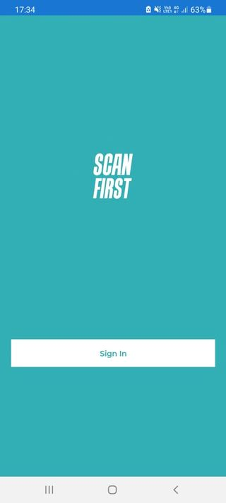

Figure 5 - The Landing Page Figure 6 - The Login Page

The Home Page

This page represents the most utilized screen, being the main page where the user can choose what action to perform within the mobile application.
As it can be noticed from the below print screen, the design is minimalist and easy to understand. There are two main buttons placed in the center of the page: the Scan button and the Food Departments button. The Menu button is located on the upper side in the left corner. The application logo is placed at the top right of the screen. The functionality bar that contains the four buttons whose functions are very well-defined is placed at the bottom of the screen.
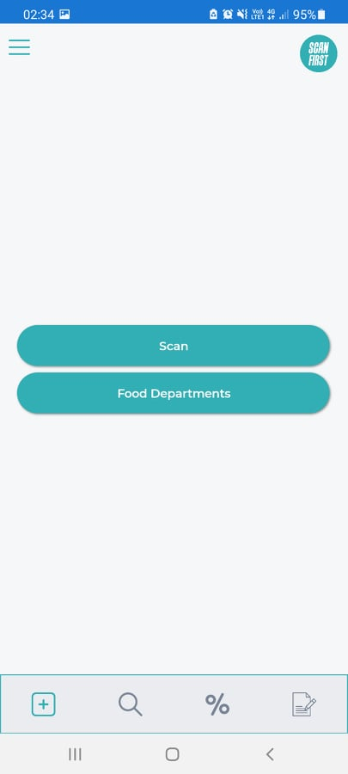

Figure 7 – The Home Page

The Menu Page

Accessing the Home page, adding a new user, adding a product, or simply logging out from the system can be made accessing the Menu by pressing the button placed on the top left side of the screen.
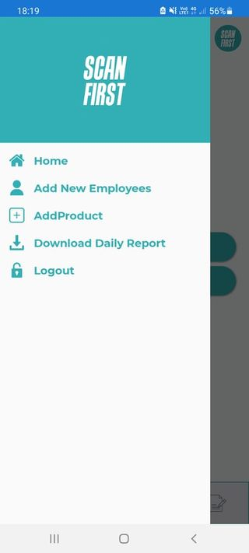
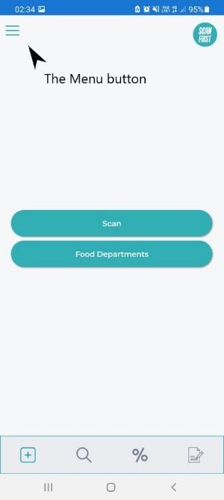

Figure 8 - The Menu Button Figure 9 - The Menu Page

4.2 Database Design
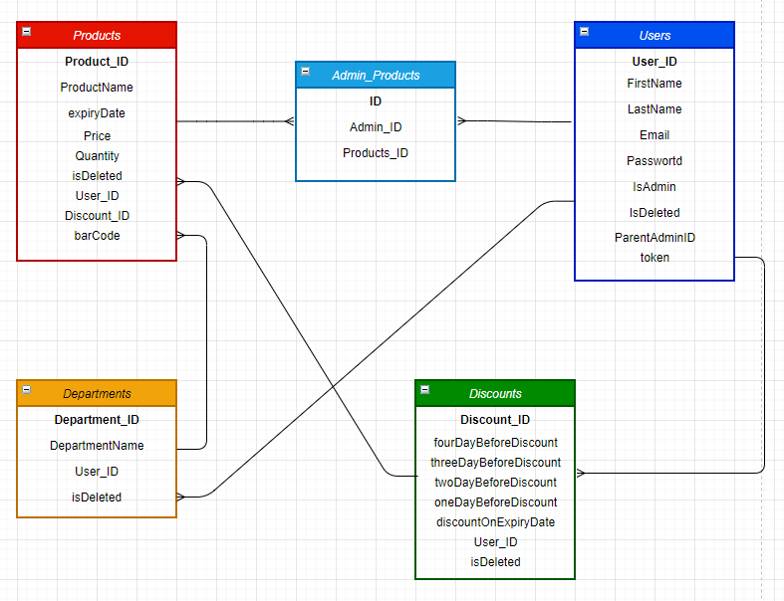
Figure 10 – Database Design Scheme

The database contains 5 tables, such as: Products, Users, Departments, Admin_Products and Discounts. Each table has a primary key, known as ID and auto-increments with every new insert.
Between Products table and Users table is taking place a many-to-many relationship. It is not feasible to explicitly express a many-to-many relationship in a relation scheme, since two tables cannot be children of one another – there are no assignable parent/child roles when both cardinalities are many. Thus, for each many-to-many relationship, will be required an additional table in the database, referred to as a junction table, to hold all the relationship instances.
The database scheme diagram also includes the relational strategy for such junction tables. A junction table's scheme (sometimes referred to as a link table) will have two distinct sets of Foreign Keys characteristics, one for each side of the relationship. If no association class exists, the scheme comprises simply these two Foreign Keys. If an association class exists (as is the case with Admin Products in this example), its attributes will be included in the junction table.

Chapter 5. Implementation

As it was stated above, the Android mobile application contains two important sections: the Frontend and the Backend. The Frontend side represents the application that is running on an Android smartphone with all the features that can be used by the user. Also, the Backend side represents the API (Application Programming Interface).
For a better understanding, the API is a collection of procedures, protocols, and tools that facilitate the development of software applications. The API defines how software elements should communicate between them, and they are utilised for developing the Graphical User Interface (GUI) components.
The system's implementation will be discussed in detail here, including how the application is created and the logical explanations about how the features work.
Before describing the application implementation, the development environment must be configured accordingly. The first step is to configure the development environment, which includes the installation of all necessary tools. The Android SDK, Android Development Tools, and Android Platforms are all included in this set of tools.
The following step would be to create an Android Virtual Device (AVD) using an Android Emulator, which would enable the PC to simulate an Android application. Additionally, after the programme has been built, it is necessary to configure an actual hardware device to execute it. This may be accomplished using the tools included in the SDK package.
The following step would be to create the Android project that serve as containers for the code and resource files. Due to restrictions imposed by the SDK tools, a certain structure must be followed. Additionally, there are several additional sorts of projects that help the Android development process, such as the Test projects and the Library projects.
The Code First technique adopted within this project implies the conceptual model from the classes and the mapping provided by the developer's code, as well as the Entity Framework standards, rather than being produced automatically from the Entity Data Model. Similar with Model First, this technique may be used to create a new database or to operate with an existing one. When creating a new database from the beginning, the Entity Framework helps the Code First Migrations to allow the database to develop as it is coded.
When developers' databases continue to evolve, they will need to modify the conceptual scheme, which will affect the database structure. To do this, Code First Migrations are required. When the migrations are enabled, it will be created a new folder within the Visual Studio project named Migrations. This folder will include a configuration file, an initial migration database, and any sequential migrations that are generated. Adding a Migration generates the code necessary to perform the database modifications and saves it to the Migrations folder in the location specified by the user. Then, using the Update-Database command, the Migration changes are committed to the database.
The Controllers represents the Backend primary component. Its own featured methods are being capable of responding to the different REST requests, such as GET, POST, PATCH, and DELETE.
Further, it will be presented the available functionalities that underlie the Android mobile application, Scan First. The application's implementation will be discussed in detail, including how the application was built. Additionally, an explanation of the third-party library functions utilised will be included.

5.1 The Scan Page

This feature allows users to scan UPC (Universal Product Code) of a food product. This UPC will be sent to the backend by a request, which checks if the barcode already exists. If this UPC exists in the database, the update product page will open automatically. If it does not exist in the database, the mobile application will ask the user to register the product in the system.

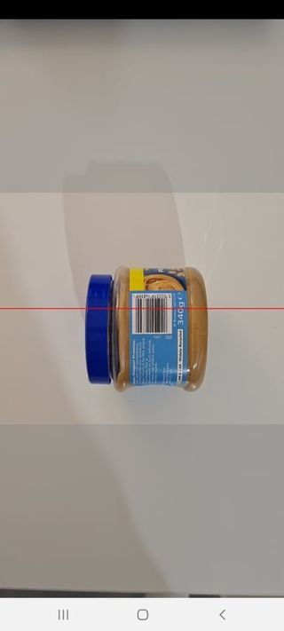

Figure 11 – Scanning a New Product

5.2 The Food Departments page

Within a supermarket there are different types of food products. These types of food products belong to a certain department. The food department’s purpose is to categorize the different types of products.
When the user opens the Food Departments page, a request will be sent to the API. The API will return all the available departments that have been already registered into the system. In case the user wants to add a new department, another request will be made again for the new department to the API, and then that department will be saved within the ‘Departments’ table from the database.
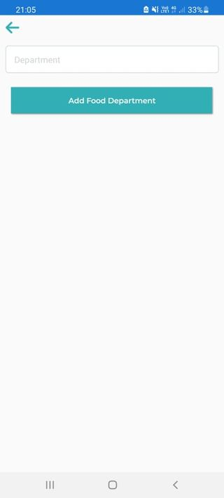
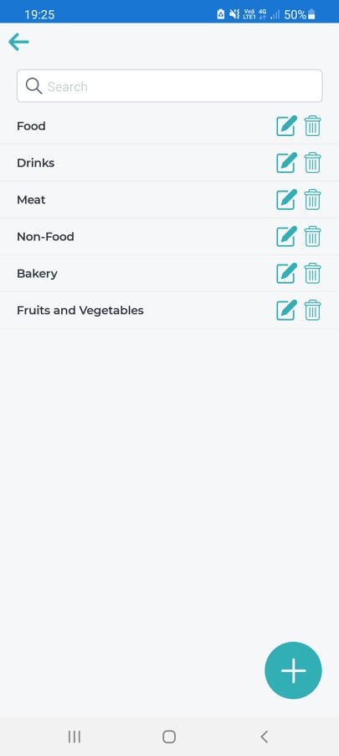

Figure 12 - The Food Departments Page Figure 13 - Add Food Department Page

5.3 The Add Product page

Within this page, the user can add a product by completing the mandatory fields about the main characteristics of a certain food product.
When adding a new product to the system, a request will be sent to the API. The API will return all the available products that have been already registered into the system. Then the new food product will be saved within the ‘Products’ table from the database.
To finalize the process, the user should press the ‘Add’ button to save the details.

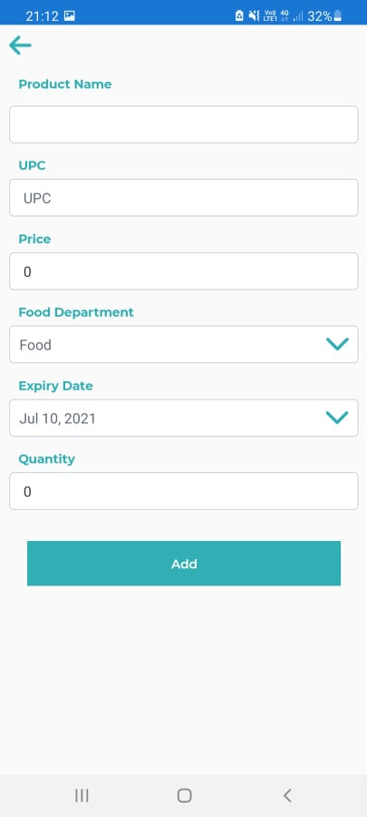

Figure 14 – The Add Product Page

5.4 The Add New Employees page

In case of new employees, the admin user can create a profile for the new users using this feature.
When adding a new employee to the system, a request will be sent to the API. The API will return all the available employees that have been already registered into the system. Then the new employee will be saved within the ‘Users’ table from the database.

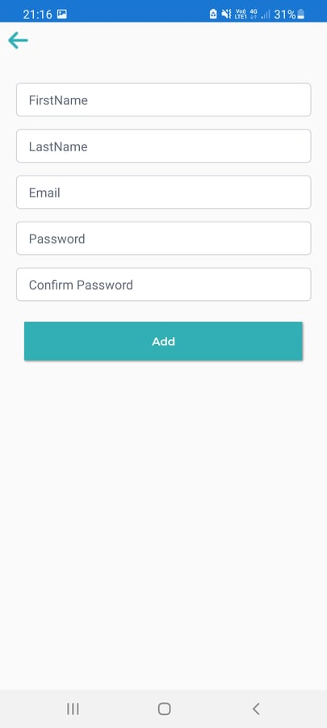
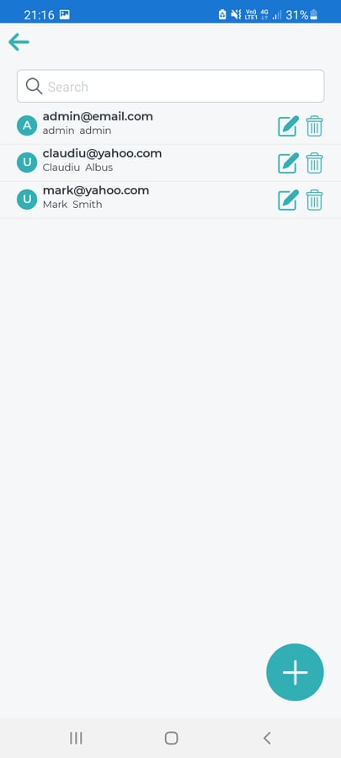

Figure 15 – The Existing Employees Figure 16 – Add New Employees Page

5.5 The Discount Page

The most important aspect using this system is to eliminate the risk of losing the food products. To achieve this, the discount option has been implemented to the system in order to sell the food products that will expire soon at lower prices, according to the discount scheme.
In the image below, can be seen the availability of four discount stages that could be applied for each food product depending on their expiry date. For example, if a food product is to expire the next day, then the highest discount option will be used, so that the product is consumed in optimal conditions by customers and at the same time at the lowest price.

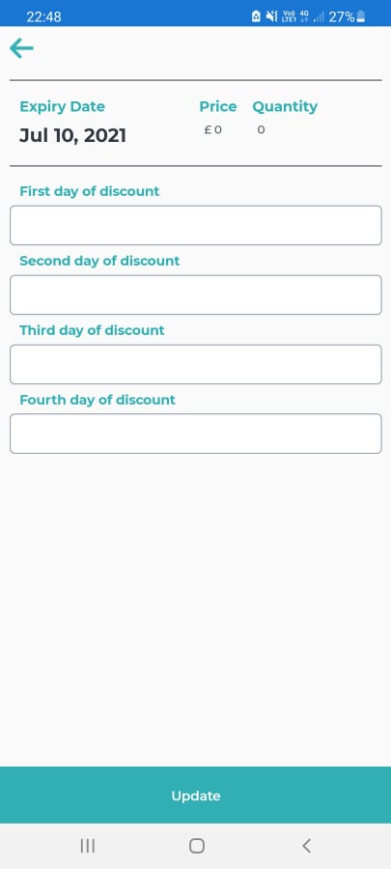
Figure 17 – The Discount Page

5.6 The Search Page

Within this page the user can search for certain food products that have been introduced previously, in order to be discounted before the expiry date.
When the product name is entered in the Search bar, a request will be made to the database where it will be checked if it is already registered in the system, if it has been previously deleted from the system, or if this product belongs to the user who requested the search.
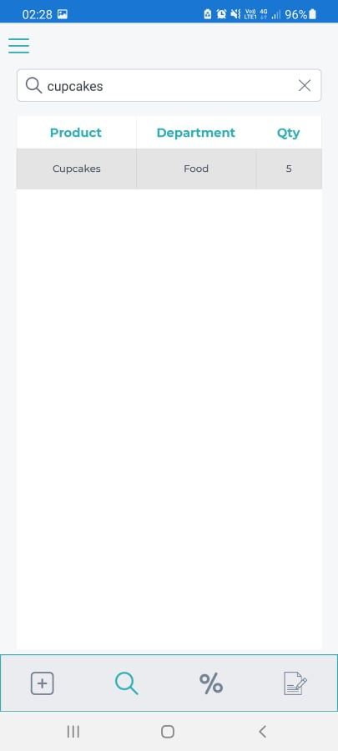
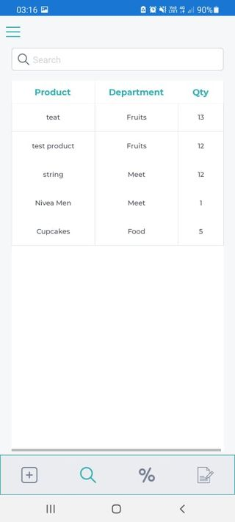

Figure 18 – The Search Page Figure 19 – Searching a Food Product

Chapter 6. Testing

This chapter is dedicated to testing all the features available from the Scan First application. All the possible test cases that may occur during the use of the application by users will be presented further.

Test Case 1 - The Login system

In case the user will enter the wrong credentials, an error will appear with a message, such as: ‘Username or password is not correct.’.
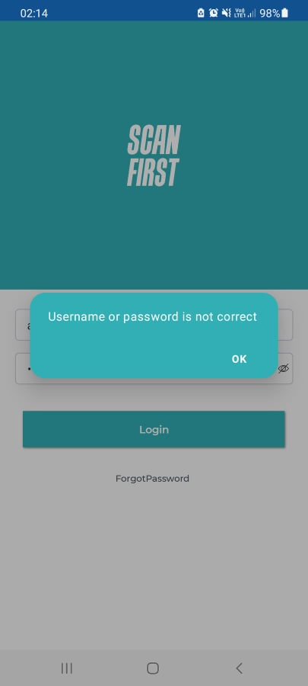
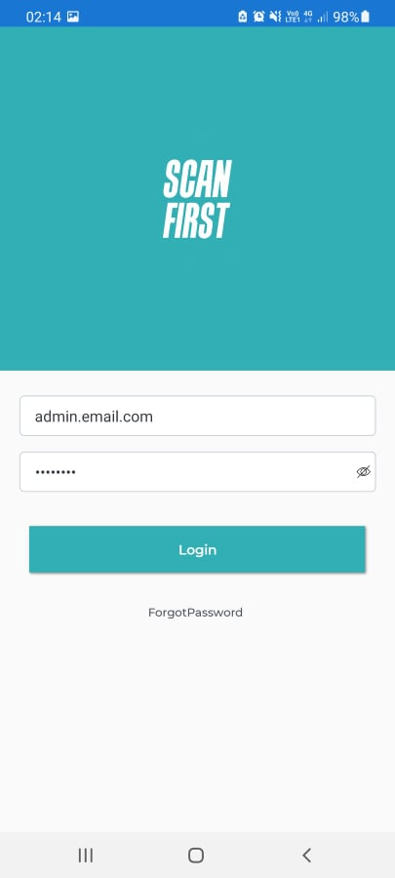

Figure 20 – Login Input Figure 21 - Login Output

By inserting the correct credentials, the user will be redirected to the Home Page.

Test Case 2 - The Add Product feature

This page contains six textboxes that should be filled by the user to capture a new product into the system. The user should provide the correct details for the food products, such as: the product name, the barcode, the price, the food department, the expiry date, and the quantity.
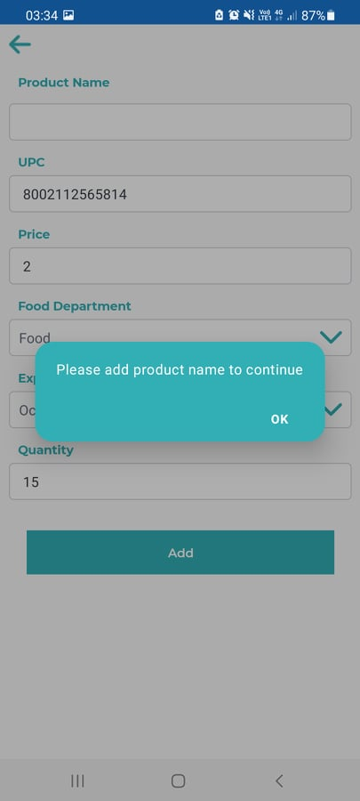
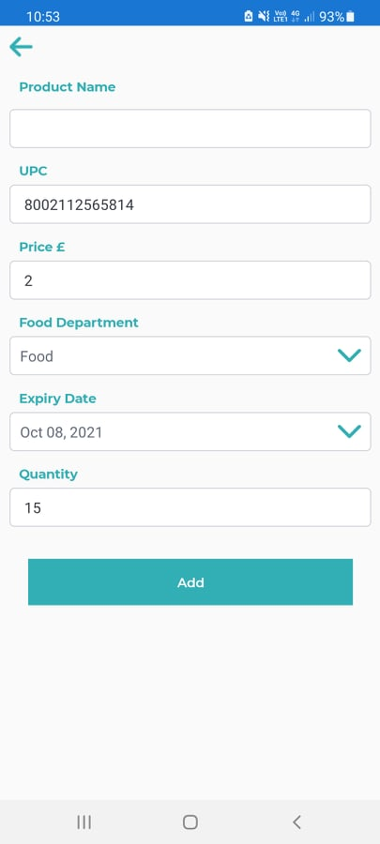

Figure 22 – Missing Name Input Figure 23 – Missing Name Output

As it can be noticed from the above print screens, the food product name was missing. In this case a message has been displayed to inform the user to provide the detail.

Test Case 3 – The Add New Employees feature

As it can be seen below, the user has provided an incorrect email. In this case, when the user pressed the ‘Update’ button, a message appeared to notify the user about the mistake.
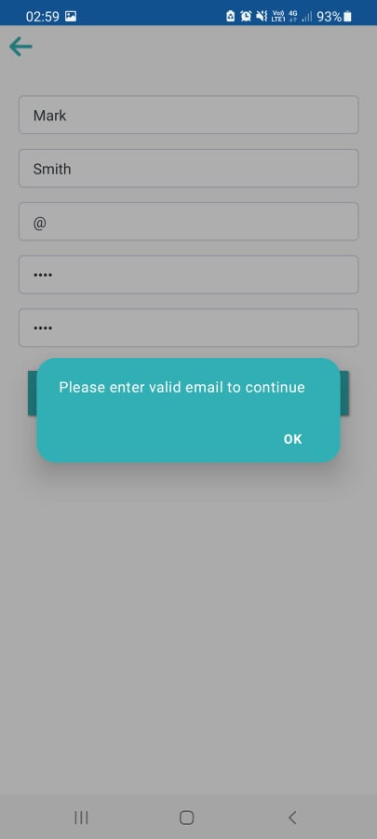
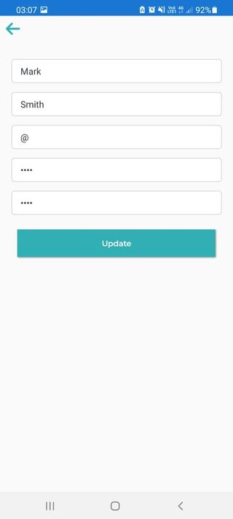

Figure 24 – Wrong Email Input Figure 25 – Wrong Email Output

Test Case 4 – The Scanning feature

In this context, a product will be scanned in order to be registered in the system. As it can be observed from the images below, after scanning the product, a notification message appeared on the screen to highlight that the product has not been previously registered within the mobile application.

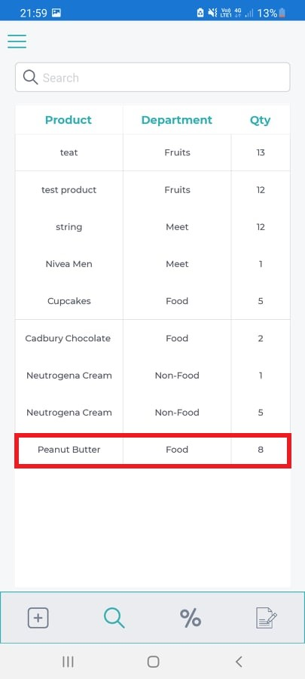
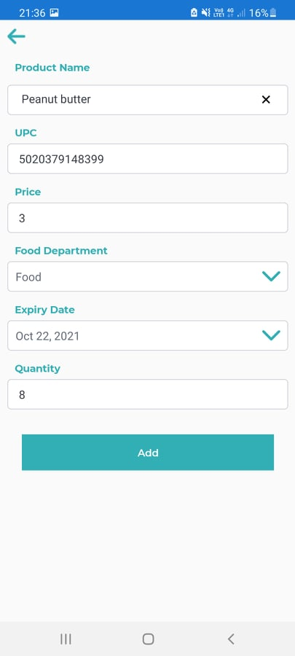

Figure 26 – Scan a New Product Figure 27 – New Product Captured

Test Case 5 – The Search feature

The users can use this feature to search for a certain food product by typing its name. As it can be observed below, the user was searching for the ‘Tomatoes’ item.

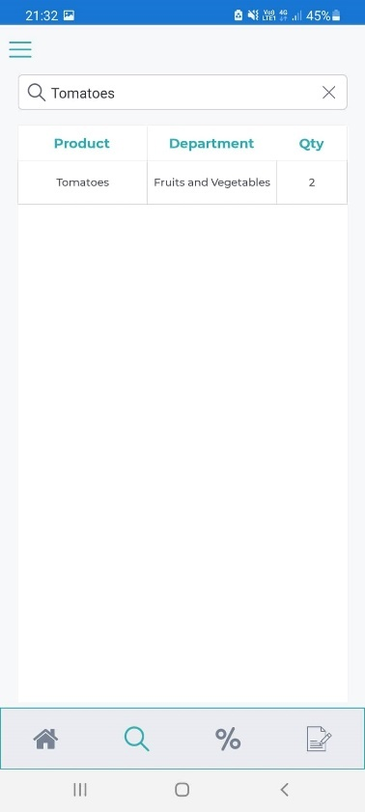
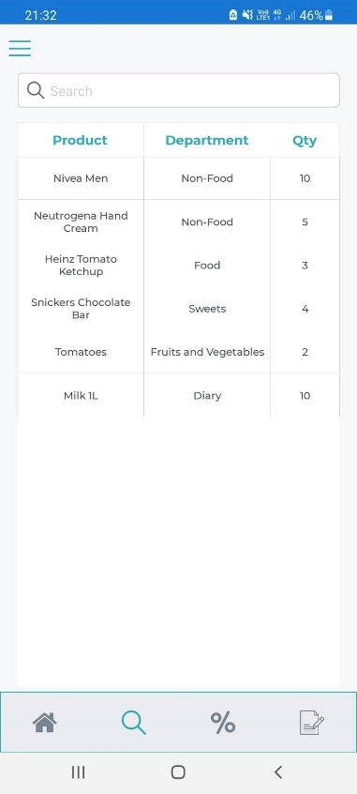

Figure 28 – The Searching Page Figure 29 – Searching for a Product

Test Case 6 – The Discount Products feature

As it can be noticed in the below print screens, the user can use this feature to offer discounts to the products before the expiry date.

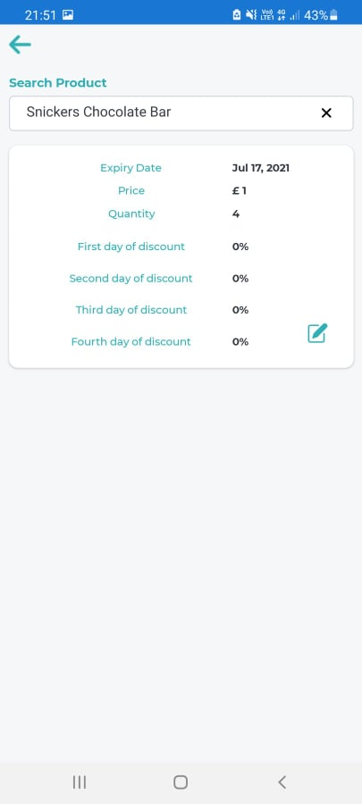
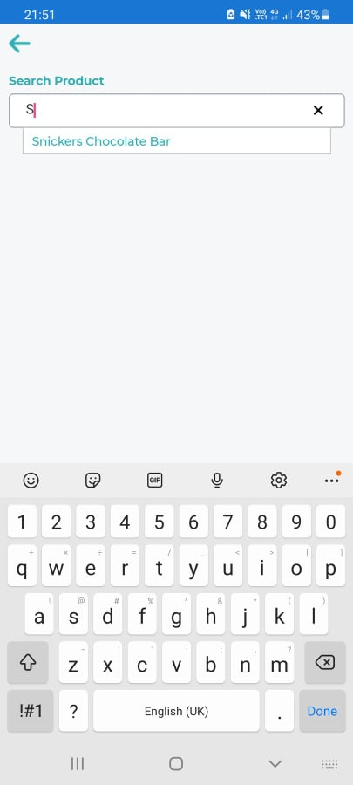
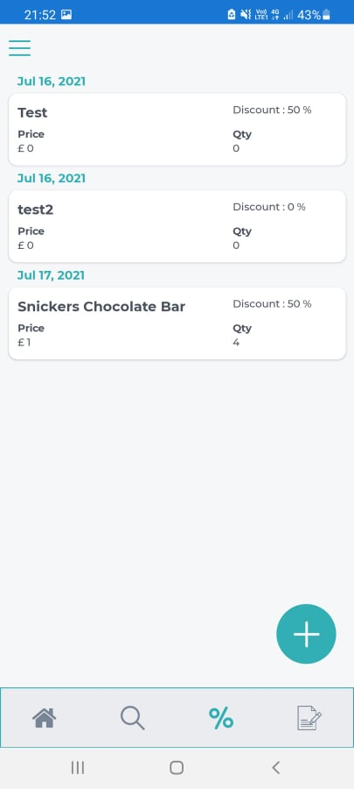

Figure 30 - Searching the Item Figure 31 – Applying the Discount

Test Case 7 – Adding New Food Departments

Adding the food departments within the system is essential. As attached below, the user was adding a new food department, ‘Cereals’.

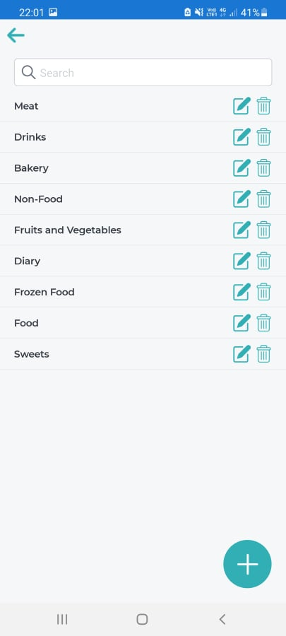
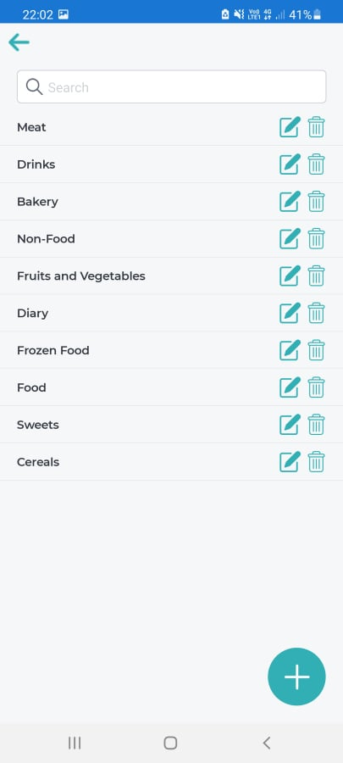
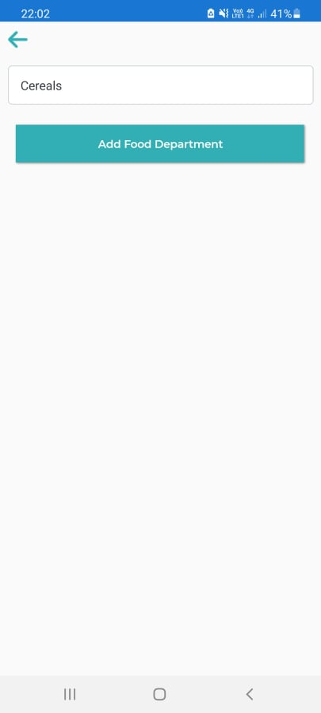

Figure 32 – The Food Departments Figure 33 – Adding a New Food Department

Chapter 7. Evaluation

7.1 The system evaluation and the time management

From what has been achieved, it can be concluded that the results obtained are satisfactory. It was a successful challenge despite my limited knowledge regarding the C# programming and the SQL databases.
Before constructing Scan First application, I have conducted a research about the technologies that would be required to complete this project. After deciding on which platform, I will develop the system, I have started learning all the skills necessary, as I have intended to make this application compatible with the Android platform.
Overall, I have gained a lot more knowledge while completing my thesis. Previous to my study, I was unfamiliar with the programming languages utilised with the Android SDK or the iOS SDK. Additionally, I was inexperienced with building mobile applications due to my lack of exposure to the Android ecosystem.
Due to the well-documented nature of both development platforms, it was not difficult to access information. In fact, the amount of information was sufficient, due to the number of duplicates within the documents founded. Additionally, I learned how to develop critical thinking skills and how to filter the irrelevant materials in order to follow the main scope.
At the completion of the project, I understood that I had gained valuable knowledge not just about mobile programming, but also about system-specific issues. I had learned a multitude of basic information about everything associated with the research, from SDK usage, to building and delivering the entire mobile application.
Following the resources offered by the university, plus several other online courses available about C# and programming SQL databases, my skills have developed significantly. Whenever I have encountered certain problems or errors, the possibility to find all the necessary answers or solutions were available on dedicated websites.
I should be noted that in the future it would be necessary to implement new functionalities, that would offer a much more satisfying user experience. Also, a more detailed testing of the application should be considered.

7.2 Future enhancements

The Scan First application could be upgraded with several features that may be helpful in the future for the existing and the future users.
Some features that can improve the quality of the service offered by the Scan First Android application are:
- Easy Login System - In the future, work badges that contain a unique barcode for each employee could be created. This barcode will be able to be scanned with the help of the smartphone camera and thus login will take place. If the user forgets their badge at home, they can log in using their own credentials, the username, and the password.
- Push Notifications - This feature displays a notification about a specific food product that has already been registered in the system.
- Generating and downloading the Reports - At the end of each day, after the food products have been registered in the application, the user can generate and download a list containing all the details about these products.
- Availability on the iOS platform - Due to the time constraints, it was not possible to develop the code for the iOS platform. But in the future the application could be made available on the market for the iOS users.
- Better security - At the moment the only security method within the application is the login system, by using the username and password. Other safer and more efficient methods could be added in the future.

Conclusions

The vast quantity of information, the tools, the code examples, and the big number of experienced developers ready to assist the others when a problem arises are only a few of the major benefits of utilising the Android platform.
The development of new mobile applications does not require the purchasing of a costly license. The development environment is accessible, being free and available to anyone who wants to explore this sector.
Also, it should be noted that, during the development process, some constraints have been discovered. One of the problems is when a food product is scanned, the product name will not be displayed, and the user should insert the name using the keyboard. However, the scanning system that has been implemented is running at optimal standards. Another shortcoming of the application is related to the reports section. Within this feature the system should create a list based on the products captured at the end of the day in the system.
The personal contribution consists in creating an application on the Android platform that allows the use of the offered functionalities that can run on any Android smartphone. It involves creating a graphical interface, the food scanning system, creating a version compatible with the Android platform to the server connection protocol, and creating a database for managing the registered food products.

References

[1] Gustavsson J, Cederberg C, Sonesson U, Otterdijk Rv, Meybeck A., Global food losses and food waste: extent, causes and prevention, In Interpack 2011. Rome, Italy: Food and Agriculture Organization of the United Nations, pp. 1-3, 2011. Available: http://www.fao.org/3/i2697e/i2697e.pdf [Accessed 20 November 2020].
[2] Jedermann R, Nicometo M, Uysal I, Lang W., Reducing food losses by intelligent food logistics, Phil. Trans. R. Soc. A, 372: 20130302, 2014.
Available: http://dx.doi.org/10.1098/rsta.2013.0302
[Accessed 20 November 2020].
[3] Kazi Zunnurhain, Karan Nayee, Rahul Patel, Parth Patel, Always fresh: tracking food expiry with mobile app, 2019.
Available: https://dl.acm.org/doi/abs/10.5555/3381569.3381612
[Accessed 23 November 2020].
[4] Lim Sin Hong, (2014). Mobile food planning and conservation system (Food tagging and inventory control), pp. 5-6, 2014.
[5] Javier Berrocal, Jose Garcia-Alonso, Cristina Vicente-Chicote, Juan Hernández, Tommi Mikkonen, Carlos Canal, Juan M. Murillo, Early analysis of resource consumption patterns in mobile applications, Pervasive and Mobile Computing, Volume 35, pp. 32-50, ISSN 1574-1192, 2017. Available at: https://doi.org/10.1016/j.pmcj.2016.06.011. [Accessed 03 March 2021].
[6] Jenneke K. Heising, G. D. H. Claassen, Matthijs Dekker, Options for reducing food waste by quality-controlled logistics using intelligent packaging along the supply chain, pp. 1672-1680, 2017. Available: https://doi.org/10.1080/19440049.2017.1315776 [Accessed 03 March 2021].
[7] Norbert Raak, Claudia Symmank, Susann Zahn, Jessica Aschemann-Witzelb, Harald Rohm, Processing- and product-related causes for food waste and implications for the food supply chain, Volume 61, pp. 461-472, ISSN 0956-053X, 2017. Available: https://doi.org/10.1016/j.wasman.2016.12.027 [Accessed 03 March 2021].
[8] Viachaslau Filimonau, Adriano Gherbin, An exploratory study of food waste management practices in the UK grocery retail sector, Journal of Cleaner Production, Volume 167, pp. 1184-1194, ISSN 0959-6526, 2017. Available: https://doi.org/10.1016/j.jclepro.2017.07.229 [Accessed 03 March 2021].
[9] Priefer Carmen, Juliane Jörissen, Klaus-Rainer Bräutigam, Food waste prevention in Europe – A cause-driven approach to identify the most relevant leverage points for action, Resources, Conservation and Recycling, Volume 109, pp. 155-165, ISSN 0921-3449, 2017. Available: https://doi.org/10.1016/j.resconrec.2016.03.004 [Accessed 03 March 2021].
[10] James, R. P., An Application for Keeping Track of Food Item Expiration. (Master's thesis), pp. 5 -6, 2013. Available: https://scholarcommons.sc.edu/etd/2463 [Accessed 03 March 2021].
[11] Chester SW, Food Checklist - Groceries Expiration and Shopping, 2021. Available: https://play.google.com/store/apps/details?id=com.chestersw.foodlist&hl=en_GB&gl=US [Accessed 17 March 2021].
[12] Somdip Dey Corp., nosh - Manage food inventory & reduce food waste, 2021. Available: https://play.google.com/store/apps/details?id=app.F6NHQc92Bw.nosh.technologies&hl=en_GB&gl=US [Accessed 17 March 2021].
[13] Huus Daniel Andreas Ravnestad, Mobile cross-platform development in fragmentized environments (Master thesis), pp. 18-19, pp. 75-76, 2015. Available: https://himolde.brage.unit.no/himolde-xmlui/bitstream/handle/11250/2414862/master_huus.pdf?sequence=1&isAllowed=y [Accessed 17 March 2021].
[14] Hermes Dan, Xamarin Mobile Application Development: Cross-Platform C# and Xamarin.Forms Fundamentals, 1st Edition, Apress, pp. 1 – 4, 2015.
[15] Navez Jérôme, Xavier Perignon, Development of a cross-platform mobile application using cloud computing (Master Thesis), pp.13-14, 2018. Available:
https://dial.uclouvain.be/memoire/ucl/fr/object/thesis%3A14684/datastream/PDF_01/view [Accessed 20 April 2021].
[16] Goetz Jozef, Yan Li, Evaluation of Cross-Platform Frameworks for Mobile Applications, International Journal of Engineering and Innovative Technology (IJEIT) Volume 8, Issue 3, pp. 10-17, 2018. Available: https://www.researchgate.net/publication/329488825_Evaluation_of_Cross-Platform_Frameworks_for_Mobile_Applications [Accessed 20 April 2021].
[17] Timo Jääskeläinen, Cross-Platform Mobile Application Development with Xamarin.Forms (Bachelor Thesis), pp.12-13, 2016. Available: https://www.theseus.fi/bitstream/handle/10024/111535/Jaaskelainen_Timo.pdf
[Accessed 20 April 2021].
[18] Eero Maasalmi, Panu Pitkänen, Comparing Google’s Android and Apple’s iOS Mobile Software Development Environments, pp. 4-5, 2011. Available: https://www.theseus.fi/bitstream/handle/10024/36104/Maasalmi_Eero_Pitkanen_Panu.pdf?sequence=1&isAllowed=y [Accessed 10 May 2021].
[19] Aaditya Jain, Samridha Raj, Bala Buksh, A Comparative Study of Mobile Operating Systems with Special Emphasis on Android OS, Volume 5, Issue 7, International Journal of Computer & Mathematical Sciences, pp. 5-6, 2016. Available:
https://web.archive.org/web/20180425052110id_/http://www.academicscience.co.in/admin/resources/project/paper/f201607111468295711.pdf [Accessed 10 May 2021].
[20] Alessio Merlo, Gabriele Costa, Luca Verderame, Alessandro Armando, Android vs. SEAndroid: An empirical assessment, Volume 30, pp. 113-131, ISSN 1574-1192, 2016. Available: https://doi.org/10.1016/j.pmcj.2016.01.006 [Accessed 10 May 2021].
[21] Benjamin Speckmann, The Android mobile platform (Master Thesis), pp. 15, 2008. Available: https://citeseerx.ist.psu.edu/viewdoc/download?doi=10.1.1.175.2961&rep=rep1&type=pdf [Accessed 10 May 2021].
[22] Kaur Anureet, Kulwant Kaur, Suitability of existing Software development Life Cycle (SDLC) in context of Mobile Application Development Life Cycle, pp. 5, 2015. Available: http://citeseerx.ist.psu.edu/viewdoc/download?doi=10.1.1.695.6714&rep=rep1&type=pdf [Accessed 10 May 2021].
[23] Ivan Bumbak, Software Development Methodologies on Android Application (Master Thesis), pp. 22-23, 2018. Available: https://zir.nsk.hr/islandora/object/vus%3A1197 [Accessed 2 June 2021].
[24] Bikesh Maharjan, Puzzle game using Android MVVM Architecture, p.13-14, 2018. Available: https://www.theseus.fi/handle/10024/145871 [Accessed 2 June 2021].
[25] Krishna Raj Bagale, Development of a Geolocation App in iOS Platform and Its Market Analysis, pp. 18, 2016. Available: https://www.theseus.fi/bitstream/handle/10024/107507/krishna_Bagale_thesis.pdf?sequence=1&isAllowed=y [Accessed 2 June 2021].
[26] Sami Krouvi, Implementation of a video game collection. Games for educational use, pp. 16-17, 2019. Available: https://www.theseus.fi/bitstream/handle/10024/263314/Krouvi_Sami.pdf?sequence=2&isAllowed=y [Accessed 16 June 2021].
[27] Amrit Poudel, Mobile Application Development for Android Operating System (Bachelor’s Thesis), pp. 15-16, 2013. Available: https://www.theseus.fi/bitstream/handle/10024/64719/Poudel_Amrit.pdf [Accessed 16 June 2021].
[28] Software Development Life Cycle (SDLC) scheme [Online], Available at: https://www.winklix.com/blog/software-development-life-cycle-sdlc/ [Accessed 16 June 2021].
[29] Waterfall Methodology scheme [Online], Available at: https://www.bitbean.com/resources/unlocking-potential-of-software-development-life-cycle/ [Accessed 16 June 2021].
[30] Muhammad Syakir Arif, Aziz Musthafa, Dihin Muriyatmoko, Implementation of Model-View-ViewModel (MVVM) Architecture Pattern in the Sistem Informasi Akademik UNIDA Gontor Mobile Application, pp. 285, 2020. Available: https://pdfs.semanticscholar.org/33a5/98c031441c756462f3a236c02a6f632faebc.pdf?_ga=2.66104749.2001671999.1627213857-1054123702.1627213857 [Accessed 16 June 2021].

Appendices

Gantt Chart
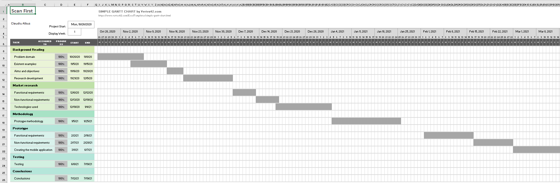
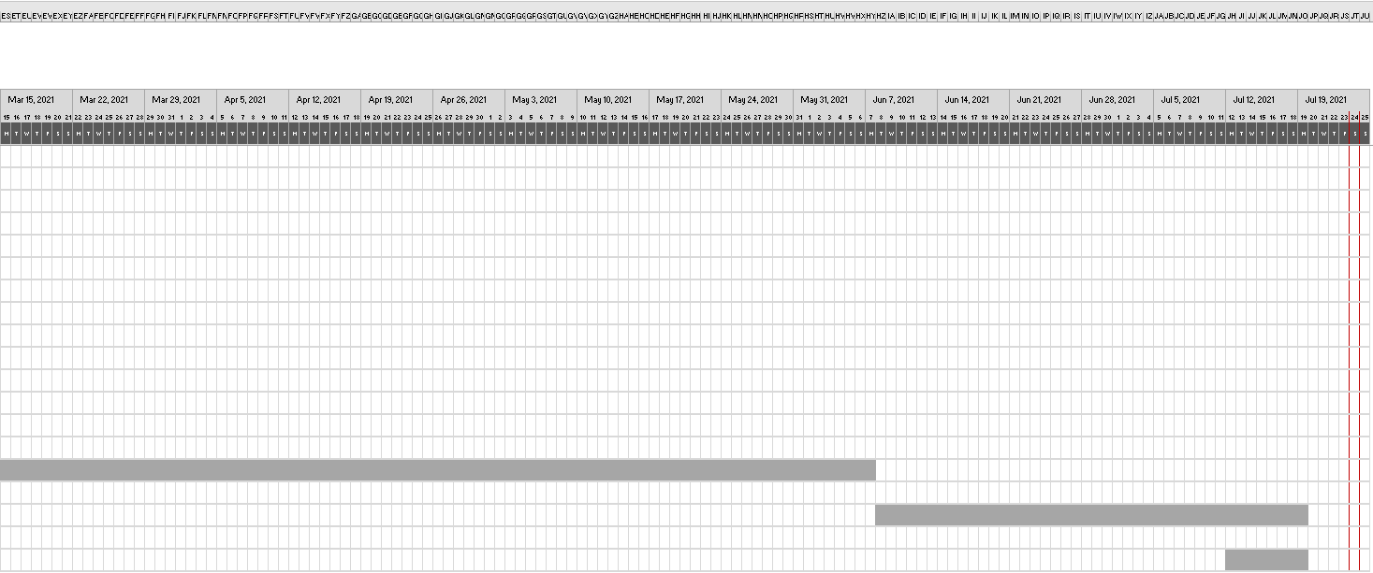

C# Source Code Pages
AddProductPageViewModel.cs
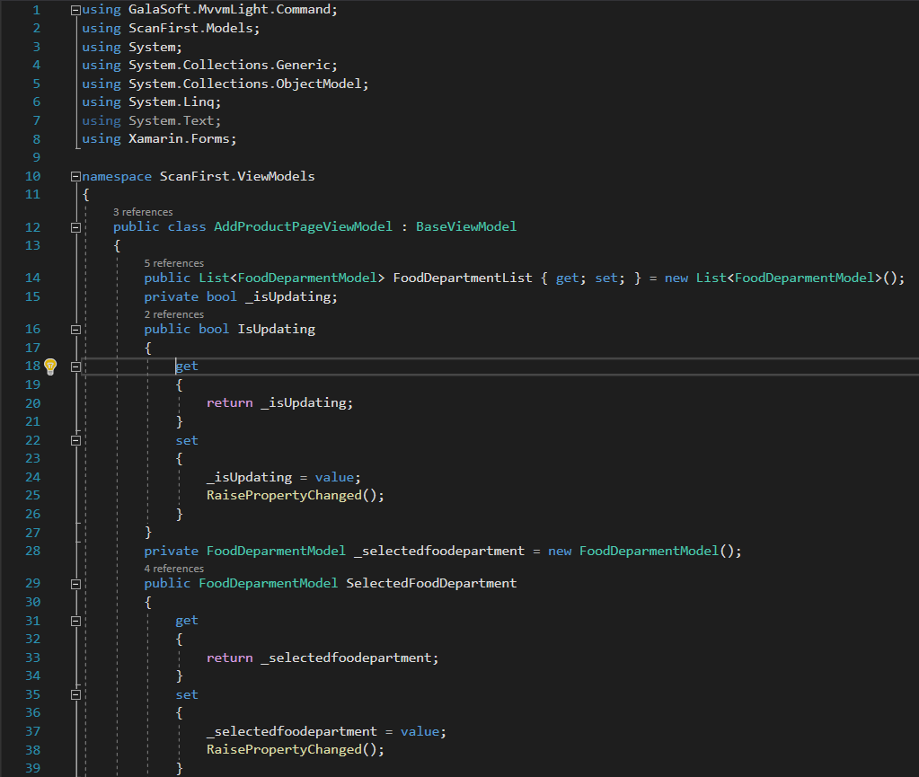

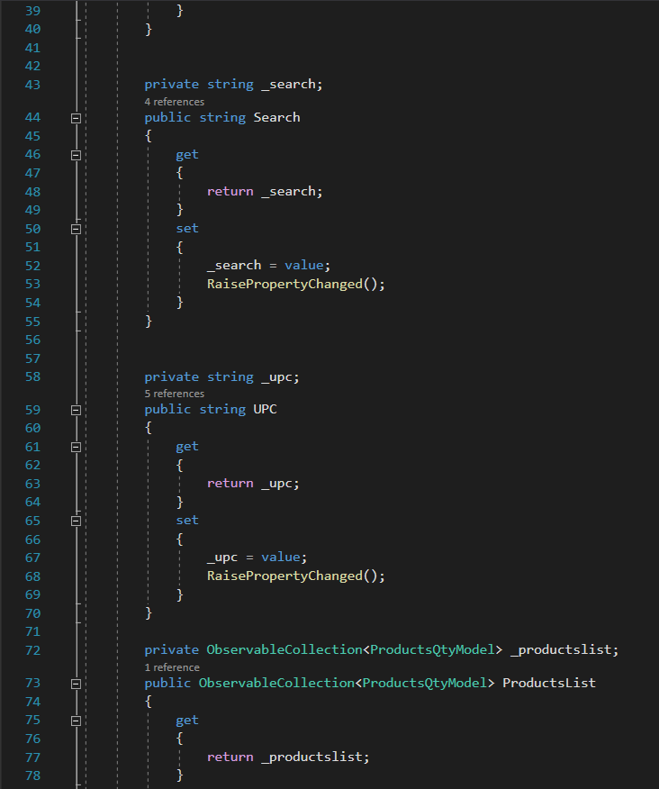

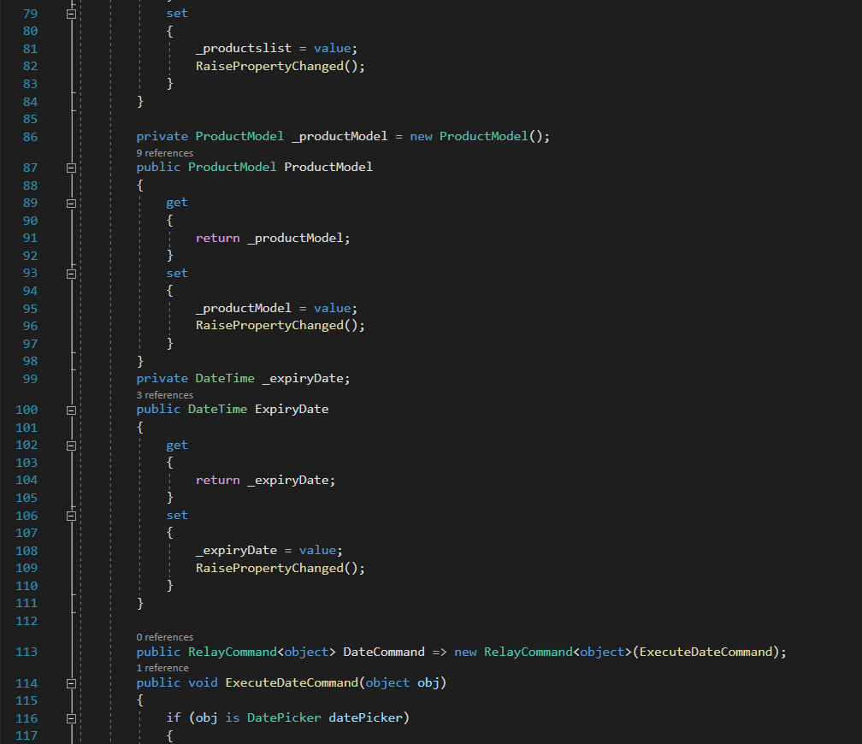

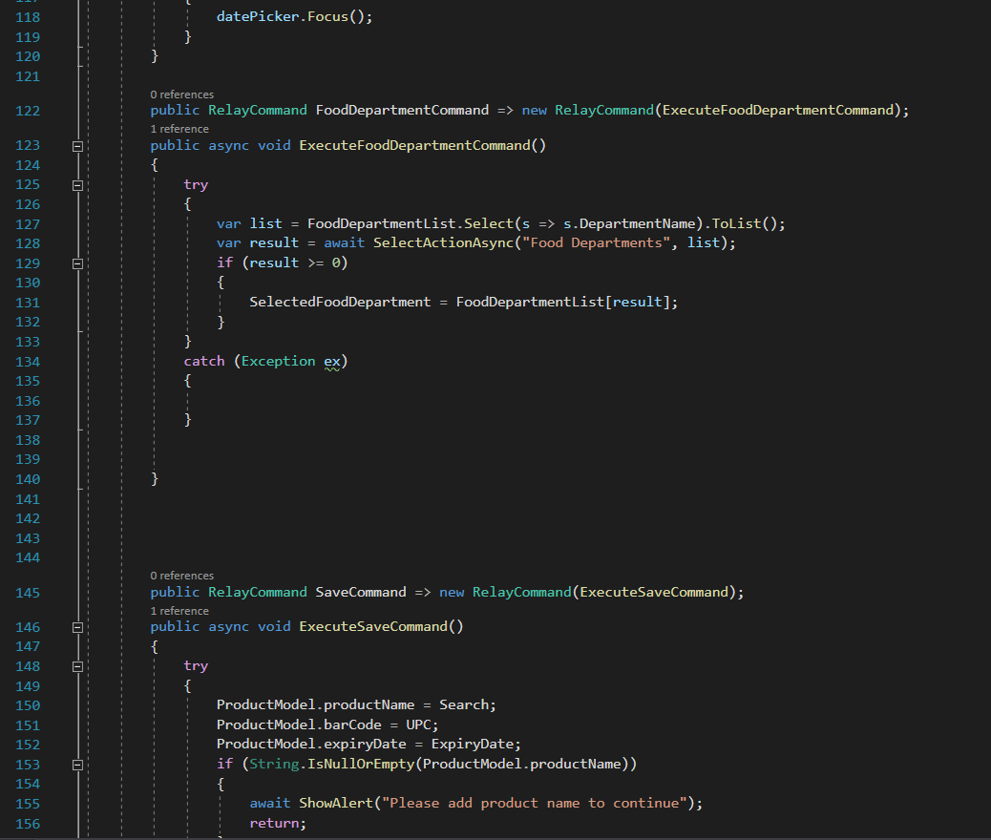

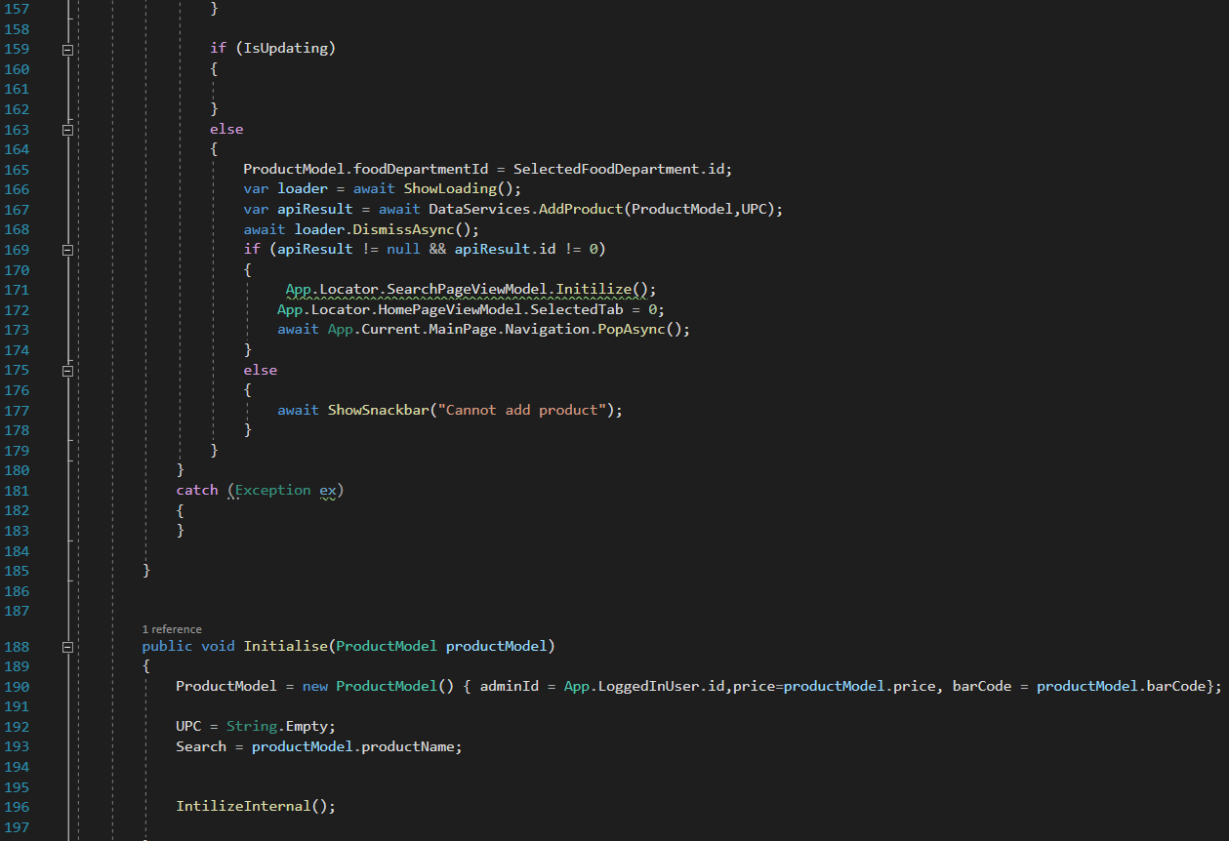
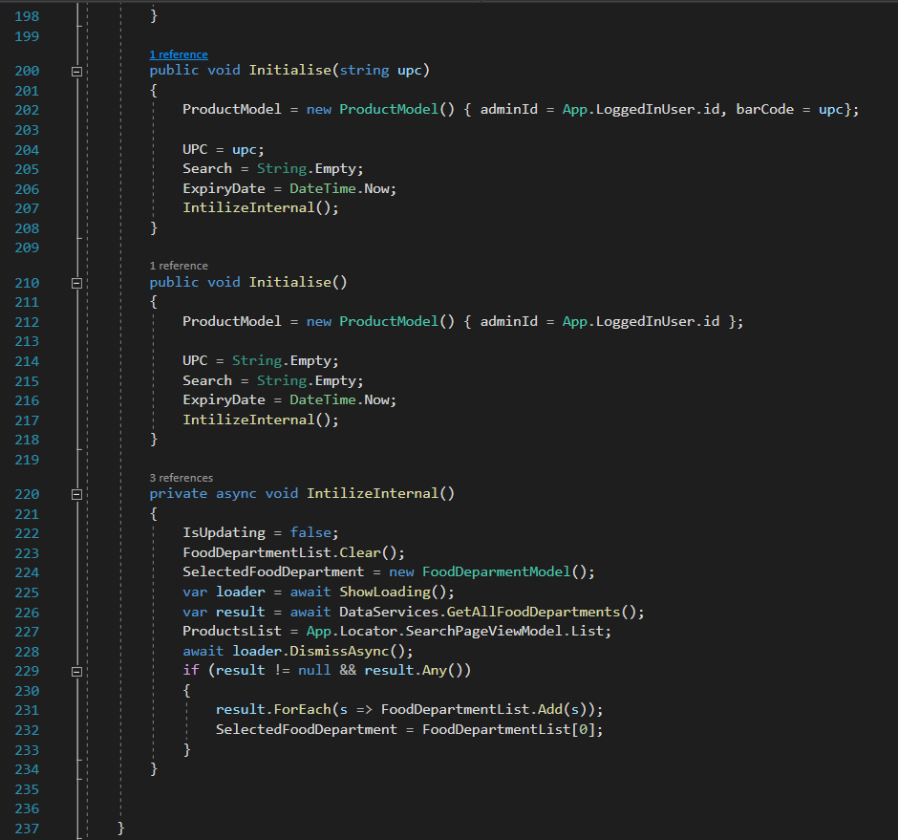

ScanPageViewModel.cs
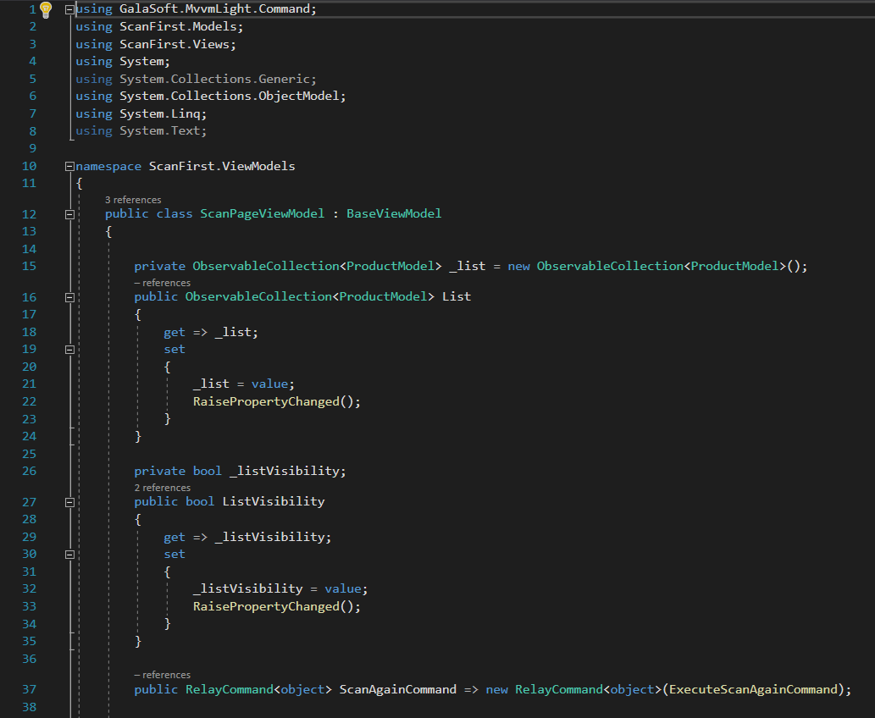

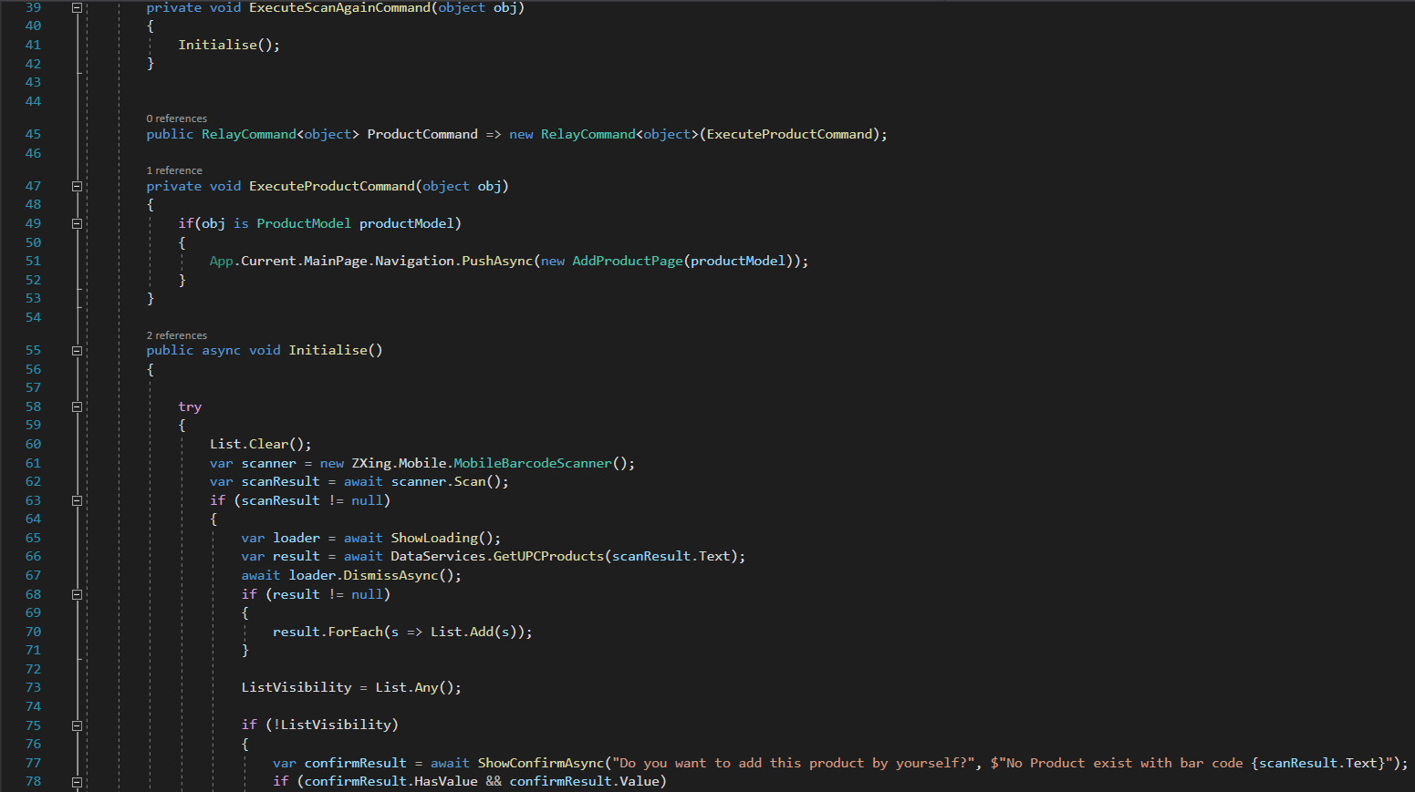

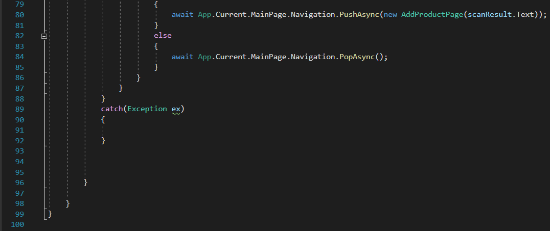

AddDiscountPageInternalViewModel.cs
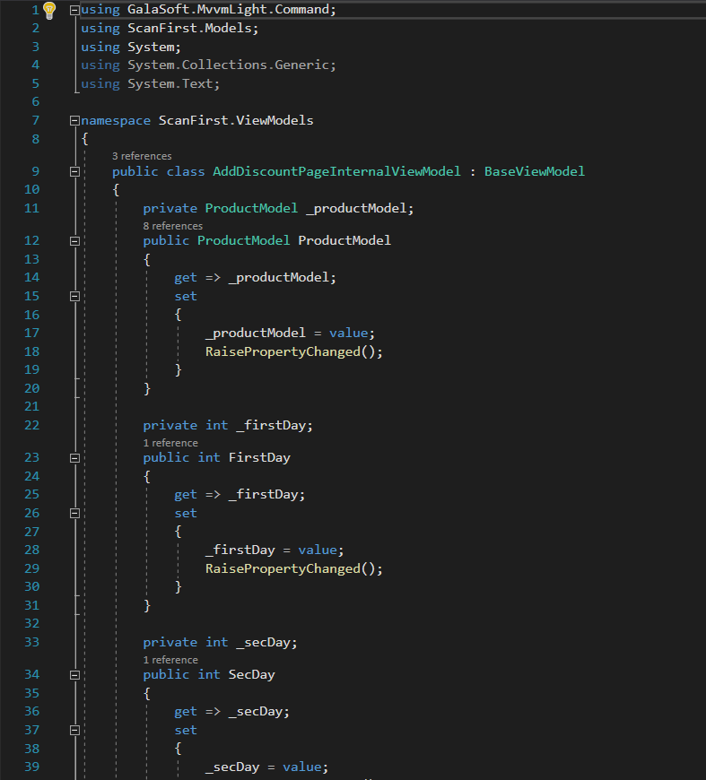

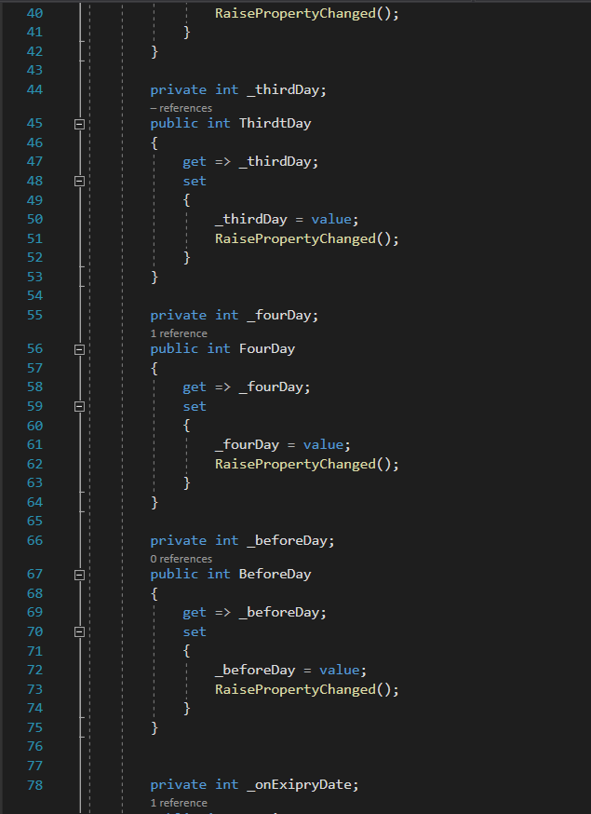

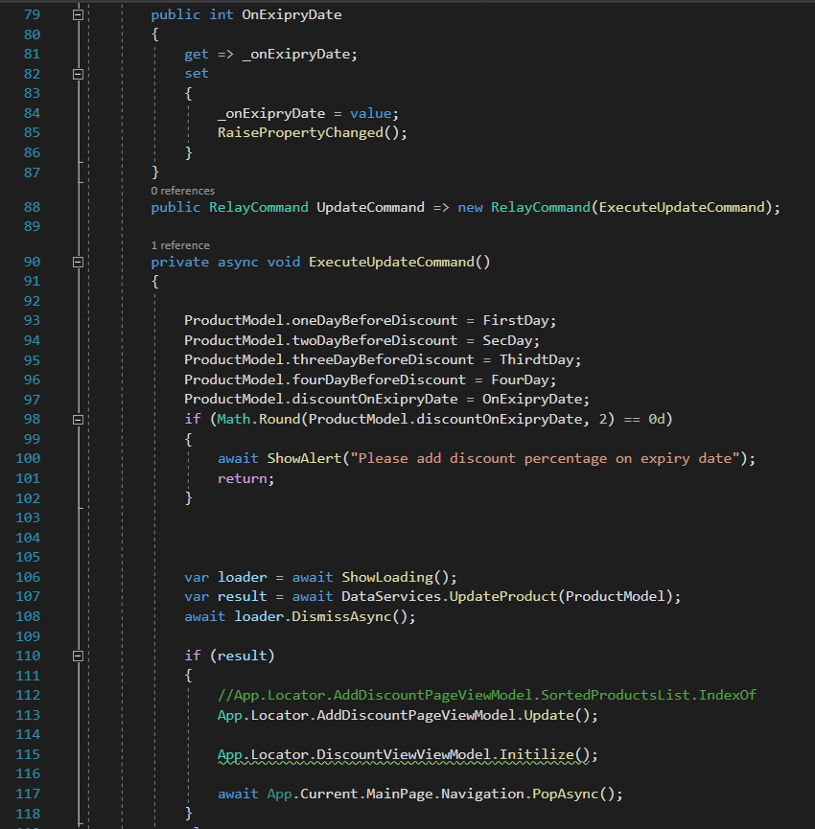

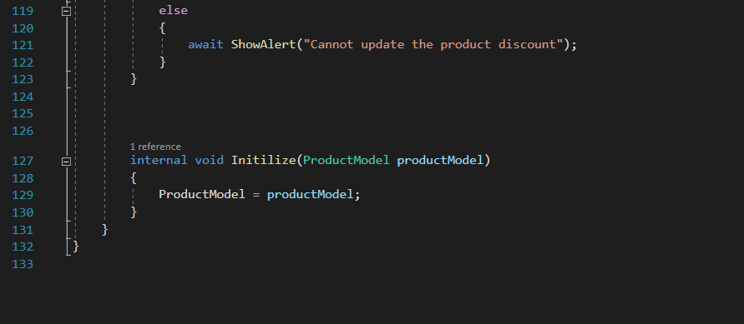

FoodDepartmentPageViewModel.cs

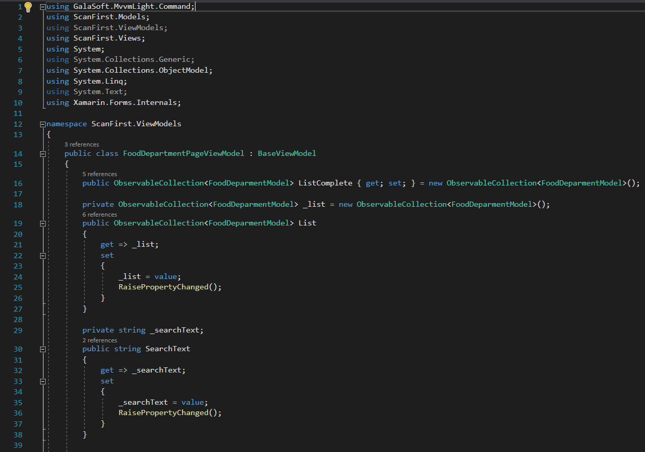

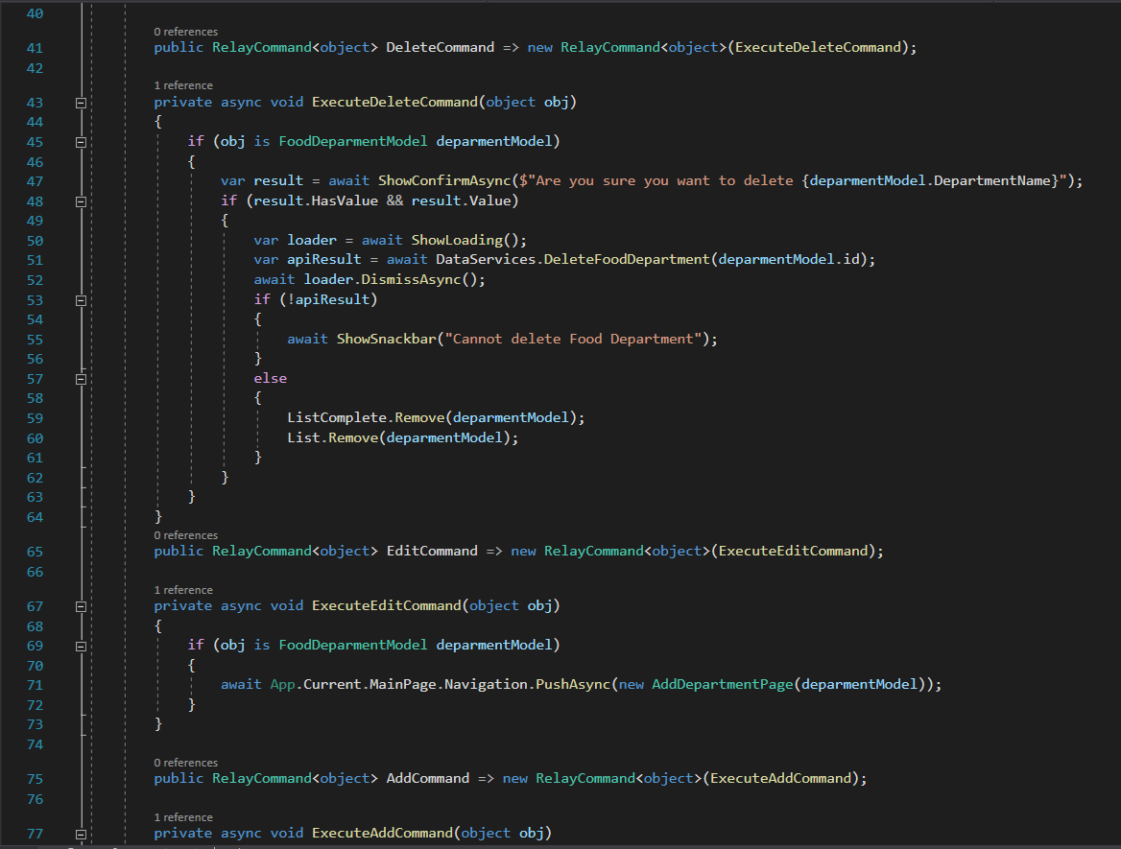

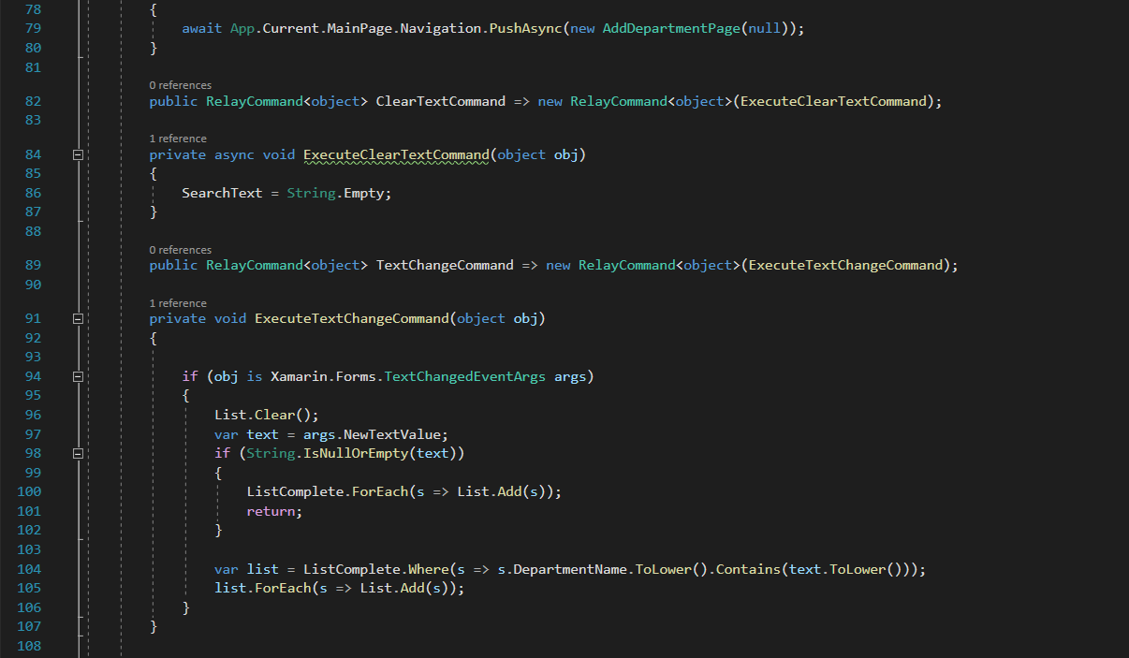

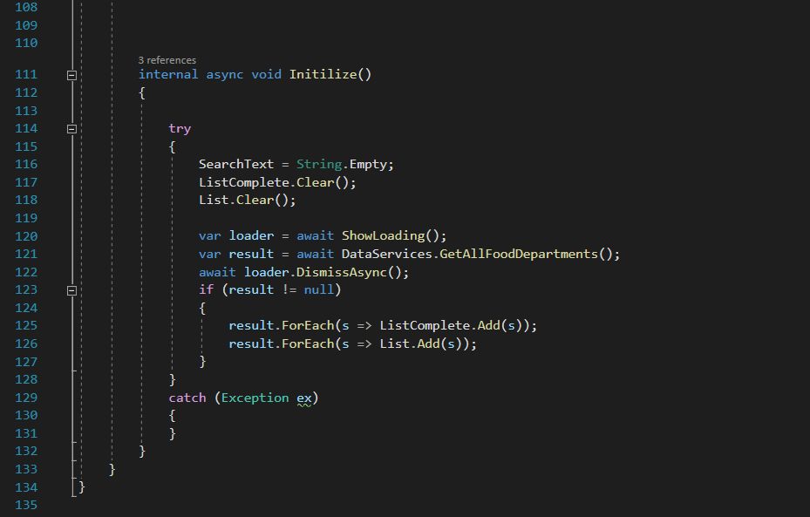

PROJECT RESEARCH Approval Form (Ethics)

Have you considered whether there are any problematic ‘ethical issues’ in your proposed research project? If not, you really should talk to your Course Tutor or Supervisor to discuss if there are any issues you need to address.

If you have already completed an ‘Ethics Approval Form’ within your Faculty/School, you do not need to complete this form. However, you haven’t considered the ethics issues in your proposal, you need to complete this form.

Not all details necessarily apply to your area of study, so you may leave some boxes blank, but do try and complete it as fully as you can. All sections deal with potential ethical issues which need careful consideration before you commence your research, to ensure you deal with them properly (in accordance with the law, for example). You may find it easier to complete the form with assistance from your tutor/supervisor.

Name: | Claudiu Octavian Albus
Project/Research Title: | Scan First - An expiry management system for tracking and controlling the food products expiry dates
Name of Supervisor: | Renuga Jayakumar
School/Dept. | University of Wales Trinity Saint David
Faculty: | BSc (HONS) Cloud Computing
Proposed Start Date: | October 2020 | End Date: | July 2020

1. Summary of planned research please indicate briefly below the purpose of your planned project/research, together with your aims, main research questions and research design – you can continue onto a separate sheet if necessary
Scan First project has been created as an additional solution in overcoming the expired food products to be sold within the supermarkets or small stores. To prevent this aspect, a new Android application has been developed. Its purpose is to reduce the number of the expired products and to protect the customers from buying products that no longer meet the food standards.

2. Methodology you need to be clear about the methodology you intend to use in your study; this could include any number of methods, so either tick those shown below (where appropriate) or put the details in the box marked *

 | Interviews |  | Participant Observation |  | Use of personal data
 | Focus groups |  | Questionnaire | x | Literature Review
 | Performance |  | Presentation |  | Other (state below)*

3. Participants - Does your proposed project/research involve human participants?

 | 1. Yes, as a primary source* |  | 2. Yes, as a secondary source* | x | No- go to section 4

*If you have ticked yes, you are likely to need an Advanced CRB check before undertaking your study

If yes, indicate who your participants are:

 | Early years/Pre-School children |  | Adults - give details below
 | School age children |  | Vulnerable people - give details below
 | Young People aged 17-18
 | Unknown at this stage

4. Other Ethical issues (tick all that may apply to your research)

 | Administration of drugs incl. alcohol |  | Deprivation
 | Unpleasant stimuli in any manner or form |  | Active deception or withholding information
 | Collection of highly personal information |  | Payment

5. Are there any ethical concerns other than those listed above?

6. If there are any ethical concerns, please state how you intend to minimise any risk of harm or distress that could be caused

You should enclose the research proposal form, together with any materials (e.g., questionnaire, interview schedule) when submitting this form to your tutor/supervisor.

Student Signature _______Claudiu Octavian Albus________________Date___24.07.2021

***************************************************************************
Supervisor’s Signature ________Renuga Jayakumar_______________Date___24.07.2021
_
Ethics clearance given at Faculty Level
Clearance not given at Faculty level – forwarded for discussion at the next meeting of the University Ethics Committee. Details below:
Comments:

Chair’s Initials |  | Date

Details on this form will always be dealt with in accordance with the terms of the Data Protection Act 1998. The completed form will be retained on the student’s file after approval (for audit purposes) and may be forwarded firstly to the Faculty Board and thereafter to the University Ethics Committee for a discussion of the issues highlighted.

