Digital Skills and Research Methods
BMSW4003
STUDENT: Mihai Tarana
STUDENT ID: 1909886
LECTURER: Modak Koushik

Table of Contents

Introduction…………………………………………………………………………………………………………………………3
Background of the research……………………………………………………………………………………………….…3
Primary Analysis……………………………………………………………………………………………………………………4
Secondary Analysis……………………………………………………………………………………………………………….8
Professional Practice…………………………………………………………………………………………………………….9
Conclusion………………………………………………………………………………………………………………………….10
References………………………………………………………………………………………………………………………….11

Introduction
An exceptional paradigm concerning education has been constructed collaterally by the concepts of ‘Teaching’ and ‘Education’ respectively. Eventually, information technologies and also communicational media have developed with the passage of time towards the digital future. These developments led to the creation of Virtual Learning Environments (VLE), or platforms which are utilized for enabling the flow of education and teaching across the entire globe, thereby firmly enhancing the concept of digital learning or e-learning. The advent of this along with the development of technology, embedded sustainability in the quest for a convenient learning experience, which offers flexibility despite the presence of certain hardships (Pezzullo et al., 2017)

Background of the research
There has been prevalent advent of several proprietary products which are commercially offered for teaching and education concerning the VLE. Concerning the Open Source Course Management Systems (OSCMS), Moodle has been one of the most favoured applications which tends to provide a manageable platform in accordance with VLE. University of Wales Trinity Saint David London Campus, has implemented the concept of VLE within their management, and thereby Moodle has been selected as their platform of utilization. The research has been intended to analyse the experience of the students of this college concerning the concept of learning. Certain questionnaires have been developed and distributed among 20 students of the college for primary data collection on the basis of face-to-face enhancement of knowledge. The results received enhance the sense of understanding owing to the revealed aftermaths on learning. Secondary methods of data collection ought to be conducted for enhancing the ambit of knowledge concerning VLE, and analysis of its impact in the workplace will also be done, through this

Primary Analysis

Question 1:
Are you familiar with Virtual learning experience?
Familiarity with Virtual Learning Environment
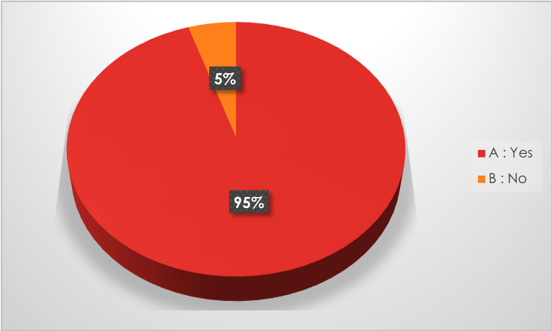
The question that has been asked firstly, was about acknowledging the familiarity of the concept of VLE. According to the responses received, it has bn observed that there were a majority of positive answers, from 20 students 19 had responded affirmative and one gave a negative answer. This brings us to the analysis that Virtual Learning Environment is a widespread concept. This proves that the implementation of this concept has gathered the attention of the students thereby enhancing their curiosity to act as a catalyst for the increased engagement and flexible Learning.

Question 2:
How often do you use our platform?
Tentative Usage of Virtual Learning Platform
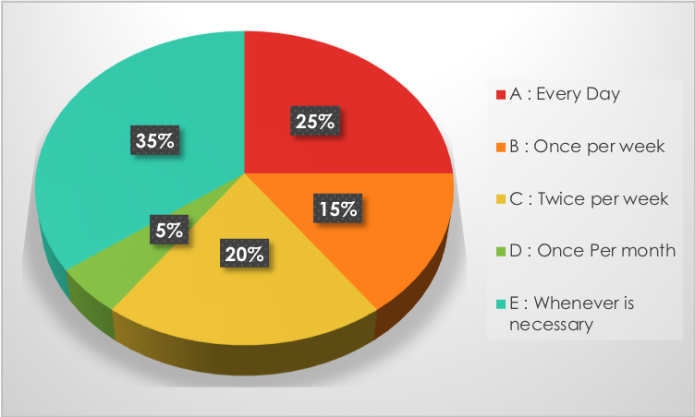
The next question was their intensity of usage concerning VLE, in accordance with the respective platform utilized. Among the responses received, it has been observed that there have been majority responses concerning the fact that it is used whenever is necessary. This embeds the knowledge that it has been utilized by several students only when it is required and thereby allowing the sense of requisite to prevail. It was followed by responses which also had a handful number concerning the answer that it is used every day. This invoked the realization and understanding that it has been cherished by certain students in lieu if its flexibility and friendly interface of learning. However, there were tree answers regarding the usage of VLE once a week and four answers regarding the usage of it twice a week. This enhanced the probability that the concept of VLE is gradually being cherished by all.

Question 3:
Do you think virtual learning environment is difficult to use?
Learning Environment
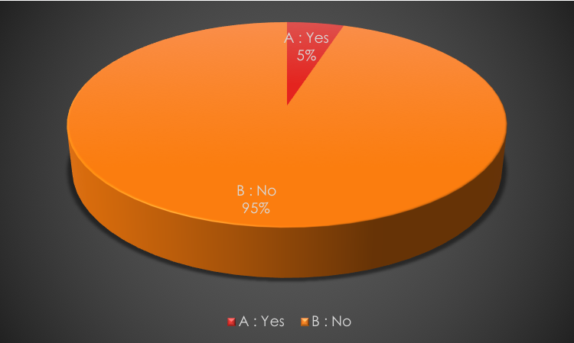
This particular question was regarding the concept of difficulty in usage concerning VLE, which received the maximum number of positive responses. Except one student who accepted that it was a difficult medium of learning, all the respondents replied that they had no difficulties in learning. This brings us the fact that the concept of VLE was readily by all in accordance with ease.

Question 4:
Do you think it is beneficial for students?
Impact on students

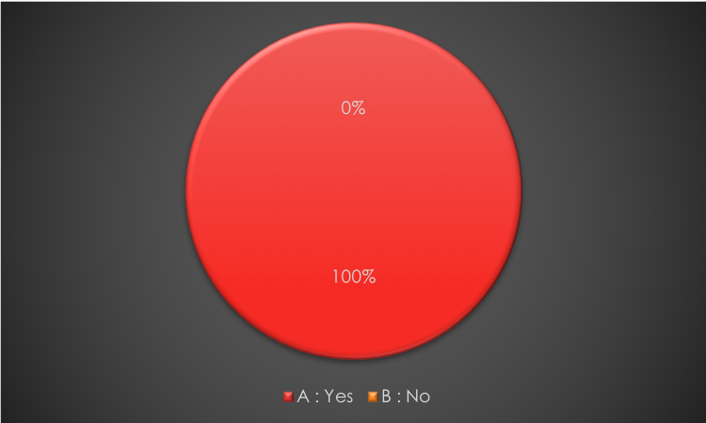
This question was regarding the beneficial nature of VLE on students. It was found that all the students had a positive response. They supported that it was a beneficial mode of learning, which brings us to the fact that the concept has an underlying positive impact on the learning experience of the users, especially the respondents.

Question 5:
How did Moodle help you with your academic studies?
Moodle-Virtual Learning Environment

The next question was regarding the impacts which Moodle creates on the students, concerning the beneficial nature it exhibits. There have been several responses which outlined that the platform provided convenience concerning the search of theories and also aided in comprehending informative assignments. It was also found from certain responses that it helped the students to miss less classes and even match up to the pace of studies even after missing any class or classes. Lastly, it was also found that the platform provided every necessary information at the fingertips, which embedded utmost positivity in their learning experience.

Question 6:
How satisfied are you with our Virtual Learning Environment?
Presence of Moodle

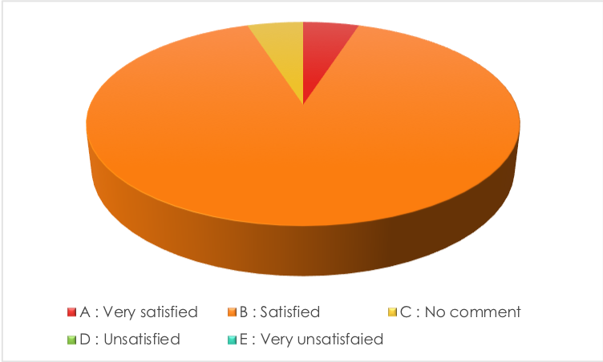
Next question was regarding the satisfactory quotient of Moodle, in implementing VLE. Majority of the responses portrayed that they were satisfied concerning the convenience of the platform as well as its diversified usufructuary nature, one was satisfied and another student responded with no comment, which brings the light into the fact that there might be some power hindrances, concerning the specific platform.

Question 7:
In your own words, what are the things which you like the most about Moodle?
Benefits of Moodle

The next question was regarding the preferences of benefits. The respondents were asked to emphasize about their favourable benefits. Several responses were received concerning the concept of easy access to a variety of information. This has been the most favoured benefit of Moodle among the students of the college. The diversification of this particular sphere of learning has also been another favoured benefit of Moodle. Another important benefit which was portrayed by the students was that they can access their attendance conveniently, thereby enhancing the concept of engagement in a learning session.

Question 8:
Are you facing any problems with VLE (Moodle)?
Impacts of Moodle
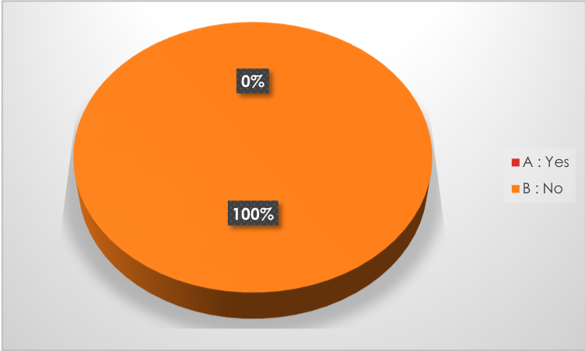
The next question enquired that, whether there were posed hindrances regarding the implementation of Moodle, and also relating to its interface. All of them responded positively, which brings light to the fact that there was no problem in the VLE, concerning Moodle.

Question 9:
In few words, explain what are the changes you would like to make to Moodle?
Recommended Changes

The Last question was asked to the students for receiving recommendation, regarding the concerned platform Moodle. There were few responses which enlightened that the interface was slow. Few of them complained that its ambit of collection is confined to a certain extent and lacks variety. Handful of responses was also received regarding the concept that it does not require any further changes, which emphasizes its satisfactory quotient. This, it can be analysed that there are certain posed difficulties in the concerned medium, relating to VLE.

Secondary Analysis

Concept of Virtual Learning Experience
As per the perception of Zulkarnian and Rahim, (2018), the concept of VLE is a widespread concept relating to the positive paradigm it creates along with education and learning. In accordance with the development of communication and technologies, the sphere of education has been attaining positivity and recognition. However, it has been observed that VLE has embedded a global tinge to the sphere of learning, in lieu of its nature of rendering convenience. It has also been observed that with the concept of VLE, the advent of several platforms is also evident which brings us to the concept that the global sphere of futuristic learning is paving its way into education (Talafian et al., 2019).
Intensity of usage
The intensity of usage concerning the VLE, has been quite high I accordance with the passage of time. It has been observed that there has been high usage of VLE in recent days as compared to what it was three to four years ago. As per statistic received in 2017, there has been a 29% rise concerning the usage of VLE, as compared to the statistics in 2017. The distinct rise in the intensity of usage clearly narrates the fact that, increment of widespread recognition of this particular concept of learning thereby modulating the learning experience towards positivity and entertaining (Cuthell,2017)
Assessment of Virtual Learning Environment
VLE, as a medium to preach and promote convenient education has been acting positively amidst the developing society and also has been recognized by all, which brings to analysis to the fact that it has been embedding positivity among the respective strata of society. As per the views of Lam et at., (2019), there have been several benefits rendered by this particular concept of platform, which primarily consisted of convenience and an immense sphere of information available at ease.
Impacts
The impacts laid down by the concept of VLE has been positive enough to gather maximum recognition. The availability of information at fingertips has been the most important criteria for the students to accept easily. It has also been found out that, the concept of VLE, enhanced the engagement of students in lieu of the increased curiosity and entertaining nature of learning. The impact it had on the students can be very well considered as positive relating to the satisfactory ration and enhanced usage of the platform. The convenience of learning increased its demand amidst the sphere of education and teaching (Janßen et al.,2017).
Moodle
Moodle has been one of the most favoured applications concerning the concept of VLE. It is a free to download application which aids in a better and easy learning experience. It has enhanced the sphere of learning through rendering positive experience in learning. The implementation of Moodle within ant concerned institution might result in enhanced embedded positivity among its layers of operation.

Professional Practice
As opined by Goeser et al., VLE can help people from various professionals such as educators for planning their lessons along with managing administrative work and tracking the performance of students along with their actions and standard of engagement. This can help in additional materials along with support for the people who might need it. According to Huang et al., (2019), the concept of VLE along with the earning platform has been helping to integrate the web-based tools that can help the teacher learn along with parents involved in education to enhance the delivery and their management. Any type of virtual learning can be required for ongoing support along with proper district and school teams that can help proper professional development sessions that can help the teachers for utilizing the various forms of virtual learning in a proper manner.

Conclusion
This, it has been observed that the concept of VLE has attained widespread recognition. It has also been observed that the posed usufructuary nature of the platform has aided in convenient
Education and learning. The ambit of knowledge and teaching can now be conducted in a global sphere. Despite certain posed challenges, which can very well be dealt with, this concept has been attaining heights. The changes are recommended, if implemented, can yield positive concerning education as well as a friendly workplace.

References

Cheng, K.H. and Tsai, C.C., 2019. A case study of immersive virtual field trips in an elementary classroom: Students’ learning experience and teacher-student interaction behaviors. Computers & Education, 140, p.103600.
Cuthell, J.P., 2017. Virtual learning. Routledge.
Goeser, P.T., Hamza-Lup, F.G., Johnson, W.M. and Scharfer, D., 2018. VIEW: A virtual interactive web-based learning environment for engineering. arXiv preprint arXiv:1811.07463.
Huang, Y.C., Backman, S.J., Backman, K.F., McGuire, F.A. and Moore, D., 2019. An investigation of motivation and experience in virtual learning environments: a self-determination theory. Education and Information Technologies, 24(1), pp.591-611.
Janßen, D., Tummel, C., Richert, A. and Isenhardt, I., 2016, June. Towards measuring user experience, activation and task performance in immersive virtual learning environments for students. In International Conference on Immersive Learning (pp. 45-58). Springer, Cham.
Lam, J.T., Gutierrez, M.A., Goad, J.A., Odessky, L. and Bock, J., 2019. Use of virtual games for interactive learning in a pharmacy curriculum. Currents in Pharmacy Teaching and Learning, 11(1), pp.51-57.
Pezzullo, L.G., Wiggins, J.B., Frankosky, M.H., Min, W., Boyer, K.E., Mott, B.W., Wiebe, E.N. and Lester, J.C., 2017, June. “Thanks Alisha, Keep in Touch”: Gender Effects and Engagement with Virtual Learning Companions. In International Conference on Artificial Intelligence in Education (pp. 299-310). Springer, Cham.
Talafian, H., Barany, A., Petrovich Jr, M., Shah, M. and Foster, A., 2019, March. Facilitating and Tracing Identity Change in Augmented Virtual Learning Environments. In Society for Information Technology & Teacher Education International Conference (pp. 2062-2069). Association for the Advancement of Computing in Education (AACE).
Zulkanain, N.A. and Rahim, E.E.A., 2018. Assessing the Students’ Perceptions Towards Their Virtual Learning Experience Based on an Adapted Multi-User Virtual Environment (MUVE) Indicators. Advanced Science Letters, 24(11), pp.8778-8781.

