

Master of Business Administration
International Business Concepts
LCMB7034
Assignment Title: Report
International Business Consultancy Report of Unilever

Lecturer’s Name: Akshay Narayanan (London)
Student Name:
Student ID.:
Word count: 4973
Submission Date:

Table of Contents
Introduction 2
Benefits and challenges of international operations 3
Justification of Unilever as an MNC/TNC 3
Nature of Unilever Plc’s Global Operations: Value-Chain Focus 3
Entry Modes Used by Unilever in International Markets 5
Key benefits obtained by Unilever from its international operations 7
Impact of OLI Factors on Unilever’s Market Entry Strategy 10
Ownership (O): Firm-Specific Strengths Driving Control 10
Location (L): Market Opportunities and Context in Uzbekistan 11
Internalisation (I): The Rationale for Retaining Control 12
Integration of OLI Factors and Recommended Entry Mode 12
Influence of Cultural Differences on Unilever’s Market Success 14
Influence of UK–Uzbek Cultural Distance on Unilever’s Market Entry Strategy 14
Impact of UK–Uzbek Cultural Differences on Unilever’s Long-Term Market Success 15
Key SOP Adjustments for Unilever’s Success in Emerging Markets 17
Adjustment One: Localisation of Supply Chain Processes and Production 17
Adjustment Two: Human Resource and Management SOPs Cultural Alignment 18
Adjustment Three: Customer Service, Product Strategy and Consumer Engagement 19
Conclusion 20
Reference List 22

Introduction
This report is an international business analysis that evaluates Unilever’s possible expansion into Uzbekistan. It will seek to know whether this is an appropriate emerging market to the company and what strategic measures are required to enter successfully. The report is made to analyse the opportunities, threats and cultural variations as well as the most suitable entry strategy in the market to be taken by Unilever. To finish this report, several steps are implemented: the analysis of the global operations of Unilever, an overview of its international entry modes, the implementation of the Dunning OLI framework, and a discussion of cultural differences between the UK and Uzbekistan. The Standard Operating Procedure (SOP) changes to adapt to the local area are also evaluated in the report. Unilever is a multinational corporation that specialises in FMCG products and is based in more than 190 countries, with its brands being strong in the beauty, personal care, home care, and nutrition sectors (Unilever Annual Report, 2024).

Benefits and challenges of international operations

Justification of Unilever as an MNC/TNC
A multinational corporation has global activities in various countries that are coordinated and centrally controlled in terms of strategy. Unilever Plc can be referred to as a Multinational and Transnational Corporation (MNC/TNC) because of the Great global presence, decentralised structure and integrated operations in many countries. The company has operations in more than 190 countries, with 58% of yearly turnover coming from emerging markets and a global turnover of 60.8 billion euros. It employs over 127,000 people worldwide, and approximately 3.4 billion people are daily users of Unilever products (Unilever Annual Report, 2024). Unilever has diversified into the major segments of its business, including beauty, personal care, home care and nutrition, with 5,000+ R&D professionals and an annual investment of €987 million in research and development. Unilever was one of the five leading companies in the world by market value in the FMCG category, which also reflects its transnational character, globalisation, and high cross-country brand impact of the company.
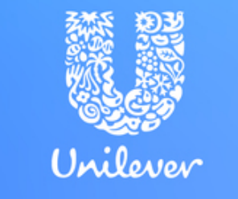
Source 1: Logo of the Entity
(Source: Unilever Annual Report, 2024)
In conclusion, the size, worldwide presence, and global integrated operations of Unilever are all indicative reasons as to why this is a powerful multinational and transnational company.

Nature of Unilever Plc’s Global Operations: Value-Chain Focus
Unilever operates a highly interwoven international value chain that integrates innovations, growth, production, marketing, and investment to achieve good global performance.
Research & Development
Unilever has invested a lot in innovation, and it has invested about 949 million in R&D and more than 20,000 patents in the portfolio of its global brands. According to the company, it has approximately 5,000 research specialists (500 PhDs) and has 6 innovation centres worldwide and 12 regional hubs in vibrant markets such as the UK, US, India, China and the Netherlands (Unilever Annual Report, 2024). The information demonstrates that Unilever has a robust international innovation system, which is backed by massive investments in research and development, thousands of professionals, numerous patents, and a system of global innovation centres and hubs that spur product development and competitiveness.
Its R&D activities are oriented to next-generation packaging, biotechnology, and microbiome science. Other non-current assets increased by €1.8 billion, primarily due to higher purchases of property, plant and equipment, as well as a higher net pension surplus due to the strong performance of equity and other growth assets.
Sourcing & Procurement
Unilever focuses on sustainability and resiliency on the sourcing side. Its value-chain descriptions demonstrate that it has a strong supplier-risk structure that includes raw materials, packaging and logistics, in order to bring in transparency and minimise disruption. As an example, the company has been involved in a large partnership of a sustainable palm oil supply chain, which enhances the traceability of its international sourcing of raw materials.
Production, Manufacturing and Distribution
The production network of Unilever is very huge and modernised. In one of its company news releases published in 2025, it is said that one factory in Mannheim, Germany, serves more than 50 countries and that the factory processes more than 60 million units/year through its distribution centre (Unilever Annual Report, 2024). This data shows Unilever’s Mannheim factory has strong global reach and high production capacity. In addition, the company is going digital with all its value chain members- it deems cloud solutions as a way of simplifying the end-to-end order and distribution process.
Sales and Marketing
The 2024 results of Unilever indicate a total turnover of €60.8 billion, of which 58% is in the emerging markets. Its Power Brands (top 30) accounted for over 75% of its turnover, and the sales growth was provided by the volume growth of 2.9% in 2024 (Unilever Annual Report, 2024). The level of marketing and brand investment was great as global brand equity and adaptation to the local market were considered to be important.
Financing and Strategic Investment
Unilever enjoys scale and financial benefits; it is a global company that is diversified, and its cash generation is very strong. Cash flow in 2024 is free and is at €6.9 billion (Unilever Annual Report, 2024). The strategic investments that the company has put in the manufacturing, R&D and supply-chain transformation are meant to further empower the competitive positioning of the company in the markets. As an illustration, news outlets describe that Unilever is in the process of reworking its supply chain in Europe, spending more than €150 million in the home-care business (Unilever Annual Report, 2024). The data shows strong cash flow enabling major investments to improve Unilever’s global supply chain and competitiveness.
Through its combination of all value-chain elements, such as R&D, sourcing, production, sales and financing, Unilever has shown a really global and integrated footprint. These attributes enable it to be classified as one of the top multinational consumer goods firms with profound globalisation and local sensitivity.
In conclusion, the integrated value-chain system of Unilever allows global coverage, stable development, and market leadership. It competes and adapts in some countries with its strong R&D, sourcing, scale, and digital operations.

Entry Modes Used by Unilever in International Markets
Unilever is expanding to international markets through various modes that strike a balance between control, cost, and risk besides assisting the company to grow and adjust to other international markets.
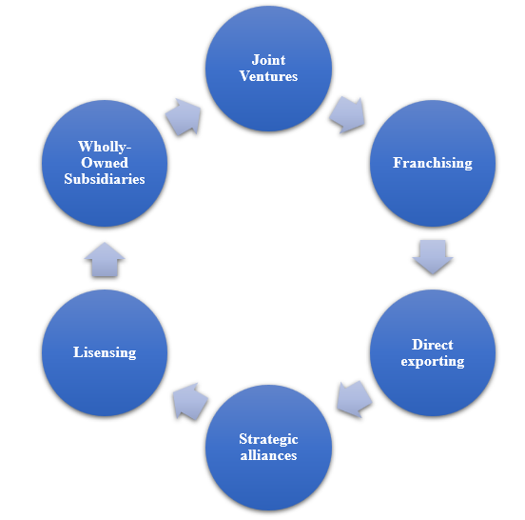
Figure 2: Different Entry Modes
(Source: Self-Created)
Direct Exporting
Even though most of the operations of Unilever are localised, the company occasionally employs direct export to penetrate small or regional markets. In these situations, Unilever produces in one nation and exports to a subsidiary or distributor in a different nation. As an example, Unilever has delivered finished goods in certain smaller markets in the Caribbean or African regions instead of having a full manufacturing facility (ADO, 2021).
Licensing & Franchising
Licencing and franchising have less commonly been used by Unilever as the key entry modes. Licensing could also entail the production or distribution of Unilever-branded products under a licence by local companies (Hardy, 2023). Franchising would be more applicable in the case of distribution/retail models. Although the annual report of Unilever does not particularly point to massive licensing transactions, scholarly studies of FMCGs indicate that licensing can be employed in cases where restricted direct control can be tolerated.
Joint Ventures
Unilever employs joint ventures (JVs) in markets where local regulations or risk present a challenge to complete ownership. Indeed, Unilever formed several JVs in China between 1986-1999 to allow local production and remain within the local regulations (Joseph and Thomas Karackattu, 2023). In a joint venture, there is a joint risk as well as market risk with a local partner and local market knowledge, but control is less than in wholly-owned operations.
Wholly-Owned Subsidiaries
Unilever's preferred entry mode is fully-owned subsidiaries, either through greenfield investment or through the acquisition of local existing firms. Several fully-owned subsidiaries worldwide. Unilever's purchase of a local company in Brazil or Argentina (named in the subsidiary list) allows for full control of operations, full integration into Unilever's global value chain, and execution according to its global strategy (Unilever, 2024).
Strategic Alliances
Another type of activity Unilever is involved in is strategic alliances, whereby the company collaborates with other companies towards a certain objective (technology, distribution, sustainability) (Zahoor et al., 2024). These alliances help in the entry of new business models into markets, although not always through ownership. Indicatively, the numerous acquisitions (more than 60 acquisitions by Unilever in 15 countries) demonstrate the strategic alliances and acquisitions to grow.
Dominant Entry Mode
In general, the dominant entry mode of Unilever is wholly-owned subsidiaries, since this will offer the greatest level of control, which will be in tandem with its global brand and supply-chain integration strategy. This mode is a supporting factor to its transnational structure and complete value chain synergies in the area of R&D, production, sourcing and financing.
Moreover, the primary methods of strong control mostly employed by Unilever are wholly-owned subsidiaries, although it employs exports, JVs, alliances and limited licensing as flexible ways of managing risks, adapting to different market needs.

Key benefits obtained by Unilever from its international operations
The global existence of Unilever also enables the company to expand, innovate, and find a wide range of customers and address the risks and adjust to various market situations.
Market Expansion
Unilever targets a multinational population of over 190 countries and this enables it to expand both in the developed and new markets (Unilever Annual Report, 2024). This broad coverage assists the firm in promoting demand of the products and competitiveness. New markets need products and strategies to be modified to conform to new cultural and regulatory frameworks.
Revenue Growth
The diversification of the business in different regions aids Unilever in generating high and dependable revenues. Its turnover of 60.8 billion Euros in 2024 has also exhibited good growth potential, with 58% of the total revenue originating from its emerging markets (Unilever Annual Report, 2024). Problems relating to revenue may vary with the instability of currency or uncertainty in the economy of certain countries.
Access to Resources
Global sourcing enables Unilever to acquire raw materials, suppliers, as well as qualified talent across several regions. This assists in the sustainability of production and enables the company to sustain its sustainability level. Conversely, Yenet et al. (2023) stated that certain developing markets can be characterised by supply problems, which influence the reliability and quality.
Economies of Scale
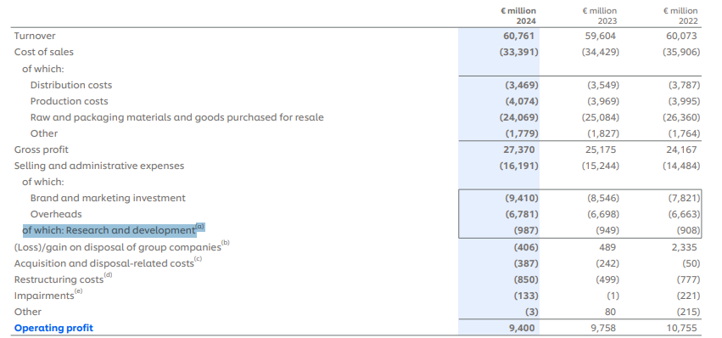
Figure 3: Operating costs
(Source: Unilever Annual Report, 2024)
Its presence in 190 countries allows Unilever to enjoy the economies of scale in terms of production, procurement and logistics. R&D investments of centralised consumption of 987 million and the globalisation of supply chains (Unilever Annual Report, 2024). Issues such as big operations and coordination are needed, and when there is a disturbance of the network in a region, the whole network is affected.
Innovation Benefits
The global R&D system of Unilever facilitates the rapid exchange of ideas among markets and assists in developing powerful global products. The company has more than 5,000 experts, which helps it to enjoy a variety of expertise. But innovations cannot always conform to the local needs of consumers.
Brand Recognition
Unilever has a high loyalty to its brands as it is used by 3.4 billion people every day; hence, it has high visibility. Its international status is used to develop trust as well as a competitive advantage. Conversely, it is hard to ensure a similar quality of the brand in various markets because of different standards.
Risk Diversification
This is because Unilever operates in numerous regions, thereby reducing the risk of being attached to a particular economy. Powerful markets can outperform weaker ones in the case of economic fluctuations (Bipasha, 2022). On the contrary, managing various types of risks in international markets makes it more difficult to be strategic.
In conclusion, the global presence of Unilever provides a good growth, scale, innovation and stability, although the company must deal with cultural, regulatory and supply issues to retain its global benefits and sustainability over time.

Impact of OLI Factors on Unilever’s Market Entry Strategy
Use of Dunning's OLI (Ownership, Location, and Internalisation) framework gives a systematic explanation of how Unilever Plc, a top global fast-moving consumer goods (FMCG) player, can successfully enter and grow in Uzbekistan, an emerging economy with high growth prospects.
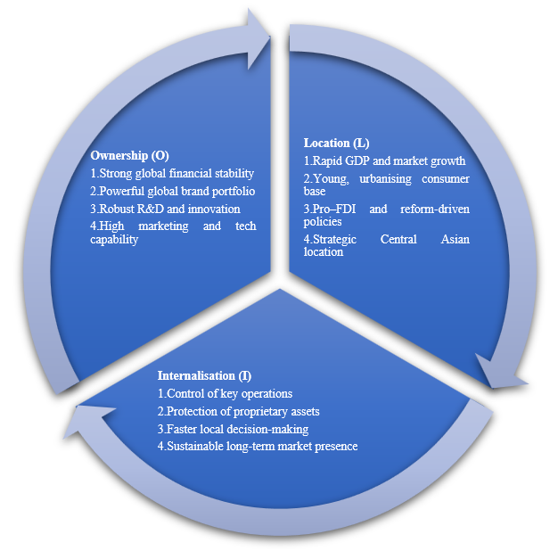.
Figure 4: OLI Factors
(Source: Self-Created)

Ownership (O): Firm-Specific Strengths Driving Control
Unilever has significant ownership strengths that reinforce its competencies to perform successfully in new foreign markets. Unilever has a stable financial position with a turnover of €60.8 billion in 2024, underlies sales growth of 4.2%, and a free cash flow of 6.9 billion, and is therefore operationally efficient. Unilever has done well in the high-growth economies as its emerging markets generated 58% of the total revenue. Its gross margin also increased to 45, and the underlying operating profit topped 11.2 billion, meaning it has high reinvestment potential and can afford market expansion (Unilever Annual Report, 2024).
In addition, the Growth Action Plan (GAP 2030) of the company aims at addressing the performance of its brands, streamlining its organisational structure in order to grow in the areas it thinks matter most within the business priorities, including beauty, personal care, home care and nutrition.
Building on the progress made in 2024, Unilever have unveiled a refreshed purpose and a new set of strategic priorities for Unilever. The GAP 2030 puts the consumer at the heart of the company’s plans and sets out what it believes the company can achieve by 2030. A focused and standardised global portfolio is ensured with Unilever having 30 Power Brands that provide more than 75% of global sales (Unilever Annual Report, 2024). Its 5000 plus researchers and its spending in R&D of 987 million Euro are facilitated in coming up with product innovations to address the needs of local consumers, but at the global standards of quality.
The high degree of technological integration and marketing skills of Unilever is enabling it to sustain a uniform global brand equity. The quality of the balance sheet of the company and the reorganisation of operations to become category-oriented are expected to improve efficiency and responsiveness on a local level at Unilever.

Location (L): Market Opportunities and Context in Uzbekistan
Uzbekistan is an attractive emerging market with its economic reform strategy, demographic patterns and geographical location. Statista (2025) estimates the nominal GDP of Uzbekistan at USD 115 billion in 2024 and the growth rate as 6.5, which ranks Uzbekistan as one of the fastest-growing economies in the region of Central Asia. The data shows Uzbekistan’s strong economic growth, making it a fast-rising market with high future potential. The World Bank (2024) also indicates that the population of Uzbekistan, of over 37.17 million, are young and urbanising at a high rate, thus the demand for packaged food, hygiene and personal care products- some of the most important segments of the Unilever global product portfolio is increasing. The data shows Uzbekistan’s young, urbanising population is driving rising demand for Unilever’s key product categories. The fact that the Uzbek government has consistently been interested in economic liberalisation and foreign direct investment (FDI) reforms makes the market more attractive. The special treatment of consumer goods firms with incentives like lower importation charges and an easier licensing process has made local operations interesting to the firms.
Experience in other emerging markets will build on Unilever's capacity to overcome these challenges. Indicatively, Dube and Dube (2023) noted that Unilever underwent a strategic reset in Indonesia following brief performance declines due to shifting consumer preferences and heightened political sensitivities. With the introduction of tight operational control and portfolios, the company recorded growth of above-digit in 2025, which underscores the ability to bounce back and adjust. This experience suggests that in Uzbekistan, an opportunity/risk balanced entry approach would be through a partnership approach first and then take full control later.

Internalisation (I): The Rationale for Retaining Control
Unilever’s success historically stems from internalising key business functions such as innovation, branding, and supply chain management. The 2024 Annual Report highlights the company's priorities towards end-to-end digitalisation, AI-enabled supply chains, and data-driven marketing, which must be closely controlled to ensure standards and operational efficiency. Unilever is also committed to strategic focus and concentration of resources, as portrayed by the decision to divest its Ice Cream business and shift the focus towards the core businesses (Financial Times, 2024).
Using internalisation, Unilever secures its proprietary resources, product formulation, marketing strategy and consumer data, besides giving it quicker decision-making and responsiveness (Lieu et al., 2021). This strategy is especially useful in the emerging markets where consumer behaviour changes rapidly. The internal management saves on the cost of coordination and increases the transfer of the global learning to the local operations. It is through internalisation in Uzbekistan that Unilever will be able to replicate its established operating model, the generation of cheap yet quality products through effective supply chains and local marketing. In-country sourcing following the initial joint ventures would allow economies of scale, intellectual property protection and sustainability initiatives that are in line with the company's Climate Transition Action Plan.

Integration of OLI Factors and Recommended Entry Mode
The synthesis of OLI factors suggests a staged but control-oriented entry approach for Uzbekistan. The ownership benefits of Unilever are high control, Uzbekistan has location benefits, and continuing reforms create an opportunity, but a fairly risky opportunity; internalisation benefits will ensure that once market knowledge is obtained, there should be tight control maintained.
During the initial stage, Unilever might make an entry by direct exporting and the local distribution joint ventures, where it can determine the demand, test the product line, and build brands. With greater consumer reaction, switching over to a joint venture (JV) with a well-known Uzbek FMCG or boxing associate would localise the production and distribution. After ensuring market potential and stability in operations, Unilever must gradually invest in its share to become a wholly-owned subsidiary in accordance with its international management approach of having an integrated value-chain control.
Dominant OLI Factor
The OLI framework created by Dunning is used to understand the expansion of Unilever to foreign markets. For example, the international strategy is supported by the firm through global R&D centres, a robust brand portfolio, and integrated supply chains in over 190 countries. Critically evaluated, the dominant factor in the OLI model is Ownership, as Unilever largely depends on its financial power, technological ability, and global brand power to penetrate and rival new markets. The superior competitive capabilities in ownership, including 30 Power Brands, and spending of €987 million on research and development, make its competitive strengths that are not easily replicated by competitors, and ownership is the most important factor in its global achievement.
In conclusion, Dunning's OLI model illustrates that Unilever's ownership advantages, Uzbekistan's location advantages, and internalisation advantages together form a strategic choice for a staged high-control entry mode. The pairing of brand equity, financial resources, reform-led market opportunity, and operational control priorities indicates the development of a joint venture into a fully-owned subsidiary.

Influence of Cultural Differences on Unilever’s Market Success

Influence of UK–Uzbek Cultural Distance on Unilever’s Market Entry Strategy
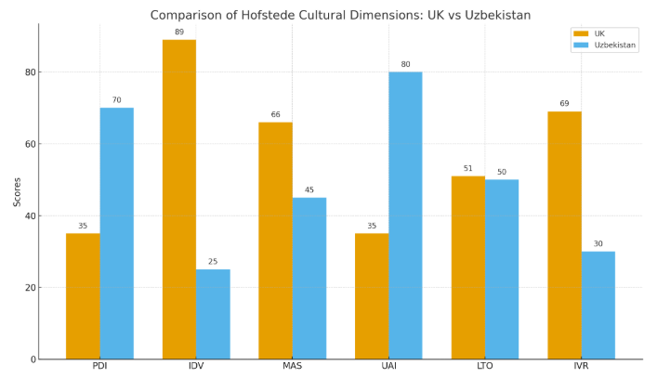
Figure 5: Cultural Differences between UK and Uzbekistan
(Source: Self-Generated)
Power Distance and Ownership Decisions
Cultural differences between the United Kingdom and Uzbekistan will strongly influence Unilever’s entry strategy. The UK has a low power distance score of 35, meaning decentralised decisions and open employee dialogue. Uzbekistan, however, scores 70, showing strong hierarchy and authority concentration in senior leadership and state agencies. This paradox implies that Unilever can not export its flat structure in the UK to Uzbekistan. Rather, Kukard (2023) portrayed that centralised reporting channels will be required to suit local requirements in the company. This has an impact on ownership choice as well. However, despite the fact that Unilever has favoured wholly-owned subsidiaries to ensure that the quality control is strict, this mode might not succeed immediately due to the fact that hierarchical institutions in Uzbekistan are more inclined towards firms that involve local partners. Coming in as a wholly-owned subsidiary could hence be sluggish in approval, though long-term control is appealing. The cultural environment will be better addressed by a phased entry at the first joint venture and subsequently a fully-owned subsidiary.
Individualism, Collectivism and Marketing Adaptation
The UK demonstrates high individualism with a score of 89, while Uzbekistan scores 25, indicating strong collectivism. This cultural paradox needs modifications in the entry marketing of Unilever. The UK campaigns use personal lifestyle, whereas the Uzbek campaigns should be aimed at family wellbeing and shared benefits. Unilever statistics indicate that Power Brands generate 75% of the turnover on the world stage, and as such, consistency in messages becomes essential (Unilever Annual Report, 2024). Collectivism, however, implies the necessity of high local approval, which becomes more difficult to realise by a purely centralised wholly-owned subsidiary model.
Uncertainty Avoidance and Regulatory Navigation
Uzbekistan scores 80 in uncertainty avoidance, much higher than the UK’s 35—showing a preference for clear rules and predictability. The global internal systems of Unilever are well-organised, and the company is backed by the turnover of €60.8 billion, the underlying operating profit of €11.2 billion Euros and the free cash flow of €6.9 billion in 2024 (Unilever Annual Report, 2024). These advantages will enable the company to cope with risk, but a full-fledged wholly-owned subsidiary may find it difficult in the first place with ambiguous licensing and importation processes. Forming a local partnership would assist in mitigating ambiguity in regulation until Unilever is fully aware of institutional logic.
Long-Term Orientation and Investment Expectations
The UK scores 51 in long-term orientation, while Uzbekistan stands close at 50, indicating moderate similarity. Unilever is an active investor in innovation: the company invests in R&D, and in 2024, its expenditure is €987 million (Unilever Annual Report, 2024). The data shows both countries share similar long-term views, while Unilever supports this with strong R&D investment. However, Kuldosheva 2022) noted that Uzbek officials can anticipate rapid employment and timely products. This paradox implies that Unilever needs to reconcile between the long-term innovation targets and short-term local demands to prevent slow uptake in the entry process.

Impact of UK–Uzbek Cultural Differences on Unilever’s Long-Term Market Success
Leadership Style and Workforce Expectations
The cultural differences will still affect the performance of Unilever when entering. The employees of the UK value empowerment and informal leadership, whereas the Uzbek employees demand formal authority, strict hierarchy and directive leadership (Urinboyev and Dogan, 2024). The assumption of the UK-style of leadership can confuse the workforce in Uzbekistan. Conversely, Shabani and Jerie (2023) stated that using a wholly hierarchical management system can destroy the global culture of Unilever. To achieve success in the long run, a balance between the two models, such as formal hierarchy and openness in communication, will then be necessary.
Collectivism and Consumer Trust Formation
The collectivist culture in Uzbekistan will have a powerful influence on brand loyalty. Purchasing decisions are primarily affected by community networks and family groups (Zakriyokhonova, 2025). This situation can help Unilever grow faster should the brand win the confidence of the locals. However, it is also able to magnify bad experiences faster than in the United Kingdom. This demonstrates how collectivist cultures can both speed up acceptance and rejection among the collective perception.
Infrastructure Gaps and Supply Chain Reliability
The UK leads in retail systems, and Uzbekistan's logistics is not even. This paradox might interfere with the supply of products. The sheer size of distribution capability of Unilever, 3.4 billion daily users of its products worldwide, is an advantage that the company will need more decentralised warehousing and partnerships to avoid stock-out situations in Uzbekistan (Unilever Annual Report 2024).
Short-Term Expectations and Product Strategy
The Uzbek consumers are more focused on affordable opportunities and instant satisfaction in comparison to the UK consumers, who frequently regard innovations and brand image (Ataniyazova et al., 2022). This paradox implies that Unilever has to launch value-based lines of products, small packs and early promotion. When Unilever pays too much attention to long-term premium positioning, it could be adopted slowly. Nevertheless, the promptness to meet short-term demand might make Unilever win over the competitors in the initial market access.
Low Indulgence and Practical Consumption
Uzbekistan has an indulgence score of 30, much lower than the UK’s 69, meaning consumers prefer practicality over luxury. Unilever should therefore look at focusing on basic care, low prices and household necessities (Zakriyokhonova, 2025). It will be important to keep the quality standards at the level of the UK and offer cost-efficient services to ensure success in the long run.
The cultural contrasts between the UK and Uzbekistan will significantly shape Unilever’s entry strategy and long-term success. Differences in the power distance, collectivism, uncertainty avoidance and indulgence will require structural, marketing and operational changes to integrate well. A gradual partnership-to-subsidiary strategy, culturally oriented leadership, value-based products and enhanced logistics will be necessary. By matching its global strengths with the cultural expectations of Uzbekistan, Unilever has a chance of growing sustainably and developing a high level of consumer confidence in the new market.

Key SOP Adjustments for Unilever’s Success in Emerging Markets
The decision to expand into Uzbekistan will need Unilever Plc to re-align some of its Standard Operating Procedures (SOPs) to ensure its global systems are in line with the cultural, regulatory and institutional reality of the host country. Evaluation of the OLI reveals that the high ownership benefits in Unilever, as indicated by its turnover, underlying operating profit of 60.8 billion, and free cash flow of 6.9 billion in 2024, give it a solid financial and operational base to conduct business across borders (Unilever Annual Report 2024). The data indicate that Unilever has a good financial foundation that will facilitate international growth due to the high ownership advantages.
However, the power distance levels are high, and the society is collectivist with a growing regulatory framework that conflicts with the UK-based operational culture at Unilever. Consequently, Dang Khanh (2024) highlighted that Unilever needs to undertake three key SOP changes to ensure that it attains strategic fit, operational efficiency as well as long-term success in Uzbekistan.

Adjustment One: Localisation of Supply Chain Processes and Production
Coupling Production SOPs to the Local Realities
The SOPs of Unilever in the UK are dependent on the global scale production, where the quality systems and supply integration are centralised in over 190 countries. Unilever's annual report 2024 indicates that the global supply chain serves 3.4 billion daily users in the company, which is very efficient (Unilever Annual Report 2024). The figures demonstrate that the global supply chain of Unilever has been effective in serving daily users in the world.
However, direct use of this model in Uzbekistan may be contradictory. Uzbekistan also experiences inconsistent practices in customary processes and infrastructural loopholes, which would prolong lead times in the event Unilever relies purely on imported products (Thommandru and Maratovich, 2024). Thus, to minimise the logistical risk and help to enter the market more quickly, Unilever will have to introduce SOPs for the local assembly or partial production. Local production would also fit in the government incentives of foreign firms that produce employment and local value, which is against the normal reliance of Unilever in the regional mega-factories. This alignment will strengthen local relevance and ensure smoother operational integration.
Local Sourcing SOP for Supply Chain
The UK business activities are guided by the strict, environmentally friendly sourcing SOPs at Unilever, which has an investment of €987 million in R&D across the world, and the company has its focus on traceable raw materials (Unilever Annual Report, 2024). The UK business operations of the company have high global R&D and demanding, traceable, environmentally friendly sourcing policies. The supply base of Uzbekistan is in its development stage and is unlikely to sustain these requirements. Local sourcing, conversely, would minimise the level of imports and enhance cost-effectiveness in the long term. As such, Unilever needs to change its SOPs to incorporate supplier capability-building programmes and tougher internal audits (Lieu et al., 2021). This change will enable Unilever to retain its global brand promise, but at the same time enjoy the local sources of input.
Global vs Local Logistics Practices Contradictions
The digitalised UK logistics systems, implemented by Unilever based on end-to-end cloud solutions, might not entirely work with the disjointed retail networks in Uzbekistan. Therefore, decentralisation of warehousing, multiple transport partners and local forecasting have to be incorporated in SOPs. One of the real-life examples is the successful action of Coca-Cola in Uzbekistan because of the investment in the bottling facilities and the regional distribution centres (The Diplomat, 2022). It proves that global logistics SOPs modification to local realities is essential to fast-moving consumer goods companies. Such adaptation will enhance distribution reliability and protect Unilever’s market reputation.

Adjustment Two: Human Resource and Management SOPs Cultural Alignment
Balancing UK Egalitarian Culture With Uzbek Hierarchy
Low PDI in the United Kingdom promotes participative leadership, openness to communication and individual freedom. Quite on the contrary, Nofandrilla et al. (2025) stated that the high power-distance expectations of Uzbekistan attach importance to visible power, centralised decision-making and ordered reporting. In case Unilever directly transfers its UK-style egalitarian SOPs, the managers might be viewed as weak or uncertain by the employees. As such, the SOPs must be amended to incorporate the more formal organisational forms, defined roles and the reporting lines. This will ensure clarity among the employees and local cultural fit, but this goes against the traditional UK-based Unilever leadership culture. This balance will support employee confidence while maintaining global cultural alignment.
Cross-Cultural Training and Workforce Readiness
The currently reported 87% global employee engagement by Unilever indicates the existence of a strong internal capability-building (Unilever Annual Report, 2024). However, the Uzbek employees might need further training concerning the standards of hygiene, sustainability promises, the digital workflow systems and brand expectations (Nozimova, 2024). Similarly, the UK expatriates will require training on Uzbek collectivism, indirect communication and status expectations. The updated training SOPs should thus incorporate cross-cultural competency training to reduce misunderstandings and ensure an easy internal integration. Such training will reduce cultural friction and improve organisational cohesion.
Systems and Structure of Reward Motivation
The UK labour force is effective on the individual-based incentives that are a measure of high individualism. In their turn, Uzbekistan are collectivist and workers are focusing on job security, group incentives and predictable compensation. Therefore, Unilever must alter the reward SOPs to include team incentives, long-term career guarantees and recognition in terms of community. However, such changes can go against the merit-based structure traditionally held by Unilever in the UK, where high achievers are rewarded on their own (Unilever Annual Report. 2024). Blasiak et al. (2021) highlighted that Unilever will require a combined reward system that will uphold the global levels of fairness and respond to the demands of the local culture. This may incorporate the community-based recognition activities, performance rating based on the team, to enhance loyalty and low staff turnover in Uzbekistan.

Adjustment Three: Customer Service, Product Strategy and Consumer Engagement
Enhancement of Service Networks for Local Accessibility
The achievement of Unilever in the UK depends on the sophisticated service networks and regular availability of the products. However, Semenova et al. (2024) portrayed that the limitation of infrastructure in Uzbekistan could interfere with the stock flow, which goes against the high service reliability SOPs of Unilever. To deal with this, Unilever has to create local after-sales support centres, increase the distribution systems and use geographical specific models of delivery. These SOP changes will make sure that there is an availability of the products that is in line with the local expectations. Strengthened service systems will increase trust and market competitiveness.
Low-Indulgence Culture and Product Adaptation
Uzbekistan's indulgence culture prefers the necessities rather than luxurious lifestyle goods. Instead, consumers in the UK deal with high-end and luxurious types with extensive brand equity. Unilever will therefore need to change its product SOPs to accommodate the small-pack low-cost formats and essential-care products (Lieu et al., 2021). This will be comparable to the price-sensitive consumer behaviour in Uzbekistan, but at the same time, will safeguard the global quality standards of Unilever. This adaptation will support rapid adoption among cost-conscious consumers.
Community-Based Customer Engagement SOPs
The collectivist culture of Uzbekistan implies that trust in the brand is supported by social relationships at a strong rate. Individualised marketing in the UK style will be ineffective, therefore. SOPs should incorporate community promotion programmes, family promotions and advertising which are culture-oriented. These changes will enable Unilever to get quick acceptance by consumers and ensure long-term loyalty. Nuraeni (2025) noted that community-driven engagement will accelerate brand trust and sustained loyalty.
Moreover, entering Uzbekistan will mean that Unilever will have to make significant changes in production systems, HR model and customer service SOPs. Even though the culture and institutions of Uzbekistan are very different to the UK, the strategic adjustment of the SOPs would enable Unilever to stabilise its operations, gain a competitive edge and long-term expansion in this new market.

Conclusion
This report has critically examined Unilever’s potential expansion into Uzbekistan by analysing its global operations, internationalisation drivers, OLI-related strategic decisions and the cultural differences between the United Kingdom and Uzbekistan. The study reveals that the high ownership benefits of Unilever, such as its turnover of €60.8 billion, 58% emerging-market revenue share, and its high level of investment in research and development, offer a sound base on which to enter the emerging and fast-reforming economy. However, the analysis also demonstrates that the high power distance, collectivist culture, and the changing institutional culture of Uzbekistan do not support several characteristics of the UK-based systems used by Unilever. Such contradictions will necessitate strategic and operational changes, which will involve leadership practices, product approaches, sourcing, logistics and customer interaction.
Using Dunning’s OLI framework, the report concludes that a staged entry model—beginning with partnerships and advancing toward greater control would help Unilever to strike the right balance between global integration and local responsiveness. Cultural assessment also indicates that future success will be determined by the capacity of Unilever to localise marketing communication, change reward model, reinforce local supply chain and produce low-cost basic items to meet the expectations of the Uzbek consumers. This study evaluated the international business environments, analysed international market entry strategies and applied research-based international business theories to the expansion decision of Unilever. Overall, the report concludes that Unilever will be able to emerge successfully in Uzbekistan in case it pursues a culturally differentiated, locally embedded, and gradual expansion strategy.

Reference List
ADO, A.A. (2021) Challenges and opportunities of private investment, case of South Wollo Zone.
Ataniyazova, Z., Friedman, B.A. and Kiran, P. (2022) New corporate social responsibility brand evaluation in a developing country: Uzbekistan. International Journal of Corporate Social Responsibility, 7(1), p.3.
Bipasha, Y.A. (2022) Market efficiency, anomalies and behavioral finance: A review of theories and empirical evidence. World Journal of Advanced Research and Reviews, 15(02), pp.827-839.
Blasiak, R., Dauriach, A., Jouffray, J.B., Folke, C., Österblom, H., Bebbington, J., Bengtsson, F., Causevic, A., Geerts, B., Grønbrekk, W. and Henriksson, P.J. (2021) Evolving perspectives of stewardship in the seafood industry. Frontiers in Marine Science, 8, p.671837.
Dang Khanh, G. (2024) Integrating Environmental, Social and Governance Factors into Strategic Management: A Comparative Case Study of Unilever and Neste.
Dube, M. and Dube, S. (2023) Towards sustainable color cosmetics packaging. Cosmetics, 10(5), p.139.
Financial Times. (2024) Unilever to split off ice cream business and cut 7,500 jobs. [online] Available at: https://www.ft.com/content/c7b44b4a-e4c7-45b4-8831-c07c2172b181. [Accessed 26th October 2025]
Gierusz, J., Kolesnik, K., Silska-Gembka, S. and Zamojska, A. (2022) The influence of culture on accounting judgment–Evidence from Poland and the United Kingdom. Cogent Business & Management, 9(1), p.1993556.
Hardy, J. (2023) Marketing communications and media: Commercial speech, censorship and control. The Routledge Companion to Freedom of Expression and Censorship, pp.358-367.
Jones, G. and Gálvez-Muñoz, L. (2001) Foreign multinationals in the United States. Taylor & Francis Limited.
Joseph, J. and Thomas Karackattu, J. (2023) Public protests and environmental policy‐making: The cases of Xiamen antiparaxylene protests in China and the civic movement against Kodaikkanal mercury poisoning in India. Risk, Hazards & Crisis in Public Policy, 14(2), pp.94-114.
Kukard, W.A. (2023) Transforming an industry: Leveraging emerging technologies in the smart home environment to create value for the FMCG industry.
Kuldosheva, G. (2022) Challenges and Opportunities for Digital Transformation in the Public Sector in Transition Economies: The Case of Uzbekistan. Harnessing Digitalization for Sustainable Economic Development, 365.
Lieu, P.T.H., Arunjit, N., Buapradabkul, S. and Nathaniel, D. (2021). Unilever Company Strategic Business Analysis.
Nofandrilla, N., Wijaya, I.F. and Setiaji, B. (2025) Does trust matter in lending decisions? A systematic literature review and research agendas for future studies. International Review of Economics, 72(1), p.4.
Nozimova, M. (2024) The digital economy in Uzbekistan: Opportunities and challenges. Gwalior Management Academy, 71.
Nuraeni, A. (2025) The Role of Social Media Narratives in Shaping Consumer Trust and Brand Loyalty: A Literature Review. Indonesian Research of Sustainability Management, Business, & Administration, 1(02), pp.65-72.
Semenova, Y., Lim, L., Salpynov, Z., Gaipov, A. and Jakovljevic, M. (2024) Historical evolution of healthcare systems of post-soviet Russia, Belarus, Kazakhstan, Kyrgyzstan, Tajikistan, Turkmenistan, Uzbekistan, Armenia, and Azerbaijan: A scoping review. Heliyon, 10(8).
Shabani, T. and Jerie, S. (2023) A review of the applicability of Environmental Management Systems in waste management in the medical sector of Zimbabwe. Environmental monitoring and assessment, 195(6), p.789.
Statista. (2025) GDP distribution in Uzbekistan 2018-2024, by sector. [online] Available at: https://www.statista.com/statistics/1253988/gdp-distribution-by-sector-uzbekistan/. [Accessed 26th October 2025]
Thommandru, A. and Maratovich, F.F. (2024) Leveraging new emerging technologies to enhance the anticorruption arsenal: Assimilating India's experiential insights into Uzbekistan's criminoverse. Multidisciplinary Reviews, 7(3), pp.2024058-2024058.
Unilever Annual Report. (2024) Annual Report 2024. [online] Available at: https://www.unilever.com/files/unilever-annual-report-and-accounts-2024.pdf [Accessed 26th October 2025]
Unilever. (2024) Group Companies. [online] Available at: https://www.unilever.com/files/unilever-group-subsidiaries-2024.pdf [Accessed 26th October 2025]
Urinboyev, R. and Dogan, E. (2024) Navigating the Legal Uncertainty and Informality in Authoritarian Regimes: Legal Culture, Governance and Business Environment in Uzbekistan. Central Asian Affairs, 10(4), pp.349-371.
World Bank. (2024) Overview-The World Bank in Uzbekistan. [online] Available at: https://www.worldbank.org/en/country/uzbekistan/overview. [Accessed 26th October 2025]
Yenet, A., Nibret, G. and Tegegne, B.A. (2023) Challenges to the availability and affordability of essential medicines in African countries: a scoping review. ClinicoEconomics and Outcomes Research, pp.443-458.
Zahoor, N., Khan, Z., Marinova, S. and Cui, L. (2024) Ambidexterity in strategic alliances: An integrative review of the literature. International Journal of Management Reviews, 26(1), pp.82-109.
Zakriyokhonova, R. (2025) Conflict Resolution Styles and Their Effectiveness in Uzbekistan Organizations. Central Asian Journal of Innovations on Tourism Management and Finance, 6(1), pp.160-173.

