Maldives
Jade Pepperell
1903977
The Global Tourism Experience
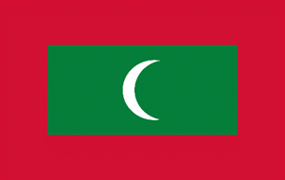
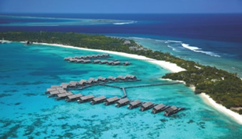

(Bwallpapers.com, 2014)
(Homedit, 2013)

Introduction
This report is a travel review for the Maldives, the report will aim to promote the Maldives to further develop its tourism industry and will be aimed at overseas travel companies/organizations. The report will cover the number of tourists currently generated, type of tourists generated, key stakeholders, the impacts of tourism, it will discuss the popular tourism destinations in Maldives and some of the issues the Maldives have faced in the past.
Location/Background
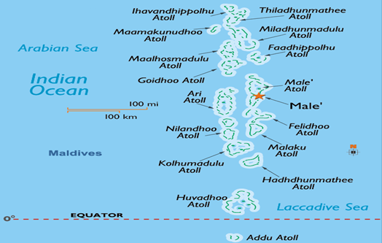
The Maldives is made up of 1192 islands in the Indian Ocean, the islands stretch across 871 kilometers. Only 200 of these islands are inhabited, and only 89 have resorts while the rest of the islands are used for industry and agriculture. Every island is surrounded by water and disconnected from the other islands. The Maldives is also an independent country made up of 357566 people. Maldives is a member of the United Nations (UN), South Asian Association for Regional Cooperation (SAARC), Commonwealth and many other international organizations. The economy is mainly based on foreign currency generated through tourism (Maldives Finest, 2019). Maldives are home to 5 percent of the planets reefs and these reefs are home to thousands of species of fish (Visit Maldives, 2020).

(Maldives Travel News, 2011)
Climate
The climate of the Maldives is tropical, temperatures range between 24 degrees C (75 degrees F) and 33 degrees C (91 degrees F) all year round. The monsoon rains generally fall between June and August, bringing 250-380 centimeters (100-150 inches) of rain.
Culture
The Maldives culture, traditions and customs are influenced by Indian, Sir Lankan, Malaysian, Arab, Persian, Indonesian and even African influences. In dance and music people will notice an African rhythm. The Boduberu, a Maldivian traditional dance illustrates this perfectly. Other music and culinary specialties are influenced by Africa and India. The inhabitants of the Maldives consume a lot of spices, curries, fish and coconut. The other peculiarity of Maldivians is their attachment to the sea. During the day women take care of the home, while men go out fish for tuna. Their way of life depends on the sea. The men gather on the beach to collect the days catch and then the women will cook. So, sea fishing makes a big impact on the economy as well as tourism. The Maldivian religion is Islam, they have a high number of mosques especially in the capital Male. The Islamic center and the Sultans park are one of the must-see tourist attractions. The Maldivian people are enjoy making braided mats, jewelry, lacquered vases and small wooden boats (Villanovo, 2020).
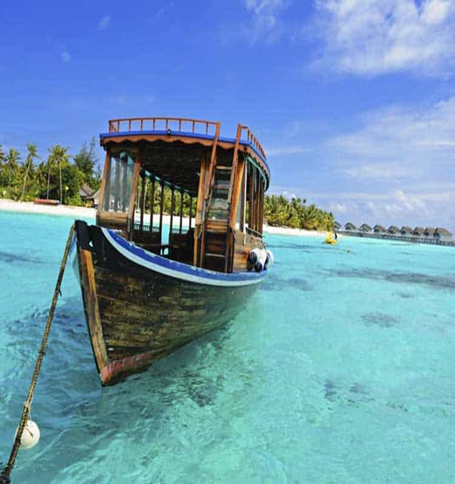
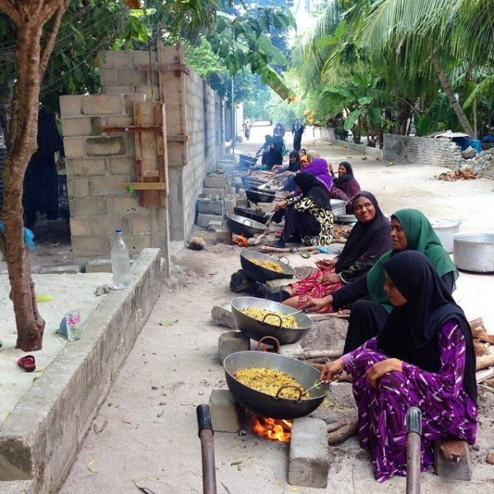

(Maldives Finest, 2019)
(Holiday Me, 2018)
Tourists Currently Generated
Graph one below shows the top ten tourism markets for the Maldives in 2017, China made up 22% of the Maldives tourism market in 2017 bringing in 306,530 tourists. Russia made up 4.5% (61,931), Germany 8.1% (112,109), France 3% (42,365), UK 7.5% (103,977), Japan 3% (41,133), Italy 6.4% (88,848), USA 2.8% (39,180), India 6% (83,019) and Korea 2.5% (34,808). The total tourist arrivals in Maldives in 2017 was 1,389,542, tourism is a big part of the Maldives, in 2017 the total tourism revenue amounted to 6,681.4 million, during 2017 the total tourism expenditure amounted to 62.8 million (Statistics Maldives, 2018). Graph two shows the top ten tourism markets to the Maldives in 2018 and the 1st quarter of 2019. China was at the top again in 2018 and 2019, in the 1st quarter of 2019 Maldives had 76,568 tourists arrive from China. There are some differences in graph two compared to graph one, Italy is second for the 1st quarter of 2019 and was fourth in 2017, Switzerland is tenth and Korea is no longer in the top ten. This could mean more countries are visiting Maldives as the years go by. In the 1st quarter of 2019 the total tourism revenue was 2,065,977,271. Tourism is the biggest industry in the Maldives, in 2017 Tourism made 16,321.7 of the industry GDP this is 24.3% (Tourism Update, 2019). According to Maslow’s Hierarchy of Needs, while people aim to meet basic needs, they seek to meet higher needs. The basic needs are physiological needs, such as food and water and the highest need is self-actualization (Learning Theories, 2020). Holidays could meet the needs of self-actualization, especially a holiday to somewhere as the Maldives.
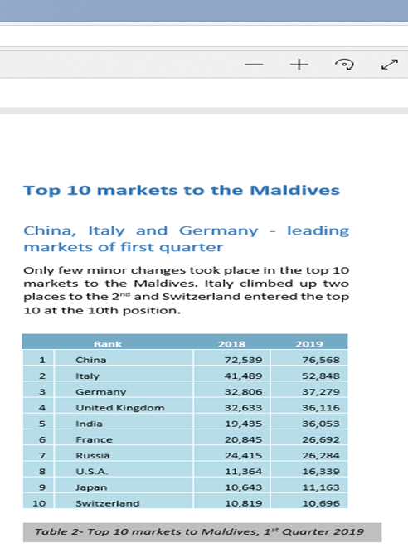
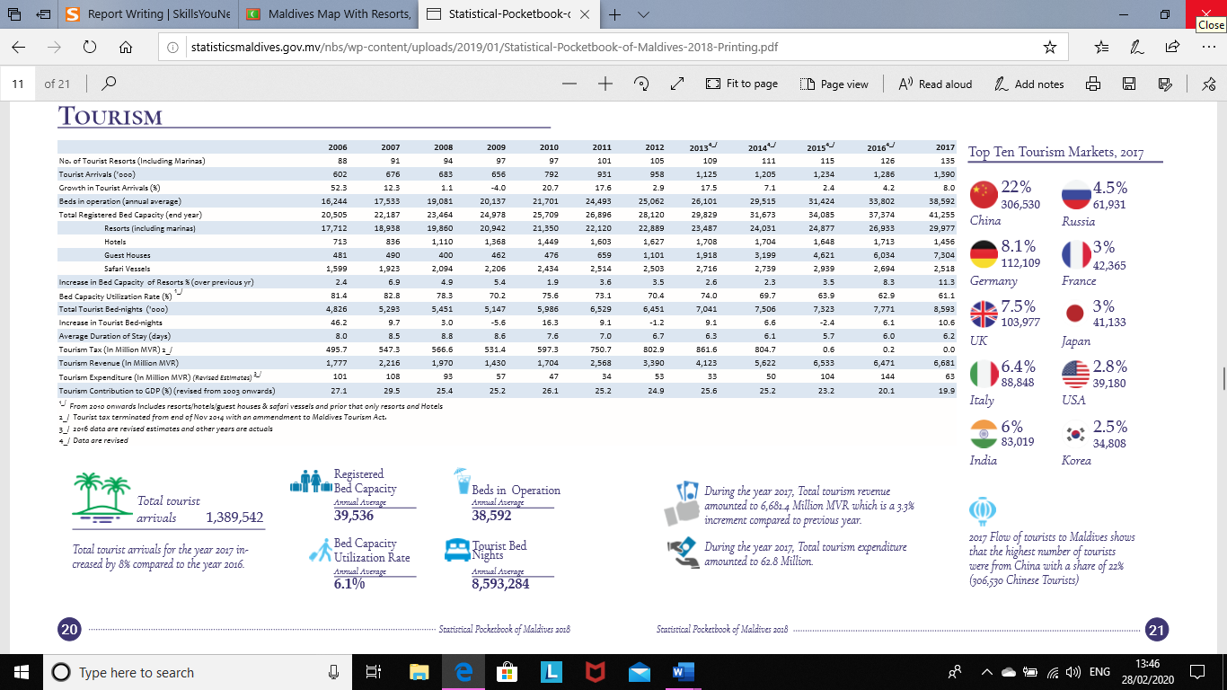

(Tourism Update, 2019)
(Statistics Maldives, 2018)

Types of Tourists
Stanley Plog has suggested he can put individuals into a series of types, which influences their holiday choice. The first type is Psychocentric, these individuals are wary of new places and certain destinations, get nervous of travelling and seem to go back to the same destinations. The second type is Allocentric, these individuals are very outgoing, they are adventurous and like to visit new and unique destinations. Plog also suggests there is a middle type, this is called Midcentric, most of the population would fall under this category (C Cooper, 2005). Cohen also split individuals into types, the organized mass tourist, the individual mass tourist, the explorer and the drifter. As can be seen from the picture below these range from individuals who go to familiar places and are purchasing ready-made package deals, to individuals who are more outgoing and looking to get out of their comfort zone (A Beaver, 2012).

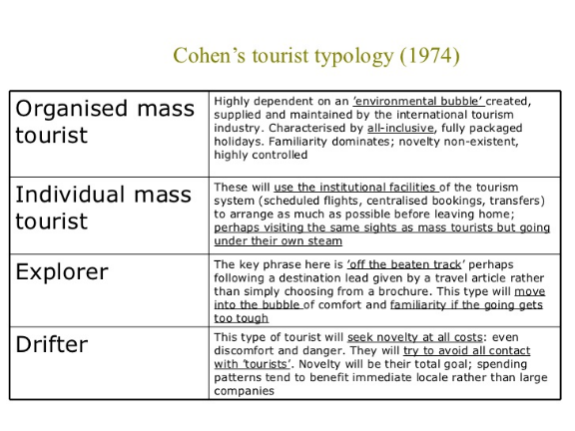
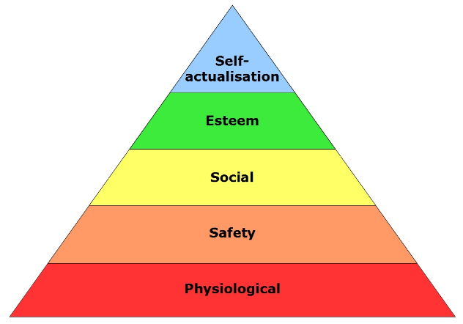

(Slide Share, 2011)
(Careers in Theory, 2010)

Key Stakeholders
The Maldives is vulnerable to climate change, a company called Mangroves for the Future are helping the Maldives to adopt a national Integrated Coastal Management approach that fully responds to and advances the Maldives National Adaptation Programme of Action on climate change. MFF is supporting awareness raising of climate change at island level. Tourism, the largest contributor to GDP, is based on the health and attractiveness of the Maldives’s coastal features (Mangrove for the Future, 2014). There are fifteen other key stakeholders such as, Atoll Ecosystem Conservation, Ministry of Fisheries Agriculture and Marine Recourses, Marine Research Centre, Ministry of Environment Energy and Water, Ministry of Tourism and Civil Aviation, Education Development Centre, Ministry of Housing and Urban Development, Maldives Association of Tourism Industry, United Nations Development Program, Project Monitoring Unit, Environmental Impact Assessment, Baa Atoll Ecosystem, Ministry of Construction and Public Infrastructure, Ministry of Planning and National Development and Environment Research Center (Stakeholder Analysis Report, 2008).
Transport
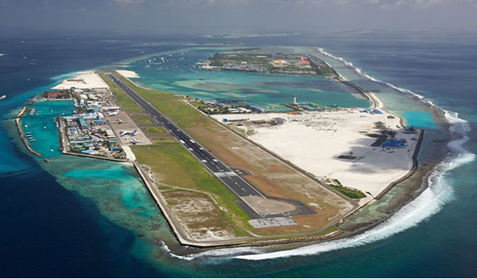
Bus services are available in the Maldives but only along certain routes, such as the airport. Buses in the Maldives are mainly for transporting people to and from the airport. Taxis are easily available in the capital of the Maldives Male, two of the popular taxi services are Fine Taxi and J.R. Taxi Services. The Maldives is one of the few countries in the world that has a seaplane as a mode of transport, it is the fastest method to get around the islands and provide a scenic and beautiful view of the islands. Two of the major companies that provide seaplanes are Trans Maldivian Airways and Maldivian Air Taxi. As the islands are small tourists do not need to hire a car while staying in the Maldives. The Maldives have no train lines. The Maldives main mode of transport is boats and ferries, there is more sea space than land space, so boats are very important in the Maldives (Transport Maldives, 2020). The Maldives also has 4 main airports, Ibrahim Nasir International Airport, Gan International Airport, Hanimadhoo International Airport and Vila International Airport (International Airports in Maldives, 2017).

(My News Desk, 2015)

Popular Tourism Attractions
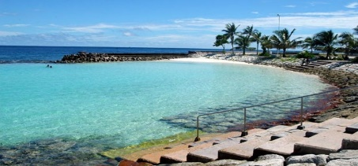
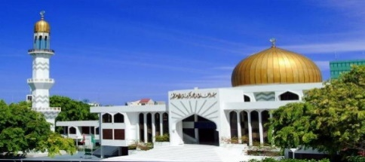
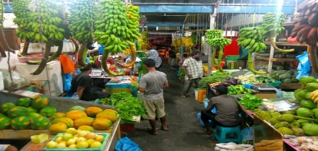
The beautiful islands are normally the main reason tourists visit the Maldives, but there is still plenty of attractions and experiences for the tourist. If the tourist is looking to experience a bit of the Maldivian culture, they can visit the Male Local Market, here they can buy foods that they wouldn’t normally buy in their country and understand the local’s culture more. If the tourist is visiting for religion the Maldives has several mosques, Grand Friday Mosque in Male has a large golden dome which is the main attraction of the mosque, the mosque has outstanding architecture and carvings. A lot of visitors who visit the Maldives go to relax and unwind, these visitors would have plenty of beaches to choose from, but The Artificial Beach is a unique visitor attraction. This beach is manmade but still a unique and beautiful place to visit. Another attraction visitors could visit is the National Museum, this museum was built with the purposing of preserving history, the museum houses a variety of items that belonged to the Sultans of ancient Maldives. Other collections include old coins, armors used in fights, furniture, shoes, embellishments, royal antiques, master art pieces and much more (Trip Advisor, 2020). The Maldives has many tourist attractions, they can suit everyone’s needs and wants.

(Fox News, 2018)
(Cush Travel, 2017)
(Trip Advisor, 2020)
Impacts of Tourism
Tourism can have a negative impact on locals because a large portion of the resorts are owned by foreign companies and that means that the locals of the Maldives won’t be receiving a high percentage of the money because it would’ve gone overseas. These foreign countries have their own marketing departments and they contract out their rooms to large tourist groups, this makes it harder for the local agencies to attract tourists because of the competition. Another negative tourism can have on the Maldives is the local’s interaction between locals, there is a greater inequality in wealth, and this is shown by the local individuals who own resorts. Another negative social impact can be shown by Doxeys Irridex, Doxey created four stages to show the residents response to tourism, these are, Euphoria: Residents and guests are happy because a few visitors come to appreciate the destination.
Apathy: Residents and guests start to take each other for granted.
Annoyance: While guests are having a positive economic impact, residents are getting frustrated with the guests.
Antagonistic: As traffic, noise, pollution and competition for recourses increase, they openly protest tourism (Tourism Nerd, 2019).
The Maldives residents are not in the antagonistic stage, but tourism is affecting the environment and residents might want less tourism to prevent this. Tourism can have a negative effect on the environment, many tourist activities such as snorkeling, diving and overfishing are slowly deteriorating the eco systems. The coral reefs are being damaged by divers, the reefs are a main part of tourism for the Maldives because many visitors want to see the reefs, if they get damaged, they will no longer attract tourists and the inhabitants of the reefs will be threatened. Also, during the construction of resorts trees were removed, this causes erosion because the trees were what held the sediment in place (Maldives Tourism, 2020).
There are also many positive impacts made by tourism, more jobs for the locals, learning new skills and understanding different cultures, more money for the economy and more help off different companies.
Recommendations
The main recommendation for the Maldives would be to put in place rules and regulations to protect the islands, sea and the reefs. They don’t need to stop people diving, fishing and snorkeling but they could make only certain areas place to do these activities or only certain times for these activities, so they don’t have so many tourists damaging the beauty of the Maldives. If the Maldives, follow the 7 P’s of marketing this could help them with getting more tourists in and getting the right tourists to the Maldives.
7 P’s:
. Product
. Price
. Promotion
. Place
. Packaging
. Positioning
. People (Entrepreneur Europe, 2004).
Conclusion
So, the Maldives is a beautiful, eye catching luxury holiday destination, like all places the Maldives has issues and tourism can cause negative impact on the environment but with rules and regulations these negative impacts could stop or slow down. Many people see the Maldives as a dream holiday destination, with the right marketing and deals there could be a rise in visitor numbers. There are plenty of activities for every visitor and different fascinating ways to learn about the Maldives culture. With the help from tourism and the key stake holders Maldives could stay a beautiful destination for the foreseeable future.

References
Advisor, T. (2020), ‘Trip Advisor’, [Online]. Available: www.tripadvisor.co.uk, [2020, March, 7th].
Beaver, A. (2012). A Dictionary of Travel and Tourism, Oxford University Press, Oxford.
Cooper C, Fletcher J et al (2005), Tourism Principles and Practice (3rd Edition), Pearson Publication, England.
Europe, E. (2004), ‘Entrepreneur Europe’, [Online]. Available: www.entrepreneur.com, [2020, March, 8th].
Finest, M. (2019), ‘Maldives Finest’, [Online]. Available: www.maldivesfinest.com, [2020, February, 28th].
Future, M. (2014), ‘Mangrove for the Future’, [Online]. Available: www.mangroveforthefuture.org, [2020, March, 6th].
Haleem, A. (2008), ‘Stakeholder Analysis Report’, [Online]. Available: www.broffice.gov.mv, [2020, March, 6th].
Maldives, I. A. I. (2017), ‘International Airports in Maldives’, [Online]. Available: www.budgetresortsmaldives.com, [2020, March, 6th].
Maldives, T. (2020), ‘Transport Maldives’, [Online]. Available: www.yatra.com, [2020, March, 6th].
Maldives, V. (2020), ‘Maldives the Sunny Side of Life’, [Online]. Available: www.visitmaldives.com, [2020, February, 17th].
Theories, L. (2020), ‘Learning Theories’, [Online]. Available: www.learning-theories.com, [2020, March, 4th].
Tourism, M. (2020), ‘Maldives Tourism’, [Online]. Available: www.11yeargeoleileikung.weebly.com, [2020, March, 7th].
Villanovo. (2020), ‘Villanovo’, [Online]. Available: www.villanovo.com, [2020, February, 28th].

Picture References
Desk, N. M. (2015), ‘My News Desk’, [Online]. Available: www.mynewsdesk.com, [2020, March, 6th].
Edit, H. (2013), ‘Homedit’, [Online]. Available: www.homedit.com, [2020, February, 17th].
Finest, M. (2017), ‘Maldives Finest’, [Online]. Available: www.maldivesfinest.com, [2020, February, 18th].
Maldives, S. (2018), ‘Statistics Maldives’, [Online]. Available: www.statisticsmaldives.gov.mv, [2020, March, 1st].
Me, H. (2018), ‘Holiday Me’, [Online]. Available: www.holidayme.com, [2020, February, 18th].
Nerd, T. (2019), ‘Tourism Nerd’, [Online]. Available: www.tourismnerd.com, [2020, March, 7th].
News, F. (2018), ‘Fox News’, [Online]. Available: www.foxnews.com, [2020, March, 7th].
News, T.M. (2011), ‘Maldives Travel News’, [Online]. Available: www.maldivestravelnews.blogspot.com, [2020, February, 17th].
Share, S. (2011), ‘Slide Share’, [Online]. Available: www.slideshare.net, [2020, March, 4th].
Theory, C. (2010), ‘Careers in Theory’, [Online]. Available: www.careersintheory.wordpress.com, [2020, March, 4th].
Travel, C. (2017), ‘Cush Travel’, [Online]. Available: www.cushtravel.com, [2020, March, 7th].
Update, T. (2019), ‘Tourism Update’, [Online]. Available: www.tourism.gov.mv, [2020, March, 1st].
Wallpapers, B. (2014), ‘Bwallpapers.com’, [Online]. Available: www.bwallpapers.com, [2020, February, 17th].

