
Research, Design and Production of a Home Security System for Private Home Use

by
Samuel Jay Lloyd (2110666)

Supervisor: Steve Mosley

Project submitted as part of the requirements for the award of
BEng (Hons) Embedded Electronic Systems

October 2024

Contents
Project Aim 3
Background for proposal 3
Literature Review 3
Project Objectives 6
Required resources 7
Planned Timings 8

Figure 1: Ring’s Doorbell Range [4] 4
Figure 2: Ring’s Camera Range [4] 4
Figure 3: SANSCO Camera Setup example [5] 5
Figure 4: SimpliSafe Basics [6] 5
Figure 5: SimpliSafe Additional Options [6] 6
Figure 6: Project Gantt Chart 9

Project Aim
The aim of this project is to research, design and produce a working modular home security system. The design will be created using research on current systems and customer desires. The system will aim to be simple to install, not have any monthly fees like existing systems, while remaining as secure as possible.

Background for proposal
What is the importance of a home security system? Home security systems aim to protect yourself, your family, home and possessions from any hazards that could occur, whether this is robberies, fires, leaks or anything else. These are all risks that are relevant for a security system to aid in, now with all the sensors available these are all monitorable and combined on one singular system.
This is a massively growing market over the last 20 years, the effect of this can be seen in the number of reported home robbers occurring [1], the numbers of recorded offences in 2002/03 being around 890,000, compared to the value being 266,000 in 2023/24. A similar trend can also be seen in the US [2], there is a clear trend that with the growing market of home security increasing and the rate of household robberies decreasing [3].
For this proposal the aim will be to research, design and build a home security system aimed for use within private homes, being a cheaper alternative option that requires no monthly fees. To complete this, research will be carried out on similar products, examining how they work, then talking to potential future customers assessing what they would look for in a product. Then design and build a working product, the current aim will be to produce a main module and 3 additional modules, an outdoor camera, an indoor camera and a window/door monitor which when the alarm is set, will trigger when opened and send an alert to the owner. Some of these modules may change build priority depending on the results of the customer surveys, as for example they may decide that indoor cameras are not as highly valued as a glass breaking monitor, a leak detection system or a fire detector that can fit in the system.

Literature Review
Within the home security market there are a range of current options that exist that all have different approaches to the task. Some of these products come with a central hub, some with an app setup, meaning no hub is needed as the storage is all cloud base, but these systems then come with a monthly fee. Some systems are only cameras, some are more, coming with motion, entry and glass break sensors. Below some of these will be discussed looking at how they approach the same goal in different methods.
Firstly, Ring [4], this has many options throughout the household with internal and external cameras with a variety of built in options, a range of doorbells with a built-in camera, microphone and speaker, seen in Figure 1, a range of camera units, seen in Figure 2, and other additional products. These products can all be accessed for live viewing using the company app and additionally the data is stored on their cloud service for 180 days. This comes with the negative of having a monthly fee, a high upfront cost, as well as the products price which are battery powered, they have not been made with any regenerative ability, which means the batteries need to be replaced. In general, this is a more expensive device but are very high quality.
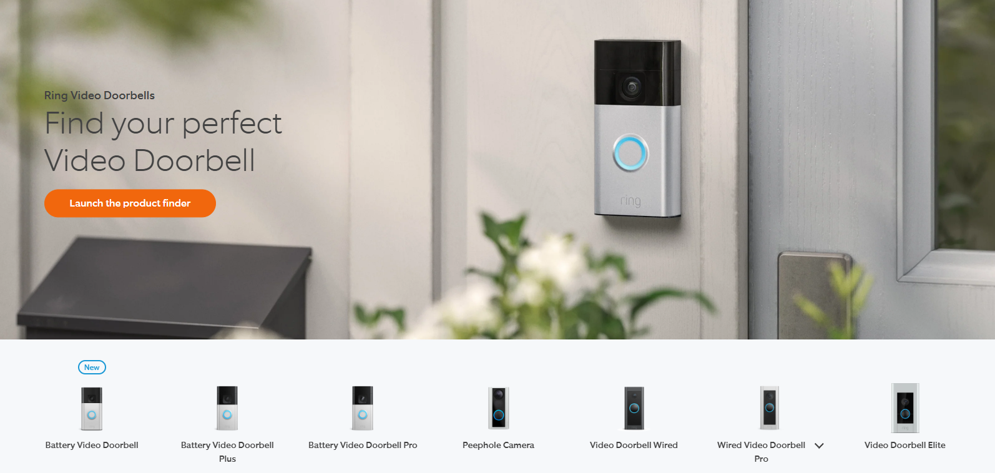
Figure 1: Ring’s Doorbell Range [4]
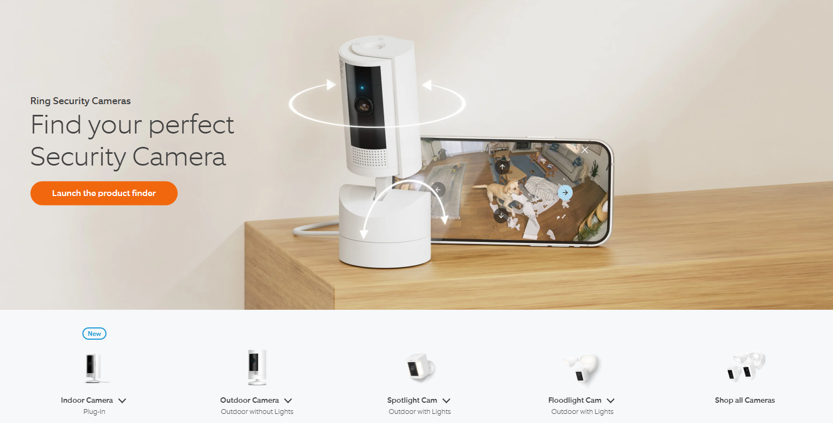
Figure 2: Ring’s Camera Range [4]
Another product is the SANSCO 5MP 8 Channel DVR Outdoor CCTV Camera System [5], this uses a similar technique that is the aim for video data storage. This default can store 1 week of video before wiping, cameras are additionally setup with an alert that is caused if there is any movement within a set area. The negative of this is all the cameras require to be hard wired into the system, the recording is done 24/7 rather than when a sensor is triggered, meaning more data is created than may be desired.
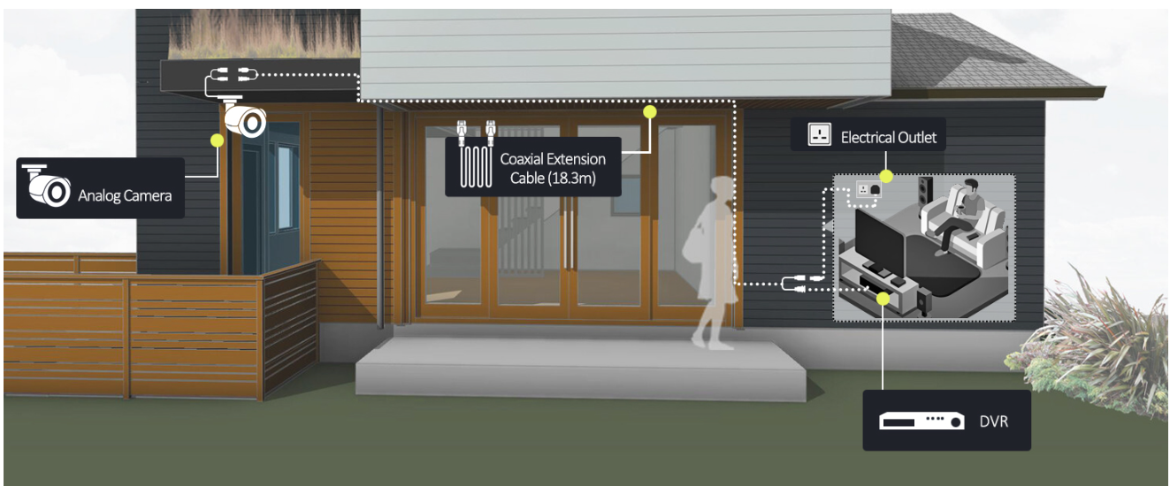
Figure 3: SANSCO Camera Setup example [5]
Another solution like the aim of this project is SimpliSafe [6], this is a modular system where a user can select the sensors they would like to have and purchase these, for example keypads, cameras, motion sensors ect, the basics seen in Figure 4, with other hazard sensors seen in Figure 5. The advantages of a system like this are that it can be custom built and is a cheap price, this also comes with a monitoring team that will alert you and the authorities if any alarms such as burglary are triggered. This comes with the negative of requiring a monthly free.
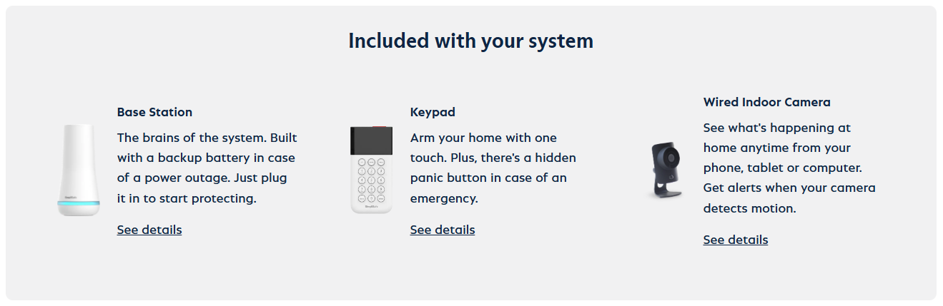
Figure 4: SimpliSafe Basics [6]
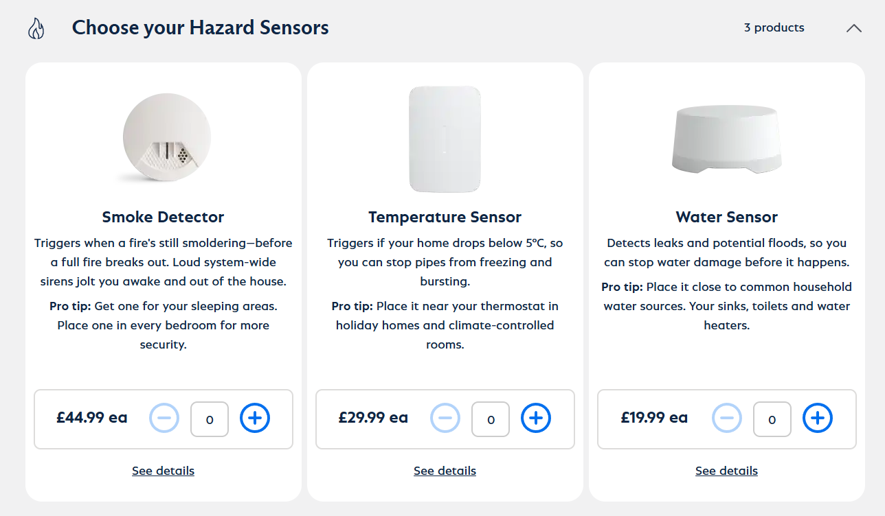
Figure 5: SimpliSafe Additional Options [6]

Project Objectives
The objectives of this project are:
- Carry out further research into current security systems, looking at the positives and negatives and what kind of products they are creating. Additionally gathering further information from various possible customers, gaining insight on their demands of how a system should operate and gaining knowledge on what modules are desired and other parts of the system.
- Look into the standards surrounding the handling and storage of video data and any other standards that may be relevant.
- After collecting all this information, design and create a control module considering the following:
  - Simple for a customer to set up and add/remove future modules from the system.
  - Allow for a simple alarm setup to be available, allowing for all sensor to be setup and when triggered create an alert.
  - Design and produce a method of communication for modules to the main hub which will allow for video and other information to be passed rapidly, further research need to be carried out on if this is safer to transmit wirelessly or not, this is due to the possible security concerns around wireless, but the complications wired adds to the user and the setup.
  - Identify how the module should operate if a power out was to occur.
  - Identify how data will be generated, how it will be stored and how long it should be stored for, this will likely mean having a basic data storage technique with an option for this to be upgraded depending on the customer’s needs.
  - A prospect for other things to be added in the future depending on the research phase and the customer requirements received.
- While concurrently designing and creating any additional modules considering the following:
  - How to power the module? This will likely vary in different modules, for example outdoor modules may be able to use solar panels to recharge, whereas modules like an indoor camera will require mains power or use of batteries, but then may require a sensor to monitor battery state and report to the hub if low.
  - How should the information be passed back to the main module? For ease of setup for the user, the best thing to do would be to create a wireless setup, but then when considering security, wired cameras are more secure due to the complications this causes if someone wants to prevent them from operating or to infiltrate them. Another consideration is Power Over Ethernet (POE), this would be simple for the user to setup and power the devices however has the negative of the system not operating if a power out was to occur. During the design phase a decision will be made on what is the best decision for each module.
  - Identify how camera modules should save data? Should this be 24/7? When the alarm system set? Only when another sensor such as motion or PIR are set high? Or another solution?
  - Additionally identify what other modules that are customers most likely to use? Would an indoor camera be desired? If so, is this always on or only when an alarm is set? Is there window and door alarms? And any other potential sensors that customers would look to use.

Required resources
The required resources for this project will include:
- Python
- C++
- Linux OS for PI
- Peripherals for PI
- Arduino IDE for ESP32
- ESP32 cable for programming
- For PCB production (If PCB is required)
  - Proteus
  - Easy PC
  - Soldering iron
  - fume extraction
- PIC programming (If PIC is chosen)
  - CCS
  - MPLab
  - PIC kit

Planned Timings
Below in Figure 6 you can see the Gantt chart for the planned timings spent on each part of the project. Additionally, the actual time taken will be added to this sheet later to show the comparison of how long this really took compared to the plan.
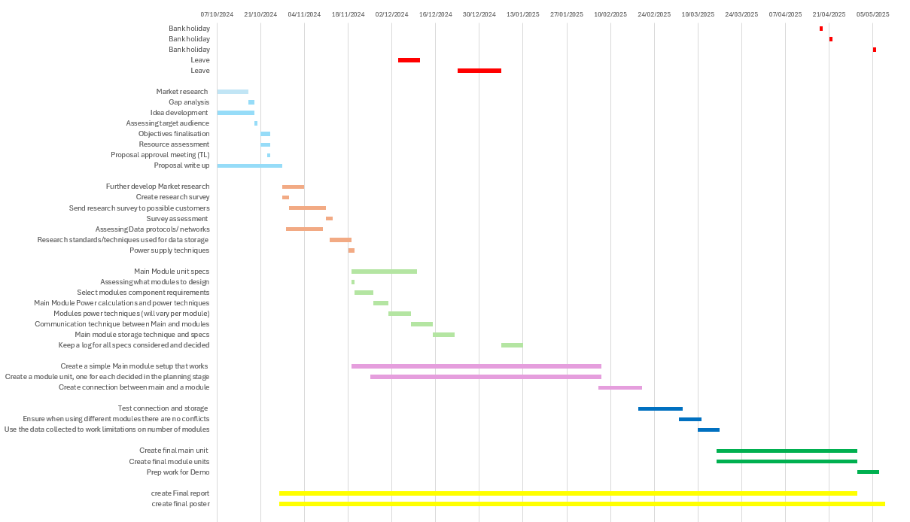
Figure 6: Project Gantt Chart

References
[1] | D.Clark, Number of police recorded burglary offences in England and Wales from 2002/03 to 2023/24, https://www.statista.com/statistics/956906/burglaries-in-england-and-wales/: Statista, Jul 24, 2024.
[2] | R. B. Nyahne Bergeron, Home security statistics 2024, https://www.consumeraffairs.com/homeowners/home-security-statistics.html: ConsumerAffairs, March 2024.
[3] | D. Carter, How Effective Are Home Alarm Systems, https://storables.com/home-security-and-surveillance/how-effective-are-home-alarm-systems/, October 2024.
[4] | Ring, Ring webpage, https://en-uk.ring.com/?utm_source=bing&utm_medium=cpc&utm_campaign=UK_English_Search_Brand_Core_Exact_Google_CPC&utm_content=Core_Exact+%2F+ring&utm_term=ring&utm_source=bing&utm_medium=cpc&utm_campaign=UK_English_Search_Brand_Core_Exact_Google_CPC&utm_c.
[5] | Amazon, SANSCO data, https://www.amazon.co.uk/dp/B00BPMGUEC?tag=georiot-trd-21&th=1&ascsubtag=trdpro-gb-6044690710933138796-21&geniuslink=true.
[6] | SimpliSafe, The Pembroke, https://simplisafe.co.uk/home-security-system-pembroke?gclid=337cffa134691eedba7198ac202914b2&gclsrc=3p.ds&&utm_id=430071942_1241348908267087_&msclkid=337cffa134691eedba7198ac202914b2&utm_source=bing&utm_medium=cpc&utm_campaign=Shopping%20(Non-Brand)&utm_.

