Amber Mole (2403613)
Bmlw4008
From learning to earning: future career planning

Table of Contents
Success in the Workplace 2
CV 3
Covering Letter 4
LinkedIn Profile 5
Reference List 6

Success in the Workplace
When working everyone looks to be successful in their area of career and their skill set however, how does one become successful and what steps can be taken to rise in the workplace.

According to the National Careers Service (2025a), volunteering is an effective way for one to not only climb up the ladder in the workplace but to make a rational decision on what career path to take. Volunteering is beneficial also to help people develop new and relevant skills or to develop skills one already possesses which can be needed or preferred in the work they are interested in pursuing. Coming from Royal Voluntary Service (2025), volunteering is a beneficial way to prove to future employers that a person is passionate about the cause and that they are committed to working. This can be favoured when employers are looking through, they’re application.
Furthermore, Indeed (2025), volunteering can provide many chances for the person to meet people in the field of work that they are interested in, these people may end up becoming part of the persons network, these connections later down the line may be able to help grow a person’s job prospects.
Moreover, volunteering can increase a person’s self-esteem and confidence, coming from Citizens Advice (2025),
Overall volunteering can help increase a person’s confidence and self-esteem, their connections with people who are involved in their chosen or aspiring career path and can help to develop new or current skill sets. Volunteering is seen as an important factor of success in the workplace as it helps develop and shape the individual in many ways leading to them not only being a good colleague and employee but a great one with many favoured qualities.

Moving on, another factor that can lead to success in the workplace according to the Cabinet Office (2025) is experience. Experience is a good indicator of the fit a person is for the role they are applying or being assessed for. For example, Cabinet Office (2025) state that when looking at a person’s experience, they focus on ‘previous examples of things you have achieved, your knowledge in a particular field which is relevant to the job role, how you performed in a particular field not how long you served for’. Some examples of ways experienced can be gained are volunteer work, group or class projects, past employment and skills that someone may have gained through hobbies or school (National Careers Service,2025b)
Experience is not necessarily something that is learnt before entering a job. For example, many people learn on the job and case experience by having the self-esteem and confidence to ‘give things a go’ and learn from the achievements or mistakes. According to Industry Training Fedaration (2011), learning from experience is vital and employees with less experienced can be supported with ‘scaffolding’ by more experienced employees. The more experienced employee will slowly begin to ‘dismantle the scaffolding’ and allow the learner to complete some tasks on their own until they feel they are cable of completing the tasks without any support.
Overall, the word ‘experience’ in the workplace can have more than one meaning, for example learning on the job or past experience a person has like past employment or how someone has performed in a particular field. This can lead to success in the workplace as employers are more likely to hire a person if they have more experience which demonstrates the persons fit for the role, furthermore, if the individual can demonstrate their capability to learn and open-mindedness whilst on the job, they may be more likely to move up in the workplace due to their ability to learn and deep understanding of the job.

Lastly, time management is an important factor of being successful in the workplace, according to Aeon et al (2021) meta-analysis, time management is moderately related to a person’s job performance. The result of the meta-analysis suggests that ‘time management enhances job performance, academic achievement and wellbeing.’
Coming from Charity for Civil Servants (2025), time management can help a person productivity and work success while also decreasing a person’s stress and depression. It is also stated that by working on an individual’s time management it can help to address the ‘bigger picture’ and what a person wants to prioritise not only in life but in their career and can help set realistic goals to reach their aspirations.
Time management is a quality that is favoured by employers as it demonstrates that the individual knows how to handle a work life balance and is productive by using their time wisely for example, completing tasks by a deadline and producing good quality work in a short time frame.

Many different factors contribute to ‘success in the workplace’ but what can be seen is that it is up to the individual’s commitment, motivation and schedule to be able to gather the qualities to climb in their aspire career pathway.

CV
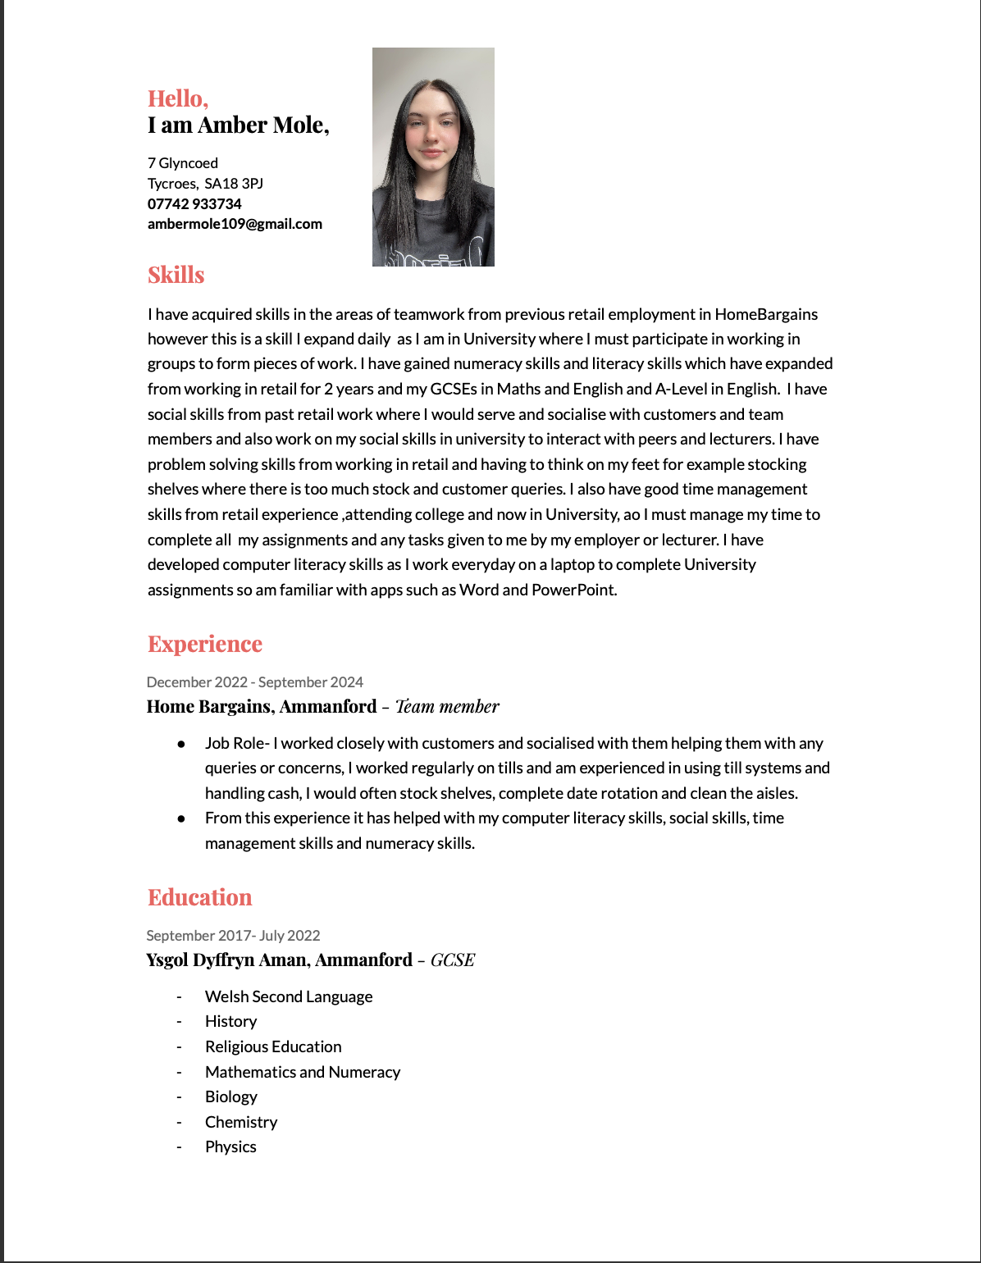
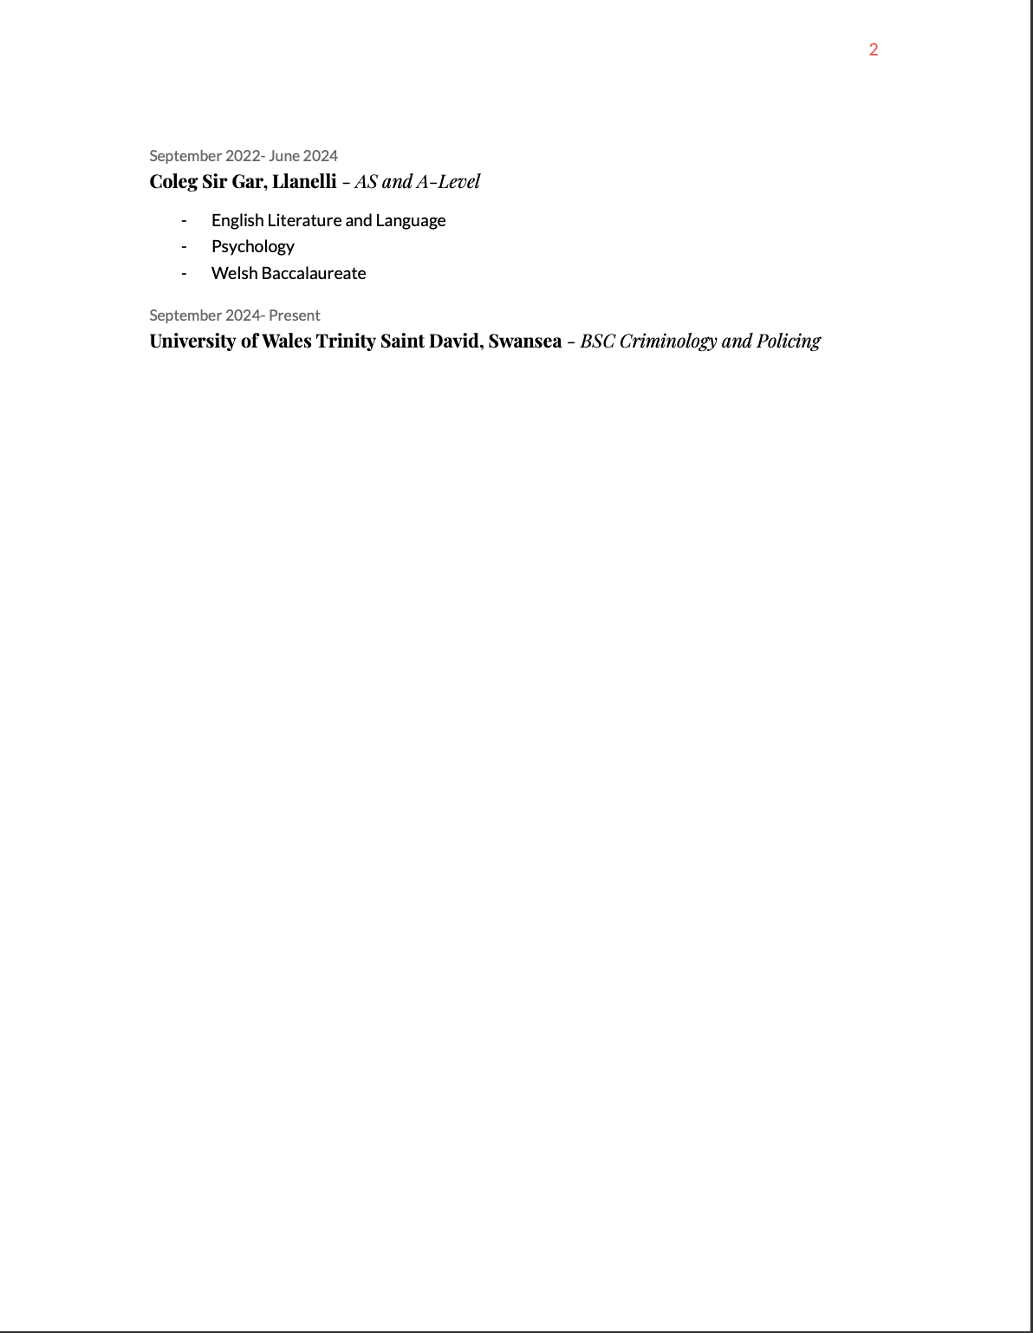

Covering Letter

Dear whom ever it may concern,
I am writing to express my interest in the position at your company. With my experience in retail and the skills I have developed from my retail experience, I am confident that I am able to make a significant contribution to your team.
My previous role at Home Bargains, I was responsible for stocking shelves, serving customers on the main till, dealing with customer concerns and queries and date rotation of food products. I have a strong understanding of teamwork, time management, social skills, numeracy skills, literacy skills and IT skills. I am particularly drawn to your company because of the customer service so I can be of service to the public and help with the best of my ability whilst also broadening my social skills.
I am eager to learn more about the opportunity and how my skills and experience align with the needs of the position at your company.
Thank you for considering my application for the position.
I look forward to hearing from you soon.
Kind regards,
Amber Mole.

LinkedIn Profile
https://www.linkedin.com/in/amber-mole-b156a6357/?trk=opento_sprofile_topcard
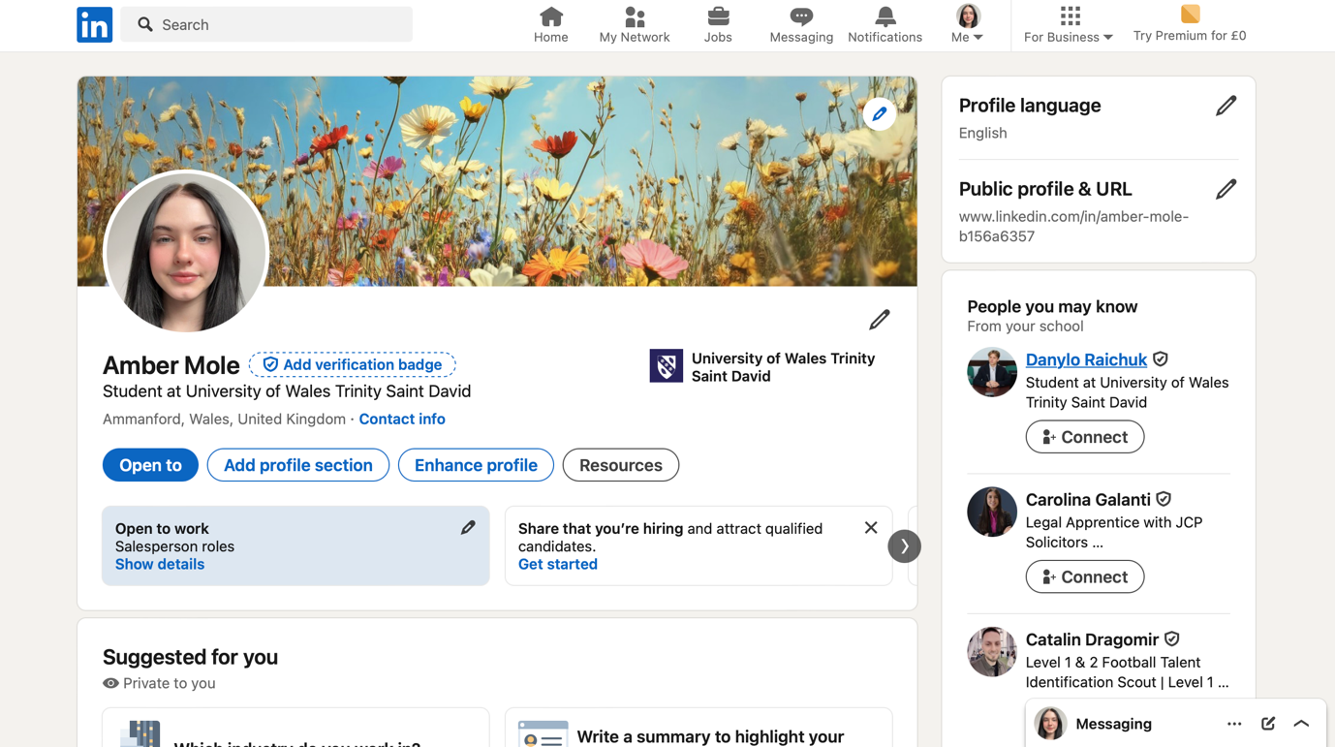

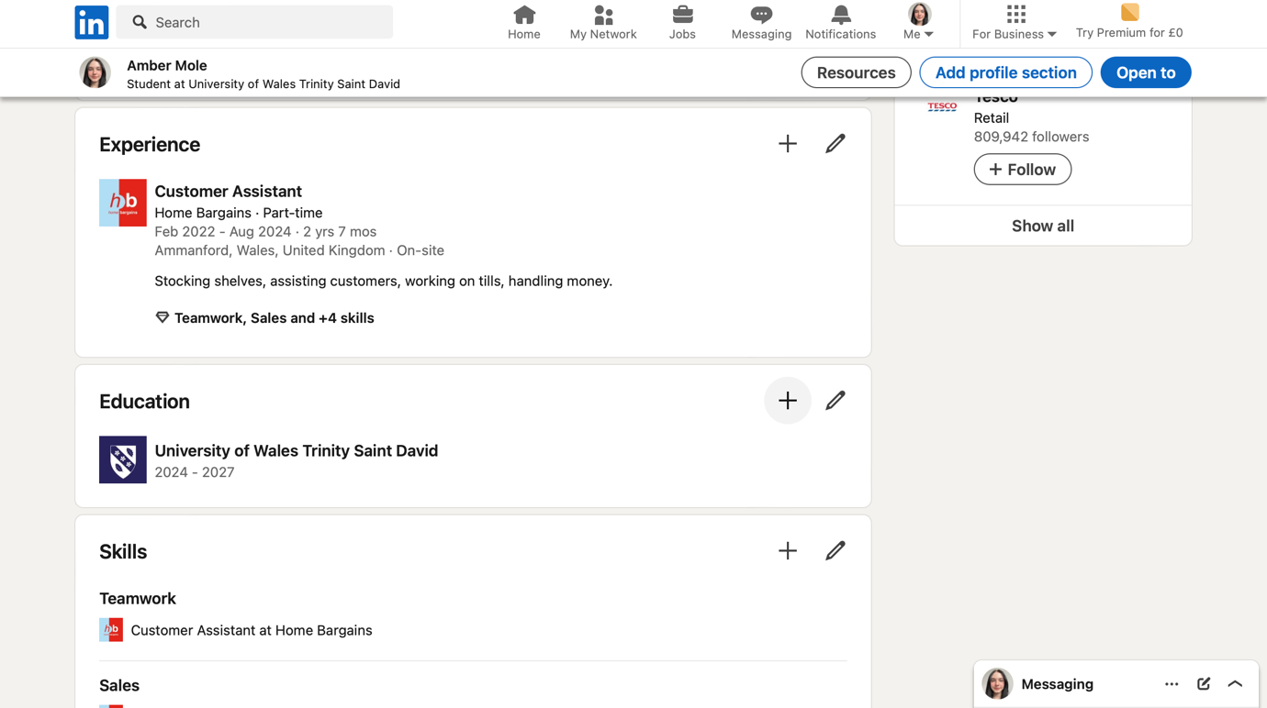

Reference List
Aeon, B, Faber, A, Panaccio, A (2021) ‘Does time management work? A meta-analysis’ 16(1) Available at: https://pmc.ncbi.nlm.nih.gov/articles/PMC7799745/
Cabinet Office (2025) Success Profiles: Experience. Available at: https://www.gov.uk/government/publications/success-profiles/success-profiles-experience?_ga=2.127196621.1758608276.1745942999-908741826.1745942999 (Accessed: 25th April 2025)
Charity For Civil Servants (2025) Time Management. Available at: https://www.cfcs.org.uk/help-advice/health-and-wellbeing/wellbeing-at-work/time-management/ (Accessed : 30th April 2025)
Citizens Advice (2025) Understanding the benefits of volunteering, Available at: https://www.citizensadvice.org.uk/about-us/information/understanding-the-benefits-of-volunteering/ (Accessed: 29th April 2025)
Indeed (2025) 12 social, professional and personal benefits of volunteering. Available at: https://uk.indeed.com/career-advice/career-development/benefits-of-volunteering (Accessed: 29th April 2025).
Industry Training Federation (2011) Successful Workplace Learning:How learning happens at work. Available at: https://d1wqtxts1xzle7.cloudfront.net/63015149/Successful_Workplace_Learning_How_learni20200419-22052-1cyfslj.pdf?1738398444=&response-content-disposition=inline%3B+filename%3DSuccessful_workplace_learning_how_learni.pdf&Expires=1745947226&Signature=V4NYB9lJprDcoT00ld4tzdwvk6PO9Xk6ouJ30966deauWoowH831vV1CYkZEUSHSjUNFQPWDiBvCm89~if-zJf-k1EClQUpv4X1x31dGw8tcQ3LMWQX8jwd1Na~~L8tufvl4uNWNsKeQ6Z744XKsvVHLq9ZllNQAb0-Uib4c13FtYdBIWL~Ji18EFS93~Zua~W0XF98rrbqTzhwfLLNNORtriKj87UiBXlAyyAGaY0pjm5PyusVWOlmxZkZtD2-1iJ~ntNs1gb0GkBNDbOkLuoLSQ79-BoqVCmr4yVY85v4hOAp-~h2mgE3xtpTo4dqQGUcKCgG3PM9yRsGE8~vhQA__&Key-Pair-Id=APKAJLOHF5GGSLRBV4ZA
National Careers Service (2025b) How to get work experience. Available at: https://nationalcareers.service.gov.uk/careers-advice/types-of-work-experience (Accessed: 24th April 2025)
National Careers Service (2025a) Volunteering advice. Available at: https://nationalcareers.service.gov.uk/careers-advice/advice-on-volunteering (Accessed: 29th April 2025)
Royal Voluntary Service (2025) Benefits of volunteering. Available at: https://www.royalvoluntaryservice.org.uk/volunteering/why-volunteer/benefits-of-volunteering/ (Accessed: 28th April 2025)

