Building Surveying

Semester 3

Reeve Thomas

2419449

Contents

- Introduction
  - The Indispensable Role of Building Surveys
  - Digital Technology
- Building Survey Intents
  - Processes
  - Scope
- Property Assessment Strategy
  - Phase 1
  - Phase 2
  - Phase 3
  - Phase 4
- Instruments & Softwares
  - Theodolites
  - 3D Scanners
  - Thermal Cameras
- Complications & Solutions
- Conclusion
- Referancing

1. Introduction
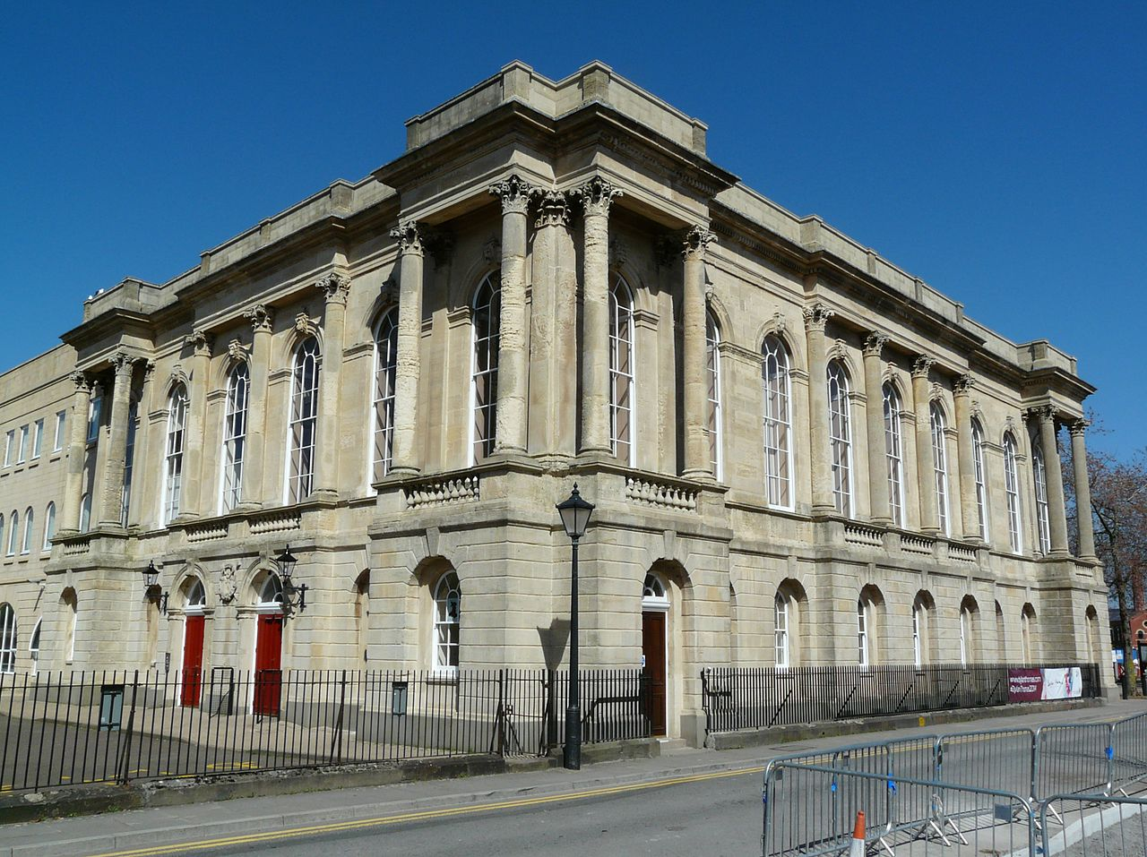

‘Image taken from Wikipedia, produced by Ham’
This assignment is aimed at the Dylan Thomas centre in Swansea. The building was created in 1852, since them times the building has a lot of structural issues. As you can see from the images that I have taken below there are certain cracks going through the building this can be a possibility of subsidence, and the material hasn’t had the proper maintenance as there is a lot of signs of discolouration. This might be due from being close to the sea the saltwater spraying from the water or even the different boat fumes that pass by on a day-to-day bases.
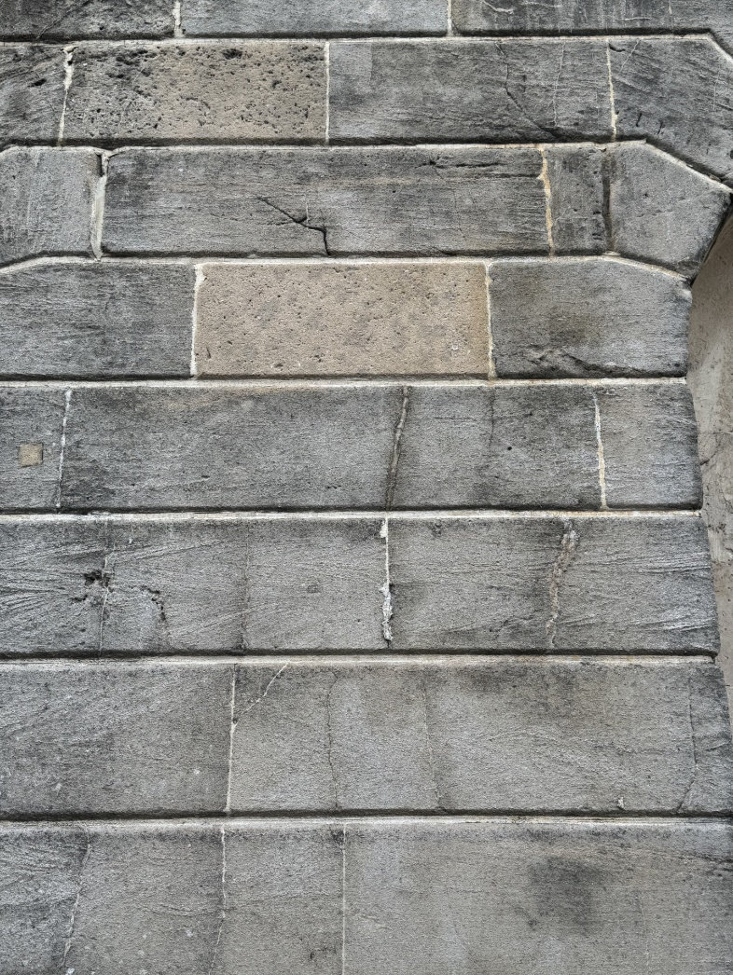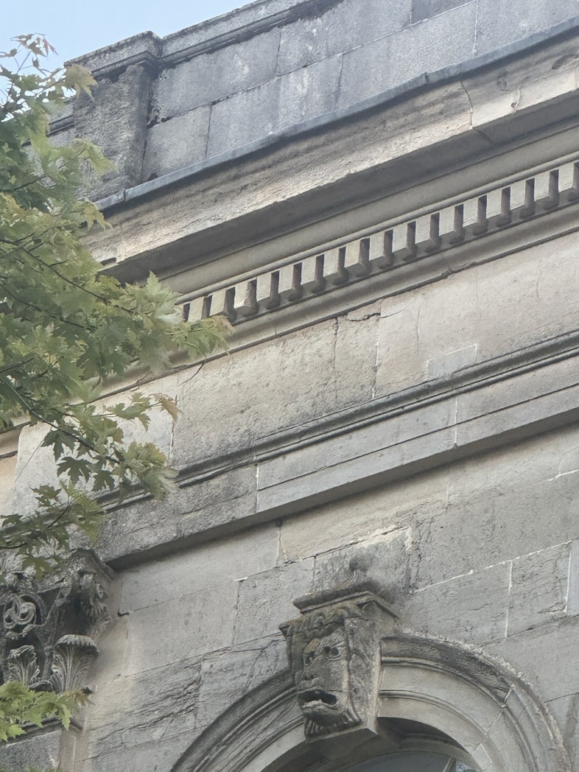

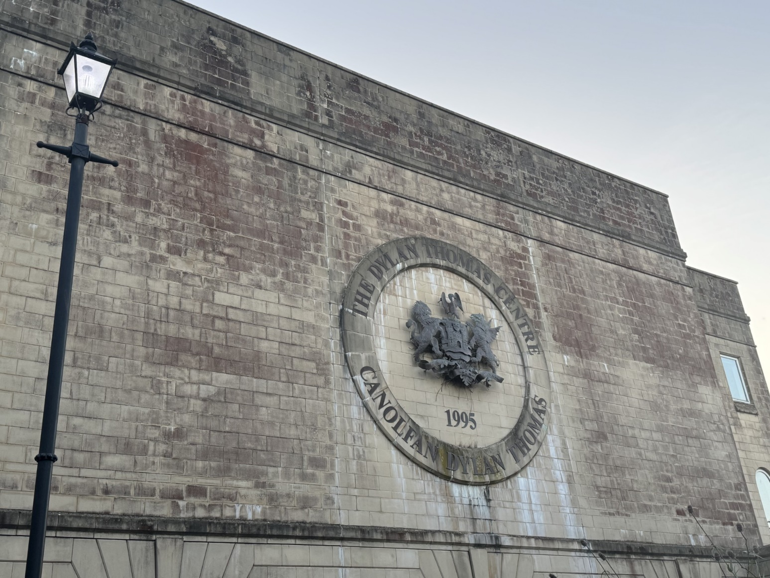

I. The Indispensable Role of Building Surveys

Firstly, when looking at the different building surveys that go on throughout the construction process, they are very crucial across various sectors serving as a cornerstone for informed decision- making and continuous improvement in the construction project.

- They will provide a very detailed assessment of the different building conditions
- It will also help make suggestions about how to make the construction more sustainable
- It can also reveal certain hidden features that can’t be seen when looking at it.
- Building surveys can help the buyer make an offer for the property by evaluating the different issues that are consisted within the building survey.

In conclusion building surveys are very important when it comes to buying or selling a property. As the values can either increase or decrease. It is also important to make sure that the building is safe and meets the recent health and safety regulations.

II. Digital Technology

Digital technology has transformed the art of the building surveys, to be more accurate, efficient and help visualise any project before it is constructed. Traditional ways of conducting surveys heavily relied on manual measurements and paper-based documents. However now days the surveys can be carried out by a number of instruments such as, theodolites, laser levels, 3D scanners and much more the data created by these instruments can be entered into many different building software’s such as CAD and Revit.

2. Building Survey Intents

I. Processes

When looking at building surveying the primary intents can include:

- Assess a condition of a property
- Locate existing or potential defects
- Provide advice on necessary repairs
- Evaluate building systems
- Check the buildings compliance
- Identify safety hazards
- Locate where energy can be more efficient
- And inform decision-making

II. Scope

All of these points sum up what the building survey is all about. These points go into every survey that is carried out including carrying out a survey in the Dylan Thomas centre. This survey will highlight a lot of issues with the building as from the images above there seems like the building is wearing away. I will make sure that I will feed these images into my building survey report to make sure that I have 100% accuracy. The building survey can also help to see what issues are inside the wall and for example leaks. These factors will help the process not just be very accurate but can help with decision making when answers are required. It can also be ideal with a plan on how to fix the issues located by the building survey that we have carried out.

3. Property Assessment Strategy

When looking conducting a building survey on an old building like this one you must have some steps involved to make sure you collate as much data as possible.

I. Phase 1

Firstly, conduct my research on this building to find out about the buildings age as I have already done, its past usage, previous renovations to the building and even the architectural style of the building. To do this I can use a number of research applications and places. Such as the historical map website Digi maps, I can view the different planning applications on the council website, and I can even take a trip to Swansea’s archives. Once I know what we are up against I can then define the areas that need to be surveyed the most to the least. I will also make sure that I check if I need permission to access the different parts of the building.

II. Phase 2

Once phase 1 has been completed the 3D scanner will be placed in a good location to fully capture 1 data set, it will need a good view of building so that we can provide accurate data. We can then start the structural assessment, by examining the foundation, walls, floors and even the roof for signs degradation. When conducting the building survey, as we are going along, I will make sure that I document detailed notes and videos of all findings. Material analysis is also needed when it comes to a building survey, I will identify what type of material it is and its condition. By examining the material, the thermal camera can pick up if there are any signs of moisture for example leaks, water damage and even dampness. With the thermal camera I will also inspect the heating and ventilation systems to check if they are okay and are met with the latest building regs.

III. Phase 3

Furthermore, once the practical parts are done and I am happy with the data that we have collected, we can then start to organise all data and fit the 3D model developed by the laser scanner into place ready for the client to see. When organising data, I can gather them all together and create a detailed report highlighting all issues that have been picked up during the building survey. In the report I will also enter screenshots of the 3D model so that the relevant people know where the discrepancies can be located inside or outside the building and provide recommendations on how to fix the problems at hand I will also enter in the thermal photos taken from the thermal cameras that is picking up any leaks, or any moisture ingress to the building. The theodolite will also provide me with the different measurements of the building so that I can also insert that into the report to demonstrate to the client and the relevant parties so that they know how big the job is going to be. I can also include in the report about how much all of the issues are going to cost to repair, and prioritize various different issues based on the severity and potential impact.

IV. Phase 4

Finally, I will then review the report with the client and stakeholders to answer any questions they may have. When in the meeting I will develop a detailed action plan based on the building survey reports, so that I don’t miss anything from the meeting and waste time querying. I will then implement to the client about the repairs or renovations needed and how much they are going to cost, in line with the building survey report. We also need to make sure to monitor and maintain the buildings condition over a period of time to make sure that there are no issues arise.

4. Instruments & Softwares

I. Theodolites
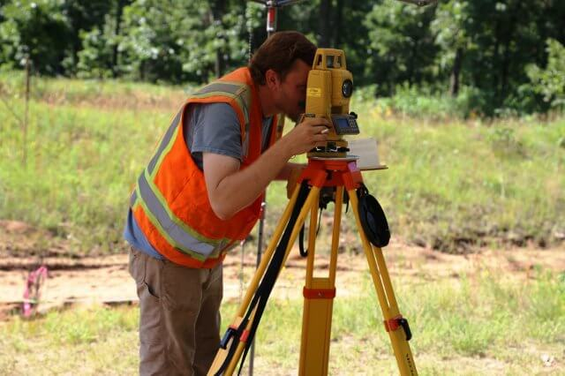

‘Image taken from Civil Today, produced by Army.Mil’
There are a number of different instruments used when creating a building survey this can include theodolites. This instrument can help with measuring horizontal and vertical angles. It can help with determining the relative positions of where the various points in the building are. This is very important when creating maps or plans for the building or the buildings renovation plans.

II. 3D Scanners



‘Image taken from CADS, produced by Iain Tubby’
Moreover, there is also another instrument used such as the 3D laser scanner. This can illustrate more accurate information compared to the theodolite. The instrument will send out up to 3 million lasers a second to measure its surroundings and finally create a scaled 3D model of the building, inside and out, as shown below. This helps create a visual impact for the client to see the final production and for them to add suggestions or questions, to make the building better.
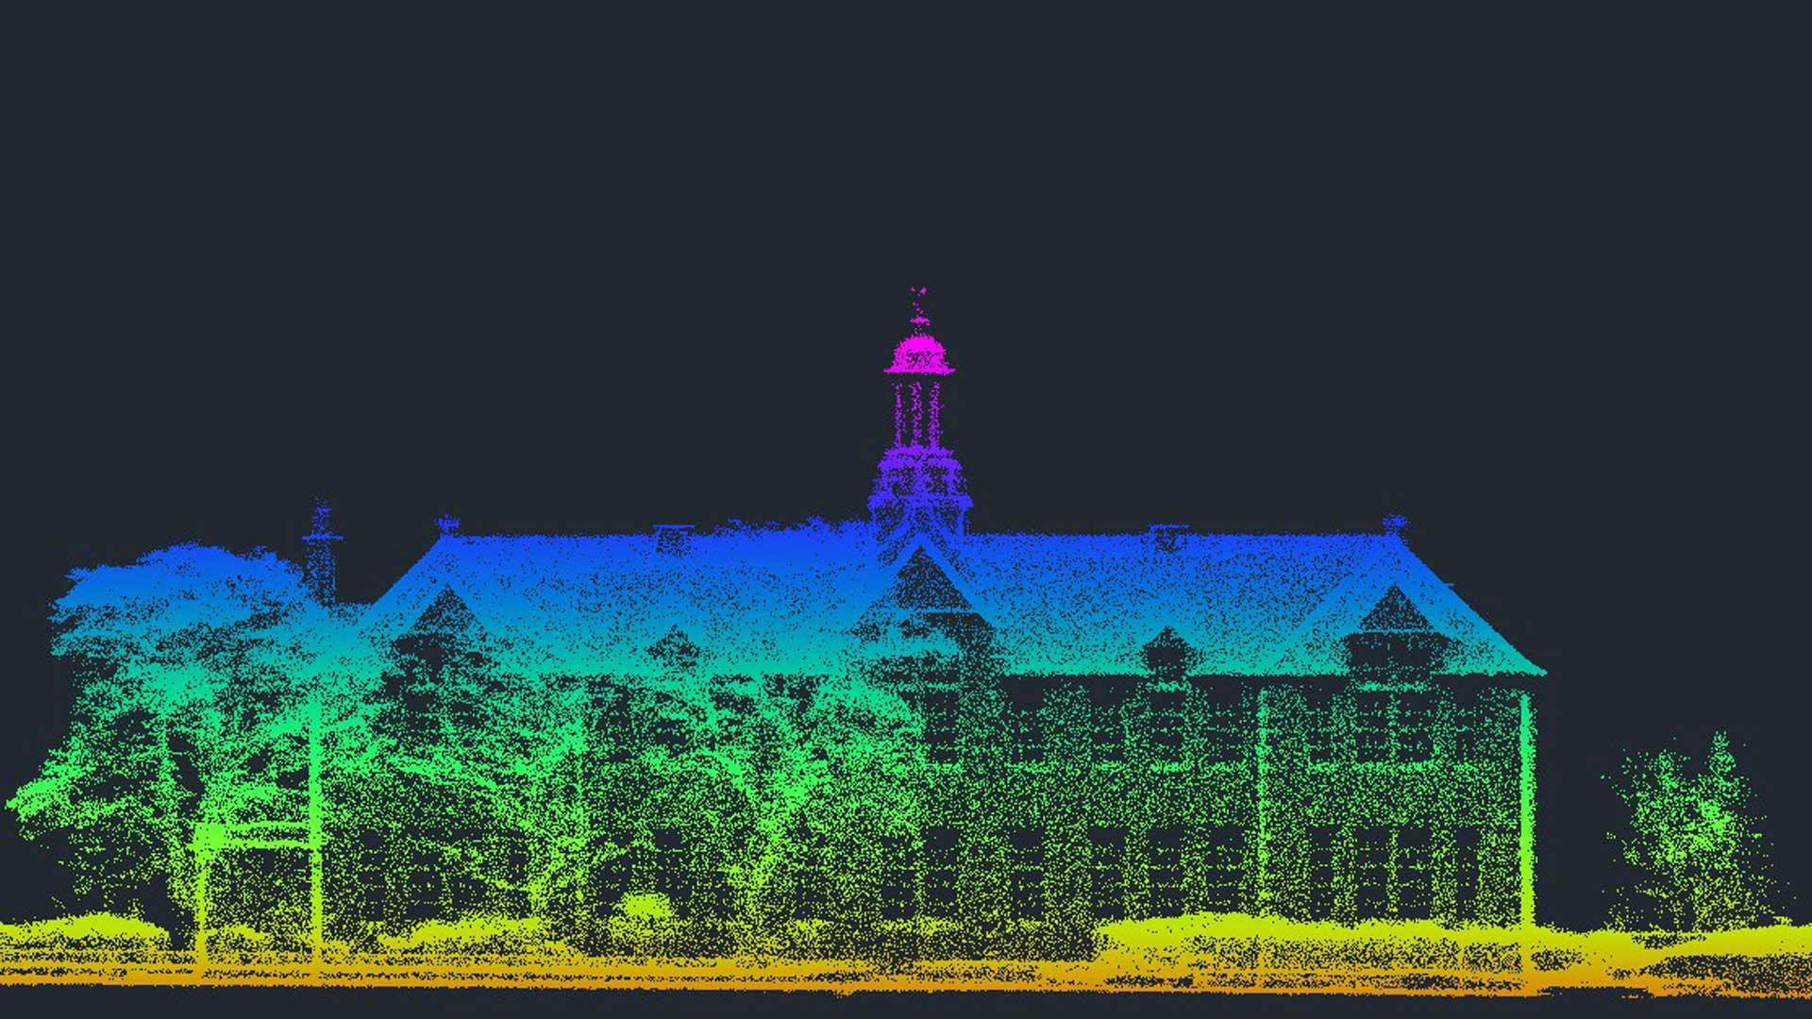

‘Image taken from CADS, produced by Simon Jones’
The 3D model is created by using different types of digital technology that you can use on multiple devices such as iPads, laptops and PC’s. This process can be easy and very efficient compared to the other traditional methods. It can capture an entire building or site in a fraction of the time. Using this form of technology and instrument it will reduce the errors when carrying out a building survey. Once we get around of conducting the building survey on the Dylan Thomas centre, I will make sure that everyone is suitable to use the equipment as it can be very expensive and needs to be levelled and place correctly to collate the most accurate datasets.

III. Thermal Cameras

Furthermore, another extraordinary piece of kit for a building survey is a thermal camera. As we are surveying an old building that might not have much insulation as the more modern buildings today this instrument is ideal when locating where the heat escapes from, leading to energy inefficiency. When it comes from heat escaping the windows and roof will normally be where the heat escapes, as the windows inside the building have hardly been renovated in line with the latest building regulations.
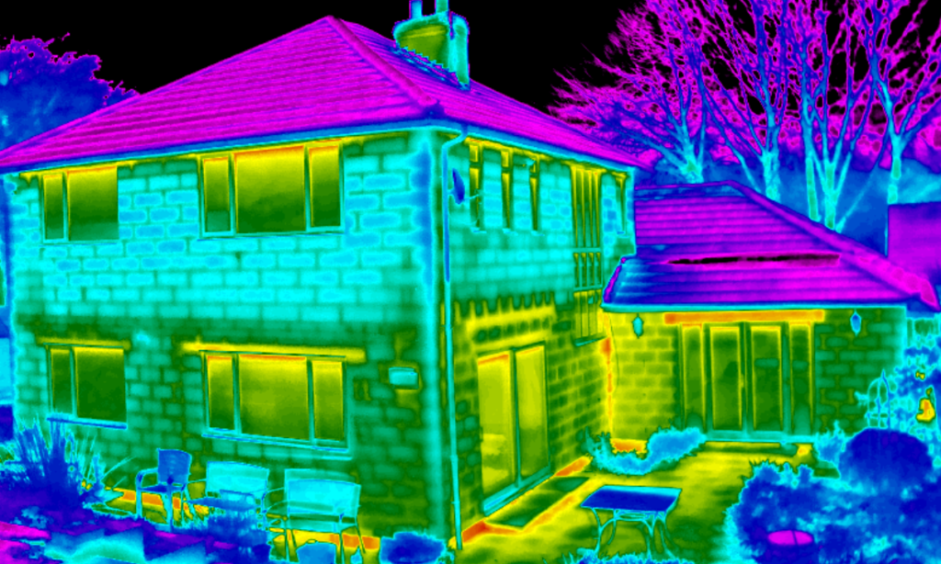
‘Image taken from Scantherm, produced by Scantherm’

This is not all the advantages of a thermal camera they can also help pinpoint moisture intrusion, as wet areas of the building will cool down slower than dry spots. They can also help with locating electrical faults inside the walls of the buildings. As you can see this will majorly help us produce a more accurate building survey and results. I will make sure that I use as much equipment as possible as it can create the building survey process to be a lot easier, faster and accurate

5. Complications & Solutions

Conducting a building survey is never a smooth process there is always complications and solutions. These are some of the challenges when it comes to carrying out a building survey in an old building like the Dylan Thomas centre:

Complications | Solutions
Structural instability, this means that there are problems with the foundation or even wearing away beams | Employ structural engineers to reinforce the weak elements of the building
Hazardous Materials such as asbestos, lead pain and much more that can pose health problems. | Conduct testing procedure, then the removal procedure and use PPE
Outdated systems that don’t comply with the latest building regulations | Develop upgrade plans with the correct personal
Limited access such as confined spaces and unsafe areas | Make sure everyone has completed and qualified in confined space training and create temporary access points
Time constraints such as tight deadlines | To make sure I or someone else allocates each person to an area around the building for more efficient workflows

6. Conclusion

In conclusion, the building survey can be very helpful when it comes to renovating an old building like the Dylan Thomas centre. It is a very time-consuming process but will provide the best and accurate results for each construction site. I will make sure that I have found the objective that we need to achieve, schedule the building survey so that it is split into phases other that do it all in one. Outline which instruments are best fit for the survey and make sure to include all information when conducting the survey report.

7. Referencing

- Produced by Ham for Wikipedia, Produced on (19th May 2025) Dylan Thomas Centre [Online] Available at: https://en.wikipedia.org/wiki/Dylan_Thomas_Centre#/media/File:Canolfan_Dylan_Thomas,_Abertawe.JPG [Accessed 19th July 2025]
- Produced by Army.Mil for Civil Today, produced on (5th September 2019) What is Theodolite? Uses of theodolite in surveying [Online] Available at: https://civiltoday.com/surveying/290-what-is-theodolite-uses-of-theodolite-in-surveying [Accessed 19th July 2025]
- Produced by Iain Tubby for CADS, produced on (4th August 2022) 3D Laser Scanning surveys and their advantages [Online] Available at: https://cadsonline.com/insights/survey/3d-laser-scanning-surveys-and-their-advantages/ [Accessed 20th July 2025]
- Produced by Simon Jones for CADS, produced on (4th August 2022) Get accurate results with our 3D laser and point clous surveys [Online] Available at: https://cadsonline.com/measured-site-survey-services/3d-laser-surveys/ [Accessed 20th July 2025]
- Produced by Scantherm for Scantherm produced on (6th July 2023) A thermal imaging heat loss survey provides home owners answers as to why their home is cold, where it is costing them money and wasting energy [Online] Available at: https://www.scantherm.co.uk/thermal-imaging-surveys/heat-loss-home-surveys/ [Accessed 22nd July 2025]

