UNIVERSITY OF WALES TRINITY SAINT DAVID (UWTSD)

ASSESSMENT DS1
My Digital Life
📘 Module: LCLM4001 – Academic Skills
💼 Course: CertHE : Business Skills for the Workplace
Student Name | Ana – Maria Matasel
Student ID | 2540177
Lecturer / Tutor | Zulfiqar Khan
Submission Date | 7th June 2026

🎓 University of Wales Trinity Saint David


Photo of my A3 in-class notes:
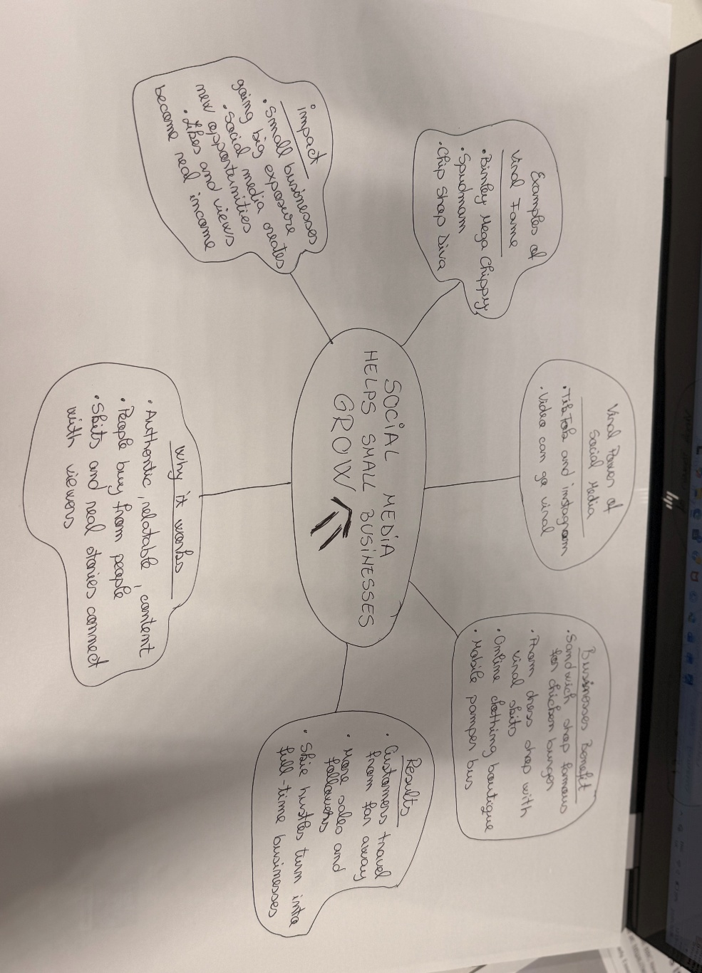

1. Answer these questions using the sentence starters below
a. What is the main idea of the text?
The main idea of the article is that small local businesses can become extremely popular and successful with the help of social media platforms. Videos posted either by business owners or by their customers can go viral on platforms such as TikTok and Instagram when they provide engaging content and respond to the interests of the public, thus contributing to increased visibility and a larger number of customers.

b. What are two key points?
- Social media contributes significantly to the promotion and development of small businesses
Platforms such as TikTok and Instagram have changed the way local businesses can gain popularity and visibility in the online environment. A simple video can reach millions of users in a very short time, generating interest and attracting a large number of customers. The article highlights the fact that several small businesses in the United Kingdom, such as Binley Mega Chippy, Spudman, and Chip Shop Diva, became nationally known due to viral content shared on social media. Therefore, social media represents an important modern marketing tool, contributing to the economic success and growing popularity of these businesses.
- Honywood Sandwich Shop represents an example of the positive impact of viral content created by customers
The article presents the case of Honywood Sandwich Shop in Basildon, a small local business that became highly popular due to videos posted by customers on TikTok. These online materials attracted public attention and encouraged people from different parts of the country to travel in order to try the products offered by the shop, especially the chicken burger. The owner of the business states that the success achieved through social media was unexpected and contributed significantly to the development of the business. This example demonstrates the strong influence that online recommendations and shared customer experiences can have on consumer behaviour and on the success of a local business.
c. What part of the text did you find most important? Why?
The most important part of the text is the section explaining that a video posted on social media by one of the restaurant’s loyal customers encouraged many other people to travel for hours in order to visit and eat at the restaurant. This idea is clearly illustrated in the text: "It was a big surprise to me to hear [customers] had travelled for our chicken burger for three hours,"
This is the most important part of the article because the text aims to highlight the fact that social media platforms such as TikTok and Instagram can contribute significantly to the development and promotion of a business. These platforms provide a form of free advertising that can attract the attention of a very large number of people and encourage customers to travel considerable distances in order to visit a particular business.
The article also mentions other businesses that became popular online, such as Binley Mega Chippy, Spudman, and Chip Shop Diva. However, the case of Honywood Sandwich Shop represents the clearest evidence that viral videos shared on TikTok and Instagram can have a significant positive impact on the success and visibility of a local business.

d. Was anything unclear or difficult to understand?
I was not sure about the meaning of the expression 'boosted its bottom line'. The difficulty in understanding this expression stems from the fact that it is a business and economic term whose meaning cannot be inferred literally. Only after analysing the text did I understand that the author is actually referring to the increase in the company's profits as a result of the exposure and popularity gained through social media platforms.
e. How did your group help you understand the text better?
My group helped me by discussing the main ideas presented in the article. Through these discussions, I gained a better understanding of how social media can influence the success of small businesses. My group members shared their interpretations of the text and clarified several points that I initially found difficult to understand. By analysing the examples provided by the author, we identified the main message of the article: that popularity on social media platforms can attract more customers and contribute to the growth and profitability of a business. This collaborative work helped me develop a deeper understanding of the text and improve my critical thinking skills.
3. One sentence reflection
Question: What did you find challenging about this task?
I found it challenging to understand some of the business-related expressions and terms used in the article, particularly the phrase 'boosted its bottom line'. At first, the meaning of this expression was not clear to me because it is an idiom commonly used in business and economic contexts and cannot be interpreted literally. This difficulty encouraged me to pay closer attention to the context in which the expression was used and to analyse the information surrounding it. In addition, discussions with my group members played an important role in clarifying its meaning, as we were able to compare different interpretations and perspectives on the text. Through this analysis, I came to understand that the author uses the expression to describe an increase in the company's profits and financial success as a result of the popularity it gained through social media platforms. This experience not only helped me understand the article more effectively but also improved my ability to interpret idiomatic expressions and specialised vocabulary in professional contexts.

