ENTREPRENEURSHIP
Assessment 1

Name: George Tivga
Student Number: 2024060
Module: Entrepreneurship (LCBB5001)
Module Lector Name: Nishi Ramsurrun
Table of Contents

Introduction ………………………………………………………….………………………..…………… 3
Task 1
Product services ……………………………………….…………………...…………………….. 4
Product life cycle …………………………………………………………………….…………… 5
Place ……………………………………………………..………………………………………… 6
Price ………………………………………………………………………..……………………… 6
Promotion …………………………………………………………………………………………. 6
Feasibility ……………………………………………………………………………….………… 7
Market research ………………………………………………………………………………….. 9
Task 2
Description ……………………………………………………….……………………………… 14
Feeling ………………………………………………………......……………………………….. 14
Evaluation …………………………………………..……………………………………………. 14
Analysis …………………………………………………………………………………..………. 15
Communication …………………………………………………….……………………………. 15
Contingency leadership ……………………………………………..…………………………. 16
Creativity and innovation ……………………………………………………………………… 16
Problem-solving ……………………………………………………….………………………… 16
Business mind and analytics………………………………………..………………………….. 17
Time management techniques…………………………………..……………………………… 17
Action plan ……………………………..………………………………………….………………17
Conclusion ……………………………………………………………..…………………………………. 18
References ……………………………………………………………………..…………………………. 19

Introduction

Entrepreneurship is both an art and a science dealing with business creation. The entrepreneurs are more than just business creators; they are change agents in society (Joseph Schumpeter, 1911). In this paper based on the topic of entrepreneurship I will present a business idea and its evaluation to address the needs and problems of the broader community. The essay is divided into two Tasks. Task 1 includes the process of idea generation market research which is primary as well as secondary. I will also refer to the product life cycle the 4 P’s and the feasibility study. Task 2 is a personal reflection on the development while participating in completing Task 1. This personal reflection (Gibbs, 1988) will demonstrate the improvement and gaining of entrepreneurial skills and knowledge while creating solutions to problems and addressing consumer needs with the entrepreneurial idea. The business idea discussed in the assignment is a recruitment company called ISO RECRUITMENT.

TASK 1

PRODUCT/SERVICES
ISO RECRUITMENT supports a business to hire high expert individuals and assistants to attract the right talent. There can be a variety of Areas where recruitment companies can work including administrative and others (Ročkutė et al., 2018). The major responsibility of the recruitment company is to provide recommendations to the selection panel of the business. Recruitment company generally offers different services to the consumers which mainly include the following:
- Executive search – searching for skilled candidates
- Selection process engagement
- Conducting recruitments for specialist areas
- Advertisement
- Candidate shortlisting
- Initial enquiry handling
- Initial Reference and skill evaluation
- Selection documentation assistance
- Assistance to unqualified candidates
- Organizing interviews
- Analysing the talent pool
The target market for the recruitment complete includes young professionals who seek recruitment opportunities (Lindsay and Ahmed, 2021). The customer needs for the recruitment company can be easily addressed by the following process:
- 1. Need recognition includes defining the various requirements of the target market. The organization's services include most job positions and can also solve problems.
- The main search for information includes the implementation of methods to meet the needs and services for creative production.
- Evaluation of alternatives generally includes creating products and results if they do not fulfil customer needs.
- Purchase decision is the thought process that leads generating options.
- Post-purchase evaluation helps in determining the issues encountered by the consumers regarding products and services.
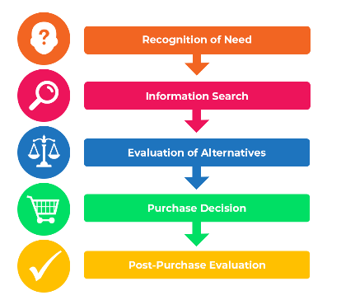
Source: https://www.professionalacademy.com/blogs/marketing-theories-explaining-the-consumer-decision-making-process/

PRODUCT LIFE CICLE
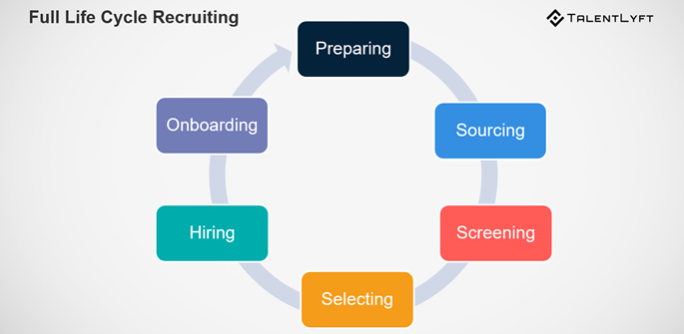
Source: https://www.talentlyft.com/en/blog/article/88/everything-you-need-to-know-about-full-life-cycle-recruiting
Because the hiring process can be a repetitive process (Anja Zojceska, 2018), the decline of the product does not apply in this case.

PLACE
As businesses nowadays prefer both physical as well as online presence because it provides a better reach full stop ISO RECRUITMENT will include a physical consultancy firm along with an online presence to attract a higher consumer crowd for the business.

PRICE
The pricing strategy which will be used by ISO RECRUITMENT will be of two types. The first one will include pricing for businesses in order to attract and analyse the right candidates. The second one will include pricing and costing for candidates to ensure they upgrade their resumes and are selected by good organisations. Cost leadership for the second one will be beneficial.

PROMOTION
The major promotion activities which will be included by ISO RECRUITMENT for marketing purposes are online and digital marketing websites, SEO, and social media marketing. other than these, the talent hunt will include audio and visual marketing practices like banners, flyers, and pamphlets supporting advertising practices for the business.

FEASIBILITY

SWOT ANALYSIS
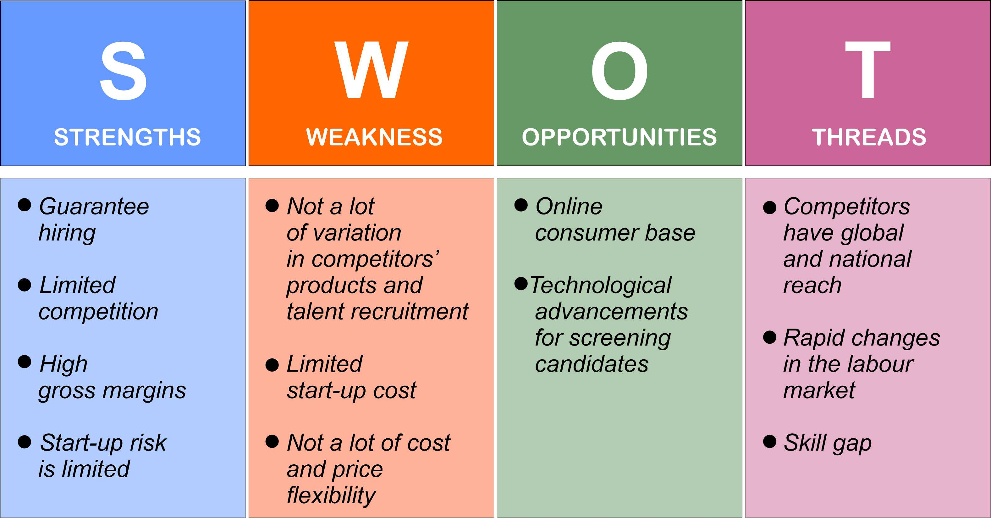

VRIO ANALYSIS CONSIDERING POTERS 5 FORCES
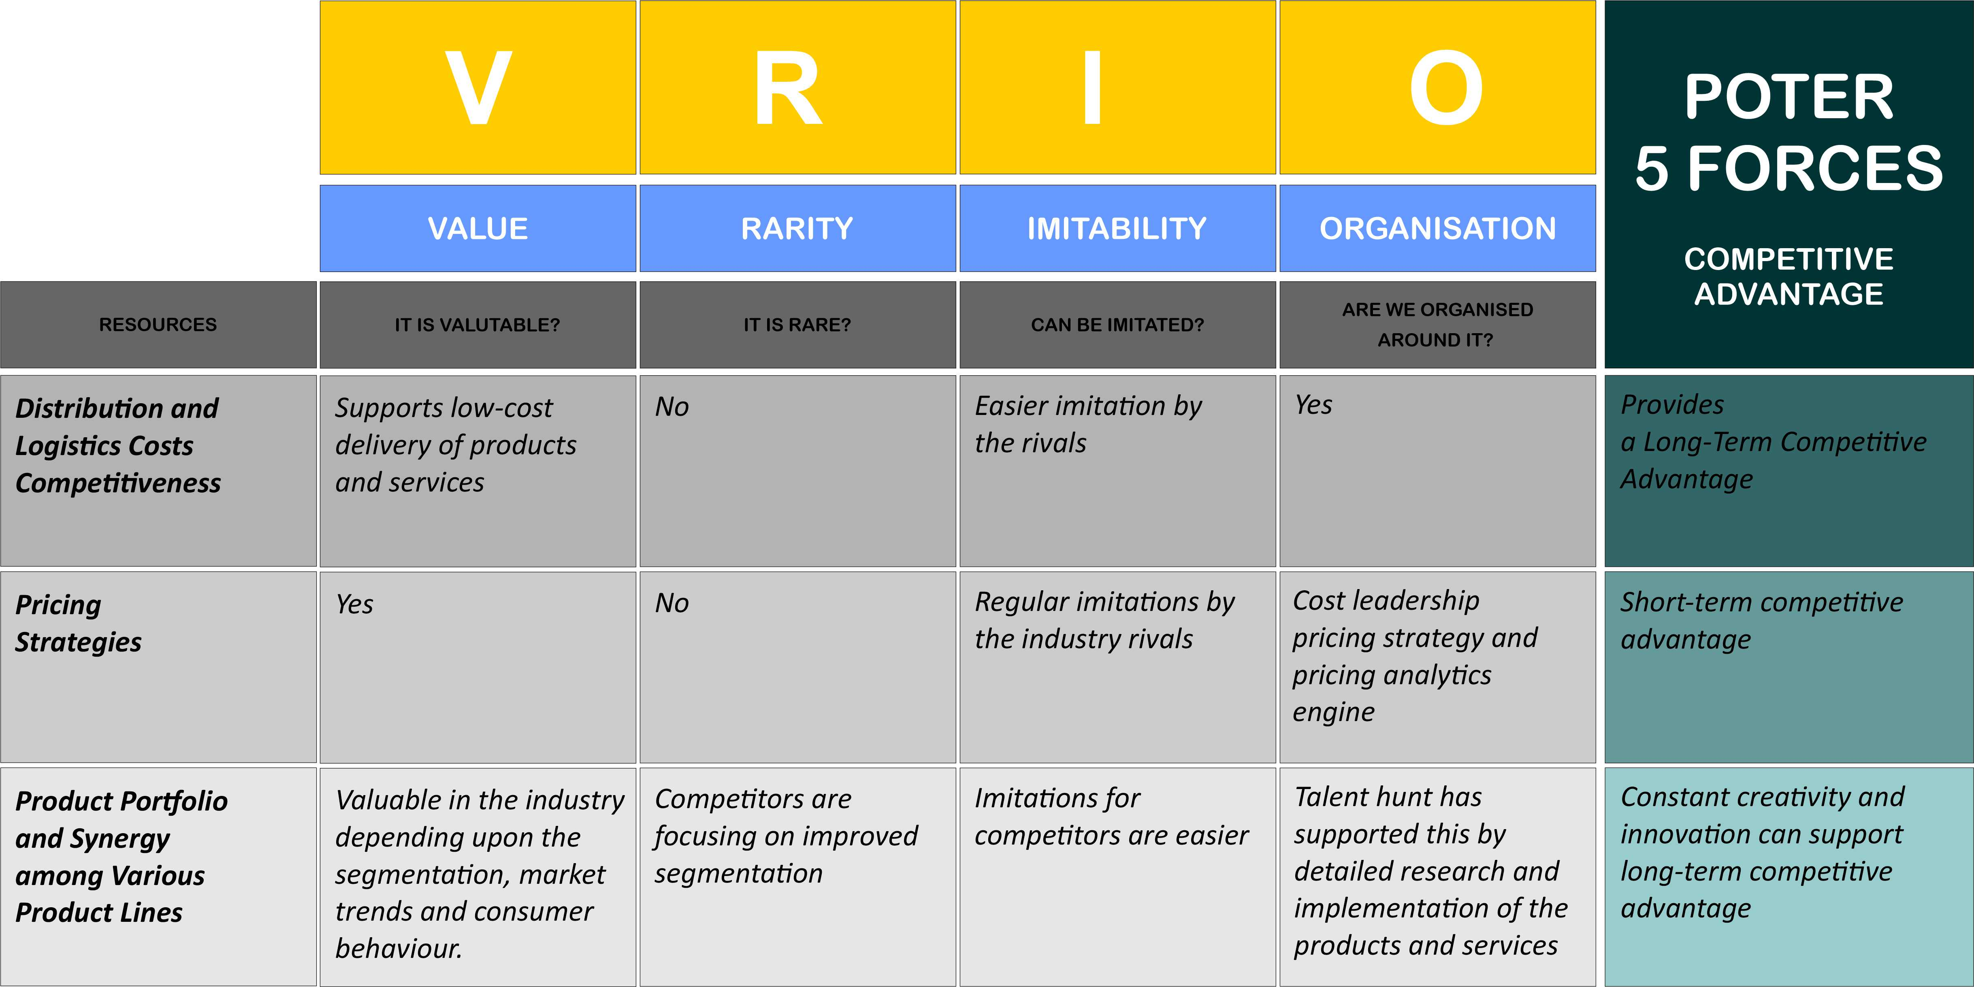
START-UP COST
Summary Statement
Sources of Capital
Owners' and other investments | £ | 16000
Bank loans | £ | 15000
Other loans | £ | 20000
Total Source of Funds | £ | 51000
Start-up Expenses
Buildings/real estate | £ | 20000
Leasehold improvements | £ | 5900
Capital equipment | £ | 7700
Location/administration expenses | £ | 3360
Opening inventory | £ | 15000
Advertising/promotional expenses | £ | 3000
Contingency fund | £ | 8000
Working capital | £ | 7820
Total Start-up Expenses | £ | 70780

MARKET RESEARCH

PRIMARY RESEARCH

Question 1: What are your expectations from recruiting company?
  - Financial growth
  - Professional growth
  - Work-life balance
  - All of the above
Options | Response
Financial growth | 8
Professional growth | 3
Work-life balance | 5
All of the above | 4
Total | 20

Question 2: Which technologies can be used by the recruiting company to select the candidate?
- Recruitment candidate relationship management
- Application tracking systems
- Mobile recruitment
- Video interviews
Options | Response
Recruitment candidate relationship management | 5
Application tracking systems | 7
Mobile recruitment | 6
Video interviews | 4
Total | 20

`

Question 3: Have you used any recruitment firm in order to get selected by the recruitment organization?
  - Yes
  - No
Options | Response
Yes | 8
No | 12
Total | 20

Question 4: Are you satisfied with the selection criteria and methods used by the recruiters while selecting the candidate?
- Yes
- No
Options | Response
Yes | 5
No | 15
Total | 20

SECONDARY RESEARCH
Variety of techniques is used by recruitment agencies in order to ensure the organisation hires the best employee for the organisation (Hamza et al., 2021). The process of value-based hiring supports the same. Value-based hiring is a technique where the recruitment process is focused on the personal values and beliefs of the candidate in alignment with organizational values. This can a challenging task for the hiring process, but the implementation of a comprehensive plan can support a better fit for the organisation.

TASK 2

DESCRIPTION
ISO RECRUITMENT is a third-party organization that helps other organizations to recruit people for their firms. The recruitment process has become costly and this organization will allow companies to hire new people at lesser operational cost and also in lesser time. Employees decide the fate of the organization and any organization needs to have employees who match the job requirements. ISO RECRUITMENT will use information and communication technologies to locate talented candidates. The organization will also use virtual interview processes which will allow the organization to hire candidates in lesser time.

FEELING
The main idea behind the business was to provide recruitment services at a lesser operational cost. Since the covid 19 pandemic, organizations have been facing the issue of a high employee turnover rate (Chen et al., 2021). This makes it necessary for them to constantly hire new employees. It was also important to avoid the continuous hiring process. ISO RECRUITMENT will have the responsibility to find candidates who match the job requirements. In the future, the organization may have to face trouble in achieving sustainability, since the motive of the organization is to provide services at a lesser cost but the use of technologies requires monetary resources.

EVALUATION
In the initial phase, the organization will have some success and will be able to convince companies to use the employment services of ISO RECRUTMENT. The organization will have to expand its roots and improve its business in different locations. Considering that the company will carry out its activity mostly online, it can be assumed that there is a high potential and it can achieve the desired objectives. Consolidation of the market position is important and it will have to face high competition from rivals in the market. It can become difficult to find talented candidates and invite them to hiring processes as there are various job opportunities available. The use of technological progress can help achieve this.

ANALYSIS
The strength of the organization is the sustainable approach, which will help the company in offering good services to the clients with the same efficiency (Abbas et al., 2019). The clients of the organization have been facing the issue of adjusting the budget. This organization will allowed them to complete the hiring process at a lesser cost which makes it easier to adjust the budget. The organization is likely to be successful in the future given the market penetration strategy (Philip T. Kotler, Gary Armstrong, 2017) and potential of the organization. Information and communication technologies provide huge opportunities for the organization.

COMMUNICATION
Clarity: the organization it is clear in its goals. Providing good service at a lower cost is prioritized. This will allow the organization to gain trust.
Fairness: Uses fair resources and practices to conduct employment practices. Information and communication technologies are doing this quickly. It is also important to ensure customer data is safe. On job portals, candidates will have to give their details. These details can be confidential and it is important to keep them safe (Pollák and Markovič, 2021).
Consciousness: it is important to convey what are job requirements are and the organization is highly focused on making ads for that (Scarborough and Cornwall, 2018).
Courtesy: in the hiring process, not all the candidates will get hired and it is important to convey positive messages to them. It is also important to be unbiased in the recruitment practices (Pollák and Markovič, 2021).
Concreteness: it is important for the organization to give clear messages and what their expectations from the candidates are. The job advertisements should highlight the key skills, experience and educational background required.
Consideration: candidates should be allowed to provide their feedback. This will allow the organization to work on the flaws and make the hiring processes more effective (Pollák and Markovič, 2021).
Completeness: it is important to provide complete information about the job description.

CONTINGENCY LEADERSHIP
Leadership plays an important role in the success of the organization. The leadership style used in the organization is democratic. It is important to ensure that leaders are in a state of mental well-being and that social issues do not affect the success of the organization (Romão et al., 2022).

CREATIVITY AND INNOVATION
The organization will ask some creative interview questions. These questions allow the organization to gain insight into the candidates. The organization also plans to use innovative sources to hire new candidates and take a step forward in innovation.

PROBLEM-SOLVING
Candidates may face several issues in the recruitment process and the organization allows them to provide feedback about their experiences. These experiences help the organization to improve the processes in the future.

BUSINESS MIND AND ANALYTICS
The statistical data from the primary and secondary research help in providing an idea of the business performance of the business (Ajah and Nweke, 2019). This supports improved management and can improve decision-making for the business. Also, this can directly impact the performance of the business.

TIME MANAGEMENT TECHNIQUES
This organization have the vision of competing for the hiring processes in lesser time while keeping the same efficiency. To manage time, the organization will use virtual interview processes. Candidates can appear for these interviews from anywhere and this helps both the candidates and the organization to save time.

ACTION PLAN
In the next three months I will develop the business plan for this activity. I will read Case Studies in these field and specialized books. I will also observe the movements of competitors on the market. I will review the plan every week to improve it and to be able to put it into practice. At the end of the three months, I will contact a consulting firm to evaluate it. This first step is of very high importance. Also, in the next three months, I will develop my democratic leadership skill by following online courses. It has a medium importance. I will evaluate my progress through exams every month.

Conclusion

The task report studies the reception of entrepreneurship during the performance of tasks. The first task is presented in the form of an essay giving a business idea and its evaluation to meet consumer needs and also finding solutions. The essay included a discussion of the 4 P's idea generation process and market research along with product life cycle and feasibility study. Task 2 is a personal reflection based on Task 1. Task 2 reflect the improving entrepreneurial skills and knowledge while completing Task 1 and address consumer needs and problems with different solutions.

References

Abbas, J., Hussain, I., Hussain, S., Akram, S., Shaheen, I. and Niu, B., 2019. The impact of knowledge sharing and innovation on sustainable performance in Islamic banks: a mediation analysis through a SEM approach. Sustainability, 11(15), p.4049.

Ajah, I.A. and Nweke, H.F., 2019. Big data and business analytics: Trends, platforms, success factors and applications. Big Data and Cognitive Computing, 3(2), p.32.

Chen, C.L., Lin, Y.C., Chen, W.H., Chao, C.F. and Pandia, H., 2021. Role of government to enhance digital transformation in small service business. Sustainability, 13(3), p.1028. International Journal of Engineering, Business and Management, 5(3), pp.1-13.

Hamza, P.A., Othman, B.J., Gardi, B., Sorguli, S., Aziz, H.M., Ahmed, S.A., Sabir, B.Y., Ismael, N.B., Ali, B.J. and Anwar, G., 2021. Recruitment and selection: The relationship between recruitment and selection with organizational performance.

Lindsay, S. and Ahmed, H., 2021. School and Employment-Related Barriers for Youth and Young Adults with and without a Disability during the COVID-19 Pandemic in the Greater Toronto Area. Adolescents, 1(4), pp.442-460.

Pollák, F. and Markovič, P., 2021. Economic activity as a determinant for customer adoption of social media marketing. Sustainability, 13(7), p.3999.

Ročkutė, K., Minelgaitė, I., Zailskaitė-Jakštė, L. and Damaševičius, R., 2018. Brand awareness in the context of mistrust: The case study of an employment agency. Sustainability, 10(3), p.695.

Romão, S., Ribeiro, N., Gomes, D.R. and Singh, S., 2022. The Impact of Leaders’ Coaching Skills on Employees’ Happiness and Turnover Intention. Administrative Sciences, 12(3), p.84.

Schumpeter, J.A., 1911. The Theory of Economic Development. Harvard University Press, Cambridge.

Scarborough, N.M. and Cornwall, J.R., 2016. Essentials of Entrepreneurship and Small Business management. 8th ed., Global Edition, Upper Saddle River: Pearson p.74.

Subramoniam, R., Sundin, E., Subramoniam, S. and Huisingh, D., 2021. Riding the digital product life cycle waves towards a circular economy. Sustainability, 13(16), p.8960.

Everything You Need to Know About Full Life Cycle Recruiting
https://www.talentlyft.com/en/blog/article/88/everything-you-need-to-know-about-full-life-cycle-recruiting
Accessed: 27.07.2022

Philip T. Kotler, Gary Armstrong, 2017, Principles of Marketing, 17th Edition, Pearson, p.333.

Gibbs, G., 1988. Learning by Doing: A Guide to Teaching and Learning Methods.
United Kingdom: FEU.

