

Student Name: Kamal Hussain
Student ID: 2503973

Programme: Master of Business Administration
Module Name: International Marketing: Principles and Practices
Module Code: LCMB7026
Assignment Title: Assessment component 1:
Individual report
Lecturer: Dian Mayasari

Submission Deadline: 27/03/2026

Contents
Section 1 1
1. Introduction 1
2. Brand and Country Overview: Zara in the United Kingdom and India 2
2.1 Brand History and Overview 2
2.2 Home Country: Spain 3
2.3 Hosts Countries: United Kingdom and India.. 3
2.4 Internationalisation Approach 3
2.5 Rational for Internationalisation. 3
3. Comparative PESTLE Analysis of the UK and India 4
3.1 Political & Legal Environment 4
3.2 Economic Environment 5
3.3 Social and cultural Environment 5
3.4 Technological, Environmental Trends 6
4. Comparison of Brand’s STP Strategies: Zara in the UK and India 7
4.1 Brand Context 7
5. Comparison of Marketing Mix Strategies: Zara in the UK and India 10
5.1 Brand Strategy 10
5.2 Product Strategy 12
5.3 Pricing Strategy 13
5.4 Promotion Strategy 13
5.5 Type of Appeal (Sex/Sensuality) 14
5.6 Place (Distribution) Strategy. 15
5.7 Individuals, Process, and Physical Evidence 15
6. Directional Development Strategy of Zara in India 16
6.1 Overview of Zara’s Market Position in India 16
6.2 Market Performance 16
7. Evaluation of Marketing Ethics Practices: Zara 18
7.1 Product and Supply Chain Practices: Ethical Issue 18
8. Recommendations and Conclusion 20
8.1 General Analysis of the Marketing Strategies. 20
8.2 Which Marketing Strategies Are Effective 20
8.3 What Marketing Strategies are not that Effective? 21
8.4 Strategic Recommendations 21
9. Conclusion 23
Section 2 24
Reflective Account (Gibbs’ Reflective Cycle) 24
1. Description 24
2. Feelings 25
3. Evaluation 25
4. Analysis 26
5. Conclusion 27
6. Action Plan 27
References 28

List of Table
Table 1: Comparative PESTLE Analysis of UK and India 4
Table 2: Segmentation Strategy Comparison 7
Table 3: Marketing Mix Comparison of Zara in UK and India 11

List of Figure
Figure 1: Key Milestones in Zara’s International Expansion 2
Figure 2: Hofstede Cultural Dimension Comparison 8
Figure 3: “Brand Positioning Map: UK vs India Fashion Markets”……….……………………………………………………………… 10
Figure 4: Zara Winter Collection campaign 14
Figure 5: Zara store opening and promotional sale poster for Kolkata store. 14

Section 1

1. Introduction
International marketing can be defined as the practice of marketing principles in a manner that bridges the national boundaries so that the firms can achieve flexibility in strategies based on the cultural, economic, and regulatory conditions. To discuss the implementation of international marketing principles in the United Kingdom and India, the current report is devoted to Zara, one of the major fast-fashion retailers globally. Agile supply chain, responsiveness to the market, and the emphasis on customer-focused product development make Zara highly successful due to its ability to adjust to the local preferences of consumers very quickly (Kotler et al., 2021). UK is a very mature and highly competitive fashion market with trend-sensitive customers, and India is a fast growing emerging market with cultural diversity and rising disposable income (Czinkota and Ronkainen, 2022).

2. Brand and Country Overview: Zara in the United Kingdom and India

2.1 Brand History and Overview
Zara is a Spanish fast-fashion company that was established in 1975 by a man called Amancio Ortega in Spain. Zara is a core brand of Inditex Group that is one of the biggest fashion conglomerates in the world. It has a famous design-to-retail model, which makes this brand introduce new fashion trends to the stores in a few weeks. The product range in Zara covers clothes, shoes, accessories, and home products, and it primarily deals with fashionable, affordable, and quality products that are offered to men, women, and children (Czinkota and Ronkainen, 2022).
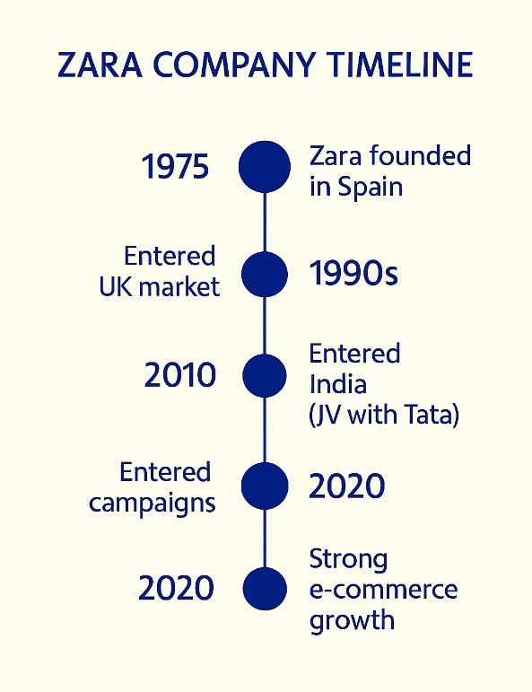
Figure 1: Key Milestones in Zara’s International Expansion

Zara is a rather traditional multinational company but not a born global one. Although it has a large international footprint, its internationalisation was done in stages, expanding first to Europe, followed by Asia, then the Americas and Africa (Hollensen, 2020).

2.2 Home Country: Spain
Zara is a Spanish company and it is its motherland, which offers the base of corporate culture, operational strategies, and design philosophy. Zara has developed its business model based on the focus of the Spanish fashion market on style, quality, and affordability. Zara has its headquarters in Arteixo, Galicia and therefore it makes use of the centralised design and production strengths of Spain to ensure it has a tight hold on the quality and responsiveness to global market trends.

2.3 Hosts Countries: United Kingdom and India
The United Kingdom (UK) and India have been selected as host countries in analysing this report. UK is a well-developed market, having a highly fashion-conscious consumer base, high level of competition and good digital penetration. Zarfashion-consciousUK in 1988 by opening its wholly owned stores based on direct investment mode where it can keep its brand constant and control. (Armstrong and Kotler, 2023).
India on the other hand is an emerging market, whose disposable incomes are soaring, and the urbanisation together with the young trendy consumers are increasing.

2.4 Internationalisation Approach
The internationalisation strategy of Zara partially follows the Uppsala model that focuses on the slow expansion following their market understanding and risk avoidance. The company started with similar countries in Europe in terms of culture and geographical location before expanding to other markets that were far-off and culturally different such as India and the US. The decision-making of Zara regarding expansion purposes is based on the prospects of the market, customer preferences, city-based retail and strategies of growth rather than on the opportunistic nature of decisions (Hollensen, 2020; Kotler et al., 2021).

2.5 Rational for Internationalisation
The move to enter the UK and India can be seen as a mix of the market opportunity, the potential of revenue growth, and positioning the brand globally. The UK is offering a stable and high-spending market whereas India is offering a long-term growth potential in an underpenetrated market with increasing demand of international fashion.

3. Comparative PESTLE Analysis of the UK and India
Table 1: Comparative PESTLE Analysis of UK and India
Factor | UK | India
Political | Stable democracy | Federal system
Economic | High income economy | Emerging economy
Social | Individualistic culture | Collectivist culture
Technological | Advanced digital retail | Rapid digital growth
Environmental | Strong sustainability regulation | Developing sustainability policies
Legal | Strict consumer protection | Complex regulations

3.1 Political & Legal Environment
The United Kingdom enjoys a stable parliamentary democracy, and legal institutions that secure intellectual property, consumer and business contract. It has a regulatory structure that promotes a fair competition and implements employment, environmental and data protection laws. (Czinkota and Ronkainen, 2022).
India on the other hand is a complex regulatory environment with a federal republic that is governed by both the central and the state laws. Although the business entry has been facilitated by new reforms like the Goods and Services Tax (GST) and liberalisation of foreign direct investment (FDI) policies, complex procedures and bureaucracy is significant. (Hollensen, 2020).
Implication for Zara: The advanced regulatory framework in UK facilitates uniformity of operational activities and India, due to its transitional nature of the law, might need to focus on localised compliance plans and an effective government relations efforts especially in labour and retail regulation activities.

3.2 Economic Environment
GDP, Income Levels and Development
The UK is a high-income and developed economy with one of the highest GDP per capita in the world. Its economy is quite services-driven with the purchasing power and extensive retailing infrastructure. The consumer expenditure on fashion is very strong, but the discretionary expenditure has been dampened by recent inflationary pressures.
India, on the contrary, is a lower-middle-income emerging economy, whose economy has grown rapidly over the last few decades. Despite the fact that the GDP per capita is very low in comparison with UK, India has a big population and has a growing middle income, which has a huge market potential. (Kotler et al., 2021).
Trade Agreements & Economic Integration
The UK is signatory to many trade agreements which have included its post Brexit agreements with the EU and the Commonwealth countries. India has regional trade ties (e.g., SAFTA) and is involved in discussions on larger trade deals such as RCEP.
Implication for Zara: The stable and affluent consumer base in the UK would justify premium pricing strategies and standardised global collections, but India has varying levels of income that would require different pricing, local sourcing and different collections of products to fit in the value perception.

3.3 Social and cultural Environment
Dimensions of National Culture
Applying the Hofstede cultural dimensions provides an understanding of difference in consumer behaviour that can be critical to the marketing strategy:
- Power Distance: India ranks higher than the UK which means the ranking of hierarchies and value on authority. The consumers in the UK are more inclined towards equality and individualism (Hofstede Insights, 2025).
- Individualism vs Collectivism: UK is a very individualistic country, which emphasises personal choice and self-expression, and India balances the goals of the individual with the highly rated community and family values.
- Uncertainty Avoidance: UK has moderate uncertainty avoidance which encourages taking risks and acceptance of innovations; India, though slightly higher, shows variability in market behaviour.
- These cultural indicators determine what people buy: a UK buyer can make the purchase based on brand recognition, fashion ability, and personal outfits, and an Indian can make the purchase based on family, cultural suitability of fashion, and cost-effectiveness (Hofstede Insights, 2025).
Language, Norms, and Values
The major language used in business in the UK is English, and also in the urban centres of India, which makes communication in marketing and retailing convenient. The linguistic diversity of India (Hindi, regional languages) however needs multilingual promotion techniques to appeal to segments.
Implication for Zara: Marketing communications and product messaging should be standardised in the main branding but linguistic and cultural differences optimised in India but can be utilised more generally in the UK

3.4 Technological, Environmental Trends
UK exhibits high-level retail technologies, well-developed e-commerce, and the ubiquity of e-payments, which supports the Omnichannel strategies. India is experiencing a high rate of digital consumption, specifically mobile internet penetration, but infrastructure gaps and the use of e-payments vary by region.
Implication for Zara: Zara can be standardised technologically in its digital platforms but it has to be adapted to user interface, mobile-friendly and logistics strategies in India.

4. Comparison of Brand’s STP Strategies: Zara in the UK and India

4.1 Brand Context
Zara manages an international business through a fast-fashion approach and changes its marketing approach by the market. The United Kingdom is a well-established and high-income fashion market whereas India is an emerging market with a varying range of cultural and income consumers.
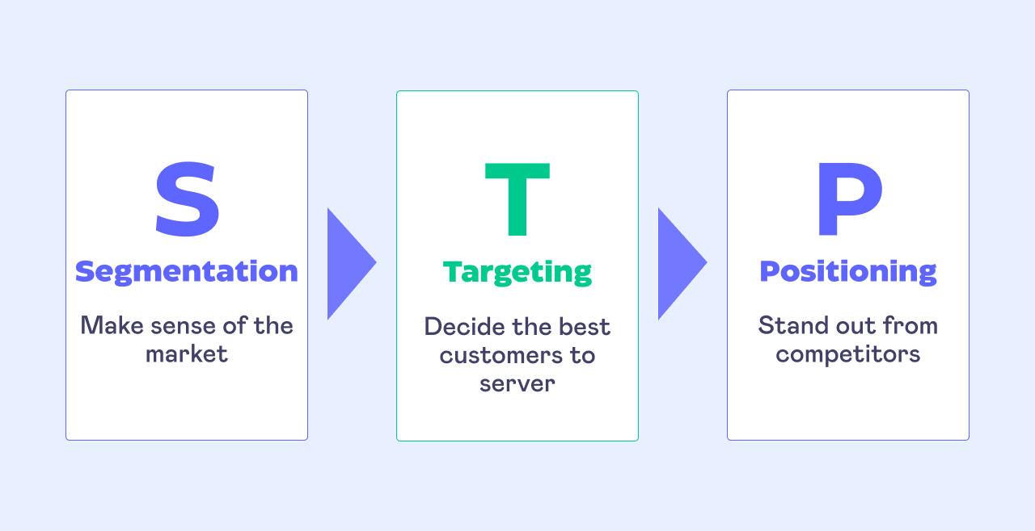
Sources- symson.com
1. Segmentation Strategy
Table 2: Segmentation Strategy Comparison
Segmentation Type | UK | India
Demographic | 18–45 professionals | Urban middle class
Geographic | National market | Tier-1 and Tier-2 cities
Psychographic | Fashion conscious | Aspirational consumers
Behavioural | Frequent shoppers | Occasion based shoppers

United Kingdom
Zara uses the psychographic and lifestyle based segmentation strategy in the UK. Consumers will be divided on the basis of:
- Demographics: Young adults and professionals (18-45) middle to upper-middle income.
- Psychographics: Style conscious, fashion conscious, brand conscious.
- Behavioural: Frequent customers, high responsiveness to fast fashion behaviour, high online shopping behaviour.
The UK consumers are very individualistic and appreciate self-expression in terms of fashion and therefore lifestyle segmentation would be a good way to market the product.
India
Zara in India employs a multi-layered segmentation strategy, which is a combination of:
- Demographics: City middle and upper-middle classes, the majority aged 18-40.
- Geographic: Tier-1 and Tier-2 cities (e.g. metropolitan areas)
- Psychographic: Aspirational/ global-brand-seeking consumers.
- Behavioural: Occasional shopping (festivals, wedding, social gatherings)
The cultural diversity and income disparity complicate segmentation and make it region specific in India.
Comparison: Zara in UK is more homogeneous and lifestyle in its segmentation as compared to India, which is more fragmented and geographically and income based.

Figure 2: Hofstede Cultural Dimension Comparison

2. Target Market Strategy
United Kingdom
Zara targets:
- Fashion-conscious individuals
- Buyers of fashionable styles at affordable rates.
- Omni channel shoppers that are digitally active.
India
Zara targets:
- For upwardly mobile and urban middle and upper-middle-class consumers.
- Young people who are aspirational and are exposed to the fashion trends of the world.
- Customers who are ready to spend more money than the local brands.
Comparison: The age distribution is also comparable in the two markets with the age, however, in the UK, Zara is in a wider mainstream segment, and in India, a smaller, wealthier niche segment.
3. Positioning Strategy
United Kingdom Positioning
Zara is positioned as:
- A trendy, fast-fashion brand
- Providing runway-based designs at low prices.
- Competitors include H&M, Mango and Uniqlo.
Positioning emphasis:
- Speed to market
- Style variety
- Value for money
- India Positioning

Zara is positioned in India as:
- An international, high value fast-fashion brand.
- The icon of modernity and global lifestyle.
- Less competitive, more aspirational.
Comparison: In the UK, Zara tends to focus on value and competitive positioning, whereas in India, it tends to focus on aspirational and premium positioning, although both countries offer an almost similar line of core products.
4. Perceptual / Positioning Map (Conceptual)
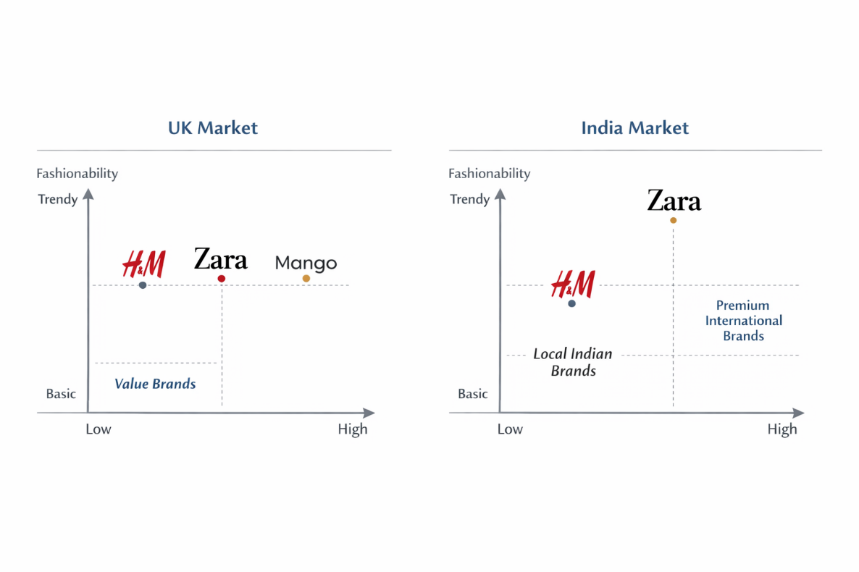
Figure 3: “Brand Positioning Map: UK vs India Fashion Markets”

5. Comparison of Marketing Mix Strategies: Zara in the UK and India

5.1 Brand Strategy
Zara adheres to the global brand approach that is based on the fast fashion, responsiveness to trends, and limited branding. The brand has a steady presence in the United Kingdom and India, where the brand identity consists of high-end aesthetic appearance of the shops, minimal advertisement, and product-based communication. But perception of brand is different. In the UK, Zara is considered to be a mid-market fast-fashion brand, and in India, it is regarded as a semi-premium international brand that is determined by the local income levels and the competitive environments (Kotler et al., 2021; Hollensen, 2020).
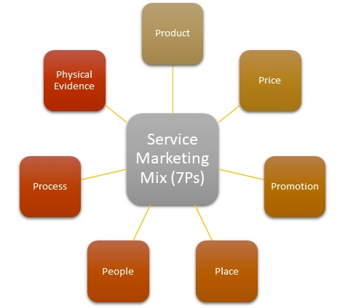
Sources- mbaskool.com
Table 3: Marketing Mix Comparison of Zara in UK and India
Element | UK Strategy | India Strategy
Product | Standardised fashion | Slight cultural adaptation
Price | Competitive | Premium
Place | Company stores + online | JV stores + online
Promotion | Social media | Aspirational campaigns
People | Self-service | Assisted service
Process | Fast inventory turnover | Slightly slower logistics
Physical Evidence | Premium store design | Same global store design

5.2 Product Strategy
Product Dimensions
- Core Product: Trendy and contemporary fashion inspired by runway fashion.
- Physical product: Clothes, shoes, and accessories of men, women, and children.
- Value added product: On-line ordering and returns, rapid movement of inventory in the store experience.
Product Lines
In both markets, Zara sells comparable products but the product range in India is smaller and more selective than in the UK which reflects uncertainty in demand and the cost of supply-chain (Czinkota and Ronkainen, 2022).
Standardisation vs Adaptation
The products tend to be largely standardised, although India adapts partially, including:
- Cuts that are more conservative and are longer.
- Local festivals and climate alignment.
- This is an aspect of culture and climatic variations (Armstrong and Kotler, 2023).
Packaging and Labelling
Packaging Elements
- Aesthetic: Bare, monochrome packaging (standardised)
- Informational: Materials and instructions of care.
- Defensive: The global uniformity of standards.
- Imagery: High-end, luxury, European style.
The packaging is very standardised, which helps in world brand uniformity.
Labelling
The labelling is done in accordance with the international standards but modified in India to contain:
- Local regulatory provisions.
- Maximum retail price (MRP)
- Import and tax information

5.3 Pricing Strategy
Pricing Objectives
- UK: Price competition to optimise market share.
- India: Value maximisation and high-end positioning.
Pricing Method
Zara mainly follows a competition-based pricing strategy, where prices are set in comparison with competitors such as H&M and Mango in the UK, and premium international brands in India (Kotler et al., 2021).
Adaptation vs Standardisation (Evidence)
Zara adopts a price adaptation strategy in India due to factors such as import duties, logistics costs, and premium brand positioning. For example, a basic Zara shirt priced at approximately £25–£30 in the UK is sold at around ₹2,990–₹3,990 (£30–£40 equivalent) in India. This indicates that the same product is significantly more expensive in India compared to the UK market, despite differences in purchasing power. This price difference highlights Zara’s adaptation strategy, where it positions itself as a premium international brand in India (Hollensen, 2020; Zara, 2024).

5.4 Promotion Strategy
- Promotion Objectives
- Build brand awareness
- Drive store traffic
- Enhance fashion leadership.
- Media and Advertising
Zara pursues the low-advertising policy in both nations with the help of:
- Prime store locations
- Window displays
- Social media presence

5.5 Type of Appeal (Sex/Sensuality)
- UK: Passion and lifestyle advertising focusing on individuality.

Figure 4: Zara Winter Collection campaign
Source: Zara Official Campaign Image (2023).
- India: Dreamy and symbolic attractions to fashion status in the world.
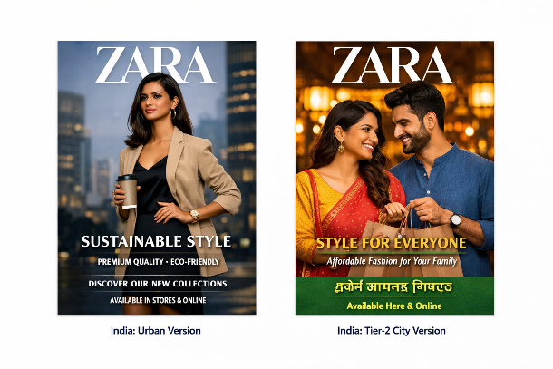
Figure 5: Zara store opening and promotional sale poster for Kolkata store.
Source: Advertisement published in The Times of India – Kolkata Edition (2022).
Adaptation vs Standardisation
Style of promotion is changed strategically:
- The UK campaigns lay stress on day-to-day fashion.
- India lays stress on exclusivity and modernity.
- This indicates differences in cultures and socio-economic (Hofstede Insights, 2025).

5.6 Place (Distribution) Strategy
Channel Intensity
- In both the markets, Zara pursues selective distribution.
Channel Length
- UK: Short channel (company-owned stores + online)
- India: A little longer channel because of joint-venture business and regulatory frameworks.
Intermediary Arrangements
In India, it is conducted in the form of a joint venture with a local company to allow the country to comply with the regulations and possess local knowledge, whereas in the UK it is conducted through wholly owned subsidiaries (Czinkota and Ronkainen, 2022).
Physical Distribution
- UK: Well optimised logistics and quick replenishment.
- India: Reduced inventory turnover because of reliance on imports.

5.7 Individuals, Process, and Physical Evidence
People
Front-office employees are trained on a worldwide basis and modified at the local level:
- UK: Concentrate on effectiveness and independence.
- India: Assisted selling is given more importance.
Process
Basic retail operations (inventory turnover, POS) are standardised, service operations however, are made to suit local consumer expectations.
Physical Evidence
Store design, interior design and ambience are very much standardised which strengthens the similar experience in the global brand across the two countries.

6. Directional Development Strategy of Zara in India

6.1 Overview of Zara’s Market Position in India
Zara has become one of the top global fast-fashion brands since it was launched in the Indian market in 2010. Zara worked in a JV with Tata Group and was able to utilise established local knowledge but retain the design independence of the company at the international level. (Czinkota and Ronkainen, 2022).

6.2 Market Performance
Annual Sales and Growth in the Market
Exact company-specific revenues in India are not released on a regular basis; however, the Indian fashion retail market has been experiencing a very high growth. The total apparel industry in India was estimated at about US 88 billion in 2022 and will grow to US 185 billion in 2030 due to urbanisation, adoption of e-commerce, and increasing incomes (Statista, 2024).
Store Count and Online Presence
By 2024, Zara could have more than 25 stores in large cities of India, such as Mumbai, Delhi, Bengaluru, Hyderabad, and Pune. The brand also enjoys an increasing e-commerce platform on platforms like Tata CLiQ, Myntra, as well as its own online store, and it reaches out to broader areas than physical locations, facilitating the expansion of Omni channel (Retailers Association of India, 2024).
Brand Knowledge and Customer Response
Zara is already a highly recognized brand among the urban Indian population, specifically among millennials and Gen Z. The trend-responsiveness, cross-national design, and store atmosphere are frequently mentioned in customer recommendations compared to the domestic markets. The metrics of social media engagement as well as the number of followers of the Instagram profiles of the Zara India show good visibility, with the Instagram profile of Zara India containing millions of followers and high activities of the users on fashion posts and collection releases (Socialbakers, 2025).
Competitive and Cultural Environment
Zara has to compete with other global fast-fashion retailers, as well as young national competitors, including Lifestyle, Pantaloons, and W Conscious. International brands have the advantage of aspirational positioning, but local competitors are less expensive and have more culturally-oriented assortment, which places Zara at a competitive disadvantage to reduce prices and provide more diversity in lines.
Fit with Strategic Market Dynamics
The market penetration strategy chosen by Zara in India is a combination of market penetration and market development:
- Market Penetration: The increase of physical presence in the Tier-I and Tier-II cities and the improvement of the usability of the digital platform.
- Market Development: Tapping into new consumer groups via product differentiation in the form of selective pricing and use of direct promotional efforts at the time of festivals and high-end shopping seasons.
Given the directional strategy of Zara to date as seen through the prism of an Ansoff Matrix, the company has focused on intensifying its existing segments (urban fashion consumers) and expanding them to the adjacent ones (e-commerce and smaller formats), which allow it to cover more markets without undermining brand positioning.
Success Evaluation
The overall analysis of the Zara performance in India allows marking that the company is moving in the right direction successfully:
Dimension Evidence
- Annual Sales Growth Part of the fastest growing region performance of Inditex (Inditex, 2023)
- Store Network Development 25 or more stores in big cities (Retailers Assoc. India, 2024)
- Online Presence Collaboration with large online stores (Myntra, Tata CLiQ)
- Brand Awareness Good social media presence, leading positions in city fashion choices (KPMG India, 2023)
- Competitive Position Strong brand equity compared to the local and international competitors.
These signs imply that Zara has adjusted its marketing and operation techniques to the conditions of the Indian market successfully, i.e., balancing between the global brand and customized assortments, prices, and sales experiences.

7. Evaluation of Marketing Ethics Practices: Zara
Marketing ethics can be described as the use of moral principles in marketing decisions in order to be fair, transparent, socially responsible and respectful to the stakeholders. Ethical marketing is becoming a critical issue in the case of global fashion brands because of the issue of labour, environmental sustainability, honest communication, and consumer well-being.
7.1 Product and Supply Chain Practices: Ethical Issue
Among the most important ethical issues impacting Zara is associated with the regime of fast fashion, which is the core of the business, focusing on speed and product turnover. Although the model can help consumers to demand fashionable and affordable fashion, it also brings ethical issues of over consumption, generation of waste, as well as impacting the environment (Hollensen, 2020).
Promotion and Marketing Communication Ethics
Zara has a low advertising policy and depends on the store design, window displays, and online channel instead of the aggressive promotion message. This helps to avoid the ethical dangers of false advertising. Marketing communication usually does not make exaggerated assertions and significant emphasis on visual narrative and lifestyle imagery, which is regarded as morally acceptable in both markets.

Pricing Ethics
Consumer expectations on pricing are fairly mature in the UK and Zara has set and is largely perceived to have a transparent and competitive pricing policy. In India, the cost of Zara is much higher because of the import tax, the logistics and the high positioning. Although this pricing strategy is economically right, the ethical issues surrounding this price strategy are of value fairness because similar products are being sold in developed markets at lower prices.
Cultural and Social Ethics
Local culture, norms and values are also sensitive to ethical marketing. By providing comparatively low-priced designs and collections that are within the season, Zara exhibits partial morally adjustment in India. Nevertheless, critics observe that Zara globalised fashion message does not always reflect the cultural identity of the location and this brings out the question of cultural homogenisation.
The Digital Ethics and Consumer Data
The increase in the use of e-commerce and digital communication in Zara creates ethical concerns regarding privacy of data and consumer consent. In the UK, data protection laws (e.g., GDPR) are very strict, which guarantees high ethical practices in the management of consumer data. More so in India, data protection regulations are in transition, but the ethical aspect dictates that Zara should implement global norms and not provincial minimum standards.
Overall Ethical Evaluation
All in all, Zara has moderate to high levels of ethical marketing, especially in areas of open communication, adherence to regulations, and new sustainability efforts. Nonetheless, there are still some ethical weaknesses in such areas as:
- The environmental effects of fast fashion.
- The perception of potential greenwashing.
- Poor promotional image inclusivity.
- Emerging market cultural sensitivity.

8. Recommendations and Conclusion

8.1 General Analysis of the Marketing Strategies
According to the overall analysis of Zara in the United Kingdom and India, it can be noted that Zara has been quite successful in applying a hybrid international marketing strategy. The brand is well balanced with regard to international standardisation and localisation especially in the making of decisions on products, prices, promotion, and distribution. Nonetheless, the strategies are effective depending on the market because of the economic, cultural, and competitive differences.

8.2 Which Marketing Strategies Are Effective
1. Good Global Brand Standardisation
The standardised brand image, in-store design, the packaging image, and fast-fashion value proposition by Zara have worked wonders in both markets. According to the marketing mix analysis, the effect of uniform store layouts, minimal branding and product rotation also supports the high image and brand recall globally. (Kotler et al., 2021).
2. India: adapted STP Strategy
The adjusted segmentation, targeting, and positioning (STP) strategy in India has been one of the major success factors. Zara can also position itself as an up-market global fashion brand by focusing on its urban, wealthy and aspirational customers. This is consistent with the emerging market model and focus on global brand presence in Indian culture as it is mentioned in the STP and PESTLE section (Hofstede Insights, 2025).
3. Selective Distribution and Omnichannel Growth
The selective distribution approach adopted by Zara, which has been reinforced by increasing integration into the Omnichannel, has helped it to build strong market presence. The directional development analysis has emphasized the expanding stores network and online presence of Zara in India, which means that the market has accepted and has a potential to grow. (Czinkota & Ronkainen, 2022).

8.3 What Marketing Strategies are not that Effective?
1. Pricing Strategy in India
Although premium pricing helps aspirational positioning in India, the pricing analysis showed there is a perceived value gap against the local competitors. Zara is also not accessible to a larger middle-class population due to its high price, which reduces market penetration. This is unlike in the UK where the pricing of Zara is perceived to be competitive and value-based (Hollensen, 2020).
2. Poor Cultural Acculturation in Advertisement
Promotional strategy is somewhat standardised particularly in the visual communication. This restricts cultural resonance in India as was found in the ethics and STP analysis as the body type, fashion standards, culture identity are more varied. This can lower the emotional attachment to domestic consumers even in case of high brand recognition (Armstrong and Kotler, 2023).
3. Sustainability Communication
Despite the sustainability efforts by Zara, the ethics assessment raised issues relating to the perceptions of greenwashing. Sustainability communication does not have transparency of communication and measurability of impact, which can destabilize trust especially in the UK where the issue of awareness of the environment is strong.

8.4 Strategic Recommendations
1. Premium Pricing in India
To penetrate India, Zara will have to implement a progressive pricing strategy because:
- Launching small selections of collections locally at reduced prices.
- Maintaining high prices on flagship and seasonal collections.

2. Improve Localised Promotion Content
To promote itself in India, Zara should engage in more cultural adaptation in marketing, especially in India, by:
- With more varied models and culturally appealing style.
- Matching campaigns to local festivals and social events.
3. Enhance Sustainability Disclosure
Zara ought to improve ethical credibility through:
- Offering more concrete sustainability measures (e.g., material sourcing, lifecycle impact).
- Separating truly sustainable lines of collections and normal fast-fashion lines.
4. Speed up the Omnichannel Integration
Based on the directional growth analysis, Zara needs to:
- Extend online-offline interactions.
- Localise inventory and demand forecasting using data analytics.
- This helps in efficiency, customer satisfaction and scalability in the two markets.

9. Conclusion
This report has examined the international marketing of Zara in the United Kingdom and India markets. The comparison has shown that Zara follows global brand approach but customizes some marketing aspects to fit the local market. The microenvironment comparison showed that there is a major difference between the two countries both economically and culturally which affect the consumer behaviour and marketing strategies. Regarding the segmentation, targeting and positioning (STP), Zara is targeting both markets with fashion-conscious urban customers and with a high premium fast-fashion positioning. Nonetheless, variations were found in advertising efforts, pricing policies and distribution channels to match the local buying capacity and market forces. The marketing mix analysis demonstrated that Zara mostly uses the standardised approach to products, but the promotional and pricing strategies are adjusted accordingly in cases of need. All in all, the capability of balancing global brand coherence and local appropriateness in markets has made Zara become a strong international player and competitor in the various markets.

Section 2

Reflective Account (Gibbs’ Reflective Cycle)
Reflective practice enables a researcher to critically examine his or her experiences during the research process and give insights on the learning outcomes as well as the areas that require improvement in future. Gibbs Reflective Cycle (1988) offers a systematic methodology consisting of six steps namely: Description, Feeling, Evaluation, Analysis, Conclusion, and the Action Plan.
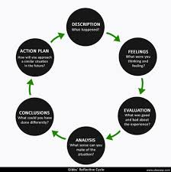
Sources- ukessays.co.uk

1. Description
The research procedure itself started with choosing Zara as the target brand because of its popularity as a fast-fashion multinational corporation and its presence in various markets in the world. I was trying to examine its approaches in two countries when comparing the UK, which is a developed Western market, and India, which is an emerging Asian market. I first aimed to investigate the brand positioning of Zara, marketing mix (4Ps), STP strategies, and ethical practices and compare the macro environmental factors (PESTLE analysis) in the two countries.
The data collection was done through secondary research and use of online sources, which included company reports, industry articles, market research databases, and academic journals. I have concentrated on recent and reliable sources of 2020-2025 to make sure that the information is modern and up to date. I used Hofstede Insights to explore cultural dimensions in the two nations as well.
The analysis stage involved the synthesis of information into their structured parts: brand overview, macro environmental comparison, STP and marketing mix strategies, directional development, and marketing ethics evaluation. The focus on each section was to integrate evidence and critical analysis, as opposed to describing it.

2. Feelings
I experienced a feeling of being overwhelmed by the scope of information on Zara and inability to compare two very different markets at the beginning of the project. The first thing that I was not certain about was how to organize the report in order to attract a coherent analysis and at the same time not to omit any of the mandatory sections. The involvement of both developed and emerging markets instilled in me the fear of having a balanced comparison more so that there are differences in the economic, cultural, as well as regulatory environments.
Nonetheless, I felt more confident as I began to gather data in an organized manner and design every section. The division of the research into phases, which included the macro environmental analysis, STP, marketing mix, and directional strategy, helped me cope with the amount of work. Applying the reflective framework by Gibbs was also a way to have a feeling of order and have time to think about the process itself and my feelings toward the challenges.

3. Evaluation
A number of aspects of the research process turned out to be successful. To begin with, the application of recent scholarly journals, market reports, and firm information was credible and reflected on the most recent information. Indicatively, the annual reports and market expansion data of Zara were used to analyse its direction development and marketing performance in India and UK precisely. The PESTLE analysis has helped me to be aware of the economic, political and cultural differences between the two countries, which influenced my judgment of marketing strategy adaptation.
The other achievement was the use of theoretical models which included the cultural dimensions presented by Hofstede and STP framework. These tools enabled me to go beyond descriptive reporting and gave me a critical perspective about why Zara does not follow the same marketing strategy in India as it does in the UK.
Nevertheless, there were certain problems. Little publicly available inside-country-specific financial information on India meant that it was not easy to do a complete quantitative comparison of market share and revenue. Likewise, the cultural implications had to be interpreted with great consideration, because the generalizations on the national culture may not be the best predictors of the target consumer groups of Zara. Such limitations pointed to the importance of critical assessment and triangulation of several sources.

4. Analysis
The analytic steps included connecting the theoretical information and the practical data. The PESTLE analysis of the UK as one of the most developed markets, demonstrated that consumer purchasing power and high regulatory requirements Favor the standardised pricing and sustainability policies of Zara, which are supported by the high purchasing power and stringent regulatory policy of the UK. Conversely, the situation in the emerging market of India demands some adaptability when it comes to pricing and promotional material to meet the needs and tastes of a wide range of socio-economic units (Hollensen, 2020).
The STP analysis highlighted that Zara in India is more selective in its segmentation whereby the company targets urban and middle/high income consumers whereas the UK market segmentations targets wider market segments as there is a greater overall market stability and familiarity with the brand.(Kotler et al., 2021).

5. Conclusion
When looking back upon the research process, I find that the combination of reflective cycle of Gibbs, theoretical frameworks and systematic data collection allowed the work to be better and deeper in its analysis. Several important learning points were strengthened in this project:
- The significance of the contextualization of marketing strategies to economic, political, and cultural contexts.
- The importance of the triangulation of data sources in order to address the gaps in state-of-the-art information.
- The importance of the connection between the theory and practice, especially the application of such models like STP, PESTLE, and the cultural dimensions of Hofstede.

6. Action Plan
In future research projects, I will apply a number of improvements, basing on this reflective process:
- Preliminary Data Collection and Organization- Begin the collection and organization of data at the initial phase to eliminate time constraints at the last moment.
- Integration of Original Data - Where feasible, carry out surveys or interviews with the consumers to sharpen information especially in new markets.
- Better Cultural Analysis - Segment segmentation in countries to better reflect the diversity in the regions.
- Depth of the Ethical Analysis- Incorporate case studies on corporate social responsibility to enhance critical assessment.
- Time Management - Take more time in doing comparative analysis of markets so that there is some balanced evaluation.

References
- Armstrong, G. and Kotler, P. (2023) Marketing: An Introduction. 15th Edition. Pearson. Available at: https://www.pearson.com
- Czinkota, M.R. and Ronkainen, I.A. (2022) International Marketing. 12th Edition. Cengage Learning. Available at: https://www.cengage.com
- Hollensen, S. (2020) Global Marketing: A Decision-Oriented Approach. 8th Edition. Pearson. Available at: https://www.pearson.com
- Kotler, P., Keller, K.L., Hoon, A.C. and Burton, S. (2021) Marketing Management. 16th Edition. Pearson. Available at: https://www.pearson.com
- Inditex (2023) Annual Report 2023. Available at: https://www.inditex.com/investor-relations/annual-reports
- Statista (2024) Apparel market revenue in India. Available at: https://www.statista.com/outlook/cmo/apparel/india
- Retailers Association of India (2024) Retail Sector Report. Available at: https://rai.net.in
- KPMG India (2023) Fashion Retail Consumer Survey 2023. Available at: https://home.kpmg/in
- Socialbakers (2025) Social Media Insights for Fashion Brands. Available at: https://www.socialbakers.com
- Hofstede Insights (2025) Country Comparison Tool. Available at: https://assignmentforum.com/hofstede-insights-cultural-comparisons?
- Nielsen India (2022) Apparel Consumer Insights Report. Available at: https://www.nielsen.com/in/en
- Fletcher, K. and Tham, M. (2021) Fashion and Sustainability: Design for Change. Laurence King. Available at: https://www.laurenceking.com
- Turker, D. and Altuntas, C. (2020) ‘Sustainable Supply Chain Management in Fast Fashion’, Journal of Cleaner Production, 275, 124098. Available at: https://doi.org/10.1016/j.jclepro.2020.124098
- Shen, B. (2021) ‘Sustainable Fashion Supply Chain: Issues and Practices’, International Journal of Retail & Distribution Management, 49(10), pp. 1303-1325. Available at: https://scholar.google.com/scholar?q=Sustainable+Fashion+Supply+Chain+Issues+and+Practices+Shen+2021
- Ghemawat, P. (2020) Redefining Global Strategy. Harvard Business Review Press. Available at: https://store.hbr.org/product/redefining-global-strategy-with-a-new-preface-crossing-borders-in-a-world-where-differences-still-matter/10203?srsltid=AfmBOooiu5sQqaQ1D-eE3JpFIT6Yn8oAct3d7_uqdTJoUdq1sXmPGyH3&utm_source=chatgpt.com
- Rugman, A.M. and Collinson, S. (2021) International Business. 8th Edition. Pearson. Available at: https://www.pearson.com
- Peng, M.W. (2022) Global Business. 5th Edition. Cengage Learning. Available at: https://www.cengage.com
- Cavusgil, S.T. et al. (2021) International Business: The New Realities. 4th Edition. Pearson. Available at: https://www.pearson.com
- Solomon, M. (2020) Consumer Behavior: Buying, Having, and Being. 13th Edition. Pearson. Available at: https://www.pearson.com
- Jackson, T. and Papadopoulos, N. (2022) ‘Cross-National Consumer Culture’, International Marketing Review, 39(2), pp. 245-269.
- Kotler, P. et al. (2022) ‘Marketing Strategies in Emerging Markets’, Journal of International Marketing, 30(3), pp. 15-33.
- Thomas, D. (2021) ‘A New Look at Fast Fashion’, Fashion Theory, 25(5), pp. 599-622.
- Burt, S. and Sparks, L. (2020) ‘Retailing in the UK: Trends and Strategies’, European Retail Research, 34(1), pp. 1-26.
- Chatterjee, P. and Kar, A.K. (2021) ‘E-commerce Adoption in India’, International Journal of Retail & Distribution Management, 49(9), pp. 1205-1227.
- Low, G. and Mohr, J. (2020) Market Entry Strategies. Routledge. Available at: https://www.routledge.com
- Czinkota, M.R. et al. (2023) ‘PESTLE Analysis in International Marketing’, Journal of Strategic Marketing, 31(4), pp. 405-419.
- Belk, R. (2021) Consumer Culture Theory. SAGE Publications. Available at: https://us.sagepub.com/
- Mintel (2024) UK Fashion Market Report. Available at: https://reports.mintel.com
- Deloitte (2023) Global Fashion Retail Outlook. Available at: https://www2.deloitte.com

