Name: Carmine Malan

ID:2313071

Lecture: Christopher Mafuva

Module: BMHP6027

Supporting Independence in Older Adults

Evaluating Care, Empowerment and the Role of Ageing Simulation Training in the UK and Japan

Poster
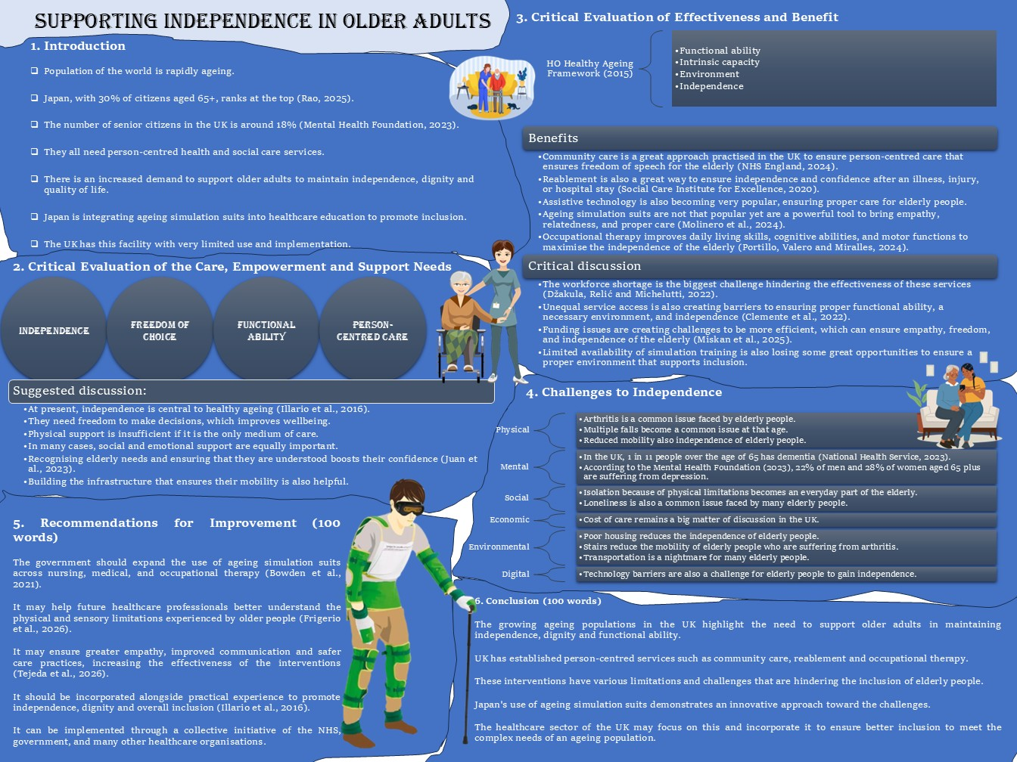

Writing of Poster

1. Introduction
Population of the world is rapidly ageing.
Japan, with 30% of citizens aged 65+, ranks at the top (Rao, 2025).
The number of senior citizens in the UK is around 18% (Mental Health Foundation, 2023).
They all need person-centred health and social care services.
There is an increased demand to support older adults to maintain independence, dignity and quality of life.
Japan is integrating ageing simulation suits into healthcare education to promote inclusion.
The UK has this facility with very limited use and implementation.

2. Critical Evaluation of the Care, Empowerment and Support Needs
Focus
Independence
Freedom of choice
Functional ability
Person-centred care
Suggested discussion:
At present, independence is central to healthy ageing (Illario et al., 2016).
They need freedom to make decisions, which improves wellbeing.
Physical support is insufficient if it is the only medium of care.
In many cases, social and emotional support are equally important.
Recognising elderly needs and ensuring that they are understood boosts their confidence (Juan et al., 2023).
Building the infrastructure that ensures their mobility is also helpful.

3. Critical Evaluation of Effectiveness and Benefit
WHO Healthy Ageing Framework (2015)
Functional ability
Intrinsic capacity
Environment
Independence
Benefits
- Community care is a great approach practiced in the UK to ensure a person-centered care that ensures freedom of speech for the elderly (NHS England, 2024).
- Rabblement is also a great way to ensure independence and confidence after an illness, injury, or hospital stay (Social Care Institute for Excellence, 2020).
- Assistive technology is also becoming very popular, ensuring proper care for elderly people.
- Ageing simulation suits are not that popular yet are a powerful tool to bring empathy, relatedness, and proper care (Molinero et al., 2024).
- Occupational therapy improves daily living skills, cognitive abilities, and motor functions to maximise the independence of the elderly (Portillo, Valero and Miralles, 2024).
Critical discussion
The workforce shortage is the biggest challenge hindering the effectiveness of these services (Džakula, Relić and Michelutti, 2022).
Unequal service access is also creating barriers to ensuring proper functional ability, a necessary environment, and independence (Clemente et al., 2022).
Funding issues are creating challenges to be more efficient, which can ensure empathy, freedom, and independence of the elderly (Miskan et al., 2025).
Limited availability of simulation training is also losing some great opportunities to ensure a proper environment that supports inclusion.

4. Challenges to Independence
Physical
Arthritis is a common issue faced by elderly people.
Multiple falls became a common issue at that age.
Reduced mobility also independence of elderly people.
Mental
In the UK, 1 in 11 people over the age of 65 have dementia (National Health Service, 2023).
According to the Mental Health Foundation (2023), 22% of men and 28% of women aged 65 plus are suffering from depression.
Social
Isolation because of physical limitations becomes an everyday part of the elderly.
Loneliness is also a common issue faced by many elderly people.
Economics
Cost of care remains a big matter of discussion in the UK.
Environmental
Poor housing reduces the independence of elderly people.
Stairs reduce the mobility of elderly people who are suffering from arthritis.
Transportation is a nightmare for many elderly people.
Digital
Technology barriers are also a challenge for elderly people to gain independence.

5. Recommendations for Improvement (100 words)
The government should expand the use of ageing simulation suits across nursing, medical, and occupational therapy (Bowden et al., 2021).
It may help future healthcare professionals better understand the physical and sensory limitations experienced by older people (Frigerio et al., 2026).
It may ensure greater empathy, improved communication and safer care practices, increasing the effectiveness of the interventions (Tejeda et al., 2026).
It should be incorporated alongside practical experience to promote independence, dignity and overall inclusion (Illario et al., 2016).
It can be implemented through a collective initiative of the NHS, government, and many other healthcare organisations.

6. Conclusion (100 words)
The growing ageing populations in the UK highlight the need to support older adults in maintaining independence, dignity and functional ability.
UK has established person-centered services such as community care, rabblement and occupational therapy.
These interventions have various limitations and challenges that are hindering the inclusion of elderly people.
Japan's use of ageing simulation suits demonstrates an innovative approach toward the challenges.
The healthcare sector of the UK may focus on this and incorporate it to ensure a batter inclusion to meet the complex needs of an ageing population.

References
Bowden, A., Chang, H.-C.R., Wilson, V. and Traynor, V. (2021). The impact of ageing simulation education on healthcare professionals to promote person-centred care towards older people: A literature review. Nurse Education in Practice, [online] 53(1), p.103077. doi: https://dx.doi.org/10.1016/j.nepr.2021.103077.
Clemente, K.A.P., Silva, S.V. da, Vieira, G.I., Bortoli, M.C. de, Toma, T.S., Ramos, V.D. and Brito, C.M.M. de (2022). Barriers to the Access of People with Disabilities to Health services: A Scoping Review. Revista de Saúde Pública, [online] 56(56), p.64. doi: https://dx.doi.org/10.11606/s1518-8787.2022056003893.
Džakula, A., Relić, D. and Michelutti, P. (2022). Health workforce shortage – doing the right things or doing things right? Croatian Medical Journal, [online] 63(2), pp.107–109. doi: https://dx.doi.org/10.3325/cmj.2022.63.107.
Frigerio, M., Charadram, N., Qurashi, M., Chebib, N. and Müller, F. (2026). Aging-Simulation Experience in Dental Education: Impact on Attitude and Empathy of Dental Students Towards Older People. Dentistry Journal, 14(4), p.224. doi: https://dx.doi.org/10.3390/dj14040224.
Illario, M., Vollenbroek-Hutten, M.M.R., Molloy, D.W., Menditto, E., Iaccarino, G. and Eklund, P. (2016). Active and Healthy Ageing and Independent Living 2016. Journal of Aging Research, 2016(1), pp.1–3. doi: https://dx.doi.org/10.1155/2016/8062079.
Juan, C.B.-W., Görgen, P., Mary Jane Schilling-Norman and Cristhian Pérez-Villalobos (2023). Identifying the Needs of Older Adults Associated with Daily Activities: A Qualitative Study. International Journal of Environmental Research and Public Health, [online] 20(5), pp.4257–4257. doi: https://dx.doi.org/10.3390/ijerph20054257.
Mental Health Foundation (2023). Older people: Statistics. [online] Www.mentalhealth.org.uk. Available at: https://www.mentalhealth.org.uk/explore-mental-health/statistics/older-people-statistics [Accessed 15 July 2026].
Miskan, N.H., Muhamad, N., Esa, M.M., Zabidi, F.S.M., Hussin, N.L. and Karim, Z.A. (2025). Financial Sustainability and Socio-Economic Well-Being of Senior Citizens in Addressing an Ageing Nation Towards 2030. International Journal of Research and Innovation in Social Science, IX(VI), pp.6427–6436. doi: https://dx.doi.org/10.47772/ijriss.2025.906000481.
Molinero, J.R., Somolinos, E.D., Medrán, B.C.M., Puerta, R.R., Liria, I.C., Fernández, R.J., Losa-Iglesias, M.E. and López-Sánchez, A.F. (2024). Use of an age-simulation suit as an empathy-building method for dental students: A pre-post study. PeerJ, 12(1), pp.e17908-e17908. doi: https://dx.doi.org/10.7717/peerj.17908.
National Health Service (2023). What is dementia. [online] Nhs.uk. Available at: https://www.nhs.uk/conditions/dementia/about-dementia/what-is-dementia/ [Accessed 14 July 2026].
NHS England (2024). Person-centred Care. [online] NHS England. Available at: https://www.hee.nhs.uk/our-work/person-centred-care [Accessed 12 July 2026].
Portillo, C.U., Valero, S.A. and Miralles, P.M. (2024). Occupational Therapy Interventions to Improve the Quality of Life of Older Adults with Dementia Living in Nursing Homes: A Systematic Review. Healthcare, [online] 12(9), p.896. doi: https://dx.doi.org/10.3390/healthcare12090896.
Rao, P. (2025). Ranked: Countries With the Highest Share of Seniors. [online] Visual Capitalist. Available at: https://www.visualcapitalist.com/ranked-countries-with-the-highest-share-of-seniors [Accessed 9 July 2026].
Social Care Institute for Excellence (2020). Reablement: A guide for carers and families. [online] SCIE. Available at: https://www.scie.org.uk/integrated-care/intermediate-care-reablement/reablement-guide/ [Accessed 16 July 2026].
Tejeda, S.S., Benítez, P.O., Hernández, L.H., Cuervo, F.M., Torres, M.P. de H., Baeza, P.S.-H., Ceacero, A.Y. and Piédrola, R.M.M. (2026). Effects of a brief aging simulation suit intervention on clinical empathy in healthcare professionals working in long-term care: A randomized controlled trial. BMC Geriatrics, 26(1). doi: https://dx.doi.org/10.1186/s12877-026-07564-x.

