
The importance of effective communication for young children’s learning and development during transitions in an Early Years Setting

1707004 2886 word count
Source: Clipart Library (2016)
^{Contents}
Introduction
who is this book for and what should I expect? 3
Transitions
What is Transitions? 4
Every Child is different… 5
Home School Contact Book 6
Communication
What is communication? 7
Verbal Communication 9
Non- Verbal Communication & Child Safeguarding 10
Theorists
John Dewey 11
Montesorri 12
Vygotsky 13
Theory to practise – The benefits 14
Activities
Try this – Activity! 16
Notes 18
References 19

Who is this book for?
Created for both Early Years Key workers and Parents working with children who are moving up from Nursery to Reception in a educational setting.

What should I expect?
In this handbook, you will find in depth advice and information, detailed definitions on aspects of a child’s development and how the transition from the nursery setting will affect them.

Further to this, you will also find information on how you as a keyworker or parent can enable strategies using various sources available throughout to enhance effective communication and make the transition easier for the child.

Inside will also include brief background information on a variety of theorists and how we can put their theories to practice at Home or at school, which will be practical for everyday life in their future.

Transition –
What does it mean?
Transition is the incremental progression from one stage of development to the next. To be put simply, it is the natural progression from one phase of a child’s growth to the other.

The influence and factors at play are relationships with the other children, their parents and their keyworkers. This encapsulates cultural background and genetic traits.

According to Early Years Matters (2017), As a teacher or parent, we must remember that this transition could be a milestone for the child. Therefore, it may have a major impact on them, as well as yourselves.
Transitions in Early Year setting may be milestones for children, but with the right encouragement and support, they should be seamless.

Therefore, by following the guidelines and advise offered in this handbook, the transition from nursery to reception although potentially stressful can be alleviated to a large degree for all parties.



Remember!
Every child is unique and will react and develop at various paces. Therefore, the advice and guidance in this handbook would be more appropriate depending on the circumstances of the child.
Therefore, it must be highlighted that the information is not definitive.
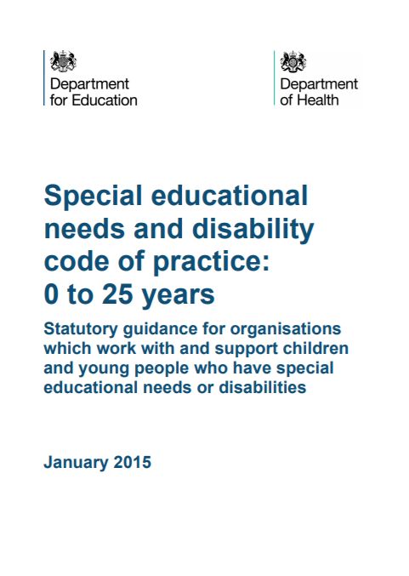
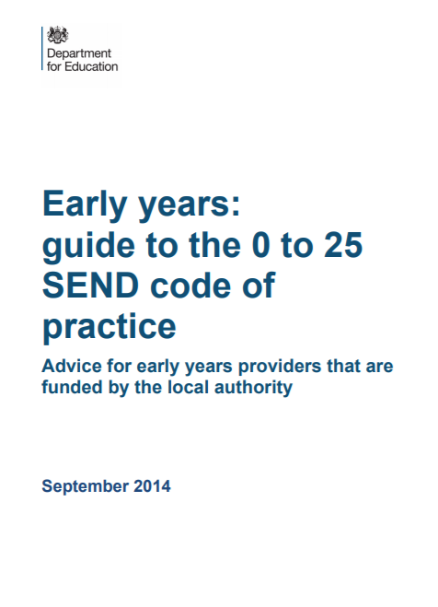
source: Gov.UK (2017) source: Gov.uk (2017)

Legislations have been put in place to advise key workers further on good practice in an Early Years setting when there may be a child with disabilities in the class.
Both legislations can be found via:
https://www.gov.uk/government/publications/send-code-of-practice-0-to-25
https://www.gov.uk/government/publications/send-guide-for-early-years-settings

Smith, K., Cowie, H., Blades, M. (2003) have implied that as a parent, your child going into a reception class may be the first time you will be without your child for a whole day, so you may have concerns, right?

- Are you aware about what happens day-to-day in the setting?
- what did your child do on their first day?
- Do you have concerns about whether their child will be able to find the toilet?
- Is your child comfortable going to the toilet in school?
- Is your child okay to ask for something they need?
- Are you worried whether your child will make friends?
- Is my child being bullied or led astray?
- Is my child safe?
- what will happen if they feel are upset or get hurt at school?

Forestdale School (2017) have introduced a Home School Contact Book. In this book parents and keyworkers can keep each other up to date. If a parent or a key worker has any concerns such as the ones above, they can make a note. Further to this, they can communicate through it, answering questions or concerns they may have.
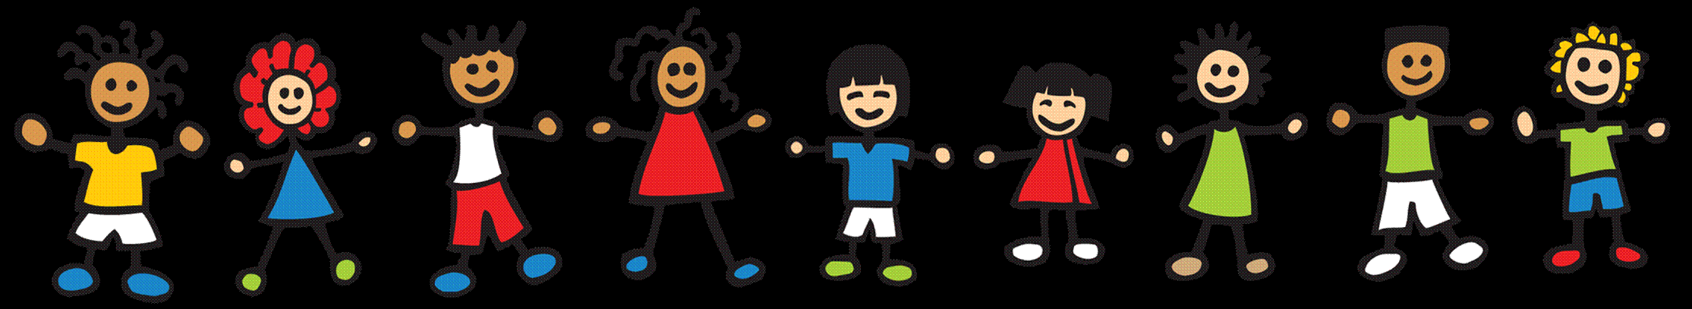
This may also interlink with Brofenbanner’s ecological systems theory.
As stated by Gulf Bend Centre (2017) networking with the child will have an effect on how the child will develop; the more reassuring and caring relationships and environments are, the better the child will develop in skills.

Source: Clipartix (2017)

What is Communication?
According to Bruce (1997), Communication skills are a vital part of a child’s development. It is the skill which enables a child to interact with other children, keyworkers and their parents.
Effective communication can be used between you and the child in terms of safeguarding. Communication between teachers and parents helps to certify the children they are safe. When a child has built a strong relationship built on trust, where they feel confident they will begin to vocalise any anxieties they may have.
Further to this, by communicating your child will also enhance their development in other assets such as friendships, relationships, learning what is right and what is wrong, manners, other forms of behaviour and social norms.

Parents and Teachers
A beneficial way for children to gain a clearer understanding about their new venture may be for the school or day care facility to organise an orientation day. By taking part in an orientation day, the child will be taking part in a variety of activities with various social groups (teachers and other students).
This exercise will be an effective method of introducing the children to the new environment at reception. Therefore, instead of jumping in at the deep end, Children would now have sampled the reception class environment which will now, no longer be completely alien experience for them.
Another effective way may be by sending an information packet home regarding what to expect from their new reception class. This way a parent and their child can sit down together and discuss it further. Furthermore, this will enable parents to be in a position to inform their children of what to expect in reception in the comfort and security of their home setting.
By discussing the transition at home, the child may feel more secure and confident to express their true feelings regarding the matter. This will also help their relationship with their parent or guardian.

Wolfson (2014) has also suggested that by communicating effectively you are starting and developing a relationship with the child. He has implied that a relationship with a pre-schooler is the relationship which influences all of their relationships for the rest of their life’s. While communicating you could show compassion and sensitivity about a subject matter they may bring up which enhance your bond. This applies to both key workers and parents.

Similarly, Smith, Cowie and Blades (2003) have said that by developing relationships, with keyworkers, parents or other student, we then feel socially accepted which will avoid a child feeling lonely or neglected. It will encourage them to engage more.
How will this make a transition easier? You have to think to yourself.. Will having a friend make an important milestone such as moving class easier for a child? Yes, it is highly likely!

According to Winston (2017) there are two forms of communication - Verbal communication and Non-Verbal Communication. As a parent or keyworker, you are continuously using both to communicate with the child. However, we must ask, how can we use the two forms of communication.
Politeness | Manners, simply teaching a child good manner such as ‘please’ and ‘thank you’ will show them respect and consideration for other people.
Compliments | We all appreciate a compliment, whether it be a praise or admiration on our appearance, personal qualities, achievements. By complimenting other people, it suggests approval and acceptance Furthermore, after receiving a compliment we feel good about ourselves. This may be a form of motivation.
Apologising | ‘sorry’ this can be a hard word for a child to say, as it normally means they have done wrong, something they may not want to admit. However, this is also a good quality to have, it is resolving conflict and suggests they know what is right from wrong. It can also lead to further communication as the other person involved in conflict may have something to apologise for too.
Verbal Communication

It is important to remember when communicating with children, to be careful with your choice of vocabulary and the tone of voice you use. Verbal communication can enable a child to gain knowledge on further qualities.
Non-Verbal Communication

Do we always need to speak to interact with someone, to let them know what we are thinking?
Winston (2017) has implied that no, we do not need to speak for someone to get a message loud and clear. Teachers, Children and parents use body language as a form of communication, everyday! By reading someone’s body language, you will gain a better understanding on how the other person is feeling.
According to Stevenson University’s Faleti (2017) effective communication will leave parties who part take feeling proficient.
How a parent or keyworker communicates with a child can play a factor for the child’s future whether it’s while they are at a job interview, future healthy or non-healthy relationship, and expressing how they feel.

Do you have any concerns?
Children may say something that as a parent or keyworker you may find disturbing or even a cause for concern. There are a variety of legislation in place to help you further. However, it is advised that you seek further advice, in a school setting there will be a designated person who you could speak with. Please see page ???? where helpline contact numbers are available for your reference.

John Dewey
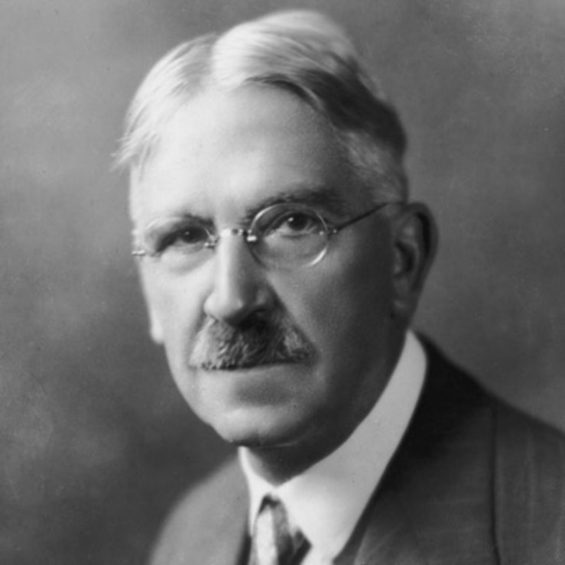

source: Biography (2017)

Dewey (2004) believed that education can be a social and interactive process.
As stated by Gray and Macblain (2012), Dewey believed the notion of Child-centred Education. It is emphasised that teachers should be using this learning method to acknowledge each child’s uniqueness and to remember that all children are individuals.
The theorist believed that children may learn better from experiences with a clear structure, which will enable them to become respected, equal, and liable members of civilization. The theorist has also stated that children may benefit a better understanding of a subject when they have hands on experience and interact with other children.
By learning through experience, a child may learn something from the lesson which may benefit their everyday life. However, by having a formal lesson in a classroom, that information may be overlooked.

Maria Montessori

Maria Montessori is a well-known influential figure in the Early Years Setting. Why? Montessori emphasises the environment which a child learns in and how it will enable a child to develop at a natural pace.
Similar to Dewey’s theory, Montessori’s theory can be utilised through both indoor and outdoor learning. Beames, S., Higgins, P., and Nicol, R. (2012) have implied that with the right amount of preparation, Teachers should consider being more creative and interlink indoor skills or lesson curriculum to outdoor activities. Further to this, by visiting a various areas children could also expand how they are developing in skills and personal qualities which may be useful when they are adults. Skills such as; employment, social, planning and decision making, responsibility taking.

Vygotsky
Vygotsky (1980) holds the view that in their very nature children are curious and consequently learn and discover through this process of being naturally inquisitive. Furthermore, he argues that basic social interaction is a part of the learning and development evolution and that the community in which the child resides is paramount.
Traditional education focuses on the role of the teacher or tutor instructing or transmitting knowledge to children parrot fashion to the children who learn by rote but not necessarily understanding the concepts and meaning below the factual information.
By contrast, Vygotsky favours the teacher as a facilitator in the transfer of knowledge where the child has to discover in a more active role rather than be receptacle of information.
This induces curiosity and a more analytical approach to learning and development.
Parents or Keyworkers
The MKO concept is an acronym for the “more knowledgeable other “ and is a reference to someone that possesses more knowledge and a far better grasp of a subject matter than the student or learner. This could be a teacher, lecturer, mentor or specialist. It could also include inanimate objects like books, journals, computers etc.
The Child
The ZPD Zone is defined as that area or gap between a learner’s ability and aptitude to carry out a task under supervision and the learner’s innate ability to carry out the task independently. According to Vygotsky this is the zone in which learning takes effect.

Theory to Practice

As you can see, Dewey, Montessori and Vygotsky all have similar theories when it comes to learning. How can these theories be practiced to help development in various skills to make the child’s transition from Nursery to Reception easier though?
Kids Matter (date unknown) have implied that keyworkers and parents should;

- Teach by Example - By demonstrating good social values and norms, the child in the classroom or in other settings can learn by the example set by the teacher. Children are very impressionable and look to their elders for guidance in behavioural patterns and standards .As well as providing verbal instruction in these matters the act of demonstration is at least as important.
- “Do” rather than “Don’t” - To impart school rules and etiquette to your charges it is more important that it is done in a positive way and in a way that is easily understood by the children. A two way discussion with pupils about the need to establish rules and decorum is helpful so that these rules are clearly understood and the pupils should be invited to come up with suggestions as to the content of these rules. They should be the framework upon which the social and moral development of children should be benchmarked.
- Be firm, fair and flexible - Whenever a set of rules are laid down, it is vital especially in a school setting that these standards are applied fairly and consistently in order that there is no hint of discrimination. An even keel approach to the application of school rules will engender respect from the pupils if they can see that no one pupil is being singled out fairly or unfairly. Although rules should be applied consistently, there should be some leeway for discretion in certain circumstances. For example, a child might be late for school which on making enquiries could be because of a domestic problem over which the child has no control .

- Set the scene for classroom cooperation - In order to make every child in a particular class feel valued and an important part of the class it is is essential that everyone cooperates in a meaningful way .The whole should be better than the sum of the parts in this context .Tasks or assignments should be structured so that every individual makes a contribution to the outcome. In this way an atmosphere of togetherness and teamwork is fostered. It makes individuals feel valued in a common task through cooperation.
- Appreciate social and cultural diversity - It is imperative that as a teacher or key worker you enquire into the social, cultural, linguistic background of all of your charges so that you are cognizant of differing needs and perspectives and adjust your instructions accordingly without losing sight of the overall objectives. Communication is a two way bridge and an exchange of differing perspectives can lead to a greater understanding of differing diversities.
- Deal promptly with discrimination and harassment - School rules will dictate policies on discrimination and harassment and if you encounter any examples of such behavior they should be dealt with promptly and firmly. Any such display of bullying based on discrimination and harassment should be eliminated from the school setting immediately otherwise the aim of tolerance and classroom cooperation is denied.

Try this!

When are children happiest? When they are having fun. There are various activities that both key workers and parents can introduce to the child to make a transition feel seamless.

Activity books
Kids Matters (date unknown) have various activity book ideas in what children could do during their transition.
The child could complete the book by doing illustrations with details of their life in school and out;
- Hello I am…
- I live at home with…
- My new friends are…
- My new teacher is…
- I like…
- I dislike…
I spy…
A traditional game that is played by all ages, yes. But Preschool plan it (2017) suggests it could be a strategy for children to get to know each other. How would you play it?

I spy with my little eye…
- Someone wearing a red top with a picture of Super Mario
- I spy with my little eye someone wearing a blue dress
- I spy with my little eye someone beginning with ‘A’

Treasure Hunt
BONUS! Keyworkers could invite parents in to take part in this activity!
The children could take part in a treasure hunt, which will lead them to a variety of areas in and around the skill. What could this do to make the transition easier? It will make them aware of where everything is. T may also illustrate where they can go and what places may be out of bounds. They can then reflect over the activity and be tested to see how well they got to know the areas. What will make it exciting? There may be an activity or treat waiting at each stop.

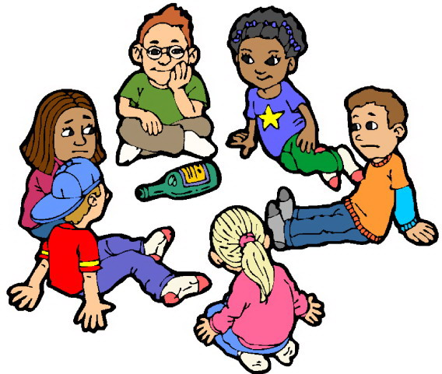
Source: Clipartix (2017)
Notes

References

Age of Montessori(2010-2017) http://ageofmntessori.org/pros-and-cons-of-a-montessori-education/ [accessed on 25/11/2017]
Beames, S., Higgins, P., Nicol, R. (2012) Learning outside the classroom, theory and guidelines for the practice. New York: Routledge
Biography (2017) https://www.biography.com/people/john-dewey-9273497 [accessed on 20/11/2017]
Bruce, T. (1997) Bruce, T., Meggit, C. (1999) Childcare & Education. (2nd ed.) Italy: Hodder & Soughton Educational
Bruce, T. (1997) Early Childhood Education (2nd ed.) Great Britain: Hodder & Soughton Educational
Clipartix (2017) http://clipartix.com/children-playing-clipart/ [accessed on 25/11/2017]
Clipart Library (2016) [URL=http://clipart-library.com/clipart/443653.htm][IMG]http://clipart-library.com/image_gallery/443653.jpg[/IMG][/URL] [accessed on 20/11/2017]
David L, "Social Development Theory (Vygotsky)," in Learning Theories (2014) https://www.learning-theories.com/vygotskys-social-learning-theory.html. [accessed on 17/11/2017]
Dewey, J. (2004) Democracy and Education. Dover Publications: New York
Doherty, J., Hughes, M. (2009) Child development theory and practice 0-11. England: Pearson Education Limited
Early Years Careers – Kelly (2017) http://www.earlyyearscareers.com/eyc/latest-news/sector-news/effective-communication/ [accessed on 11/11/2017]
Early Years Matters (2017) http://www.earlyyearsmatters.co.uk/eyfs/positive-relationships/transitions/ [accessed on 09/11/2017]
Forestdale Primary School (2017) http://www.forestdale.croydon.sch.uk/Home-Contact-Book/ [accessed on 22/11/2017]
Gov.uk (2015) https://www.gov.uk/government/publications/working-together-to-safeguard-children--2 [accessed on 11/11/2017]
Gray, C., Macblain, S. (2012) Learning theories in childhood. London: Sage Publications Limited
Gulf Bend Centre (2017) https://www.gulfbend.org/poc/view_doc.php?type=doc&id=7930 [accessed on 24/11/2017]
Kids Matter (date unknown) https://www.kidsmatter.edu.au/mental-health-matters/social-and-emotional-learning/social-development/suggestions-ec-schools [accessed on 23/11/2017]
Lindon, J. (2012) Understanding Children Development 0-8 Years. (3rd ed.) Italy: Hodder Education
NDF Admin (2016) https://novakdjokovicfoundation.org/transition-early-childhood-education/ [accessed on 09/11/2017]
NSPCC (2017) https://www.nspcc.org.uk/ [accessed on 25/11/2017]
O’Connor, A (2002) https://www.nurseryworld.co.uk/nursery-world/news/1083811/communication-language-literacy-outdoor-play-speak [accessed on 15/11/2017]
Preschool plan it (2017) https://www.preschool-plan-it.com/transition-activities.html [accessed on 23/11/2017]
Simply Psychology (2014) https://www.simplypsychology.org/vygotsky.html [accessed on 16/11/2017]
Smith, K., Cowie, H., Blades, M. (2003) understanding children’s development. (4th ed.) Oxford: Blackwell Publishing.
THE OPEN GOVERNEMENT (DATE UNKNOWN) https://www.gov.uk/early-years-foundation-stage [accessed on 6/11/2017]
THE WELSH GOVERNMENT (2017) http://gov.wales/topics/educationandskills/foundation-phase/?lang=en [ACCESSED ON 6/11/2017]
Welsh Government (2015) https://www.gov.uk/government/publications/send-code-of-practice-0-to-25 [accessed on 20/11/2017]
Welsh Government (2015) https://www.gov.uk/government/publications/send-guide-for-early-years-settings [accessed on 20/11/2017]
Winston, R. (2017) help your kids with growing up. London: Dorling Kindersley Limited
Woolfson, R (2014) Your pre-schooler bible. London:Carroll & Brown

