

Dissertation

A Study on adoption of AI Chatbots in NHS Telemedicine. Patient Perception, Trust, and Willingness to Use the Telemedicine

Student Name Luciana Ionela Florea
Student ID 2126969

Executive summary
This study investigates NHS patient perceptions of artificial intelligence (AI) chatbots within telemedicine, focusing on levels of trust, willingness to adapt, and concerns surrounding their use. Using a quantitative research design grounded in the positivist paradigm, the study collected data via a structured online survey from 63 NHS patients, stratified by age, digital literacy, and telemedicine usage. Although originally aiming for stratified random sampling, practical constraints led to the use of convenience sampling through online platforms, ensuring exploratory insight despite limitations in generalisability.
The findings show a moderately high acceptance of AI chatbots for administrative tasks such as appointment scheduling, especially among younger, digitally literate individuals. However, there remains considerable caution about using AI in clinical decision-making roles. The data reveal that 84% of participants prefer AI to complement rather than replace human doctors, highlighting strong support for augmented intelligence models in healthcare.
Concerns raised by participants included accuracy and reliability (57%), lack of human empathy (43%), and data privacy (29%), echoing broader literature on patient hesitancy towards automation in emotionally or clinically sensitive contexts. Despite this, many respondents (59%) said they would be more open to chatbot use if certified by the NHS or integrated with human oversight. Experience with telemedicine and a strong preference for trusted endorsement (e.g. from doctors) also emerged as key facilitators of AI adoption.
The study adhered to strict ethical protocols, ensuring informed consent, participant anonymity, and full compliance with GDPR and NHS data protection standards. No personally identifiable information was collected, and participants were informed of their rights, including voluntary participation and withdrawal at any time.
While the findings reflect the views of a relatively tech-savvy and educated demographic, they provide critical insight for NHS policymakers and AI developers. Recommendations include enhancing public trust through NHS certification, improving transparency and data safeguards, and ensuring inclusive design that accounts for digitally excluded populations. Future research should prioritise the perspectives of older adults and those with low digital literacy to prevent widening health inequalities in the digital age.

Table of Contents
Executive summary 2
Introduction 5
1.2 Research Aim 6
1.3 Research Objectives 7
1.3.1 Assess patient trust in AI chatbots for healthcare consultations 7
1.3.2 Identify factors influencing patients' willingness to use AI-driven medical services 7
1.3.3 Examine demographic differences (age, education, digital literacy) in AI chatbot adoption 7
1.3.4 Provide recommendations for effectively integrating AI chatbots in NHS 7
1.4 Research Questions 7
1.5 Significance of the study 8
Literature review 8
2.1 AI in Telemedicine & NHS Initiatives 8
2.2 Human-AI Interaction in Healthcare Communication 8
2.2.1 Empathy in AI 8
2.2.2 AI and Clinical Language Understanding 9
2.2.3 Access Inequality 9
2.2.4 Language barriers in chatbot interactions for non-native English speakers in the UK healthcare system 10
2.2.5 Patient Trust in AI Chatbots 10
2.3 Factors Influencing AI Adoption in Healthcare 10
2.4 Legal, Ethical and Regulatory Frameworks 11
2.4.1 GDPR & Data Privacy 11
2.4.2 Liability 12
2.5 AI Bias and Fairness 12
2.6 Ethical AI in Healthcare 12
2.7 Cost-effectiveness of AI in the UK Healthcare System 13
2.8 Theoretical Framework 13
Methodology 14
3.1 Research Design 14
3.2 Paradigm and Epistemology 15
3.3 Data Collection 15
3.4 Data Analysis 16
1 What is your age? 17
2 What is your highest level of education? 17
3 How would you rate your digital literacy? 18
4 Have you used telemedicine services (e.g., video consultations, online doctor chats) before? 19
5 Have you ever interacted with an AI chatbot for healthcare purposes (e.g., symptom checker, virtual assistant)? 20
6 How would you describe your experience with AI chatbots in healthcare? (If Applicable) 21
7 How comfortable would you be consulting an AI chatbot instead of a human doctor for minor health concerns? 22
8 What concerns, if any, do you have about using AI chatbots in healthcare consultations? (Select all that apply) 23
9. To what extent do you trust AI chatbots to provide accurate medical information? 24
10. Would you follow medical advice given by an AI chatbot without consulting a doctor? 25
11. What would increase your trust in AI chatbots for health care? (Select all that apply) 26
12. How likely are you to use an AI chatbot for booking appointments or checking symptoms in NHS telemedicine? 27
13. If AI chatbots improved NHS efficiency (e.g. Reducing waiting times), would you be more willing to use them? 28
14. Would you be more open to using AI chatbots if they worked alongside human doctors rather than replacing them? 29
15. what factors would encourage you to use AI chatbots in telemedicine? (Select all that apply) 30
16. Do you think AI chatbots should be a primary consultation method in NHS telemedicine? 31
3.5 Ethical Considerations 32
3.6 Generalisability, Reliability & Validity 32
Conclusion 33
References 36
Appendix 44
Link to the Survey: 44

Introduction
The integration of Artificial Intelligence (AI) in healthcare has seen significant growth in the recent years, particularly in telemedicine. AI applications, such as chatbots, are increasingly utilized to enhance patient consultations and streamline healthcare services, reducing pressure on overburdened system like the united Kingdom’s National Health Service (NHS) and increase operational efficiency (Andrikopoulou, 2023). For instance, Babylon Health has partnered with the UK's National Health Service (NHS) to implement an AI-powered chatbot for the NHS 111 service, aiming to provide efficient triage and medical advice to patients. These technologies promise to reduce waiting times, improve health outcomes, and allow healthcare professionals to focus on more complex clinical tasks.
AI chatbots in healthcare serve multiple roles, including symptom checking, patient round-the-clock triage, and providing basic medical information aiming to minimise unnecessary in person visits (O'Hear, 2017). These tools are designed to assess patient symptoms and direct them to appropriate care pathways, potentially reducing the burden on healthcare professionals and improving patient access to medical services (Coherent Solutions, 2024) (Clark & Bailey, 2024). The NHS's collaboration with Babylon Health exemplifies this approach, where the AI chatbot assists in managing patient inquiries, thereby alleviating pressure on the healthcare system.
Despite the promising applications of AI chatbots, patient acceptance remains uncertain. Numerous studies suggest that patient trust in AI-driven services is still limited. Concerns regarding trust, data privacy, and the reliability of AI-driven consultations (Mennella et al., 2024) may influence patients' willingness to engage with these technologies. Understanding patient perceptions and addressing these concerns are crucial for the successful implementation of AI in telemedicine. Although AI chatbots can process data quickly and deliver consistent information, they often fall short in offering nuanced, empathetic responses that are crucial in areas like mental health or end-life care (Heather, 2017).
In the context of the NHS, understanding public perception of AI chatbot consultations is essential. The UK’s healthcare system is built on values of trust, equity, and human-centred care Introducing non-human digital agents in frontline services demands a deep understanding of how patients perceive and interact with these systems, especially given concerns related to digital exclusion and technological literacy.

1.2 Research Aim
This research aims to examine patient perceptions, trust levels, and willingness to use AI chatbots in NHS telemedicine. The objective is to gather quantifiable data from a broad sample of participants to explore how different people experience and evaluate AI chatbot consultations, and to inform the design and implementation of patient-centred digital health tools. After examining these the aims is to improve healthcare devices and procedures (Thornton et al., 2024).

1.3 Research Objectives

1.3.1 Assess patient trust in AI chatbots for healthcare consultations

1.3.2 Identify factors influencing patients' willingness to use AI-driven medical services

1.3.3 Examine demographic differences (age, education, digital literacy) in AI chatbot adoption

1.3.4 Provide recommendations for effectively integrating AI chatbots in NHS

1.4 Research Questions
How do patients perceive AI chatbots compared to human-led consultations in NHS telemedicine? (Thornton et al., 2024)
What factors influence patient trust and willingness to use AI chatbots in healthcare?
How do demographic factors impact adoption rates of AI chatbots?
How can AI Chatbots be effectively integrated into telemedicine and healthcare?
By addressing these questions, the researcher aims to provide insights into patient attitudes toward AI in healthcare, informing strategies to enhance the adoption and effectiveness of AI chatbots in NHS telemedicine services.
This study uses a quantitative research approach, relying on questionnaires that will be distributed to a sample of up to 100 participants. The aim is to collect measurable data that can help identify patterns and trends in how patients perceive and use AI chatbots in NHS telemedicine. The research is based on the idea that knowledge about people’s attitudes and behaviours can be gathered by observing and analysing responses in a systematic way. By using this structured method, the study seeks to draw general conclusions that could apply to a wider population, rather than focusing only on individual experiences. This approach supports the use of statistics and objective analysis to better understand the overall level of trust, willingness, and usage among different patient groups (Creswell, 2009). By using questionnaires that generate numerical data, the study aims to collect information in a way that is consistent and unbiased. This allows the findings to be analysed using statistics, helping to ensure that the results are based on evidence rather than personal opinions or interpretations. (Bryman, 2016)

1.5 Significance of the study
This research is timely given the NHS’s post-COVID emphasis on digital transformation and remote care. By exploring how different demographics perceive and respond to AI chatbot services, the study will provide insights for healthcare policymakers, designers, and NHS administrators seeking to improve patient-centred digital tools. The use of questionnaire data will help quantify public sentiment and identify areas for improvement in both technology and patient education, supporting safe, ethical, and equitable AI integration in healthcare.

Literature review

2.1 AI in Telemedicine & NHS Initiatives
AI chatbots have become increasingly prevalent in healthcare settings. For instance, Ada Health offers a chatbot that assesses users' health by comparing their symptom inputs against a vast AI database, allowing users to share their AI-generated assessments with their doctors (Filipsson, 2025). In the UK, the app can connect users with a general practitioner. Similarly, Babylon Health provides a chatbot capable of evaluating symptoms and offering medical advice, guiding patients on whether to consult a doctor (Studman, 2021).
The UK's National Health Service (NHS) has been proactive in incorporating AI-powered solutions to improve patient care. The NHS AI Lab, for example, creates an environment for collaboration by bringing together programs that address barriers to developing and deploying AI systems in health and care, aiming to revolutionise healthcare while ensuring appropriate guidance and regulations to protect patients (NHS England, 2024).
Additionally, the NHS is leveraging AI to predict patients who are at risk of becoming frequent users of emergency services, enabling staff to provide more appropriate care at an earlier stage (National Health Executive, 2024).

2.2 Human-AI Interaction in Healthcare Communication

2.2.1 Empathy in AI
In recent developments, AI conversational systems have increasingly aimed to simulate empathetic interactions; however, scholarly opinions remain divided, with some researchers arguing that AI responses still lack genuine emotional depth, while others suggest that AI is approaching human-like emotional communication. Despite these advancements, today’s AI still struggles with demonstrating real empathy, which is critical for patients facing mental health challenges or terminal illness. Although conversational AI attempts to sound caring, it often falls short (Kerasidou, 2020).
AI responses typically miss the deeper emotional cues essential for meaningful engagement. Similarly, (Montemayor et al., 2021) demonstrated that while AI can mimic empathetic behaviours, it fails to establish true emotional connections, leaving patients feeling unheard. Without genuine emotional support, AI risks functioning more as a mechanical tool than as a supportive companion in patient care.

2.2.2 AI and Clinical Language Understanding
AI is transforming clinical language understanding by enabling more accurate extraction of patient information from unstructured medical texts. Natural Language Processing (NLP) models, such as those discussed by (Demner-Fushman et al., 2009) can identify clinical concepts, symptoms, and treatment patterns with increasing precision. However, challenges persist, including ambiguity in medical language and the need for domain-specific training data (Rajkomar et al., 2019). Advanced models like ClinicalBERT have shown promise in improving diagnostic decision support (Alsentzer et al., 2019). Nonetheless, ethical concerns about data bias, patient privacy, and model interpretability highlight the importance of cautious implementation in clinical settings.

2.2.3 Access Inequality
Access inequality remains a major barrier in healthcare, education, and digital technologies, disproportionately affecting marginalized populations. According to van Dijk (2022), unequal access to digital resources reinforces existing social and economic disparities (Dijk, 2022). In healthcare, (Obermeyer et al., 2019) found that biased algorithms can exacerbate inequities by systematically underestimating the needs of minority patients. Furthermore, structural factors such as income, geography, and education level continue to limit equitable access to essential services (WHO, 2022). Addressing access inequality requires systemic reforms, including more inclusive technology design, equitable healthcare policies, and targeted social interventions to ensure marginalised groups are not left behind.

2.2.4 Language barriers in chatbot interactions for non-native English speakers in the UK healthcare system
Language barriers significantly impact the effectiveness of chatbot interactions for non-native English speakers within the UK healthcare system. Research by (Palanica et al., 2019) found that medical chatbots often struggle with linguistic diversity, leading to misunderstandings and reduced care quality. In the UK, (Patel et al., 2021) highlighted that limited English proficiency correlates with lower engagement and trust in digital health tools. Without multilingual support or culturally sensitive designs, chatbots risk exacerbating health inequalities (Rasi, 2020). Without multilingual support or culturally sensitive designs, chatbots risk exacerbating health inequalities (Whitehead et al., 2023).
Addressing these barriers is essential to ensure equitable access to healthcare services and improve patient outcomes across diverse linguistic groups.

2.2.5 Patient Trust in AI Chatbots
Trust plays a pivotal role in the adoption of AI in healthcare. Patients' willingness to engage with AI-driven medical services is significantly influenced by their trust in the technology. Key concerns affecting this trust include data security, accuracy of diagnoses, and ethical considerations. Ensuring that AI chatbots maintain patient confidentiality and provide reliable medical advice is crucial for building and sustaining trust (Shevtsova et al., 2024).
Studies on AI acceptance in healthcare indicate that while some patients appreciate the convenience and efficiency of AI chatbots, others remain sceptical due to fears of misdiagnosis and the absence of human empathy (Witkowski et al., 2024). Addressing these concerns through transparent communication about how AI systems work, their benefits, and limitations can help in mitigating apprehensions and fostering trust among users (Bekbolatova et al., 2024) (Adeniran et al., 2024).

2.3 Factors Influencing AI Adoption in Healthcare
The adoption of AI chatbots in healthcare is influenced by several key factors, including perceived usefulness and efficiency, (Becker, 2019) potential risks and privacy concerns, (Li, 2023) as well as demographic (Chagpar, 2022) and digital literacy considerations (Bejaković & Mrnjavac, 2024).
AI chatbots offer faster diagnosis, 24/7 availability, and reduced waiting times, which can enhance patient satisfaction and encourage adoption (Clark & Bailey, 2024). By streamlining healthcare services and providing immediate medical guidance, these tools can alleviate pressure on overburdened healthcare systems such as the NHS, making care more accessible and efficient. Patients who recognize these benefits may be more willing to engage with AI chatbots as part of their healthcare experience.
Potential risks such as misdiagnosis, lack of human touch, and security vulnerabilities can deter patients from using AI chatbots. Ensuring robust data protection measures and integrating human oversight can alleviate some of these concerns (Voice, 2024).
Age, education level, and technological experience significantly impact patients' comfort and willingness to use AI-driven healthcare services. Younger, more tech-savvy individuals may be more inclined to adopt AI chatbots, while older adults or those with limited digital literacy might exhibit resistance (Mason et al., 2022).

2.4 Legal, Ethical and Regulatory Frameworks

2.4.1 GDPR & Data Privacy
The General Data Protection Regulation (GDPR) is a critical legal framework governing data privacy and protection in the European Union and the UK. It emphasizes individual rights over personal data, requiring transparency, consent, and accountability from organizations (European Parliament, 2016). Collections of health data, such as those held by the UK’s National Health Service (NHS), have been praised for their potential to transform patient care by enabling the development of artificial intelligence technologies that can identify risk factors, detect early signs of disease, guide therapy, and facilitate future drug development. However, in healthcare, strict GDPR compliance is essential to protect sensitive patient information and maintain public trust, ensuring that innovation does not come at the expense of privacy and ethical standards (Graham, 2021). Failure to adhere to GDPR can result in substantial fines and reputational damage. As digital technologies like AI expand in healthcare, ensuring GDPR-compliant data practices becomes increasingly complex, highlighting the need for robust ethical and regulatory oversight (Voigt & Von dem Bussche, 2017).

2.4.2 Liability
The issue of liability in AI healthcare is complex, as it remains unclear who is responsible when AI systems cause harm. Traditionally, liability falls on healthcare providers, but AI introduces challenges regarding accountability for errors made by autonomous systems (Gerke et al., 2020). Questions arise whether blame lies with clinicians, developers, or healthcare institutions (Yu et al., 2018).
The UK legal framework is evolving, but current regulations still largely assume human decision-making but it’s true that it is enhanced using the AI (Bavli & Galea, 2024). Without clear guidelines, fear of liability may slow AI adoption in clinical settings, highlighting the urgent need for specific legal standards in AI healthcare use (Habli et al., 2020).

2.5 AI Bias and Fairness
AI bias and fairness are growing concerns, particularly in healthcare, hiring, and criminal justice systems. Bias often arises from imbalanced training data or flawed model design, leading to systematic disadvantages for minority groups (Mehrabi et al., 2021). In healthcare, (Obermeyer et al., 2019) demonstrated that algorithms could underestimate the needs of Black patients due to biased data proxies. Efforts to promote fairness include bias auditing, diverse data collection, and algorithmic transparency (Rajkomar et al., 2018). Addressing bias is essential to ensure AI systems support equitable outcomes rather than reinforcing existing social inequalities.

2.6 Ethical AI in Healthcare
Ethical AI in healthcare is essential to ensure that artificial intelligence technologies align with moral values, promote fairness, and protect patient privacy. Concerns about AI include potential bias in algorithms, data privacy issues, and the lack of transparency in decision-making processes (Obermeyer et al., 2019). To address these, frameworks emphasizing transparency, accountability, and inclusivity are needed (Gerke et al., 2020). Moreover, AI's use in healthcare must adhere to ethical standards, ensuring that it complements human judgment and enhances patient care without exacerbating health inequalities (Malik & Solaiman, 2024). Ethical AI in healthcare is essential to ensure that artificial intelligence technologies align with moral values, promote fairness, and protect patient privacy. Concerns about AI include potential bias in algorithms, data privacy issues, and the lack of transparency in decision-making processes (Obermeyer et al., 2019).

2.7 Cost-effectiveness of AI in the UK Healthcare System
The financial impact of AI adoption within the UK’s National Health Service (NHS) presents both opportunities and challenges. AI tools, such as predictive analytics and diagnostic algorithms, have the potential to drive cost savings by streamlining administrative tasks, improving decision-making accuracy, and reducing human error (Wolff et al., 2020). For example, AI can optimise hospital operations by predicting patient demand, thus preventing overstaffing and underutilisation of resources. However, the upfront costs of implementing AI technologies, including software, infrastructure, and staff training, represent significant financial burdens for the NHS (Kunchev, 2024) (Khambholja, 2025). Compared to the private healthcare sector, the NHS faces stricter budget constraints and longer implementation timelines, which can hinder widespread AI integration.
New AI technologies, such as MIA, must demonstrate not only cost-effectiveness but ideally cost savings—or at least comparable effectiveness at a lower cost compared to standard practice (SP)—to be considered for adoption within a publicly funded system like the UK NHS. In the context of breast cancer diagnosis for women, AI can offer direct benefits, such as reducing the labour intensity of screening services by assisting radiologists. The implementation of AI in healthcare involves several cost components, including initial set-up expenses, per-scan charges, ongoing maintenance fees, and potential costs related to the use of locum services to support clinical operations (Vargas-Palacios et al., 2023). However, these benefits alone may not guarantee adoption, as the high initial investment required for AI systems can be a significant barrier, particularly for NHS trusts facing competing funding priorities. While, the private sector can afford more rapid adoption of AI, its focus on profit may prioritise efficiency over equitable care, posing ethical dilemmas. Balancing these factors will determine AI’s long-term financial impact on the NHS.

2.8 Theoretical Framework
The Technology Acceptance Model (TAM) provides a useful framework for understanding how users come to accept and use technology. According to TAM, perceived usefulness and perceived ease of use are primary factors influencing users' decisions to adopt new technology. In the context of AI chatbots in healthcare, if patients find the chatbots beneficial and easy to interact with, they are more likely to use them (Shachak et al., 2019).
Trust Theory is a fundamental framework that explains how trust is developed, maintained, and influenced in various contexts, including technology adoption. In the case of AI-powered medical services, Trust Theory highlights the importance of reliability, competence, and integrity in fostering patient confidence. Trust in AI chatbots is built when users perceive the technology as dependable, capable of delivering accurate information, and aligned with ethical standards. In healthcare, trust is particularly critical because patients rely on medical advice for their well-being. According to Gille et al. (2020), transparent communication about AI capabilities and limitations, as well as empirical evidence of its effectiveness, can enhance trust. This aligns with Trust Theory’s emphasis on reducing uncertainty through consistent and credible interactions. By addressing concerns related to data privacy, algorithmic biases, and AI decision-making transparency, healthcare providers can strengthen patient trust and encourage the adoption of AI-driven medical services.
While AI chatbots hold significant potential to transform healthcare delivery by enhancing efficiency and accessibility, their successful integration into patient care requires careful consideration of patient trust, perceived risks, and demographic factors. Applying theoretical frameworks like TAM and Trust Theory can provide valuable insights into strategies for promoting the adoption of AI-driven healthcare services enhance user acceptance, address concerns about reliability and data security, and improve patient engagement through transparent and ethical AI implementation.

Methodology

3.1 Research Design
This study will adopt a positivist research paradigm and employ a quantitative survey-based approach to examine patient perceptions, trust levels, and willingness to use AI chatbots in NHS telemedicine. The positivist paradigm is appropriate as it is grounded in the belief that knowledge can be obtained through objective measurements and empirical data (Creswell, 2009). A quantitative approach allows for the systematic measurement of attitudes, trends, and statistical correlations across a larger population, ensuring generalizability. By using structured survey questions, the study can provide objective and replicable insights into factors influencing AI chatbot adoption, ensuring reliability and validity in the findings (Clark et al., 2021)

3.2 Paradigm and Epistemology
The critical realist paradigm used in this study recognises an objective reality (such as chatbots and NHS infrastructure) but also acknowledges that social, psychological, and contextual factors influence people's experiences and perceptions (Saunders et al., 2021). The selected pragmatic epistemology is appropriate for comprehending complex phenomena like the acceptance and trust of AI chatbots in telemedicine since it values both measurable, observable data and patients' actual experiences (Crotty, 1998).
The study does not strictly follow a positivist philosophy, despite the use of quantitative data. Instead of presuming value-free objectivity, the study acknowledges that situational contexts and subjective interpretations affect patient perceptions, even though they can be measured. This encourages a nuanced, practical investigation and reflects the critical realist's multi-layered perspective of reality (Kuhn, 1970).

3.3 Data Collection
A structured survey questionnaire will be developed to collect data from NHS patients, including those who have used telemedicine services. The questionnaire will consist of 15–20 questions, combining Likert scale items, multiple-choice questions, and demographic questions to assess trust, perceived usefulness, concerns, and willingness to adopt AI chatbots. Likert scale responses will help quantify patient sentiment towards AI chatbots, while multiple-choice questions will identify key concerns and influencing factors (Fowler, 2014)
To ensure a representative sample, this study will employ a stratified random sampling approach (Saunders et al., 2021). NHS patients will be grouped based on relevant characteristics, such as age, frequency of telemedicine use, and digital literacy, to ensure diverse perspectives are captured. A minimum sample size of X respondents (to be determined based on power analysis) will be targeted to allow for statistical significance (Creswell, 2009). Recruitment will take place through NHS online patient portals, telemedicine service providers, and social media groups related to digital healthcare. Inclusion criteria will require participants to be 18 years or older, registered NHS patients, and either current or past users of telemedicine services. This approach will help capture varied experiences and trust levels in AI chatbots, ensuring meaningful and generalisable findings. The survey will be distributed online through NHS-related forums, patient networks, and social media groups to maximise outreach. The target population includes NHS patients, both those with prior experience in telemedicine and those unfamiliar with it, ensuring diverse perspectives on AI chatbots in healthcare. A sample size of 100+ respondents will be sought, as this is sufficient for identifying general trends in AI adoption. (Saunders et al., 2021) Given practical constraints, a non-probability convenience sampling method will be employed, allowing access to participants through readily available online platforms. While convenience sampling may limit generalisability, it remains a viable method for exploratory research in healthcare settings. (Etikan, 2016)

3.4 Data Analysis
Collected data will be analysed using descriptive statistics to provide an overview of patient attitudes towards AI chatbots in telemedicine. Frequencies and percentages will illustrate the proportion of respondents who trust or distrust AI chatbots and help identify demographic trends in adoption rates. (Saunders et al., 2021) Additionally, key factors influencing patient willingness to use AI chatbots, such as perceived usefulness, privacy concerns, and digital literacy will be examined. The following findings will provide valuable insights into NHS patients' perceptions of AI-driven healthcare solutions and guide future AI implementation strategy.
Questionnaire Answers

1 What is your age?
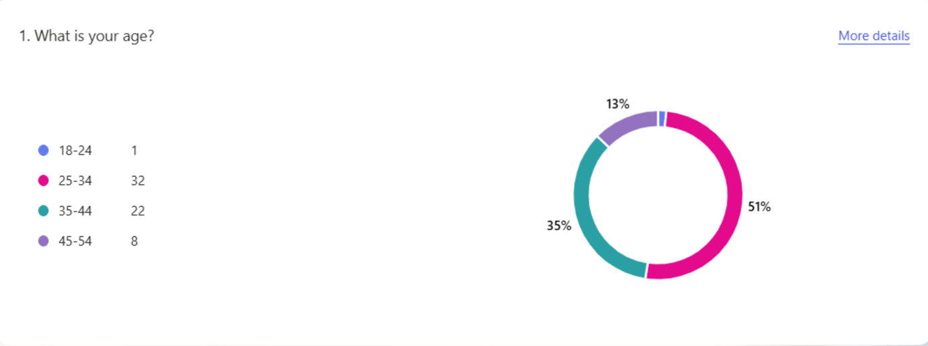The questionnaire received responses from 63 individuals, distributed across four age groups. Most participants (50.8%) were aged between 25 and 34, indicating that the research topic resonated most strongly with individuals in this demographic, who are often in early to mid-career stages. Respondents aged 35 to 44 made up 34.9% of the sample, while those aged 45 to 54 accounted for 12.7%. Only one respondent (1.6%) was aged 18 to 24, highlighting a notable underrepresentation of younger participants. This age distribution suggests that the findings are more reflective of perspectives from adults aged 25 to 44 and may not fully capture the views of younger or older populations. Therefore, while the data provides valuable insights, the demographic skew should be considered when interpreting the results and their broader applicability.

2 What is your highest level of education?
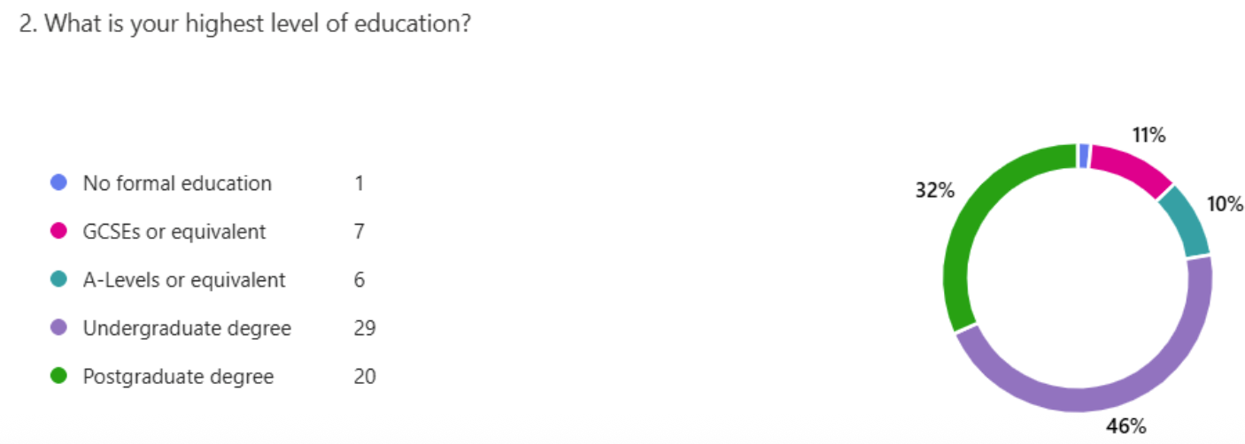
The survey was completed by 63 participants, representing a range of educational backgrounds. Most respondents held higher education qualifications, with 29 individuals (46%) having an undergraduate degree and 20 (32%) holding a postgraduate degree. This indicates that over three-quarters of the participants (78%) were educated to degree level or higher. In contrast, 6 respondents (9.5%) had A-Levels or equivalent, 7 (11%) had GCSEs or equivalent, and only 1 participant (1.6%) reported having no formal education.
This high concentration of respondents with advanced education levels may suggest a greater familiarity with or openness to digital technologies such as AI chatbots in healthcare. Higher educational attainment is often associated with increased digital literacy, which could positively influence trust and willingness to adopt AI-driven telemedicine services. However, it also presents a limitation, as the sample may not fully reflect the perspectives of patients with lower educational backgrounds, who may face different challenges or hold different concerns regarding AI in healthcare.

3 How would you rate your digital literacy?
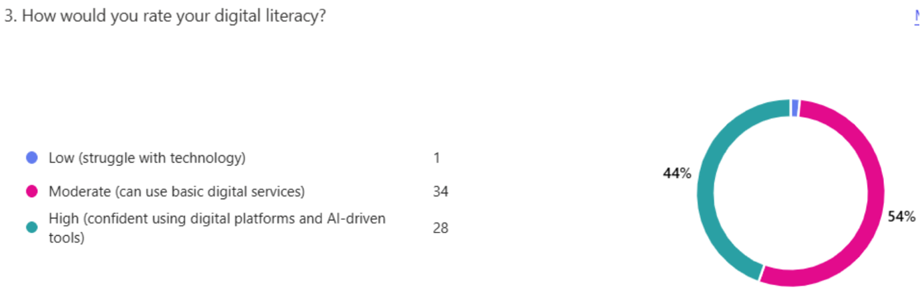
The digital literacy levels of the participants revealed that the majority felt capable or confident when using technology. Out of 63 respondents, 34 individuals (54%) rated their digital literacy as moderate, indicating they can use basic digital services such as email, online forms, or simple apps. A further 28 respondents (44%) considered themselves to have high digital literacy, expressing confidence in using digital platforms and AI-driven tools. Only one respondent (1.6%) reported low digital literacy, suggesting they struggle with technology.
This overall high level of digital competence among participants is significant in the context of AI adoption in NHS telemedicine. It suggests a population largely equipped to engage with digital health platforms and potentially receptive to the use of AI chatbots in healthcare settings. High and moderate digital literacy levels can positively influence user trust, perceived ease of use, and willingness to adopt AI-powered health tools, which are critical factors in the Technology Acceptance Model (Davis, 1989).
However, the very low representation of individuals with low digital literacy may limit the generalisability of findings to more vulnerable or digitally excluded populations. This is especially important in the NHS context, where equitable access to care is essential. Future research should aim to capture the views of individuals with lower digital skills to understand barriers to digital inclusion and to ensure that AI implementation does not widen the existing health gap.

4 Have you used telemedicine services (e.g., video consultations, online doctor chats) before?
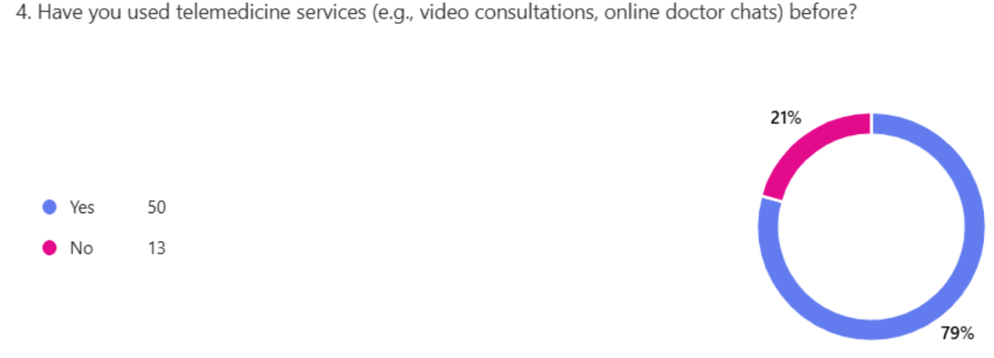
A significant majority of respondents (50 out of 63; 79%) reported having used telemedicine services such as video consultations and online doctor chats, while only 13 participants (21%) stated they had not. This high engagement rate indicates that telemedicine has already gained considerable attraction among patients, which may positively influence their openness to further digital innovations such as AI chatbots in NHS healthcare delivery.
Previous studies support the idea that prior use of telemedicine increases acceptance of digital tools, including AI-driven services, as familiarity can enhance perceived usefulness and reduce anxiety associated with new technologies (Gajarawala and Pelkowski, 2021). Moreover, individuals with firsthand experience of digital consultations are more likely to value their convenience and efficiency, which aligns with core constructs of the Technology Acceptance Model (Davis, 1989), particularly perceived usefulness and ease of use.
However, the 21% who have not yet used telemedicine represent a patient segment that may require targeted support or education to ensure digital health initiatives are inclusive and accessible. (Van Velthoven & Cordon, 2019)

5 Have you ever interacted with an AI chatbot for healthcare purposes (e.g., symptom checker, virtual assistant)?
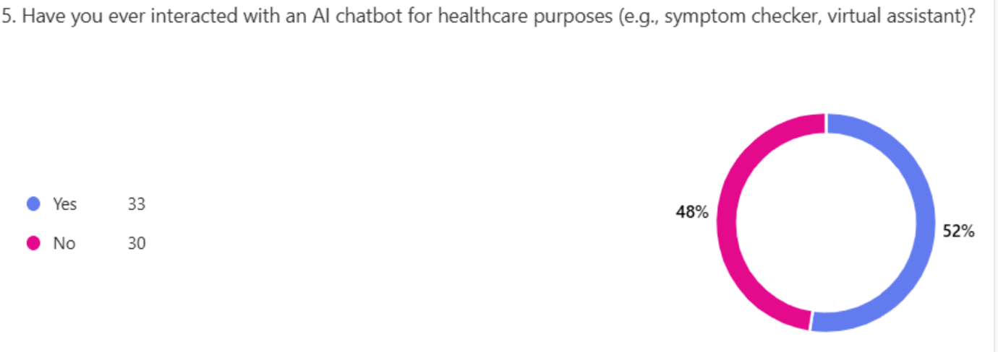
Out of the 63 participants, 33 respondents (52%) reported having interacted with an AI chatbot for healthcare purposes, while 30 respondents (48%) had not. This near even split highlights an important insight: while AI-powered tools in healthcare are becoming more prevalent and familiar, a significant portion of patients still lack direct experience with them.
Those who have previously used AI chatbots may already recognise their potential benefits, such as convenience, quick access to information, and reduced waiting times factors that have been shown to increase user trust and willingness to adopt AI-driven health tools (Oh, S. et al., 2019). This supports the premise of the Technology Acceptance Model (Davis, 1989), in which both perceived usefulness and prior experience are strong predictors of technology acceptance.
On the other hand, the nearly half of participants who have not yet interacted with healthcare AI chatbots may be more cautious or uncertain, possibly due to lack of awareness, concerns about data privacy, or limited exposure to AI applications in the NHS setting (Mesko et al., 2018). This divide underscores the need for targeted education and communication strategies to build trust and familiarity among broader patient groups, especially if NHS telemedicine aims to expand its use of AI-based services equitably.
6 How would you describe your experience with AI chatbots in healthcare? (If Applicable)
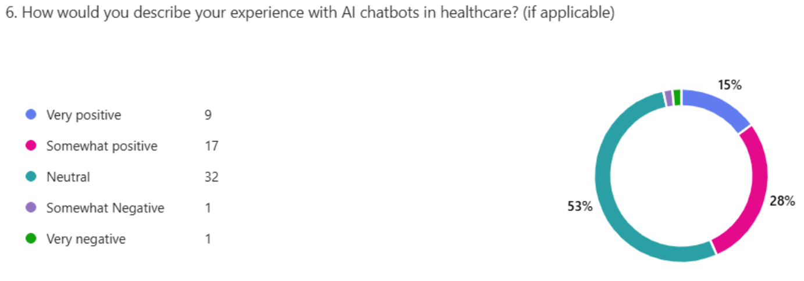
Participants who had interacted with AI chatbots in a healthcare setting were asked to describe their experience. Among the 60 valid responses, 9 (15%) described their experience as very positive and 17 (28%) as somewhat positive, indicating that 43% of users had a generally favourable perception of AI chatbot interactions. Most respondents (32 participants, or 53%) selected neutral, suggesting either limited interaction or an experience that did not significantly affect their opinion. Only 2 respondents (3%) described their experience as somewhat negative or very negative.
This distribution highlights a cautious but generally non-hostile reception toward AI chatbot technologies in healthcare. The low incidence of negative experiences suggests that chatbots are not commonly viewed as harmful or frustrating, which is a positive indicator for broader adoption (Blease et al., 2019). However, the high rate of neutral responses may reflect a lack of strong emotional engagement, perceived limitations in chatbot capabilities, or uncertainty about their reliability in clinical decision-making (Bibault et al., 2019).
Patient trust and satisfaction with AI tools are critical to successful integration within the NHS. Research shows that clear communication, user-friendly design, and accurate responses can significantly improve user perception and trust in AI chatbots (Oh et al., 2019). The challenge ahead lies in enhancing the quality of interaction so that users not only accept but also prefer AI chatbots as part of their digital health journey.

7 How comfortable would you be consulting an AI chatbot instead of a human doctor for minor health concerns?
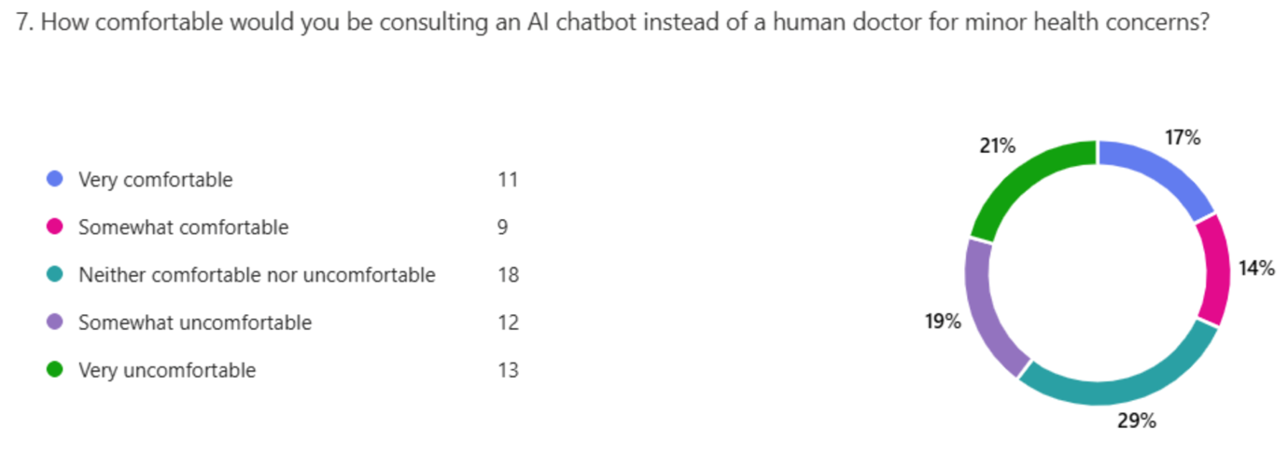
When asked how comfortable they would feel consulting an AI chatbot instead of a human doctor, participants provided mixed responses.
This distribution suggests that while a minority (31%) of participants are open to replacing human interaction with AI chatbots in healthcare consultations, a larger proportion (40%) expressed discomfort with the idea. The high number of neutral responses (29%) further reflects uncertainty, possibly due to unfamiliarity with chatbot capabilities or concerns about the accuracy and empathy of AI systems in complex or sensitive medical contexts.
This finding aligns with literature highlighting that patient trust, perceived empathy, and belief in clinical competence are central to acceptance of AI in healthcare settings (Longoni et al., 2019). Even as chatbot technologies advance, patients often prioritise the human touch, especially in emotionally charged or serious health situations (Blease et al., 2019).
In the context of the NHS, these results underscore the importance of blending AI support with human oversight, rather than full automation, to preserve trust and enhance the perceived safety of digital consultations. As AI becomes more integrated into healthcare delivery, user education, transparent communication about limitations, and hybrid models of care may help shift comfort levels over time.

8 What concerns, if any, do you have about using AI chatbots in healthcare consultations? (Select all that apply)
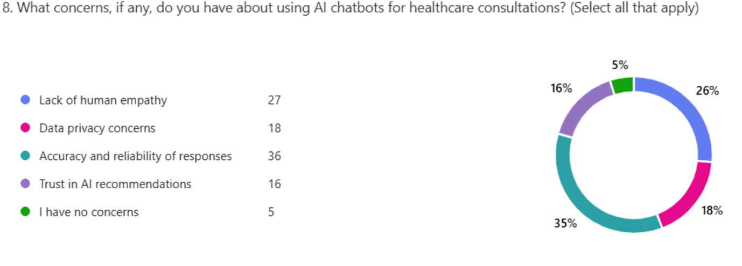
The most frequently cited concern was accuracy and reliability, raised by over half the respondents (57%), underscoring patient uncertainty around AI's ability to provide correct or safe medical advice. This aligns with existing literature that questions whether AI systems can consistently deliver trustworthy outputs in high-stakes environments such as healthcare (Topol, 2019; Nadarzynski et al., 2019).
The second-most common concern, cited by 43%, was the lack of human empathy, reinforcing that patients often value emotional connection and holistic communication in medical encounters-something current AI technologies cannot replicate (Bickmore and Picard, 2005). This concern is particularly relevant in NHS settings where trust, understanding, and compassion is integral to patient care.

Data privacy was another significant issue, mentioned by 18 respondents (29%), echoing widespread public apprehension about how personal health data is stored, used, and potentially shared by AI systems (Mesko et al., 2018). Concerns around trust in AI recommendations (25%) also point to a general hesitancy about delegating health decisions to machines, especially when transparency and explainability are lacking (Longoni et al., 2019).
Only 5 respondents (8%) reported having no concerns, suggesting that most participants remain cautious about fully embracing AI in healthcare. These findings indicate that education, transparency, and regulation will be essential for the successful integration of AI chatbots in NHS telemedicine, especially to address emotional and ethical expectations.

9. To what extent do you trust AI chatbots to provide accurate medical information?
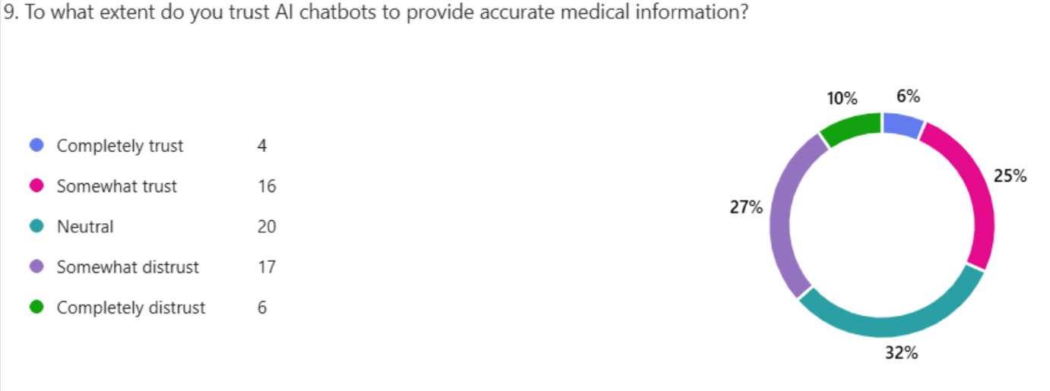
These results reveal a cautious stance: while 32% of participants (20 individuals) expressed some degree of trust (completely or somewhat), a similar portion (37%, or 23 participants) leaned toward distrust.
Notably, the largest single group (32%) remained neutral, indicating uncertainty rather than outright rejection or acceptance of AI accuracy in healthcare.
This ambivalence may reflect the relatively early stage of chatbot implementation in clinical environments, where public exposure is still limited. Previous research has shown that trust in AI health tools is strongly influenced by user experience, transparency, and perceived accountability (Fritsch et al., 2022). Patients often require consistent, positive interactions with digital systems before developing trust (Nadarzynski et al., 2019).
Moreover, trust is closely linked to perceived risk in healthcare. Since incorrect medical advice can have serious consequences, people may hesitate to rely solely on AI for clinical decision-making (Blease et al., 2019). Without sufficient information on how chatbots are developed, validated, and supervised by medical professionals, users may default to cautious or neutral positions.
To build trust, it is critical that NHS telemedicine initiatives incorporating chatbots communicate safety protocols, highlight human oversight, and encourage transparency in how AI recommendations are generated. This could gradually shift perceptions and increase acceptance over time.

10. Would you follow medical advice given by an AI chatbot without consulting a doctor?
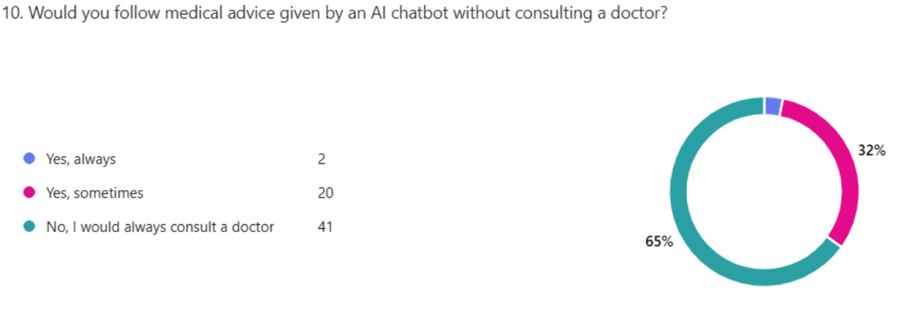
The distribution shows that most respondents (66%) would always consult a doctor before acting on chatbot-generated medical advice. Only 2 participants (3%) reported that they would always follow such advice, while 32% indicated they would sometimes do so.
These results suggest that most patients see AI chatbots as a supplementary tool, not a substitute for professional medical judgment. This is consistent with studies showing that trust in AI for autonomous clinical decision-making remains low, particularly when the stakes are high (Blease et al., 2019; Fritsch et al., 2022).
Participants’ reluctance to rely solely on AI may also stem from concerns about the limitations of current AI models, such as misinterpretation of symptoms or lack of context-sensitive judgment (Topol, 2019). Additionally, human oversight continues to be a critical factor in establishing credibility, especially in sensitive health matters (Nadarzynski et al., 2019).
These findings reinforce the argument that while AI chatbots are increasingly accepted for information retrieval and preliminary triage, patients still prefer clinical validation from a qualified medical professional before acting on any advice. Therefore, in the context of NHS telemedicine, AI tools should be positioned as support systems rather than autonomous diagnostic agents.

11. What would increase your trust in AI chatbots for health care? (Select all that apply)
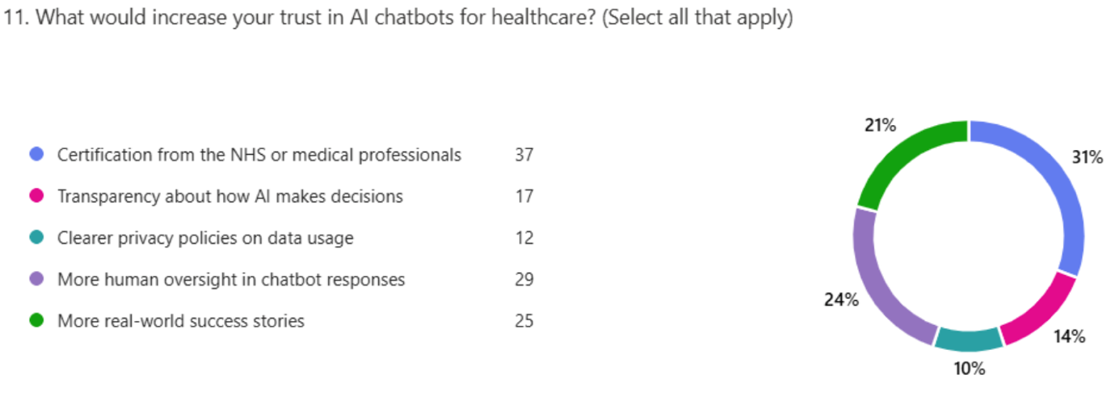
The most frequently cited factor was official certification by the NHS or medical professionals (59%), highlighting the importance of institutional endorsement in fostering trust. This finding is consistent with prior studies showing that when AI systems are validated by trusted health authorities, patients perceive them as safer and more credible (Longoni et al., 2019; Nadarzynski et al., 2019).
The second most common response was the need for greater human oversight (46%), suggesting that while users are open to AI support, they want reassurance that a qualified human clinician is monitoring or reviewing AI-generated outputs. This aligns with the principle of human-in-the-loop (HITL) AI models, which are known to enhance user confidence in automated systems (Blease et al., 2019).
A substantial number of participants (40%) also cited real-world success stories as a confidence booster. This suggests that experiential evidence — seeing or hearing that AI chatbots have helped others — plays a key role in reducing scepticism. Demonstrable effectiveness can often matter more to patients than technical explanations (Fritsch et al., 2022).
Less frequently, respondents highlighted the need for algorithmic transparency (27%) and data privacy clarity (19%), indicating that while these are important, they may be less immediately motivating for general users compared to endorsement by healthcare authorities and the reassurance of human supervision.
These findings suggest that increasing trust in AI chatbots within NHS telemedicine would require a multi-pronged approach: securing formal medical validation, integrating human oversight, showcasing successful use cases, and ensuring privacy and transparency standards.

12. How likely are you to use an AI chatbot for booking appointments or checking symptoms in NHS telemedicine?
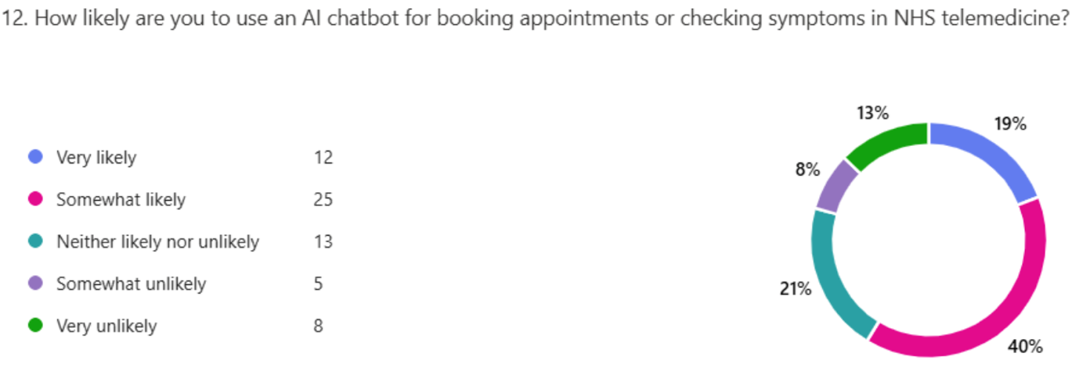
Overall, 37 participants (59%) expressed some degree of likelihood (either "very" or "somewhat") to use AI chatbots for administrative tasks. Only 13 participants (21%) indicated reluctance, while the remaining 20% were neutral.
These results suggest a moderately high acceptance of AI chatbots for low-risk, task-oriented roles within NHS telemedicine. This aligns with prior research indicating that patients are more receptive to AI for logistical and information retrieval purposes, rather than direct clinical advice or diagnoses (Blease et al., 2019; Sarker et al., 2020). The relative simplicity and routine nature of booking appointments or symptom triage may lower the perceived risks associated with relying on AI (Longoni et al., 2019).
Moreover, this level of acceptance reflects growing patient familiarity with digital self-service tools, especially following the COVID-19 pandemic, which accelerated digital health adoption (Keesara, Jonas & Schulman, 2020). However, the presence of 13 respondents (21%) who are unlikely or very unlikely to use chatbots even for administrative purposes highlights that digital literacy, trust, or access barriers still exist and must be addressed for full adoption (Fritsch et al., 2022).
Therefore, AI chatbot integration into telemedicine workflows should begin with non-clinical applications where patient acceptance is already relatively strong. This can serve as a gateway to wider adoption once users grow more familiar with the technology.

13. If AI chatbots improved NHS efficiency (e.g. Reducing waiting times), would you be more willing to use them?
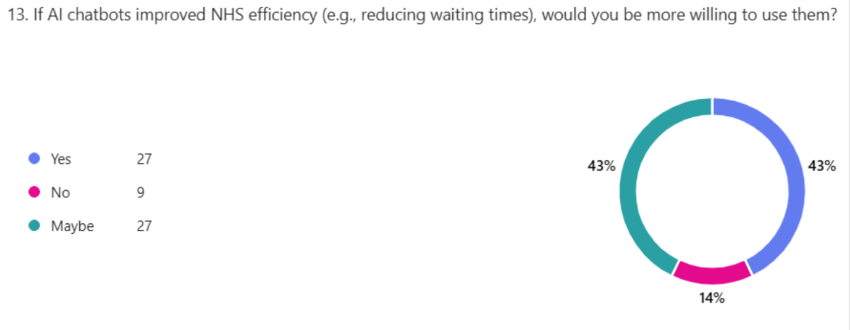
Most respondents (41%, n=27) stated they would be willing to use AI chatbots if it helped the NHS function more efficiently, particularly through reducing waiting times, which is a well-documented pressure point in UK healthcare (The King's Fund, 2024)
Notably, an equal number (41%) selected "maybe", indicating conditional openness dependent on other factors such as proven reliability, ethical safeguards, or user experience.
Only 9 participants (14%) rejected the idea entirely, showing relatively low outright resistance to AI-based solutions when framed around system-level benefits. This aligns with previous findings suggesting that patients are more likely to accept digital interventions if they clearly contribute to overall healthcare improvement (Nadarzynski et al., 2019; Blease et al., 2019).
The high proportion of “maybe” responses also reflects ongoing public ambivalence, which is often linked to uncertainties around trust, data use, and the perceived limitations of AI in healthcare (Fritsch et al., 2022). This suggests that patient education and transparency about the practical benefits and limitations of AI tools could significantly influence adoption rates.
Framing AI chatbot use to relieve NHS pressure and enhance access may thus be a persuasive strategy, particularly if combined with real-world success cases, NHS endorsement, and user-friendly interfaces (Longoni et al., 2019)

14. Would you be more open to using AI chatbots if they worked alongside human doctors rather than replacing them?
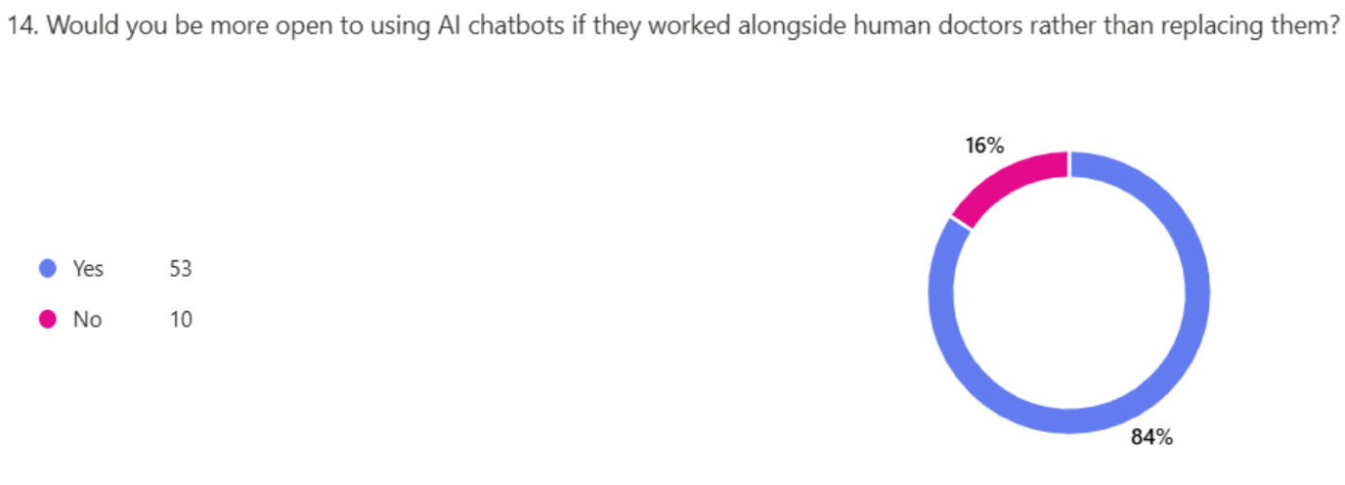
An overwhelming 84% of participants (yes = 53) stated they would be more willing to engage with AI chatbots if the technology were integrated alongside human healthcare providers. Only 16% (no = 10) were not more inclined to use AI chatbots under this condition.
These results underscore a widely reported theme in AI healthcare adoption literature: users express greater comfort and trust when AI is positioned as a supportive, rather than replacement, tool (Longoni et al., 2019; Blease et al., 2019). This "augmented intelligence" approach—where AI enhances but does not replace clinician roles—is increasingly seen as the most ethically and practically acceptable application of AI in healthcare (Topol, 2019).
Concerns about loss of human empathy, reduced accountability, and over-reliance on algorithms are often cited as barriers to chatbot acceptance (Fritsch et al., 2022; Nadarzynski et al., 2019). Therefore, presenting AI chatbots as a complementary tool to human decision-making not only aligns with patient preferences but also contributes to higher perceived trustworthiness and safety of the system.
This finding also supports the idea that successful adoption of AI in the NHS may rely not just on the technology’s performance but on how it is communicated, positioned, and integrated within existing care models.

15. what factors would encourage you to use AI chatbots in telemedicine? (Select all that apply)
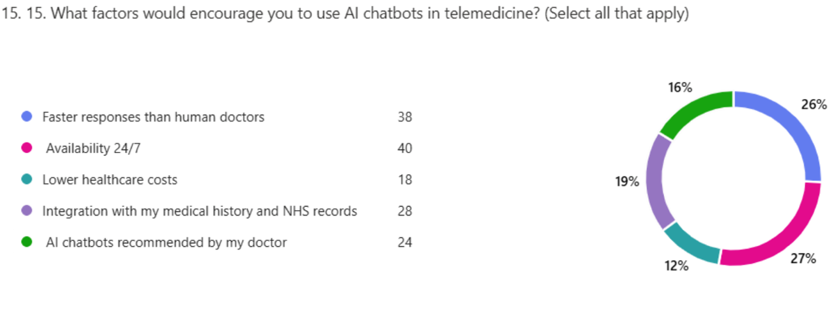
The top motivators were 24/7 availability (selected by 40 respondents) and faster responses than human doctors (38 respondents), indicating that patients place high value on accessibility and responsiveness—two long-standing limitations of traditional healthcare models (Topol, 2019; The King’s Fund, 2024). These preferences reflect common patient frustrations such as long waiting times, restricted consultation hours, and delays in follow-up—issues that AI chatbots can potentially alleviate.
A significant portion of respondents (n=28) also cited integration with medical history and NHS records as an important factor. This highlights a desire for continuity of care and personalised advice, which could help mitigate fears around fragmented or generic AI interactions (Fritsch et al., 2022).
Interestingly, 24 participants (nearly 38%) indicated that they would be more likely to use AI chatbots if recommended by their doctor. This suggests a persistently high level of trust in human healthcare professionals and underscores the importance of physician endorsement in technology adoption (Blease et al., 2019; Longoni et al., 2019). The implication is that even in a technologically advanced setting, human authority and reassurance remain central to patient acceptance. This supports the “human-in-the-loop” model in which clinicians remain involved in guiding the use of digital health tools.
Fewer respondents (18) selected lower healthcare cost as a motivating factor, which might indicate that within the context of the NHS - where most services are already free at the point of use - cost is a less pressing concern compared to access and speed. However, this may be more influential in private healthcare models.
Overall, the results suggest that while technological benefits like speed, convenience, and system integration are key drivers, human trust and endorsement continue to play a critical role in technology acceptance in healthcare.

16. Do you think AI chatbots should be a primary consultation method in NHS telemedicine?
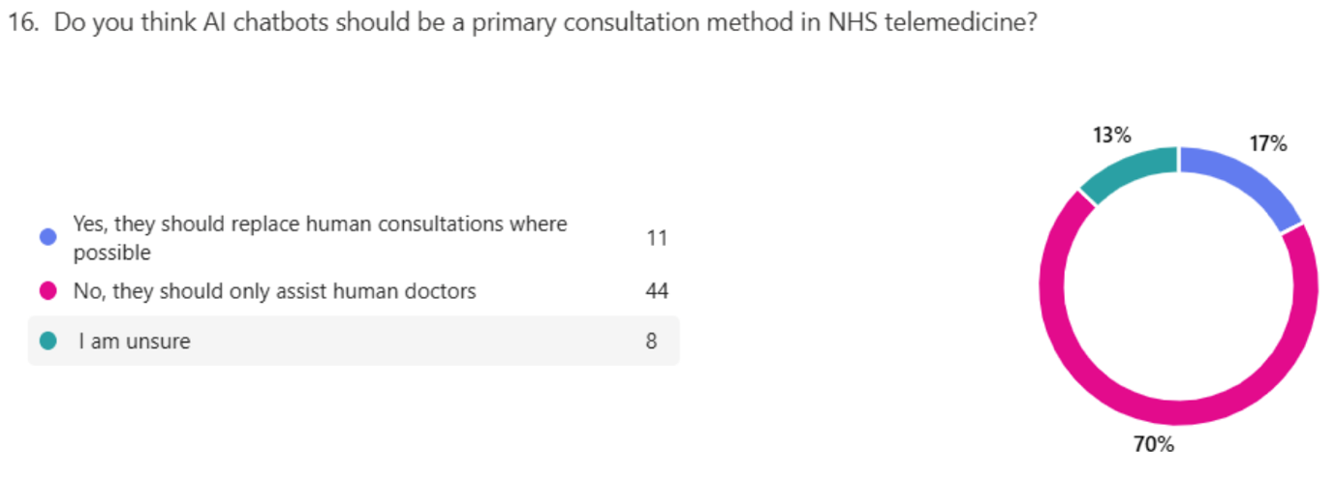
The data reveals a strong preference for a supportive rather than a substitutive role for AI chatbots in NHS healthcare. Most respondents (44) over two-third, believe that AI chatbots should only assist human doctors, rather than replace them. This finding reflects a high level of trust in human healthcare providers and indicates that patients are not yet ready to fully embrace AI-driven consultations without human oversight.
Only 11 respondents were in favour of chatbots replacing human consultations where possible, suggesting that while some support the potential of AI to improve efficiency or accessibility, this view remains a minority. The unsure group (8) shows that some people are still forming opinions or may need more information or experience before taking a stance, a common pattern when emerging technologies are introduced in sensitive sectors like healthcare (Blease et al., 2019).
This aligns with existing literature suggesting that AI acceptance in healthcare is highest when it augments rather than replaces human professionals (Longoni et al., 2019). Patients value the efficiency and availability of AI tools but remain cautious about relinquishing the empathetic, ethical, and clinical judgment that human doctors provide (Topol, 2019). Trust, accountability, and perceived emotional intelligence are factors AI still struggles to match in human interactions (Wartman & Combs, 2018).
These results reinforce the notion that hybrid models, where AI tools assist but do not replace clinicians, are likely to be more acceptable and effective in current NHS settings.

3.5 Ethical Considerations
Ensuring ethical integrity is crucial in conducting research involving patient perceptions of AI in telemedicine. This study will adhere to ethical principles by prioritising anonymity, confidentiality, informed consent, and compliance with data protection regulations. (Resnik, 2025)
Anonymity and confidentiality will be maintained throughout the study. No personally identifiable information will be collected, and responses will be stored securely. Participants will be assured that their data will be used solely for research purposes, reducing concerns about privacy and potential misuse. (Wiles et al., 2007)
Informed consent will be obtained from all respondents before participation. The survey will include a clear introduction explaining the purpose of the study, voluntary participation, the right to withdraw at any time, and assurances of anonymity. Participants will need to provide explicit agreement before proceeding, ensuring they understand the research and its implications. (Clark et al., 2021)
Additionally, this study will comply with General Data Protection Regulation (GDPR) and NHS data protection guidelines to uphold legal and ethical standards. GDPR mandates that personal data must be processed lawfully, fairly, and transparently, even when anonymised. (European Parliament, 2016) NHS data protection guidelines further emphasize safeguarding patient information and ethical research practices. (NHS England Digital, 2018) By adhering to these ethical considerations, the study ensures responsible handling of participant data while fostering trust and transparency.

3.6 Generalisability, Reliability & Validity
In quantitative research, ensuring generalisability, reliability, and validity is essential for producing credible and applicable findings. Generalisability refers to the extent to which the results of the study can be applied to a broader population beyond the sample (Saunders et al., 2021). This study enhances generalisability by using a stratified random sampling approach to ensure diverse representation of NHS patients based on age, digital literacy, and frequency of telemedicine use. A sufficiently large sample size, determined through power analysis, will further strengthen the external validity of the study (Creswell, 2009)
Reliability pertains to the consistency and repeatability of the research findings (Clark et al., 2021) To enhance reliability, the study will use a structured and standardised survey questionnaire, ensuring that all respondents receive the same questions in the same format.
Validity refers to the accuracy of the research in measuring what it intends to measure (Creswell, 2009) This study ensures content validity by designing survey questions based on established theoretical frameworks. Construct validity will be assessed by conducting factor analysis to confirm that survey items accurately reflect key constructs such as trust, perceived usefulness, and willingness to adopt AI chatbots. (Hair, 2010)
The study anticipates that younger, tech-savvy individuals will demonstrate higher adoption rates of AI chatbots in NHS telemedicine, while older adults and those with lower digital literacy may show resistance. Trust in AI chatbots is likely to be influenced by past telemedicine experience, with frequent users being more receptive. (Stoumpos et al., 2023)
Findings from this research can provide valuable insights for NHS policymakers, guiding strategies for AI chatbot integration. Additionally, the results can help improve AI chatbot design, addressing patient concerns to enhance acceptance and usability within NHS services.

Conclusion
This study offers important new information about how NHS patients feel about the use of AI chatbots in telemedicine. The results, which are based on structured survey responses and descriptive statistics, show that most people are amenable to the integration of AI, especially when it comes to low-risk and administrative healthcare tasks. But there are still a lot of concerns about replacing human medical professionals, especially when it comes to intricate or delicate interactions.
The sample's demographics, which are primarily made up of people between the ages of 25 and 44 who have degrees and moderate to high levels of digital literacy, point to a population that is well-positioned to comprehend and use emerging technologies. Higher levels of familiarity and openness to AI chatbots were reported by these groups, highlighting the importance of digital competency in promoting the adoption of new technologies (Davis, 1989; Gajarawala and Pelkowski, 2021). However, a potential digital divide is highlighted by the under-representation of older adults and people with less digital literacy, where patients who are marginalised or digitally excluded might find it difficult to access or trust such services (Van Velthoven and Cordon, 2019).
The findings also show that patients' perceptions are greatly influenced by their past experiences with telemedicine and AI tools. The Technology Acceptance Model's emphasis on perceived utility and prior use as predictors of acceptance is supported by most participants who had previously used telemedicine expressing more positive opinions towards AI integration (Davis, 1989). Additionally, 59% of participants said they would be willing to use AI chatbots for non-clinical tasks like scheduling appointments because they appreciated how responsive and convenient they were. In contrast to diagnostic or consultative roles, patients are more open to AI in administrative roles, according to previous research (Sarker et al., 2020; Blease et al., 2019).
Despite this openness, concerns around trust, empathy, accuracy, and data privacy remain prominent. The study found that 57% of participants questioned the reliability of AI-generated medical advice, while 43% expressed concern about the lack of human empathy. These findings echo previous literature emphasizing the importance of human touch and emotional intelligence in healthcare delivery (Topol, 2019; Bickmore and Picard, 2005). Furthermore, data privacy and algorithmic transparency, although cited by fewer respondents, remain critical to building long-term trust in AI technologies (Mesko et al., 2018; Longoni et al., 2019).
Most respondents (84%) prefer AI chatbots to complement human doctors rather than take their place, which is one of the most important findings. This is in line with the augmented intelligence model, which promotes cooperation between humans and AI as opposed to automation (Wartman and Combs, 2018). These hybrid models seem to be the most morally and practically sound ways to incorporate AI into NHS telemedicine.

Recommendations for increasing trust include NHS certification, human oversight, and the use of real-world success stories, factors that were cited by most respondents. These results suggest that effective AI implementation strategies in healthcare must go beyond technical efficiency and address patient-centred concerns through transparency, ethical safeguards, and empathetic communication (Fritsch et al., 2022; Blease et al., 2019).
Finally, although NHS patients are becoming more receptive to the use of AI chatbots, particularly for administrative duties, their broad clinical adoption will rely on resolving issues with empathy, trust, and digital inclusivity. To guarantee fair access to healthcare, future studies should concentrate on under-represented groups, such as senior citizens and people with low levels of digital literacy. These insights are useful not only for NHS policymakers but also for AI system developers and designers, who must put user trust and ethical integration first to guarantee long-term adoption and benefits.

References:
Alsentzer, E. et al. (2019) ‘Publicly available clinical’, Proceedings of the 2nd Clinical Natural Language Processing Workshop [Preprint]. doi:10.18653/v1/w19-1909.
Andrikopoulou, E. (2023) ‘The rise of ai in Telehealth’, Emerging Practices in Telehealth, pp. 183–207. doi:10.1016/b978-0-443-15980-0.00011-9.
Adeniran, A.A., Onebunne, A.P. and William, P. (2024) ‘Explainable AI (XAI) in Healthcare: Enhancing Trust and transparency in critical decision-making’, World Journal of Advanced Research and Reviews, 23(3), pp. 2447–2658. doi:10.30574/wjarr.2024.23.3.2936
Bavli, I. and Galea, S. (2024) ‘Key considerations in the adoption of Artificial Intelligence in public health’, PLOS Digital Health, 3(7). doi:10.1371/journal.pdig.0000540.
Bekbolatova, M. et al. (2024) ‘Transformative potential of AI in healthcare: Definitions, applications, and navigating the Ethical Landscape and public perspectives’, Healthcare, 12(2), p. 125. doi:10.3390/healthcare12020125.
Becker, A. (2019) ‘Artificial Intelligence in medicine: What is it doing for us today?’, Health Policy and Technology, 8(2), pp. 198–205. doi:10.1016/j.hlpt.2019.03.004.
Bejaković, P. and Mrnjavac, Ž. (2024) ‘The characteristics and role of digital literacy in an effective health protection’, Heliyon, 10(8). doi:10.1016/j.heliyon.2024.e29737.
Bibault, J.-E. et al. (2019) ‘A chatbot versus physicians to provide information for patients with breast cancer: Blind, randomized controlled Noninferiority Trial’, Journal of Medical Internet Research, 21(11). doi:10.2196/15787.
Bickmore, T.W. and Picard, R.W. (2005) ‘Establishing and maintaining long-term human-computer relationships’, ACM Transactions on Computer-Human Interaction, 12(2), pp. 293–327. doi:10.1145/1067860.1067867.
Blease, C. et al. (2019) ‘Artificial Intelligence and the future of primary care: Exploratory qualitative study of UK General Practitioners’ views’, Journal of Medical Internet Research, 21(3). doi:10.2196/12802.
Bryman, A. (2016) Social Research Methods. 5th ed. Oxford, UK: Oxford University Press.
Chagpar, A.B. (2022) ‘Sociodemographic factors affecting telemedicine access: A population-based analysis’, Surgery, 171(3), pp. 793–798. doi:10.1016/j.surg.2021.08.059.
Clark, M. and Bailey, S. (2024) Chatbots in health care: Connecting patients to information, National Centre for Biotechnology Information. Available at: https://www.ncbi.nlm.nih.gov/books/NBK602381/ (Accessed: 05 February 2025).
Clark, T. et al. (2021) Bryman’s Social Research Methods. 6th ed. Oxford, UK: Oxford University Press.
Coherent Solutions (2024) Ai Chatbots in healthcare: Use cases, examples, benefits, Coherent Solutions. Available at: https://www.coherentsolutions.com/insights/how-ai-chatbots-advance-healthcare-for-patients-and-providers (Accessed: 05 February 2025).
Creswell, J.W. (2009) Research design: Qualitative, quantitative, and mixed methods approaches. 3rd ed. Los Angeles, USA: Sage.
Crotty, M. (1998) The foundations of social research: Meaning and perspective in the research process. 1st ed. London, UK: Sage.
Davis, F.D. (1989) ‘Perceived usefulness, perceived ease of use, and user acceptance of Information Technology’, MIS Quarterly, 13(3), p. 319. doi:10.2307/249008.
Demner-Fushman, D., Chapman, W.W. and McDonald, C.J. (2009) ‘What can natural language processing do for clinical decision support?’, Journal of Biomedical Informatics, 42(5), pp. 760–772. doi:10.1016/j.jbi.2009.08.007.
Dijk, J.A.G.M. van (2022) ǂThe ǂdigital divide. 2nd edn. Cambridge, UK: Polity Press.
Etikan, I. (2016) ‘Comparison of convenience sampling and purposive sampling’, American Journal of Theoretical and Applied Statistics, 5(1), p. 1. doi:10.11648/j.ajtas.20160501.11.
European Parliament (2016) Regulation - 2016/679 - en - GDPR - EUR-lex, EUR. Available at: https://eur-lex.europa.eu/eli/reg/2016/679/oj/eng (Accessed: 22 April 2025).
Filipsson, F. (2025) Ada Health: A real-life use case in AI-powered healthcare, Redress Compliance - Just another WordPress site. Available at: https://redresscompliance.com/ada-health-a-real-life-use-case-in-ai-powered-healthcare/ (Accessed: 06 February 2025).
Fowler, F.J. (2014) Survey research methods. 5th ed. London, UK: Sage Publication.
Fritsch, S.J. et al. (2022) ‘Attitudes and perception of artificial intelligence in Healthcare: A cross-sectional survey among patients’, DIGITAL HEALTH, 8, p. 205520762211167. doi:10.1177/20552076221116772.
Gajarawala, S.N. and Pelkowski, J.N. (2021) ‘Telehealth benefits and barriers’, The Journal for Nurse Practitioners, 17(2), pp. 218–221. doi:10.1016/j.nurpra.2020.09.013.
Gerke, S., Minssen, T. and Cohen, G. (2020) ‘Ethical and legal challenges of artificial intelligence-driven healthcare’, Artificial Intelligence in Healthcare, pp. 295–336. doi:10.1016/b978-0-12-818438-7.00012-5.
Gille, F., Jobin, A. and Ienca, M. (2020) ‘What we talk about when we talk about trust: Theory of trust for AI in Healthcare’, Intelligence-Based Medicine, 1–2, p. 100001. doi:10.1016/j.ibmed.2020.100001.
Graham, M. (2021) ‘Data for sale: Trust, confidence and sharing health data with commercial companies’, Journal of Medical Ethics, 49(7), pp. 515–522. doi:10.1136/medethics-2021-107464.
Habli, I., Lawton, T. and Porter, Z. (2020) ‘Artificial Intelligence in health care: Accountability and safety’, Bulletin of the World Health Organization, 98(4), pp. 251–256. doi:10.2471/blt.19.237487.
Hair, J.F. (2010) Multivariate Data Analysis: A global perspective. 7th ed. Upper Saddle River, N.J, USA: Pearson Education.
Heather, B. (2017) Babylon health to power NHS 111 with ‘ai triage’ bot, Digital Health. Available at: https://www.digitalhealth.net/2017/01/babylon-health-to-power-nhs-111-with-ai-triage-bot/ (Accessed: 06 February 2025).
Keesara, S., Jonas, A. and Schulman, K. (2020) ‘Covid-19 and Health Care’s Digital Revolution’, New England Journal of Medicine, 382(23). doi:10.1056/nejmp2005835.
Kerasidou, A. (2020) ‘Artificial Intelligence and the ongoing need for empathy, compassion and trust in Healthcare’, Bulletin of the World Health Organization, 98(4), pp. 245–250. doi:10.2471/blt.19.237198.
Khambholja, M. (2025) Cost of AI in healthcare: Implementation expenses & key insights, Openxcell. Available at: https://www.openxcell.com/blog/cost-of-ai-in-healthcare/ (Accessed: 25 April 2025).
Kuhn, T.S. (1970) The structure of Scientific Revolutions. 1st ed. Chicago, Illinois: Chicago Univeristy Press.
Kunchev, K. (2024) The cost of implementing AI in healthcare: Key insights I scalefocus, Scalefocus. Available at: https://www.scalefocus.com/blog/the-cost-of-implementing-ai-in-healthcare-key-insights (Accessed: 23 April 2025).
Li, J. (2023) ‘Security implications of AI Chatbots in health care’, Journal of Medical Internet Research, 25. doi:10.2196/47551.
Longoni, C., Bonezzi, A. and Morewedge, C.K. (2019) ‘Resistance to medical artificial intelligence’, Journal of Consumer Research, 46(4), pp. 629–650. doi:10.1093/jcr/ucz013.
Malik, A. and Solaiman, B. (2024) ‘Ai In Hospital Administration and Management: Ethical and Legal Implications’, Research Handbook on Health, AI and the Law, pp. 20–40. doi:10.4337/9781802205657.ch02.
Mehrabi, N. et al. (2021) ‘A survey on bias and fairness in machine learning’, ACM Computing Surveys, 54(6), pp. 1–35. doi:10.1145/3457607.
Mennella, C. et al. (2024) ‘Ethical and regulatory challenges of AI technologies in Healthcare: A narrative review’, Heliyon, 10(4). doi:10.1016/j.heliyon.2024.e26297.
Meskó, B., Hetényi, G. and Győrffy, Z. (2018) ‘Will artificial intelligence solve the human resource crisis in Healthcare?’, BMC Health Services Research, 18(1). doi:10.1186/s12913-018-3359-4.
Montemayor, C., Halpern, J. and Fairweather, A. (2021) ‘In principle obstacles for empathic AI: Why we can’t replace human empathy in Healthcare’, AI &amp; SOCIETY, 37(4), pp. 1353–1359. doi:10.1007/s00146-021-01230-z.
National Health Executive (2024) AI supporting NHS Care Improvement, National Health Executive. Available at: https://www.nationalhealthexecutive.com/articles/ai-supporting-nhs-care-improvement (Accessed: 07 February 2025).
Nadarzynski, T. et al. (2019) ‘Acceptability of Artificial Intelligence (ai)-led chatbot services in Healthcare: A mixed-methods study’, Digital Health, 5. doi:10.1177/2055207619871808.
NHS England (2024) NHS artificial intelligence (AI) giving patients better care and support, NHS choices. Available at: https://www.england.nhs.uk/2024/12/nhs-ai-giving-patients-better-care-and-support/ (Accessed: 07 February 2025).
Obermeyer, Z. et al. (2019) ‘Dissecting racial bias in an algorithm used to manage the health of populations’, Science, 366(6464), pp. 447–453. doi:10.1126/science.aax2342.
Oh, S. et al. (2019) ‘Physician confidence in artificial intelligence: An online mobile survey’, Journal of Medical Internet Research, 21(3). doi:10.2196/12422.
O’Hear, S. (2017) Babylon Health partners with UK’s NHS to replace telephone helpline with AI-powered chatbot, TechCrunch. Available at: https://techcrunch.com/2017/01/04/babylon-health-partners-with-uks-nhs-to-replace-telephone-helpline-with-ai-powered-chatbot/ (Accessed: 05 February 2025).
Oyeniyi, J. (2024) ‘The role of AI and mobile apps in patient-centric healthcare delivery’, World Journal of Advanced Research and Reviews, 22(1), pp. 1897–1907. doi:10.30574/wjarr.2024.22.1.1331.
Palanica, A. et al. (2019) ‘Physicians’ perceptions of Chatbots in health care: Cross-sectional web-based survey’, Journal of Medical Internet Research, 21(4). doi:10.2196/12887.
Patel, R. et al. (2021) ‘Addressing health inequalities through the NHS Health Check Programme in England’, SSRN Electronic Journal [Preprint]. doi:10.2139/ssrn.3937909.
Rajkomar, A. et al. (2018) ‘Ensuring fairness in machine learning to Advance Health Equity’, Annals of Internal Medicine, 169(12), pp. 866–872. doi:10.7326/m18-1990.
Rasi, S. (2020) ‘Impact of language barriers on access to healthcare services by immigrant patients: A systematic review’, Asia Pacific Journal of Health Management, 15(1), pp. 35–48. doi:10.24083/apjhm.v15i1.271.
Resnik, D.B. (2025) Ethics of research with human subjects protecting people, Advancing Science, promoting trust. 2nd ed. CHAM, Switzerland: SPRINGER.
Sarker, A. et al. (2020) ‘Self-reported covid-19 symptoms on Twitter: An analysis and a research resource’, Journal of the American Medical Informatics Association, 27(8), pp. 1310–1315. doi:10.1093/jamia/ocaa116.
Saunders, M.N.K., Lewis, P. and Thornhill, A. (2021) Research methods for business students. 8th edn. Harlow, UK: Pearson Education Limited
Shachak, A., Kuziemsky, C. and Petersen, C. (2019) ‘Beyond Tam and utaut: Future directions for hit implementation research’, Journal of Biomedical Informatics, 100, p. 103315. doi:10.1016/j.jbi.2019.103315.
Shevtsova, D. et al. (2024) ‘Trust in and acceptance of artificial intelligence applications in medicine: Mixed Methods Study’, JMIR Human Factors, 11. doi:10.2196/47031.
Stoumpos, A.I., Kitsios, F. and Talias, M.A. (2023) ‘Digital Transformation in Healthcare: Technology Acceptance and its applications’, International Journal of Environmental Research and Public Health, 20(4), p. 3407. doi:10.3390/ijerph20043407.
Studman, A. (2021) Ada, babylon and webmd: Can you trust medical apps with your health? - which? news, Which?Available at: https://www.which.co.uk/news/article/ada-babylon-and-webmd-can-you-trust-medical-apps-with-your-health-aZndV4L2KYsZ (Accessed: 07 February 2025).
The King’s Fund (2024) Waiting times for elective (non-urgent) treatment: Referral to treatment (RTT) | The King’s Fund, The King’s Fund. Available at: https://www.kingsfund.org.uk/insight-and-analysis/data-and-charts/waiting-times-non-urgent-treatment (Accessed: 06 June 2025).
Thornton, N. et al. (2024) Ai in health care: What do the public and NHS staff think?, The Health Foundation. Available at: https://www.health.org.uk/reports-and-analysis/analysis/ai-in-health-care-what-do-the-public-and-nhs-staff-think (Accessed: 06 February 2025).
Topol, E.J. (2019) Deep Medicine: How Artificial Intelligence Can Make Healthcare Human Again. 1st edn. New York, USA: Basic Books.
Van Velthoven, M.H. and Cordon, C. (2019) ‘Sustainable adoption of Digital Health Innovations: Perspectives from a stakeholder workshop’, Journal of Medical Internet Research, 21(3). doi:10.2196/11922.
Vargas-Palacios, A., Sharma, N. and Sagoo, G.S. (2023) ‘Cost-effectiveness requirements for implementing Artificial Intelligence Technology in the women’s UK breast cancer screening service’, Nature Communications, 14(1). doi:10.1038/s41467-023-41754-0.
Voice (2024) Negatives of AI in Healthcare: The hidden risks we need to address, Voiceoc. Available at: https://www.voiceoc.com/blogs/negatives-of-ai-in-healthcare-the-hidden-risks-we-need-to-address (Accessed: 08 February 2025).
Voigt, P. and von dem Bussche, A. (2017) The EU general data protection regulation (GDPR) [Preprint]. doi:10.1007/978-3-319-57959-7.
Wartman, S.A. and Combs, C.D. (2018) ‘Medical education must move from the information age to the age of Artificial Intelligence’, Academic Medicine, 93(8), pp. 1107–1109. doi:10.1097/acm.0000000000002044.
WHO (2022) Global report on health equity for persons with disabilities, World Health Organization. Available at: https://www.who.int/publications/i/item/9789240063600 (Accessed: 20 April 2025).
Whitehead, L. et al. (2023) ‘Barriers to and facilitators of digital health among culturally and linguistically diverse populations: Qualitative systematic review’, Journal of Medical Internet Research, 25. doi:10.2196/42719.
Wiles, R. et al. (2007) ‘Informed consent and the research process: Following rules or striking balances?’, Sociological Research Online, 12(2), pp. 99–110. doi:10.5153/sro.1208.
Witkowski, K., Okhai, R. and Neely, S.R. (2024) ‘Public perceptions of artificial intelligence in Healthcare: Ethical concerns and opportunities for patient-centered care’, BMC Medical Ethics, 25(1). doi:10.1186/s12910-024-01066-4.
Wolff, J. et al. (2020) ‘Systematic Review of Economic Impact Studies of Artificial Intelligence in health care’, Journal of Medical Internet Research, 22(2). doi:10.2196/16866.
Yu, K.-H., Beam, A.L. and Kohane, I.S. (2018) ‘Artificial Intelligence in Healthcare’, Nature Biomedical Engineering, 2(10), pp. 719–731. doi:10.1038/s41551-018-0305-z.

Appendix
The following link directs to the online questionnaire used in this study to collect data from NHS patients regarding their perceptions of AI chatbots in telemedicine.

Link to the Survey:
https://forms.office.com/Pages/ResponsePage.aspx?id=-REPTm4EBUWcuNshUjEeIbk90DwF1jZFvw8J9K7udltUMVkzSU1JWDE2NEhNRUtCU0s1UjI5SDE1Ui4u

