Project Management Individual report

Shamuel Hashan

1803153

Web Development

Lecturer: Sue Maw
Contents
Introduction 3
Risk Management 4
Codes of practice: Sustainability 7
Codes of practice: Ethical and Legal 8
Quality Assurance 9
Conclusion 10
Appendix 11
Bibliography 12

Introduction

This is a report on how the project that me and my team are working on will be managed. We will manage the risks. To do this, we will identify what the risks are and how we plan on managing those risks to reduce its impact. We will also look at the sustainability issues that comes with the project and we will analyse the issues that we could face. We will then look at the ethical and legal issues of the project. Will look at the British Computer Society Code of Conduct and how we will apply it to our project. We will also discuss the quality assurance of our project and provide examples of the quality metrics.

Risk Management

Risks
When it comes to doing a project there are a lot of risks that we will face and should be looked at.
R1 – Time constraints
One of the risks we face is the fact that we do not meet our deadlines. We have various deadlines set that we intend to meet. Failing to meet the deadlines can end up with the project being a fail and having unhappy client. We might have issues with time due to certain parts of the project being done too late. Making sure we use effective time management can protect us from failing to meet our deadlines.
This can impact us a lot since it can cause us to miss more deadlines. For example, the longer it takes for us to design the website, then we would have less time to code the website.
R2 - Losing work
We also face a chance that we lose all our progress on the work and are forced to do the work again. We could use the work due to technical difficulties. The computers could get attacked by a virus or harmful malware resulting in important files being lost. The devices could also get damaged. This would cause us to have to do the work again if this does happen. We can reduce the risk of this happening by making sure the work is backed up regularly.
This would have a high impact level as it can also cause us to finish the work a bit later.
R3 – Unhappy client
Another risk that we will face is the risk that our client is not happy with the final product. We can make a website and send it off to the client but if the client does not like it, we could have to start again. We can reduce the chances of an unhappy client by giving the client regular updates. This way the client will know exactly how their website is going and how it is looking and can change things earlier rather than showing it to them once we are done.
This would be a big impact as it would mean we would have failed to do our job, or we might have to go back and change the website to make the client happy which would take up more time.
R4 – Inexperienced Team members
A risk that we also face is the fact that the team members in the project might not be able to do certain jobs due to inexperience in that aspect. For example, one of us might not know how to code a certain part of the website.
The probability of this effecting us is not that significant as we all been put into roles that best suit us and if one of us does need help then we are always able to lend them a hand.

R5 – Team member becoming ill
There is also a risk of one of the team members falling ill. For example, our back-end developer could be faced within a serious illness that could disrupt how much they work or worse, they could unfortunately pass away. We would lose a team member and our efficiency will be decreased. We might struggle finding someone to fill the missing role. For example, if Rhys passed away, we would probably have Connor or Mark taking his role since they are also good at coding websites.
R6 – Risk we lack communication
Communication is extremely important for this project and there is a small risk that we do not communicate effectively enough. This can affect us as it can reduce the efficiency of us working together.
R7 – Legal risks
There will be many legal risks we will have to worry about. Especially since our website will be being used by BRD sports. We will be held accountable for breaching any of the laws regarding data protection and copyright laws. We will mostly be using original images and videos provided by Ben Room, so we would not get done for copyright.
This risk has a low chance of happening, but the impact will be quite severe since we can get into legal trouble.

Risk exposure calculations
Different risks have a different amount of chances of us being exposed to them. And different risks will have different levels of impact.

Risk evaluation matrix
We would then have to evaluate the risks to see which ones we should prioritise reducing the impact of.
We would have had to look at all the risks to see which one is the most important to look at and which one would affect us the most and focus and reducing the chances of those risks happening or reducing the impact of that risks effect on us. Evaluating the risks helps us see which risks we will need to prioritise
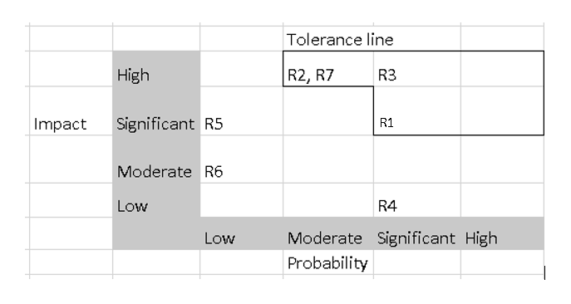
Risks 1, 2, 3 and 7 are the risks we are going to prioritise trying to limit the impact of.

Managing risks
We can manage these risks in various ways.
We can reduce the impact of failing to deal with time constraints by doing some effective time management. We can make sure of this by creating a schedule that states when we should to complete certain tasks and meet certain deadlines.
We can also reduce the impact of losing our work. We will do this by making sure all of our work is backed up regularly. This way, if we do lose our work, we can always get the work we have backed up and start from there instead of starting it again.
The risk of having an unhappy client can also be reduced by giving the client regular updates so they see how the website is turning out and they can say what they dislike then instead of saying it at the end. This would give us more time to change the website to fit the client’s needs.

Codes of practice: Sustainability

There are some issues regarding sustainability when it comes to doing our project. IT does have some impact when it comes to the environment. We will need to be are of the green house gasses we are emitting and try to reduce our carbon footprint as much as possible. We will have to make sure we act accordingly due to the many laws set in place to reduce the harm being done to the environment such as the climate change bill. Our product will be sustainable.

First order impact
The 1st order impact will be the direct result of our product.
There will be some First order sustainability impacts that we would have. For example, we will raise the GHG emissions due to the amount energy we might use and probably create some e waste. We can create less greenhouse gas emissions by reducing our energy consumption. To do this, we might use less servers.

Second order impact
The second order impact will be caused by the result of our product being used.
There could also be second order impacts that we would need to think about when it comes to using our services. We can reduce the impact that transport or travel adds to the environment as we will not really need to do much travelling for our product as coding the website could be done at home. We will also be able to have calls from our homes instead of travelling to a place to meet.

Third Order impact
The third order impact will be a long-term impact that our product has on the socioeconomic structures.
There will be a lot less trees cut down due to our website being made for BRD sports as it will allow us to fill in forms online rather than using paper. This will reduce the demand for trees being cut down since people will be using less paper in the future.

Codes of practice: Ethical and Legal

While we do the project, we will need to make sure that we follow the codes of practice since failing to do so could result in serious issues. Making sure the project is ethical can improve the trust we have with potential customers as well as it is improving the security against potential dangers.
We must make sure that we follow the British Computer Society Code of Conduct. IT professionals need to follow this. Following this will make sure that we follow the ethical, legal and social issues that we would face.
It is important that we are respectful to the organisations that we will be working for. We will have to careful while working and act in the best interest of the company and our clients. We will be responsible for any our actions.
One of the things we must do is to make sure that private customer information such as their medical records or their financial records are kept private and secure from unauthorized access. It is important this information is protected and backed up in case the data is lost.
The data protection act 2018 outlines how the organisations should use personal information. It ensures that all personal data is used in a lawful manner. It also states that personal data should only be used for specific purposes. The data must be accurate, and it must not be held for longer than necessary. This would mean that would mean that companies would have to get rid of the personal data when they no longer need it. The data being held will also have to be kept secure to protect the data from attackers. We must also make sure any data we gather is gathered lawfully and with consent of the user.
We also need to make sure that our website is friendly for all users without showing any discrimination to a certain race, gender or disability. We can make our website more accessible for the elderly people by making it possible for them to make the font bigger.
Another thing we will need to watch out for is the Copyright Designs and Patents Act. This law gives the creates of books, music, videos, images and software control on how their creation is used. You would need permission to use someone else’s work. For example, if we used a picture or video for our website that we did not have the right for, we could potentially be breaching the copyright designs and patents act. Therefore, our website for Ben Room will mostly be using original pictures and videos.

Quality Assurance

Another thing that we need to consider is the quality metrics for our project. We should see that our website is functionable, reliable, easy to use, efficient and portable.
The websites we will create should be effective. It should meet the requirements sent by the client. Our team can make it happen. We have the skills to do so. Productivity is another thing we should look at. Our product will be quite productive. Users will be able to use it to do a variety of actions. The website we are building for BRD sports will allow users to make purchases, bookings and find out information. We will make sure that the website is safe. We will use appropriate security to protect all the personal information. We aim to have satisfied users. We will achieve this by showing our website to some of the public before it is published to see what they think. This why they will be able to give us feedback and we will be able to act on their feedback.
Our website should satisfy the user needs as we will be keeping the client updated and will meet the requirements set to us by our client. The website should be reliable as it would have been tested multiple times during the process of creating it. It is designed to be user friendly. It is designed to be easy to navigate. Our product should be easy to maintain since there is not a lot we need to do after we are done with the website. Since our product is on the internet it should be easily portable. It can be accessed from anywhere or anything with access to the world wide web.

Conclusion

In this report I have discussed how we will manage any risks that might come with the project and how we can ensure that the impact of these risks is reduced.
We also talked about the sustainability issues and how we can work on reducing them as well as how we might be impacting it.
We also looked at the ethical and legal issues that might come with the project and how we can abide by these rules to make sure our product is as ethical as possible.
We also looked at the quality metrics to ensure that our product can be of highest quality as possible

Appendix

This is our product protoype
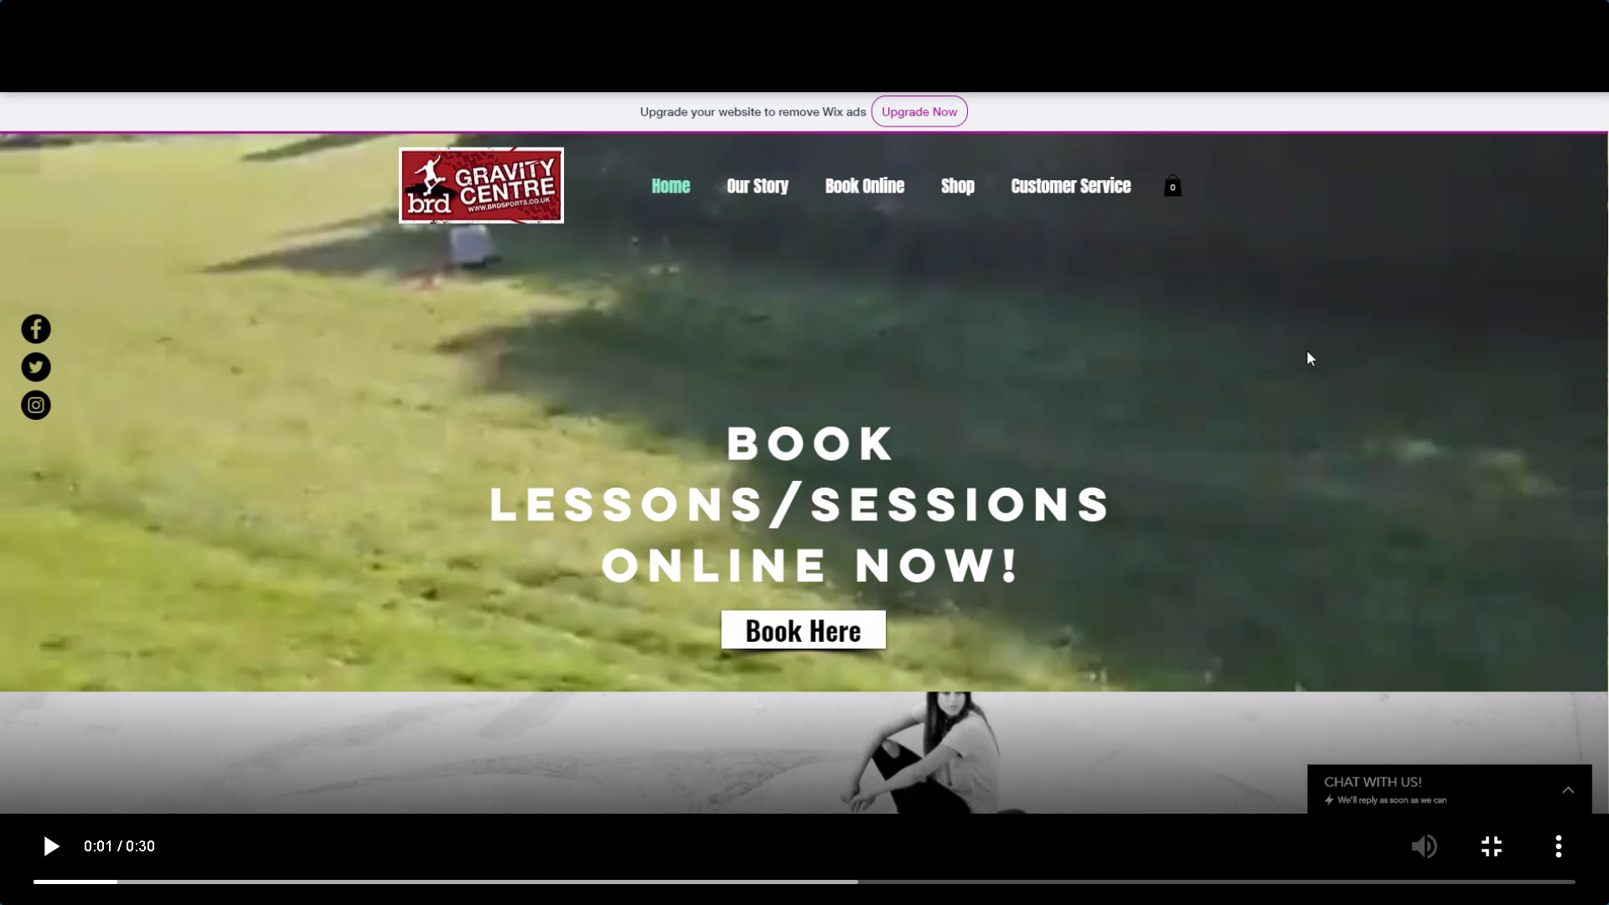
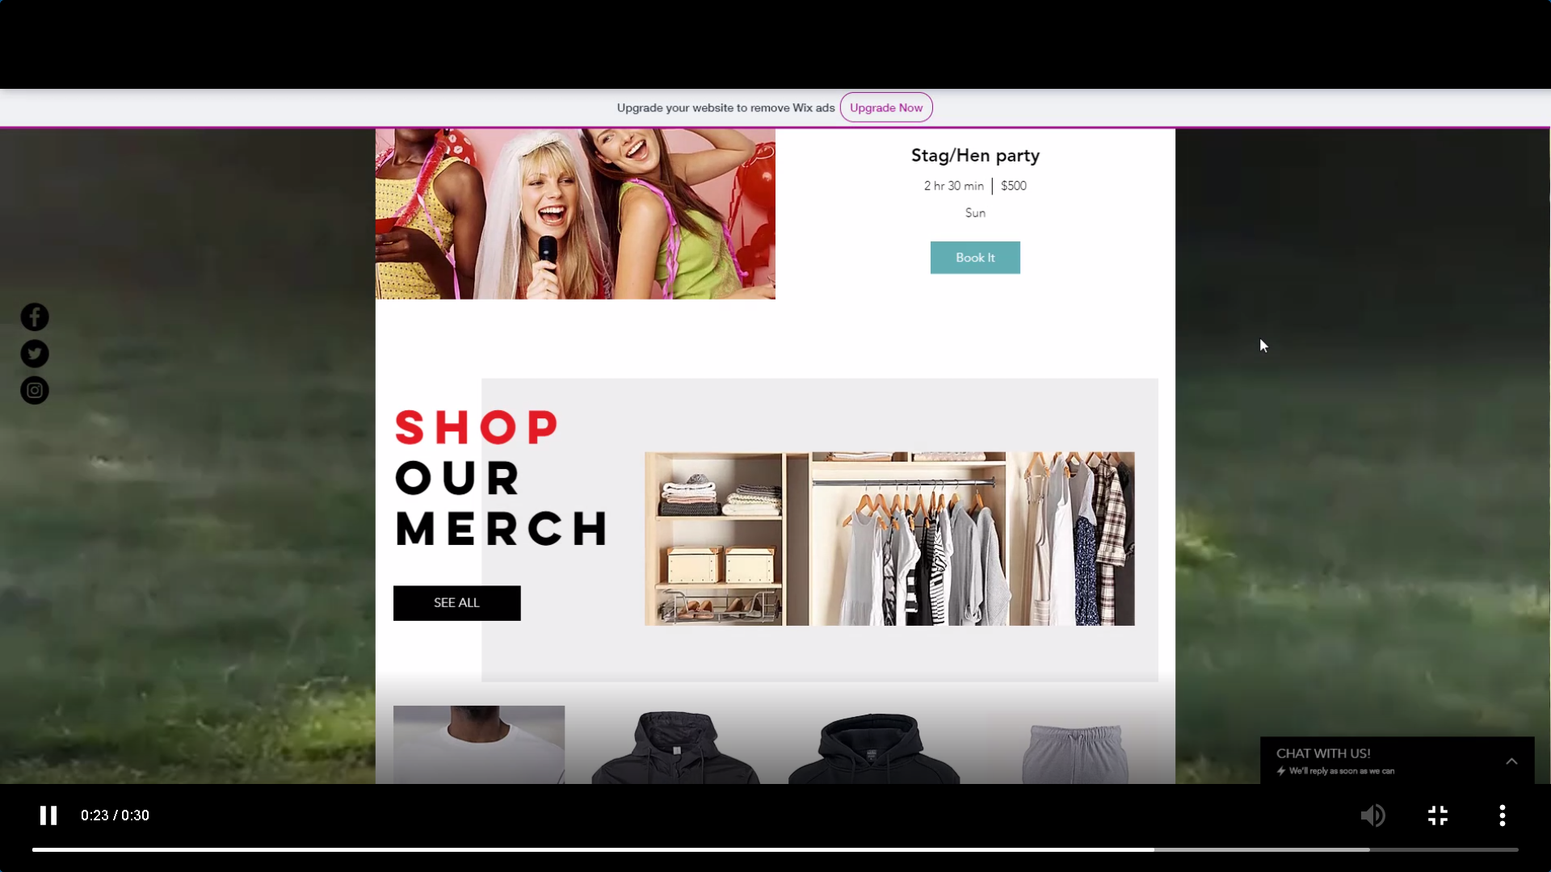

Bibliography

[1] | “BCS Code of Conduct,” BCS, [Online]. Available: https://www.bcs.org/membership/become-a-member/bcs-code-of-conduct/. [Accessed 28 01 2020].
[2] | “Data Protection,” Gov.UK, [Online]. Available: https://www.gov.uk/data-protection. [Accessed 30 01 2000].
[3] | H. Macqueen, “Intellectual Property: Patents, Copyright, Trade Marks and Allied RIghts (6th edition),” Probably the best UK IP textbook, vol. 6, p. 3, 2008.
[4] | F. F. M. F. Giuseppe Lami, “SUSTAINABILITY MANAGEMENT IN,” A Methodology to Derive Sustainability Indicators for.

