BA (Hons) Developing Leadership and Management

Module Title: Managing Projects in Organisations
Module Code: BMSW5009

Assignment Title:
Reflective Blogs

Project:
Student Business Pop-Up Market

Student Name: Catalina Binzaru
Student Number: 2222369
Lecturer: Lan Zhang
Submission Date: 19 June 2026

Blog: Introduction and Project Overview

When I joined the Managing Projects in Organisations module, I was interested in applying project management concepts to a real project rather than studying them in theory. Our project, Student Business Pop-Up Market, aims to provide students with an opportunity to experience entrepreneurship by showcasing and selling their products in a city-centre market environment.

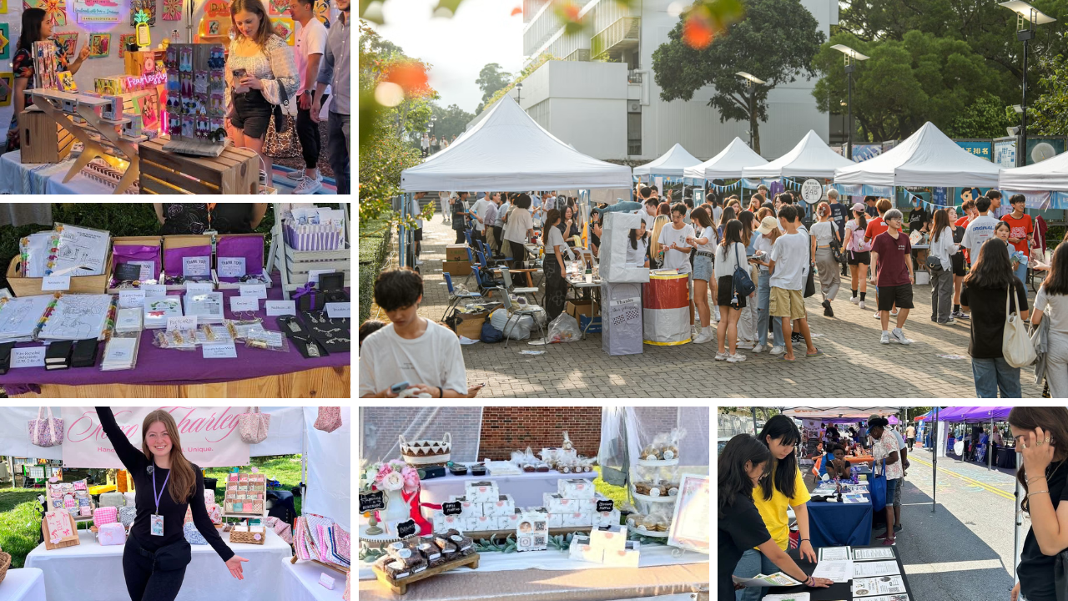
(unsplash.com)

The project is supported by the university module team, which acts as the sponsor by promoting the development of employability and business skills. While the idea initially seemed straightforward, I quickly realised that organising an event requires much more than creativity. It involves planning, coordination and managing practical constraints such as permissions, resources and time. This reflects the characteristics of projects as temporary, goal-focused and resource-limited activities (Heagney, 2016).

My role within the team is Venue Coordinator. I am responsible for supporting venue planning, considering layout requirements and helping coordinate permissions for the proposed location. My organisational skills and attention to detail contribute effectively. Reflecting on Belbin’s Team Roles, I identified most closely with the coordinator role because I enjoy bringing people and tasks together to achieve a shared objective (Belbin, 2010).

This stage helped me understand that successful projects begin with realistic planning. I initially assumed a strong idea would be enough, but I learned that practical feasibility must be considered from the beginning.

Blog: Project Initiation, Scope, Aims and Objectives

During the initiation stage, I found that transforming a general idea into a realistic project was more challenging than I expected. Although the concept of a Student Business Pop-Up Market was agreed quickly, defining its boundaries required structured discussion and decision-making.


(unsplash.com)

Our aim is to organise a student-led market that provides practical business experience while developing entrepreneurial skills. We established objectives such as delivering the event within 12 weeks, encouraging student participation and evaluating the event through feedback. Key deliverables include promotional materials, a registration system, an event schedule and the final event (PMI, 2021).

During scope discussions, I initially supported the idea of expanding the event to include live performances, as I thought it would attract more visitors. However, other team members highlighted time and budget limitations. After the discussion, I understood that adding too many elements would increase risk and complexity. This challenged my early assumption that bigger is better in project planning.

The Iron Triangle showed how time, cost and quality influenced our project decisions (Clegg, 2020). With limited time and budget, our group reduced planned activities to maintain the quality of the main event. This helped me understand that project initiation requires prioritising ideas and making realistic trade-offs between competing constraints and expectations.

Blog: Stakeholder Analysis and Communication

This week helped me understand that project success depends heavily on managing stakeholders effectively, not just completing tasks. In our Student Business Pop-Up Market, key stakeholders include the project sponsor, project team, Cardiff Council, participating students, volunteers and event attendees.


(unsplash.com)

Although identifying stakeholders was straightforward, I initially underestimated how their differing levels of influence would affect project progress. For example, Cardiff Council has high influence due to venue approval requirements, which impacted our planning timeline. In contrast, students and volunteers have lower influence but remain essential for project engagement. This reflects (Freeman, 1984) view that stakeholder management supports project success by aligning expectations with project objectives.

During the project, I experienced the importance of adapting communication methods. When I contributed to drafting an email for venue approval, I realised it lacked sufficient detail regarding event requirements, which led to clarification. This showed me that external communication must be precise and structured to avoid delays.

Internally, I also noticed that informal communication among team members was effective for quick decisions but sometimes led to assumptions not being recorded clearly. This highlighted the importance of balancing informal collaboration with formal records.

Overall, this stage helped me understand that stakeholder management is not just about identifying stakeholders, but actively managing expectations through communication strategies tailored to influence, urgency and context.

Blog: Work Breakdown Structure and Gantt Chart

The development of the Work Breakdown Structure (WBS) and Gantt Chart helped me understand how complex project activities can be structured into manageable tasks. At the beginning, I found the project overwhelming because several activities were happening at the same time, and responsibilities were not fully clear.


(unsplash.com)

While creating the WBS, I realised we had initially missed key tasks such as confirming venue requirements and external approval processes. This gap made me understand that breaking a project into smaller components is not only organisational but also a way to identify risks early and avoid delays (PMI, 2021). As Venue Coordinator, I specifically focused on venue-related tasks, including permission deadlines and layout preparation, which helped the team prioritise logistical work more effectively.

The Gantt Chart allowed me to visualise task sequencing and dependencies. For example, marketing and student recruitment could not fully progress until Cardiff Council approved the venue. This highlighted how delays in one task can impact the overall schedule and reinforced the importance of sequencing activities correctly (Richard, 2024).

One challenge was estimating realistic timescales for activities that depended on external stakeholders, particularly approval processes. This experience taught me that planning should remain flexible and that project schedules often require adjustment. Overall, these tools improved my understanding of how structured planning contributes to successful project delivery.

Blog: Risk Analysis and Reflection

Reflecting on the project so far, I have realised that managing uncertainty is more challenging in practice than I initially expected. Identifying potential risks encouraged me to think beyond planned activities and consider what might prevent the project from achieving its objectives (Carmichael, 2022).

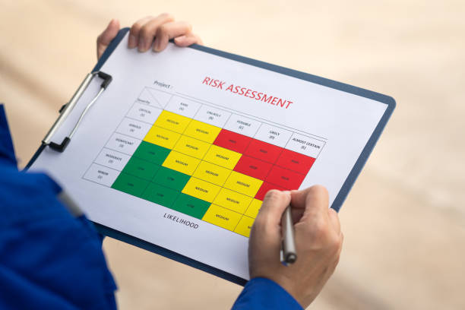
(unsplash.com)

Several risks were identified during the planning process, including delays in obtaining permission from Cardiff Council, adverse weather conditions and low student participation. Discussing these risks helped us develop mitigation strategies, such as submitting applications early, considering weather protection and increasing promotional activities.

As Venue Coordinator, I contributed to discussions on venue logistics and practical arrangements. My main strength was staying organised and consistently supporting planning discussions, which helped ensure key venue considerations were included in decisions.

However, I also recognised some hesitation in challenging ideas during decision-making.
In addition, I recognised an area for improvement. I sometimes lack confidence when challenging ideas or making formal decisions. For instance, I agreed with an initial venue setup plan without fully questioning spatial limitations, which later needed adjustment. This highlighted the importance of being more assertive in group decision-making.

In future projects, I plan to take a more active role during discussions and contribute more confidently to decision-making. This experience has shown me that personal growth is an important outcome of project work alongside achieving project objectives.

References List

Belbin, R. M. (2010). Team Roles at Work. 2nd edn. London: Elsevier.

Carmichael, D.G. (2022). Risk and Systems: With Applications in Infrastructure Project
Management. CRC Press.

Clegg, S. R. (2020). Project Management: A Value Creation Approach. London: Sage.

Freeman, R. E. (1984). Strategic Management: A Stakeholder Approach. Boston: Pitman.

Heagney, J. (2016). Fundamentals of Project Management. 5th edn. New York: AMACOM
American Management Association.

Kabir, M. F. (2026). Assessment of the Application of Project Management Tools and
Techniques used for Building Construction Project Delivery. PM World Journal, XV(III),
pp.1-14. Available at: www.pmworldjournal.com.

Project Management Institute (PMI) (2021). A Guide to the Project Management Body of
Knowledge, PMBOK Guide and The Standard for Project Management. 7th edn. Newtown
Square: Project Management Institute.

Richard, M. (2024). The Gantt Chart in Modern Project Management: An Empirical
Analysis from Developing Countries.
Available at: https://doi.org/10.13140/RG.2.2.30341.15847

