Global Challenges
Within Bank Of St. Vincent And The Grenadines (BOSVG)
Program: MBA Module: Global Business Challenges Module code: BMMB7006D Lecturer: Anthony Burns Assignment Title: Global Challenges Purpose: the current environmental forces and their impact on the organization.
ZaraJohn-Nicholls Student No. : 2114488
07-Jan-22

BOSVG Background 4
Substantial In Share Capital As At December 31, 2020 5
Vision Statement 6
Mission Statement 6
Core value 7
Correspondent Banks 7
International Trade 9
The Group 10
Foreign Exchange Services 10
Wire Transfers - SWIFT 10
Foreign Currency Transactions (Anon., 2020) 11
What is the role of banks in international trade? 11
How is BOSVG institution essential in an Economy? 12
The Roles of BOSVG in Financial System In SVG 12
Macroeconomic factors 12
Porter’s Five Forces Analysis 13
T1: Threat of New Entrants: 13
O1: Bargaining Power of Suppliers: 14
T2: Bargaining Power of Buyers 14
T3: Threat of Substitute Products 14
T4: Competitive Rivalry: 14
PESTLE Analysis 15
T5: Political 15
T6: Economic: 16
O2. Social 16
O3: Technology 17
Environmental 17
T7: Legal 17
SWOT/TOWS Analyze 17
O4. Strength 18
T8: Weakness 19
Vulnerable to new Technology 19
O5: Opportunity 19
T9: Treats 20
Economic Recessions 20
T10: Competition 22
BOSVG Demand and Supply Chain 1 23
Covid-19 Impact 28
Application of the going concern principle considering the impact of Covid- 19 30
Potential new ways BOSVG moving forward in the future. 31
Critical accounting estimates, and judgments in applying accounting policies 35
Bibliography 36

BOSVG Background
The Bank of Saint Vincent & the Grenadines is formerly the National Commercial Bank (SVG) Ltd. A company listed on the Eastern Caribbean Securities Exchange was incorporated in St. Vincent and the Grenadines (SVG) on 01 June 1977 by The Honorable Robert Milton Cato the then Premier of Saint Vincent with 11 staff members at a single Branch. The Bank has been serving the people of St. Vincent and the Grenadines for over forty-four (44) years, having opened its doors on July 1, 1977. On 19 June 2009, BOSVG Development Bank Inc. was amalgamated and continued under the name of National Commercial Bank (SVG) Ltd. The bank name was changed to Bank of Saint Vincent & the Grenadines ltd. On 26th November 2012. The current staff complement is 173 and the Bank operates from 2 locations in Kingstown which include its Head Office, five sub-branches, and the Exchange Bureau at the Argyle International Airport. The sub-branches are located in Georgetown on the Windward side of St. Vincent, Barrouallie on the Leeward side, and the Grenadine Islands of Bequia, Canouan, and Union Island.
Bank of St Vincent and the Grenadines Ltd, a market leader in St. Vincent and the Grenadines, offers the full spectrum of commercial banking services through a wide branch network and several electronic channels. As of June 30, 2021, the Bank has an asset base of just over XCD 1.2 billion. The Bank is owned by over two thousand (2,000) shareholders and is listed on the Eastern Caribbean Securities Exchange (ECSE). BOSVG’s customer base includes individuals, small and middle-market businesses, large corporations, statutory bodies, and Central Government. Bank of Saint Vincent & the Grenadines currently offers services in retail banking which includes savings and deposits in addition to credit and investment banking.

Substantial In Share Capital As At December 31, 2020
The shareholding at December 31, 2020, was as follows:
Figure 1
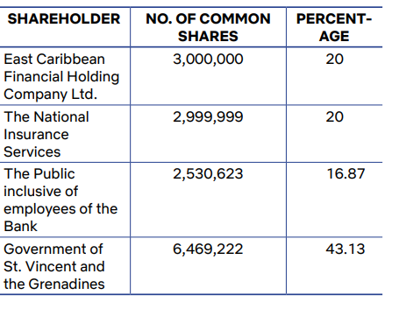

Vision Statement
To be the premier financial institution in S. Vincent and the Grenadines
Deeply rooted in the local community, we are the leaders in delivering a more unique banking experience through quality people, strong relationships, financial strength, sustained growth, and integrity.

Mission Statement
We are the providers of diverse financial solutions, adding value to our shareholders, customers, employees, and community built on a foundation of excellent service operation and good governance.
- To be customer-focused, innovative, and efficient.
- To be the preferred provider of superior financial products and services through caring, professional staff, and appropriate technology.
- To exceed shareholder expectations and be a catalyst for development.

Core value
Focus on Professionalism Accountability and Transparency, Integrity, Continuous Learning and Results Orientation.
Figure 2
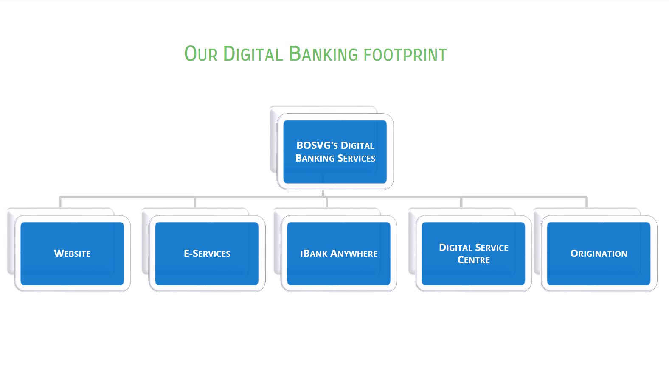
Figure 3
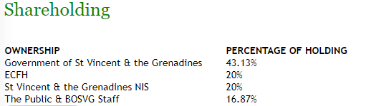

Figure 4

Correspondent Banks

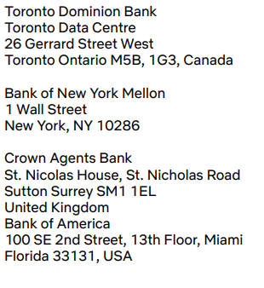
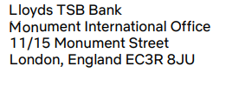

Executive summary
In this brief excerpt from this report, I will examine the Macro and Microeconomic theory. In addition, highlight the evaluation of the current environmental forces that determine where BOSVG currently sits within its existing environment and how the firm has interpreted these findings in terms of the decisions it has made on a microeconomic level. A critical evaluation of the environmental conditions in which the BOSVG operates will be underlined. The actual and potential consequences of the various factors on the BOSVG will be demonstrated and converse. This report contains the competitive environment that necessitates the identification, analysis, and interpretation of industry-specific figures. The appropriate analytical tools and models such as PESTEL, Porter's 5 Forces, SWOT, TOWS, will be employed. A comprehensive conclusion will be highlighted from the preceding analysis that evaluates the Bank of St.Vincent and the Grenadine current position in the international market and provides an outlook/ scenario for BOSVG's future organizational decisions and developments. In this report, I will highlight how the demand and supply model connects those who want to supply financial capital (i.e., savings) and those who want to borrow money, which is on the demand side of BOSVG. Individuals or businesses can be on the BOSVG supply side. Analysis of the breadth and depth of COVID19's impact on the global economy and financial markets will be discussed. As well as how these decisions may change if BOSVG decides to pursue any potential new ways of moving forward in the future.

Introduction

International Trade
Banks play an important role in international trade facilitation. Aside from providing liquidity, they guarantee payment for roughly one-fifth of global trade (Abel, n.d.). As a result, the banking sector plays an important role in international trade. BOSVG plays a critical role in establishing a trust bond between buying and selling agents executing transactions in international markets. BOSVG has intermediary banks outside the country that help with international payments, allowing locals to receive and pay for goods and services.
To better serve their international business community, BOSVG has formed collaborative alliances and established correspondent banking relationships with banks in other countries BOSVG plays a critical role in foreign trade by providing the financial structure and instruments required for the conduct of business transactions between foreign buyers and sellers. Many specialized banking services are required by multinational corporations, such as foreign currency exchange and funding for overseas investments. BOSVG functions as a network of financial
Institutions, providing a variety of services such as cash, deposits services, credit, money transfers, Dash, card services, lending services, convenient banking services, foreign exchange services. BOSVG wealth management, financial calculators, currency converter, application form, and other services and other transactions provided by the bank.

BOSVG uses public funds (deposit, lend, and profit from them). BOSVG also provides trade-related services, such as global cash management, to help businesses manage their cash flows, improve payment efficiency, and reduce their exposure to operational risks. Banks ensure the security and transparency of the flow of documents and money. The banking industry is considered as one of the most significant drivers in strengthening the soundness of an economy in terms of investment, job creation, facilitating the flow of funds nationally and globally. Similarly, the BOSVG have played their part in facilitating investment and savings as well as economic growth of local, regional and international. The Five Forces model by Porter provides an objective scenario of the major drivers that surround an industry.
Presently here in St Vincent and the Grenadines (SVG), they are various foreign investors who are in the process of constructing hotels on the island and have barrow loans from BOSVG for these projects. BOSVG facilitates international trade by providing importers and exporters with financing and guarantees. Access to external funds is critical for domestic production, but it is especially critical for exporting firms. Several studies have found that firms in countries with strong financial institutions tend to export more, particularly in financially vulnerable sectors ( Beck, 2002). BOSVG provides the funds required to carry out various programs in the economic development process. The bank collects savings from large numbers of people dispersed throughout St. Vincent and the Grenadines and various international countries, which would have remained ideal and unproductive in the absence of banks; these dispersed amounts are collected, pooled together, and made accessible to commerce and industry for meeting financial requirements. The banking sector is made up of many small parts, such as investment banking, retail, corporate, management, and administration. According to estimates, the retail sector grew significantly between 2006 and 2011 (Anon., 2020). However, the banking sector is a major driving force in global economies and governments.

The Group
Property Holdings SVG Ltd. (“the Subsidiary”) is wholly owned by the Bank. The Subsidiary was incorporated in St. Vincent and the Grenadines on 13 December 2010. The Subsidiary’s principal activity is to own, develop and manage real estate properties acquired by the Bank. The principal activities of the Bank and its Subsidiary (“the Group”) are the provision of retail and corporate banking and investment services in St. Vincent and the Grenadines. The Bank is publicly listed on the Eastern Caribbean Stock Exchange.

Foreign Exchange Services

Wire Transfers - SWIFT

With SWIFT, you can transfer funds to and from any part of the world. Customer’s transactions are handled promptly to provide same-day credit. SWIFT transfers are done at the day’s selling rate at a commission.

Foreign Currency Transactions (Anon., 2020)
The Bank of St Vincent & the Grenadines Ltd trades in the following foreign currencies:
Figure 5
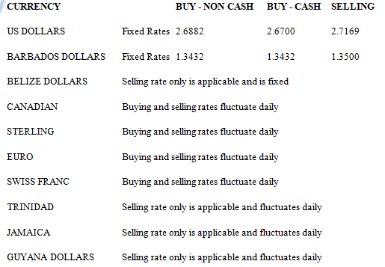

Body

What is the role of banks in international trade?
In terms of international trade, banks have earned a reputation for providing quick and efficient processing of international business transactions such as foreign exchange for companies involved in the import and export of capital goods (Demirguc-Kunt, Asli, Luc Laeven, and Ross Levine, 2004). BOSVG provides services such as remittance processing. Through its advisory board, associate editors, and referees from academic, financial, and governmental institutions around the world, the BOSVG represents a diverse range of perspectives and specializations in its fields. Financial institutions' primary role is to provide liquidity to the economy and enable higher levels of economic activity than would otherwise be possible. According to the Brookings Institute, banks accomplish this in three ways: by providing credit, managing markets, and pooling consumer risk.. (Mcdonald, 2017).

How is BOSVG institution essential in an Economy?
BOSVG plays an important role in the payment system, which enables the economy to exchange goods and services for money or other financial assets. As a result, the bank reduces transaction costs and serves as financial intermediaries, bringing together savers and borrowers.

The Roles of BOSVG in Financial System In SVG
BOSVG plays a variety of roles in the economy. For starters, the address information gaps between investors and borrowers by monitoring the latter and ensuring proper use of depositors' funds. Second, it provides intertemporal smoothing of risk that cannot be diversified at any given point in time, as well as depositor insurance against unexpected consumption shocks. BOSVG is vulnerable to runs and systemic risk due to the maturity mismatch between its assets and liabilities. Third, BOSVG contributes to economic growth. Fourth, they play a critical role in corporate governance. The relative importance of banks' various roles varies significantly across countries and times, but banks are always critical to the financial system.

Macroeconomic factors
The standard also requires the incorporation of macroeconomic factors in models for the Emergency Credit Line Guarantee Scheme (ECLS). In its models, the Group conducted an assessment of a broad range of forward-looking economic information as possible inputs, such as GDP growth, unemployment rates, and Eastern Caribbean Central Bank interest rates. There was little correlation between the overall performance of the economy and historical loss trends. It was therefore not possible to directly correlate macroeconomic expectations to adjustments within the ECL models.
Figure 6 (Anon., 2020)
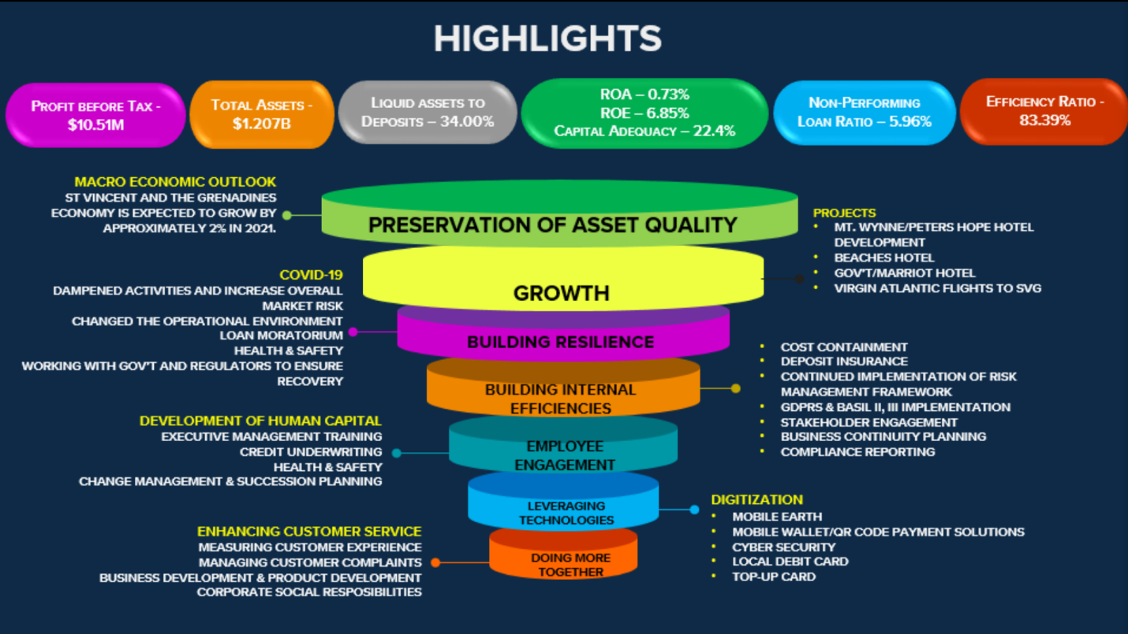

Porter’s Five Forces Analysis
According to Porter's Five Forces framework, competitiveness is generated by more than just competitors. Rather, the state of competition in an industry is determined by five fundamental forces (Scott, 2020), which are as follows:

T1: Threat of New Entrants:
Because the industry deals with other people's money and financial information new banks find it difficult to start up (Scott, 2020). People are more willing to place their trust in BOSVG, a well-known, major bank that they consider to be trustworthy, hence, the biggest barrier of entry for the banking industry, trust. BOSVG deals with its customer’s money and financial information, therefore new banks find it difficult to start up. BOSVG has undergone consolidation (with CIBC) with a major attempt to serve its entire customer's financial needs under one roof. The banking industry is highly regulated, with the BOSVG imposing numerous laws and regulations. Subsequently, the banking industry's entry barriers are relatively low.

O1: Bargaining Power of Suppliers:
Capital is BOSVG's primary resource, and there are four major suppliers such as customer deposits, mortgages, and loans, mortgage-backed securities, and loans from other financial institutions. The following factors demonstrate that suppliers' bargaining power is favorable/ beneficial for BOSVG:
- Rather than a fragmented source of supply, BOSVG is dominated by a large number of suppliers.
- There are substitutes for the specific input, the suppliers' customers, i.e. BOSVG is concentrated i.e it provides more or less similar rates for deposits,
- The switching costs from one customer to another are not high.
The power of the suppliers is largely based on the market, their power is often considered to fluctuate between medium to high.

T2: Bargaining Power of Buyers
Buyers can pose a threat to the industry by driving prices down, bargaining for higher quality or more services, and pitting competitors against one another (Scott, 2020). Profitability suffers as a result. Another major factor influencing buyer power at BOSVG is relatively high switching costs. The internet also has significantly increased the consumer's power in the banking industry. The internet has made it much easier and less expensive for consumers to compare the costs of opening/holding accounts as well as the rates offered by BOSVG.

T3: Threat of Substitute Products
Some of BOSVG's largest threats of substitution are not from rival banks but non-financial competitors such as insurance companies and credit unions. BOSVG does not suffer any real threat of substitutes as far as deposits or withdrawals; however, insurances, mutual funds, and fixed income securities are some of the many banking services that are also offered by non-banking companies. There is also the threat of payment method substitutes and loans are relatively high for BOSVG. Similar to the threat of new entrants, the threat of substitutes is determined by factors such as customer brand loyalty, close customer relationships, switching costs for customers, the relative price for substitute performance, and current trends.

T4: Competitive Rivalry:
Rivalry is the competitive struggle between banks in an industry to gain market share from each other. As a result, BOSVG is trying to entice customers away from competitors. This is accomplished by providing lower financing, higher rates, investment services, and more conveniences than their competitors. A threat to new entry can cause BOSVG customers to transfer to their competitors if they don't have strong customer loyalty and excellent service.

PESTLE Analysis
PESTEL Analysis is a concept in marketing principles, where companies use a tool to monitor the environment they’re operating in or are planning to launch a new project/product/service (Anon., n.d.). PESTLE is the context that a business should measure itself against to review competitors, markets, and the situation in which an organization finds itself.

To grow business internationally you have to notice that different banking institutions have different reasons for growing their business by focusing on various drivers such as competition, market factors, and technology, etc (Anon., n.d.). The banking industry has an impact on all countries. Hence, BOSVG is subservient to many factors, most notably the government of St Vincent and the Grenadines and the economy whether international or regional. The bank is unable to function independently and is required to provide services in compliance with specific laws that affect its growth and offerings. In addition to the Company’s Act of 1994, the Bank is subject to the provisions of the Banking Act 2015, the Securities Act No. 29 of 2001, and provisions of other legislation applicable to the business of the Bank (Anon., 2020).

T5: Political
The banking sector appears to be all-powerful, but it is vulnerable to a larger giant: the government. The state of the BOSVG is influenced by the government of SVG legislation. The government can intervene in banking matters at any time, leaving BOSVG vulnerable to political influence.
- Local financial services can become global financial services due to government subsidies due to their positive impact on the country’s economy (Ministry of Finance 2020).
- Due to industrial fragmentation, the banks’ profit margins are declining

T6: Economic:

The question of the day is, “When will the economy return to its 2019 level and trajectory of growth?” The potential for near-term economic recovery is uncertain. The COVID-19 crisis is not a banking crisis; it is a real-economy crisis. BOSVG will undoubtedly suffer as credit losses spread throughout the economy and demand for banking services falls The banking industry and the economy are inextricably linked. The amount of capital BOSVG can access is affected by how income flows, whether the economy is prospering or barely surviving during recessions. Customers' spending habits, as well as the reasons for them, influence when they borrow or spend money at banks will also be affected.

O2. Social
- BOSVG has signed a definitive agreement to acquire CIBC First Caribbean's branches and banking operations in Dominica, Grenada, St. Kitts, and Nevis, and St. Vincent and the Grenadines. The agreement, which was signed on October 12, 2021, is subject to regulatory approval and the usual closing conditions. Derry Williams, Managing Director of Bank of St Vincent and the Grenadines Ltd, stated in making the announcement, "This acquisition is a significant step forward in the evolution of BOSVG' banking system (Anon., 2020). The bank is confident that, once approved by regulators, it will lay the groundwork for even more enhanced value creation in the local economy and greater prosperity for our society."
- Increasing competition and technological progress encourage traditional financial institutions
- The behaviors and attitudes of people in a particular demographic
- Consumer tastes and preferences are becoming more uniform around the world, and they are becoming more knowledgeable about various products and willing to try other alternatives. (Purchasing habits)
- Borrowing

O3: Technology
- Perceptions of product quality and customer service.
- Customer service was environment virtually nonexistent.
- Automation
- Access to new technology
- Level of innovation
- Technological awareness

Environmental
- Increasing competition for BOSVG encourages the inclusion of an increasing number of new market segments as they expand their business
- Environmental policies

T7: Legal
Stiffening regulation necessitates system flexibility (Ministry of Finance 2020);
- Industry digitalization trends necessitate advanced authentication and secure access tools
- Antitrust laws
- Consumer protection laws

SWOT/TOWS Analyze
SWOT Analysis (also known as SWOT Matrix) is a business framework that aids in the evaluation of a wide range of factors that can have a significant impact on a company's performance (Humphrey, A. 2005). These elements can be either internal or external to a company While TOWS analysis first matches internal factors to external factors to aid in the identification of relevant strategic options that an organization could pursue (Lynch, 2020). This TOWS is a strategy used by BOSVG to determine how the bank/group’ can capitalize on opportunities, mitigate threats, overcome weaknesses, and capitalize on any strengths. It’s going to analyze the internal and external factors impacting the financial institutions. Here’s the swot analysis of the BOSVG as follows;

O4. Strength
- Online Banking: Digital or online banking is the most recent and cutting-edge banking method in the financial industry (FRUE, 2019). BOSVG online banking enables its customers to use various services such as transferring funds, paying bills, depositing money, or applying for a credit card without having to visit the bank. Only then should you go to the bank if you want something more. The covid-19 pandemic, social distancing, and global lockdown have increased the use of digital banking. Online banking is now a critical component of banking. Other strengths include:
- Convenience: The banking industry's competition has compelled bankers to step outside of their comfort zone and embrace technology. For BOSVG to gain a competitive advantage, the bank is now working on finding newer ways to make their customers' lives easier.
- Financial Support: When there is an economic, financial, or environmental crisis, the government or the people are in desperate need of assistance. BOSVG is responsible for providing those insurances, loans, investments, or capital support so that they can get back on their feet.
- Economic Growth
- Faster and simpler processes
- Government support
- Quality services
- Highly convenient locations
- High service levels
- Highly automated systems
- IT/software expertise
- Easy access to capital and funding

T8: Weakness

Vulnerable to new Technology
- Despite the advantages and the innovation undergone in BOSVG, there is some factor that relates to the bank's weakness. Although BOSVG provides internet banking and other cutting-edge technology, it is slow to adopt the technology. Just like many banks BOSVG, for example, does not even allow customers to use special characters in their passwords. Weak passwords are easily cracked by hackers. Regulatory rigor is also a major weakness for BOSVG. Other weaknesses are:
- Limited online advertising experience
- No expertise in creating engaging online content
- No real relationships with online “influencers”

O5: Opportunity
BOSVG will increase its asset base by more than $500 million in the coming months, following the completion of its acquisition of the CIBC First Caribbean branch in this country. A consortium of Eastern Caribbean Currency Union (ECCU) banks announced on Tuesday that it had entered into a definitive agreement to acquire CIBC First Caribbean's branches and banking operations in Dominica, Grenada, St Kitts, and Nevis, and St Vincent and the Grenadines (Anon., 2020). The four members of the Consortium are the National Bank of Dominica Limited; Grenada Co-operative Bank Limited; St. Kitts-Nevis-Anguilla National Bank Limited; and the Bank of St. Vincent and the Grenadines Limited (BOSVG), which is also the agent of the consortium. He also noted BOSVG’s intention to roll out in short order, the I-Wallet, as well as being in the final stages of implementing D-Cash, which is offered by the Eastern Caribbean Central Bank (ECCB). The potential benefit of such a transaction includes increased customer base, leading to increased revenue growth and profitability, reduced concentration in deposit portfolio, the provision of access to other key resources including personnel and facilities. Most importantly, BOSVG keeps in mind that the needs and demands of their customers' markets vary by geography and customer. A student's, a businessman's, and a family person's needs are all different. Other opportunity includes
- Build online engagement with our brand
- Advertise on online comparison websites
- Build/acquire digital marketing expertise

T9: Treats
The banking industry, like any other, faces its fair share of threats. International banking can be a high-risk venture due to political and economic uncertainty in other countries (FRUE, 2019). BOSVG was not immune to the 2007–2009 financial crises. The most important types of risk for BOSVG are credit risk, liquidity risk, market risk, and other operational risks. Market risk includes currency risk and interest rate risk.

Economic Recessions
The biggest threat to any industry handling money is a recession. It’s the most critical threat that can make or break a business. If small and big businesses fall, it’ll have a direct consequence on the banking industry. The significant economic impact of the COVID-19 pandemic has resulted in ongoing uncertainty about the timing of recovery.
- Online Fraud: Some customers are wary of e-banking because they believe it is easily manipulated. Concerns about the security and safety of internet transactions cause people to be hesitant to use digital banking services. Customers are hesitant to use digital banking due to the hacking of sensitive personal information (Saadeh & Mikhael, 2016).
- Market risk: BOSVG takes on exposure to market risks, which is the risk that the fair value or future cash flows of a financial instrument will fluctuate because of changes in market prices. The Bank's exposure to market risks arises from its non-trading and trading portfolios. Non-trading portfolios market risk primarily arises from the interest rate management of the Group’s retail and commercial banking assets and liabilities.
- Currency risk: The Group accepts exposure to the effects of fluctuating foreign currency exchange rates on its financial position and cash flows. The Group's exposure to currency risk is limited because the majority of its foreign assets and liabilities are held in US dollars. Since 1974, the Eastern Caribbean dollar (EC$) to US dollar (US$) exchange rate has been formally pegged at EC$2.70 = US$1.00.
- Interest rate risk: Cash flow interest rate risk is the risk that the future cash flows of a financial instrument will fluctuate because of changes in market interest rates.
Figure 7 (Anon., 2020)
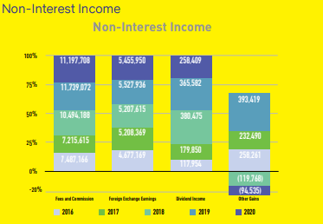
- Liquidation Risk: The risk that the Group will be unable to meet its obligations when they become due as a result of customer deposits being withdrawn, payment of cash requirements from contractual commitments, or other cash outflows is referred to as liquidity risk. Liquidity, as measured by the liquid assets to total deposits decreased marginally from 41.9% at the end of 2019 to 39.3% as of December 31, 2020 (Anon., 2020). At the onset of the pandemic, it was envisaged that the Bank’s liquidity would have decreased significantly due to increased private and public sector spending. However, the overall liquidity held steady for the most part during the period.
- Cyber-hacking and data protection failure/ Breach of data/privacy issues
- Unfavorable regulation
- Growing competitive set
- Many emerging new entrants
- Disruptive technology
- High levels of inflation
- Uncertain market conditions

T10: Competition
In recent years, the banking industry has grown increasingly competitive. Many new banks are niche-focused, providing services in a single category such as agriculture, commercial banking, savings banking, insurance banking, and so on (FRUE, 2019). They pose a significant threat to traditional banks because they only specialize in one area. Alternative financing firms Mutual funds, credit unions, and insurance companies fall into this category.

Tows
Banks must understand future changes in information, training, and development that are appropriate for the global environment. After all, banks can inform their customers about the adopted protection policies and security measures via any available medium to foster a trusting relationship between the bank and the client ((Saadeh & Mikhael, 2016; Charbaji, 2005)
O6: SO - strategy: when a BOSVG uses and strengthens its internal strengths to capitalize on available opportunities in the external environment.
O7: WO -strategy: When BOSVG reduces internal weaknesses that may act as a barrier to the implementation of diffusion of external opportunities.
O8: ST-strategy: When BOSVG uses internal strengths as a tool to reduce external factors that threaten their performance or competitiveness.
O9: WT-strategy: When BOSVG eliminates internal weaknesses to prevent the emergence or spread of external threats.
Table 6 summarizes some of the proposed strategies as a SWOT/TOWS Matrix in which policymakers can adopt for better implementation of e-banking in Lebanon.
Table 8 (Anon., 2020)
SO  - Benefit from Banks' distribution in SVG and International region Larger marketing campaigns More internet users Better policies and internet infrastructure  - Support Perceived enjoyment: improve screen design and ease of navigation on Banks' websites | WO  - Create a mobile banking application that is compatible with BOSVG's current internet features.  - Attract consumer attention to internet services  - Reduce lack of awareness, and increase trust in e-banking through sales promotion and public relations tools, offer free testing and trials.  - Perceived usefulness: banks should inform customers about the features, rewards, and benefits of e-banking.
ST  - Help boost application and security protocols  - create an acceptance state for e-banking  - demonstrate time accessibility and increased productivity | WT  - enact laws and standards to strengthen banks' ability to combat cybercrime  - Improved web security systems  - Take action to eliminate any third-party disruptions  - Promote an e-learning culture

BOSVG Demand and Supply Chain 1
In the financial markets, the laws of demand and supply continue to apply. A higher rate of return (that is, a higher price) will reduce the quantity demanded; according to the law of demand (Kim, n.d.). Consumers will reduce the amount they borrow as interest rates rise. A higher price, according to the law of supply, increases the quantity supplied. As a result, as the interest rate on credit card borrowing rises, more businesses will want to issue credit cards and encourage customers to use them. If the interest rate on credit cards falls, the amount of financial capital supplied in the credit card market falls, as does the amount demanded.
The "price" in BOSVG's demand and supply analysis is the rate of return or the interest rate received. The money that flows from those who supply financial capital to those who demand it is used to calculate the quantity. BOSVG has taken a different approach by investigating how leading consumer business (CB) organizations efficiently move cash (goods) through their supply chains. BOSVG has used CB strategies to reduce excess inventory, reduce handling and processing costs, increase operational efficiency, and optimize its ATM network. More importantly, BOSVG is better at managing its cash supply chain, allowing them to improve productivity and position itself to compete in the market.
Figure 9 Demand & Supply for BOSVG Prospective
Demand | Supply
1. Deposits | - Loans  - Credit Cards  - Overdraft

Table 10
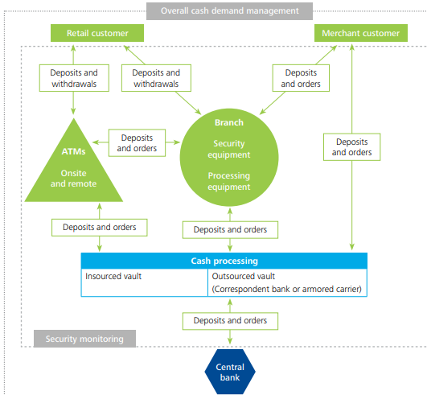

Figure 11 Stakeholders and Core Business Objective
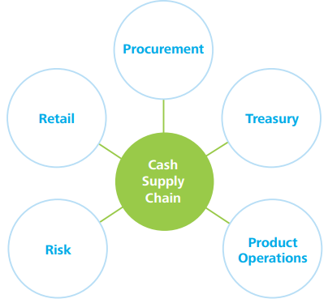
NOTES TO THE CONSOLIDATED FINANCIAL STATEMENTS For the year ended 31 December 2020 (Expressed in Eastern Caribbean dollars)
Figure 12: Financial Risk Management
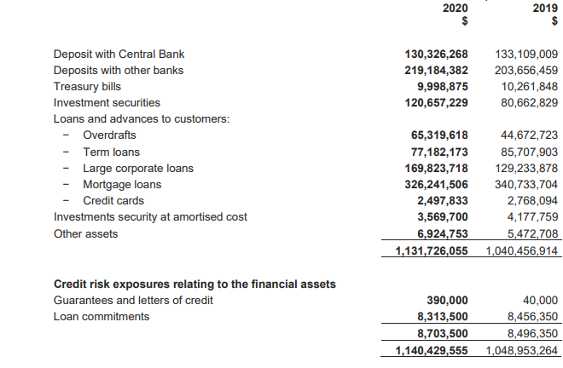

Figure 13 Supply & Demand Management Strategies
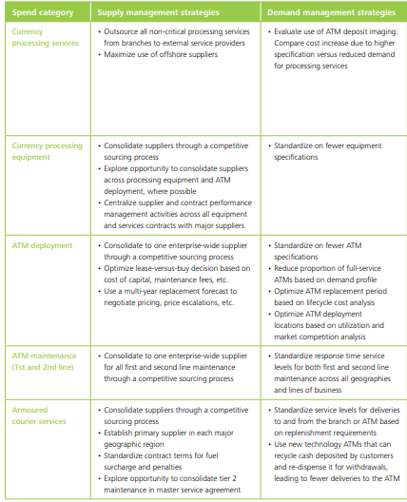

Conclusion
Banks are an ancient institution that contributes to the growth of any economy and is regarded as an important service industry in the modern world. Economic history demonstrates that development begins with the banking system, and its contribution to a country's financial development is greatest in the early stages. BOSVG plays an important role in the economy by facilitating payment and mobilizing resources. A bank is the most important financial institution in a country’s economic growth because the development of the banking sector is dependent on the development of the banking sector. BOSVG offers not only traditional banking services but also a wide range of financial services. With the supportive regulatory framework, BOSVG has played a significant role in over-the-counter mobile money transactions. Money can now be deposited, withdrawn, and transferred using a handset.
This service also handles utility bills as well as payments for goods and services. No matter the size of the business, threats, and opportunities can be highlighted by the PESTLE. Thriving companies in the digital age see these opportunities and adapt or create new product ranges and fearlessly move into new markets. According to the results of SWOT and PESTEL analyses, a lot of capital is being invested in BOSVG and a huge growth is expected.

Covid-19 Impact

This pandemic evolves with disruptive effects on BOSVG employees, customers, and the community, affecting bank operations, financial results, and current and future risks to the Bank (Group's) business. . However, the issues are not entirely of one's own making. BOSVG was well capitalized when the crisis hit, and it is far more resourceful than it was 12 years ago. The COVID-19 pandemic’s significant impact on the economy resulted in continued uncertainty on the timing of recovery. To calculate expected credit losses, IFRS 9 requires taking into account past events, current conditions, and reasonable and supportable forward-looking information over the life of the exposure. Furthermore, when determining the stage, entities must consider changes in the risk of a default occurring over the expected life of a financial instrument to assess a significant increase in credit risk.
Under IFRS 9, the IASB and global regulators issued guidance for entities to consider the exceptional circumstances of the COVID-19 pandemic. This includes taking into account significant government support as well as the high level of uncertainty surrounding historical long-term economic trends used in determining reasonable and supportable forward-looking information is required additional considerations to determine the allowance for credit losses. There are obligations to be similarly affected by changes in economic, political, or other conditions. Credit risks are controlled and monitored on a revolving basis and are subject to an annual or more frequent review. The duration, severity, and overall impact of the COVID-19 Pandemic will eventually determine how the Bank adapts and develops its strategies. BOSVG will continue to monitor the external environment and implement strategies that will improve the Bank's ability to remain competitive and relevant while also responding to our customers' needs. In the financial markets, the laws of demand and supply continue to apply. A higher rate of return (that is a higher price) will reduce the quantity demanded, according to the law of demand (FERNANDO, 2021). Consumers will reduce the amount they borrow as interest rates rise. A higher price, according to the law of supply, increases the quantity supplied. As a result, as the interest rate on credit card borrowing rises, more businesses will want to issue credit cards and encourage customers to use them. If the interest rate on credit cards falls, the amount of financial capital supplied in the credit card market falls, as does the amount demanded. BOSVG focuses on the threats to the bank by turning those threats into opportunities for the bank's future advancement.
Figure 14 (Anon., 2020)
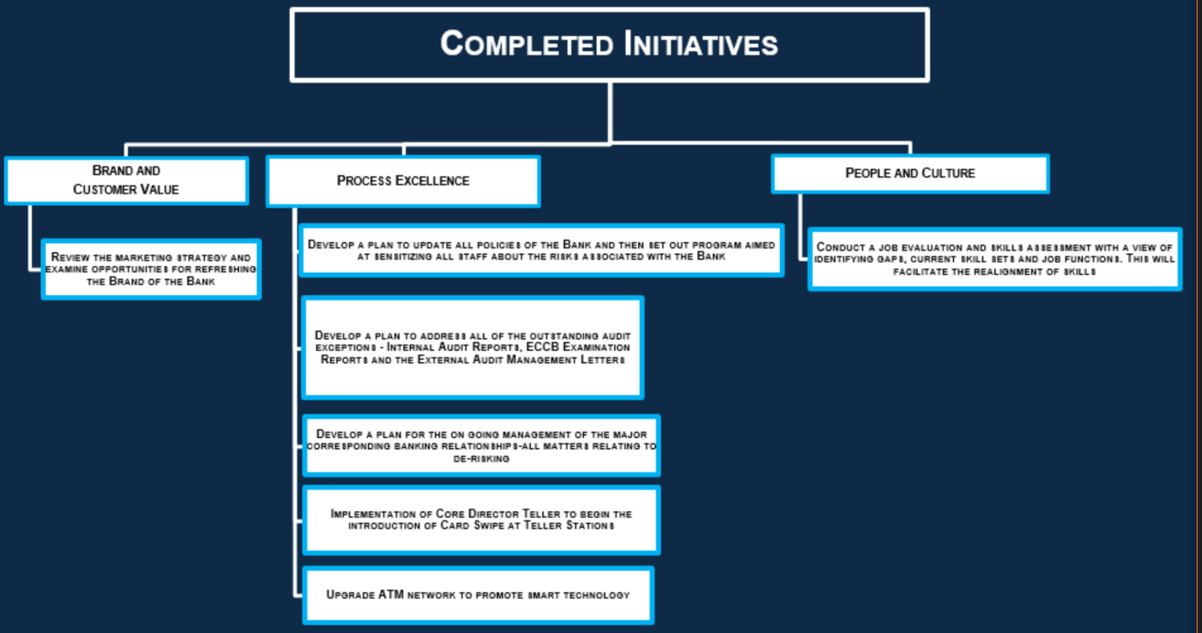

Recommendations

Despite the dominance of the COVID-19 Pandemic, the BOSVG continued to create value for all of its stakeholders in 2020. The Bank was challenged to respond effectively to the many challenges posed by the Pandemic and to put its slogan "doing more together" into action. This was accomplished by keeping our clients at the center of our strategy and activities. The immediate reaction of BOSVG management and staff to the difficult circumstances was nothing short of exceptional. BOSVG continued to provide excellent service while keeping our employees' and customers' health and safety in mind. The Bank initiated a loan moratorium program for borrowers affected by the Pandemic, which was well utilized, with loans under the moratorium totaling $171.7 million at the end of 2020 (Anon., 2020). At the same time, Management and Board members needed to stay current on the growing threats posed by sophisticated cyber-attacks. Indeed, cybercrime has increased significantly in this new environment, focusing primarily on financial institutions but affecting all businesses in general.

Application of the going concern principle considering the impact of Covid- 19

The Board (and its subcommittees) evaluated the Bank budgets and cash flow forecasts in light of the Group's going concern assumption in light of the current and expected future economic impact of the COVID 19 pandemic. This included the impact of projected cash flows on the Group's liquidity risk, credit risk, interest rate risk, regulatory capital, and market risks, as well as other related risks; all of which remained within the risk parameters of the Group's risk appetite framework. The assessment took into account the Bank's capital and liquidity to meet its operations and strategies during the pandemic and in the foreseeable future. This was accomplished by analyzing the impact of the macroeconomic outlook on the Bank's forecasted earnings growth and Balance Sheet management to determine the impact on the bank's financial outlook and operations. Several scenarios were finished and tested for sensitivity. The Group's (BOSVG, Property holding SVG Ltd.) assessment revealed that the Group has a bright future ahead of it. The going concern assumptions remain valid and applicable.

As a result, one of the bank's top priorities in 2020 and beyond is to keep the bank secure and compliant to maintain our customers' trust and confidence. Management and the Board's approach to this problem are to anticipate threats and keep them from becoming a reality. In collaboration with the Eastern Caribbean Central Bank (ECCB) and many indigenous banks from the ECCU, the Bank has launched an initiative to capitalize on opportunities for shared services in risk management and compliance. Meanwhile, the BOSVG is well on its way to completing its (ERMF). This framework enables the core components of risk identification and assessment completing a risk reporting template that captures the risks identified and assessed will make risk reporting easier. The outcome of the detailed design of the shared service framework with the ECCU banks and the ECCB will determine which elements of the framework are fully developed.

Potential new ways BOSVG moving forward in the future.
The government of St. Vincent and the Grenadines, as well as the Eastern Caribbean Central Bank, is the bank's regulators. The Bank has taken and continues to take significant steps to provide economic assistance to Individual households and businesses, market stability, and economic growth are all supported. The efficiency duration and scale of COVID-19 will determine the duration and scope of these programs. Funding approach: Sources of liquidity are regularly reviewed to maintain a wide diversification by currency, geography, provider, product, and term.
Figure 15 (Anon., 2020)
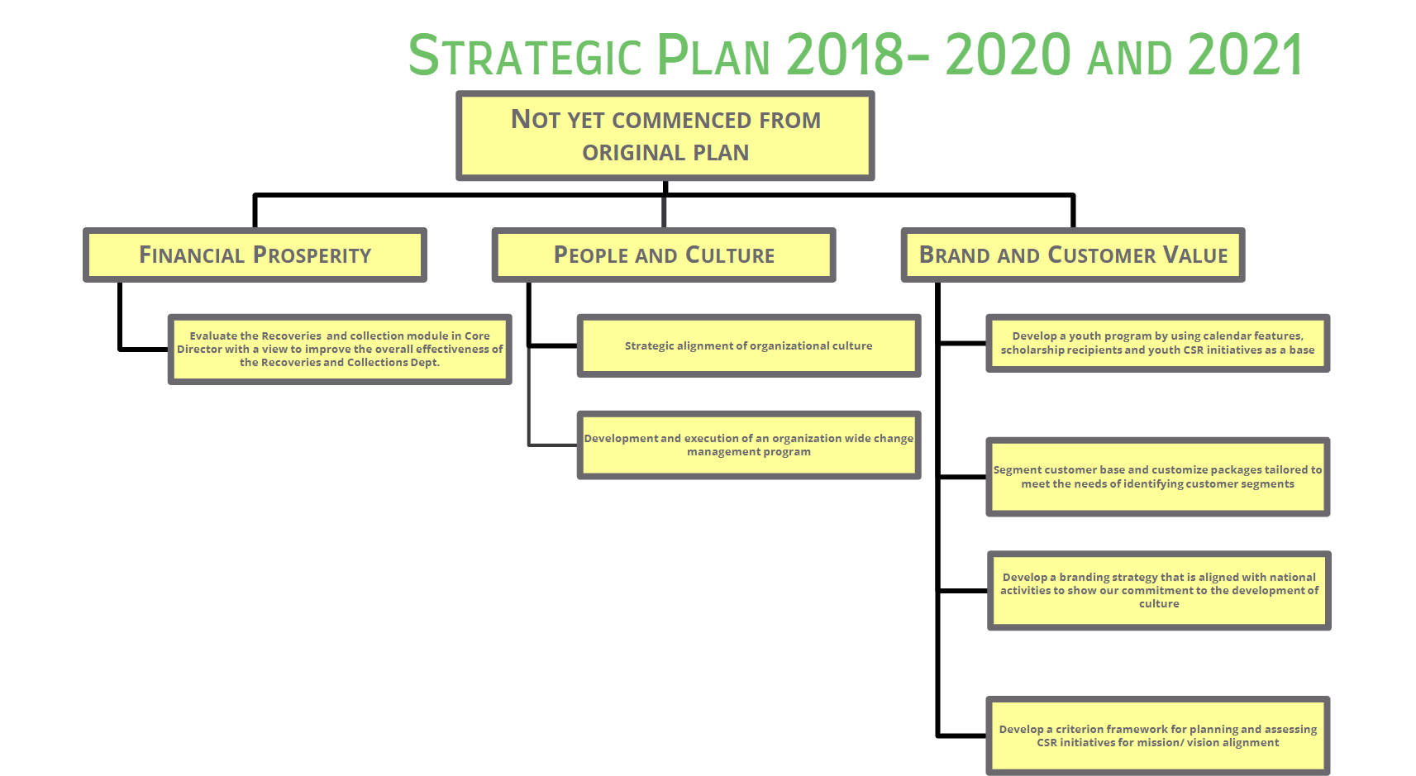

Figure 16 (Anon., 2020)
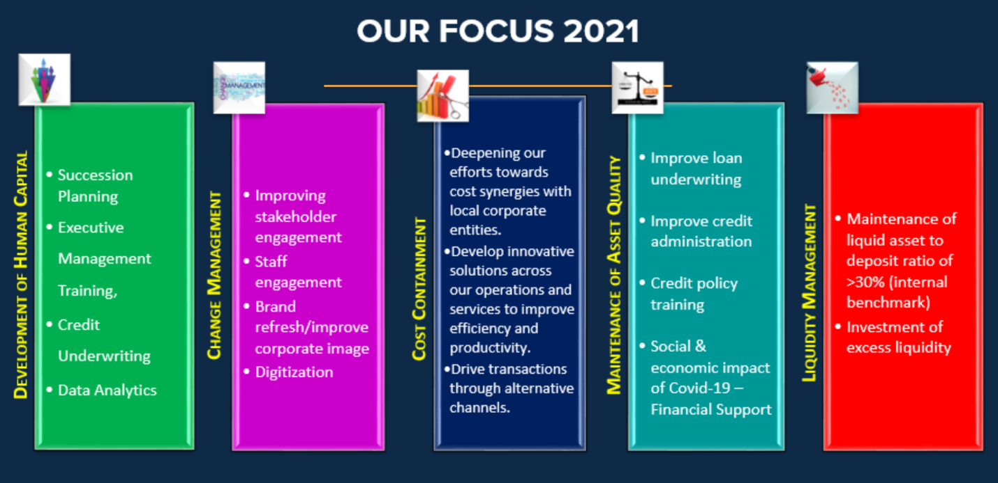
Figure 17 (Anon., 2020)
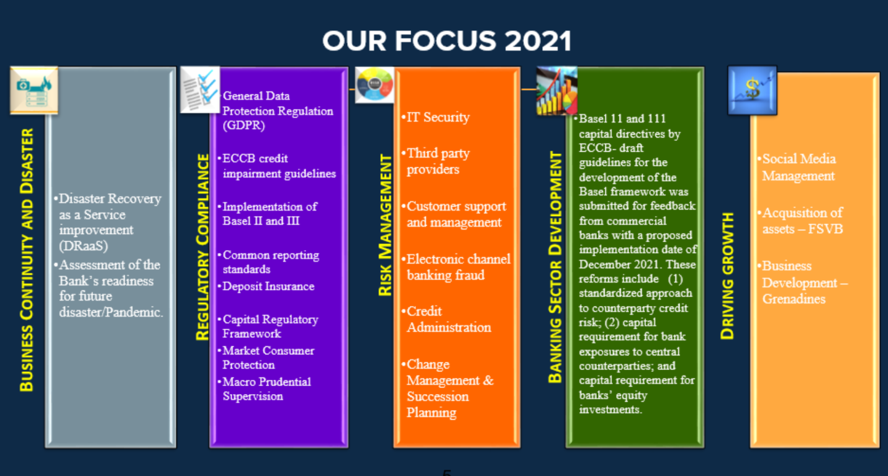

Figure 18 (Anon., 2020)
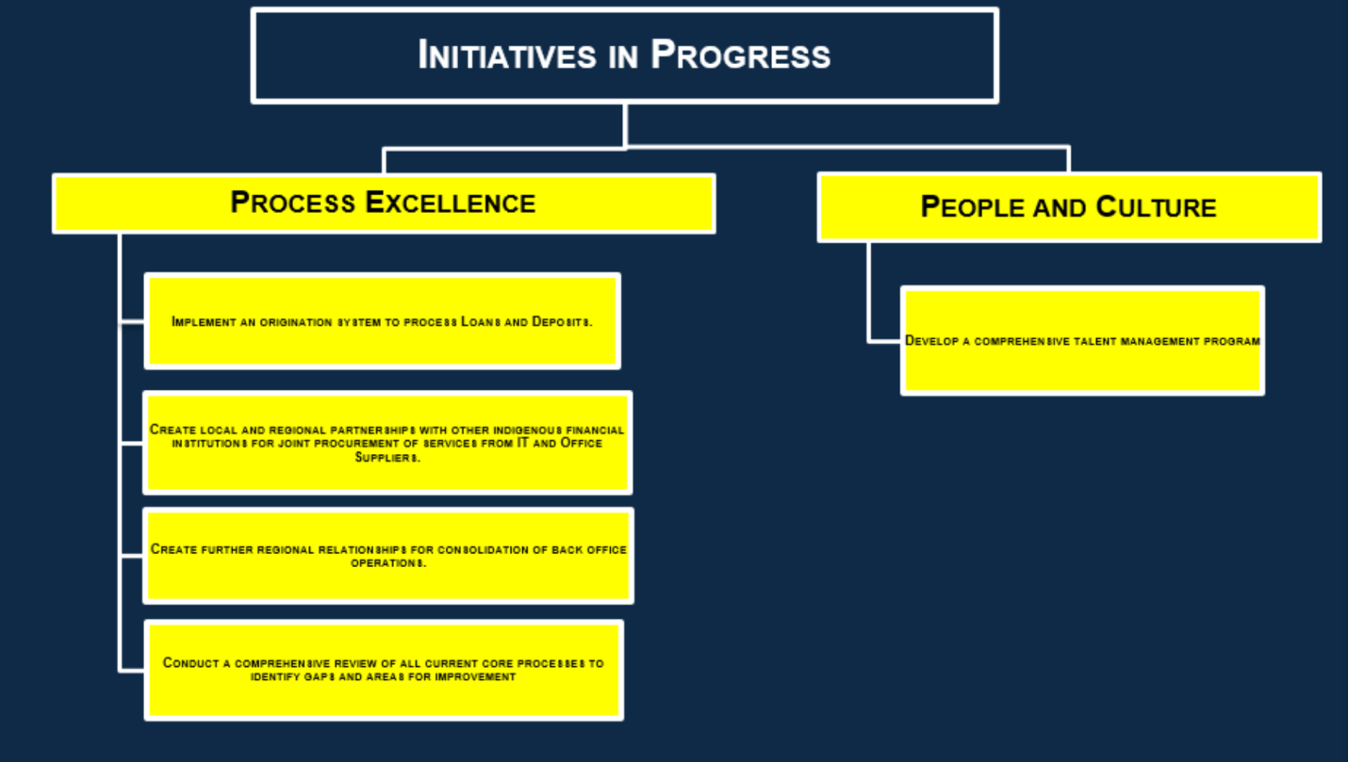
Figure 19 (Anon., 2020)
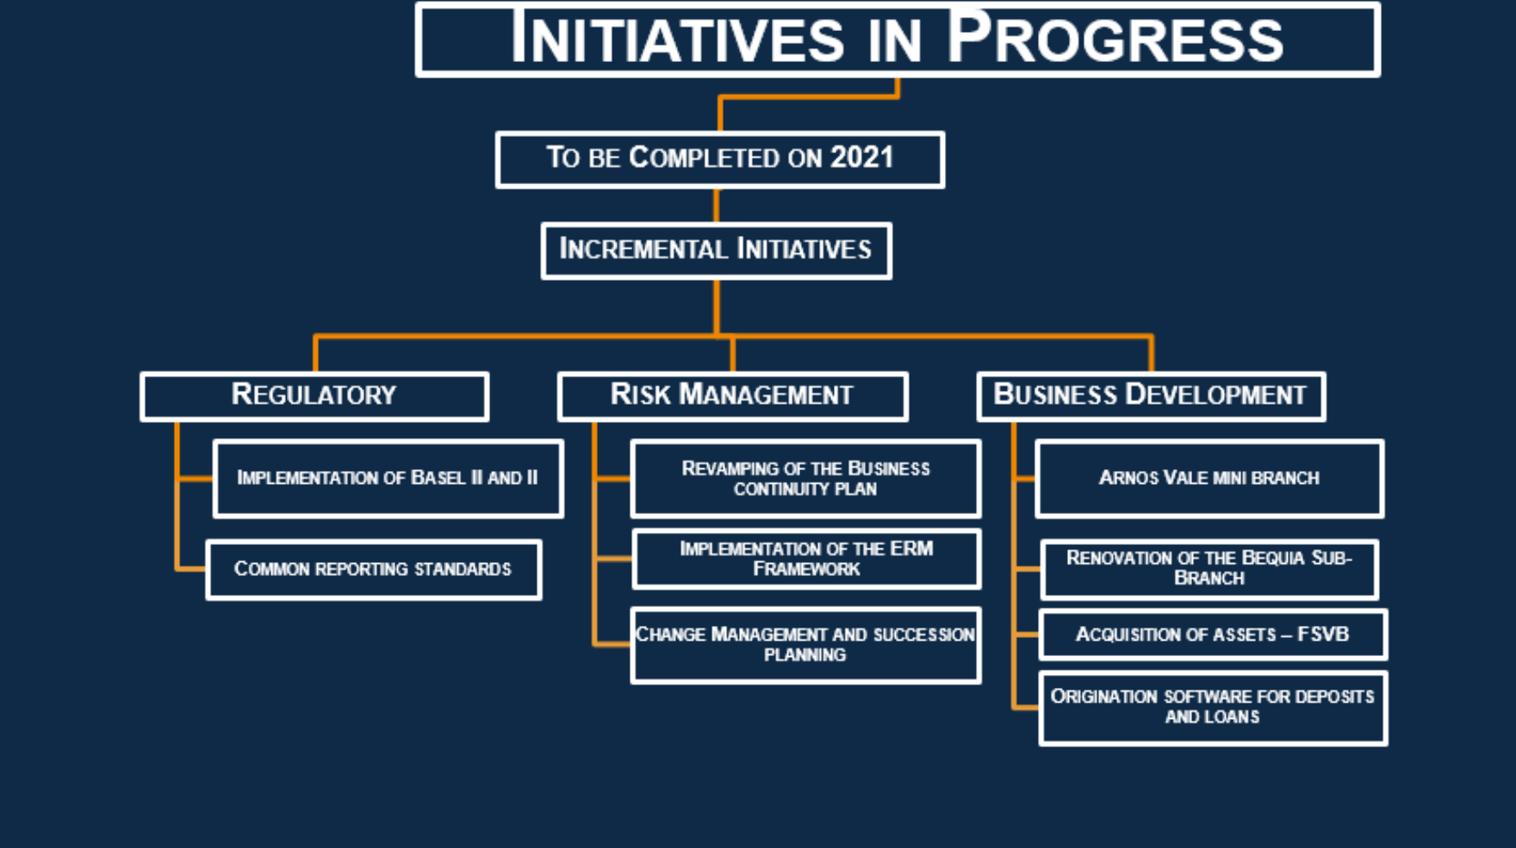
Figure 20 (Anon., 2020)
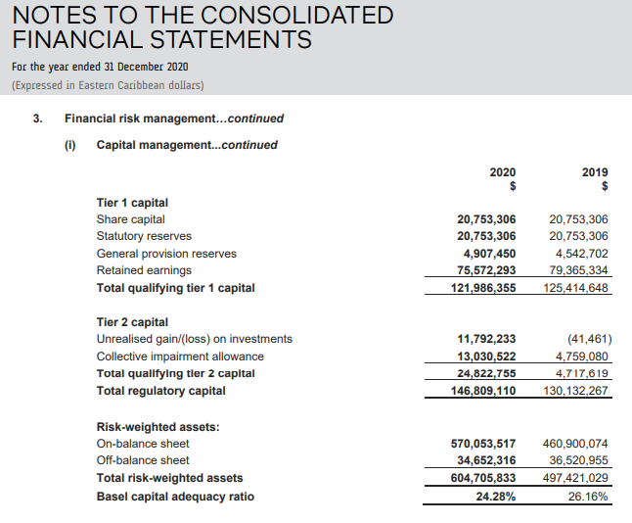

Critical accounting estimates, and judgments in applying accounting policies
- Measurement of the expected credit loss allowance; The Bank criteria for assessing if there has been a significant increase in credit risk; and x Development of expected credit loss models, including the choice of inputs relating to macroeconomic variables.
- Impairment losses on loans and advances to customers
- Deferred taxes

- Revaluation of investment property

- Corporate income taxes

Bibliography
- Abel, S., n.d. Role of Banks in Strengthening International Trade. [Online]
- Available at: http://www.baz.org.zw/consumer-centre/banking-basics/role-banks-strengthening-international-trade
- [Accessed 05 December 2021].
- Anon., 2018. What Went Wrong: The Demise of Toys R Us. [Online]
- Available at: https://knowledge.wharton.upenn.edu/article/the-demise-of-toys-r-us/
- [Accessed 12 October 2021].
- Anon., 2020. Bank of St Vincent and the Grenadine Annual Report. [Online]
- Available at: https://www.ecfh.com/webimages/file/BOSVG/BOSVG-AR-2020.pdf
- [Accessed 12 December 2021].
- Anon., n.d. PESTLE ANALYSIS. [Online]
- Available at: https://pestleanalysis.com/what-is-pestle-analysis/
- [Accessed December 12 2021].
- Beck, Thorsten, 2002, “Financial Development and International Trade. Is there a Link?” Journal of International Economics.
Charbaji, R. (July 2005). What new challenges are facing the local banks in Lebanon? The International Arab
Journal of Information Technology, 2(3): 228-233
Charbaji, R. (July 2005). What new challenges are facing the local banks in Lebanon? The International Arab
Journal of Information Technology, 2(3): 228-233
- Charbaji, R. (July 2005). What new challenges are facing the local banks in Lebanon? The International Arab Journal of Information Technology, 2(3): 228-233

- Demirguc-Kunt, Asli, Luc Laeven, and Ross Levine, 2004, “Regulations, market structure, institutions, and the cost of financial intermediation,” Journal of Money, Credit, and Banking.

- FERNANDO, J., 2021. Law of Supply Nad Demand. [Online]
- Available at: https://www.investopedia.com/terms/l/law-of-supply-demand.asp
- [Accessed 20 December 2021].
- FRUE, K., 2019. SWOT Analysis of the Banking Industry. [Online]
- Available at: https://pestleanalysis.com/swot-analysis-of-the-banking-industry/
- [Accessed 06 December 2021].
- Hall, M (2021). Is Demand or Supply More Important to the Economy? Available at: https://www.investopedia.com/ask/answers/040815/demand-or-supply-more-important-economy.asp#:~:text=Supply%20and%20demand%20are%20both%20keys%20to%20understanding,future%3B%20this%20point%20is%20called%20the%20equilibrium%20price. (Accessed: 2nd January 2022).
- Kim, M., n.d. Optimizing the retail bank supply chain. [Online]
- Available at: https://www2.deloitte.com/content/dam/Deloitte/ca/Documents/insights-issues-optimizing-the-retail-bank-supply-chain.
- Lynch, W., 2020. Strategic Planning to Actionable Items: From SWOT to TOWS Analysis. [Online]
- Available at: https://warren2lynch.medium.com/from-swot-to-tows-analysis-55ac394064b7
- [Accessed 13 December2021].
- Myers, P., 2020. Is It Time to Reconstruct Porter’s Five Forces?. [Online]
- Available at: https://medium.com/swlh/is-it-time-to-reconstruct-porters-five-forces-f4c0cb7b47a[Accessed 17 October 2021].
- RUE, K., 2019. SWOT Analysis of the Banking Industry. [Online]
- Available at: https://pestleanalysis.com/swot-analysis-of-the-banking-industry/
- [Accessed 06 December 2021].

- Saadeh, L., & Mikhael, M. (2016). Hurdles of Digital Banking in Lebanon [report]. Research Department, BLOMINVEST Bank, May 7, 2016. Retrieved from http://www.databank.com.lb/docs/Hurdles%20of%20Digital%20Banking-Blominvest-2016.pdf
- Scott, G., 2020. Porter's 5 Forces. [Online]
- Available at: https://www.investopedia.com/terms/p/porter.asp
- [Accessed 17 October 2021].
- Smithson, N., 2019. Walmart SWOT Analysis & Recommendations. [Online]
- Available at: http://panmore.com/walmart-swot-analysis-recommendations-case-study
- [Accessed 14 February 2021].

BOSVG
Meaning BOSVG
Point link with Threat 4 opportunity 3
Point link with threat 2
Point link with threat 2
Interest Rate Benchmark Reform - Phase 2 Amendments to IFRS 9, IAS 39, IFRS 7, IFRS 4, and IFRS 16
Point link with threat 5
Point linked with opportunity3
Point linked with opportunity3
Point linked with threat 5
Point link with Opportunity 3
Bank of St. Vincent and the Grenadines
Point link with opportunity 3
All three bullets link with opportunity 3
Point link with threat 6
Point linked with opportunity 3
BOSVG
Strategy linked with Opportunity 4 & 5
Strategy linked with Threat 8
Strategy linked with Opportunity 4 & Threat 4
Strategy linked with Threat 8 & 9
Points linked with Threat 5 and Opportunity 3
Points linked with Opportunity 3
Point linked with Opportunity 3
Point linked with Threat 7 & 9
Point linked with opportunity 3
International Financial Regulatory Service
Eastern Caribbean Currency Union
Enterprise Risk Management Framework
Eastern Caribbean Currency Union

