

Data Handling and Business Intelligence (LCBB5000)

Assessment 2
Coursework: Report

Submission Date:
Name of the Lecture: Dr Anupam Mazumdar
Student ID: 2236845
Student name: Slavi Sinapov
Table of Contents
Part 1
Introduction 3
Data processing 3
Analysis of Monthly Sales Trends 4-5
Analysis of Best-Selling Products 5-7
Top 20 profitable segment customers 7-9
Customer Purchase in Each Transaction 10-12
Recommendations 12-13
Conclusion 14

Part 2
Data Analysis Report: Student Survey Findings 14
Student Gender Distribution 14-15
Descriptive Statistics 15-17
Mean and Median Scores by Lunch Qualification 17-20
Clustering Analysis 20-21
Comparing SPSS and Excel 21
Conclusion 21
References 22

PART 1:

Introduction
The advent of technology and the internet has catalysed the proliferation of e-commerce, fundamentally altering consumer shopping habits and business operations. This digital marketplace has presented unprecedented opportunities for enterprises to expand their market reach and optimize distribution channels.
This study endeavours to analyse a year's worth of sales data from a UK-based online retailer specializing in gifts and homewares to identify key trends, consumer behaviours, and strategic implications for profit enhancement.
According to Azevedo and Santos (2015) data mining (DM) has emerged as a pivotal discipline in the contemporary business landscape, enabling organizations to unlock the hidden value within their vast datasets. By employing sophisticated algorithms and statistical techniques, DM facilitates the discovery of patterns, trends, and correlations that would otherwise remain obscured. As a critical component of business intelligence (BI), DM empowers organizations to make data-driven decisions, optimize operations, and identify new opportunities.
This dataset is a compilation of transaction data procured from a UK online retailer focused on the gift and home product market. It presents a detailed record of every sale made on the platform. The data is structured into eight columns, each providing specific transaction information: transaction identifier, date of occurrence, product identification number, product name, monetary value, item quantity, customer account number, and associated country. The dataset's magnitude is substantial, with 65,536 individual transactions documented.
Data Preprocessing
To ensure data accuracy and reliability, preliminary preprocessing was undertaken. Inconsistencies in transaction numbers and date formats were rectified. A new revenue column was created by combining price and quantity data to facilitate comprehensive sales analysis. Additionally, errors in product and country names were corrected, and duplicate records were eliminated to mitigate potential biases in subsequent analysis.
The provided sales transaction dataset offers a granular perspective of the business's performance over the specified period. Through rigorous analysis, discernible trends and patterns can be identified to inform strategic decision-making.

1.Analysis of Monthly Sales Trends
Examination of monthly sales data reveals pronounced seasonal fluctuations, indicative of distinct peak and trough periods. November emerged as the most lucrative month, generating substantial revenue, while April registered the lowest sales figures. These disparities suggest significant variations in consumer demand throughout the year, potentially attributable to factors such as holiday seasons and product launches (McFedries, 2022).
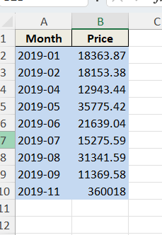
Procedure:
Data Acquisition: The core dataset Sales Transaction was extracted.
Data Preparation: The date format was standardized, and a new column indicating the month was added.
Data Summarization: Sales were aggregated by month, and monthly revenue totals were computed.
Outcome: A new worksheet, "Monthly Sales Trend," was created to display the summarized monthly sales data.

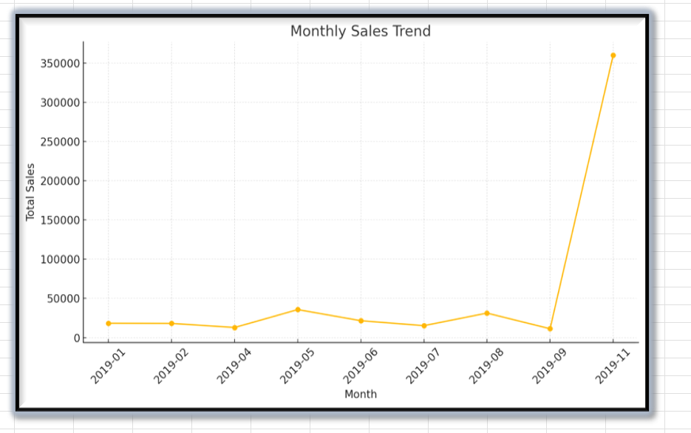
Data Range: The data covers 10 months from January 2019 to November 2019.
Sales Fluctuation: There are significant variations in sales figures across the months.
Highest Sales: November 2019 recorded the highest sales with a value of £360,018.
Lowest Sales: April 2019 had the lowest sales at £12,943.44.
Missing Data: Sales figures for March, October, and December 2019 are absent.
The provided data indicates a substantial fluctuation in sales throughout the observed period. While November 2019 witnessed a peak in sales, April 2019 experienced the lowest figures. The absence of data for certain months limits a comprehensive analysis of the overall sales trend (McFedries, 2022).
Analysis of Best-Selling Products
Procedure
Data Categorization: Products were categorized based on their names.
Quantity Calculation: Total quantities sold for each product were calculated and ranked.
Outcome: A new worksheet named "Top Products" was created to display the products with the highest sales volumes.
To determine the most frequently purchased products, a quantitative analysis of sales data was conducted. Utilizing Excel's data aggregation capabilities, specifically the COUNTIF function or pivot tables, product sales were tabulated and categorized. This process facilitated the identification of products with the highest sales volumes, providing insights into consumer preferences (Walkenbach,2007).

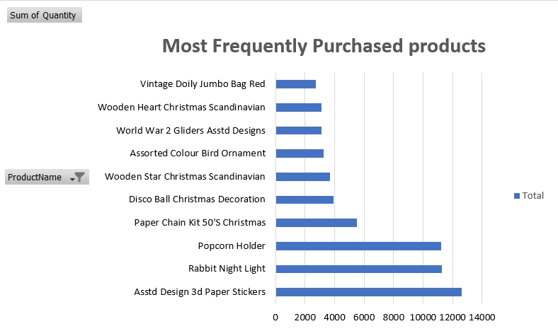

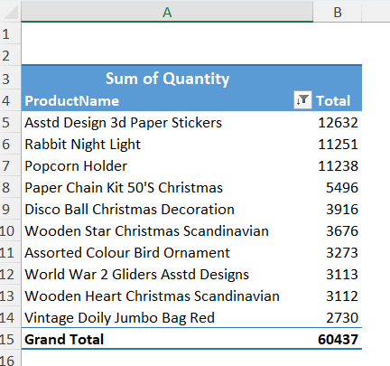
Data Range: The data appears to cover a specific period, but exact dates are not provided.
Product Popularity: The table ranks products based on their total quantity sold.
Top Seller: "Asstd Design 3d Paper Stickers" is the most popular product with a total quantity of 12,632 units sold.
Least Popular: "Vintage Doily Jumbo Bag Red" appears to be the least popular among the listed products with 2730 units sold.
Total Quantity Sold: The grand total of all products sold is 60,437 units.
Methodology Product-level sales data were aggregated by summing the quantity sold for each unique product. The resulting data was then ranked in descending order to establish a hierarchy of product popularity. A dedicated worksheet, titled "Top Products," was created to present the ranked list of products based on their total sales volume. This analysis not only reveals the best-selling items but also informs potential product assortment strategies and inventory management decisions.

Top 5 of most frequently bought products in February 2019:
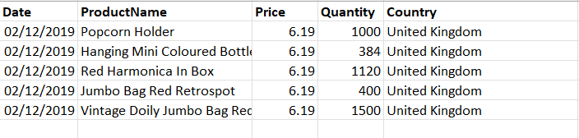
This range of products has been sold two days before Valentine’s Day in United Kingdom.
Top 20 profitable segment customers.
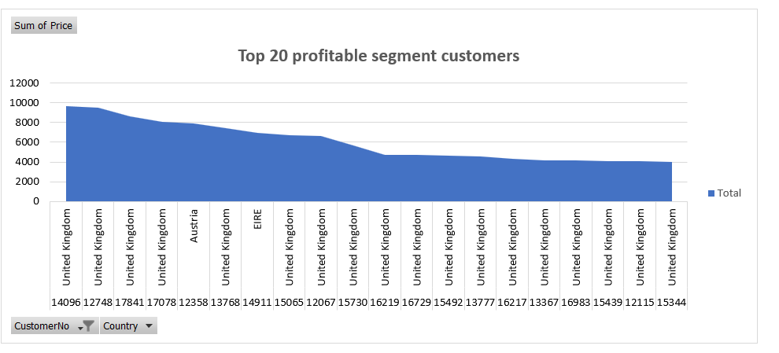

Sum of Price
CustomerNo | Country | Total
14096 | United Kingdom | 9658.86
14096 Total |  | 9658.86
12748 | United Kingdom | 9530.49
12748 Total |  | 9530.49
17841 | United Kingdom | 8634.94
17841 Total |  | 8634.94
17078 | United Kingdom | 8034.88
17078 Total |  | 8034.88
12358 | Austria | 7937.83
12358 Total |  | 7937.83
13768 | United Kingdom | 7452.63
13768 Total |  | 7452.63
14911 | EIRE | 6955.79
14911 Total |  | 6955.79
15065 | United Kingdom | 6722.69
15065 Total |  | 6722.69
12067 | United Kingdom | 6660.61
12067 Total |  | 6660.61
15730 | United Kingdom | 5649.52
15730 Total |  | 5649.52
16219 | United Kingdom | 4738.26
16219 Total |  | 4738.26
16729 | United Kingdom | 4701.25
16729 Total |  | 4701.25
15492 | United Kingdom | 4645.45
15492 Total |  | 4645.45
13777 | United Kingdom | 4591.8
13777 Total |  | 4591.8
16217 | United Kingdom | 4296.4
16217 Total |  | 4296.4
13367 | United Kingdom | 4148.8
13367 Total |  | 4148.8
16983 | United Kingdom | 4138.07
16983 Total |  | 4138.07
15439 | United Kingdom | 4061.35
15439 Total |  | 4061.35
12115 | United Kingdom | 4056.83
12115 Total |  | 4056.83
15344 | United Kingdom | 4011.98
15344 Total |  | 4011.98
Grand Total |  | 120628.43

3 Customer Purchase in Each Transaction
Transaction Variability: The graph displays significant variability in the number of products purchased per transaction. While most transactions appear to involve a relatively small number of items (less than 100), there are several notable spikes indicating much larger purchases.
Frequency of Small Purchases: Most transactions seem to involve a small number of items, as indicated by the numerous short bars across the graph. This suggests that most customers tend to make smaller, more frequent purchases rather than large, infrequent ones.
Outlier Transactions: There are several prominent spikes in the graph, with the highest reaching close to 700 items in a single transaction. These outliers could represent bulk purchases, possibly by business customers or during special promotions.
Inconsistent Purchase Patterns: The graph shows an irregular pattern of purchase sizes across different transactions, indicating that customer buying behaviour is not uniform and varies considerably from one transaction to another.
Potential for Customer Segmentation: The wide range of transaction sizes suggests an opportunity for customer segmentation. The business could potentially categorize customers based on their typical purchase volumes and tailor marketing strategies accordingly.
Need for Further Investigation: The extreme variability in purchase sizes warrants further investigation. It would be beneficial to understand the factors contributing to the very large transactions and whether they represent regular buying patterns for certain customers or are anomalies.
Customer Behaviour Insights: This data visualization provides insights into customer purchasing behaviour, which could be valuable for developing targeted marketing campaigns, adjusting product offerings, and optimizing the overall customer experience (McFedries, 2022).
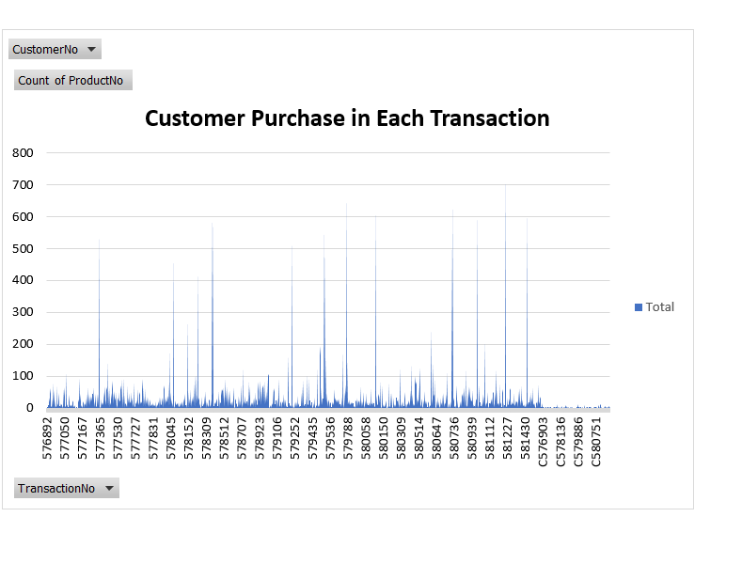
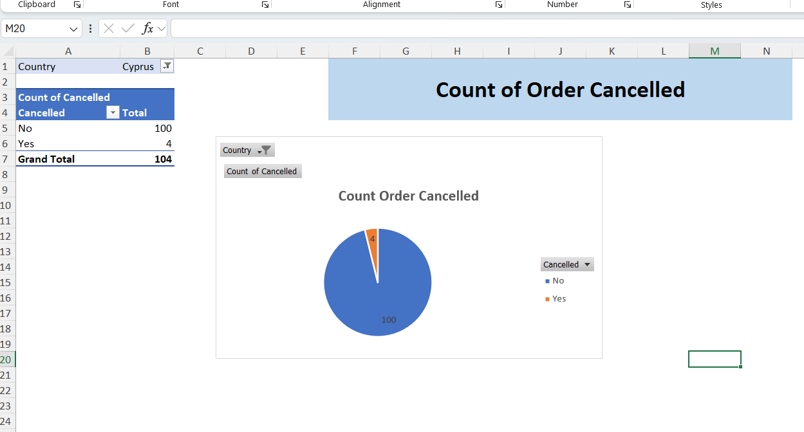

The 4% cancellation rate indicates a relatively low number of order cancellations, suggesting generally satisfied customers and efficient order fulfilment. Nonetheless, a more in-depth examination of these cancellations is crucial to identify potential improvement areas.
Paper crafts, particularly the Paper Craft Little Bride 80995, exhibit a higher return rate. This could be attributed to several factors. The product's intricate assembly process might pose challenges for customers, leading to dissatisfaction and returns. Additionally, quality control issues, such as defects or subpar materials, can result in product damage and subsequent returns. Furthermore, if the product is tied to specific events or holidays, a post-event return surge might occur (McFedries,2022).

Recommendations
Strategic Recommendations for E-commerce Business Optimization
In the rapidly evolving landscape of e-commerce, businesses must continually adapt their strategies to maintain competitive advantage and drive growth. Based on the analysis of current market trends and business performance, the following recommendations are proposed to enhance operational efficiency, customer satisfaction, and overall profitability.

1. Dynamic Pricing Strategy Implementation

The adoption of a dynamic pricing model can significantly impact revenue generation and market responsiveness. By leveraging artificial intelligence and machine learning algorithms, businesses can implement real-time price adjustments based on factors such as demand fluctuations, competitor pricing, and inventory levels. This approach not only optimizes profit margins but also enhances perceived value for price-sensitive customers during off-peak periods (Neubert,2022).
2. Personalization through Advanced Analytics
Utilizing big data analytics to create hyper-personalized customer experiences is crucial in today's competitive e-commerce environment. By implementing sophisticated recommendation engines that incorporate collaborative filtering and content-based algorithms, businesses can offer tailored product suggestions, thereby increasing cross-selling opportunities and average order value. Moreover, personalized email marketing campaigns based on individual customer behavior and preferences can significantly improve engagement rates and customer lifetime value (Wolniak and Grebski, 2023).

3. Supply Chain Optimization and Sustainability

Integrating sustainable practices into supply chain management not only addresses growing consumer concerns about environmental impact but also presents opportunities for cost reduction and brand differentiation. Implementing blockchain technology for supply chain transparency can enhance traceability and build consumer trust. Additionally, exploring eco-friendly packaging options and optimizing last-mile delivery through route optimization algorithms can reduce carbon footprint while improving operational efficiency.

4. Omnichannel Integration and Seamless Customer Experience

As the boundaries between online and offline retail continue to blur, developing a robust omnichannel strategy becomes imperative. Implementing a unified customer data platform that integrates information from various touchpoints can provide a 360-degree view of customer interactions, enabling more informed decision-making and personalized service delivery. Furthermore, technologies such as augmented reality (AR) for virtual try-ons and in-store digital kiosks can bridge the gap between digital and physical retail experiences, enhancing customer engagement and satisfaction (Wolniak and Grebski, 2023).

5. Artificial Intelligence for Customer Service Enhancement

Leveraging AI-powered chatbots and virtual assistants can significantly improve customer service efficiency while reducing operational costs. Natural Language Processing (NLP) technologies can be employed to handle routine inquiries, freeing up human agents to address more complex issues. Additionally, sentiment analysis of customer interactions can provide valuable insights for continuous service improvement and proactive problem resolution (Thomas,2024).
6. Expansion into New Market Segments through Localization
While focusing on core markets is essential, exploring new market segments through strategic localization efforts can drive growth and mitigate risks associated with market concentration.

Conclusion.
In conclusion, the implementation of these strategic recommendations requires a holistic approach that integrates technological innovation with customer-centric methodologies. By embracing data-driven decision-making processes and remaining agile in response to market dynamics, e-commerce businesses can position themselves for sustained growth and competitive advantage in an increasingly complex digital marketplace. Regular evaluation and refinement of these strategies, coupled with ongoing market research and customer feedback analysis, will be crucial for long-term success and adaptability in the face of emerging trends and consumer expectations (Mattox, et. al,2020).

PART 2:
Data Analysis Report: Student Survey Findings
This report delves into the results of a survey administered to 2133 students. The focus is on examining the connection between eligibility for free or reduced lunch and factors such as gender, pre-test, and post-test performance. The analysis utilizes SPSS, a statistical software, to uncover patterns and relationships within the data. This report will detail the findings generated through SPSS procedures, highlighting the shift from Microsoft Excel for data analysis.
Student Gender Distribution
Of the 2133 students surveyed, 1056 were male (approximately 49.5%) and 1077 were female (approximately 50.5%). While the sample is nearly evenly divided by gender, there is a slight preponderance of female students.
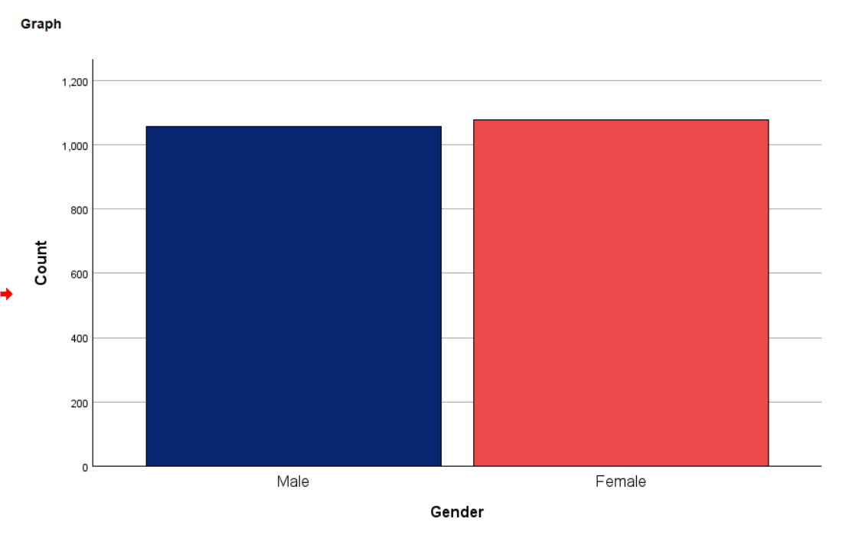
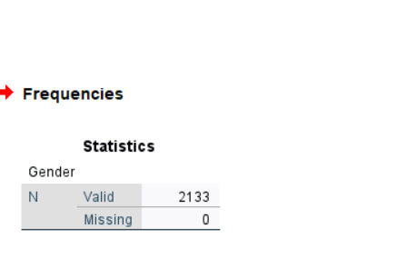
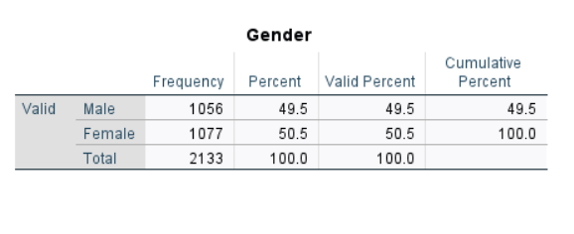

Descriptive Statistics
By comparing students test scores before and after the program, we can see how well it helped students who qualify for free or reduced lunch compared to those who don't.
Sample Size: The study includes a total of 2,133 students (N = 2133), with no missing data points, indicating a complete dataset for analysis.
Lunch Program Qualification:
  - 1,215 students (57.0%) do not qualify for free lunch
  - 918 students (43.0%) qualify for free lunch
Distribution: The data shows a binary distribution (Range = 1, Minimum = 0, Maximum = 1) for the lunch qualification variable, where likely 0 represents "Does not qualify for free lunch" and 1 represents "Qualify for free lunch".
Mode: The mode is 0, indicating that not qualifying for free lunch is the most common status among the students in this sample.
Representation: The sample has a slightly higher proportion of students who do not qualify for free lunch (57%) compared to those who do qualify (43%). This suggests a relatively balanced representation, though with a slight skew towards non-qualifying students.
Cumulative Percentage: The cumulative percentage reaches 100% with the inclusion of students who qualify for free lunch, confirming that these two categories encompass the entire sample.
Study Context: The descriptive text mentions comparing test scores before and after a program, suggesting this data is part of a larger study examining the impact of a program on student performance, with a focus on how it affects students based on their free lunch qualification status.
Potential for Further Analysis: While this output provides a clear breakdown of the lunch qualification status, it doesn't include the test score data mentioned in the description. Further analysis would be needed to understand how the program affected test scores for each group.
Socioeconomic Implications: The substantial proportion of students qualifying for free lunch (43%) suggests that a significant portion of the student population may come from lower-income backgrounds, which could have implications for educational support and resources needed.
This descriptive statistics output provides a solid foundation for understanding the composition of the sample in terms of free lunch qualification. It sets the stage for more in-depth analyses comparing the program's effects on test scores between these two groups of students (Lind, et. al,2015).
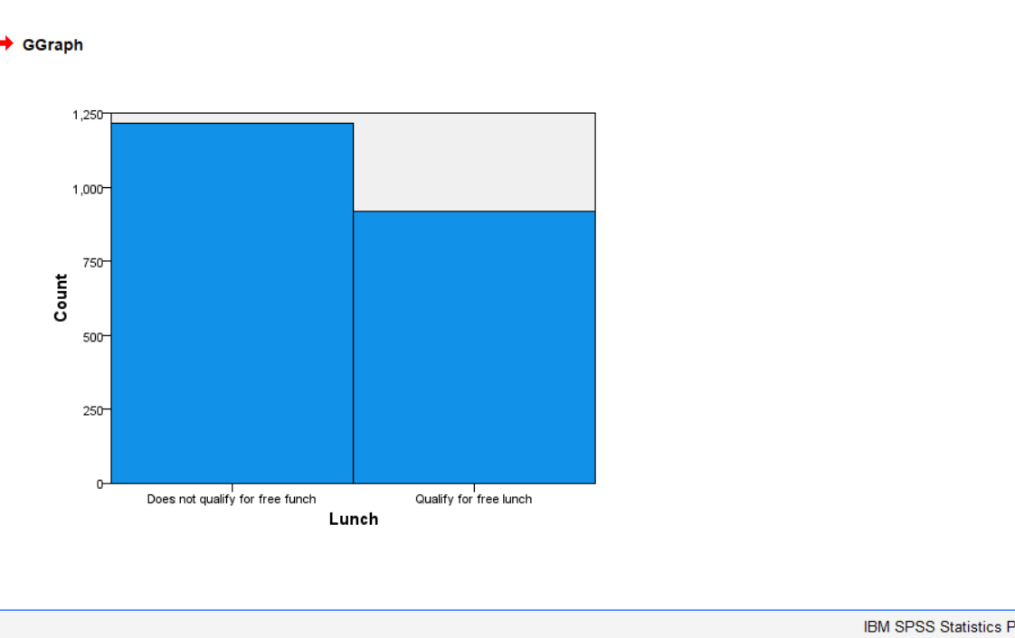
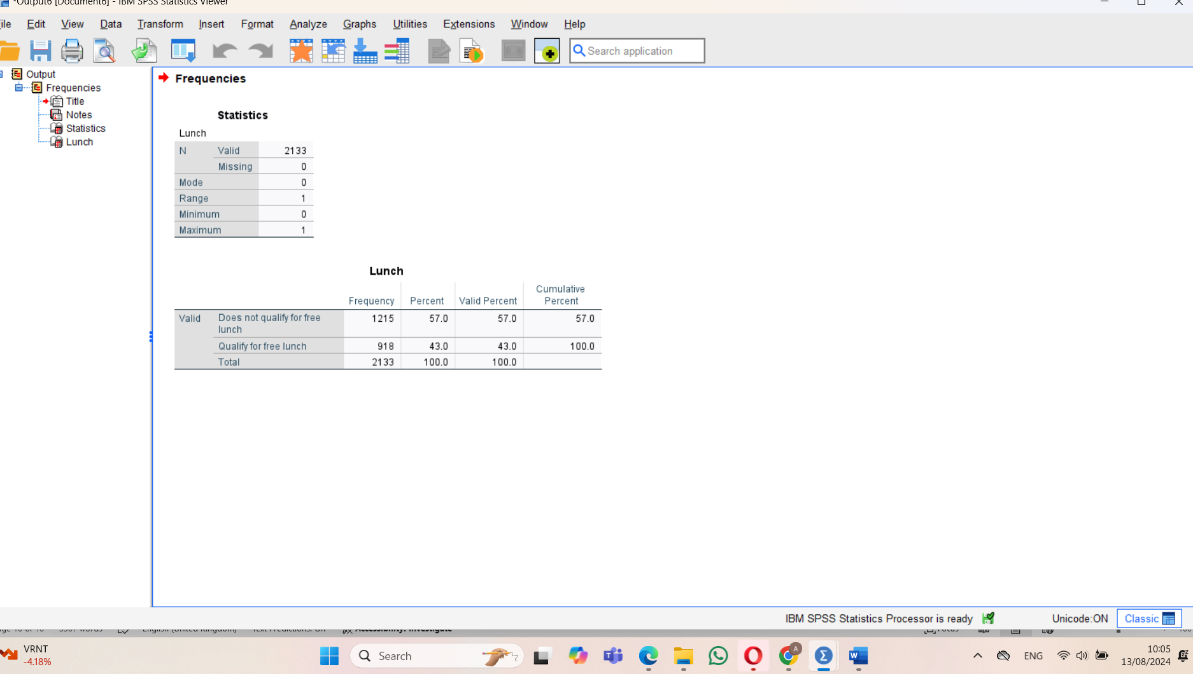
Mean and Median Scores by Lunch Qualification
Sample Size: The study includes 2,133 students, with no missing data for both pretest and post-test.
Mean and Median:
Mean: The arithmetic average of all scores. It's calculated by summing all values and dividing by the number of values.
Median: The middle value when all scores are arranged in order. It's less affected by extreme values than the mean.
Lunch Qualification Groups:
Does not qualify for free lunch:
Pretest: Mean = 62.29, Median = 62.00
Post-test: Mean = 74.38, Median = 74.00
Qualify for free lunch:
Pretest: Mean = 45.25, Median = 44.00
Post-test: Mean = 57.48, Median = 55.00
Overall Performance:
Pretest: Mean = 54.96, Median = 56.00
Post-test: Mean = 67.10, Median = 68.00
Performance Disparity: Students not qualifying for free lunch consistently outperformed those who do qualify, both in pretest and post-test scores.
Improvement:
Non-qualifying students improved from a mean of 62.29 to 74.38 (12.09-point increase)
Qualifying students improved from a mean of 45.25 to 57.48 (12.23-point increase)
Consistent Gap: The performance gap between the two groups remained relatively constant, with non-qualifying students maintaining about a 17-point lead in both pretest and post-test means.
Distribution:
For non-qualifying students, the mean and median are very close, suggesting a relatively symmetric distribution of scores.
For qualifying students, there's a slight difference between mean and median, particularly in the post-test (57.48 vs 55.00), indicating a possible slight positive skew.
Overall Improvement: Both groups showed substantial improvement from pretest to post-test, with the overall mean increasing from 54.96 to 67.10.
Effectiveness of Intervention: The program appears to have been effective for both groups, as both showed similar magnitudes of improvement. However, it did not close the performance gap between students who qualify for free lunch and those who don't.
This analysis reveals that while the educational program improved scores for all students, it did not address the underlying disparity between students from different socioeconomic backgrounds (as indicated by lunch qualification status). This suggests that while the program was generally effective, additional targeted support might be necessary to address the persistent achievement gap (Hinton and Perry,2004).
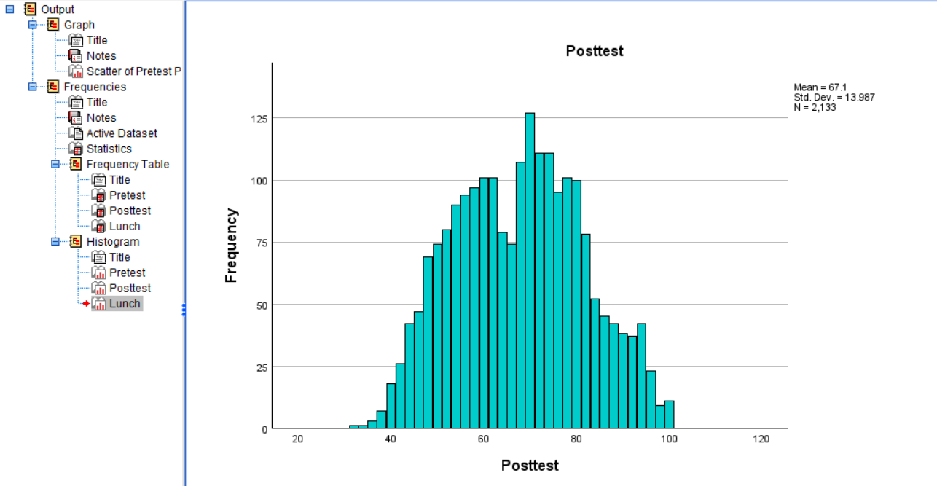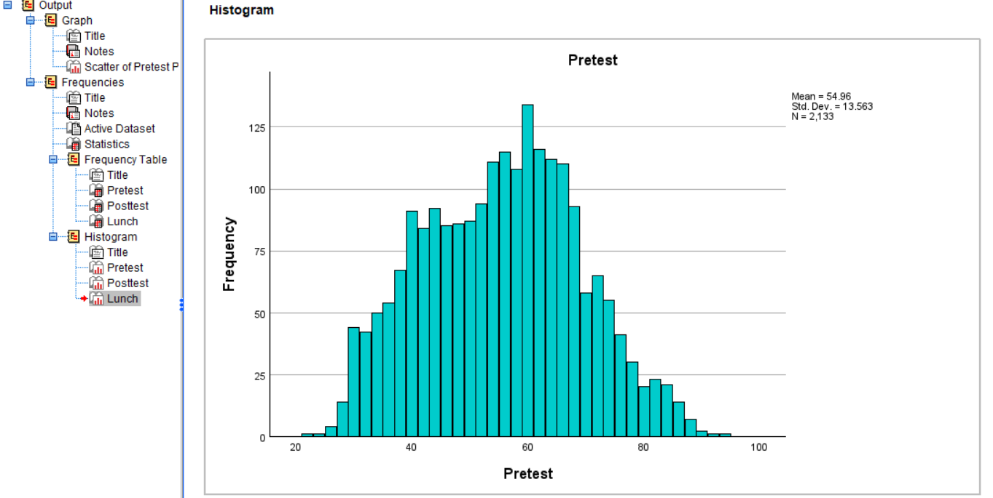
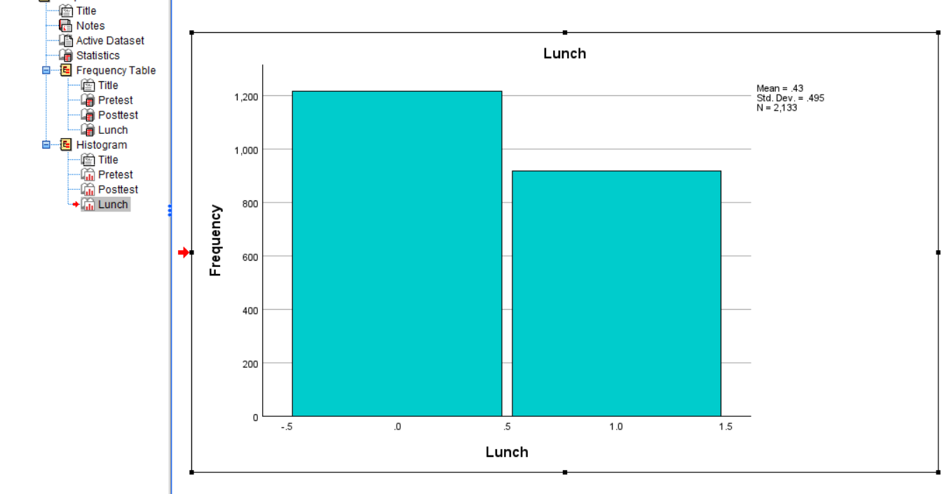
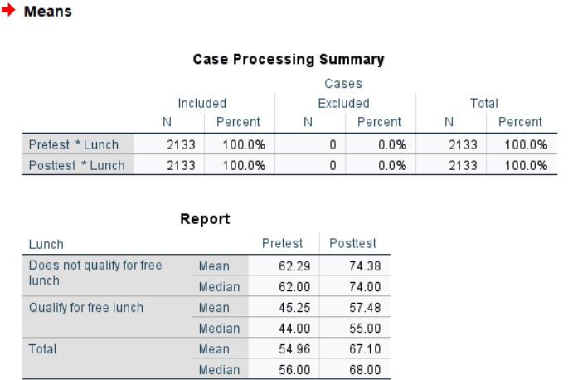

Clustering Analysis
Cluster analysis is a method for automatically grouping similar data points together. It's like sorting objects into boxes based on their likeness. Unlike other methods, there's no predefined answer to what the groups should look like. The technique can suggest possible groupings, but the final decision on how many groups and what they contain is up to the user. The quality of the groupings depends on how well they fit the data (Thrun,2018).
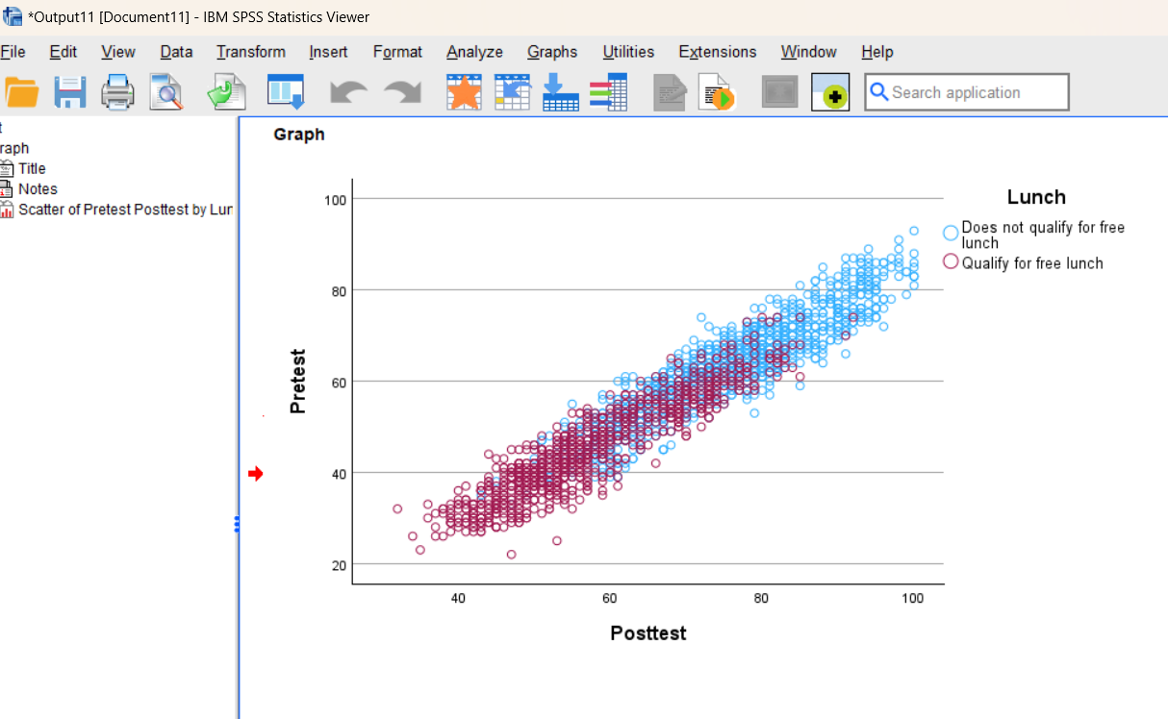
The clustering analysis using a scatter plot from IBM SPSS Statistics Viewer. The plot shows the relationship between Pretest scores (y-axis) and Posttest scores (x-axis) for students, with points color-coded based on lunch eligibility (blue for "Does not qualify for free lunch" and red for "Qualify for free lunch").
In this case, we can observe two main clusters forming based on lunch eligibility, with some overlap. The plot reveals a positive correlation between pretest and posttest scores, as points generally trend upward from left to right.
This visualization helps identify patterns and groupings within the data, allowing researchers to analyse the relationship between test performance and lunch eligibility status (Thrun,2018).

Comparing SPSS and Excel:
Excel and SPSS are two widely used software applications in data analysis and management. While both offer functionalities for data manipulation and analysis, they possess distinct strengths and weaknesses.
Excel, a spreadsheet software, is user-friendly and accessible, making it a popular choice for small to medium-sized datasets and basic statistical analyses. Its visual interface allows for easy data entry, manipulation, and creation of charts and graphs. However, Excel’s capabilities for complex statistical analyses and large datasets are limited. Additionally, the potential for human error is increased due to manual calculations and formula-based operations (Lind, Marchal, & Wathen, 2015).
SPSS, a statistical software package, is specifically designed for data analysis and modelling. It offers a robust set of statistical functions, including advanced regression, factor analysis, and hypothesis testing. SPSS is particularly well-suited for handling large datasets and complex statistical models. Nevertheless, SPSS may have a steeper learning curve compared to Excel, and its interface might be less intuitive for users without a strong statistical background (Coakes and Steed, 2017).

Conclusion
In conclusion, the choice between Excel and SPSS depends on the specific needs of the analysis. For simple data management and basic statistical calculations, Excel may suffice. However, for complex statistical modelling and large datasets, SPSS is the preferred option. It is essential to consider the nature of the data, the complexity of the analysis, and the user's statistical expertise when selecting the appropriate software.

References:
Azevedo, A. & Santos, M. F. (2015). Integration of Data Mining in Business Intelligence Systems. IGI Global. Available at: https://doi-org.ezproxy.uwtsd.ac.uk/10.4018/978-1-4666-6477-7 [Accessed on: 14/08/2024].
Coakes, S. J. and Steed, L. (2017). SPSS: Analysis Without Anguish: Version 25.0 for Windows. Milton, Australia: John Wiley & Sons.
Hinton, P. R. Perry R. (2004). SPSS explained. Routledge.
Lind, D. A., Marchal, W. G., & Wathen, S. A. (2015). Statistical methods for business and economics. McGraw-Hill Education. Available at: https://shamsfoe.wordpress.com/wp-content/uploads/2019/09/statistical-techniques-in-business-and-economics-lind-douglas-srg.pdf [Accessed on: 14/08/2024].
Mattox, J. R., Hall, C., & Parskey, P. (2020). Learning analytics: using talent data to improve business outcomes (Second edition.). Kogan Page.
McFedries, P. (2022). Teach yourself visually Excel 365. Visual.
Neubert, M. (2022) A Systematic Literature Review of Dynamic Pricing Strategies.International Business Research, 15(4), p. 1. Available at: https://www.researchgate.net/publication/359158596_A_Systematic_Literature_Review_of_Dynamic_Pricing_Strategies/citations [Accessed on: 15/08/2024].
Thomas, I. (2024). Impact of AI in Customer Service. Available at: https://www.sprinklr.com/blog/ai-in-customer-service/#:~:text=AI%20(Artificial%20Intelligence)%20in%20customer,Sentiment%20analysis [Accessed on: 16/08/2024].
Thrun, M. C. (2018). Projection-Based Clustering through Self-Organization and Swarm Intelligence: Combining Cluster Analysis with the Visualization of High-Dimensional Data (1st ed. 2018.). Springer Nature.
Walkenbach, J. (2007). Excel 2007 bible (1st edition). Wiley.
Wolniak, R. and Grebski, W. (2023) ‘The application of Business Analytics in personalized customer experience’, Scientific Papers of Silesian University of Technology. Organization and Management Series, 2023(182), pp. 613–629. Available at: https://www.researchgate.net/publication/376405255_THE_APPLICATION_OF_BUSINESS_ANALYTICS_IN_PERSONALIZED_CUSTOMER_EXPERIENCE [Accessed on: 15/08/2024].

