Assignment Title:
BRAND DEVELOPMENT PORTFOLIO: FLIXUNIBUS BY FLIXBUS

Student Name: | Keshu Jivabhai Karavadra | Student ID No.: | 2439531
Programme: | Master of Business Administration – International Business
Assignment Title: | Assessment Component 2: Marketing Portfolio
Module: | Marketing Management | Module Code: | LCMB7024
Lecturer: | Dian Mayasari (Birmingham) | Submission Date: | 19/11/2025

Table of Contents
Introduction 3
Element 1: STDP Analysis 3
1.1 Segmentation 3
1.2 Targeting 4
1.3 Differentiation 4
Element 2: Marketing Mix (7Ps) – FlixUniBus 5
Element 3: Marketing Strategy Pitch & Poster 8
Element 4: Reflection 9
References 11

Introduction
FlixBus is a leading European intercity travel provider known for its affordable, sustainable, and technology-driven transportation network. Established to revolutionise long-distance travel, the company operates an extensive fleet of eco-efficient buses across Europe, North America, and beyond. Building on its success, FlixBus is launching a new sub-brand, FlixUniBus, specifically designed for university students who require reliable, low-cost, and environmentally conscious intercity travel between campuses and major academic cities.
In this report, the brand strategy of FlixUniBus is discussed, including its positioning in the market and its future. It consists of four key parts: an STDP analysis to formulate the target market, a 7Ps marketing mix to implement the strategy, a marketing pitch and poster, and a retrospective of the overall process of brand development.

Element 1: STDP Analysis

1.1 Segmentation
FlixBus has established itself as a significant force in the delivery of low-cost intercity bus transport in Europe and other global regions. The company is focusing on the student market by establishing a new sub-brand, FlixUniBus. The four variables are the demographic, geographic, psychographic, and behavioural variables used in a segmentation strategy to identify relevant and profitable markets.
The primary segment is demographically defined by the population that consists of university students aged 18-30 who might be commuting along this route on a regular basis because of academic or social reasons or because of their personal experiences. Geographically, FlixUniBus is set to provide transit between the major university towns and cities, offering low-cost services connecting campuses and student accommodation neighbourhoods (Demir, Aslanov and Sivran, 2025). The behaviourally segmented segment is divided into two additional segments: regular travellers, who go to the destination on weekends, study trips and occasions, use economic modes of transportation, and do booking and communications using digital services.
The recent trends, such as environmental mobility (eco-mobility), remote education mobility patterns and the growing prominence of mobile tickets, are of far-reaching relevance to the FlixUniBus concept. These characteristics would be attractive to the current generation student way of life-giving students the benefit of a stress-free journey, low-cost factor, internet access, and eco-friendliness.

1.2 Targeting
FlixUniBus primarily targets students and young professionals as its primary consumers, as they tend to be compelled to commute to a different university or to a different city to learn, to have a work placement or to meet. It is a premium, technologically oriented group that values breadth and digital connection in transport. Students could be underprivileged and hence ready to seek cost-effective, safe, comfortable, and sustainable transportation methods (Versteijlen, van Wee and Wals, 2021). FlixUniBus delivers these requirements by offering discount rates, membership options, and convenient schedules that fit the university schedule.
The secondary level of the target market includes universities and learning institutions that are interested in obtaining high-quality transportation solutions concerning academic programs, student exchange programs, and field visits. One strategic alliance that sustains brand credibility and constant demand relates to university alliances.
The long-range target group also encompasses new graduates and young workers, all of whom remain in need of affordable, eco-friendly, and connected transport options. The good friend image and useful service item are sure to be loyal to customers in the web of academic to professional life.
To the market with this specific demographic, FlixUniBus shall meet the raging needs of low-cost intercity transport, which has to be ecologically conscious and sustainable. The brand does not solely meet practical transportation requirements but is also factoring in the independence, connectivity and ecological concerns of students.

1.3 Differentiation
FlixUniBus can be distinguished in the competitive intercity travel market with the student-centred, ecological and technological value proposition. It is a sub-brand intended to cater to the mobility needs of students as needed, rather than typical intercity services such as BlaBlaCar, National Express, or Megabus.
The first aspect of its distinction is the low-cost model supported by price bends, including term-time discounts, academic subscriptions, and loyalty credits. The application of eco-friendly electric and hybrid cars also defines the FlixUniBus and guarantees the sustainability goal and environmental sensitivity of younger users (Schulz et al., 2021). Buses are equipped with Wi-Fi, power outlets, and seat cushions, and are built to study or relax on the road.
Another high-impact differentiator is the digital integration of its platform. One provides student-only prices, online tickets and bus-tracking. When universities are involved, it is also easy to fly to campus terminals, and the last-mile problem is solved because the route is convenient.
FlixUniBus brand values include accessibility, sustainability, and digital convenience. Its modern application, accessibility technology and academic cooperation make it an identity beyond a means of transportation but a social platform that forms a sense of belonging and movement among students across campuses.
1.4 Positioning
FlixUniBus is promoted as “The Smart, Sustainable Ride for University Life.” Its brand vision is to be a favourite among the students who would like to travel cheaply and ethically across campuses and cities. Its value is based on: practical benefits and comfort versus emotional value, connection, freedom and social interaction.
The traditional competitors like National Express (expensive) and Megabus (small and uncomfortable) would also score low in affordability and comfort in the perceptual map relative to FlixUniBus. BlaBlaCar is cheaper, less reliable, and eco-friendly than FlixUniBus.
FlixUniBus is a student-centred, community-based transportation service founded on sustainability, innovation and inclusivity. Its green fleet and intelligent digital platform provide efficient, timely travel and indicate the increasing climate consciousness of students. Not simply a bus service, FlixUniBus represents a responsible, young way of life- making connections between education, travel, and the environment.

Element 2: Marketing Mix (7Ps) – FlixUniBus
7Ps Element | Detailed Strategy and Alignment with Brand Positioning
Product | FlixUniBus is a student-only and eco-friendly Wi-Fi bus service. The buses are customised with the go-from-life-to-work lifestyles in terms of ergonomic seats, charging stations, and quiet study spaces. To create a digital experience, a digital ticketing system will be created to allow the students to book, cancel and retain points through the FlixUniBus app. The product can be made with the pillars, which are valued by the target audience the most: comfort, convenience and sustainability. Electric buses or hybrid buses are closer to the goals of sustainability and form a more favourable connotation of environmental friendliness (Aydin, 2024). This product offering gives a breakdown of the positioning statement, The Smart, Sustainable Ride in University Life, that is serving quality, hard-to-find services on top of the highly identified with green living and modern student life.
Price | The price philosophy of FlixUniBus is based on price, equity, and flexibility. For special discount fare for students is 1/3 of the base fare price for each travel journey in FlixUniBus. Also introduced FlixPass for students, which helps these students travel for a month. The dynamic pricing model will change prices based on demand and distance covered, maintaining low and profitable fares. Student-only deals and loyalty memberships are also good ideas and help the brand in the heart of low prices. The second advantage of working with universities is that the organisations can offer subsidies or pre-selling tickets to schools and universities, which promises a flow of bulk money, a constant occupancy rate. Here is the customer-oriented pricing that puts FlixUniBus a step ahead of the other who have offered the same cost to everybody. Catering to cheaper structures and offers that are easier to follow, the brand can appeal to more cost-conscious students and not harm their socially responsible image (Widhiarini and Pradiani, 2023). This is the tension of quality and cost that is core of the brand promise of ensuring sustainable travel is affordable to all students.
Place | FlixUniBus has a high demand covering college and university routes across UK and Europe, with major cities, campuses, and residence areas being connected. It is a hub-and-spoke distribution, in that the hubs are the university bus stops, residential groupings, and other interests of the student. A place strategy is the core of digital access as it enables students to book, update and track their rides via the application or via kiosks available on campus. Integration to education transportation systems enables ticketing through institutional Portals or student Identities. In addition to the convenient digital access, the brand focuses on physical access via frequent schedules, stops as convenient, and cooperation with local transport. This distribution (both physical and online) enhances the user experience and positions FlixUniBus to be seen as a flexible and convenient mobile solution focused on being student-oriented.
Promotion | FlixUniBus is a digital, experiential and partnership marketing promotion plan that is youthful and exciting. The campaign will centre on the shared story of students who use FlixUniBus to access friends, family, and education. Partnerships with Instagram, TikTok, and YouTube influencers generate a sense of authenticity and engagement. At student hubs, high brand awareness is created by using campus pop-up booths, referral programs, and university partnerships (Aissaoui, Harakti and Lahouel, 2024). Moreover, environmental inclination of the brand can also be emphasised via corporate social responsibility (CSR) events, such as green travel days and carbon offset programs. Remark: Gamified tasks, like the rewarding journeys, via the app, also generate a closer interaction.
People | The people dimension of FlixUniBus is professionalism, compassion, and community affiliation. CSA, drivers and student ambassadors are critical towards providing services that are unified. Every employee is sensitised to safety practice, communication practice and sustainability, such that no passenger feels less secure. Student ambassadors on campus provide offers and feedback to improve the travelling experience (Santoro et al., 2025). Chatbots, support applications and helplines are available 24/7. This anthropocentric approach will transform FlixUniBus from not only a transport-rendering service but a community-enabler among students
Process | The working process at FlixUniBus will be simplified and transparent. All touchpoints are comfort-based and time-based, beginning with the booking, then arrival. The FlixUniBus application is the mobile platform that handles ticketing, route search, online payments and real-time tracking. Real-time schedules, seat availability and anticipated arrival times are availed to passengers and eliminate uncertainty. The uncertain timeline of the students can also be resolved with the possibility of re-associating and refunding on the digital platform, with the least interaction with humans. The garbage of the background in AI-aided demand forecasting optimises the route strategies and reduces waste in operations, which increases its sustainability rating. The move enhances the brand promise of relaxed travel, sustainable travel, and connected travel.
Physical Evidence | The outlook of FlixUniBus is eco-modernism and its commitment to the provision of quality service. The buses will also have a universal green and orange identity, a colour combination that can be said to be youthful, sustainable and energetic. Space is arranged to offer student student-friendly attitude, study light, comfortable seating and less intense light. Credibility of the cave of success stories of environmental pictures and the cooperation with academic departments. The non-aesthetic impact of the digital asset’s website, app, and e-ticket of the brand enhances trust of the user and professional impression. Physical reliability and safety are expressed physically through digital receipts, branded uniforms, and a clean car exterior.

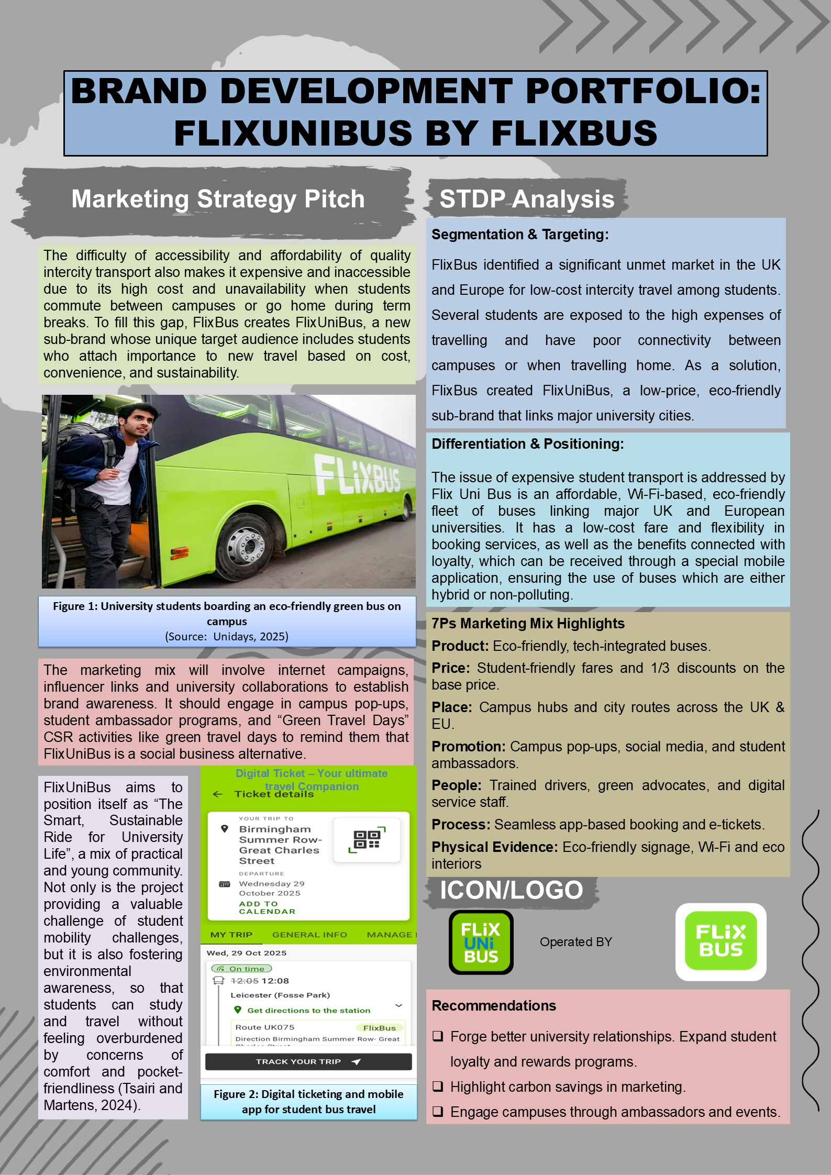
Element 3: Marketing Strategy Pitch & Poster

Element 4: Reflection
The development of brand concepts exercise in FlixUniBus was a kind of an eye opener and it taught me more about marketing strategy, brand development, and consumer behaviour. The activity helped to apply abstract concepts such as Segmentation, Targeting, Differentiation and Positioning (STDP) and the marketing mix 7Ps as a real case and close the gap between theory and practice. This focus on the student travelling market also taught me that such careful choice of the segmentation and positioning can impact the overall image perception formation and dictate whether such a brand could be sustained in the long term.
The STDP analysis assisted me in getting the sense of why specific audience groups needed to be addressed in terms of demographic, psychographic, and behavioural factors. These facts helped me understand what the brands should do to make their value propositions resonate with consumer lifestyles and motivations, since the target market is university students. The shift towards making FlixUniBus a “The Smart, Sustainable Ride for University Life” highlighted the essence of emotional branding and the impact of goal-oriented communication in facilitating brand affinity. Following this, the 7Ps framework helped in analysing the relationships between various operational and marketing variables. As a case study, the emphasis on flexibility in pricing, online access and eco-friendly services showed how brand integrity affects customer satisfaction and loyalty.
As this case study shows, the flexibility in pricing, online location availability, and environmentally friendly services contribute to maintaining customer satisfaction and loyalty by building trust in the brand. FlixUniBus marketing capitalised on creativity, I thought of posters and slogans, like "Study Hard. Travel Smart.” It got me to consider keeping blandness to straightforward and attractiveness by design. After studying about the competitors such as National Express and Megabus, I found loopholes in mobility favouring students, which resulted in making the service unique and priced low. The exercise made me more competitive and provided methods for developing feasible, creative brand strategies.
I see what I need to improve. More data and competitor comparison, especially the sum of how they travel amongst students, should have been stepped up. Obviously, ads would be catchier with more attractive graphic programs. I also learned how to balance facts and creativity in order to come up with creative business ideas.
All in all, this project contributed to my professional growth as a marketer. I was on the job, so I learned about marketing research, campaign development, persuasive communication, and brand implementation. Most importantly, I learned that successful marketing is not about selling individuals, but about experiences that deliver to the heart and communicate a shared social value. The strategic-sustainability-meets-student-empowerment synergy was FlixUniBus, and through it I have realised how I can think about the kinds of self-confidence and critical thinking I will need to control those kinds of projects in my marketing career later.

References
Aissaoui, A., Harakti, K. and Lahouel, S., 2024. THE IMPACT OF THE MARKETING MIX ON SHAPING PEOPLE'S ATTITUDES TOWARDS ENCOURAGING THE USE OF SUSTAINABLE MASS TRANSIT. Journal of Law and Sustainable Development, 12(10), pp.e4022-e4022.
Aydın, A., 2024. The importance of brand equity and branding in terms of product/service preference and internationalisation: An analysis of civil air transportation with marketing strategies. Journal of Aviation, 8(2), pp.182-191.
Demir, B., Aslanov, M. and Şirvan, E., 2025. Global Trends and Strategic Insights in Green Aviation: A Comprehensive Bibliometric and SWOT Analysis (2000–2024). European Archives of Social Sciences, 2(2).
Santoro, I., Borghetti, F., Ratto, E. and Rossi, S., 2025. How to Measure the Impact of Electronic Ticketing Systems in Local Public Transport? An Italian Case Study. Transportation Research Procedia, 90, pp.750-757.
Schulz, T., Böhm, M., Gewald, H. and Krcmar, H., 2021. Smart mobility–an analysis of potential customers’ preference structures. Electronic Markets, 31(1), pp.105-124.
Versteijlen, M., van Wee, B. and Wals, A., 2021. Exploring sustainable student travel behaviour in the Netherlands: balancing online and on-campus learning. International Journal of Sustainability in Higher Education, 22(8), pp.146-166.
Widhiarini, N.M.A.N. and Pradiani, T., 2023. Investigating the impact of green marketing on stay decisions: the mediating role of green consumer behavior. International Journal of Social Science and Business, 7(2), pp.435-447.
Poster References
Bus-news.com. (2025). Available at: https://bus-news.com/wp-content/uploads/sites/4/2025/02/EN-2048x1365-1.png [Accessed 30 Oct. 2025].
Damanik, J., Priyambodo, T.K., Wibowo, M.E., Pitanatri, P.D.S. and Wachyuni, S.S., 2023. Travel behaviour differences among Indonesian youth in Generations Y and Z: pre-, during and post-travel. Consumer Behavior in Tourism and Hospitality, 18(1), pp.35-48.
Mzstatic.com. (2025). Available at: https://is1-ssl.mzstatic.com/image/thumb/PurpleSource221/v4/63/52/a0/6352a087-d46d-1fde-6aac-965e86fc2cda/7224e056-7152-43c8-ab27-35980cf0e3ee_3_-_iOS__U00281284_x_2778_U0029.jpg/300x0w.jpg [Accessed 30 Oct. 2025].
Tsairi, Y. and Martens, K., 2024. Workplace responsibility for employee mobility? A review of sustainability reporting frameworks. Transport Reviews, 44(5), pp.1077-1102.
Unidays.world. (2025). Available at: https://images.unidays.world/i/self-serve/content/offer80505d2d-5794-4eef-adcb-386c591c460d?w=640&format=webp [Accessed 30 Oct. 2025].
‌

‌

‌

‌

