

Assignment Title: Assessment 1
LCBB5005 PROJECT MANAGEMENT

Prepared by: ANITA NIKOLAEVA DRAGANCHEVA
Student number : 2021940

12/09/2022

Table of Contents
Introduction 3
Critical Success or Failure Factors 3
Crossrail Project Requirements 4
General Project Requirements 4
Crossrail Project Requirements 4
Management Plan for Crossrail Project 4
Overview of Management Plan 4
Crossrail’s Management Plan 4
Integral Milestones 5
Elaboration of Milestones and their Purpose 5
Milestones of Crossrail Project 6
Open Communication in Project Management 6
What is Communication 6
Importance of Open Communication in Crossrail Project 7
Project Management Application Software 7
Role of Application Software in Project Management 7
Application Software Used by Crossrail Project 7
Testing of Deliverables 8
Definition of Deliverables Testing 8
Crossrail’s Deliverables Testing 8
Learning Objectives 8
Recommendations 9
Career Opportunities in Project Management 10
Conclusion 11
Reference 11

Introduction
In the previous report, the Crossrail Project has been evaluated critically. In that report, major components like budget, quality stakeholders, risk factors, time etc. have been elaborated. In relation to the last one, this particular report will analyze and describe the success and failure factors associated with the project. In that regard, the requirements of the Crossrail project, management plan for it, integral milestones, open communication in the management of project, testing of deliverables and learning objectives will be elongated. In addition to that, recommendations for the project will be given so that the barriers can be overcome. At the end, career opportunity in project management will be elaborated with a befitting conclusion.

Critical Success or Failure Factors
This report is being made on Crossrail, a mega rail transportation project of Transportation for London, which is intended on being used to deliver transportation services that are executed by utilizing large railways. The Crossrail project was started in 2009 while the permission to build it was attained in 2007. The project envisages the running area of the Crossrail to go from Essex to Berkshire and then by going through the tunnels reaching directly the central London. This Crossrail is named the Elizabeth line, as well.
Now, in the completion or abandonment of a project, certain factors are thoroughly emphasized on in order to comprehend how the activities need to pan out so that the success factors can be utilized to the fullest and the debilitating failure factors’ effects can be mitigated as much as possible. (Attarzadeh, I., et, el. 2008) When a project becomes successful, by the word successful, it refers to the deliverability of the work that has been in progress and that the stakeholders can be satiated with the returns on the project. (Kamata, M.I., et, el. 2007) There are different aspects to a project’s completion such as time, budget etc. which the project manager needs to effectively make the best use of and derive the intended results. But it all majorly comes down to the efficiency as well as effectiveness of the decisions that the project manager undertakes. (Dempsey, M., et, el. 2021) If the project manager is to take decisions and plan executable tasks properly, the success factors become more strengthened, enervating the failure factors.

Crossrail Project Requirements

General Project Requirements
The major project requirements that need to be met mandatorily can be identified as features, processes and tasks. In addition to that, there are other aspects to the management of a project involving time, cost, quality of the intended product or service. (Burke, R., 2013) In order to make a project successful, it is of utmost importance that the requirements and additional aspects are emphasized on properly and that the purpose can be achieved efficiently. (Packendorff, J., 1995)

Crossrail Project Requirements
In the Crossrail project, the project requirements are to build a rail line that will be more than 100km in scale as well as connect over 40 stations in Europe. These requirements are placed with a view to mitigating the current issues with transportation alongside the intention of saving the general people’s productive hours. (Crossrail Learning Legacy. 2022)

Management Plan for Crossrail Project

Overview of Management Plan
In projects, creating an elaborative management plan is important as such plans mainly contain different measurements and include the goals and objectives needed to be achieved by the completion of it. (Kerzner, H., 2017) The management plan plays a key role in instructing the approaches that need to be adopted and implemented as well as monitor and control the deviances seen in the ongoing project. (Bourne, L., et, el. 2004) There are also other aspects namely as budget, allocated time, required volume, actual timeline etc.

Crossrail’s Management Plan
The management plan for the Crossrail project includes all the goals and objectives intended on achieving, budget, timeline, allocated time, volume of it and as such. As for the time, the Crossrail was supposed to start operating by 2018 at the start of the construction for the Crossrail. Moreover, the targeted passenger number has been around 70000 per hour when it is running through the peak hours. (Crossrail Learning Legacy. 2022)
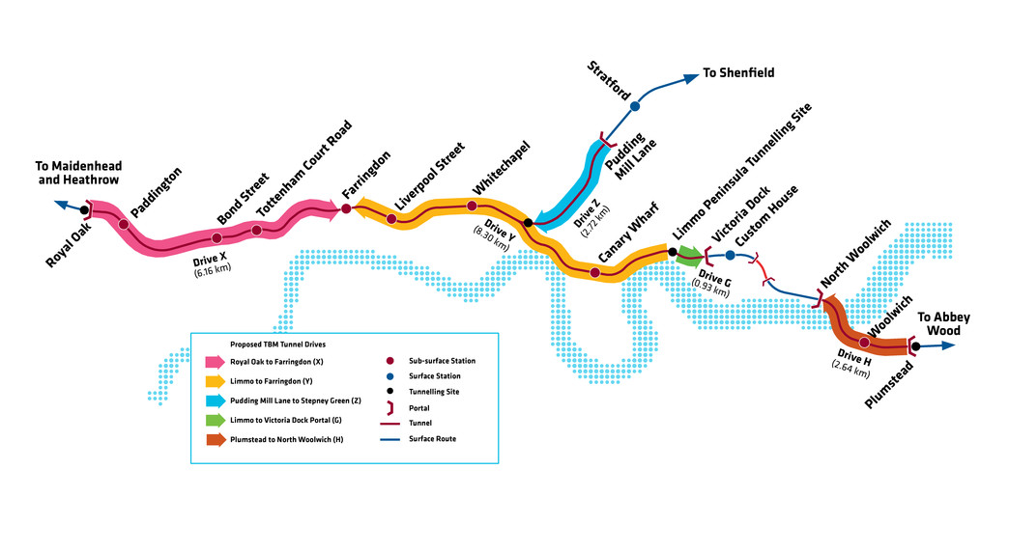
Picture: Planned tunnels of the Crossrail Project (Source: archaeology.crossrail.co.uk)

Integral Milestones

Elaboration of Milestones and their Purpose
Milestones are the points where it can be easily comprehended of the actual progress of a project. In project management, it is important to understand how progressive the project is and then take necessary steps to either expedite the overall process or streamline operations in order to bring efficiency up. (Qutb, S., et, el. 1978) In simple words, milestones are those purposes that are supervised under the completion of different activities. In project milestones, typically four strata of it can be found which are initiation, planning, implementation and closure. A milestone is generally achieved by measuring the project development and progress as well as the starting and ending dates alongside project growth.

Milestones of Crossrail Project
There have been different milestones being set in different timelines for Crossrail project. Of the many milestones, the most recent one is the doubling number of trains being tested on the rail lines. In the past, first trial of train can be identified to be one of the most remarkable ones back in 2016. Also, many other milestones have been achieved in the given budget as well as time period over the years. As for the budget, the Crossrail project has already consumed over 18b Pounds and has been expected to open in the later half of 2022 which has been accomplished as well.
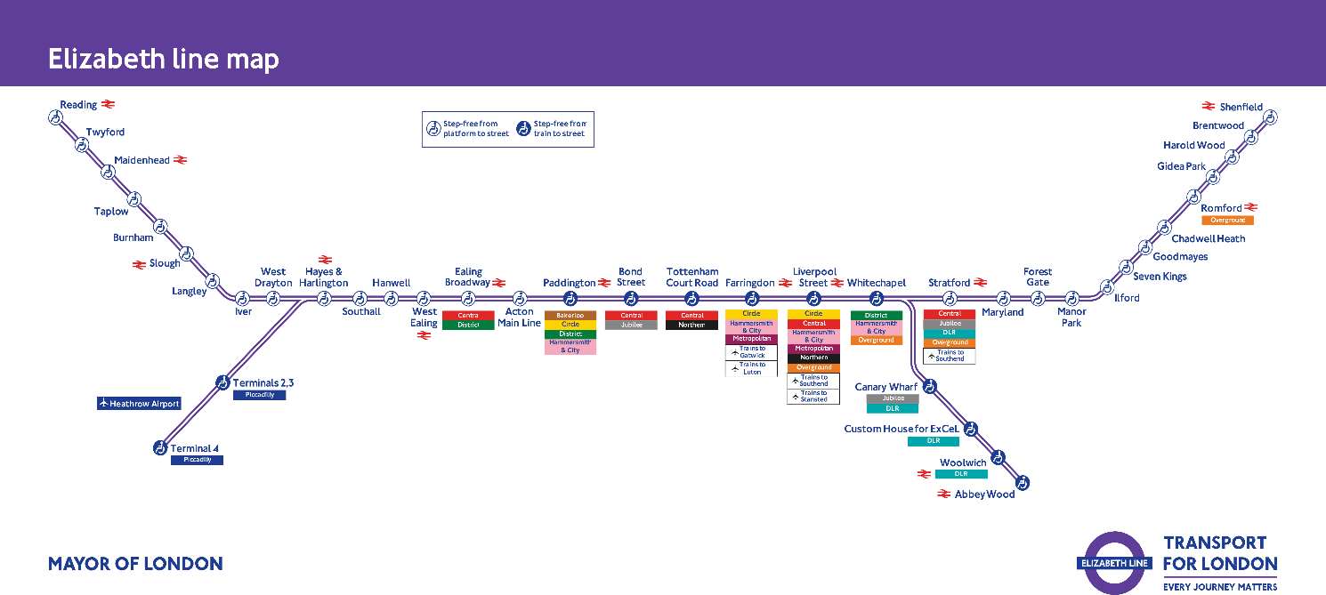
Picture: Map of Elizabeth line (Source: arstechnica.netblogpro.com)

Open Communication in Project Management

What is Communication
In any kind of work, communication is the key to opening a lot of aspects. Communication simply means conveying one’s ideas, thoughts, information to others in such a manner that enables the parties involved to comprehend what the core matter actually is whereas open communication means the ability to express anything with the involved parties with enough freedom. (Shad, F., et, el. 2019)
Project management is an intricate job to do and getting more and more ideas and thoughts on different subject matters can be of much help to the manager. In that regard, managers should make the work environment more open in order to gain insights on things that he may or may not be aware of. (Rogers, D.P., 1987) As there are many kinds of communication such as verbal, non-verbal and as such, the baseline should be the capability of others to provide the needed information.

Importance of Open Communication in Crossrail Project
As mentioned before, communication is indeed the key to opening many horizons that can provide perspective never thought of before. When there remain complications regarding communication, more complexities are bound to arise. Those complexities will only beget several other issues. That’s why the stakeholders of the Crossrail project need to maintain transparency with each other so that there remains no information void. The parties needed to provide insights should do so and the parties needed to analyze and utilize those insights, i.e., project manager, should make the best use of it to make the transportation service flawless and performant.

Project Management Application Software

Role of Application Software in Project Management
In the current world, information is getting larger in quantities as well as more complex in processing just by humans. As things get even more complicated, managing projects, where tons of information are acquired and processed, application software is the only remaining alternative. (da Silva, F.Q., et, el. 2010) Different database software help projects to store, analyze and utilize information more effectively. Moreover, breakthroughs such as AI are also being utilized by different organisations in projects that require such things.

Application Software Used by Crossrail Project
The Crossrail project has already used a number of application software such as the CDE, MDM, GIS etc. CDE or Common Data Environment, MDM or Master Data Management, GIS or Geographical Information System, all of these application software enhance the overall processes of the Crossrail project. (Sourceable.net. 2022)

Testing of Deliverables

Definition of Deliverables Testing
There is a need of evaluating projects in all of the phases such as continual, completion and post-completion. As different projects require different kinds of tools, the necessary tools are created in order to measure the overall standings of a project. The question of deliverables testing comes when the product or service reaches the finalized form and can deliver the required results.

Crossrail’s Deliverables Testing
Crossrail or Elizabeth’s line is one of the most important mega projects in the UK. Although the deliverance of the project got thwarted by the recently concluded pandemic, the project is yet again being made ready for testing and consequently operation with a view to partially opening the project on May of 2022 and the final structure being completed by the end of 2023. (Corporate Finance Institute. 2022)

Learning Objectives
Learning is a continuous process that can be found in many aspects. In that regard, learning objectives are definite lessons that one can learning by completing different tasks. Attaining different levels of learning is only possible when someone is put through the test. The Crossrail project can be a great place to acquire insights on different aspects such as success & failure factors, obstructions and many more. As there cannot be anything that can be possibly done perfectly, down to the last bits, there have been some things that Crossrail failed to capitalize on. All the aspects of Crossrail project are elaborated below.
Capitalizing on Technologies
The advancement made in the technological world in the recent past has been quite substantial. There is now technology for almost every possible complication. As the rail line project was started, many technologies including different tools, equipment etc. were used to facilitate the overall project progression. Moreover, the Crossrail project involved people from all backgrounds and in that, the whole progress was possible to be expedited.
Designing Effectively
For projects such as the Elizabeth line, a large sum of money and a lot of time are generally provided in order to get the best possible result out of the investment. The Crossrail project is a mega project that involved connection to over 40 stations across Europe. As going to other countries can be an intricate job to persecute, the Crossrail Project required a lot of skilled manpower in order to be able to execute all the plans.
Small & Large Bits
The Crossrail project has involved large constructors for its work process, but involving large constructors don’t always bring the required results necessarily. On the contrary, contractors who are small in scale can contribute hugely to the development or accomplishment of a project. The Crossrail project surely missed that particular opportunity here.

Recommendations
Although the project managers have adopted many technologies and techniques to make the Crossrail project a successful one, there remain certain aspects that need supervision and possibly changes in order to extract the best possible performance and results out of this mega project. The necessary recommendations have been given below.
Sustainability
In any mega project, the duration of the use of the built infrastructure generally is estimated to be quite longer than other projects. Moreover, spending billions on a single project alone can bring economic distress if the project can bring enough ROI. That’s why sustainability of the project needs to be ensured so that it can used on a long-term basis and bring infrastructural developments to increase the overall efficiency of the Crossrail.
Tunnel’s Design
Boasting a passenger-friendly design in the stations as well as the overall design of the tunnels is a must needed architectural aspect that the project managers need to make sure of. As the Crossrail is mostly underground, making the stations recognizable with the outer environment is something that the project managers should emphasize on.
Measures for Safety
As the users of this Crossrail will be general passengers mostly going in and out of the tunnels and different cross-sections, it is important on the part of the project managers that they ensure enough safety measures in the whole Crossrail so that the protection of the passengers can be bolstered.

Career Opportunities in Project Management
Project management is a difficult job yet quite the demanding one, meaning that the incremental adoption of newer and newer projects and overall operations being carried out at different organisations beget to many opportunities for proper candidates to leverage from. But, as the job is quite tasking, it requires myriads of skills, as well, such as communication, risk management, leadership etc. the skills needed in the area of project management can be quite intimidating at first, because this particular job sector requires people who can get the job done without any complication or even if something is to go disarray, the project manager must have the skills to overcome the complexities. The brief discussion of the skills is given below.
Leadership
In projects, different people work under one or more managers. As the people need direction and motivation to keep working, a project manager is needed to possess leadership qualities in order to be able to direct a group of people successfully.
Communication
As a project manager, one has to have communication skills in order to be concise in delivering all the needed information as well as guidelines. Without proper communication skills, a project manager can’t ever convey the needed guidelines to the subordinates.
Risk Management
While completing a project, many difficult circumstances can arise where the project manager will have to deal with the issues by doing proper risk management so that nothing gets out of hands and no unnecessary risk is undertaken.
Now, the career opportunities that can be explored by the aspirant people are discussed below.
- There has been substantial growth in the research & development area of many organisations and they are undertaking more projects than ever in order to cope up with the rapidly developing world. That’s why there are ample opportunities to get a service job in this sector. (Richardson, T.M., et, el. 2015)
- If one has both undergraduate and Master’s degree on project management along with proper experience, the profile then becomes quite formidable in the job market and can provide the aspirant with a job providing salary over 50 grands. (McKevitt, D., et, el. 2017)
- In the UK, the demand of project managers is ever increasing. That’s why the skilled people can quite competently avail themselves of jobs with many job facilities and the scope of going up the ladder through proper measures.

Conclusion
As the Elizabeth line or Crossrail project is one of the most important projects in the UK, the project managers needed to be really crafty in achieving the required goals and objectives within the given time bounds and budget allocation although the overall progress was stomped by the Coronavirus pandemic. Yet, the managers have done well in terms of utilizing the new technologies and adopting new measures to make the project a successful one. But there need some changes in the current development of the project which this report has already given. In short, this report has covered all the aspects to critical success or failure factors of the Crossrail project including an elaboration on career opportunity in project management.

Reference
- Attarzadeh, I. and Ow, S.H., 2008. Project management practices: the criteria for success or failure. Communications of the IBIMA, 1(28), pp.234-241.
- Bourne, L. and Walker, D.H., 2004. Advancing project management in learning organizations. The Learning Organization.
- Burke, R., 2013. Project management: planning and control techniques. John Wiley & Sons.
- Corporate Finance Institute. 2022. Deliverables. [online] Available at: <https://corporatefinanceinstitute.com/resources/knowledge/other/deliverables/> [Accessed 28 August 2022].
- Crossrail Learning Legacy. 2022. Crossrail Management Plan - Crossrail Learning Legacy. [online] Available at: <https://learninglegacy.crossrail.co.uk/documents/crossrail-management-plan/> [Accessed 28 August 2022].
- Crossrail Learning Legacy. 2022. Delivery/Execution Strategy - Crossrail Learning Legacy. [online] Available at: <https://learninglegacy.crossrail.co.uk/learning-legacy-themes/project-and-programme-management/deliveryexecution-strategy/> [Accessed 28 August 2022].
- da Silva, F.Q., Costa, C., Franca, A.C.C. and Prikladinicki, R., 2010, August. Challenges and solutions in distributed software development project management: A systematic literature review. In 2010 5th IEEE International Conference on Global Software Engineering (pp. 87-96). IEEE.
- Dempsey, M., Geitner, L., Brennan, A. and McAvoy, J., 2021. A review of the success and failure factors for change management. IEEE Engineering Management Review.
- Kamata, M.I. and Tamai, T., 2007, October. How does requirements quality relate to project success or failure?. In 15th IEEE International Requirements Engineering Conference (RE 2007) (pp. 69-78). IEEE.
- Kerzner, H., 2017. Project management: a systems approach to planning, scheduling, and controlling. John Wiley & Sons.
- McKevitt, D., Carbery, R. and Lyons, A., 2017. A profession but not a career? Work identity and career satisfaction in project management. International Journal of Project Management, 35(8), pp.1673-1682.
- Packendorff, J., 1995. Inquiring into the temporary organization: new directions for project management research. Scandinavian journal of management, 11(4), pp.319-333.
- Qutb, S. and Qurtb, S., 1978. Milestones (p. 0). Beirut: Holy Koran Publishing House.
- Richardson, T.M., Earnhardt, M.P. and Marion, J.W., 2015. Is project management still an accidental profession? A qualitative study of career trajectory. Sage Open, 5(1), p.2158244015572098.
- Rogers, D.P., 1987. The development of a measure of perceived communication openness. The Journal of Business Communication (1973), 24(4), pp.53-61.
- Shad, F., Shah, F.A., Jan, S. and Ahmad, S., 2019. Importance of communication in project management: A case study of communication & works department Peshawar. Sarhad Journal of Management Sciences, 5(2), pp.267-280.
- Sourceable.net. 2022. Crossrail’s Lessons on Project Management Technology – Architecture . Construction . Engineering . Property. [online] Available at: <https://sourceable.net/crossrails-lessons-project-management-technology/> [Accessed 28 August 2022].

