
Master of Business Administration
International Business Concepts
Lecturer: Dr. Gladius Kulothungan
Assignment Title: Assessment Component 1: Individual Report
Student name: Kopil Uddin
Student ID number: 2434290
LCMB7034 – Individual Report
Industry: Ready-Made Garments
Country: Bangladesh

dy
Table of Contents
1. Introduction 3
2. Industry and Country Overview 4
2.1 The Textile and RMG Industry in the Context of Bangladesh 4
2.2 Size, Scope, and Economic Importance of the Industry 4
2.3 Key Domestic and Multinational Firms: Comparative Analysis 6
3. Porter's Diamond Model of National Advantage: Bangladesh's Textile Industry 9
3.1 Factor Conditions 11
3.2 Demand Conditions 11
3.3 Related and Supporting Industries 12
3.4 Firm Strategy, Structure, and Rivalry 12
3.5 Government and Chance 12
4. Youngone Corporation: Critical Evaluation of Operations in Bangladesh 13
4.1 Company Background and Entry Rationale 13
4.2 Political Factors 13
4.3 Economic Factors 14
4.4 Legal Factors 15
4.5 Cultural Factors 16
5. Conclusion 20
6. Reflective Account: Gibbs Reflective Cycle 22
6.1 Description 22
6.2 Feelings 23
6.3 Evaluation 23
6.4 Analysis 24
6.5 Conclusion 24
6.6 Action Plan 25
References 27

1. Introduction
Bangladesh's status in the global economy as the second-largest exporter of ready-made garments (RMG) and textiles, with USD 47.39 billion in exports in FY2022-23 and more than 84% of total merchandise exports (BGMEA, 2024), is unique (BGMEA, 2024). Bangladesh's RMG industry is widely recognised by scholars as a prime example of exploiting labour-cost advantages in global value chain arrangements to drive rapid economic development (Gereffi and Memedovic, 2003; Kaplinsky and Morris, 2001; Staritz, 2011). The past 40 years of this transformation has been facilitated by targeted industrial policy, favourable trade regimes, and focused foreign direct investment (FDI) mobilisation, and Bangladesh has become an interesting case for international business analysis at a pivotal point in its development. The industry's contribution to Bangladesh's GDP (11-12%), its employment of more than 4.2 million people, and its position as the driver of export-led development merit ongoing research (World Bank, 2024). This report offers a holistic international business analysis comprising: Section 2 provides an overview of the industry and benchmarks major domestic and global firms; Section 3 examines the Porter (1990) Diamond Model of National Advantage; Section 4 critically evaluates Youngone Corporation using a PESTLE framework based on OLI, Hofstede and CAGE; Section 5 concludes with reflections on strategic lessons; and Section 6 examines the research process through the Gibbs (1988) Reflective Cycle.

2. Industry and Country Overview

2.1 The Textile and RMG Industry in the Context of Bangladesh

The development of Bangladesh’s textile and RMG industries was, in large part, institutionalised by the global trade regime and government policy (Rashid, 2006). The Multifibre Arrangement (MFA) in the late 1970s provided quota-based incentives for investment to shift from quota-limited producers to low-cost producers (Bhattacharya and Rahman, 1999; Kabeer and Mahmud, 2004). Bangladesh leveraged this opportunity through EPZ set-ups at Chittagong (1983) and Dhaka (1993); while technical assistance from South Korea kick-started the industry, an early manifestation of FDI-induced capability spillovers and host-country industrial upgrading (Rhee, 1990; Dunning and Lundan, 2008).

More than 4,600 export-oriented factories are registered with BGMEA, forming one of the world's largest textile manufacturing clusters (BGMEA, 2024), in line with Porter's (1998) cluster theory, where localised knowledge spillovers, specialised labour market pooling, and backward-linkage density complement competitive advantage. Marshallian (1920) agglomeration economics is vividly illustrated in the Dhaka-Gazipur-Narayanganj garment belt. Duty-free market access via EU’s Everything but Arms (EBA) is of significant commercial value (EU Commission, 2023; Hossain, 2018). But projected LDC graduation in November 2029 presents structural shift to be actively managed (Raihan et al., 2022), as GSP+ requires adherence to 27 international conventions relating to human rights, labour, and environmental protection - a compliance challenge, but also an opportunity to sustain preferential market access through institutional credibility.

2.2 Size, Scope, and Economic Importance of the Industry
As Figure 1 shows, RMG export earnings increased to record USD 47.39 billion in FY202223, as compared to USD 34.13 billion in the previous year, 2020, which is impressive recovery in the wake of the COVID-19 contraction to USD 27.95 billion in FY201920 (BGMEA, 2024 With 4.2 million employees, with an estimated 65 percent being women, the sector is also one of the most radical means of women economic empowerment in the developing world, a structural change that has social and household welfare externalities far-reaching (ILO, 2023). With spinning, weaving, dyeing, and finishing sub-sectors, the industry has a contribution of 11-12 per cent to GDP with widespread backward-linkage multiplier effects (World Bank, 2024).
Upstream inputs in Bangladesh are provided by more than 3,000 textile mills. The ratio of backward linkage has increased to more than 75% in knitwear (CPD, 2023) - this represents the shift in the production of assemblies to full package production in global value chains that Gereffi et al. (2005) refer to as a structurally more advanced form of supply chain involvement. Man-made fibres and woven garments are more import-dependent. The EU is the most significant export market (52.3), then the US (17.8) and the UK (10.2), with GCC countries amounting to USD 1.8 billion in FY202223 (EPB, 2024). This type of diversification of the export market to systemic resilience against demand-side shocks in any one destination market minimizes the structural exposure that comes with over-reliance on bilateral trade relationships (Neidik and Gereffi, 2006).
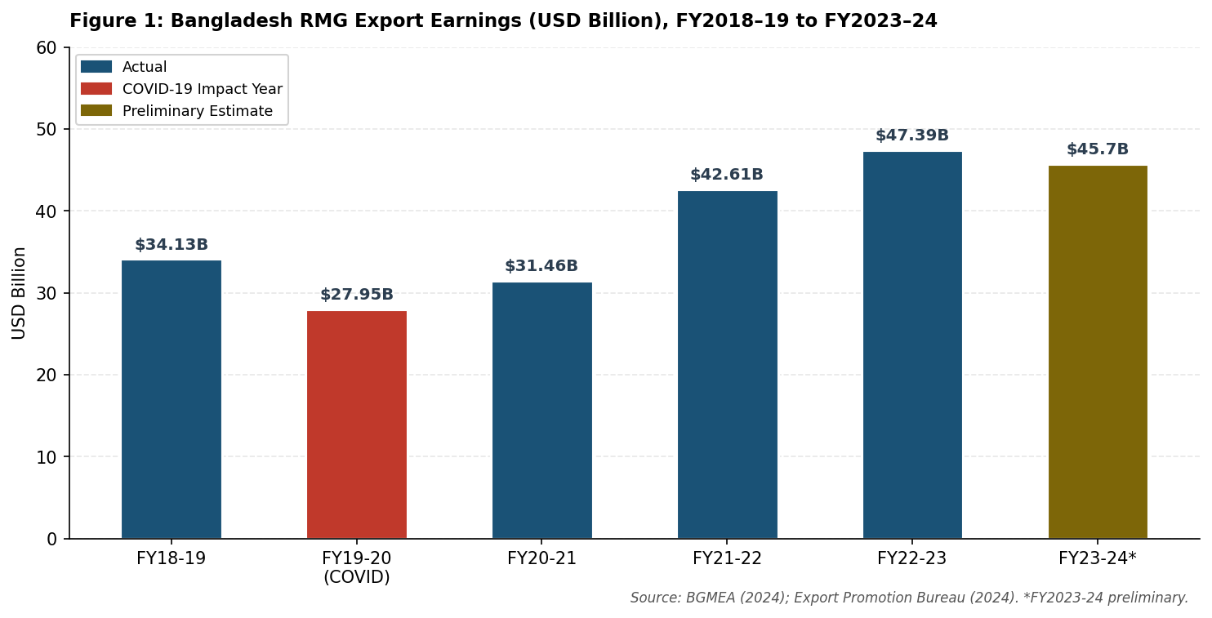
Figure 1: Bangladesh RMG Export Earnings (USD Billion), FY2018–19 to FY2023–24. Source: BGMEA (2024); Export Promotion Bureau (2024). *FY2023–24 is preliminary data.
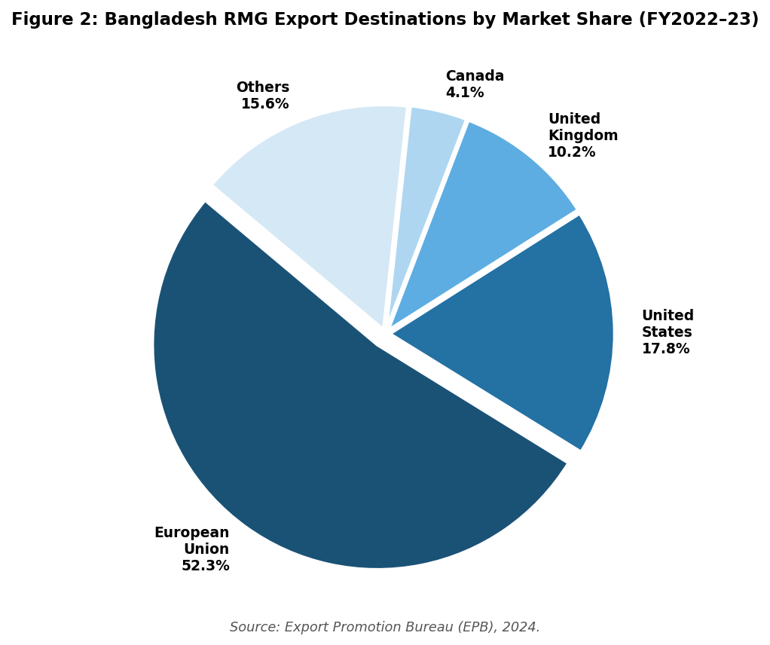
Figure 2: Bangladesh RMG Export Destinations by Market Share (FY2022–23). Source: Export Promotion Bureau (EPB), 2024.

2.3 Key Domestic and Multinational Firms: Comparative Analysis
An analysis of two domestic companies leading in Bangladesh, Beximco Textiles Ltd and DBL Group, and two multinational companies with operations in Bangladesh manufacturing business, Youngone Corporation (South Korea) and Crystal Martin (Hong Kong) are presented below. A comparative overview is given in Table 1.
Table 1: Comparative analysis of key domestic and multinational firms in Bangladesh's textile sector. Sources: BGMEA (2024); Youngone Corporation (2023); Beximco Annual Report (2023); Company websites.
Criteria | Beximco Textiles | DBL Group | Youngone Corp. | Crystal Martin
Origin | Bangladesh (Domestic) | Bangladesh (Domestic) | South Korea (MNC) | Hong Kong (MNC)
Employees (BD ops.) | ~65,000 | ~45,000 | ~80,000 | ~20,000
Product Segment | Woven, knit, denim, PPE | Vertically integrated knitwear | Technical outerwear, sportswear | Womenswear, casualwear, full-package
Key Clients | H&M, Walmart, Zara, Tesco | H&M, M&S, Adidas, Next | The North Face, Patagonia, Columbia | Gap, PVH, Abercrombie & Fitch
Core Strategy | Vertical integration; diversification into pharmaceuticals | Green manufacturing; compliance-led differentiation | Technical product complexity; EPZ-based export focus | Full-package service; design-to-delivery model
Revenue (approx.) | USD ~400M | USD ~300M | USD ~1.2B (BD ops.) | USD ~250M
Sustainability | 2 LEED-certified factories; ACCORD member | 10 LEED Gold/Platinum certified factories | ZDHC-compliant; ISO 14001; HIGG Index | SA8000 certified; Fair Wear Foundation
Stock Exchange | DSE/CSE + NYSE (Beximco Ltd) | Private | Korea Exchange (KRX) | Private
Beximco Textiles Ltd engages in backward vertical integration in spinning, dyeing, weaving, knitting and finishing. The parent company, which is listed on the NYSE, offers capital market access on which large-scale compliance investment is based (Beximco, 2023). The ability to diversify into the production of PPE evidences dynamic capabilities- the ability to feel the opportunities, capture them by reshaping resources, and rebalancing assets to environmental discontinuities (Teece et al., 1997).
DBL Group has focused on making ESG compliance its main strategic resource. LEED Platinum and founding Accord signatory status have built buyer relationships, in which the ESG credentials are non-negotiable (DBL Group, 2023). Lim and Phillips (2008) reveal that CSR-centric approaches gain price premiums and long-term purchase commitments, as is typical of the Creating Shared Value model posited by Porter and Kramer (2011) where social investment creates, but not depletes, competitive advantage.
The competitive strategy of Youngone Corporation is based on the product technical complexity. Its manufacture of high-performance outdoor and technical sportswear which demands specialised sewing methods, sophisticated handling of materials and high-quality standards place it in market segments that have a lower price elastic and higher entry barriers.
Crystal Martin (Hong Kong) has a quite differentiated full-package sourcing strategy which positions it at the top of the Bangladesh textile MNC competitive hierarchy. Crystal Martin, unlike commodity oriented manufacturers who primarily compete on unit cost, has a vertically integrated design-to-delivery service model which includes in-house design studios and staffed with international stylists, raw material sourcing teams with global supplier networks (including fabrics, trims, accessories, and packaging), production planning, quality assurance and logistics co-ordination all under one service umbrella. This end-to-end system radically simplifies the transactional complexity and coordination costs incurred by premium brand customers, like Gap Inc., PVH Corp., and Abercrombie & Fitch, which run lean sourcing teams globally and require consolidated responsibility to a single manufacturing partner as opposed to having to manage a fragmented relationship network of multiple vendors.
The competitive positioning of Crystal Martin is based on four strategic pillars that are reinforcing. First, its independent, sustainably sourced ethical credentials under the form of the SA8000 Social Accountability certification and Fair Wear Foundation membership offer ethically sourced, which is becoming non-negotiable in the view of the US and European premium apparel brands to the mandatory supply chain due diligence requirements under the EU Corporate Sustainability Due Diligence Directive (CSDDD, 2024) and similar national Second, its Hong Kong heritage provides access to East Asian networks of innovation in textile, allowing quick sourcing of trend-sensitive performance fabrics, technical trimmings, and specialty materials that cannot be sourced at the same efficiency or to the same level of quality by purely Bangladesh-based manufacturers. Third, Crystal Martin makes strategic investments in the development of its workforce skills, with in-house pattern grading, computer-aided design (CAD), high-technology sewing, and quality control methodology-developing a dedicated human capital base that can perform technically challenging womenswear and casualwear to the high tolerance standards of high-end international brands. Fourth, its strategically sustained operational scale (about 20,000 employees in the Bangladesh facilities) retains the agility and intimate client relationship management that is structurally lost in bigger conglomerates as they increase in scale to a commodity-volume production paradigm.
The cost-leadership strategies of domestic corporations and the technical differentiation efforts of MNCs like Youngone and Crystal Martin exemplify the new bifurcation of the Bangladesh competitive scene-along the lines of the Humphrey and Schmitz (2002) differentiation of captive’s price-based and relational trust-based suppliers. This bifurcation will have grave strategic consequences on the long-term competitiveness in the sector as pure cost-leadership steadily gets eroded by LDC graduation in 2029, as well as increasing ESG requirements (Barrientos et al., 2011; Ponte and Gibbon, 2005).
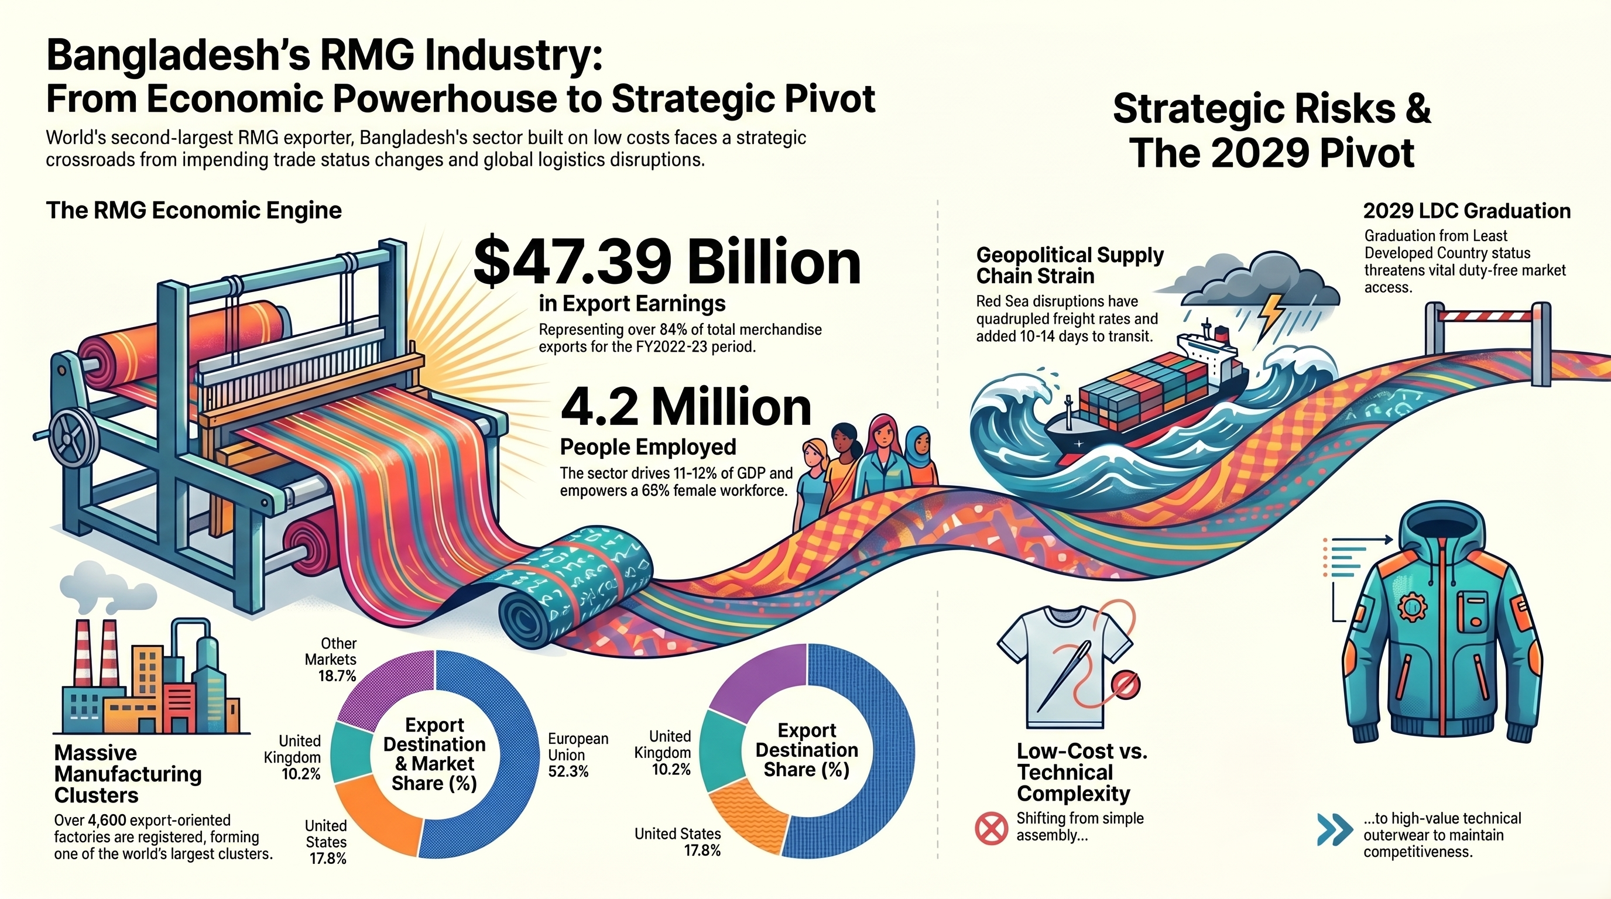Infographic: Bangladesh’s Garment Industry Strategic Pivot

3. Porter's Diamond Model of National Advantage: Bangladesh's Textile Industry
The Diamond Model of National Advantage outlined by Porter (1990) is a model of how particular countries end up producing internationally competitive industries based on four interlocking determinants (Factor Conditions, Demand Conditions, Related and Supporting Industries, and Firm Strategy, Structure and Rivalry), with Government and Chance as exogenous variables. A framework that is arguably analytically valuable to the export-oriented sector of Bangladesh has been suggested as an extension by critics such as Rugman and D’Cruz (1993) to the so-called small open economies as a so-called double diamond. Applied here, it indicates high levels of factor-endowments strengths and high levels of weaknesses of demand sophistication and firm-level innovation. The analysis is summarised in table 2.
Table 2: Porter's Diamond Analysis of Bangladesh's Textile & RMG Industry. Sources: Porter (1990); BGMEA (2024); World Bank (2024); CPD (2023); ILO (2023).
Diamond Determinant | Strengths | Weaknesses / Challenges
Factor Conditions | Abundant, low-cost labour (min. USD 113/month); large female workforce; improving EPZ infrastructure; bonded warehousing | Chronic energy shortages; port congestion; limited advanced skills in technical textiles; weak R&D infrastructure
Demand Conditions | EU/US buyers impose rigorous ESG standards that drive quality upgrading; large export volumes create scale efficiencies | Absent sophisticated domestic demand; price sensitivity dominates over quality orientation at home market level
Related & Supporting Industries | ~3,000 textile mills; strong knitwear backward linkage (75%+ domestic sourcing); BGMEA/BKMEA associations; compliance laboratories | Woven fabric still largely imported; synthetic/MMF supply chain nascent; limited domestic machinery manufacturing
Firm Strategy, Structure & Rivalry | 4,600+ factories drive intense rivalry; post-Rana Plaza consolidation improving efficiency; leading firms diversifying into MMF and activewear | Race-to-bottom pricing erodes margins; limited R&D investment; skills shortage at management and technical levels
Government | EPZ incentives; zero import duty on capital machinery; 12% export cash incentive; EU EBA/GSP access; National Textile Policy 2015 | LDC graduation threatens GSP; political transition (2024) creating policy uncertainty; labour law enforcement gaps
Chance | COVID-19 accelerated China+1 sourcing diversification benefiting Bangladesh; Rana Plaza (2013) paradoxically accelerated compliance investment | Red Sea/Middle East crisis increasing shipping costs; climate vulnerability (flooding, cyclones) threatening infrastructure
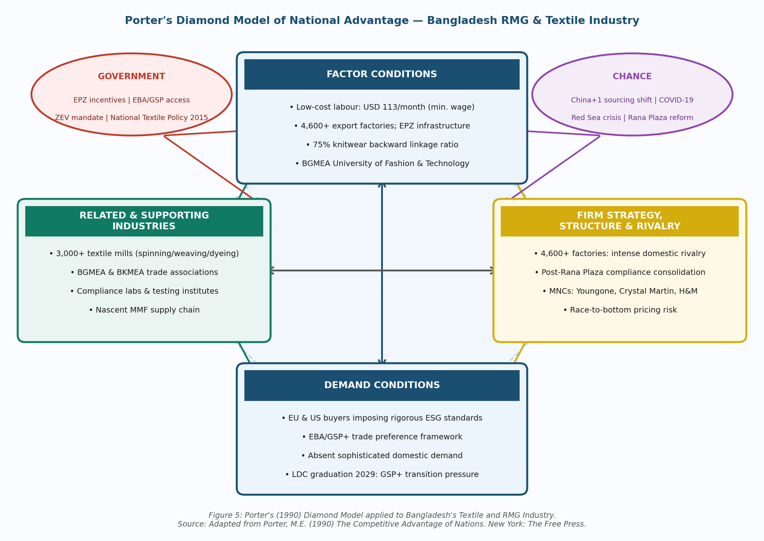
Figure 5: Porter’s Diamond Model of National Advantage applied to Bangladesh’s Textile and RMG Industry. Source: Adapted from Porter, M.E. (1990) The Competitive Advantage of Nations. New York: The Free Press; BGMEA (2024).

3.1 Factor Conditions

The major factor advantage of Bangladesh is low-cost labour as the minimum wage of BDT 12,500 (USD 113/month) is still significantly lower than those of Vietnam (USD 180250) and China (USD 350420) (Better Work, 2024). Porter (1990), however, differentiates between basic and advanced conditions of factors- the latter include specialised skills and research infrastructure. The Bangladesh labor force is large and productive at the assembly stage, but it does not have a skilled workforce in developing technical textiles and digital design (Fernandez-Stark et al., 2011; Labowitz and Baumann-Pauly, 2015). The lack of infrastructure, such as congestion in roads and inefficiencies in ports, and electricity shortage of 2,0003,000 MW cost imposes 23 percent of export value and limits competitiveness in time-sensitive systems (World Bank, 2024; Cadot et al., 2014). The Padma Bridge and Matarbari port investments indicate ambition by the government, but the growth rate of development is lower than growth in the sector (Moazzem and Sehrin, 2016).

3.2 Demand Conditions

The RMG industry in Bangladesh is virtually a pure export industry; the lack of local consumer demand constrains endogenous innovations pressure, which is a structural weakness of export industries in developing countries that are solely dependent on buyer-based upgrading (Altenburg et al., 2008). The externalised source of demand sophistication is European and North American customers, whose demands are increasingly putting regulatory pressure, e.g. the CSDDD (2024) of the EU, the German Supply Chain Act (2023), and the Duty of Vigilance Law (2017) of France, changing the quality standards across the manufacturing base of Bangladesh (European Commission, 2023; BMA As Schmitz and Knorringa (2000) note, this type of buyer-led upgrading is both knowledge transferring of managerial knowledge and competitive asset-creating compliance demands handed over to able suppliers.

3.3 Related and Supporting Industries

This is the most developed aspect of diamond in Bangladesh. The industry is enjoying a favorable backup of about 1,500 spinning mills, 800 weaving plants and 3,000+ knitting mills, with the dependency on imports and lead times dropping by more than three-quarters (CPD, 2023; BGMEA, 2024) - which significantly lowers the reliance on imports and the lead times. Man-made fibres and woven clothes are also still dependent on imports and this presents an upgrade option to the industry. The costs of transactions are decreased at a cluster level by industry associations (BGMEA, BKMEA), specialised training institutions like BGMEA University of Fashion and Technology, testing and compliance laboratories, and trade finance networks. Pietrobelli and Rabellotti (2011) posit such associations as key collective governance processes that co-ordinate industry-wide compliance reactions, which BGMEA has, in fact, played in the post-Rana Plaza structural change in Bangladesh.

3.4 Firm Strategy, Structure, and Rivalry

The intense competition posed by the more than 4,600 registered factories has resulted in cost efficiency and suppressed margins and investments in research and development. The compliance transformation led by the Bangladesh Accord and Alliance for Bangladesh Worker Safety (Akter et al., 2020) following the 2013 Rana Plaza disaster forced the industry to become a paradise of compliance-competent companies (ironically), which in turn gathers around the companies. Bangladesh has become a key beneficiary of the post-COVID strategy of sourcing diversification (China+1) (McKinsey, 2023), since the change in sourcing geography by buyers can lead to the sustained upgrading pathways wherein the suppliers will invest in quality and compliance at the same pace as buyer demands are changing (Gereffi and Lee, 2012).

3.5 Government and Chance

The government has been a continuously facilitating factor by EPZ incentives, zero duty machinery import, export cash incentives, tax holidays, and bonded warehousing (Bangladesh Investment Development Authority, 2024). Rodrik (2004) puts such instruments in the context of corrective mechanisms to market co-ordination failures that cannot be solved unilaterally by private investors. The EU EBA agreement is the government-mediated access of colossal commercial worth to the market (Hossain, 2018). The interim government led by Professor Muhammad Yun after August 2024 is an indication of reform intentions in the areas of labour rights, and anti-corruption mechanisms a potentially transformative yet uncertain policy environment (World Bank, 2024).

Competitive forces have been influenced by chance as well. The interruption of China-based supply chains under the influence of the COVID-19 pandemic led to a rapid reevaluation of sourcing locations by large international brands, with the country of Bangladesh becoming a key alternative source of production. The recent Red Sea shipping crisis that was caused by a Middle Eastern geopolitical conflict has strengthened the significance of supply chain resilience as a competitive variable, to which implications are discussed in detail in Section 4.

4. Youngone Corporation: Critical Evaluation of Operations in Bangladesh

4.1 Company Background and Entry Rationale

One of the largest vertically integrated manufacturers of textiles in Asia, Youngone Corporation (Seoul, South Korea) has its revenues in the world reaching USD 2.5 billion in Bangladesh, Vietnam, Ethiopia, El Salvador and Nicaragua (Youngone Corporation, 2023). It became one of the earliest investors in the EPZ in Bangladesh in 1985 and currently operates six establishments within the Chittagong EPZ and has 80,000 employees and its exports earn USD 1.2 billion. The North Face, Columbia Sportswear, and Patagonia are premium clients, whose brands require the highest standards of technical quality and ethical sourcing practices.

The presence of Youngone in Bangladesh can be explained using OLI Paradigm by Dunning (2001). Proprietary technical manufacturing processes, quality buyer relationships, and Korean quality management systems, are the ownership benefits- VRIN resources as described by Barney (1991). Location benefits include labour cost difference in Bangladesh, GSP/EBA inclinations and EPZ fiscal benefits. The benefits of internalisation are due to quality control, which is achieved by having wholly owned operations, instead of arm-length contracting (Buckley and Casson, 1976). The competitive position of Bangladesh is reinforced with each investment that is Bangladesh-specific due to learning-by-doing (Kogut and Zander, 1993).

4.2 Political Factors

In August 2024, the political environment in Bangladesh shifted seismically as Prime Minister Sheikh Hasina stepped down due to mass student-led demonstrations, and an interim government led by Nobel Laureate Professor Muhammad Yunus took over (BBC, 2024). In the case of Youngone, this brings about regulatory uncertainty. Kobrin (1979) cites political instability as a source of environmental turbulence that increases unpredictability of government decisions that influence FDI. The last administration ensured predictable EPZ governance and consistent export incentives supported by BGMEA co-ordination, and the reform intentions of the interim government in both labor rights and enforcement of anti-corruption measures could change the EPZ operating environment significantly (CPD, 2023).

The Middle East aspect is also material. Since October 2023, armed conflict involved Iran-supported Houthi forces into Red Sea attacks on commercial shipping in November 2023 (United Nations, 2024), forcing Maersk, Hapag-Lloyd, MSC and CMA CGM to route around the Cape of Good Hope, which is essentially rearranging global East-West shipping logistics and directly affects the Bangladesh European export supply chains.

In the case of Youngone, closure of the Red Sea is a structural supply chain weakness considering that Bangladesh is almost wholly dependent on the Suez Canal to access the European market. A UN Security Council Resolution 2722 (2024) that requires Houthi attacks to be abandoned has had very little impact in reality; the geopolitical situation has not been resolved, and the textile exporters of Bangladesh will be facing a long period of high shipping risk with direct commercial implications.

4.3 Economic Factors
Drewry World Container Index registered a rate of freight nearly four times higher in December 2023 to USD 5,620 per TEU in July 2024 (Drewry, 2024). Rerouting of Cape of Good Hope increased route length by 7,000 nautical miles and transit time by 10-14 days, and war-risk insurance premiums increased 800-1000 percent (IMF, 2024). As Hummels (2007) shows, bilateral trade volumes decrease by about 1.5% with a 1% increase in shipping costs- highlighting the commercially significant nature of cost inflation in logistics to manufacturers with thin margins. This interference as shown in Figure 3 below is structurally unprecedented in its concurrent effects on cost, time, and insurance aspects.
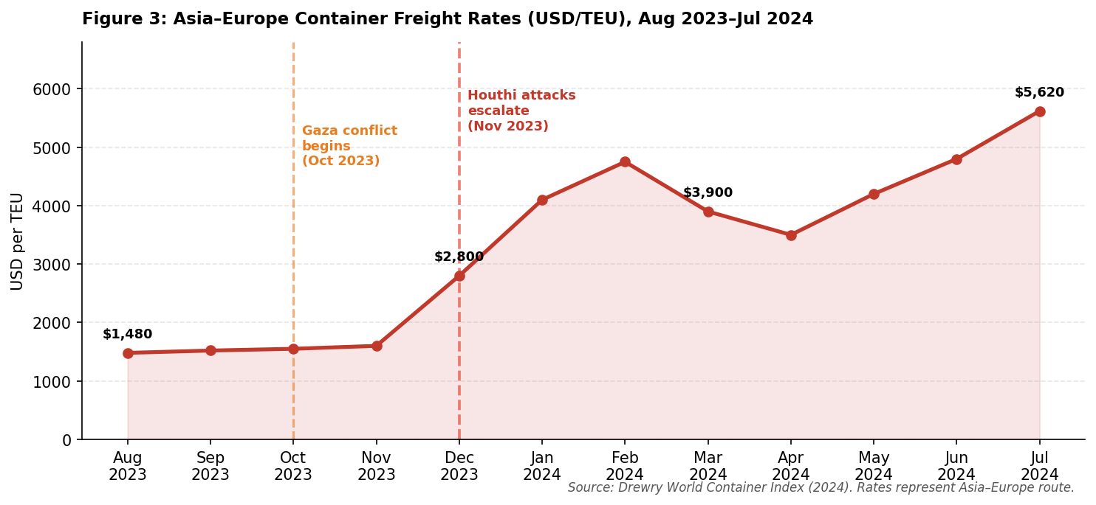
Figure 3: Asia–Europe Container Freight Rates (USD/TEU), August 2023 – July 2024. Note: Red Sea transit suspension by major carriers began December 2023. Source: Drewry World Container Index (2024).

To manufacturers who make net margins of 58%, high freight rates squeeze the profitability that cannot be readily transferred in the short-term. The IMF (2024) predicts the addition of 1.52 percentage points to EU import prices by Asian manufacturers, with Bangladesh being affected more than others. Further transit time (25-28 days to 38-42 days, Chittagong-Rotterdam) and puts working capital strain on seasonal lines. Long lead times increase the effect of the bullwhip effect, exaggerating the oscillations in demand in an upward direction and overloading remote manufacturers (Chopra and Meindl, 2016).

At home, the consumer price inflation stood at 9.94% in July 2024 (Bangladesh Bureau of Statistics, 2024), and the Taka has dropped to between BDT 85 and BDT 110 per USD. Although a portion of competitiveness offset is provided by the depreciation of the dollar-denominated cost of labour, essentially a pricing-to-market mechanism (Froot and Klemperer, 1989), increasing the cost of electricity and the limitation of LNG supply seriously mitigate this advantage, as noted by IMF (2024) as a key structural bottleneck to manufacturing competitiveness.

The Middle East is also an emerging consumer market- GCC nations imported USD 1.8 billion of Bangladeshi clothes in FY202223 (EPB, 2024) which is threatened by decline in demand due to conflict and consumer boycotts in Muslim-majority markets targeting brands linked to Israeli military activity. The brand equity framework by Keller (2013) cautions that scandals in the supply chain destroy consumer-based brand equity leaving the premium brand customers of Youngone with high consumer visibility within the impacted markets.

4.4 Legal Factors

To manufacturers who make net margins of 58%, high freight rates squeeze the profitability that cannot be readily transferred in the short-term. The IMF (2024) predicts the addition of 1.52 percentage points to EU import prices by Asian manufacturers, with Bangladesh being affected more than others. Further transit time (25-28 days to 38-42 days, Chittagong-Rotterdam) and puts working capital strain on seasonal lines. Long lead times increase the effect of the bullwhip effect, exaggerating the oscillations in demand in an upward direction and overloading remote manufacturers (Chopra and Meindl, 2016).

At home, the consumer price inflation stood at 9.94% in July 2024 (Bangladesh Bureau of Statistics, 2024), and the Taka has dropped to between BDT 85 and BDT 110 per USD. Although a portion of competitiveness offset is provided by the depreciation of the dollar-denominated cost of labour, essentially a pricing-to-market mechanism (Froot and Klemperer, 1989), increasing the cost of electricity and the limitation of LNG supply seriously mitigate this advantage, as noted by IMF (2024) as a key structural bottleneck to manufacturing competitiveness.

The Middle East is also an emerging consumer market- GCC nations imported USD 1.8 billion of Bangladeshi clothes in FY202223 (EPB, 2024) which is threatened by decline in demand due to conflict and consumer boycotts in Muslim-majority markets targeting brands linked to Israeli military activity. The brand equity framework by Keller (2013) cautions that scandals in the supply chain destroy consumer-based brand equity leaving the premium brand customers of Youngone with high consumer visibility within the impacted markets.

4.5 Cultural Factors
The cultural dimensions model by Hofstede (2011) can be used to offer a systematic method of examining the interface between the South Korean corporate culture of Youngone and the Muslim, Bengali-speaking, workforce in Bangladesh. McSweeney (2002) has criticised the national-level aggregation of Hofstede, but its relative usefulness in initial cross-cultural mapping is generally accepted (Taras et al., 2010).
South Korea has a moderate Power Distance score (60), a very high Long-Term Orientation score (100), and a high Uncertainty Avoidance score (85) - which indicates the hierarchical, future-oriented chaebol corporation model (Hofstede Insights, 2024). Bangladesh is very high in Power Distance (80) and Collectivism. Directive management is possible owing to the convergence on Power Distance, whereas friction arises due to divergence in Uncertainty Avoidance: the tendency of South Korean managers to use rigid process standardisation can clash with the relational, contextually flexible approach to problems adopted by Bangladeshi supervisors, resulting in performance deficits recorded by Newman and Nollen (1996) in cross-cultural management dyads.
The CAGE Framework by Ghemawat (2001) unveils additional cultural friction. The collective accountability model of loyalty practiced in South Korea contrasts sharply with the relational, face-saving culture of supervisory in Bangladesh- distance effects are strong in hierarchical production-based manufacturing-based (Shenkar, 2001). The information attenuation risks are posed by multilingual management chains of the Korean senior management down to the English-speaking mid-managers to the Bangla speaking workers. Religion practice such as Friday prayers, Ramadan patterns, long Eid holidays must be accommodated through conscious scheduling in line with Brannen and Salk (2000) notion of negotiated culture in subsidiaries in MNCs.
The 40 years of establishment in Bangladesh on the part of Youngone is institutional cultural capital- embedded tacit knowledge which is a major competitive edge over new entrants (Johanson and Vahlne, 2009). The recent minimum wage rise by BDT 8,000 to BDT 12,500 and the following worker uprisings can demonstrate the cultural accommodation is not fixed as it is an ongoing process (Islam and Parasnis, 2021) that needs to be adjusted based on the current circumstances and not on the historically rooted practices.
Cumulatively, the PESTLE analysis, designed by Dunning using OLI and Hofstede using dimensions, and CAGE, portrays the operations of Youngone in Bangladesh as both robust and vulnerable. The resilience is based on strong asset imbedding, diversified premium buyer relations, technical product complexity, and four decades of institutional knowledge all in line with how long-held subsidiaries of MNCs can surpass the liability of foreignness to create locally-embedded advantages that are unattainable by new entrants (Zaheer, 1995). The Middle East-based Red Sea crisis and a fast-changing regulatory environment out of control by firms create exposure. Rugman and Verbeke (2004) state that MNC advantage in host markets is based on location-specific firm-specific advantages that have been created through long-lasting local investment- that explains the continued existence of Youngone as well as the strategic risk of any situation that would force it to exit its operations. Its core strategic thrust is to capitalize on the strengths of the incumbents and take the initiative to ensure supply chain resilience, legal compliance infrastructure and cultural adaptive capacity that would be adequate to maintain competitive advantage amid an increasingly complex global business environment.
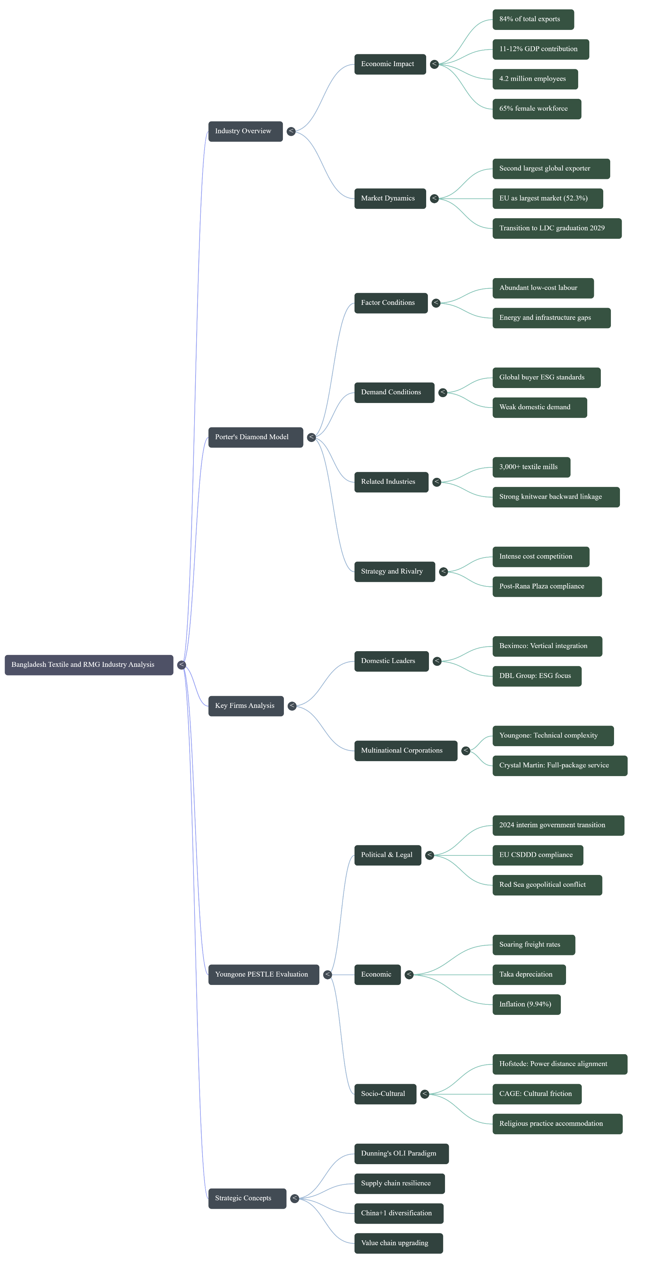Mind map: Bangladesh Ready-Made Garment Industry: A Strategic Framework

5. Conclusion
This report has explored the RMG industry in Bangladesh in a variety of analytical perspectives and has shown that this sector is one of exceptional competitive acuity that is supported by structural vulnerabilities that require immediate strategic response. Porters (1990) Diamond affirms competitive advantage which is based mostly on labour force scale and cost which are supplemented by the upstream cluster that is well developed and trade preference supported by the government. These benefits are under increasing pressure on two fronts: LDC graduation by 2029 posing a threat to EBA duty-free access (Raihan et al., 2022), and the geopolitical crisis in the Middle East structurally increasing the cost of the export supply chain and transit time (IMF, 2024).
The four-decade longevity of Youngone is the epitome of OLI logic (Dunning, 2001) but the convergence of the Red Sea shipping crisis, the domestic political shift and a growing due diligence pressure is a multidimensional risk environment that even experienced operators cannot wholly protect themselves against. Quadrupled freight rates, protracted transit times of 2528 to 3842 days and working capital strains directly squeeze margins in an industry with thin profitability. Sheffi (2005) contends that supply chain resilience, the ability to predict, react, and adapt to disruptions, has become a strategic competency that must be invested in through the provision of redundant routing paths, supplier diversification, and real-time supply chain visibility systems that convert operational agility into enduring competitive advantage.
In the twenty-first century global value chains, competitive advantage is becoming co-determined by geopolitical forces that are outside the control of any firm (Contractor, 2022). Classical frameworks have become essential analytical tools, including Porters Diamond, OLI, Hofstede, and have to be combined with geopolitical risk assessment as a fundamental strategic dimension (Witt et al., 2023). In the case of the RMG industry in Bangladesh, the need to remain competitive in the post-LDC era is clear: to stay competitive, investment into more advanced factor conditions, diversification of the product portfolio into both technical and man-made fibre segments, and supply chain resilience architectures that are less susceptible to geopolitical disruption are necessary. Market forces alone cannot achieve this change, it needs the type of intentional, co-ordinated policy intervention that Rodrik (2004) identifies as the institutional complement needed to attain market-driven competitiveness-a convergence of strategic will between the government, industry leadership, and international development partners that will eventually decide whether the current export miracle in Bangladesh continues after the LDC graduation point.

6. Reflective Account: Gibbs Reflective Cycle
This reflective report uses the Reflective Cycle model that was developed by Gibbs (1988) as a complex of six stages of reflection that can be identified as progressive stages of work: Description, Feelings, Evaluation, Analysis, Conclusion and Action Plan to critically analyse the process of researching, analysing, and preparing the previous international business report. According to Moon (2006), structured reflective frameworks can best be used systematically to apply to concrete learning experiences and turn experiential episodes into generalisable professional understandings.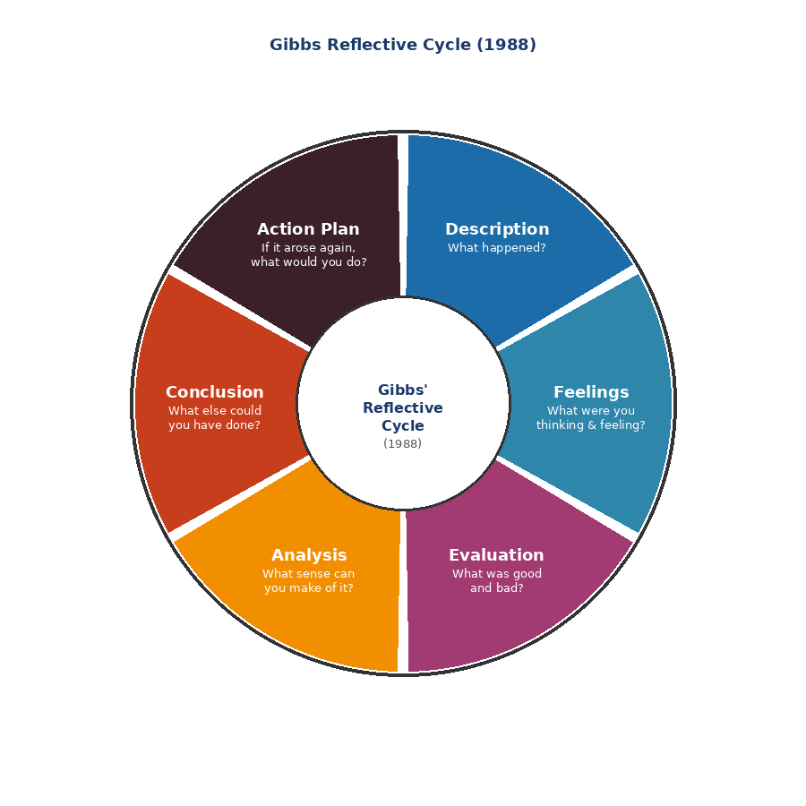
Figure 6: Gibbs’ Reflective Cycle (1988). Source: Adapted from Gibbs, G. (1988) Learning by Doing: A Guide to Teaching and Learning Methods. Oxford: Oxford Polytechnic.

6.1 Description

It conducted multi-stage research to prepare this international business report. Deliberate transformation of concrete experience into abstract conceptualisation is, according to Kolb (1984), the best way of generating learning. The RMG industry of Bangladesh was chosen due to the abundance of existing institutional data (BGMEA, World Bank, ILO), theoretical richness in a key juncture in development (LDC graduation, political transition), and modern relevance due to Middle East geopolitical supply chain disruptions.

A source hierarchy based on level of tier was used in research: academic databases provided peer-reviewed theory, BGMEA, World Bank, ILO, EPB and IMF publications contained empirical information. Youngone Corporation was chosen as the central MNC because of its history of four decades of operations in Bangladesh, its significant public reporting and its direct involvement in the Red Sea crisis due to EU-led exports. Frameworks were used as critical evidence tools and not as description checklists.

6.2 Feelings

The first confidence based on previous participation in MBA frameworks was replaced by unexpected complexity, which provided intellectual stimulation and epistemic frustration that Boud et al. (1985) consider to be the key to triggers of deep reflective engagement.

The geopolitical aspect, especially the Houthi Red Sea attacks and their supply chain economics needed to be involved in the politics and security studies sphere far outside of the normal international business courses. Measuring the commercial cost of logistics disruption caused by conflicts required methodological nimbleness, and I felt a sense of genuine uncertainty in accepting conflicted data on freight offered by Drewry versus Freightos Baltic Index suppliers, and in accepting early FY202324 export data whose revision history was ambiguous. The most problematic aspect was the political transition of August 2024: since there was virtually no peer-reviewed literature on the topic of such a recent event, I had to use journalistic sources and think-tank analyses, the epistemological quality of which had to be assessed with a high level of care before being integrated into the analytical framework.

6.3 Evaluation

Being honest in the process means recognizing both strengths and limitations- a balanced judgment which Gibbs (1988) states as one of the key elements in reflective practice. On the positive side, the choice of Youngone Corporation was analytically fruitful: the four decades of operational history gave the study longitudinal depth; the complexity of technical products facilitated Porters-Diamond demand analysis; and the Red Sea exposure gave the report an authentic contemporary relevance, making it more than an exercise in the application of a framework. The combination of Hofstede dimensions and CAGE produced a more cultural distance explanation than either of the two frameworks alone- as Shenkar (2001) claims multi-lens cultural analysis exposes aspects of cross-national distance that none of the single-framework methods can, an observation made as much by the nature of the analytical process itself as by design.

The main constraint was the lack of peer-reviewed literature on the events in 20232024, which resulted in the reliance on grey literature, which is a structural issue of applied social science research on events that unfold and happen quickly (Bryman, 2016). BGMEA reporting also exhibited institutional data bias, which had to be triangulated with independent sources to counter systematically positive reporting.

6.4 Analysis

This experience throws light on important methodological lessons. First, the assessment of source credibility needs to be evidence-based not category-based: IMF Outlooks, UN Security Council reports, and ILO Better Work syntheses are created with high standards of methodology that are often higher than popular media. Merriam and Tisdell (2016) advocate the use of institutional independence and methodological transparency as the means of evaluating the sources instead of the type of publication.

Second, the simultaneous application of several frameworks may lead to superficial coverage. The MNC analysis was best analytically generative when using OLI and CAGE; Diamond by Porter is structurally useful but presents a relatively stagnant competitiveness account capable of explaining geopolitically induced disruptions, a weakness Rugman and Verbeke (2004) attribute to volatile global environments. It could have been better to have been more deliberate and question-driven in the selection of the frameworks to enhance the depth of analysis.

Third, frameworks should be seen as guidelines and not template. The most valuable learning occurred not in filling in framework boxes but in challenging frameworks to evidence - asking questions about the interplay of Diamond determinants that are not expected or where OLI logic fails to work with geopolitical pressure (Verbeke, 2013). The concept of the reflective practitioner presented by Schon (1983) can be directly applied: the ability to reformulate analytical problems based on the new evidence is the distinguishing feature of the level of intellectual practice.

6.5 Conclusion

In retrospect, framework choice would have been more judiciously fine-tuned: OLI and CAGE as the main MNC frameworks, Porters Diamond as industry competitiveness, and PESTLE as environmental scanning, with the understanding that PESTLE would be the environmental scanning framework, and that OLI and CAGE would be the frameworks within which industry competitiveness is framed, i.e. a hierarchical The collection of information took too much of the available time, which resulted in the lack of enough time to do the further analytical and synthesis work that marks the difference level scholarship and merit level scholarship. More initial investment in a systematic research plan would have made it possible to move to critical analysis sooner.

More open citation practices, as well as minimized unconscious use of sources of variable methodological quality, would have been enabled by a consciously constructed source matrix, which, based on the approach of Creswell and Creswell (2018), is the recommended practice in the methodological discipline.

6.6 Action Plan
These lessons can be converted to action-driven promises in future research practice. First, I will develop an explicit map of theoretical frameworks at the beginning of each project- that is, which frameworks are most generative analytically to the research question, and will assign each framework a specific word count, as opposed to giving equal attention to all possible frameworks. This intentional prioritisation averts superficial multiple-framework coverage such as this research experience has shown as one looming danger. Second, in geopolitically dynamic research scenarios, I will put primary emphasis in geopolitically dynamic research on international organisation sources (IMF, World Bank, ILO, OECD) and established think-tanks (Chatham House, Brookings Institution, Centre for Policy Dialogue) as primary grey literature, with journalistic sources being used only as sources of factual chronology but not sources of analytical interpretation. Third, I will use reflexive journaling as I go on with the research process and not on a post-hoc basis- Moon (2006) asserts that current reflection can capture both methodological decisions and analytical choices which are definitely lost in a post-hoc reflection alone- which is in line with the concept of reflection-in-action by Schon (1983) where self-monitoring and real-time adapt Fourth, and last, I will ensure that I seek a structured peer feedback during the stage of analytical frameworks, before substantive drafting will start, to determine structural weaknesses with minimal revision costs and correction still easy, by exploiting the formative feedback cycles demonstrated by Nicol and Macfarlane-Dick (2006) to achieve self-regulated learning outcomes with a significant difference in academic research at the graduate level.

References
- Akter, S., Jamal, N. and Faruk, O. (2020) 'Post-Rana Plaza: Compliance and competitive transformation in Bangladesh's garment sector', Journal of Cleaner Production, 265, p. 121595. doi: 10.1016/j.jclepro.2020.121595
- Bangladesh Bureau of Statistics (BBS) (2024) Consumer Price Index: July 2024 Update. Dhaka: Bangladesh Bureau of Statistics.
- Bangladesh Export Processing Zones Authority (BEPZA) (2023) Annual Report 2022–23. Dhaka: BEPZA.
- Bangladesh Garment Manufacturers and Exporters Association (BGMEA) (2024) Annual Report 2023–24. Dhaka: BGMEA.
- Bangladesh Investment Development Authority (BIDA) (2024) Investment Incentives and Facilities. Dhaka: BIDA.
- BBC (2024) 'Bangladesh PM Sheikh Hasina resigns amid protests and flees country', BBC News, 5 August 2024. Available at: https://www.bbc.com/news/articles/c9dl1gvkln5o (Accessed: 10 March 2025).
- Beximco Limited (2023) Annual Report 2022–23. Dhaka: Beximco Limited.
- Better Work (2024) Bangladesh Garment Industry: Compliance Synthesis Report 2023–24. Geneva: ILO/IFC.
- Bhattacharya, D. and Rahman, M. (1999) 'Female employment under export-propelled industrialisation: Prospects for internalising global opportunities in Bangladesh's apparel sector', UNCTAD Discussion Papers, No. 143. Geneva: UNCTAD.
- BMAS (Federal Ministry of Labour and Social Affairs, Germany) (2023) The Supply Chain Due Diligence Act: Information for Companies. Berlin: BMAS.
- Centre for Policy Dialogue (CPD) (2023) State of the Bangladesh Economy: An Interim Review, FY2022–23. Dhaka: CPD.
- DBL Group (2023) Sustainability Report 2022–23. Dhaka: DBL Group.
- Drewry Shipping Consultants (2024) World Container Index: Weekly Reports, August 2023 – July 2024. London: Drewry. Available at: https://www.drewry.co.uk (Accessed: 12 March 2025).
- Dunning, J.H. (2001) 'The eclectic (OLI) paradigm of international production: Past, present and future', International Journal of the Economics of Business, 8(2), pp. 173–190. doi:10.1080/13571510110051441
- European Commission (2023) Generalised Scheme of Preferences: Bangladesh Country Profile. Brussels: European Commission Directorate-General for Trade.
- Export Promotion Bureau (EPB) (2024) Export Performance Statistics: FY2022–23. Dhaka: Ministry of Commerce, Government of Bangladesh.
- Ghemawat, P. (2001) 'Distance still matters: The hard reality of global expansion', Harvard Business Review, 79(8), pp. 137–147.
- Gibbs, G. (1988) Learning by Doing: A Guide to Teaching and Learning Methods. Oxford: Oxford Polytechnic.
- Hofstede Insights (2024) Country Comparison Tool: Bangladesh and South Korea. Available at: https://www.hofstede-insights.com (Accessed: 11 March 2025).
- International Labour Organization (ILO) (2023) Decent Work in Global Supply Chains: Bangladesh Sectoral Update 2022–23. Geneva: ILO.
- International Monetary Fund (IMF) (2024) World Economic Outlook Update: July 2024 – The Global Economy in a Sticky Spot. Washington DC: IMF.
- McKinsey & Company (2023) The State of Fashion: Sportswear. New York: McKinsey & Company and The Business of Fashion.
- Moon, J.A. (2006) Learning Journals: A Handbook for Reflective Practice and Professional Development. 2nd edn. London: Routledge.
- Porter, M.E. (1990) The Competitive Advantage of Nations. New York: The Free Press.
- United Nations Security Council (2024) Report of the Panel of Experts on Yemen, S/2024/183. New York: United Nations.
- Verbeke, A. (2013) International Business Strategy: Rethinking the Foundations of Global Corporate Success. 2nd edn. Cambridge: Cambridge University Press.
- World Intellectual Property Organization (WIPO) (2023) Global Innovation Index 2023: Innovation in the Face of Uncertainty. Geneva: WIPO.
- World Bank (2024) Bangladesh Development Update: Navigating Headwinds. Washington DC: World Bank Group.
- Youngone Corporation (2023) Integrated Sustainability Report 2022–23. Seoul: Youngone Corporation.
- Altenburg, T., Schmitz, H. and Stamm, A. (2008) ‘Breakthrough? China’s and India’s transition from production to innovation’, World Development, 36(2), pp. 325–344. doi: 10.1016/j.worlddev.2007.06.011
- Barney, J. (1991) ‘Firm resources and sustained competitive advantage’, Journal of Management, 17(1), pp. 99–120. doi:10.1177/014920639101700108
- Barrientos, S. and Smith, S. (2007) ‘Do workers benefit from ethical trade? Assessing codes of labour practice in global production systems’, Third World Quarterly, 28(4), pp. 713–729. doi:10.1080/01436590701336580
- Barrientos, S., Gereffi, G. and Rossi, A. (2011) ‘Economic and social upgrading in global production networks: A new paradigm for a changing world’, International Labour Review, 150(3–4), pp. 319–340. doi:10.1111/j.1564-913X.2011. 00119.x
- Boud, D., Keogh, R. and Walker, D. (eds.) (1985) Reflection: Turning Experience into Learning. London: Kogan Page.
- Brannen, M.Y. and Salk, J.E. (2000) ‘Partnering across borders: Negotiating organisational culture in a German–Japanese joint venture’, Human Relations, 53(4), pp. 451–487. doi:10.1177/0018726700534001
- Bryman, A. (2016) Social Research Methods. 5th edn. Oxford: Oxford University Press.
- Buckley, P.J. and Casson, M. (1976) The Future of the Multinational Enterprise. London: Macmillan.
- Cadot, O., Carrere, C. and Strauss-Kahn, V. (2014) ‘Trade diversification, income, and growth: What do we know?’, Journal of Economic Surveys, 27(4), pp. 790–812. doi:10.1111/joes.12059
- Chopra, S. and Meindl, P. (2016) Supply Chain Management: Strategy, Planning, and Operation. 6th edn. Harlow: Pearson.
- Choudhury, M., Salman, A. and Yusuf, M. (2019) ‘Consumer boycotts in the Muslim world: Political expression through market action’, Journal of Islamic Marketing, 10(3), pp. 948–965. doi:10.1108/JIMA-08-2017-0095
- Contractor, F.J. (2022) ‘The world economy will need even more globalisation in the post-pandemic 2021 decade’, Journal of International Business Studies, 53(1), pp. 156–171. doi:10.1057/s41267-020-00394-y
- Creswell, J.W. and Creswell, J.D. (2018) Research Design: Qualitative, Quantitative, and Mixed Methods Approaches. 5th edn. Thousand Oaks, CA: SAGE Publications.
- Dunning, J.H. and Lundan, S.M. (2008) Multinational Enterprises and the Global Economy. 2nd edn. Cheltenham: Edward Elgar.
- Fernandez-Stark, K., Frederick, S. and Gereffi, G. (2011) ‘The apparel global value chain: Economic upgrading and workforce development’, in Gereffi, G., Bamber, P. and Frederick, S. (eds.) Skills for Upgrading: Workforce Development and Global Value Chains in Developing Countries. Durham, NC: Duke University, pp. 67–110.
- Froot, K.A. and Klemperer, P.D. (1989) ‘Exchange rate pass-through when market share matters’, American Economic Review, 79(4), pp. 637–654.
- Gereffi, G. and Lee, J. (2012) ‘Why the world suddenly cares about global supply chains’, Journal of Supply Chain Management, 48(3), pp. 24–32. doi:10.1111/j.1745-493X.2012. 03271.x
- Gereffi, G. and Memedovic, O. (2003) The Global Apparel Value Chain: What Prospects for Upgrading by Developing Countries. Vienna: UNIDO.
- Gereffi, G., Humphrey, J. and Sturgeon, T. (2005) ‘The governance of global value chains’, Review of International Political Economy, 12(1), pp. 78–104. doi:10.1080/09692290500049805
- Harrigan, K.R. (1985) ‘Vertical integration and corporate strategy’, Academy of Management Journal, 28(2), pp. 397–425. doi:10.2307/256208
- Hofstede, G. (2011) ‘Dimensionalising cultures: The Hofstede model in context’, Online Readings in Psychology and Culture, 2(1). doi:10.9707/2307-0919.1014
- Hossain, M. (2018) ‘The EU’s Everything but Arms initiative and Bangladesh’s RMG exports: A gravity model analysis’, Journal of International Trade and Economic Development, 27(4), pp. 384–400. doi:10.1080/09638199.2017.1390949
- Hummels, D. (2007) ‘Transportation costs and international trade in the second era of globalisation’, Journal of Economic Perspectives, 21(3), pp. 131–154. doi:10.1257/jep.21.3.131
- Humphrey, J. and Schmitz, H. (2002) ‘How does insertion in global value chains affect upgrading in industrial clusters?’, Regional Studies, 36(9), pp. 1017–1027. doi:10.1080/0034340022000022198
- Islam, A. and Parasnis, J. (2021) ‘Labour market conditions and female labour force participation in Bangladesh’, Economic Analysis and Policy, 72, pp. 248–264. doi: 10.1016/j.eap.2021.08.006
- Javorcik, B.S. (2004) ‘Does foreign direct investment increase the productivity of domestic firms? In search of spillovers through backward linkages’, American Economic Review, 94(3), pp. 605–627. doi:10.1257/0002828041464605
- Johanson, J. and Vahlne, J.E. (2009) ‘The Uppsala internationalisation process model revisited: From liability of foreignness to liability of outsidership’, Journal of International Business Studies, 40(9), pp. 1411–1431. doi:10.1057/jibs.2009.24
- Kabeer, N. and Mahmud, S. (2004) ‘Globalisation, gender and poverty: Bangladeshi women workers in export and local markets’, Journal of International Development, 16(1), pp. 93–109. doi:10.1002/jid.1065
- Kaplinsky, R. and Morris, M. (2001) A Handbook for Value Chain Research. Brighton: Institute of Development Studies.
- Keller, K.L. (2013) Strategic Brand Management: Building, Measuring, and Managing Brand Equity. 4th edn. Harlow: Pearson.
- Kobrin, S.J. (1979) ‘Political risk: A review and reconsideration’, Journal of International Business Studies, 10(1), pp. 67–80. doi: 10.1057/palgrave.jibs.8490631
- Kogut, B. and Zander, U. (1993) ‘Knowledge of the firm and the evolutionary theory of the multinational corporation’, Journal of International Business Studies, 24(4), pp. 625–645. doi: 10.1057/palgrave.jibs.8490248
- Kolb, D.A. (1984) Experiential Learning: Experience as the Source of Learning and Development. Englewood Cliffs, NJ: Prentice-Hall.
- Labowitz, S. and Baumann-Pauly, D. (2015) Beyond the Tip of the Iceberg: Bangladesh’s Forgotten Apparel Workers. New York: NYU Stern Center for Business and Human Rights.
- Lim, S.J. and Phillips, J. (2008) ‘Embedding CSR values: The global footwear industry’s evolving governance structure’, Journal of Business Ethics, 81(1), pp. 143–156. doi:10.1007/s10551-007-9485-0
- Marshall, A. (1920) Principles of Economics. 8th edn. London: Macmillan.
- McSweeney, B. (2002) ‘Hofstede’s model of national cultural differences and their consequences: A triumph of faith – a failure of analysis’, Human Relations, 55(1), pp. 89–118. doi:10.1177/0018726702551004
- Merriam, S.B. and Tisdell, E.J. (2016) Qualitative Research: A Guide to Design and Implementation. 4th edn. San Francisco, CA: Jossey-Bass.
- Moazzem, K.G. and Sehrin, F. (2016) ‘Economic governance of Bangladesh’s readymade garment sector: A review of policies and institutions’, South Asia Economic Journal, 17(1), pp. 80–104. doi:10.1177/1391561415621578
- Moon, H.C., Rugman, A.M. and Verbeke, A. (1998) ‘A generalised double diamond approach to the global competitiveness of Korea and Singapore’, International Business Review, 7(2), pp. 135–150. doi:10.1016/S0969-5931(98)00002-X
- Mottaleb, K.A. and Sonobe, T. (2011) ‘An inquiry into the rapid growth of the garment industry in Bangladesh’, Economic Development and Cultural Change, 60(1), pp. 67–89. doi:10.1086/661218
- Neidik, B. and Gereffi, G. (2006) ‘Explaining Turkey’s emergence and sustained competitiveness as a full-package supplier of apparel’, Environment and Planning A, 38(12), pp. 2285–2303. doi:10.1068/a38219
- Newman, K.L. and Nollen, S.D. (1996) ‘Culture and congruence: The fit between management practices and national culture’, Journal of International Business Studies, 27(4), pp. 753–779. doi: 10.1057/palgrave.jibs.8490152
- Nicol, D.J. and Macfarlane-Dick, D. (2006) ‘Formative assessment and self-regulated learning: A model and seven principles of good feedback practice’, Studies in Higher Education, 31(2), pp. 199–218. doi:10.1080/03075070600572090
- Park, W.G. and Lippoldt, D. (2008) ‘Technology transfer and the economic implications of the strengthening of intellectual property rights in developing countries’, OECD Trade Policy Papers, No. 62. Paris: OECD.
- Pietrobelli, C. and Rabellotti, R. (2011) ‘Global value chains meet innovation systems: Are there learning opportunities for developing countries?’, World Development, 39(7), pp. 1261–1269. doi: 10.1016/j.worlddev.2010.12.008
- Ponte, S. and Gibbon, P. (2005) ‘Quality standards, conventions and the governance of global value chains’, Economy and Society, 34(1), pp. 1–31. doi:10.1080/0308514042000329315
- Porter, M.E. (1998) ‘Clusters and the new economics of competition’, Harvard Business Review, 76(6), pp. 77–90.
- Porter, M.E. and Kramer, M.R. (2011) ‘Creating shared value’, Harvard Business Review, 89(1–2), pp. 62–77.
- Raihan, S., Ferdous Hossain, S.M. and Islam, S. (2022) ‘LDC graduation and its implications for the RMG sector of Bangladesh’, South Asian Journal of Business Studies, 11(2), pp. 186–206. doi:10.1108/SAJBS-02-2021-0059
- Rashid, M.A. (2006) ‘Rise of readymade garments industry in Bangladesh: Entrepreneurial ingenuity or public policy’, Paper presented at the Workshop on Governance and Development, Dhaka, Bangladesh, 11–12 November 2006.
- Rhee, Y.W. (1990) ‘The catalyst model of development: Lessons from Bangladesh’s success with garment exports’, World Development, 18(2), pp. 333–346. doi:10.1016/0305-750X(90)90117-R
- Rodrik, D. (2004) ‘Industrial policy for the twenty-first century’, UNIDO Working Paper. Available at: https://www.sss.ias.edu/files/pdfs/Rodrik/Research/industrial-policy-twenty-first-century.pdf (Accessed: 15 March 2025).
- Rugman, A.M. and D’Cruz, J.R. (1993) ‘The “double diamond” model of international competitiveness: The Canadian experience’, Management International Review, 33(Special Issue 2), pp. 17–39.
- Rugman, A.M. and Verbeke, A. (2004) ‘A perspective on regional and global strategies of multinational enterprises’, Journal of International Business Studies, 35(1), pp. 3–18. doi: 10.1057/palgrave.jibs.8400073
- Schmitz, H. and Knorringa, P. (2000) ‘Learning from global buyers’, Journal of Development Studies, 37(2), pp. 177–205. doi:10.1080/713600072
- Schon, D.A. (1983) The Reflective Practitioner: How Professionals Think in Action. New York: Basic Books.
- Sheffi, Y. (2005) The Resilient Enterprise: Overcoming Vulnerability for Competitive Advantage. Cambridge, MA: MIT Press.
- Shenkar, O. (2001) ‘Cultural distance revisited: Towards a more rigorous conceptualisation and measurement of cultural differences’, Journal of International Business Studies, 32(3), pp. 519–535. doi: 10.1057/palgrave.jibs.8490982
- Staritz, C. (2011) Making the Cut? Low-Income Countries and the Global Clothing Value Chain in a Post-Quota and Post-Crisis World. Washington DC: World Bank.
- Taras, V., Kirkman, B.L. and Steel, P. (2010) ‘Examining the impact of Culture’s consequences: A three-decade, multilevel, meta-analytic review of Hofstede’s cultural value dimensions’, Journal of Applied Psychology, 95(3), pp. 405–439. doi:10.1037/a0018938
- Teece, D.J., Pisano, G. and Shuen, A. (1997) ‘Dynamic capabilities and strategic management’, Strategic Management Journal, 18(7), pp. 509–533. doi:10.1002/(SICI)1097-0266(199708)18:7<509::AID-SMJ882>3.0.CO;2-Z
- Waverman, L. (1995) ‘A critical analysis of Porter’s framework on the competitive advantage of nations’, in Rugman, A.M., Van Den Broeck, J. and Verbeke, A. (eds.) Research in Global Strategic Management. Greenwich, CT: JAI Press, pp. 67–116.
- Witt, M.A., De Castro, L.R.K., Amaeshi, K., Mahroum, S., Bohle, D. and Saez, L. (2023) ‘Mapping the business systems of 61 major economies: A taxonomy and implications for varieties of capitalism and business systems research’, Socio-Economic Review, 21(4), pp. 1875–1924. doi:10.1093/ser/mwac060
- Zaheer, S. (1995) ‘Overcoming the liability of foreignness’, Academy of Management Journal, 38(2), pp. 341–363. doi:10.2307/256683
- Zerk, J.A. (2010) ‘Extraterritorial jurisdiction: Lessons for the business and human rights sphere from six regulatory areas’, Corporate Social Responsibility Initiative Working Paper, No. 59. Cambridge, MA: Harvard Kennedy School.

