Appendices

Appendix A

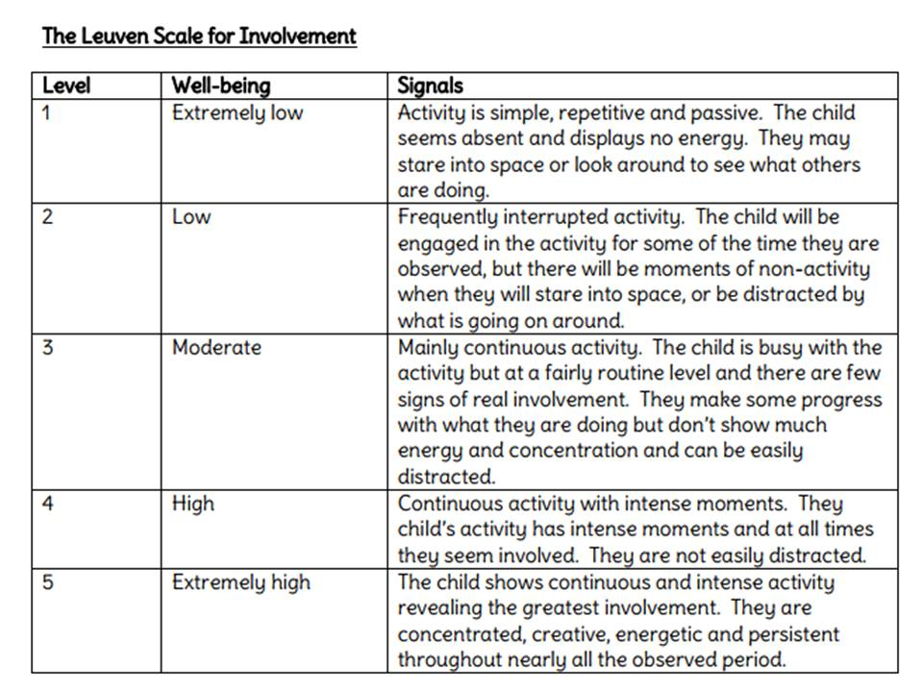

Appendix B
Information sheet.
What the research is trying to find out?
The research is trying to find out how can we improve pupils’ engagement (regarding learning objectives) by using the differentiated success criteria?
What is the purpose of the research?
The purpose of this small-scale research study is to work collaboratively with another student teacher to plan, develop and deliver a lesson to pupils that will be observed to focus on children’s learning.
Who is carrying it out the research?
Myself Francesca Morris and my research partner Lauren Parsons will be carrying out the essay.
What will be asked of participants?
The participants will be asked to use the differentiated success criteria throughout the lesson, then the selected three children will be asked to participate in a focused group interview where they will be provided myself and my research partner their opinion on using the differentiated success criteria.
How the information they provide will be recorded?
The information they provide will be audio recorded.

What will then happen to the data?
The data will be retained in a safe and secure manner – password protected file until the completion of the P-PGCE programme. Hard copies of any records will be stored securely in a locked cupboard
What degree of confidentiality and anonymity is afforded?
At all times, data collection will adhere to the University and BERA guidelines. To ensure participants have the right to privacy, I will manage the research data with confidentiality and anonymity. The use of pseudonyms for the participants will be given, Child A, Child B and Child C. Therefore as a result, no individuals can be identified in any way. Data will be shared with my research partner in order to discuss and analyse results. However the data shared will ensure participants are not identifiable. To ensure anonymity, the data collected will not include information such as address, date of birth or background information regarding the pupils. The data that will be collected, will be specific to the research study.
- How the information will be analysed?
The information will be analysed using qualitative methods.
- How will the findings will be reported?
The findings of the research study will be reported both orally and in written form. However, If the results are request, it will be provided on request to the school and the participants
Who will see the results of the study?
I and my research partner will see the results of the study, alongside the university on submitting of the research study. However, If the results are request, it will be provided on request to the school and the participants. The results will be provided orally and in written form.

Appendix C
Reflection Proforma

Date:
Reflection of:

Autobiographical lens:

Students’ lens:

Colleagues lens:

Theoretical lens:

Appendix D

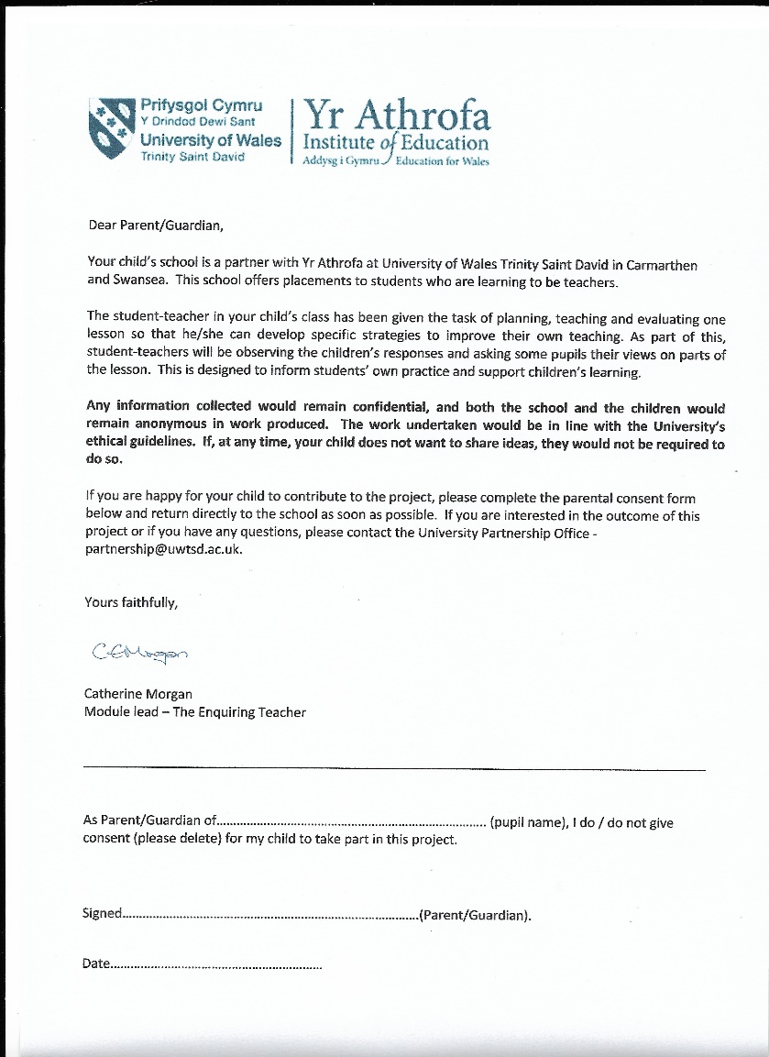

Appendix E
Observation Sheet

Name of teacher: Fran Morris Date:15/02 School X or Y: Y
Name of observer: Lauren Parsons Time: 9.15 am Year Group: 4
Lesson objective: To produce the final draft our monster poem
Time | Child A | Child B | Child C
9.25 am | 3 | 2 | 4
9.40 am | 3 | 3 | 4
9.55 am | 3 | 3 | 5

Level | Engagement | Description
1 | Extremely low | The activity is non goal- orientated, simple and repetitive. The child gives minimal contribution throughout the lesson and needs constant reminding of the lesson objective. The child has a passive attitude and seems to be in a day dreamer state. The child fails to acknowledge the success criteria and produces little to no work.
2 | Low | There are frequent disruptions during the activity. The child is engaged for short periods of the lesson, but there still is a tendency to get distracted. The child produces minimal work expected and takes time to follow instructions. There is very little engagement towards the success criteria.
3 | Moderate | The child has limited motivation to engage in the lesson. They have made very little progress and at times are still distracted by what is going on around. The child does not use his/her capabilities to full extent, only showing moderate progress towards the success criteria.
4 | High | The child is constantly focused and is involved in the task at all times. The child is addressing the success criteria frequently, and shows greater understanding of the activity set. The engagement levels of the children are high and are not easily distracted.
5 | Extremely high | The child constantly adheres and address the success criteria. The child is highly motivated to challenge their learning and focussed throughout the activity. They are energetic, motived and eager to engage fully in the lesson.

Appendix F
Interview Question Responses
      - Have you used a differentiated SC checklist before in any lessons?
Pupil A: no
Pupil B: no
Pupil C: no

      - How do you feel about having a differentiated SC checklist to support your learning?
Pupil A: Yes, it helps me to remember to use capital letters and full stops.
Pupil B: Yes, it helps me to remember to use similes
Pupil C: Yes, it helps me to remember to use capital letters and full stops.

      - Do you feel that the checklist affected your engagement towards the learning objectives? If so, how?
Pupil A: Yes, as it helped me understand what is meant by the wording of the learning objective.
Pupil B: Yes, it helped me to remember what I had to do to achieve the learning objective.
Pupil C: Yes, it made me feel that the learning objective was more achievable

      - Do you feel engagement level towards the learning objective was higher at certain times of the lesson? If so when?
Pupil A: Yes, at the middle of the lesson, as it reminded me what I had to do to complete the task.
Pupil B: Yes, at the middle of the lesson, as this time, I had more stuff to complete and read about during the task.
Pupil C: Yes, at the end of the lesson, as at this time I thought about extra things to add to my work.
      - Is there anything you would change about the differentiated SC checklist?
Pupil A: No I wouldn’t change anything but it is a good thing to use. It is easy to read and easy to use.
Pupil B: Yes I would like the checklist to be made smaller and not so many points on the sheet. I would include a peer assessment.
Pupil C: No I wouldn’t change anything but it’s a good thing to use improve our work
      - Do you think is another way in which we could use the differentiated success criteria to improve your engagement of the learning objectives?
Pupil A: No, this sheet was helpful and useful
Pupil B: No, this sheet was helpful and useful
Pupil C: No, this sheet was helpful and useful

Appendix G
Observation Sheet

Name of teacher: Lauren Parsons Date:21/02 School X or Y: X
Name of observer: Fran Morris Time: 9.30 Year Group: 4
Lesson objective: I can compare different types of rocks

Time | Child A | Child B | Child C
9.50 am | 2 | 2 | 3
10.10 am | 1 | 3 | 3
10.30 am | 2 | 5 | 4
Level | Engagement | Description
1 | Extremely low | The activity is non goal- orientated, simple and repetitive. The child gives minimal contribution throughout the lesson and needs constant reminding of the lesson objective. The child has a passive attitude and seems to be in a day dreamer state. The child fails to acknowledge the success criteria and produces little to no work.
2 | Low | There are frequent disruptions during the activity. The child is engaged for short periods of the lesson, but there still is a tendency to get distracted. The child produces minimal work expected and takes time to follow instructions. There is very little engagement towards the success criteria.
3 | Moderate | The child has limited motivation to engage in the lesson. They have made very little progress and at times are still distracted by what is going on around. The child does not use his/her capabilities to full extent, only showing moderate progress towards the success criteria.
4 | High | The child is constantly focused and is involved in the task at all times. The child is addressing the success criteria frequently, and shows greater understanding of the activity set. The engagement levels of the children are high and are not easily distracted.

Appendix H
Semi-structured interview responses – School X
Q1 Have you used a differentiated SC checklist before in any lessons?
Pupil C -Yes, quite a few times
Pupil B -Yes, normally literacy
Pupil A – Yes, in topic

Q. 2 How do you feel about having a differentiated SC checklist to support your learning?
Pupil C – I think it’s better because it shows you what you need to do and what you shouldn’t do
Pupil B – I think it is good as you’re doing what you’re comfortable with
Pupil A– It didn’t help my learning, I already remembered what I had to do

Q.3 Do you feel that the checklist affected your engagement towards the learning objective? If so, why?
Pupil C – Yes, because it showed me what to do and that’s how I kept on task
Pupil B – Yes, it helped me to focus and remember what I had to include in my writing. If I wanted it to be perfect, I know I could use it to help me.
Pupil A– No, because I’m alright without it.

Q.4 Do you feel engagement level towards the LO was higher at certain times of the lesson? If so, why?
Pupil C – The middle because in the middle we had to switch around and when we went from looking at one rock we went to look at another so it helped me to remember
Pupil B – the start because I was really into writing about the rocks and the SC helped me to remember to describe what it felt like.
Pupil A – the end of the lesson because I didn’t really use it that much in the beginning. I ticked off everything I did in the end

Q.5 Is there anything you would change about the differentiated SC checklist?
Pupil C – We could have fitted another box in that we had to write about. I do like the way it was set out
Pupil B – I think that there should be a box for the teacher and us to be able to comment as well as our peers. And to include a box for a way forward, what we think we should improve and what the teacher thinks we could improve
Pupil A – No. I liked it.

Q6. Do you think there is another way in which we could use the differentiated SC to improve your engagement of the LO?
Pupil C – No, I liked it. It was helpful today.
Pupil B – To use it in a lesson like maths to remind us to put numbers in each box and different steps to make sure we can do it.
Pupil A – No, not really.

