DS 1 Template

My Screenshots/Photos
- Please add 4–6 screenshots or photos of your digital life.
- You can use your phone or laptop.
- For each screenshot, write one or two sentences explaining what it shows.

Screenshot/Photo 1
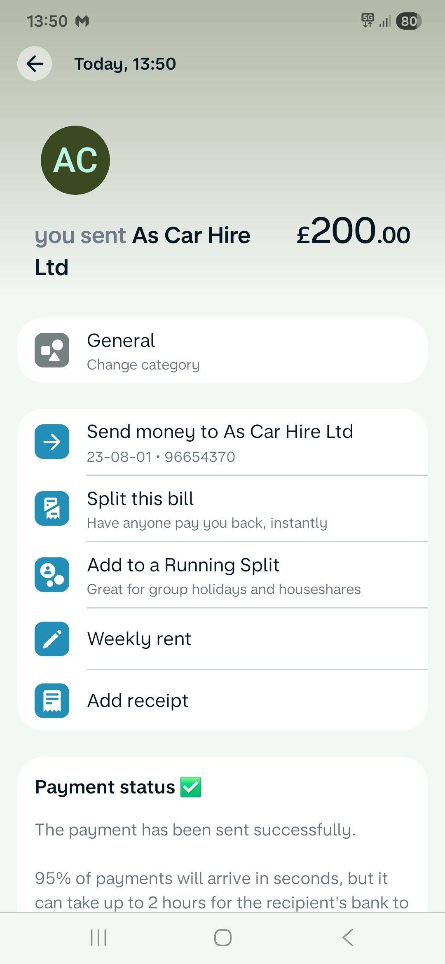
This screenshot shows how I organise my finances and the payments which I am doing every week.

Screenshot/Photo 2
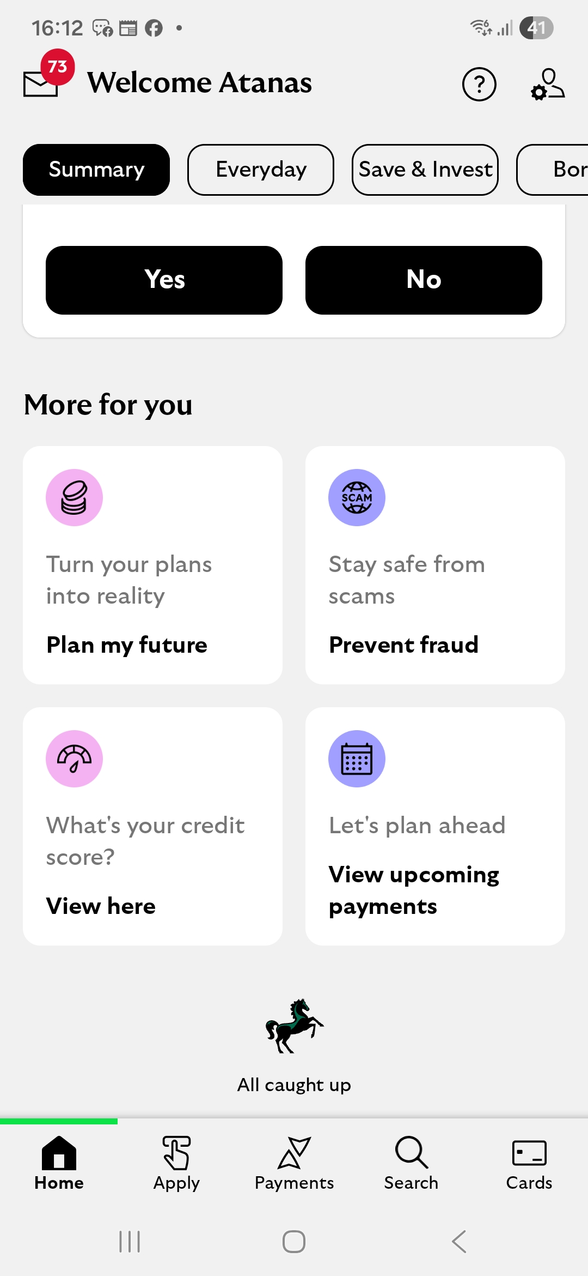
This is another banking app screenshot where I am checking my monthly incomes.

Screenshot/Photo 3
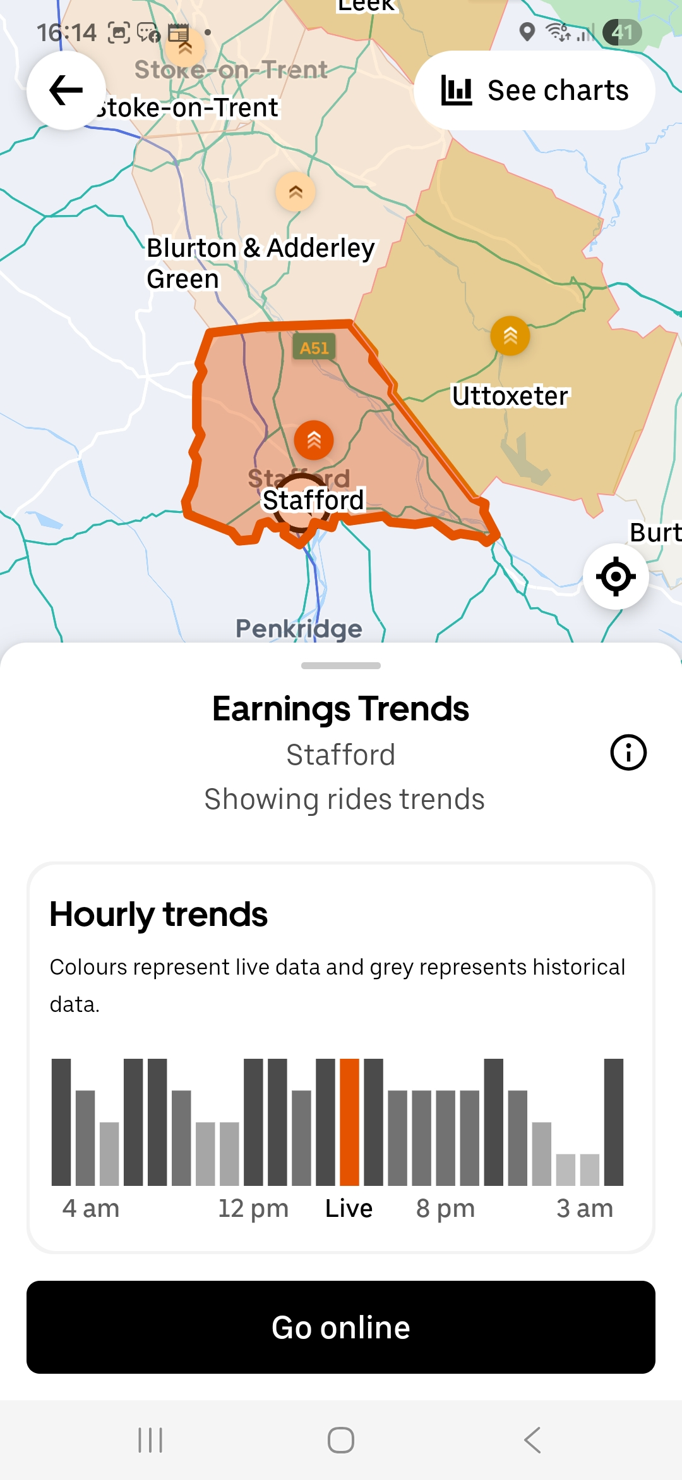
This is screenshot from Uber app where I am reading/checking information and collecting data about the expected level of earnings hourly.

Screenshot/Photo 4
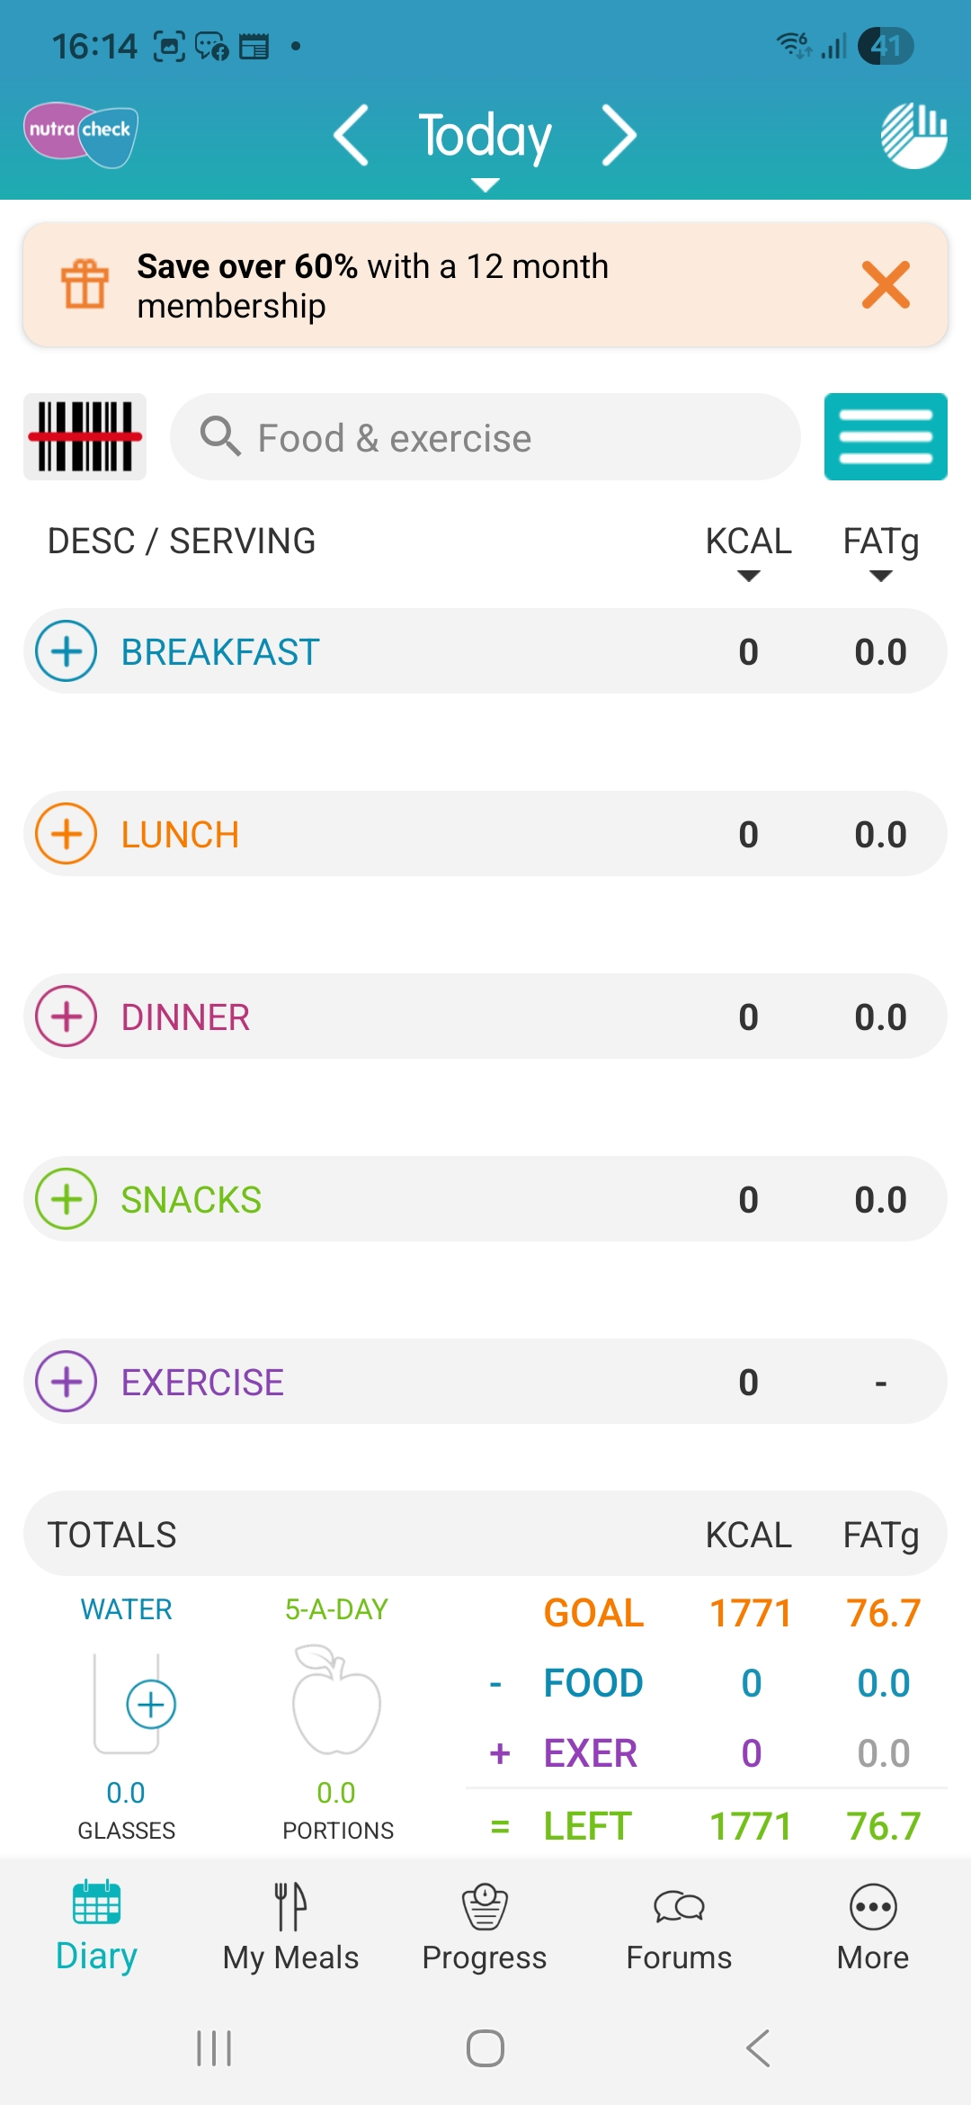
This screenshot shows how I am counting my calories and my activities in the day.

Screenshot/Photo 5
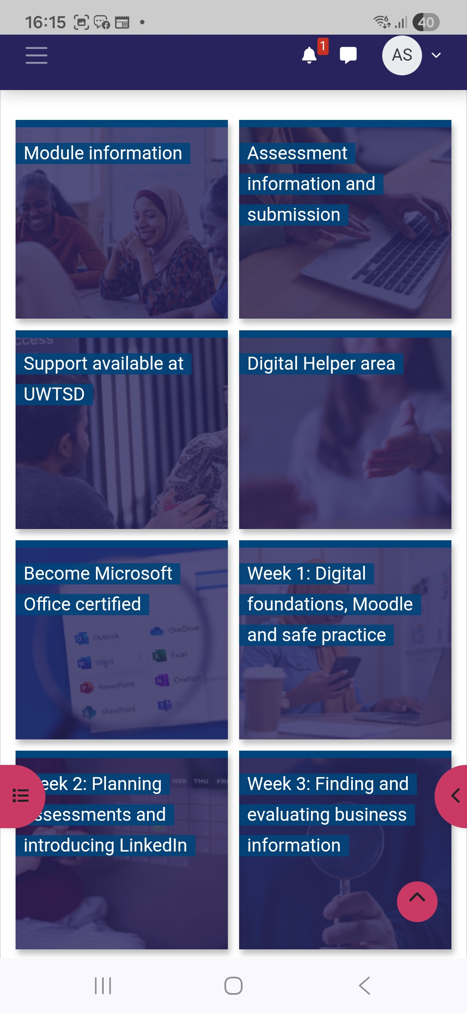
I am using my moodle app to check submission dates and to get the information which I need .

Screenshot/Photo 6
[Insert Photo/Screenshot below]

[Write what this shows of your digital life]

My Short Reflection
- Write 5–8 simple sentences about your digital life.
- You can use the sentence starters below if helpful.
I use digital tools to find information and collect data.
I feel confident when I am using Google and some online platforms.
I want to improve my digtal skills like:Jisc Discovery tool,my library search,using Word and LinkedIn.
I often use Google search using simple techniques and short words and now I often use Moodle.
I sometimes feel nervous when I start to use new tools or apps.
I hope this module will help me to improve my digital skills and feel more confident in this modern digital life.
Digital skills are important for me,because we use them everywhere and everyday in our life and big percent of employers required some level of digital skills.

Sentence starters
- I use digital tools to …
- I feel confident when I …
- I want to improve …
- I often use these tools: …
- I sometimes feel nervous about …
- I hope this module will help me …
- Digital skills are important for me because …
You can write more if you want.

Submission Checklist
Before you submit, please check:
​​​ ☒ I added 4–6 screenshots
☒ I wrote short sentences for each screenshot
☒ I wrote my short reflection
☒ My work is my own
☒ My file opens correctly
​​☒ My file opens correctly

