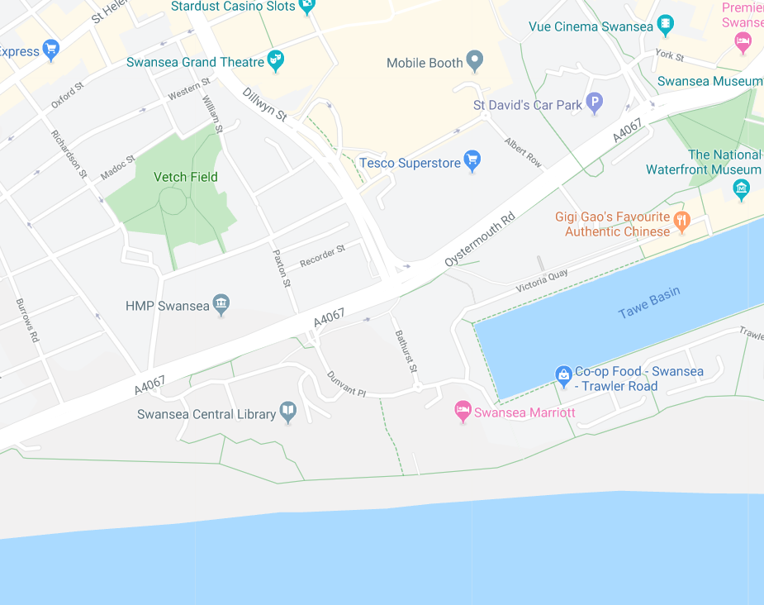

Land at Maritime Quarter, Swansea SA1 3SS

Desktop Study

Brief

Site Description

Site History

Geology and Mining

Hydrogeology and Flooding

Environmental Review

Conclusions and Recommendations

november 2019

TALIESIN CONSERVATION
Authored by: Owen Towell

Brief
Taliesin Conservation has been instructed by the City and County of Swansea to undertake a desktop assessment/study for an area of land at Maritime Quarter, Swansea, SA1 3SS. The purpose of this study is to initiate a full site investigation as part of a feasibility study and make recommendations on ground investigation and foundation methodologies.

This report has been prepared exclusively to aid with the evaluation of the potential risks associated with the proposed land.

The information contained within this report is based on observations made on site, a review of historical, geological, hydrogeological and other environmental data obtained for the site.

Proposed Development
“City and County of Swansea have chosen to enter into a joint agreement with Marriot Hotels to create a new restaurant and ice-cream parlour (with manager’s apartment) on Swansea foreshore, in the position indicated. The site is located between County Hall and the Marriot. The building, which is to share parts of the car park of both of the existing adjacent facilities, is to have a GIA (Gross Internal Area) at ground floor level of approximately 300 square metres.

Site Description
Site Description and Surroundings

Site Location Plan
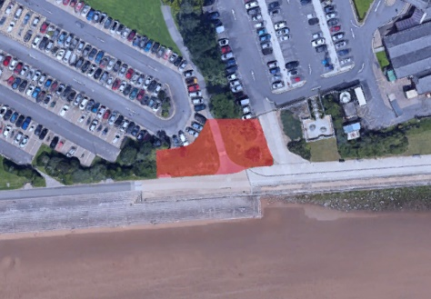
Not to scale
Fig.1: Site Location Plan. Source: Google Maps - https://www.google.com/maps/@51.6132573,-3.9456806,221m/data=!3m1!1e3

NB: The proposed area for the site is highlighted in red on the areal image above (approx. 300m²).

Continued.../
A description of the site and its surroundings are summarized in Table 1 and a site location plan is included in Fig.1 below.

Table 1:
Data | Information
Address | The land is located West of the Marriot Hotel, Maritime Quarter, Swansea, SA1 3SS and North of the coastline.
Current Site Use | The site is currently open land comprising vegetation, trees, and grass mounds
Coordinates | 51.613264, -3.945464
Site Area | 300.00m²
Surrounding Land Use | North – Carpark, Iwan Williams Driving School  East – Marriot Hotel and carpark, Tawe Basin  South - Coastline  West – Swansea Central Library and carpark

Continued.../
The Topography of the Land
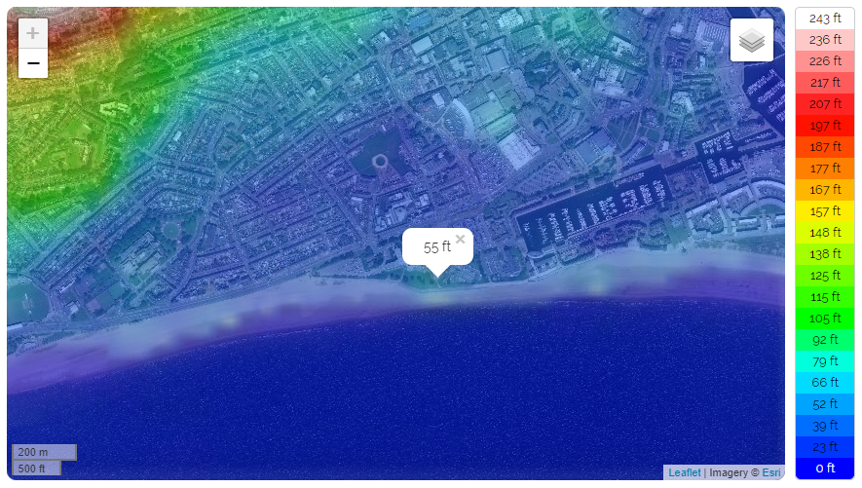
Fig.2: Topography Map. Source: Topographic-Map.com - https://en-gb.topographic-map.com/maps/b9/England/

The figure above shows the land to be approximately 55ft above sea level. According to Topographic Maps (2019), this is 122ft below the average elevation.

Continued.../
Site Walkover
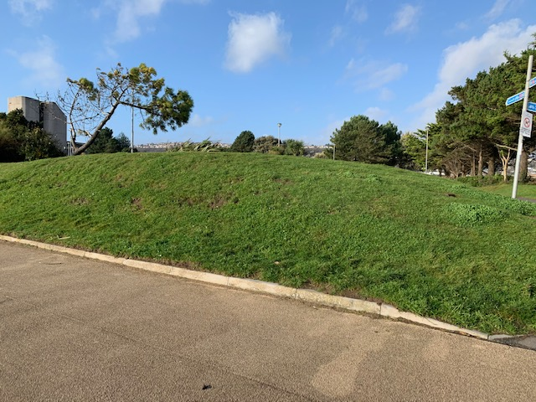
A site walkover was undertaken by Owen Towell on the 19th of November 2019. The weather was cold and dry. During the walkover, it was noted that the land has heavy footfall and vehicle traffic nearby. The land protruded from the ground in – what looks to be – man-made mounds (Fig.3 & 4) as a possible means of flood protection. It was also noted that existing services/utilities are located on the site by the presence of manholes. (Fig.5)
Fig.3: Image taken during Site Walkover showing protruding land. Source: Owen Towell

Continued.../
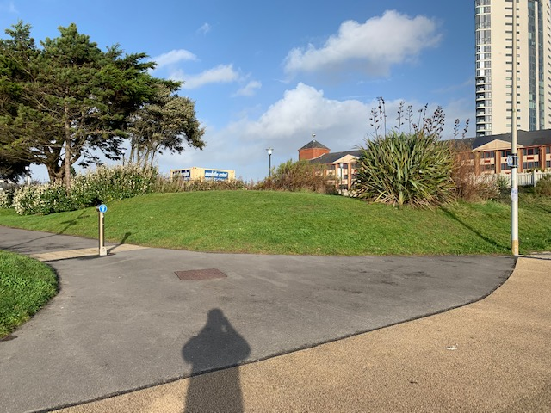
Fig.4: Image taken during Site Walkover showing protruding land. Source: Owen Towell

Continued.../
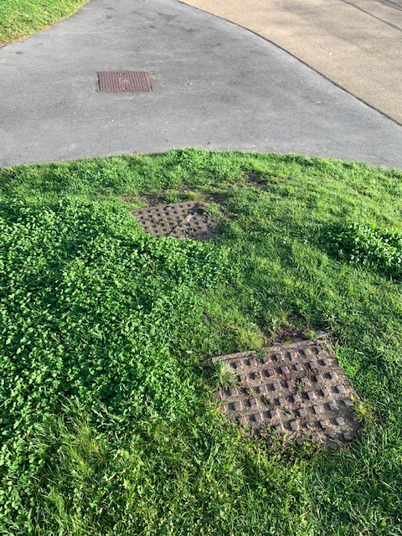
Fig.5: Image taken during Site Walkover showing existing services/utilities. Source: Owen Towell

Site History

Historical maps and areal images dating from 1888 have been procured and reviewed. The findings are summarized in the table below.

Table 2: Summary of Historical Maps and Images
Date | On-Site Observations | Adjacent Area Observations
1888 – 1913 | The Swansea and Mumbles Railway line runs directly through the site with an engine shed located approx. 100m to the West of the site. | There is a Sawmill located approx. 150m to the North East of the site.  A Gas Works is also located approx. 300m north of the site.
1937 | A canister works is located on the site | No significant changes are shown on maps.
1945-1946 | No significant changes are shown on maps | No significant changes are shown on maps
1961 | No significant changes are shown on maps | The County Goal located approx. 300m North West of the site is now the H.M. Prison.
1991 | The railway line and engine shed is no longer visible on maps | The Saw Mill is now a residential area and existing Gas Works is now a supermarket. A hotel has been developed within 25m east of the site.

NB: Historical maps only offer a brief moment in time and considerations must be taken while attempting to decipher these as it is not clear what has occurred during the intervening years. It is also important to note that industrial uses may not always be recorded.

Continued…/
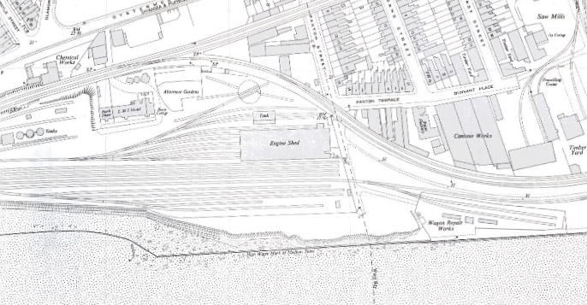
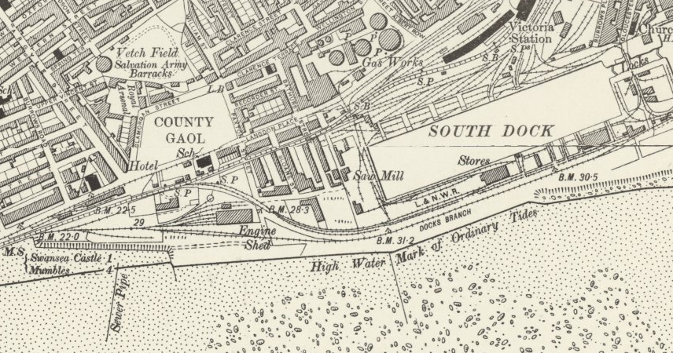
Fig.6: Map of Site dated 1888 - 1913. Source: https://maps.nls.uk/geo/explore/side-by-side/#zoom=16&lat=51.6141&lon=-3.9450&layers=6&right=BingHyb

Fig.7: Map of Site dated 1937. Source: Town Planning Register, Swansea Archives

Continued…/
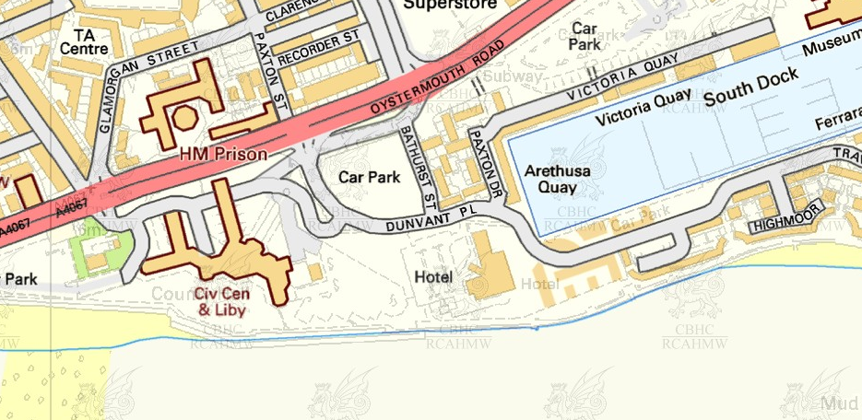
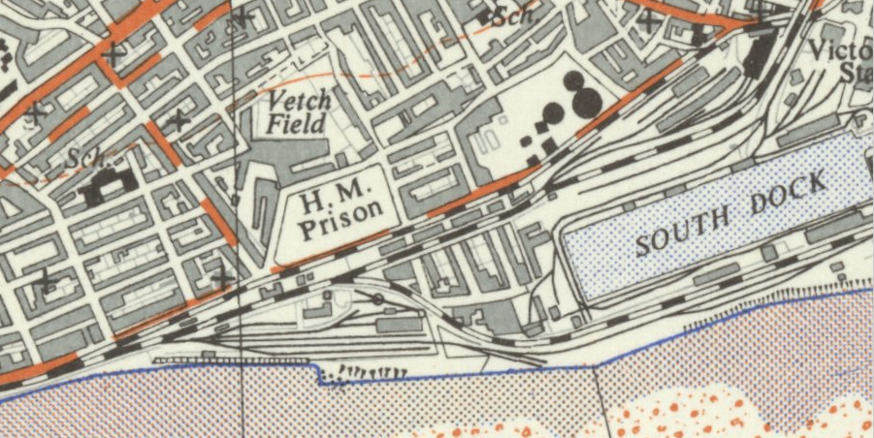
Fig.9: Map of Site dated 1991. Source: RCAHMW, Coflein

Fig.8: Map of Site dated 1961. Source: https://maps.nls.uk/geo/explore/side-by-side/#zoom=16&lat=51.6139&lon=-3.9475&layers=10&right=6

Continued…/
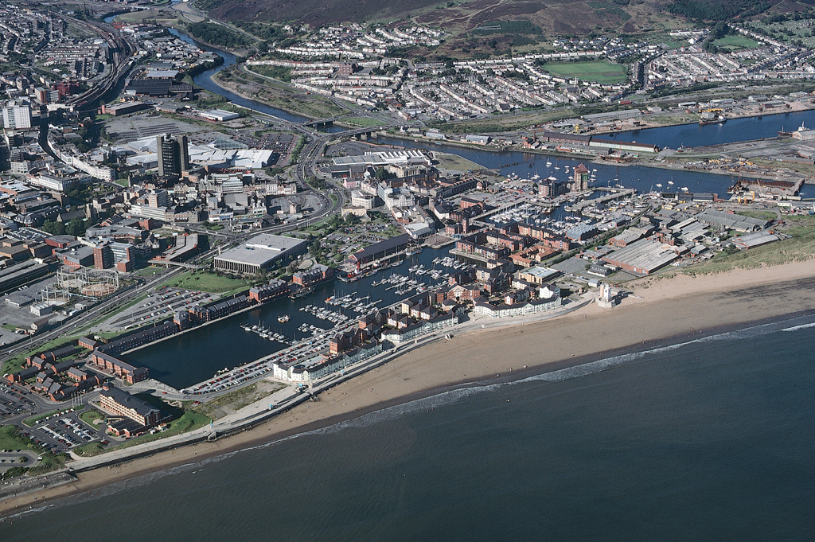
Fig.10: Aerial Photograph of Swansea Marina, 1991. Source: https://coflein.gov.uk/en/site/300028/details/south-dock-swansea-marina-swansea

Continued…/

Prior to 1888 (the earliest dated map obtained) the South Dock (East of the site) was constructed in 1859 for the export of coal from Aberdare but commercial shipping ceased in 1971 and is now the Swansea Marina. (Coflein.gov.uk, 2019)

The existing railway located north of the site was The Swansea and Mumbles Railway which was incorporated in 1804 to carry coal from the Clyne Valley, and limestone from the Mumbles. The line was re-laid in 1855 as an edge railway where steam trains operated from 1876 which were eventually subsided by electric trams in 1929. (Hughes and Reynolds, 1989).

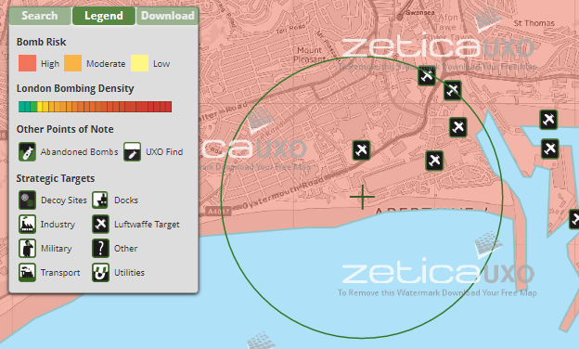
During World War II (1st September 1939 – 2nd September 1945) Swansea experienced what is now called The ‘Three Nights’ Blitz’. The Blitz of February 1943 temporarily halted any thinking of post-war development as many areas of the city were destroyed during the onslaught. As you can see from the fig. below, the site location was a direct target of the Luftwaffe and the risk of bombing was considerably high. (Roberts, 2011)
Fig.10: Mapping of WWII Munitions at Site. Source: https://zeticauxo.com/downloads-and-resources/risk-maps/

Continued…/
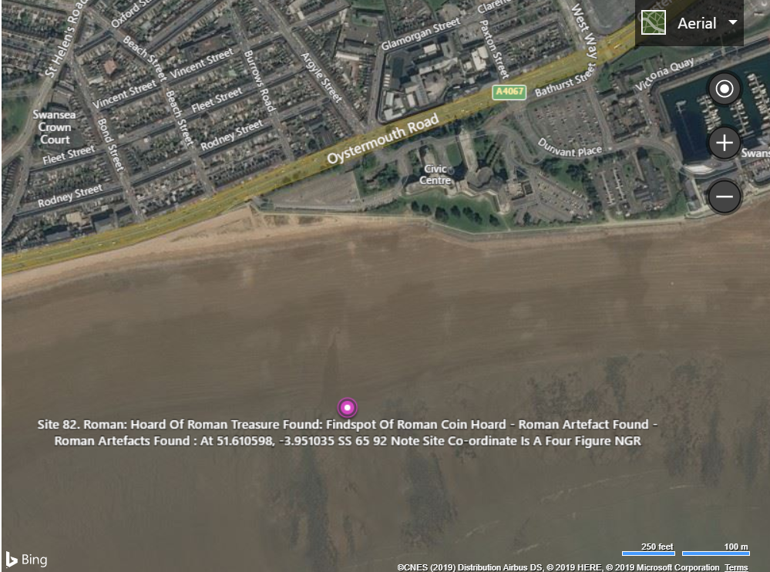
It’s also important to note there has been archaeological findings in the proximity of the site. A hoard of Roman treasure was found approx. 300m southwest of the site and the remains of a medieval castle is located approx. 700m north of the site. (See fig. below)
Fig.11: Aerial photograph showing a hoard of roman treasure found. Source: https://www.archiuk.com/

Continued…/
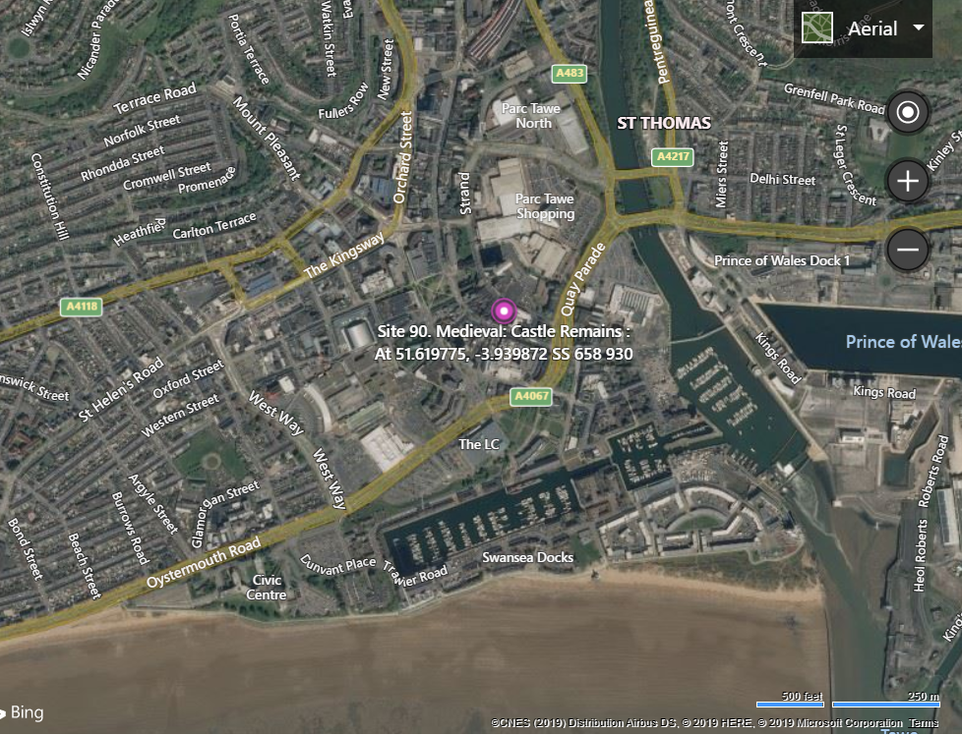
Fig.12: Aerial photograph showing medieval castle remains. Source: https://www.archiuk.com/

Geology and Mining

Geology

On review of a borehole survey undertaken by STRATA SURVEYS Ltd directly in the vicinity of the proposed site (British Geological Survey ID: 370246: BGS Reference: SS69SE345), it was concluded that the makeup of the ground is as follows:

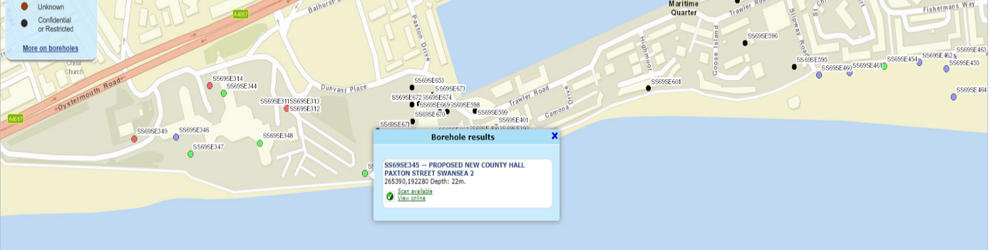
Table 3: Summary of Soil Strata, STRATA SURVEYS Ltd
Fig.13: Borehole Survey Location. Source: http://mapapps.bgs.ac.uk/geologyofbritain/home.html

Description of Strata | Thickness (m)
Made ground consisting of ashes | 0.5m
Made ground consisting of loose, light grey fine-medium sand | 1.00m
Made ground consisting of grey sand with layers of soft sandy clay | 1.05m
Made ground consisting of soft red-brown sand clay with brick shale | 0.95m
Made ground consisting of dense bricks, ashes, sand, and clay | 1.45m
Very dense brown sandy gravel with traces of sandy clay | 2.05m
Very dense brown sand with gravel | 0.95m
Still grey-brown gravelly boulder clay | 3.05m
Very stiff grey gravelly boulder clay | 7.6m
Grey mudstone | 12.82m

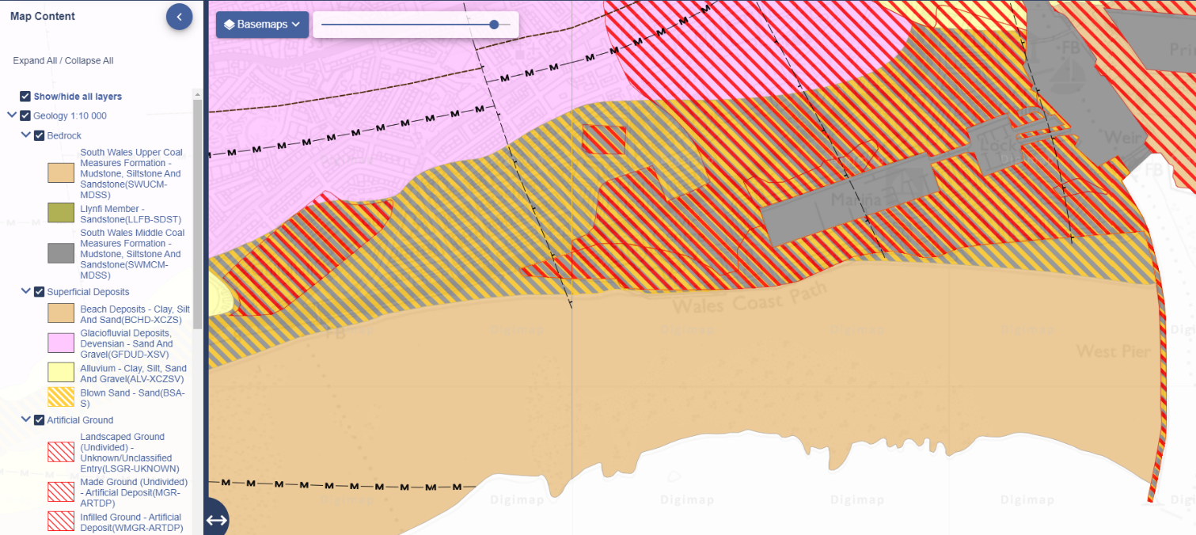
The above report coincides with additional data found regarding the makeup of the soil strata. The fig. below indicates that the ground is made up from superficial deposits of blown sand, artificial or made ground mudstone as the parent rock.
Fig.14: Geology map. Source: https://digimap.edina.ac.uk/geology

Continued…/
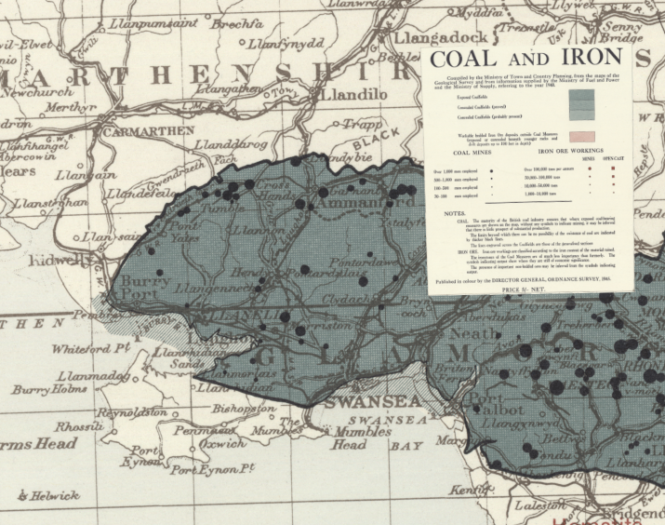
Mining
Fig.14: Coal and Iron Map. Source: https://maps.nls.uk/geo/explore/side-by-side/#zoom=10&lat=51.2384&lon=-6.4113&layers=10coal&right=6

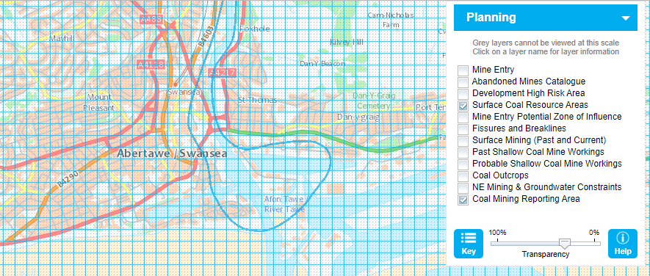
A map dated 1945 (above) states that the proposed site is located on/near exposed coalfields, and that concealed coalfields are ‘probably present’. This correlates with more recent records sourced from The Coal Authority which states that the region in which the proposed site is located is rich in coal deposits, particularly surface coal (highlighted in the fig. below).
Fig.15: Coal Authority – Planning Risk. Source: https://mapapps2.bgs.ac.uk/coalauthority/home.html

“The online records provided by The Coal Authority are used to prepare plans called “Coal Mining Development Referral Area Plans” for all coalfield Local Planning Authorities, which refine the defined coalfield areas into areas of higher risk (known as the Coal Mining Development Referral Area) and lower risk (known as Standing Advice Area).” (Risk Based Approach to Development Management, n.d.)

During the planning process of internal alterations to Meridian Tower, Trawler Road SA1 1JW in 2015 (approx. 150m from the proposed site location), a final delegated report by Swansea City Council stated the following:

Table 4: Summary of Constraints from Alterations to Meridian Tower, 2015
Constraint Type | Reference | Description | Text
Mining Area | MINE AREA | MINEAREA (Pl Consultation Zones) | MINING AREA

Coal Mining Development Referral Data | StAdvice | Coal Mining Development Referral Data | Standing Advice

Meaning that despite the area being classified as a ‘mining area’, the risk of development was low. This was also supported by a direct letter from The Coal Authority during the planning application for the construction of a 3 storey block at Trawler Road, Swansea, SA1 1UP (approx. 300m from the proposed site):

“The application site does not fall with the defined Development High Risk Area and is located instead within the defined Development Low Risk Area. This means that there is no requirement under the risk-based approach that has been agreed with the LPA for a Coal Mining Risk Assessment to be submitted or for The Coal Authority to be consulted.” (Rachael A. Bust B.Sc. (Hons), MA, M.Sc., LL.M., AMIEnvSci., MInstLM, MRTPI, 2015)

Hydrogeology and Flooding

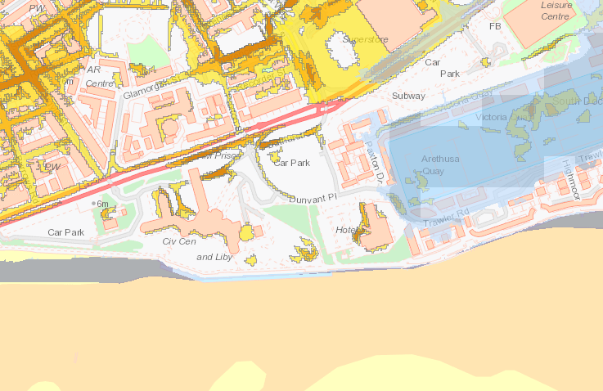
On review of online resources, the proposed location of the site shows to be situated directly in the vicinity where surface water flooding is at high risk and tidal flooding is probable.
Fig.16: Natural Resource Wales – Flood Risk Map. Source: https://maps.cyfoethnaturiolcymru.gov.uk/Html5Viewer/Index.html?configBase=https://maps.cyfoethnaturiolcymru.gov.uk/Geocortex/Essentials/REST/sites/Flood_Risk/viewers/Flood_Risk/virtualdirectory/Resources/Config/Default&layerTheme=1

Continued…/
This directly coincides with the conclusions made during the planning application for developments to the Meridian Tower, Trawler Road, SA1 1JW in 2015 (approx. 150m from the proposed site location). The final delegated report stated the following:

Table 5: Summary of Constraints from Alterations to Meridian Tower, 2015
Constraint Type | Reference | Description | Date
Flooding | Floodzone 3 - Tidal - M | 0.5% or greater Tidal Flooding | May 2013
Flooding | Floodzone 2 - Fl & Ti - M | Between 1% abd 0.1% Fluvial Flooding or 0.5% and 0.1% Tidal | May 2013
Dam Maps - Tan 15 | Zone C2 | Tan 15 - Flooding | 2013

Flood Zone 2
‘Flood Zone 2’ is defined as land that has been assessed as having between a 1 in 100 and 1 in 1000 annual probability of river flooding (1% - 0.1%) or between a 1 in 200 and 1000 annual probability of sea flooding (0.5% - 0.1%) in any year. (Environmental Agency, 2019)

Flood Zone 3
‘Flood Zone 3’ is defined as land assessed as having a 1 in 100 or greater annual probability of river flooding (>1%), or a 1 in 200 or greater annual probability of flooding from the sea (>0.5%) in any year. (Environmental Agency, 2019)

Tan 15 – Zone C2
Planning Policy Wales (2004) developed a Technical Advice Note for the Development and Flood Risk (Tan 15). The above report for the development at the Meridian Tower states that based on the Tan 15, the area is classified as a development zone of ‘Zone 2’.

Based on Environment Agency extreme flood outline, ‘Zone C2’ is defined as an area which has an equal to or greater than 0.1% (river, tidal or coastal) risk of flooding without significant flood defence infrastructure.

NB: For development proposals in Zone C, a flood consequences assessment is required. Zone C1 development can take place subject to a satisfactory assessment. In Zone C2 only less vulnerable forms of development should even be considered. (Planning Policy Wales, 2004)

Environmental Review
Historic Contaminants
During the historic review of the site, it was clear that over the years the site was heavily industrialised – and therefore considered a brownfield site (previously developed land).

The previous developments located on and in the surrounding area of the proposed site may still prove to be contaminating the land:

Table 6: Summary of Possible Contaminates
Use of Land | Location | Possible Contaminates
Railway Line | Directly through the proposed site location | - Oil-derived products  - heavy metals  - Polycyclic aromatic hydrocarbons (chemicals found naturally in coal, and crude oils)  - Polychlorinated biphenyl (manmade chemicals widely used in electrical equipment)
Engine Shed | Approx. 100m West of the site | - Oil-derived products  - heavy metals  - Polycyclic aromatic hydrocarbons (chemicals found naturally in coal, and crude oils)  - Polychlorinated biphenyl (manmade chemicals widely used in electrical equipment)
Canister Works | Located directly on the site | - Oil-derived products  - heavy metals  - Polycyclic aromatic hydrocarbons (chemicals found naturally in coal, and crude oils)  - Polychlorinated biphenyl (manmade chemicals widely used in electrical equipment)
Saw Mill | Approx. 150m North East of the site | - Polychlorinated phenols (preservatives)  - Polychlorinated dibenzofurans (Organic compounds)
Gas Works | Approx. 300m North of the site | - Oil-derived products  - heavy metals  - Polycyclic aromatic hydrocarbons (chemicals found naturally in coal, and crude oils)  - Polychlorinated biphenyl (manmade chemicals widely used in electrical equipment)

Continued…/

Current Emissions
Having researched the ground records of the site in question, the National Atmospheric Emissions Inventory (2019) has already identified the following contaminates to be of high levels:

Table 7: Summary of Constraints Found at Site (NAE)
Contaminate | Units Kg/1x1km
Arsenic | 0.342225 kg 1 x 1km
Cadmium | 0.047561 kg 1 x 1km
Chromium | 0.916639 kg 1x1km
Carbon dioxide as carbon | 3295.167480 t 1x1km
Copper | 12.156734 kg 1x1km
Lead | 2.149844 kg 1x1km
Nickel | 1.170992 kg 1x1km
Vanadium | 11.898720 kg 1x1km
Zinc | 11.749370 kg 1x1km

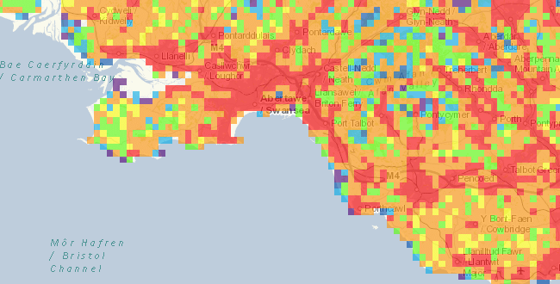
All of the above contaminated could be naturally occurring, or as a result of contamination and could be in the form of solids or gas.
Fig.17: National Atmospheric Emissions Inventory – Emissions Map. Source: https://naei.beis.gov.uk/emissionsapp/

Continued…/
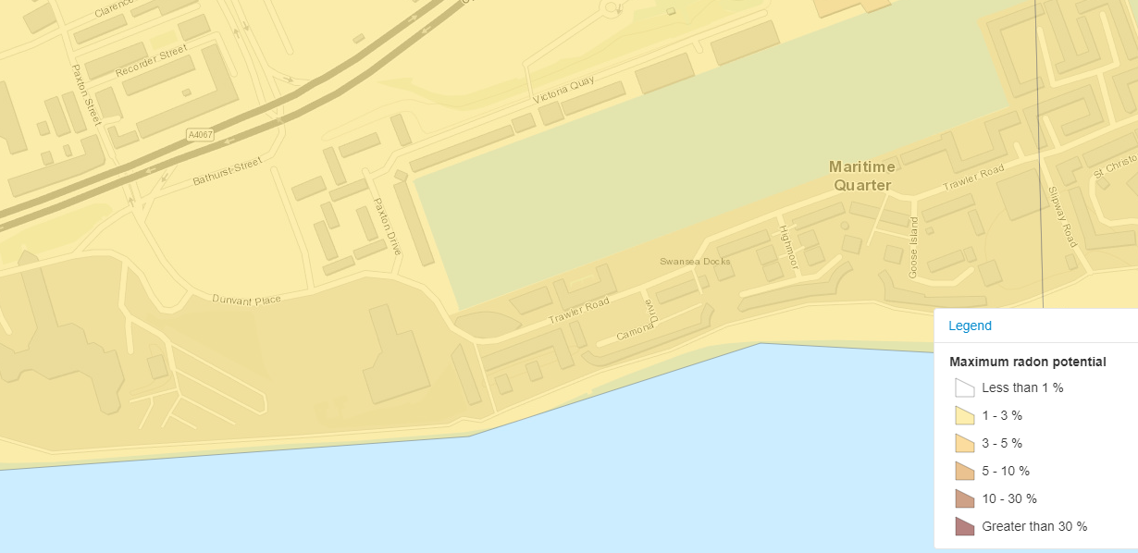
According to Public Health England, there is also the potential of encountering radon while excavating the land. (Please see fig. below)
Fig.18: Public Health England – UK Radon Map Source: https://www.ukradon.org/information/ukmaps

As shown in the map fig. above, the maximum radon potential in the area in which the proposed site is located is between 1 – 3% meaning that care should be taken while excavating due to being hazardous to health. (UKRadon.org, 2019)

Conclusion and Recommendations

Table 8: Summary of Conclusions and Recommendations
Section | Conclusion | Recommendation
Site Walkover | - Manholes present  - No utilities map available online  - The site is easily accessible | - Gain access to existing and current utility/service plans.  - Services engineer to be present on-site during the investigation to locate possible unmarked, buried utilities using surveying tools and detecting devices.  - Mark the services found and confirm their status.  NB: The above should be undertaken under the guidance of The Health and Safety Executive – Avoiding danger from underground services (HSG47, 2014) and should comply with BSI PAS 128:2014 – The Robust Specification for Underground Utility Detection, Verification, and Location.
Site History | - Potential of encountering Medieval hoards  - Potential of encountering Roman hoards  - Possibility of encountering unexploded ordinates. | - Archaeologists to be present during site investigation and excavation.  - Should the contractor come into contact with anything of interest to the Archaeologist, work must stop and further investigation is required.  NB: All the above should be undertaken, ensuring compliance with the CIfA Regulations, standards and guidelines.  - A full UXO (unexploded ordnance) survey is recommended to be undertaken during ground investigation to highlight the potential of encountering any munitions.  The above should be undertaken in compliance with CIRIA C681 Guidelines in order to fulfil their duties under CDM2015.
Geology and Mining | - Surface coal probable  - Made up ground  - Sand and silt | - Further investigation required to investigate the soil strata. This should be undertaken by a competent and licensed contractor (see investigation recommendations below)  NB: The above should be undertaking in compliance with BS 5930:2015 – Code of practice for ground investigations  - A Coal Authority report must be obtained  - The probability of shallow coal workings affecting surface stability should be established in conjunction with the Coal Authority Report  - An engineer with suitable experience and qualifications should address any potential of mine working or mine entries in the proposed site location.  NB: The above should be undertaken in accordance with CIRIA SP 31: Construction Over Abandoned Mine Workings.
Hydrogeology and flooding | - Potential of surface, and tidal flooding | - Allowances for sustainable flood and coastal erosional risk measures must be in place to allow for: rises in drainage charges, and protected water supplies.  NB: The above must comply with The Flood and Water Management Ace (2010)  - Soakaway tests should be undertaken to determine the infiltration rate of the ground.  The above must be undertaken in accordance with BRE Digest 365 ‘Soakaway design’, BS 5930 ‘Code of practise for site investigation’ – field permeability and percolation test.
Environmental | - High probability of existing contaminates.  - Radon likely present in the ground. | - An environmental engineer is recommended to be on-site during site investigation, excavation and construction.  - Due to the possible contaminates of the land, capping layers will likely be required for the proposed development.  - Should radon be present during excavation, it’s recommended that either a Radon sump or positive pressure system installed prior to the construction to avoid the probability of seepages post-construction.  NB: The design of the building should comply with BS 8485:2015 – The code of practice for the design of protective measures for methane and carbon dioxide ground gases for new buildings.

Continued…/

Ground Investigation Method
We recommend that vertical boreholes are undertaken in clusters over the proposed footprint of the building and are carried out in compliance with Construction (Design & Management) Regulations 2015, Borehole Sites, Operations Regulations 1995, GSHVBS Vertical Borehole Standards and BS 5930:2015 – Code of practice for ground investigations.

Should the layout of the structure not be established while the site investigation is conducted, then it’s recommended that uniformly spaced grid boreholes are undertaken. Eurocode 7 specifications state that the spacing for exploration stations creating a grid ranges from 20-40m and should be positioned close to the suggested foundation.

“(a) The minimum number of boreholes to be carried out should be 1 per 300 m2 of the area of project site, 2 per block of building and not less than 3 per site. The borehole spacing should be between 10m to 30m apart.” (Building and Construction Authority, 2016)

We recommend that the number of boreholes carried out complies with the Building and Construction Authority’s recommendations, therefore, we recommend a minimum of 3no boreholes across the footprint of the site.

Following data review of the existing borehole surveys carried out on site, it would be reasonable to conclude that bedrock is at a depth of approx. 22m. We, therefore, recommend that the appropriate plant is used to accommodate the assumed depth – this being an Open Hollow Stem Auger. The reason being that it is compatible with non-cohesive, softer sediments such as sand and gravel deposits and can reach the necessary depths. The Open Hollow Stem Auger can also drill below water tables, and considering the hydrology and flooding data found, we feel this is necessary. This method has the capacity to case the borehole sampling as it proceeds and allow sampling of the ‘undisturbed soil’ below the bit.

Continued…/
Foundation Type
Due to the presumed depth of parent rock, and the poor ground bearing capacity of the strata above, we recommend that end baring piles should be the foundation method of choice. Silts and sands are prone to settlement, therefore bedrock must be met to ensure an equally distributed load - thus minimizing the risk of future complications. (Nantel, 2019)

We recommend that the method of piling should be by way of replacement, using a Continuous Flight Auger (CFA) and cast in situ concrete with reinforced concrete link beams between pile caps. This method is suitable in weaker soils and is economical and fast in installation. Concrete should be poured utilizing a tremie pipe from the bottom upwards to avoid cavities/air bubbles, thus minimising the probability of failure. Steel caging is then lowered into the concrete as reinforcement, extruded at the top of the pile where caps and beams are connected and installed. (Ground Development LTD, 2019)

Ground Development LTD state that Continuous Flight Augers are the quietest and least disruptive form of piling due to being rotary as opposed to percussion - which is relevant considering the site location. The Welsh Government has declared this area to be a ‘quiet area’ and any construction works should comply with Local Authority rules and regulations relating to permissible noise levels as recommended in BS 5228-1:2009, Code of practice for noise and vibration control on construction and open sites, the Control of Noise at Work Regulations 2005 and the Control of Vibration at Work regulations 2005. There are also several tall buildings adjacent to the site which could be affected by heavy vibrations caused by percussion.

Continued…/
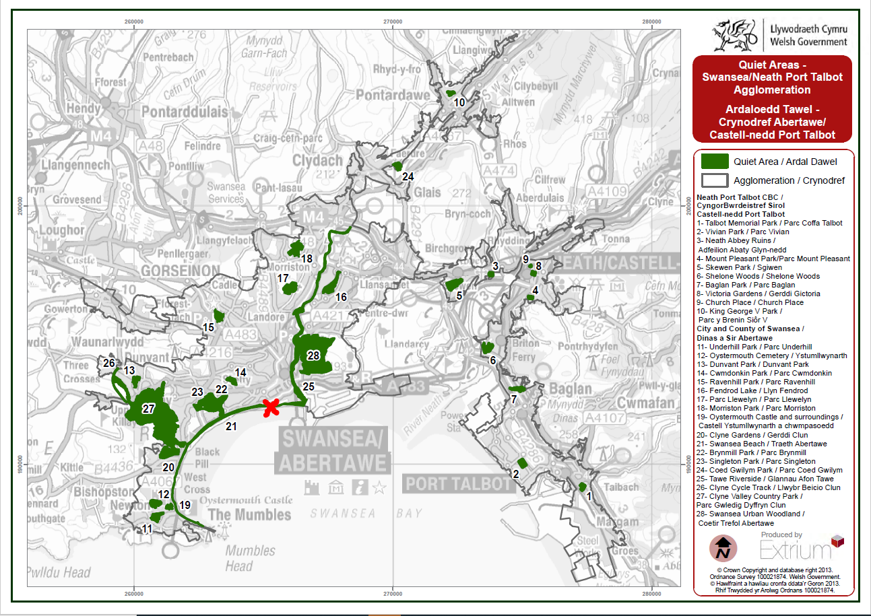
Fig.19: Welsh Government – Quiet Area Map Source: https://gov.wales/quiet-area-map-swansea-and-neath-port-talbot

As the proposed site is located near the coast, the permeability of the concrete must be considered to protect the steel reinforcement inside. Steel will corrode rapidly when exposed to the combination of moisture, oxygen and sodium chloride (seawater) and therefore must be protected with a coat of red oxide. We also recommend lowering the permeability of the concrete by substituting between 25-65% slag cement for Portland cement. (Slag Cement Association, 2019)

Design, layout, construction, monitoring and maintenance of pile foundations should be compliant with BS 8004:2015 – Code of practice for foundations. We recommend that an experienced structural and civil engineer is involved during the design stage to carry out calculations of load-bearing capacities to accurately design the proposed layout and pile spacing.

The plant used for the ground investigation boreholes would also facilitate the foundation piling method with additional attachments - therefore plant can remain on-site following investigation until required, thus minimizing costs and environmental impact.
Sketches

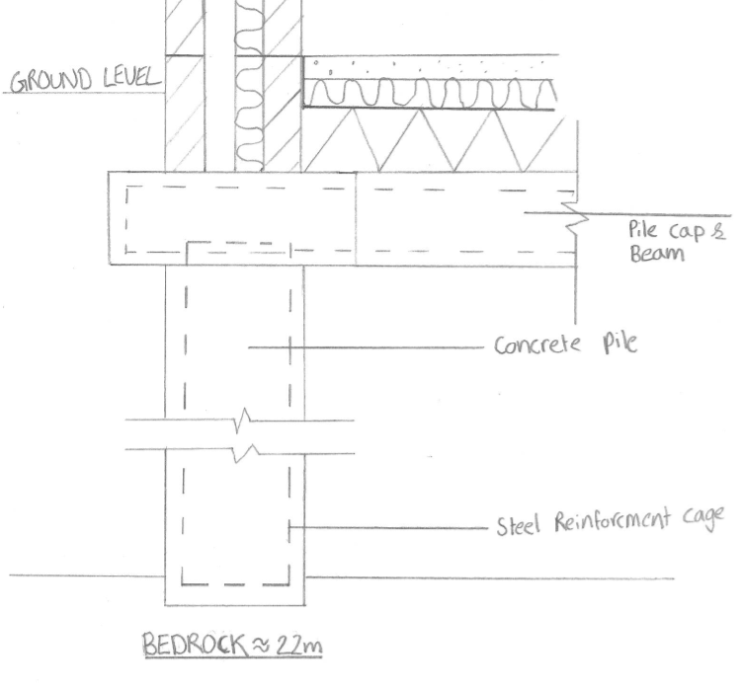
NB: The proposed pile sketches below are indicative and should be accurately re-designed by a civil engineer once the footprint and ground makeup is confirmed. DRAWINGS ARE NOT TO SCALE.
Fig.20: Foundation Sketch – Cross Section. Source: Owen Towell

Continued…/
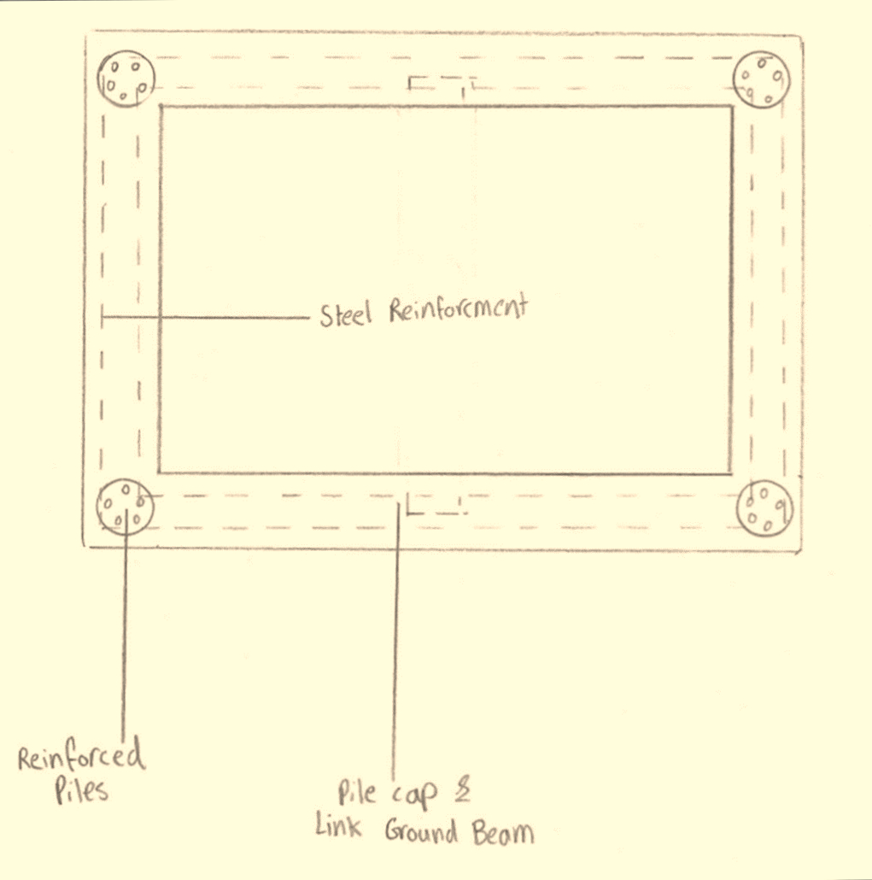
Fig.21: Foundation Sketch – Plan. Source: Owen Towell

Bibliography

References
- Archiuk.com. (2019). ARCHI UK | Discover Archaeological and Historic Sites in Britain and Worldwide | archiUK | diggR App | digger app | LIDAR | Archaeological Sites in Britain (England, Scotland and Wales) and Metal Detecting Finds Worldwide Database, Maps and Aerial Photographs. [online] Available at: https://www.archiuk.com/ [Accessed 29 Nov. 2019].
- Coflein.gov.uk. (2019). SOUTH DOCK; SWANSEA MARINA, SWANSEA | Coflein. [online] Available at: https://coflein.gov.uk/en/site/300028/details/south-dock-swansea-marina-swansea [Accessed 29 Nov. 2019].
- Google Maps. (2019). Google Maps. [online] Available at: https://www.google.com/maps/@51.6132573,-3.9456806,221m/data=!3m1!1e3 [Accessed 29 Nov. 2019].
- Hughes, S. and Reynolds, P. (1989). Industrial archaeology of the Swansea region. [Place of publication not identified]: Royal Commission on Ancient and Historical Monuments in Wales.
- Maps, T., Kingdom, U., 3, 1., Britain, G., 7, 2., 2, 0. and notice, L. (2019). England topographic map, relief map, elevations map. [online] topographic-map.com. Available at: https://en-gb.topographic-map.com/maps/b9/England/ [Accessed 29 Nov. 2019].
- Maps.nls.uk. (2019). Side by side georeferenced maps viewer - Map images - National Library of Scotland. [online] Available at: https://maps.nls.uk/geo/explore/side-by-side/#zoom=16&lat=51.6141&lon=-3.9450&layers=6&right=BingHyb [Accessed 29 Nov. 2019].
- Roberts, D. (2011). Swansea's burning. [Place of publication not identified]: Bryngold Books, p.20.
- West Glamorgan Archive Service (1937). Town Planning Register. Swansea.
- Zetica UXO. (2019). Risk Maps - Zetica UXO. [online] Available at: https://zeticauxo.com/downloads-and-resources/risk-maps/ [Accessed 29 Nov. 2019].
- Bust, R. (2015). PLANNING APPLICATION: INV - 2015/1498. [email].
- Digimap.edina.ac.uk. (2019). Digimap. [online] Available at: https://digimap.edina.ac.uk/geology [Accessed 9 Dec. 2019].
- Mapapps2.bgs.ac.uk. (2019). Interactive Map Viewer | Coal Authority. [online] Available at: https://mapapps2.bgs.ac.uk/coalauthority/home.html [Accessed 9 Dec. 2019].
- Mapapps.bgs.ac.uk. (2019). Geology of Britain viewer | British Geological Survey (BGS). [online] Available at: http://mapapps.bgs.ac.uk/geologyofbritain/home.html [Accessed 9 Dec. 2019].
- Maps.nls.uk. (2019). Side by side georeferenced maps viewer - Map images - National Library of Scotland. [online] Available at: https://maps.nls.uk/geo/explore/side-by-side/#zoom=10&lat=51.2384&lon=-6.4113&layers=10coal&right=6 [Accessed 9 Dec. 2019].
- Risk Based Approach to Development Managment. (n.d.). [ebook] Bridgend: The Coal Authority. Available at: https://www.bridgend.gov.uk/media/2051/sd110.pdf [Accessed 9 Dec. 2019].
- STRATA SURVEYS Ltd, Cheshire (1972). Borehole Survey - Proposed New County Hall, Paxton Street Swansea. [online] West Glamorgan: County Engineer and Surveyor's Dept. Available at: http://scans.bgs.ac.uk/sobi_scans/boreholes/370246/images/10677923.html [Accessed 6 Dec. 2019].
- Swansea City Council (2013). DELEGATED REPORT - Application No. 2015/2129. [online] Swansea: Swansea City Council. Available at: https://www.swansea.gov.uk/planningsearch [Accessed 9 Dec. 2019].
- Apps.environment-agency.gov.uk. (2019). Environment Agency - Flood Map for Planning Risk. [online] Available at: http://apps.environment-agency.gov.uk/wiyby/cy/151263.aspx [Accessed 04 Dec. 2019].
- Kitunen, V. and Salkinoja-Salonen, M. (1990). Soil contamination at abandoned sawmill areas. Chemosphere, 20(10-12), pp.1671-1677.
- Maps.cyfoethnaturiolcymru.gov.uk. (2019). [online] Available at: https://maps.cyfoethnaturiolcymru.gov.uk/Html5Viewer/Index.html?configBase=https://maps.cyfoethnaturiolcymru.gov.uk/Geocortex/Essentials/REST/sites/Flood_Risk/viewers/Flood_Risk/virtualdirectory/Resources/Config/Default&layerTheme=1 [Accessed 10 Dec. 2019].
- Naei.beis.gov.uk. (2019). UK Emissions Interactive Map - NAEI, UK. [online] Available at: https://naei.beis.gov.uk/emissionsapp/ [Accessed 03 Dec. 2019].
- Planning Policy Wales (2004). Technical Advice Note: 15. Development and and Flood Risk. [online] Welsh Assembly Government. Available at: https://gov.wales/sites/default/files/publications/2018-09/tan15-development-flood-risk.pdf [Accessed 10 Dec. 2019].
- Sciencedirect.com. (2019). Polychlorinated Dibenzofurans - an overview | ScienceDirect Topics. [online] Available at: https://www.sciencedirect.com/topics/pharmacology-toxicology-and-pharmaceutical-science/polychlorinated-dibenzofurans [Accessed 10 Dec. 2019].
- Wierzbicka, M., Bemowska-Kałabun, O. and Gworek, B. (2015). Multidimensional evaluation of soil pollution from railway tracks. Ecotoxicology, 24(4), pp.805-822.
- Ukradon.org. (2019). UKradon - UK maps of radon. [online] Available at: https://www.ukradon.org/information/ukmaps [Accessed 10 Dec. 2019].

- Hse.gov.uk. (2019). [online] Available at: https://www.hse.gov.uk/pUbns/priced/hsg47.pdf [Accessed 10 Dec. 2019].

- Cementaid.co.uk. (2019). Salt water and corrosion of reinforced concrete – cementaid.co.uk. [online] Available at: http://cementaid.co.uk/salt-water-and-corrosion-resistant-concrete/ [Accessed 11 Dec. 2019].
- CivilBlog.Org. (2019). HOW TO DECIDE DEPTH AND SPACING OF TRIAL PITS AND BORING? - CivilBlog.Org. [online] Available at: https://civilblog.org/2015/09/25/how-to-decide-depth-and-spacing-of-trial-pits-and-boring/ [Accessed 11 Dec. 2019].
- Contractors, P. (2014). YouTube. [video] Youtube.com. Available at: https://www.youtube.com/watch?v=aAZoTG0EY3U [Accessed 08 Dec. 2019].
- Corenet.gov.sg. (2019). [online] Available at: https://www.corenet.gov.sg/media/2032990/circular-on-ground-investigation-and-pile-load-test_sep16.pdf [Accessed 01 Dec. 2019].
- Deltasimons.com. (2019). [online] Available at: https://www.deltasimons.com/assets/downloads/Delta-Simons_Drilling_Brochure.pdf [Accessed 01 Dec. 2019].
- Hse.gov.uk. (2019). [online] Available at: http://www.hse.gov.uk/pUbns/priced/l72.pdf [Accessed 01 Dec. 2019].
- Hse.gov.uk. (2019). [online] Available at: https://www.hse.gov.uk/pUbns/priced/l72.pdf [Accessed 10 Dec. 2019].
- Slagcement.org. (2019). Reducing permeability. [online] Available at: https://www.slagcement.org/aboutslagcement/is-06.aspx [Accessed 11 Dec. 2019].
- Nantel, A. (2019). Fundamentals of Construction - Ground Investigation & Foundations.

