
Skills for the Workplace
Module Assignment Submission
Student Name: | Azizul Hoque
Student Number: | 1818767
Module No: | BMSK4001-2
Module Title: | Academic writing and Employability skills
Lecturer: | Sylvia Hoffman

Table of Contents
Reflective Essay (Description) 3
Feelings 3
Evaluation 3
Analysis 3
Action Plan 4
Conclusion 5
Appendix 1 7

Reflective Essay

Description
On the first term of my class, I have been taught the importance of paraphrasing, summarizing and referencing. paraphrasings means to modify the sentences that have been collected from another source (Gleitman and Gleitman, 1970). Summarizing means to precise a topic into some little word which is very important in report writing (Bonissone, Patterson, Durham, 2003). Referencing refers to connect the writing that has been acquired from another source (Nigel Gilbert, 1977). I have learned about academic skills in term one and came to know about the importance of paraphrasing, summarizing and referencing. The highlights of the term two was how to write an effective CV and cover letter. A CV which is called curriculum vitae is a detailed document consisting of skills and academic information (Gallagher, Wodlinger, 2010). I was given the assignment to submit where it was mandatory to analyze my employability skills. It’s very important to make an effective CV for a job opportunity. The teacher taught me to write a skill-based CV where all the skills of mine will be highlighted and I have also been taught how to write a CV on one page. In the class, I learned about how to manage time properly and I was provided with a model of Eisenhower and a weekly hour calendar template to learn how to manage personal time management. To check what I have learned my teacher choose me to prepare a presentation on time management and present it in the class. Some of the other criteria for giving a presentation were evaluated on this. I learned about the details of employability skills and what kind of skills I need to get a job and our teacher showed us some job criteria from a job website. A job website or job employment website is a place where job board publisher jobs circulars (Jobsite.co.uk, 2019). Job search websites are designed in a structural way that helps the applicant to find out jobs based on criteria (Indeed.co.uk, 2019). I was assigned to write a cover letter and the format was provided by the teacher. Unfortunately, I missed the class to attend the class exercise. I went on my reschedule date but unfortunately it didn’t work out. We were directed on how to write a cover letter, what things we have to include and what things should not. We learned about the top job skills. I have taught how to write reflective writing using a model.

Feelings

During the classes, I felt energetic that I have learned a lot of things in a very short time. All of the lectures and exercises have helped me increases my academic and employability skills. I was very shocked to learn that I can use online sources in my assignment by paraphrasing which will help me to avoid plagiarism. The most important thing that I have learned was how a CV for a job can be written. While learning I was very sad that the way I write the cover letter before was a wrong pattern. That’s why I was rejected by some company while searching for a part-time job. After getting the task of giving a presentation I felt very embarrassed because I didn’t know how to make a presentation slide using extensions to make it more realistic. But somehow made a good presentable slide. I got nervous while presenting the slides. Making eye contact with the audience was so good that I felt more motivated. While I came to know about the job skills, I was so much disappointed because most of my skills don’t match with the requirements, I felt that I should increase my skills. I also realized that I have to improve a lot of things such as CV writing, presenting, and reflective writings.

Evaluation

It was such a good experience that I have to get from the class. All the experiences were good to expect some events. I started with the learnings of academic skills including academic writing. When I was learning paraphrase, summarizing and referencing, the report that we had to submit I found that the learning that I have learned was so much easy while doing this. It was so easy to manipulate online information to make it unique writing by paraphrasing and referencing do the rest of the part. I was assigned to write a cover letter and things that I had included in that was not appropriate and there was lots of mistake in the writing. There was a mistake in highlighting skills and educational qualifications. I didn’t highlight those rather I have highlighted my personal information and extras. While comparing with the job requirements of job websites I was not competent in skills and the format of my CV was very poor in contrast with the effective format. While I was learning time management and giving my presentation, I founded out my pretty good capability. The things that went good in the presentation that I was able to present the slides in a good and structured manner and the teacher was fully satisfied. As I made the slide, I was full knowledge about the topic for which I have added some extra information that catches the eye of the teacher. My teacher was so much interested and it carried till the end of my presentation. The best thing is that my teacher founded me optimistic during the presentation. I have seen during the presentation some of the students were not fully dressed up where I was fully prepared and well dressed up which made the teacher mark me well. I was so much conscious about the presentation which made me properly eye contact with the audience and to maintain my body language properly. While making the slides I practiced a lot which helped to use the time effectively and I was able to finish my presentation on time. During term one, the experience of making the slides for different module was so good that I got a comparative advantage such as not using notes while presentation because the topic was clear to me and I presented it on my own. My voice was clear I delivered my speech loudly which helped me to maintain the volume. I tried to cover so many things in a short time so my pace was good and I had a good introduction and conclusion which helped me to gather good marks. In my in-class presentations, I had to suffer a lot. I couldn’t have a good experience with effectively delivering materials. That caused me less marking in the mini-presentation. All the other areas such as knowing the topic properly, creating the interest of the lecturer from the top to bottom, maintaining eye contact, maintain volume, clear speech was a little bit less than expected which made me get 4 marks. The introduction and conclusion part were worse in this mini-presentation area. I couldn’t deliver my speech properly and used notes. I have learned employability skills for my future job offerings. The best experience was to make a comparison among traditional CV and effective modern one-page CV.

Analysis

I figured out during my whole term that academic skills and employability skills are attached as Indeed.com (2019) mentioned, which make an influence on the job opportunity. Academic report writing needs more quality writing using paraphrasing while using online sources. The performance of mine during this session was good enough but I have to improve myself with paraphrasing, using the synonymous word while taking information from the web. I have to increase skills in summarizing reports or other writing because I have figured out that quality writing needs 10 lines to summarize where I was using 25 lines to summarize causing me to make writing much bigger than usual. But I was sharp at referencing. While writing CV none of our formats was good. The CV needs to get highlighted in the skills and educational area where the quality of my CV was very bad. Mostly there is one more format of a CV which is only one page and I learned it in a lesson where our lecturer showed us from some job website. I figured out that the chance of getting a job relies on a perfect CV (Jobsite.co.uk, 2019). I didn’t know about models for time management. From Eisenhower, I realized that there are 4 parts to think about whether to do work or not. According to time-management-abilities.com, (2019), it’s very important to schedule tasks whether I should do the work now or later or fixed the time on which I will do the work. The model is divided into four parts which are urgent, not urgent, and important and not important. I applied the method in one of my classwork and I compared two of my works and have done the work which is important and urgent. I have delegated work which is urgent but not important. I have decided to decide whether to do the work or not when the work is not urgent but important and lastly, I have not done the work which is not important and not urgent.

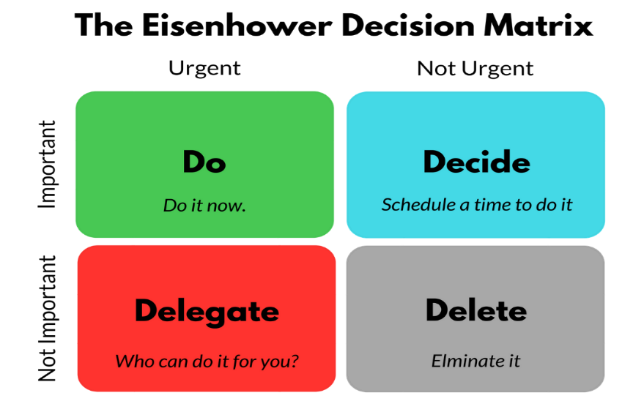
The best presentation and an effective presentation need to be perfect at every stage of a presentation. During my mini-presentation on time management I have improved my public speaking skills. According to Peter Morgan (2016), public speaking skills is very important to get a better job. In a presentation, it’s very important to make the presentation materials more technically arranged, while making presentation the presentation should be fully aware of the topic and also have to be well organized with an effective pace, clear voice, able to present all the materials without using notes, and lastly have to make an extraordinary introduction and conclusion. My mark distribution was from 3 to 5. Mostly I have acquired between 3 to 4. I got 2 marks on the conclusion for not making the conclusion precise and accurate.

Action Plan

While I will write reports again, I will write more accurate paraphrases while collecting information from websites. I will write a CV on one page and will highlight skills and educational qualifications more accurately and in an attractive way. I will search for more skills in writing CV which will help me to write a CV in the best format. According to my lecturer, LinkedIn is one of the advanced tools to create a skills-based CV. I will start building my LinkedIn profile to attract employer. I will attend a class exercise where I can find out my cover letter writing ability, as I missed my recent opportunity to get a feedback. I will deliver a speech by involving the audiences more and will make the lecturer remain to keep interested from beginning to last. I will talk more loudly and will walk among the listeners which will make me get more involved throughout the presentation.

Conclusion

I have learned a lot during the whole class test, exercises and everything. While learning I should have learned more about how to paraphrase because while I was writing the assignment, I felt that I was still lacking behind in writing paraphrasing. References should have written more accurately from websites. I should have submitted a CV written on my best-learned format on a job website so that I can figure out if it’s good enough to make the opportunity for me. While giving the presentation could have to make slides more attractive and the use of materials should have presented more precisely. Before giving the presentation, I can study the topic more, making the pace of the presentation more.

References

Gleitman, L.R. and Gleitman, H., 1970. Phrase and Paraphrase: Some Innovative Uses of Language.
Nigel Gilbert, G., 1977. Referencing as persuasion. Social studies of science, 7(1), pp.113-122.
Bonissone, P., Messmer, R., Patterson, A., Russell, D., Durham, W., Yang, D., Pavese, M., Coburn, D., Mogro-Campero, A., Merchant, V. and Orlando, J., 2003. System for summarizing information for insurance underwriting suitable for use by an automated system. U.S. Patent Application 10/175,419.
Gallagher, J.C. and Wodlinger Jackson, A.M., 2010. How to write a curriculum vitae. American Journal of Health-System Pharmacy, 67(6), pp.446-447.
Jobsite.co.uk. (2019). Find 1000s of UK Jobs. Start your job search with Jobsite UK. [online] Available at: https://www.jobsite.co.uk/ [Accessed 31 Dec. 2019].
Indeed.co.uk. (2019). Job Search | Indeed. [online] Available at: https://www.indeed.co.uk/
Morgan, P. (2016). The Business Student’s Guide to Study and Employability.

Appendix 1



