EFFECTIVE TEAM WORKING AND COMMUNICATION
BMSW4002

STUDENT NAME: ROXANA ZARNESCU(GROUP 13)

STUDENT ID: 1906075

LECTURER: LLOYD BEHARRY

Table of contents:

1.INTRODUCTION

2.WHAT IS COMMUNICATION?

3.HOW DOES A COMMUNICATION CYCLE FUNCTION?

4. COMMUNICATION MODELS AND METHODS

5.COMMUNICATION BETWEEN MANAGEMENT AND EMPLOYEES

7.ANNALYSING COMMUNICATION AT LAURA’S WORKPLACE

8.CONCLUSION

9.REFERENCES

1.INTRODUCTION

The following report will provide an overview of effective communication skills and discuss how the workplace is affected by this. There are several types of communication such as: verbal, non-verbal, written, formal, in-formal and visual. Communication is critical in management as this is where the foundation for a plan is to be applied and eventually the key to demonstrating good leadership. Management must ensure that their message is delivered correctly and with consistency in order for the receiver to properly understand it.

2.WHAT IS COMMUNICATION?

" It is the process of passing information and understanding from one person to another. Therefore, all communication influences at least two people: the one who sends the message and the one who receives it "(Idalberto Chiavenato ,2006)

Comunication elements

Receiver, sender, message, meaning, code, and channel are the communication components.

Issuer: The sender is identified as the recipient or source of the information or message being exchanged.

Receiver: receiver is known as the person or computer responsible for receiving the message that the issuer sends.

Message: the message is defined as the information to be exchanged between the sender and the recipient.

Context: it is the environment surrounding the emitter and the receiver, that is, the environment in which information is exchanged.

Code: these are the signs and rules that form the message when combined; the language spoken or written, sounds, symbols, signs, notes, etc.

Channel: the channel is defined as the means of transmitting a message. The information often includes the issuance or receipt of travel through a system.

Noise: noise is known as any signal that interferes with a sender-receiver message being transmitted regularly. (Lifepersona, 2006)

3.HOW DOES A COMMUNICATION CYCLE FUNCTION?

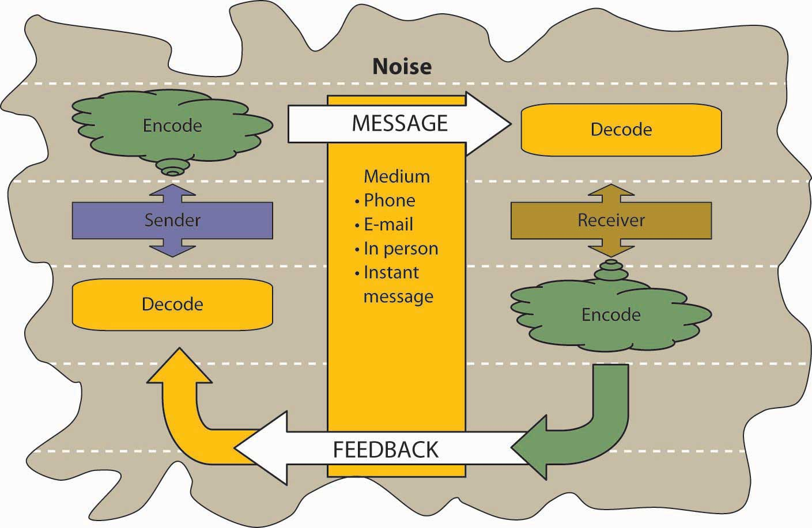
This Photo by Unknown Author is licensed under CC BY-SA-NC

The communication cycle is the mechanism through which one person sends a message and it passes through a receiver chain. A contact cycle's timing and usefulness is based on how long it takes for the original sender to receive feedback.
Complicated messages may act as barriers in communication.

Barriers in Communication:
If there is a disruption in the communication cycle, it is usually attributed to the barriers that stop the free flow of ideas. Ultimately, this disruption can defeat the purpose of communication.
Communication barriers include the following:
-Physical
-Structural
-Attitudinal
-Personal
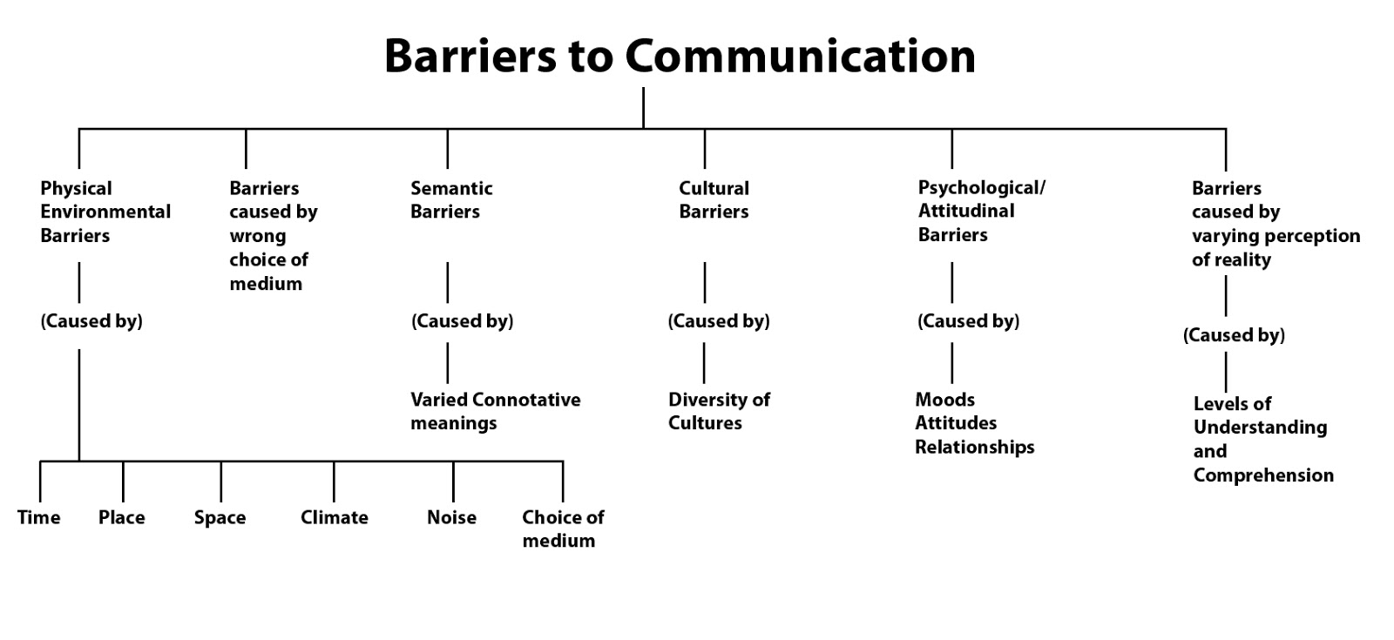
Effective communication involves clear communication between communicators, but there are many barriers to communication along the way that can cause your message to be misunderstood and misinterpreted.

4.COMMUNICATION MODELS AND METHODS
We have learned about three models of communication which help us to understand the mechanism of communication:

SHANNON AND WEAVER 1948 (Businesstopia, 2018 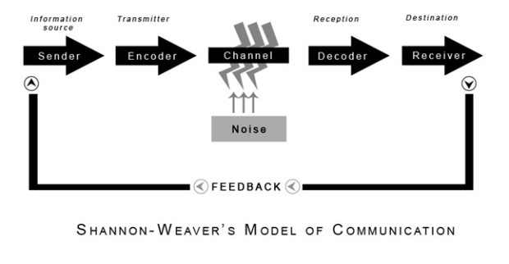
Shannon Weaver model of communication was developed in 1948 when Claude Shannon wrote an article “A Mathematical Theory of Communication” with Warren Weaver in Bell System Technical Journal Shannon and Weaver model is one of the important models in the field of the communication
Shannon and weaver model of communication deals with various concepts like Information source, transmitter, Noise, channel, message, receiver, channel, information destination, encode and decode so this model is more technological than other linear models.
This model of communication was used as an in-class exercise to explain a case study provided by our lecturer Lloyd Beharry
Case study: MARIA AND PEDRO
Maria told Pedro to buy a chicken on his way back home, but the noise on the background caused interruption and he misunderstood Maria. As there was no feedback they could not clarify the original message REFFER TO APENDIX 1- MARIA AND PEDRO

WILBER SCHRAMM’S MODEL OF COMMUNICATION 1954(Dennis G, 2018)
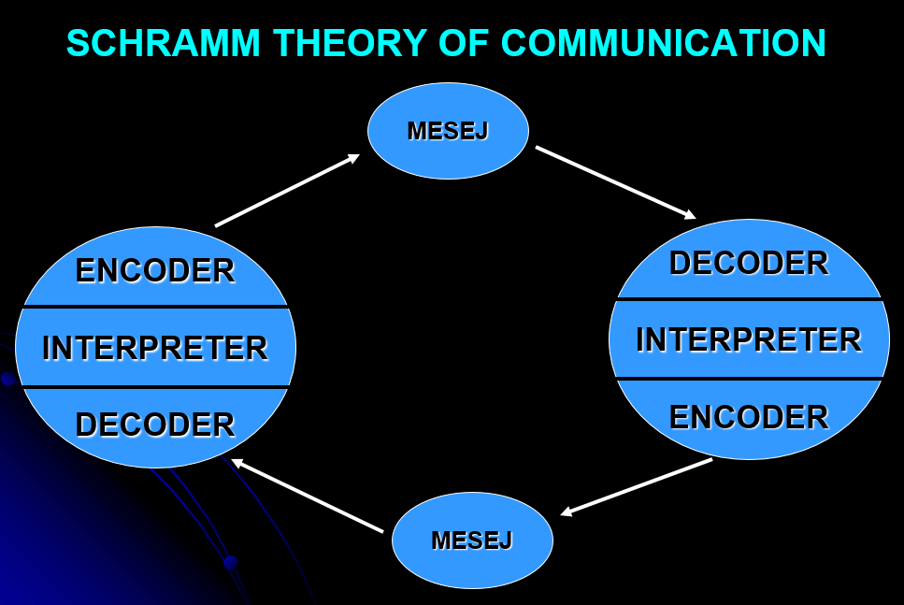

The Schramm Communication Model is a cyclical communication model containing all basic principles of communication. It can be used to determine how communication between two people works when they’re exchanging information, ideas, or attitudes.
The cyclical communication model is based on the theory and belief that communication is a two-way street. This is called intra-personal communication. The former is called interpersonal communication. (Denis,2018)
Imagine a person not responding to him sharing his thoughts with his friend. NO. Schramm believed that communication between the first party and the second party is in fact a two-way process.

BERLO’S MODEL OF COMMUNICATION 1960
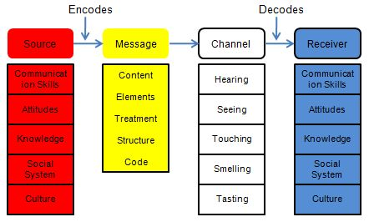
In 1960, David Berlo extended the 1949 linear communication model of Shannon and Weaver and developed the communication model of the Sender-Message-Channel-Receiver (SMCR). The SMCR communication model divided the model into basic parts and it was expanded by other scholars.
The communication method of Berlo is a simple application for person-to-person communication that includes the source of communication, encoder, message, channel, decoder, and receiver of communication. Furthermore, some factors that affect the contact process between two people were discussed by David Berlo. The variables are communication skills, level of knowledge, social system, cultural environment, and attitude.
The Berlo’s Model contact process starts at the source. This is the dimension that determines the communication skills, mindset, perception, social system, and cultural culture of the people involved. The encoder step starts after the message is generated, which are elements in a symbol array. The encoder process is where motor skills arise while speaking or writing. The message goes through the medium that holds the message through listening, seeing, touching, feeling, or tasting. Then there is the process of decoding. The receiver interprets the message with her or his sensory abilities in this process. Finally, the source of contact gets the entire message understood.

An in-class exercise required us to analyse the communication between “The professor and the village people”. In this exercise I use Berlo’s model of communication because is a big difference of education between the professor and the village people.

REFFER TO APENDIX 2: THE PROFESSOR AND THE VILLAGE PEOPLE

5.METHODS OF COMMUNICATION

The different categories of communication include:
Spoken or Verbal Communication, which includes face-to-face, telephone, radio or television and other media.
Non-Verbal contact, which includes the language of the body, movements, how we dress or behave, where we stand, and even our fragrance. We interact with others (maybe even unintentionally) in many subtle ways. The tone of voice, for example, may provide clues to mood or emotional state, whereas hand signals or gestures may add to a spoken message.
Written Communication: covering letters, emails, social media, books, newspapers, websites, and other media.
Before recently, a relatively small number of authors and publishers were very effective when the written word was shared. Today, we can all write and publish our ideas online, which has led to an explosion of information and communication possibilities. Visualizations: graphs and charts, maps, logos and other visualizations can all communicate messages. (https://www.skillsyouneed.com)

6.COMMUNICATION BETWEEN MANAGEMENT AND EMPLOYEES

“As an efficient and competitive leader or manager, effective and reliable communication acts as an important factor to develop. To achieve professional success managers must be effective and convincing communicators. It is crucial for managers and their teams to learn how to communicate properly, because this will not only help teams successfully complete their tasks, but also allow organisations to succeed and develop.” (Lee Froschheiser, 2014). According to many researchers, leader is one who has an ability to take charge, direct, encourage, or stimulate others. They have an attitude to convince others and to make them follow the goals or the participles defined by them. They are results oriented hence, well trained and expert in controlling difficult to difficult conditions and help to enhance the outputs of teams working with him. “Anyone could be a leader, as the person who takes the charge is a leader. He could be a prime minister of any nation or an executive working in an organization. These people have cluster of leadership qualities, but are not able to lead if they are not good communicators. Communication enables them to share what they have and what they expect from others. So, it is effective communication, which makes leaders to lead successfully. Good communication skills help to develop better understanding and beliefs among people inspire them to follow the principles and values which their leader wants to inculcate in them.” (Frese. et.al. 2003, Deborah J. Barrett, 2006)
For employees, learning how to communicate effectively in their organisation with individuals at all levels is a skill they need to acquire to excel in their workplaces. Poor communication skills can put a stop in a career, or even end it.
“Communication can be made effective in a business organization by being clear, complete, concise, concrete, considerate, correct and courteous.” (Chron, 2019)
An in-class exercise provided by our Lecturer required us to write a business email offering a customer information about a product/service that they want which is not available at the moment.
REFER TO APPENDIX 3: THE BUSSINESS EMAIL

7.ANNALYSING COMMUNICATION AT LAURA DEAN’S WORKPLACE

Laura Dean is working as an assistant manager for one of the biggest pharmacy chain in UK “Boots”. Her responsibility is to work alongside the store manager and to inspire the team to deliver business growth by providing exceptional care to their customers and patients. She has to be an example for her co-workers.
Laura is using many methods of communication to deal with customers complaints, questions ,orders and so on. She widely uses written communication such as emails, letters and notes.
One of the biggest advantages of written communication is the fact that it allows for permanent records, which is something other means of communication such as oral communication do not have.
But there are also some disadvantages: Poor writing skills can hamper written communication's effectiveness. If the writer is unable to write efficiently then there is a high probability that the message being sent will be misunderstood by many people. For any company, this can be a very negative thing and can come with a lot of serious repercussions.
This is what happened to Laura as well, because English is her second language and her writing is not perfect.
She replied to a customer complaint by email using few words that the customer didn’t understood and from there all her problems started.
The complaint was escalated to the general manager and Laura lost her job because her poor writing skills.

If a message contains just the written word (such as a text or email), the sender needs to be confident in its clarity, that it cannot be misinterpreted. Emails can often come off cold or clipped without that being the intention of the sender, for example, yet it's not considered professional to have emoticons in formal communication to help convey the proper meaning and context. (Richard, 2019)

As in-class exercise provided by our Lecturer required us to analyse and evaluate the Chief and Mark’s communication skills during a meeting and what could be improved

REFER TO APPENDIX 4: A DAY WITH THE CHIEF

8.CONCLUSION

Communication is playing a vital role in the personality of any individual. Without communication we cannot know the feeling of the other person and cannot express his feeling towards other person. From the group discussion and personal interview, Interviewer can judge the level of communication skill of particular candidates.

“Communication is the basic tool for an organization to be successfully and proficiently.
Effective communication helps ensure that information within the company is conveyed correctly and accurately. If the information relay is wrong the efficiency of the company may be impaired.”Mikitka (2009) also confirms this by stating that managers need good communication skills as their job requires them to increase efficiency, satisfy customers, implement strategies and disseminate information. Managers should also improve the communication skills of the employees (Bambacas & Patrickson 2008). The authors further state that employees will perform better if they are able to communicate with one another effectively. Therefore, communication skills are essential for an effective and efficient management
According to Tagreed(2012), A key factor that makes cultural differences a barrier to effective communication is language. English is not the commonly spoken language in some cultures.

9.REFERENCES

https://www.lifepersona.com/definition-of-communication-according-to-5-authors
[online] accessed on 26/12/2019

Bussinestopia,(2018) SHANON AND WEAVER MODEL OF COMMUNICATION-[online] Available at:https://www.businesstopia.net/communication/shannon-and-weaver-model-communication [accessed on 16/12/2019 at 09:57]

Businesstopia, "Berlo’s SMCR Model of Communication," https://www.businesstopia.net/communication/berlo-model-communication.

Deborah, J., (2006),“Leadership Communication: A Communication Approach for Senior-Level Managers” [Online]
Available: https://scholarship.rice.edu/bitstream/ handle/1911/27037/Leadership/Communication/A/Com municatin/Approach/for/SeniorLevel/Managers

Jha ,S .K and Malik, M.(n.d) COMMUNICATION SKILLS.[online]
Available at: https://www.agrimoon.com [accessed on the 12/12/2019 at 14.25pm]

Janse, B. (2019). Schramm Communication Model. Retrieved [16/12/2019] from toolshero: https://www.toolshero.com/communication-skills/schramm-communication-model

Lawrence Robinson, Jeanne Segal, Ph. D., and Melinda Smith, M.A. (2019) [online]
Available at: https://www.helpguide.org/articles/relationships-communication/effective-communication.htm (accessed on 22/12/2019 at 12:15)

Maund. A, Schriek, M and Tinkler, P.K, (2017). CERTIFICATE IN HIGHER EDUCATION: skills for the workplace student yearbook. LONDON: Sage Publications ltd

Nordquist, Richard. "What Is Communication?" ThoughtCo, Sep. 19, 2019, thoughtco.com/what-is-communication-1689877.

(2019). What is Communication? Verbal, Non-Verbal & Written | SkillsYouNeed. [online] Skillsyouneed.com. Available at: https://www.skillsyouneed.com/ips/what-is-communication.html [Accessed 18 Dec. 2019].
Tagreed, I.K.( 2012)"Cross-cultural Differences in Management", International Journal of Business and Social Science, vol. 3, no. 6, pp. n/a

https://www.skillsyouneed.com [online] Accessed on 22/12/2019 at 13:10



