HTML AND CSS WEB DEVELOPMENT

NAME: ANESIPO SOBEKWA
STUDENT NUMBER: 2308434
MODULE: INTRODUCTION TO WEB AND DATABASE CONCEPTS
DATE: 15/04/24

CONTENT

- INTRODUCTION
- REQUIREMENTS
- IMPLEMENTATIONS
- EVALUATION
- REFERENCE

Introduction

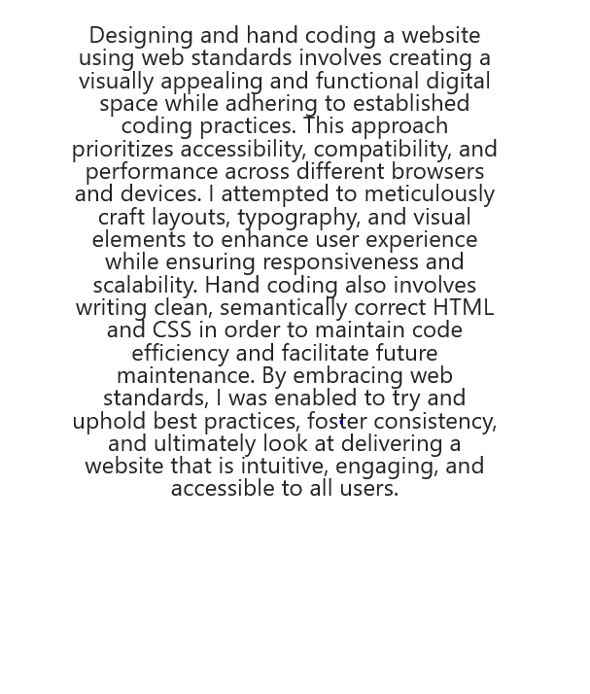

Requirements

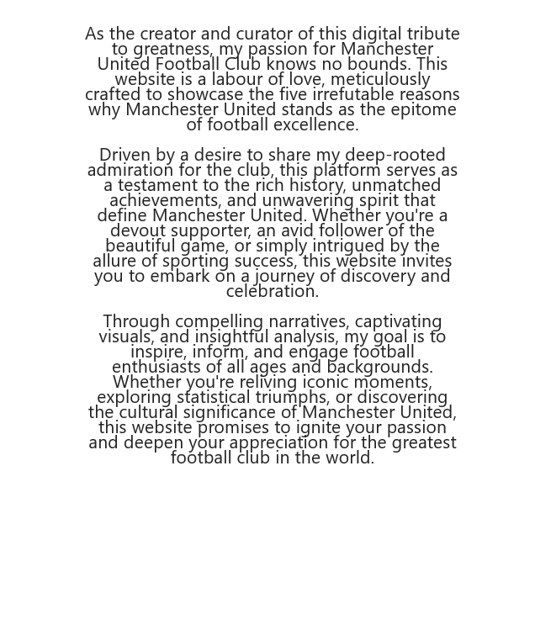

Implementation
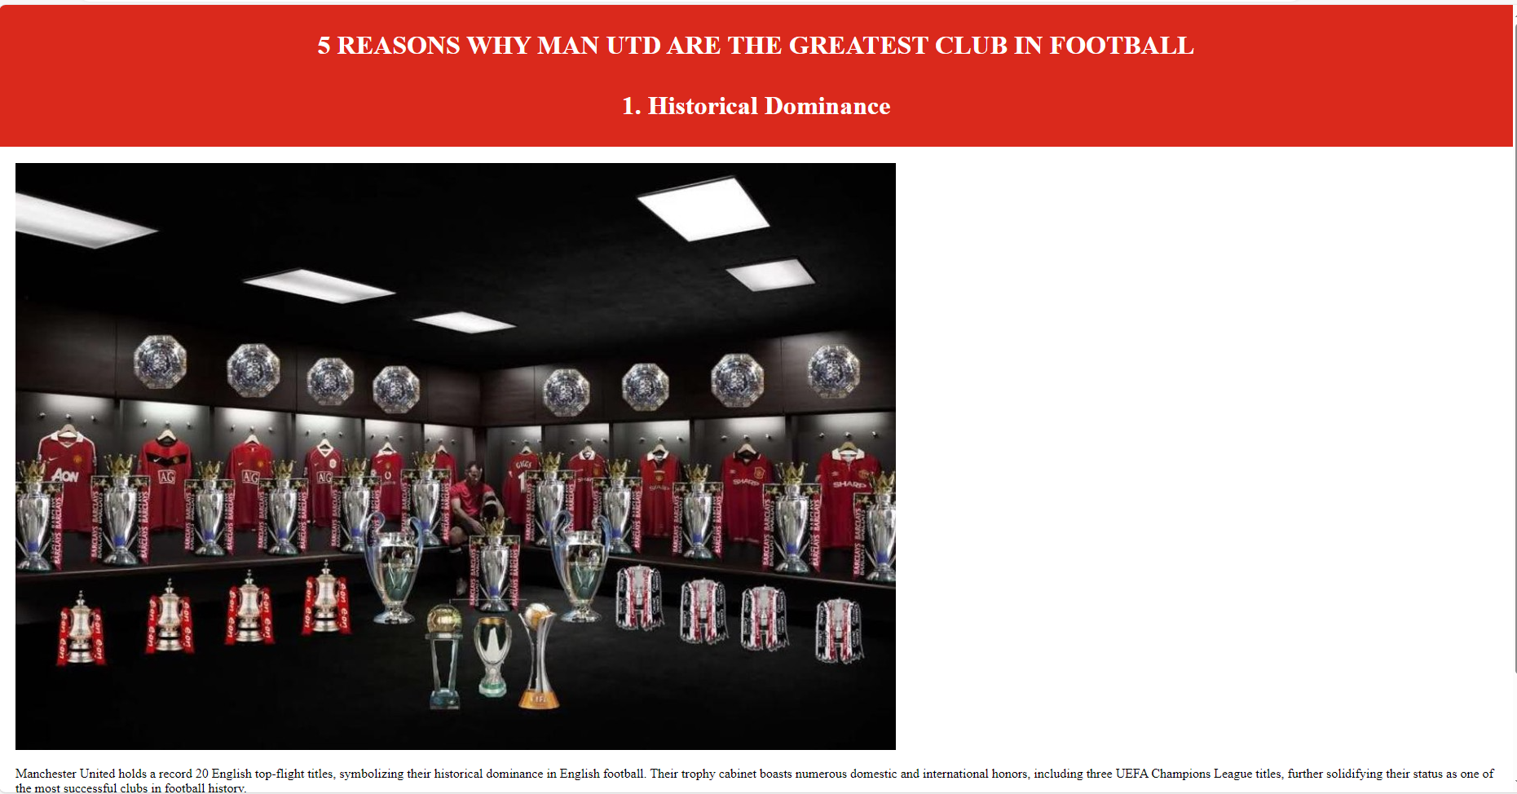
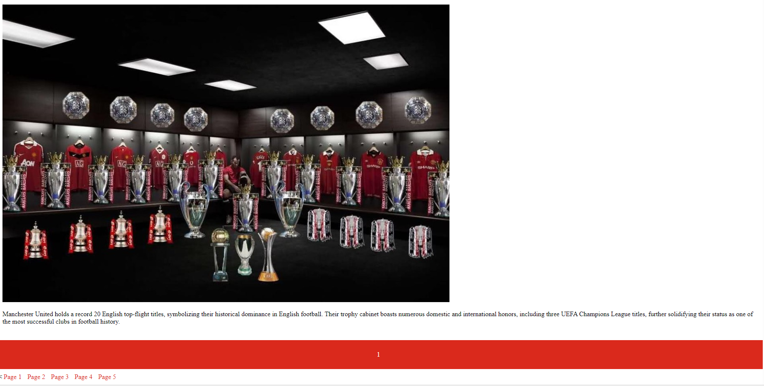
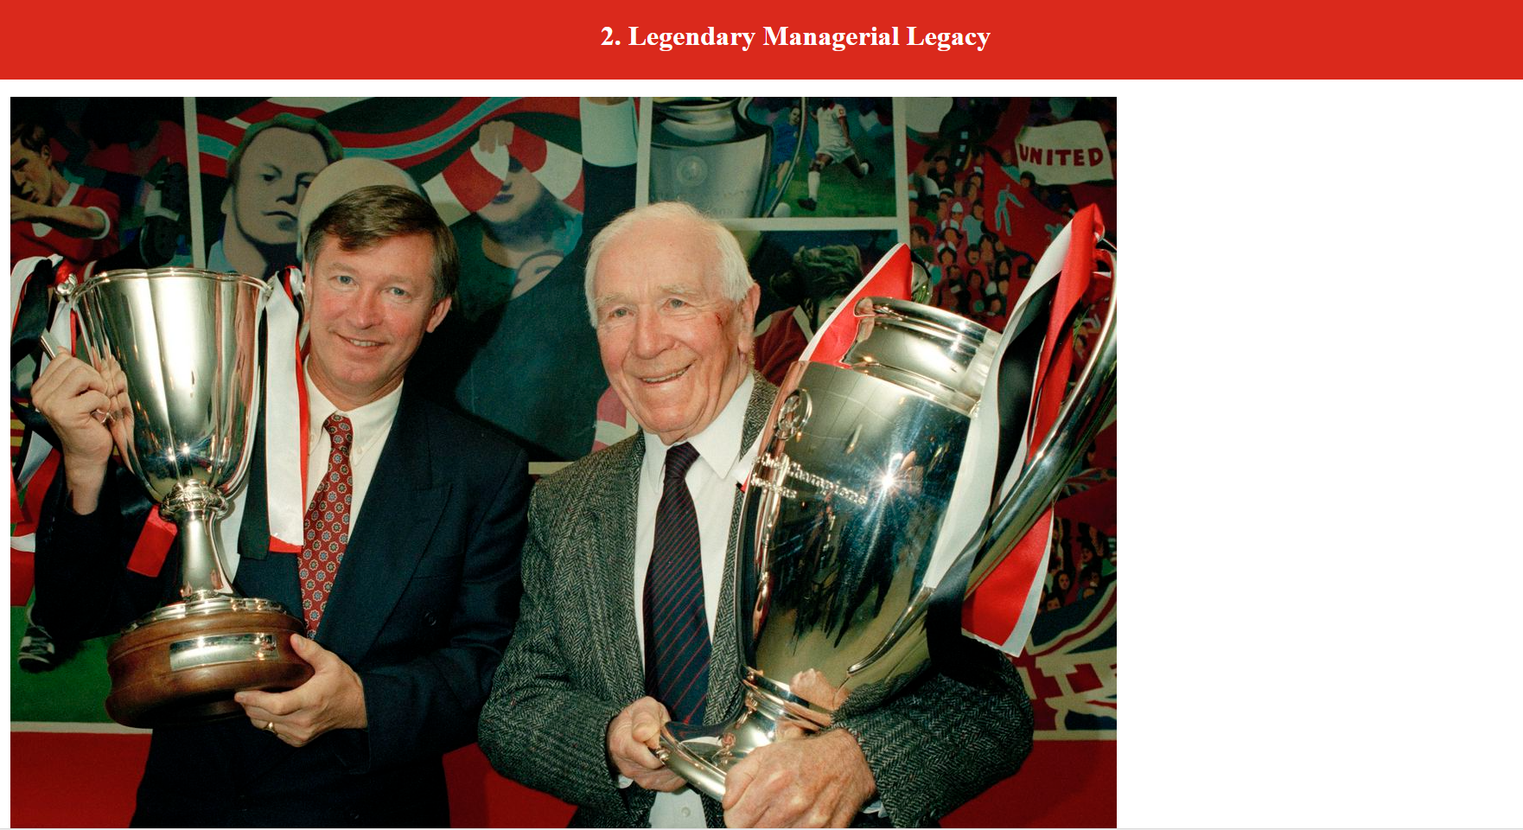

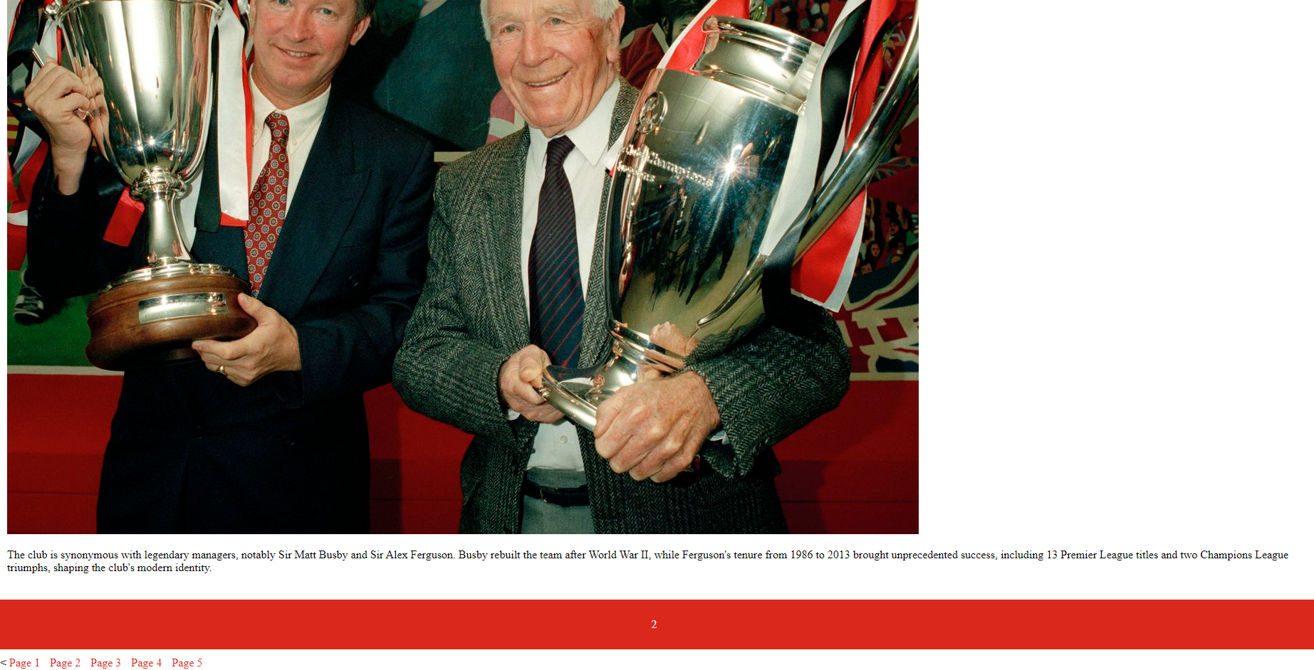
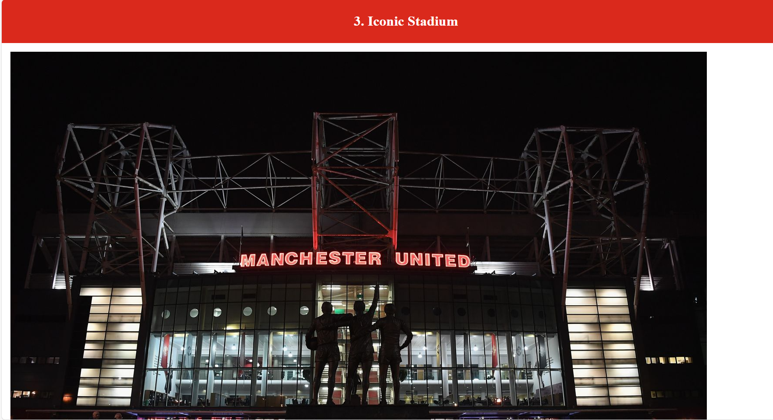
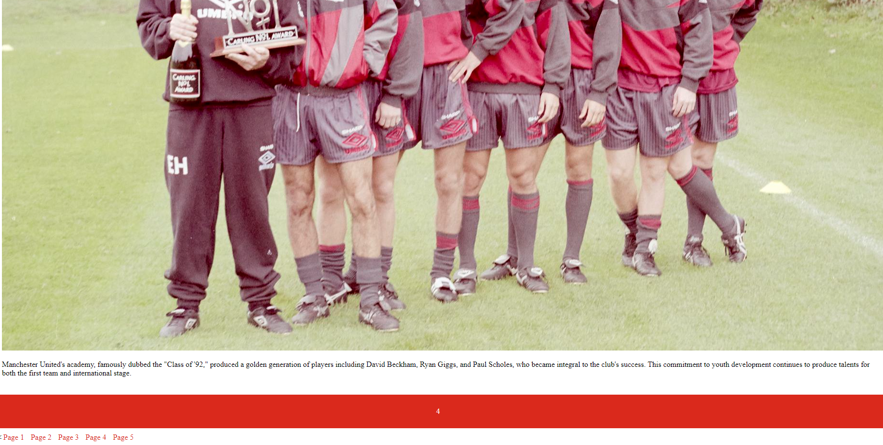
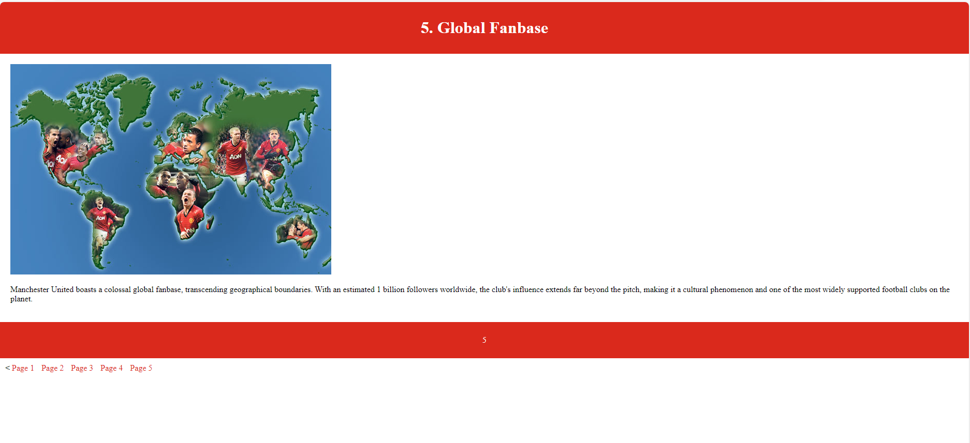
Evaluation
1 Website Usability**:
Website usability refers to the ease with which users can navigate and interact with a website to achieve their goals effectively and efficiently. It encompasses factors such as intuitive navigation, clear layout, readable content, and user-friendly design. A website with good usability ensures that visitors can find the information they need quickly, complete tasks without confusion, and have a positive experience overall. Usability testing, user feedback, and continuous improvement are essential in optimizing website usability.
2. **Accessibility**:
Website accessibility focuses on ensuring that websites are usable and navigable by people with disabilities, including visual, auditory, motor, and cognitive impairments. An accessible website accommodates a diverse range of users by providing alternative means of accessing content, such as screen readers for visually impaired users, keyboard navigation for those with motor disabilities, and captions for videos for deaf users. Accessibility standards, such as the Web Content Accessibility Guidelines (WCAG), provide guidelines and techniques for developers to follow to make their websites accessible to all users, regardless of their abilities.
3. **Search Engine Optimization (SEO)**:
SEO is the process of optimizing a website to increase its visibility and ranking in search engine results pages (SERPs). The goal of SEO is to attract organic (non-paid) traffic to a website by improving its relevance, authority, and trustworthiness in the eyes of search engines like Google, Bing, and Yahoo. Key elements of SEO include optimizing on-page factors such as keywords, meta tags, and content quality, as well as off-page factors such as backlinks and social signals. By adhering to SEO best practices, web developers can ensure that their websites rank higher in search results, driving more traffic and potential customers to their site.
In web development, each of these aspects plays a crucial role in creating high-quality websites that meet the needs of users, comply with accessibility standards, and perform well in search engine rankings. By prioritizing usability, accessibility, and SEO, developers can create websites that are user-friendly, inclusive, and discoverable, ultimately providing a better experience for all visitors.

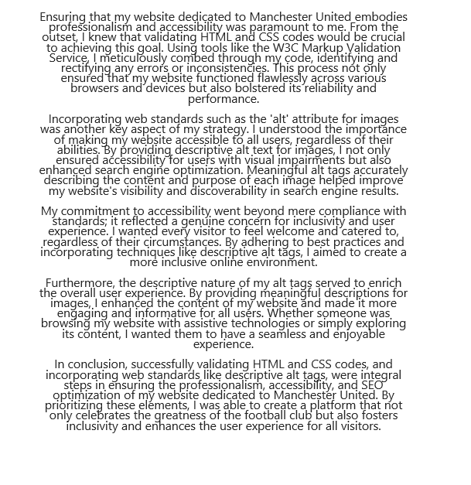

References

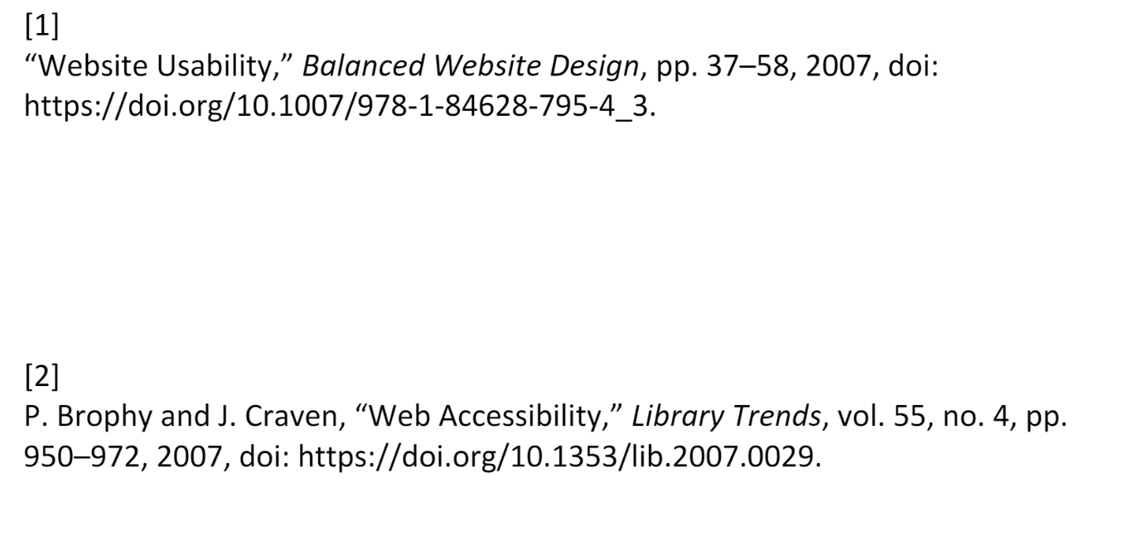

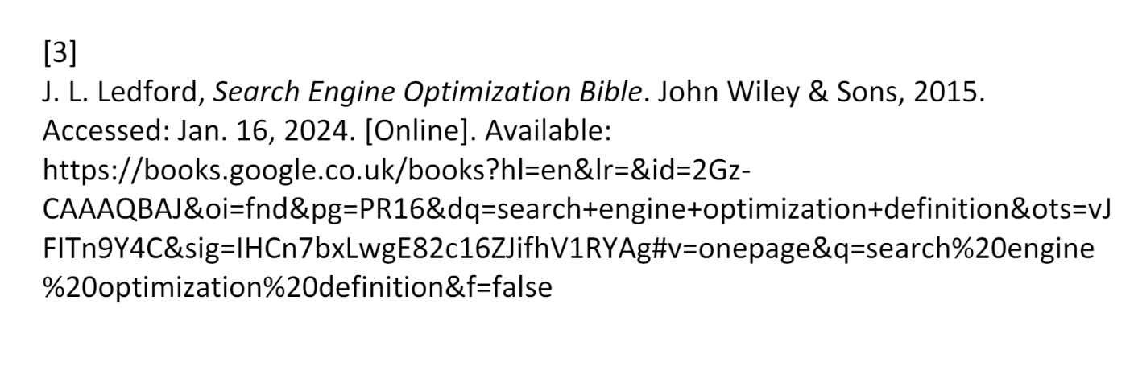

Appendices
<!DOCTYPE html>
<html>
<head>
<title>Manchester United</title>
<link rel="stylesheet" type="text/css" href="stylesheet.css">
</head>
<body>
<header>
<h1> 5 REASONS WHY MAN UTD ARE THE GREATEST CLUB IN FOOTBALL <br><br>

1. Historical Dominance</h1>
</header>

<main>
<img src="https://media.licdn.com/dms/image/D4D12AQG33MB16JTAaw/article-cover_image-shrink_720_1280/0/1709542657610?e=2147483647&v=beta&t=Hwq2sri7JIRIkixGNQhJLH5ZThx9qPCkPHxATGfZTwE" alt="Manchester United Trophy cabinet">
<p> Manchester United holds a record 20 English top-flight titles, symbolizing their historical dominance in English football. Their trophy cabinet boasts numerous domestic and international honors, including three UEFA Champions League titles, further solidifying their status as one of the most successful clubs in football history.
</p></main>
<footer>
<p>1</p>
</footer>
<nav>
<ul>
<
<li><a href="page1.html">Page 1</a></li>
<li><a href="page2.html">Page 2</a></li>
<li><a href="page3.html">Page 3</a></li>
<li><a href="page4.html">Page 4</a></li>
<li><a href="page5.html">Page 5</a></li>
</ul>
</nav>
</body>
</html>

<!DOCTYPE html>
<html>
<head>
<title>Manchester United</title>
<link rel="stylesheet" type="text/css" href="stylesheet.css">
</head>
<body>
<header>
<h1>2. Legendary Managerial Legacy</h1>
</header>

<main>
<img src="https://assets.manutd.com/AssetPicker/images/0/0/8/143/561132/GettyImages-10890595761517504650759_medium.jpg" alt="Sir Alex Ferguson and Sir Matt Busby">
<p>The club is synonymous with legendary managers, notably Sir Matt Busby and Sir Alex Ferguson. Busby rebuilt the team after World War II, while Ferguson's tenure from 1986 to 2013 brought unprecedented success, including 13 Premier League titles and two Champions League triumphs, shaping the club's modern identity.
</p>

</main>
<footer>
<p>2</p>
</footer>
<nav>
<ul>
<
<li><a href="page1.html">Page 1</a></li>
<li><a href="page2.html">Page 2</a></li>
<li><a href="page3.html">Page 3</a></li>
<li><a href="page4.html">Page 4</a></li>
<li><a href="page5.html">Page 5</a></li>
</ul>
</nav>
</body>
</html>
<!DOCTYPE html>
<html>
<head>
<title>Manchester United</title>
<link rel="stylesheet" type="text/css" href="stylesheet.css">
</head>
<body>
<header>
<h1>3. Iconic Stadium</h1>
</header>

<main>
<img src="https://e0.365dm.com/16/11/1600x900/skysports-old-trafford-generic-night-time-view_3843500.jpg?20161130194837" alt="Manchester United Stadium, Old Trafford">
<p>Old Trafford, affectionately known as the "Theatre of Dreams," is an iconic venue steeped in history and tradition. With a capacity exceeding 74,000, it's one of the largest club stadiums in Europe. The atmosphere generated by the passionate fans makes it a fortress for Manchester United.
</p>
</main>
<footer>
<p>3</p>
</footer>
<nav>
<ul>
<
<li><a href="page1.html">Page 1</a></li>
<li><a href="page2.html">Page 2</a></li>
<li><a href="page3.html">Page 3</a></li>
<li><a href="page4.html">Page 4</a></li>
<li><a href="page5.html">Page 5</a></li>
</ul>
</nav>
</body>
</html>

<!DOCTYPE html>
<html>
<head>
<title>Manchester United</title>
<link rel="stylesheet" type="text/css" href="stylesheet.css">
</head>
<body>
<header>
<h1>4. Youth Development</h1>
</header>

<main>
<img src="https://assets.manutd.com/AssetPicker/images/0/0/12/208/839706/19951001_MUFC_Drinks__0035-11575903465118_large.jpg" alt="Manchester United Class of 92">
<p> Manchester United's academy, famously dubbed the "Class of '92," produced a golden generation of players including David Beckham, Ryan Giggs, and Paul Scholes, who became integral to the club's success. This commitment to youth development continues to produce talents for both the first team and international stage.</p>
</main>
<footer>
<p>4</p>
</footer>
<nav>
<ul>
<
<li><a href="page1.html">Page 1</a></li>
<li><a href="page2.html">Page 2</a></li>
<li><a href="page3.html">Page 3</a></li>
<li><a href="page4.html">Page 4</a></li>
<li><a href="page5.html">Page 5</a></li>
</ul>
</nav>
</body>
</html>

<!DOCTYPE html>
<html>
<head>
<title>Manchester United</title>
<link rel="stylesheet" type="text/css" href="stylesheet.css">
</head>
<body>
<header>
<h1>5. Global Fanbase</h1>
</header>

<main>
<img src="https://www.manchesterlalala.com/wp-content/uploads/2014/07/Fergie_pic_1646249a.jpg" alt="Manchester United Global fanbase heatmap">
<p> Manchester United boasts a colossal global fanbase, transcending geographical boundaries. With an estimated 1 billion followers worldwide, the club's influence extends far beyond the pitch, making it a cultural phenomenon and one of the most widely supported football clubs on the planet.</p>
</main>
<footer>
<p>5</p>
</footer>
<nav>
<ul>
<
<li><a href="page1.html">Page 1</a></li>
<li><a href="page2.html">Page 2</a></li>
<li><a href="page3.html">Page 3</a></li>
<li><a href="page4.html">Page 4</a></li>
<li><a href="page5.html">Page 5</a></li>
</ul>
</nav>
</body>
</html>
body {
background-image: url('"https://wallpapercave.com/wp/wp3293755.jpg');
background-repeat: no-repeat;
background-size: cover;
margin: 0;
padding: 0;
}

header {
background-color: #DA291C;
color: white;
padding: 10px;
text-align: center;
}

nav {
background-color: #FFFFFF;
padding: 10px;
}

nav ul {
list-style-type: none;
margin: 0;
padding: 0;
}

nav li {
display: inline;
margin-right: 10px;
}

nav a {
color: #DA291C;
text-decoration: none;
}

main {
padding: 20px;
}

footer {
background-color: #DA291C;
color: white;
padding: 10px;
text-align: center;

