

Module Name: Academic Skills in the Digital Era
Module Code: BMSW4013
Assessment 1: E-Portfolio
Student Name: Khalil Ullah
Student Number:2508657
Lecturer: Scott James
Deadline: Friday 21st November 23:59PM

Navigating Student Success in the Digital Era
A Combined Research Plan and Analytical Report on Challenges, Opportunities, and Adaptation Strategies for Modern Learners

Component 3: Reflective Presentation

Slide 1: Title Slide
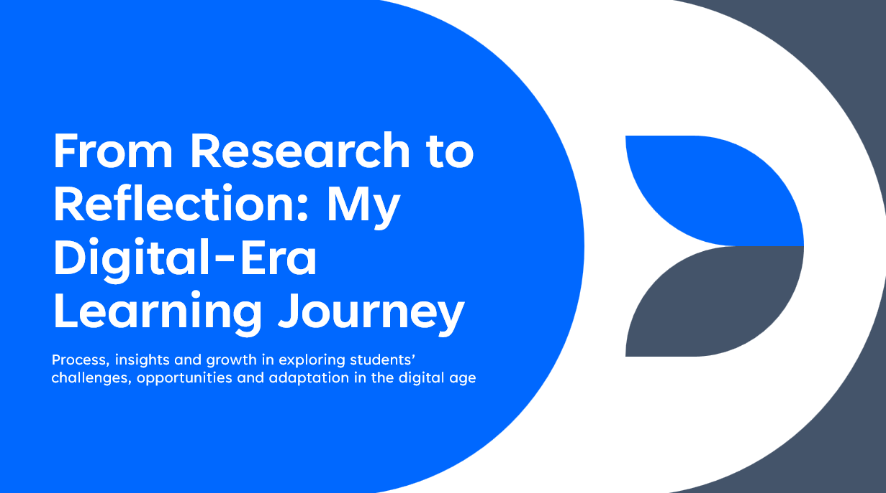

Slide 2: Overview
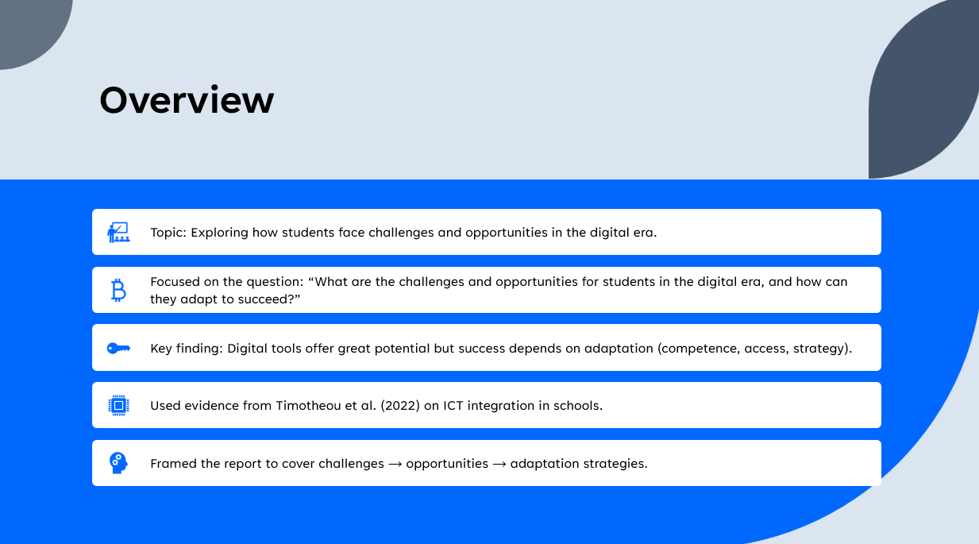

Slide 3: Research Process
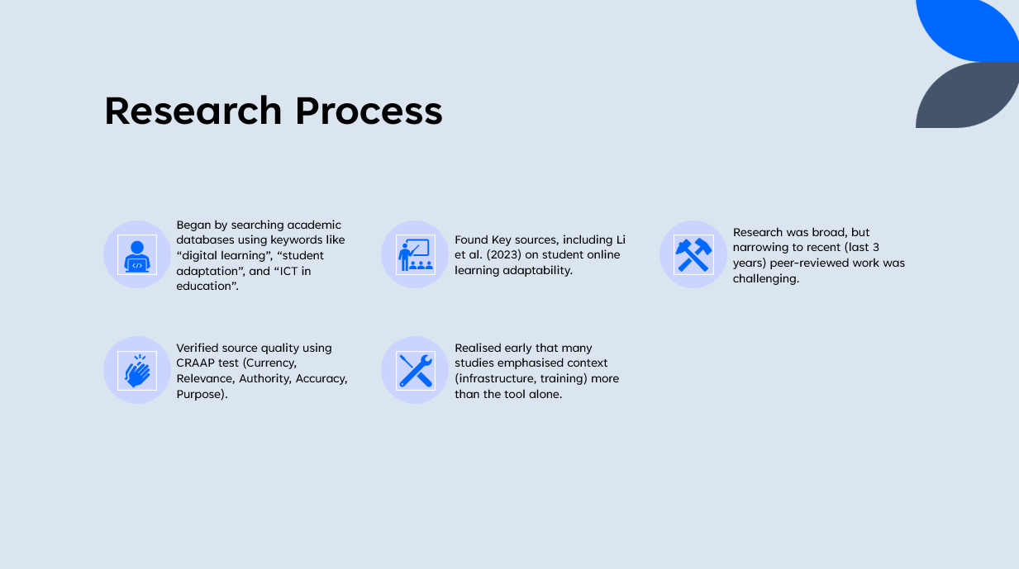

Slide 4: Planning & Writing
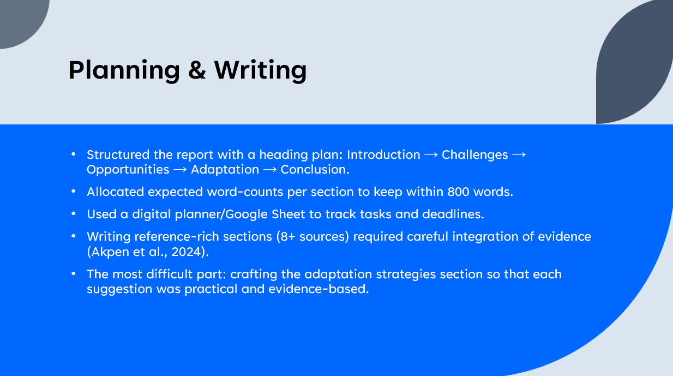

Slide 5: Key Challenges & Successes
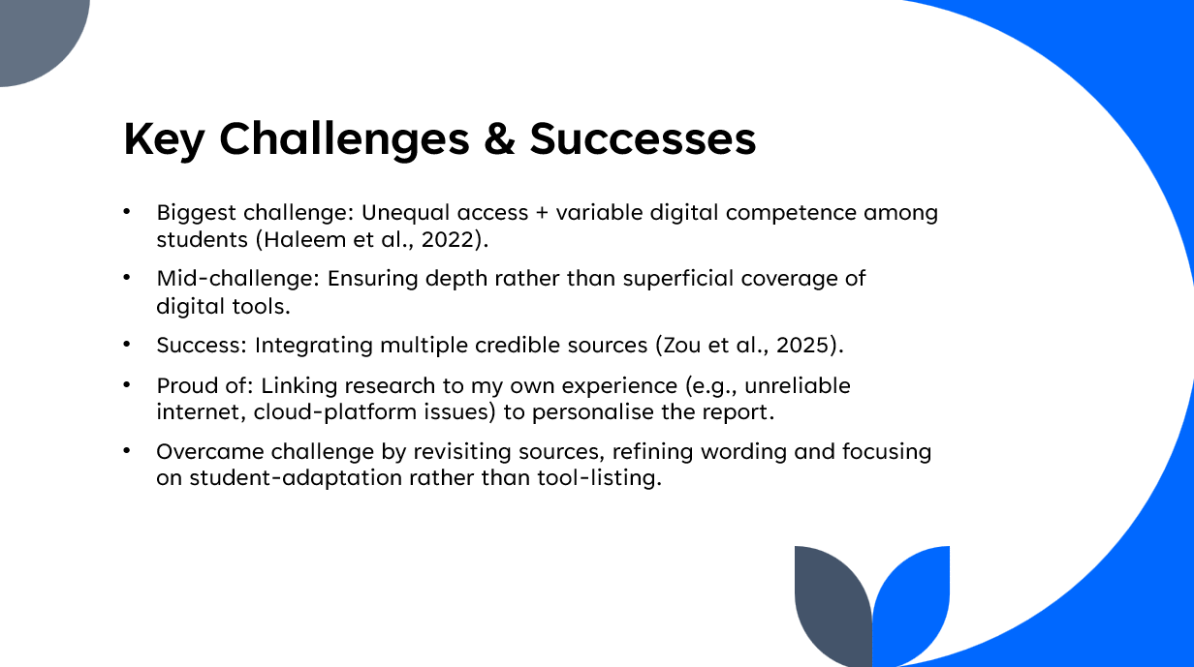

Slide 6: Looking Forward
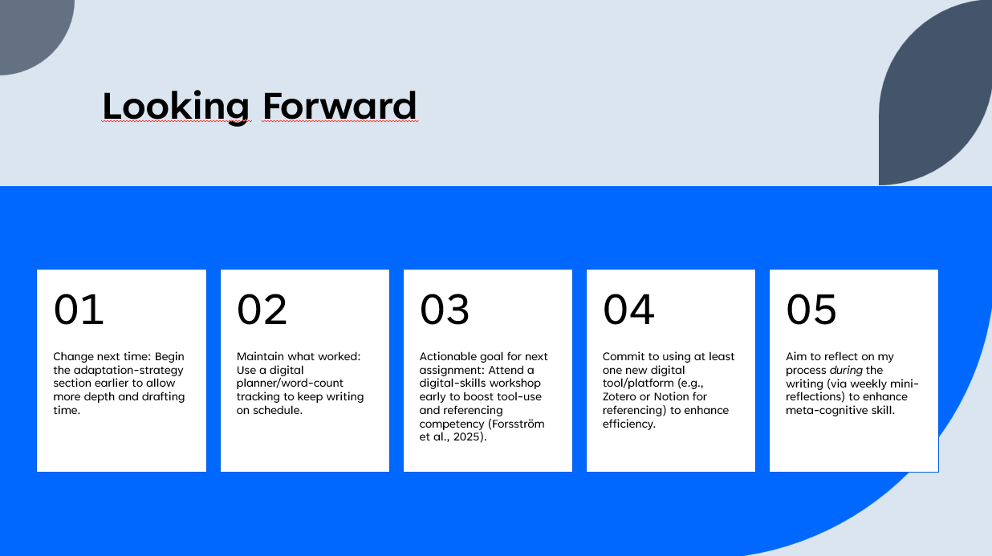

Slide 7: References
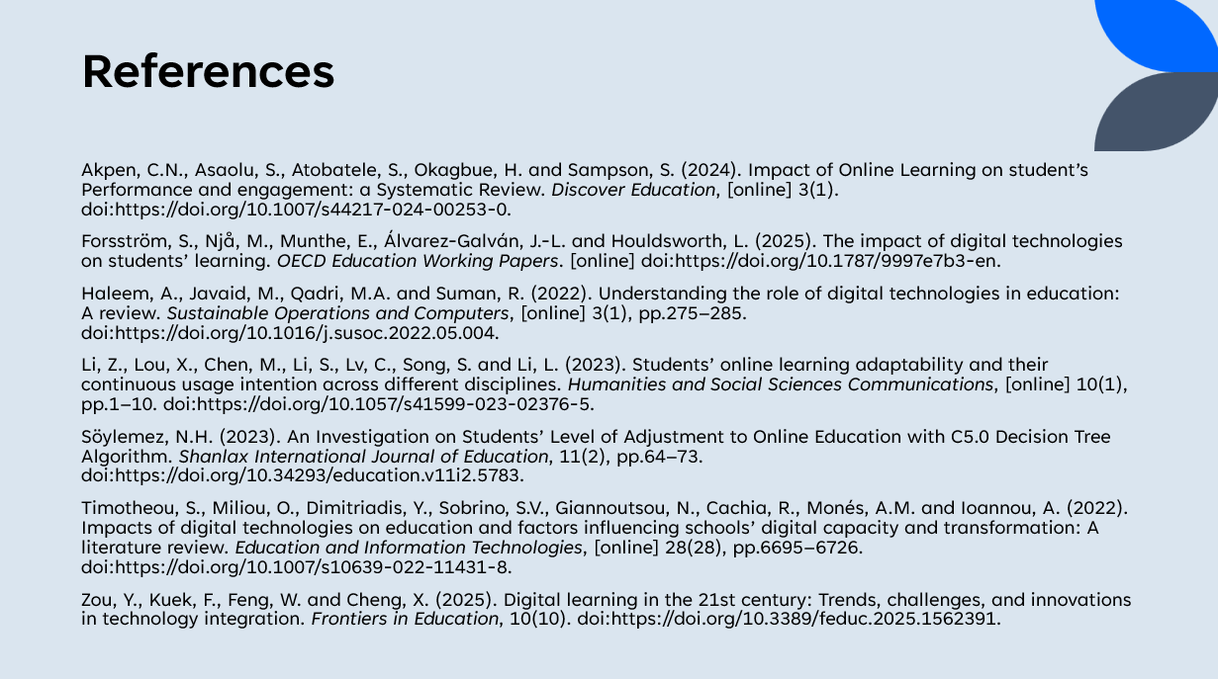

Reference list
Akpen, C.N., Asaolu, S., Atobatele, S., Okagbue, H. and Sampson, S. (2024). Impact of Online Learning on student’s Performance and engagement: a Systematic Review. Discover Education, [online] 3(1). doi:https://doi.org/10.1007/s44217-024-00253-0.
Bogiannidis, N., Southcott, J. and Gindidis, M. (2023). An exploration of the possible educational opportunities and the challenges at the intersection of the physical and digital worlds occupied by 10–14 year-old students. Smart Learning Environments, 10(1). doi:https://doi.org/10.1186/s40561-023-00246-w.
Chen, Z. and Singh, C. (2025). Opportunities and Challenges in Harnessing Digital Technology for Effective Teaching and Learning. Trends in Higher Education, 4(1), p.6. doi:https://doi.org/10.3390/higheredu4010006.
Forsström, S., Njå, M., Munthe, E., Álvarez-Galván, J.-L. and Houldsworth, L. (2025). The impact of digital technologies on students’ learning. OECD Education Working Papers. [online] doi:https://doi.org/10.1787/9997e7b3-en.
Haleem, A., Javaid, M., Qadri, M.A. and Suman, R. (2022). Understanding the role of digital technologies in education: A review. Sustainable Operations and Computers, [online] 3(1), pp.275–285. doi:https://doi.org/10.1016/j.susoc.2022.05.004.
Li, Z., Lou, X., Chen, M., Li, S., Lv, C., Song, S. and Li, L. (2023). Students’ online learning adaptability and their continuous usage intention across different disciplines. Humanities and Social Sciences Communications, [online] 10(1), pp.1–10. doi:https://doi.org/10.1057/s41599-023-02376-5.
Mhlongo, S., Mbatha, K., Ramatsetse, B. and Dlamini, R. (2023). Challenges, opportunities, and prospects of adopting and using smart digital technologies in learning environments: An iterative review. Heliyon, 9(6), pp.1–20. doi:https://doi.org/10.1016/j.heliyon.2023.e16348.
Rueda, M.M., Cerero, J.F., Cerero, D.F. and Meneses, E.L. (2024). Perspectives on online learning: Advantages and challenges in higher education. Contemporary Educational Technology, 16(4), p.ep525. doi:https://doi.org/10.30935/cedtech/15011.
Söylemez, N.H. (2023). An Investigation on Students’ Level of Adjustment to Online Education with C5.0 Decision Tree Algorithm. Shanlax International Journal of Education, 11(2), pp.64–73. doi:https://doi.org/10.34293/education.v11i2.5783.
Timotheou, S., Miliou, O., Dimitriadis, Y., Sobrino, S.V., Giannoutsou, N., Cachia, R., Monés, A.M. and Ioannou, A. (2022). Impacts of digital technologies on education and factors influencing schools’ digital capacity and transformation: A literature review. Education and Information Technologies, [online] 28(28), pp.6695–6726. doi:https://doi.org/10.1007/s10639-022-11431-8.
Wiitavaara, B. and Widar, L. (2025). Challenges and opportunities related to online studies in higher education. Education and Information Technologies. doi:https://doi.org/10.1007/s10639-025-13406-x.
Zou, Y., Kuek, F., Feng, W. and Cheng, X. (2025). Digital learning in the 21st century: Trends, challenges, and innovations in technology integration. Frontiers in Education, 10(10). doi:https://doi.org/10.3389/feduc.2025.1562391.

