Six Nations, France V Wales

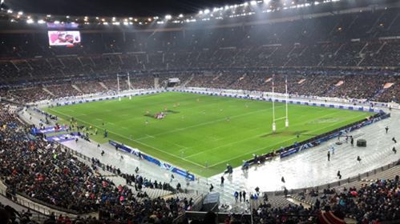

During the first day visiting Paris, some of us opted to buy tickets to watch the first Six Nations match of the year, France V Wales. It had already been such a long day for all of us, travelling from Swansea to Paris, with major delays caused by the weather, we were all eager to start the night off well and start enjoying Paris. I had never been to Paris before, I just had the perception of what it would be like after watching films and series where you would see the image of Paris is like.
The main way we got around in Paris and Switzerland was by train. I didn’t expect to be on trains for most of the week, I think we were all trained-out by the time we got home. The main use of transportation in Paris we used was the Metro. The only way I can describe the metro is it being the French version of the London underground. That was our way to get to the stadium to watch the game. We got on the first metro to go to the game, as we got off I sadly realised that someone had gone into my bag and stole my phone. The metro was full of people we barely had room to breathe on there. I knew pickpocketing was a big thing in Paris, but I don’t think anyone truly realised the fright it brings until it happened to me. I was lucky enough to be able to ring EE off Richards phone which I could block the pick pocketer from using my sim card. I was devastated to of had my phone stolen, I thought it was safe zipped up in my bag, but you don’t understand how clever theses people are. I really didn’t expect this to happen to me I think it massively changed my opinion on going back to Paris.
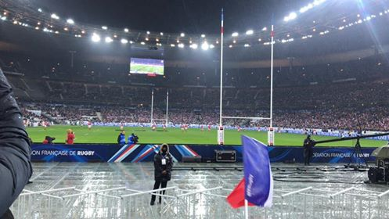
After eventually getting to the stadium it started to rain which we are all used to as we were so used to Welsh weather. Before going to our seats, we decided to grab some food and something to drink. The both came to ten euros which I thought was a reasonable price considering we were at a Six Nations match. When we eventually found our seats, I was surprised to find out we were only five rows away from the pitch. The view was amazing, and I did not expect our seats to be so good.as it was raining we were all soaking as the roof the stadium had only covered the top tier. During one of the French conversions I was talking to one of the girls and some Frenchman behind me punched me in the back. This was the second time I learnt that the French are not the politest of people.
During the first half Wales were not playing very well at all. We were all rooting for Wales to win even being soaked and stuck in the rain nothing was bringing our spirit down. The only down fall was that we were surrounded by French supporters. It would have been a lot better if we were sitting with welsh supporters. After the first half had finished we all decided that we were go and stand under shelter where the food was, so we could decide whether we should move seats. We decided that we should move seats so that we were higher up and we weren’t getting wet at the same time as that was the main reason as to why we wanted to move.
Once the second half had started we decided to grab some seats which were by the entrance which leads you into the stadium and out to where the toilets and food stands were, so it was easy access if we needed to get drinks or not. We finally found some welsh fans which were full of energy and were singing songs and just lifting everyone’s spirits. Wales managed to win the game overall which was amazing as there were thousands of French fans compared to welsh. They fought back in the second half you could tell they wanted to win as much as we wanted them to win. After the finally whistle went the atmosphere for all the welsh fans was electric.
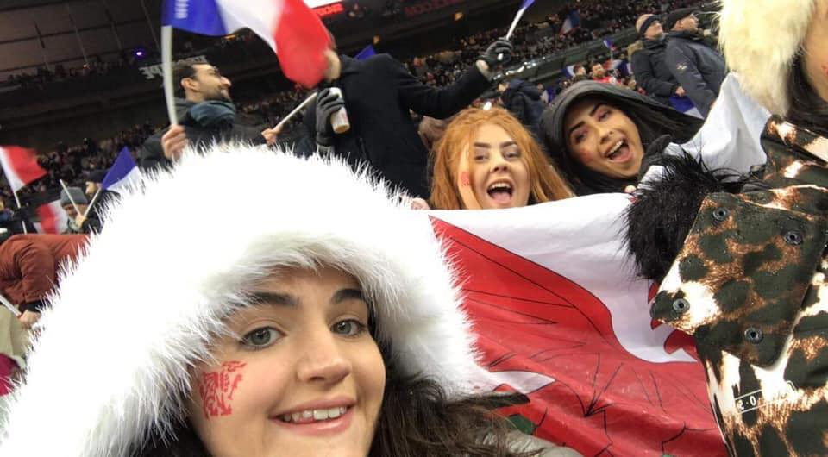
After the match we waited around to see if we could meet one of the welsh players who had attending UWTSD, but unfortunately, we didn’t get the chance to meet him. But Richard managed to get a few photos with some of the players. The overall all experience of going to my first ever six Nations match was amazing apart from the issues I had I was still eager to enjoy myself. Although I don’t think Paris is on the top of my list of city breaks I would like to go on.

