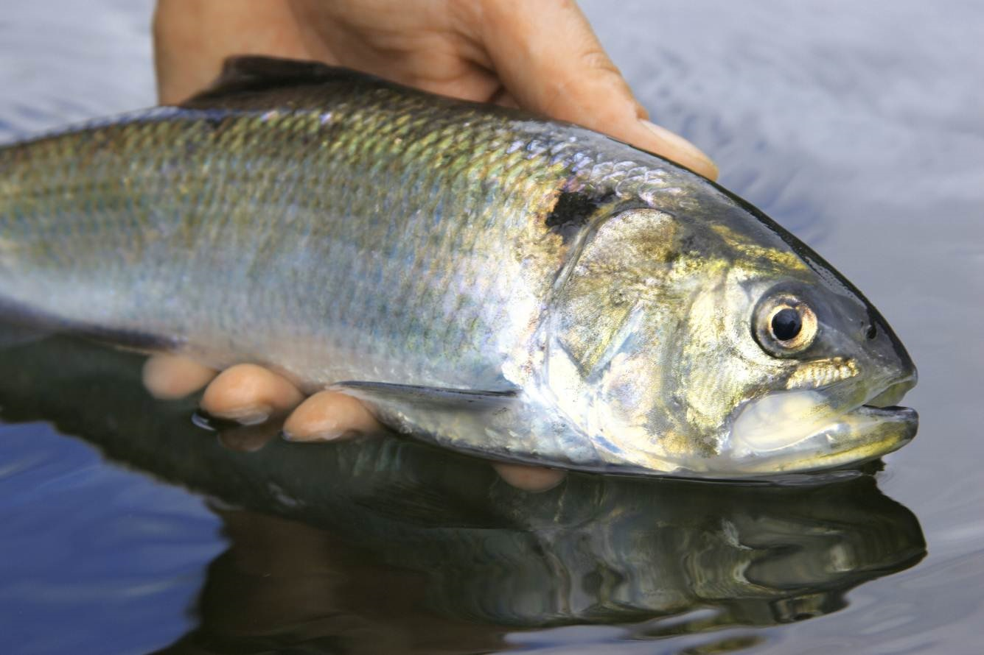
Awareness Raising of the Importance of the Twaite Shad (Alosa fallax) Population on the River Towy: A Study of River Towy Anglers

Research Methods & GIS

M5X01771, M5X01839 & M5X01904

Lecturer: Associate Professor Chris House

By Shane Thomas
Contents
Table of Figures: 3
Introduction: 5
Literature Review: 6
Correct handling procedure for Twaite Shad – 6
Awareness amongst fishermen of Twaite shad importance – 7
Minimisation practices for anglers to avoid catching Twaite shad – 8
Spawning distribution on the River Towy– 9
Methodology: 10
Limitations/Weaknesses of proposal: 14
Time – 14
Financial constraints – 14
Ethical issues – 14
Confidentiality – 14
References: 15

Table of Figures:
Figure 1: Displays a fish caught by an angler who has mishandled the fish as highlighted by the extensive loss of scales as seen in the image. 7
Figure 2: Displays a Twaite shad carefully been released back to the river as is highlighted by the majority of the fish is scales being intact. 7
Figure 3: The image above displays a Twaite shad that has been caught via a tasmanian devil lure as can be seen in the mouth of the fish 8
Figure 4: This image is of a Tasmanian devil predator lure which is said to be one of the best lures for anglers to use when specifically targeting Twaite shad 8
Figure 5: This an early example of a Devon minnow lure of the same design as is used on towy by most senior anglers. 9
Figure 6: The image above has been extracted from Natural Resources Wales is official website on advice and guidance to anglers in Wales. 9
Figure 7: Image extracted from an NRW questionnaire on Salmon/Sea Trout regulations alterations. 10
Figure 8: Image extracted from an NRW questionnaire regarding alterations to Salmon/Sea Trout regulations in the 2018 fishing season, with the above question being posed in a similar to one that will be included in the questionnaire for this research. 11
Figure 9:An extract taken from the questionnaire that has been sent out to all fishing clubs in Wales by NRW regarding changes to Salmon/Sea Trout regulations for the 2018 fishing season.. 11
Figure 10: An additional extract taken from the proposed changes sent out by NRW for the 2018 Salmon/Sea Trout fishing season with the addition of being phrased in a slightly different manner to that of a question featured as part of the questionnaire for this study. 12
Figure 11: An extract from an NRW paid for postage questionnaire, asking for any further comments. 12
Figure 12: The format that will be used for the respondent to fill in his/her personal details. 13
Figure 13: This is an extract of the conclusion from an NRW questionnaire sent to river anglers in Wales regarding changes to Salmon/Sea Trout regulations for 2016 fishing season. 13

Introduction:
The Twaite shad also known as May fish (British Sea Fishing, 2017) is found throughout much of the European coastline from Norway to Morrocco and from the western coastline of Europe to the eastern Mediterranean. It is a fish which has suffered declining populations throughout much of the European continent with the species being classed as endangered in the UK with it additionally only being found in very isolated rivers and estuaries in the UK and being placed as UKBAP Priority Species (British Sea Fishing, 2017;Canal & River Trust, 2016). Although contrary to this glum appearance populations in the Baltic and North Sea are said to be increasing (IUCN Red List, 2017).
In Wales there are three main river systems all of which are located within the Bristol Channel and Severn Estuary; these are the Towy, Wye and Usk Rivers. All three of which have water quality and quantity considered adequate to maintain this internationally vulnerable species and as a result all three of which contain a self-sustaining spawning population of Twaite shad (JNCC, 2017).
In the river Towy there is insufficient information currently provided to the majority of members of each individual club that own stretches of water on the River Towy on all relevant information discussed later regarding Twaite shad (Alosa fallax). This poses the risk of incorrect handling and release of these fish when caught by local anglers without the necessary expertise as to how to catch and release the fish safely with minimal harm and so occurs on a regular basis during the fishing season between May and June in particular to the detrement of successfully spawning numbers of Twaite shad (Alosa fallax). The significance of this is increased when it is thought that the Towy River is now considered an internationally important spawning ground for this species (JNCC, 2017). This is the research problem.
The study being proposed is that of a questionnaire survey emailed out to all clubs with waters on the river Towy to forward on via email to all their club members to fill in and return to the club for collection and subsequent analysis. It is hoped that the conclusions gained from analysing the answers gathered from the returned questionnaires can then be passed on to the relevant authority, which in this case would be Natural Resources Wales, otherwise known by the acronym NRW, to aid in influencing policy in order to further protect and help increase populations within the river for local importance as well as international.
Hypothesis:
The current level of knowledge amongst the majority of anglers in the freshwater habitat of the River Towy is insufficient and is having a negative impact on the spawning Twaite shad (Alosa fallax) population in the river.
Focus of the research:
The research will focus only on the opinions of local anglers of the River Towy and not from those of other nearby spawning sites for Twaite shad (Alosa fallax) on the rivers Wye and Usk.
Definitions of key concepts within the research –
- Informing anglers on all relevant information such as correct handling procedure, how to minimise catch rates as well as the ecological status and the significance of its presence on the River Towy.
- To subsequently lead to an increase in the number of Twaite Shad successfully spawning in the river as a result of reduced predation in the form of unintentionally catching and possibly killing/injuring the fish as a result of trauma suffered from being reeled in as well as in mishandling.
- It is aimed that this may lead to an increase in the chance of recolonization of nearby rivers, where it will again be present in its historic spawning grounds where it may have long been absent.

Literature Review:

Correct handling procedure for Twaite Shad –
The Twaite shad (Alosa fallax) along with its close relative the Allis shad (Alosa alosa) has been widely known to be a sensitive fish in relation to its handling by fishermen. Recently the Twaite shad (Alosa fallax) is now said to be more sensitive in handling in comparison to Allis shad (Alosa alosa) (Breine et al, 2017). The sensitivity of the Twaite shad (Alosa fallax) has been highlighted with its difficulty in being tagged for use in studies aiming to better understand its behaviours and movements (Breine, et al 2017). The shad is known to arrive to spawn in its welsh spawning grounds around May to June with the low, warm water conditions that are often experienced at this time of year making the handling of the Twaite shad (Alosa fallax) to require greater sensitive than in general (The Wye and Usk Foundation, 2017) (British Sea Fishing, 2018). It is recommended under UK law to return Twaite shad (Alosa fallax) to the water as quickly as possible as to minimise any possible damage (British Sea Fishing, 2017).
The literature regarding guidance to anglers in how to correctly release this endangered/protected species is difficult to find. Although not scientifically backed the angling website by the name of ‘Angling Ireland’ advises carefully un-hooking the Twaite shad (Alosa fallax) upon capture and returning it the water as quickly as possible; it goes on to advice that it should be released with its head facing upstream for maximum oxygen replenishment (Ammanford Angling Association, 2017; Angling Ireland, 2017). As is highlighted in figure 1, the Twaite shad (Alosa fallax) is highly susceptible to excessive scale loss even from minimal handling (McSevenny. S, 2015).
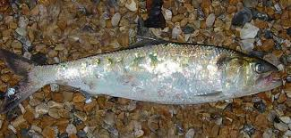
Figure 1: Displays a Twaite shad (Alosa fallax) caught by an angler who has mishandled the fish as highlighted by the extensive loss of scales as seen in the image.

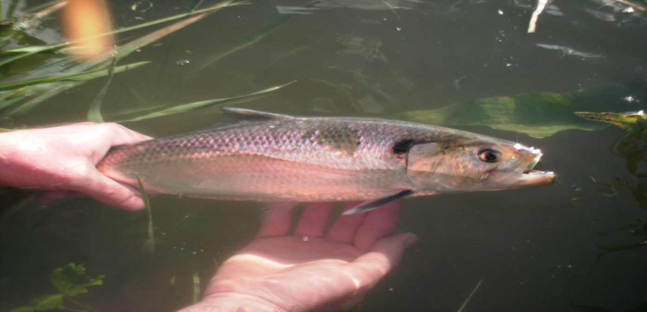
Figure 2: Displays a Twaite shad (Alosa fallax) carefully been released back to the river as is highlighted by the majority of the fish is scales being intact.

Awareness amongst fishermen of Twaite shad (Alosa fallax) importance –
The significance of Twaite shad (Alosa fallax) is presence is know well known amongst many fishermen in the South West of England and there is now evidence of the same fishermen passing on information about Twaite shad (Alosa fallax) catches, as well as returning the fish caught as by-catch by commercial fishing vessels (Hill, 2003). This is the opposite compared to the awareness of welsh river anglers. Few sources of information exist that are easy to locate and learn. Exceptions to this in Wales can be found firstly with the Wye and Usk Foundation who have published detailed guidelines on relevant information such as handling/releasing to fishermen of the rivers Wye and Usk on the Twaite shad (Alosa fallax) (The Wye and Usk Foundation, 2017). Secondly there is the Carmarthenshire Fishermen’s Federation who has to a much lesser extent highlighted to its affiliated club members the importance of Twaite shad (Alosa fallax) (Carmarthen Fishermens Federation, 2017).
In Ireland the interest in promoting the protection of the shad can be seen as a means of protecting an economic asset for the future of sport fishing the Twaite shad (Alosa fallax) in rivers that it is still found to be abundant (Angling Ireland, 2017). The river Barrow being considered Irelands greatest Twaite shad (Alosa fallax) fishery, with it attracting hundreds of anglers from in and outside of the country to aim and catch this species during their spawning season of May/June (Gasparro. E, (Article Writer) 2010). The River Barrow also plays host to a prestigious international Twaite shad (Alosa fallax) river fishing tournament which has inadvertently aided in raising the profile of Twaite shad (Alosa fallax) amongst the everyday angler in Ireland (Barrow Valley, 2017).

Minimisation practices for anglers to avoid catching Twaite shad (Alosa fallax) –
In areas such as County Carlow, Ireland, the Twaite shad (Alosa fallax) is legal to target for sport purposes only, with the most effective and popular lure for anglers to catch the species being the Tasmanian devil lure in different colour variants to suit the conditions on the day. It would be fair in assuming that a lure of a similar cylindrical design used by anglers of the Towy when targeting salmon (Salmo salar) and/or sea trout (Salmo trutta) may result in increased numbers of accidental catches of Twaite shad (Alosa fallax) than other common lures on the river. It might then be advisable logically, to prohibit the use of this lure in favour of other equally effective popular lures for targeting the same species. The Minnow lure as it is known, has slowly become less popular amongst the angling community in favour of newer lure designs that have come in recent years (T. Jones, 2017).
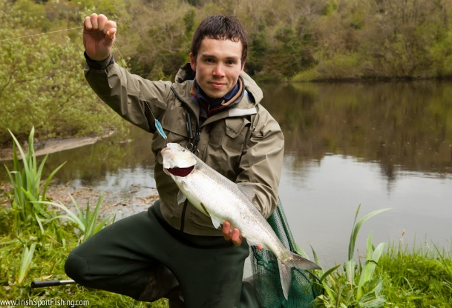
Figure 3: The image above displays a Twaite shad (Alosa fallax) that has been caught via a Tasmanian devil lure as can be seen in the mouth of the fish.
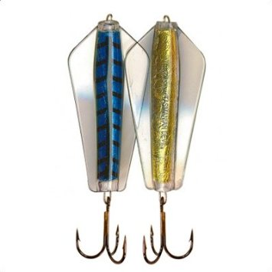

Figure 4: This image is of a Tasmanian devil predator lure which is said to be one of the best lures for anglers to use when specifically targeting Twaite shad (Alosa fallax).
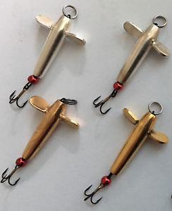
Figure 5: This an early example of a Devon minnow lure of the same design as is used on towy by most senior anglers.

Spawning distribution on the River Towy–
The spawning distribution of the Twaite shad (Alosa fallax) on the River Towy is known mainly as a result of kick sampling for eggs and /or observations of spawning adults that may be recorded by anglers who pass the knowledge on to a NRW officer or observed and recorded directly by an NRW officer (CCW, 2012). The estimation of spawning adult numbers of Twaite shad (Alosa fallax) is aided by the EAW (Eastern Acoustic Works) is acoustic and video fish counter at Ty Castell flow gauging station immediately upstream of the Capel Dewi WTW (Water Treatment Works) intake on the River Towy (CCW, 2012).
The main spawning areas have been identified as being in the lower and middle reaches of the River Towy between Whitemill and Dryslwyn (CCW, 2012). Although fish have been recorded further upstream, no other successful spawning grounds have yet been located (Peynado. A, 2017). A suggestion to be included as one of the questions in the questionnaire would regard the opinions of the angler filling out the questionnaire to restrictions on harmful fishing practices to Twaite shad (Alosa fallax) in the areas between Whitemill and Dryslwyn where the majority of spawning adults will be concentrated, in order to overall aid in reducing the mortality/injury numbers in areas where they are most vulnerable to anthropogenic un-intentional/intentional predation.

Methodology:
Methodological review –
The conclusions from this research is targeted towards the relevant authorities e.g. Natural Resources Wales (NRW) and fishing clubs, for this reason a methodology was chosen that would be familiar to both parties. The method was based on a mixture of previous NRW questionnaires from the past and of ones that have been sent out to gather opinions of angling members for changes to fishing regulations for the upcoming 2018 fishing season. The fact that the fishing clubs would already be familiar with the styling of the questionnaires laid out to them with this study, it is hoped would mean that anglers would complete it the same way in which they would fill in official NRW questionnaires; also the familiarity of the NRW with the format used in the questionnaire of this research would allow easy scrutiny of both the conclusions as well as the methodology that allowed the conclusions to be made in this piece of research; with improvements to their own future questionnaires possibly made as a result.
*A comment section will also be included for every question for the respondent to fill in with their own thoughts if necessary.
The questionnaire will be a mixture, in the fact that the questions would be posed in one of 5 ways:

- Agree
- Disagree
- Neither agree nor Disagree
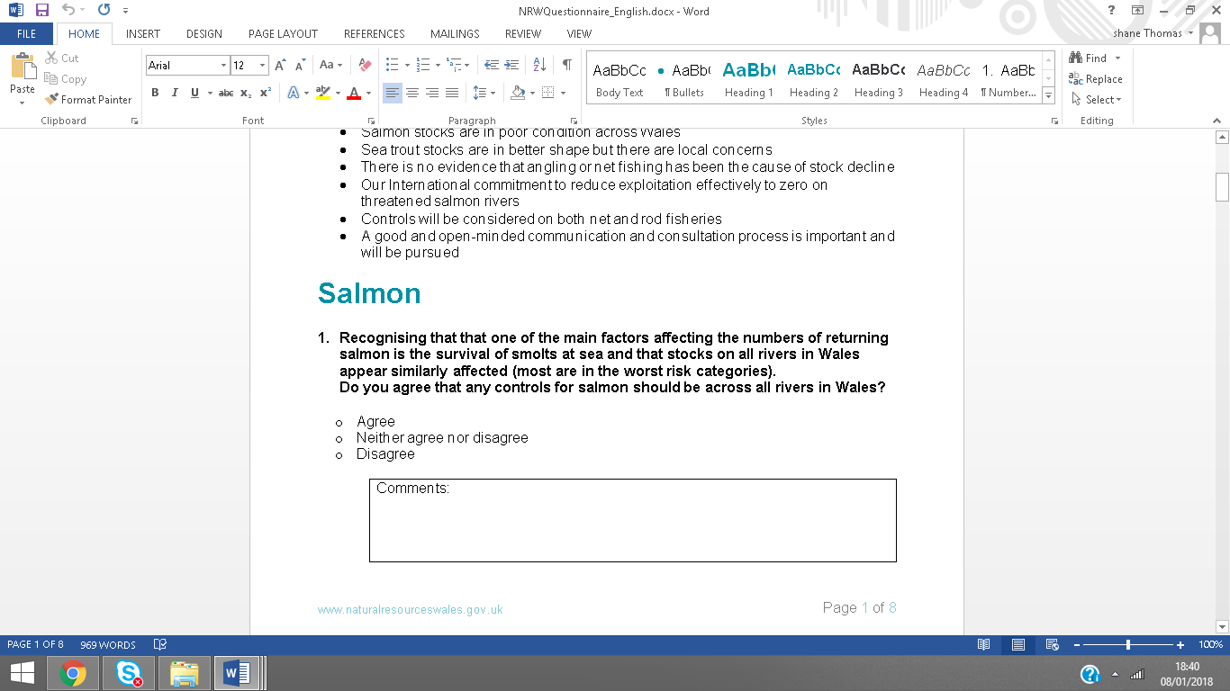
Figure 7: Image extracted from an NRW questionnaire on Salmon/Sea Trout regulations alterations.

- Yes
- No
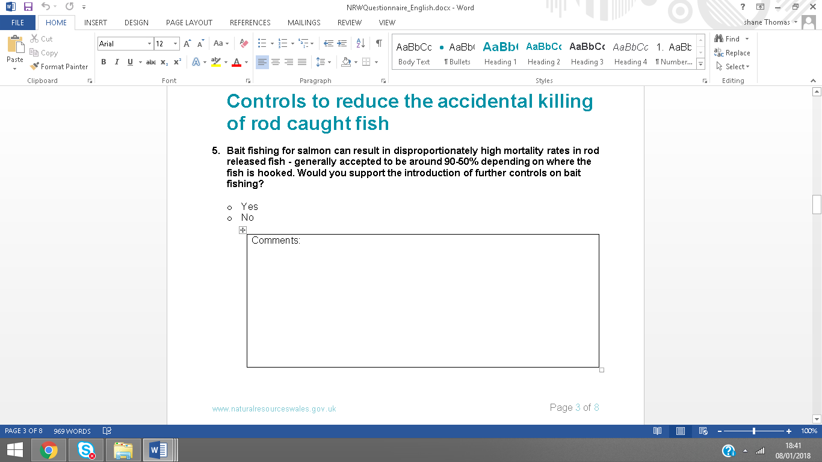
Figure 8: Image extracted from an NRW questionnaire regarding alterations to Salmon/Sea Trout regulations in the 2018 fishing season, with the above question being posed in a similar to one that will be included in the questionnaire for this research.

- Multiple Choice of no more than 5 options
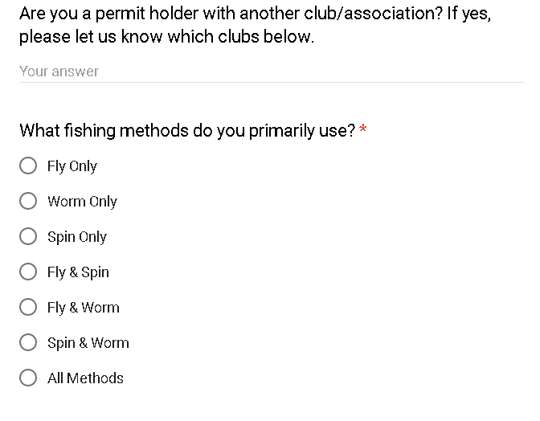
Figure 9:An extract taken from the questionnaire that has been sent out to all fishing clubs in Wales by NRW regarding changes to Salmon/Sea Trout regulations for the 2018 fishing season..

- Positively
- Negatively
- No impact at all
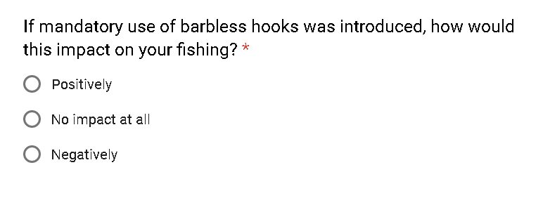
Figure 10: An additional extract taken from the proposed changes sent out by NRW for the 2018 Salmon/Sea Trout fishing season with the addition of being phrased in a slightly different manner to that of a question featured as part of the questionnaire for this study.

- Yes
- No
- I don’t know
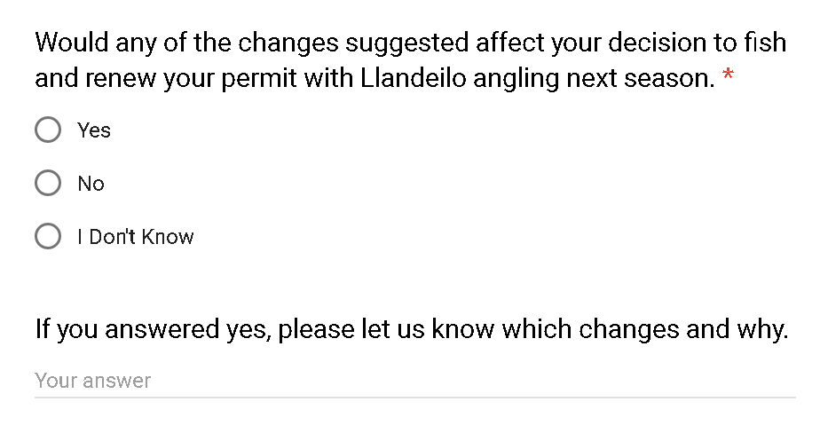
A final section will ask the respondent for any additional thoughts or comments that may or may not be related to the questions posed in the questionnaire but to the research itself.

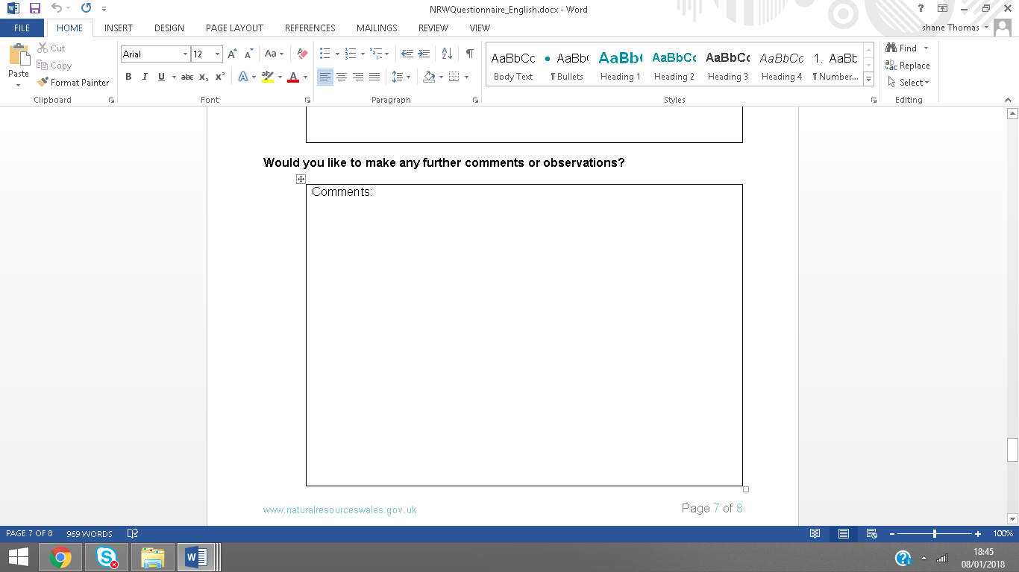
Figure 11: An extract from an NRW paid for postage questionnaire, asking for any further comments.

A layout similar to this would be used in order to gain the relevant personal information in order to keep the respondent informed –
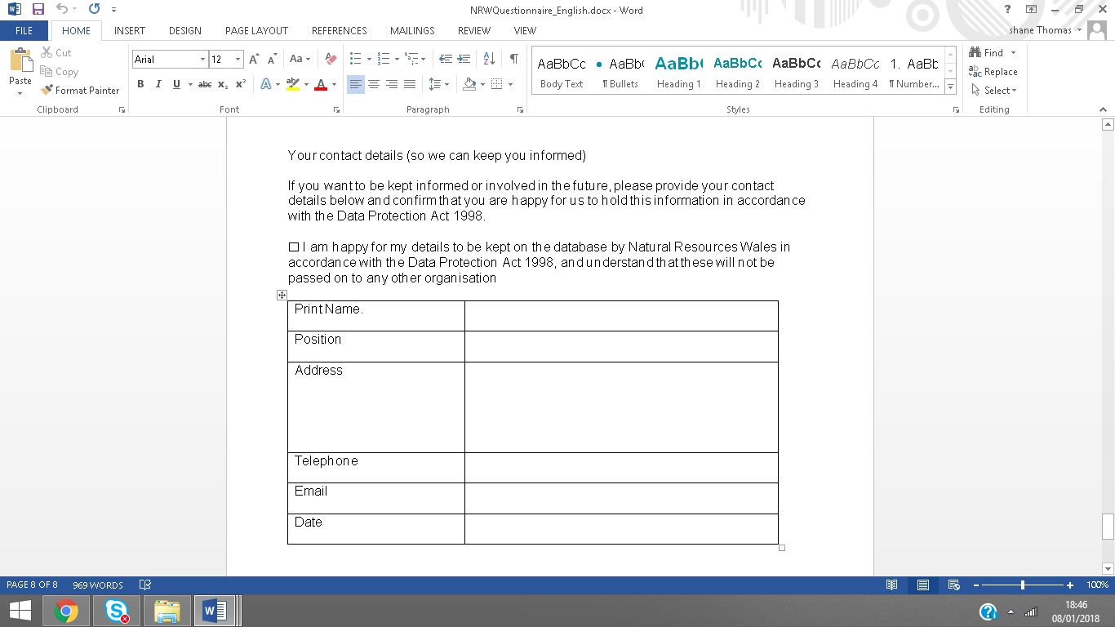
Figure 12: The format that will be used for the respondent to fill in his/her personal details.
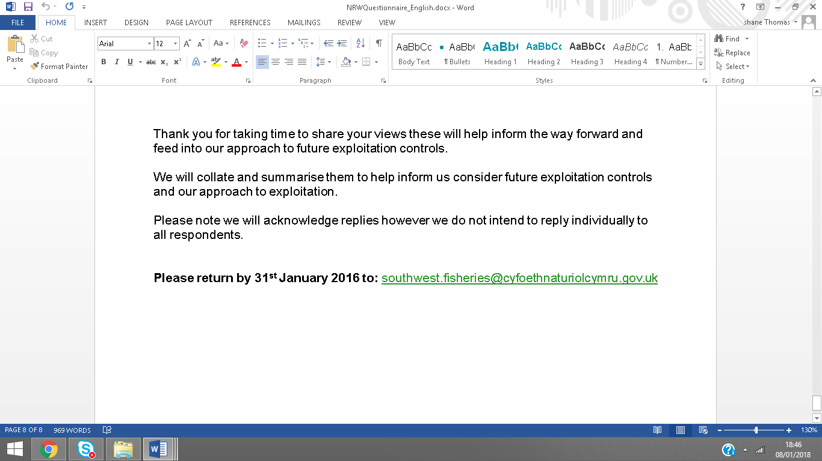
A final thank you will conclude the questionnaire, detailing what will occur next and what the respondent may expect if anything.
Figure 13: This is an extract of the conclusion from an NRW questionnaire sent to river anglers in Wales regarding changes to Salmon/Sea Trout regulations for 2016 fishing season.

Limitations/Weaknesses of proposal:

Time –
As the questionnaires have been chosen to be emailed to every chairman/woman and vice-chairman/woman of all clubs on the river Towy, the time taken to complete this in particular would only take a day if not less depending on the difficulty in obtaining the email addresses of all chair/vice chairmen/women needed for the research. It is hoped that the questionnaires will subsequently be distributed out to club members in order to reach a sufficient sample size for each club. Once a minimum sample size for each club is met, a process which may vary greatly between each club depending mostly on the speed at which affiliated members of each club send back their responses, analysis may then begin. Also prior to the analysis a deadline will be set from which no more responses will be counted in to the research after that period. Once the required number of responses has been achieved and analysis has then begun, this is expected to take roughly a week before conclusions may be drawn following analysis of the data.

Financial constraints –
The use of emails was chosen over paid-for postage as a result of the saved cost as well as the reduction in time taken to distribute. Although it can be anticipated that some chairmen/women and vice-chairmen/women may want to meet in person in order for example, to discuss the manner/purpose of the study and why their participation is needed, as a result of this potential fuel costs from travelling back and forth across Carmarthenshire to meet with club representatives should be kept in mind as a potential cost that might be met during the data gathering period.

Ethical issues –
This has been examined and no ethical issues have been found that may could be encountered during the research period as well as after it.

Confidentiality –
Many if not all angling clubs will not share information that if made public may affect the club in a negative manner or portray them in a negative light although if the research that is proposed here can be proven to club heads to be of benefit to the club and its members participation can then be initiated and a mutual partnership formed in order to aim for a set mutual objective. In this it may be the protection of club anglers from potential prosecution as a result of killing/injuring Twaite shad (Alosa fallax) while out targeting popular prize game fish such as salmon/sea trout. This protection would be achieved by attempting to inform all club anglers about all relevant information to them highlighted in this proposal on Twaite shad (Alosa fallax) in the Towy in order for them to be aware of how to avoid the fish and more importantly for themselves avoid legal action.
Written assurances should be given to club representatives and members displayed in the email of what will and will not happen with all the information provided by themselves and others in the future and for the purposes of the current research. This is aimed to aid in allowing trust to be created between the researcher and the information provider (club representatives/members) while also having the aim in increasing the number of response rates.

References:
Brirish Sea Fishing. 2017. Twaite Shad (Alosa fallax). [Online]. [Accessed 4 January 2018]. Available from: http://britishseafishing.co.uk/shad/
IUCN. 2017. Alosa fallax. [Online]. [Accessed 2 January 2017]. Available from: http://www.iucnredlist.org/details/904/0
Countryside Council for Wales. 2012. The Severn Estuary/Mor Hafren European Marine Site. [Online]. [Accessed 6 January 2018]. Available from: https://canalrivertrust.org.uk/enjoy-the-waterways/fishing/fish-species/rare-and-protected-fish/twaite-shad
Reynolds. B. 2004. The current and potential impact of diffuse pollution on water dependent biodiversity in Wales. {Online} Cardiff: Wiley.
Carmarthen Fishermens Federation. 2017. Twaite Shad. {Online}. {Accessed 6 January 2018}

