Software Engineering Principles Assignment

Course Tutor: Andrew Baker, Gordon Dickers

Course Name: Software Engineering Principles

Course Module Code: M5X01054

Written by: Ethan Randell, Rhiannon Thomas, Ruaidhri Cook

Introduction

For this Assignment the group has been asked to create a tourist application where the user could go to a heritage site e.g. Castle Coch or Saint Fagans the user could use their mobile device and scan a QR code.
Once the QR code is scanned the mobile device will give a tour around the heritage site.

A number of steps must be taken before the application can be created first The Key Stakeholders must be identified so who is the app being created for, Functional and nonfunctional requirements must be declared so what the application must be required to function, Identified requirements for first iteration, Plan requirements for the second iteration of the application.

After the first few steps have been completed the group must then design the application so we will have to use Static Design to analyze our program,we have to make a Class design in UML and in the form of Data Flow diagrams etc, we will use Dynamic Design to sort our code into smaller pieces to make the problems easier to solve, next the group has been asked to create Sequence Diagrams to understand what sequences are happening in the program.

Also the team needs to develop User Interface Design Prototypes to figure out how the applications user interface will look like in the final build.

Key stakeholders identified
A stakeholder is anyone with an interest in the business. In this case the
stakeholders in this project will be the clients, these are the people who are
investing money into this project.

Team members/structure and responsibilities
In this section all of the team members and responsibilities will be talked about and how the structure of the team will be laid out.

There are three members in this team to create this project which are Rhiannon
Thomas, Ethan Randell and Ruaidhri Cook. We all have the responsibility to work
efficiently and effectively together to create a digital tour guide application and
reach the requirements specified by the client.

Team members
- Ruaidhri Cook
- Rhiannon Thomas
- Ethan Randell
Team structure
Team Project Manager: Ruaidhri Cook
Programmer: Rhiannon Thomas
Programmer: Ethan Randell

Functional and Non Function Requirements // Rhiannon
In this section the Functional and Non-Functional Requirements for the project
will be identified.

Functional Requirements
Functional Requirements defines a function of a system or its component.
Functional requirements are technical details, data manipulation and processing
and other specific functionality that define what the system is supposed to
accomplish. Here is some functionality needed to create the Digital Tour Guide
application:
- Barcode Scanner – The client has asked us to create a barcode scanner so that users are able to scan their device.
- Buttons – The client has asked us to create three buttons which are “Press me now and listen”, “Further Descriptions” and “Move On”. When the user selects any of those three buttons it should begin the audio.
- Audio – The client has asked us to create a voice guide which will guide users to each room and asks the user to find the barcode scanner, when the barcode has been scanned then the audio description will start to play.
- GPS features – The client has asked us to use “Value Added” features, GPS features is one of them. This will allow location access to the application, which will know where the user is. Rather than the user finding the barcode scanner, the GPS will locate where the user is via mobile phone or any other devices.
- Augmented Reality - The client has asked us to use “Value Added” features, Augmented Reality is one of them. Users can visualise moving images from their camera, when the audio is playing the images will show what is going on just like an animated story.
- Map - The client has asked us to use “Value Added” features, Map is one of them. This will show the user the map of the attraction, so users are able to know where they are going.
- Link to website - The client has asked us to use “Value Added” features, Link to Website is one of them. Users will be able to click the link from the application which will direct them to the website.

Non-Functional Requirements
Non-Functional Requirements specifies criteria that can be used to judge the operation of the system, rather than specific behaviours. Here are some criteria needed to create the Digital Tour Guide application:
· Budget – The budget must be clearly identified so we are able to outline the costs of hardware and software and keep it within the given budget.
· Equipment – The equipment must be identified to ensure that we purchase the correct equipment to create the system. The equipment that will be used in this project will be Computers and Mobile phone or other digital devices.
· Software Packages – The software packages must be identified so that we know what software package we are going to use to code the system. The chosen software package is Visual Studio 2015 and the programming language will be C++.
· Timescale – The timescale must be clearly identified so that we know how much time we have got to create this system. The deadline is 9th May 2018.

Use cases derived from scenario

First Use case
USE CASE # | Get Data of heritage site (Audio file)
Goal in Context | The goal is for the application to get the data of a specific heritage site when the user scans a barcode at the heritage site.
Scope & Level | The summary of this system is to get all relevant information in the form of a video or audio tour about the specific heritage site that the user is at.  The primary task of this function is to get all relevant data that is stored in servers about a specific heritage and also the audio tour about the site.
Preconditions | The preconditions to allow this function to happen is that the user is at the heritage site and has scanned a unique QR code with their mobile device.
Success End Condition | The success end condition is that the qr is successfully scanned all relevant information has been sent to the mobile device and is giving an audio tour to the user about the heritage site.
Failed End Condition | The failed condition is the application will give a message to the user on their mobile device stating that the information about this site cannot be accessed.
Primary,  Secondary Actors | The primary actor for this use case is the user and the other systems that are needed for the use case to succeed is a recent mobile device with wireless connection capabilities.
Trigger | The trigger to activate this use case is for the mobile device to scan the unique QR code.
DESCRIPTION | Step | Action
 | 1 | User arrives at heritage site
 | 2 | User scans QR code
 | 3 | Application sends QR code information to servers
 | 4 | Server receives QR code information
 | 5 | Server sends all relevant information about the heritage site to the application on the users mobile device.
 | 6 | The application gives the user a audio tour about the heritage site.
EXTENSIONS | Step | Branching Action
 | 1a | A condition that could cause branching is the click for a further description button which will give the user more information about the sit
SUB-VARIATIONS |  | Branching Action
 | 1 | None.

Second Use case

This is available in Appendix 1.

Identify requirements for first iteration // Rhiannon
In this section the requirements for the first iteration will be identified to create
the first steps of the project. We have had a meeting with one of the stakeholders
to identify the requirements and analyse it, this meeting will be shown in
Appendix 2.

The requirements that the stakeholder would like for the first iteration:
- Tour guide app should be suitable for all ages
- Augmented Reality
- QR code scanner
- Audio Guide
- Website access
- Make the experience more exciting

Most of these requirements will be achievable however, there are some issues
that have been identified such as, the tour guide application will not be suitable
for all ages (The context will be the same from a four-year-old to an
eighty-year-old. Elderly people will want facts and figures whereas a younger
audience may be bored of that and will want more exciting and fun facts). Also,
Augmented Reality will be an issue due to the lack of time that we have got to
create the digital tour guide application. Lastly, Audio Guide will also be an issues
due to the short timescale however, instead of using Audio Guide we will instead
output text on the screen.

identify requirements for 2nd iteration // Ethan
For the second iteration of the product there are many requirements that must be met. We had a meeting with the stakeholder to see if they wanted to add any additional requirements or features to their system.

- All bugs of the first iteration must be identified and must be corrected.
- If possible code from the first iteration can be used for the second iteration but if possible try to get rid of any clutter code.
- The second iteration must have accessibility features for more elderly people who don’t have much experience with technology.
- Another requirement for the second iteration could be make the tour more suitable for the younger generation by adding videos of animations about the heritage site.
- Another requirement for the second iteration is to try and include augmented reality due to the lack of time given for the first iteration of the program.
- Also will be able to print out text while the audio file is playing to the user.
All of these requirements will be achievable for the second iteration.

Legislation and related ethical and sustainability issues.

Sustainability issues
During the life time of this project their will be a lot of issues to keep the project sustainable.
The first issue is how to keep the program itself sustainable. The first thing to keeping a project sustainable is to keep making updates to the program to remove any bugs or defects in the program.
Another issue to the sustainability of the project is the stakeholders interest in the project if they lose interest in the project, the projects life cycle could be cut short due to lack of funding from the stakeholders, to stop this issue from happening is to keep releasing updates with newer features to keep stake holder and public interest.
Another issue is environmental sustainability due to the information being kept on servers which requires a lot of energy consumption it could cause issues due to the risk to the environment sadly this issue cannot be avoided due to the fact the servers must remain operational for the application to access all relevant data.
Ethical Issues
Down below is BCS code of conduct which states what is considered to be breaches in their code thankfully the project does not breach any of the code. If a breach was made it could result in the project being cancelled and can cause repercussions with the stake holder. Also due to the Data Protection Act 1998 the project is not allowed to use or distribute confidential user data without their consent.
Interpretation of the BCS Code of Conduct
- Public Interest
You shall:
a) have due regard for public health, privacy, security and wellbeing of others and the environment.
b) have due regard for the legitimate rights of Third Parties*.
c) conduct your professional activities without discrimination on the grounds of sex, sexual orientation, marital status, nationality, colour, race, ethnic origin, religion, age or disability, or of any other condition or requirement
d) promote equal access to the benefits of IT and seek to promote the inclusion of all sectors in society wherever opportunities arise.
- Professional Competence and Integrity
You shall:
a) only undertake to do work or provide a service that is within your professional competence.
b) NOT claim any level of competence that you do not possess.
c) develop your professional knowledge, skills and competence on a continuing basis, maintaining awareness of technological developments, procedures, and standards that are relevant to your field.
d) ensure that you have the knowledge and understanding of Legislation* and that you comply with such Legislation, in carrying out your professional responsibilities.
e) respect and value alternative viewpoints and, seek, accept and offer honest criticisms of work.
f) avoid injuring others, their property, reputation, or employment by false or malicious or negligent action or inaction.
g) reject and will not make any offer of bribery or unethical inducement.
- Duty to Relevant Authority
You shall
a) carry out your professional responsibilities with due care and diligence in accordance with the Relevant Authority’s requirements whilst exercising your professional judgement at all times.
b) seek to avoid any situation that may give rise to a conflict of interest between you and your Relevant Authority.
c) accept professional responsibility for your work and for the work of colleagues who are defined in a given context as working under your supervision.
d) NOT disclose or authorise to be disclosed, or use for personal gain or to benefit a third party, confidential information except with the permission of your Relevant Authority, or as required by Legislation
e) NOT misrepresent or withhold information on the performance of products, systems or services (unless lawfully bound by a duty of confidentiality not to disclose such information), or take advantage of the lack of relevant knowledge or inexperience of others.
- Duty to the Profession
You shall:
a) accept your personal duty to uphold the reputation of the profession and not take any action which could bring the profession into disrepute.
b) seek to improve professional standards through participation in their development, use and enforcement.
c) uphold the reputation and good standing of BCS, the Chartered Institute for IT.
d) act with integrity and respect in your professional relationships with all members of BCS and with members of other professions with whom you work in a professional capacity.
e) notify BCS if convicted of a criminal offence or upon becoming bankrupt or disqualified as a Company Director and in each case give details of the relevant jurisdiction.
f) encourage and support fellow members in their professional development

Due to the width drawl of the European union this could affect the project due to the lack of funding from the Welsh government because most funding of the welsh government comes from the European union. Also the due to the lack of funding the heritage sites could also lose funding and may not be able to fund the resources to create the QR codes.

Class design (UML) // Rory
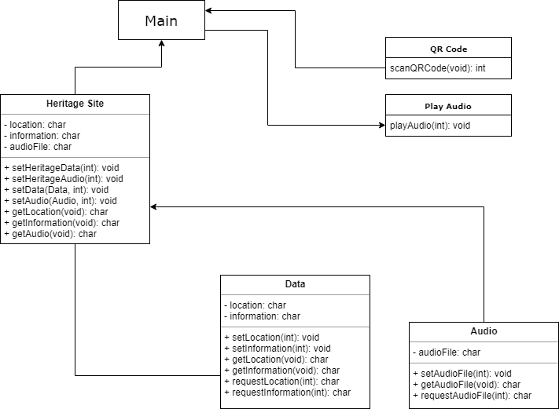
This diagram shows the relationships between the main, the functions and the objects.
Audio will request it’s variable using a set function which in turn uses the requestAudioFile function which uses file IO.
Data will request it’s variables using a set functions which in turn use the requestLocation and requestInformation function which use file IO.
Heritage Site will request it’s variables by using a set functions that pass the QR Code number to the Data and Audio objects it creates from which their gets, sets, and variables can be used.
The main will call the QR Code function. It will also create a Heritage Site object and pass it the QR Code number so it can use it’s sets and gets to obtain the variables.
The main then uses the Heritage site variables to display information and location and also passes Play audio the audio file name to the playAudio function to play the audio.

Collaboration// Rhiannon, Ethan and Rory

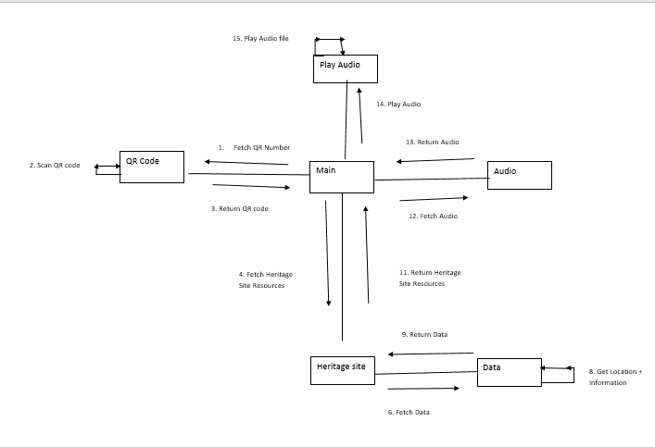
Underneath is the collaboration diagram for the program it shows all of the functions within the program and how they will interact with each other and which pieces of data go to which function (more of a description is shown in the sequence diagram section of this report).

Sequence Diagrams // Rory
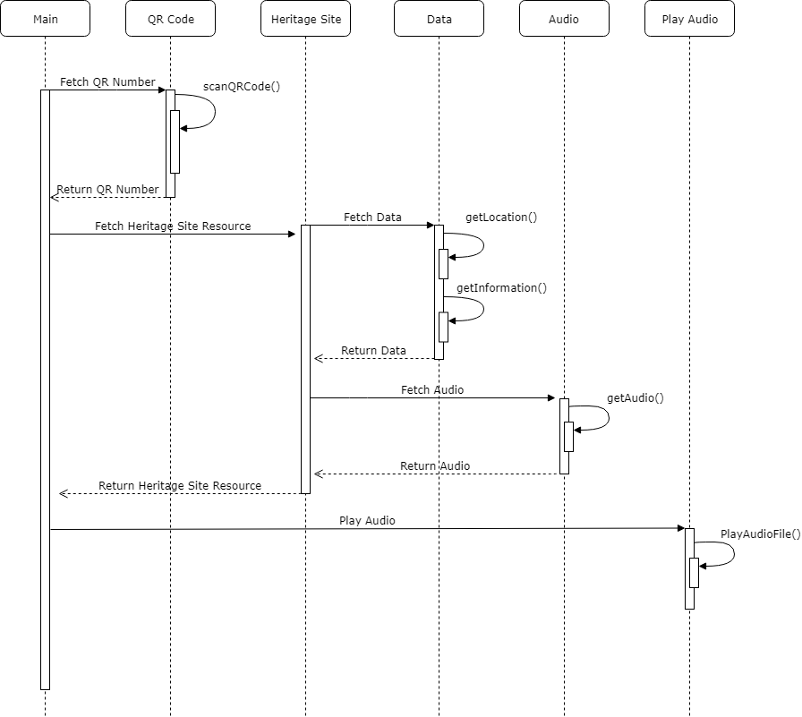
This diagram shows how the main will interact with the the functions. The main will first request the QR Code to return the QR Code number, QRCode will execute the function the scans the QR Code and it will return the QR Code Number.
The main will then request the Heritage Site to return the Heritage site resources, the Heritage site will then create a Data object to get the location and information. Then Data will obtain the location information using the QR Code Number and Heritage Site will use the get function to obtain them. Then Heritage site will create a Audio object to get the audio file name. Then Data will obtain the audio file name using the QR Code Number and Heritage Site will use the get function to obtain them.
Heritage site will then return it’s resources so the main can display the Information and Location and it will then call the play audio function which will use audio file name.

User Interface Design Prototypes // Rory
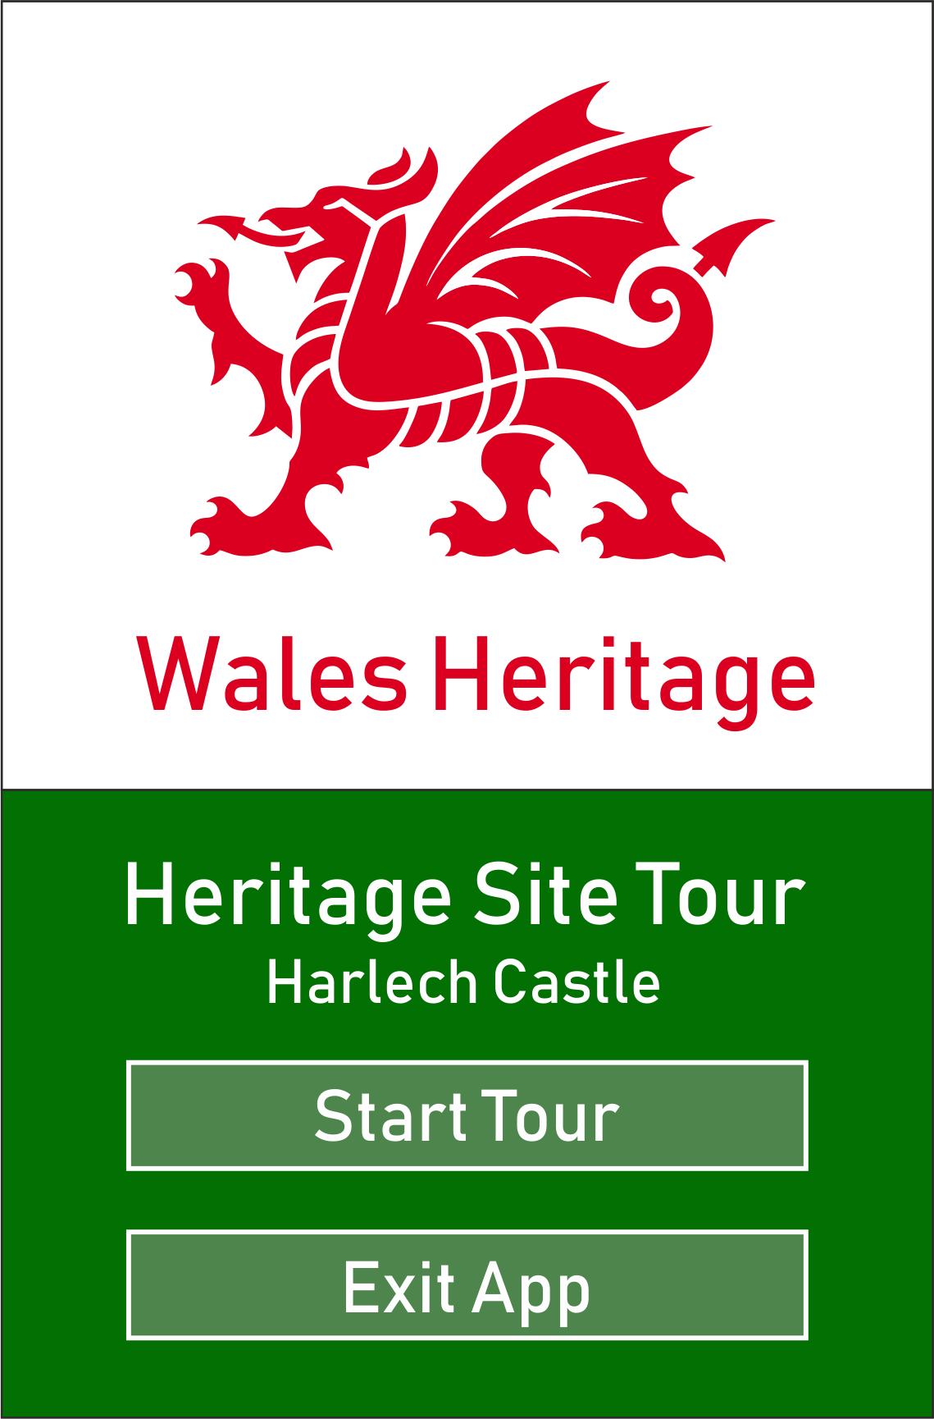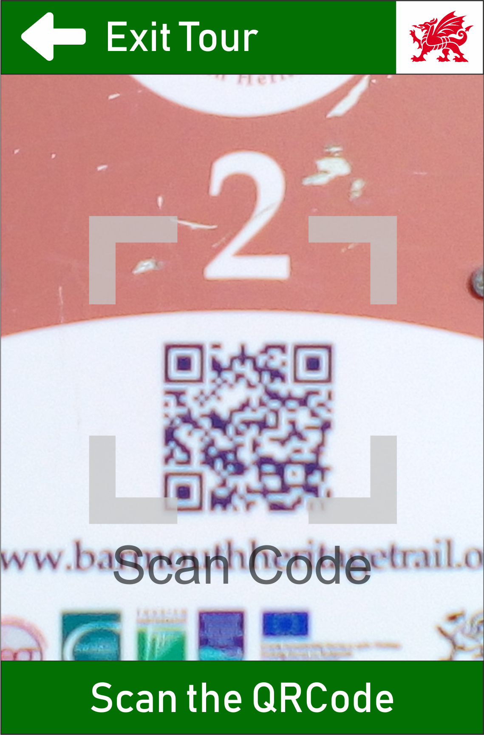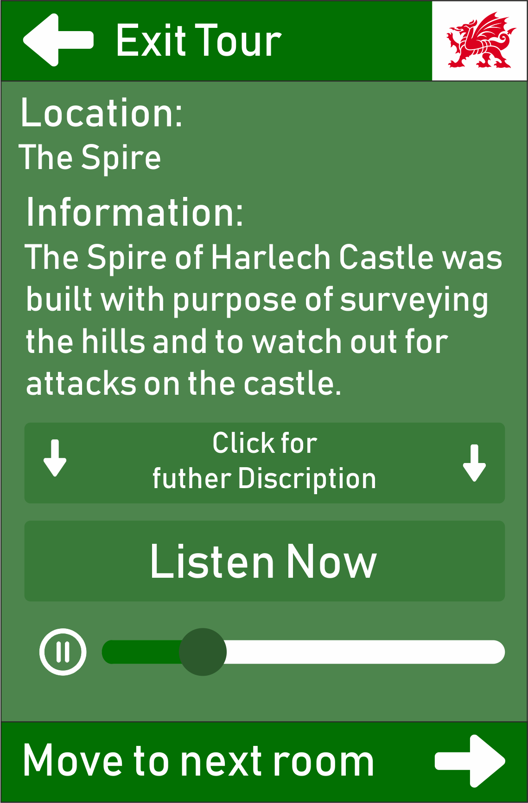
Screen 1 Screen 2 Screen 3

These images show the prototype UI design for the app.
The user will start the app on screen 1, which will have 2 buttons. The ‘Start Tour’ button will take the user to screen 2 and play the introduction audio, with the ‘Exit App’ button terminating the program.
Screen 2 will have a button at the top ‘Exit Tour’ which will allow the user to exit to screen 1. It will also have a ‘Scan the QR Code’ button at the bottom of the screen which will scan the QR Code if it is in the bounds of the feint grey square, if no QR code is detected the words “Could not scan, try again” will pop up on the middle of the screen. If a QR Code is detected the app will take the user to screen 3.
Screen 3 will have the same ‘Exit Tour’ button at the top of screen which will allow the user to exit to screen 1. It will also have a ‘Click for further description’ button which will extend the page downwards under the current information and reveal more information, when this happens the button will become a ‘Click for less description’ button will will revert the layout to how it was before. Screen 3 will also have a ‘Listen now’ button which will play the audio description for that room and give directions to the next room, this can be also be paused by pressing the pause button underneath the ‘Listen Now’ button. The audio can then be resumed by pressing the ‘Listen Now’ button again. The other button is the ‘Move to next room’ button which will take the user to screen 2 so they can scan the QR Code for the next room.

Code Implementation (1st Iteration) // Rhiannon and Rory
The first iteration has been implemented and is accessible on Bitbucket. A new
repository has been created called “AssignmentWork” which should have the Heritage
Site Project connected to it. Here are the screenshots of code that has been
implemented by Rhiannon Thomas and Ruaidhri Cook.
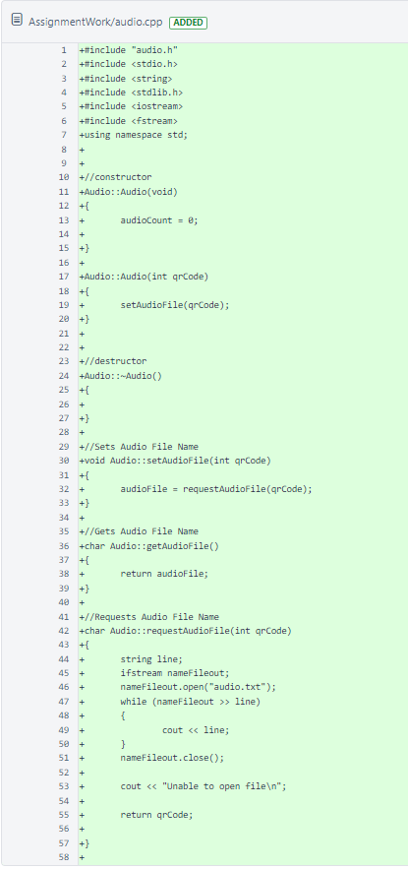

Audio.cpp

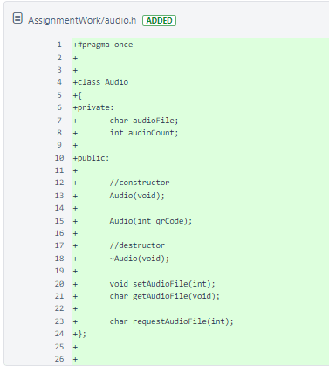

Audio.h

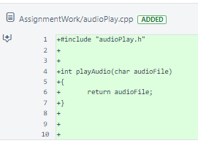

audioPlay.cpp

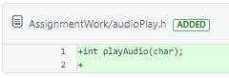
audioPlay.h

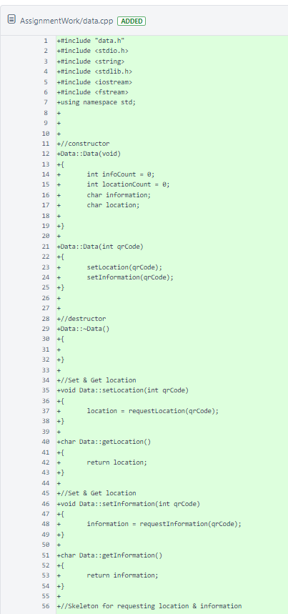

data.cpp

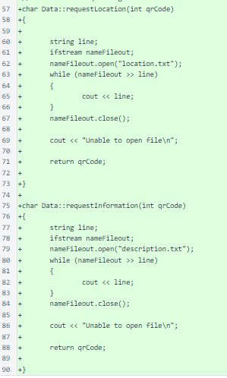

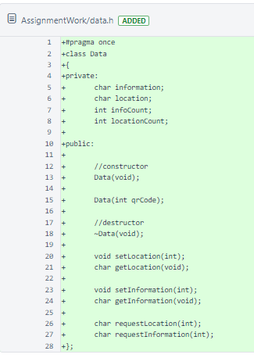

data.h

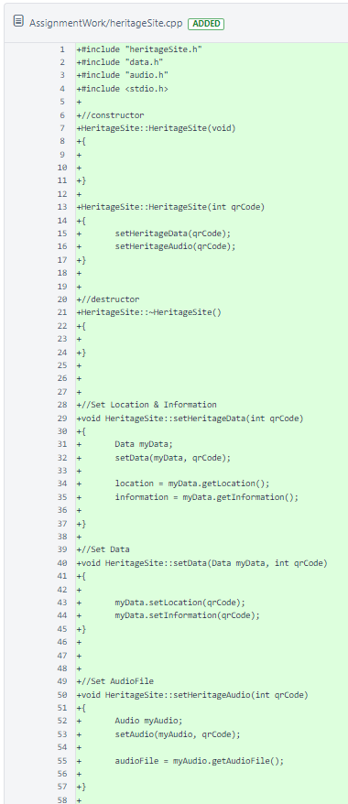

heritageSite.cpp

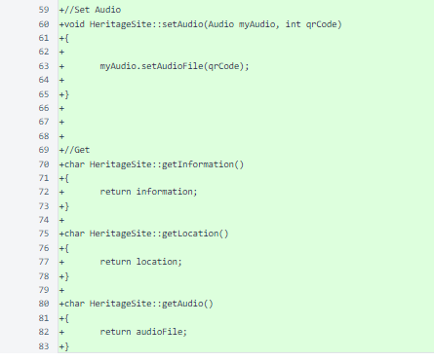

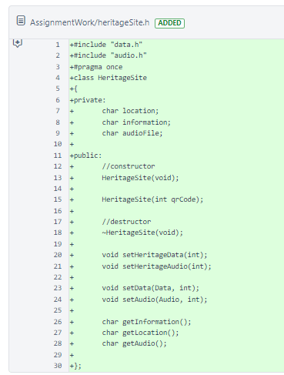

heritageSite.h

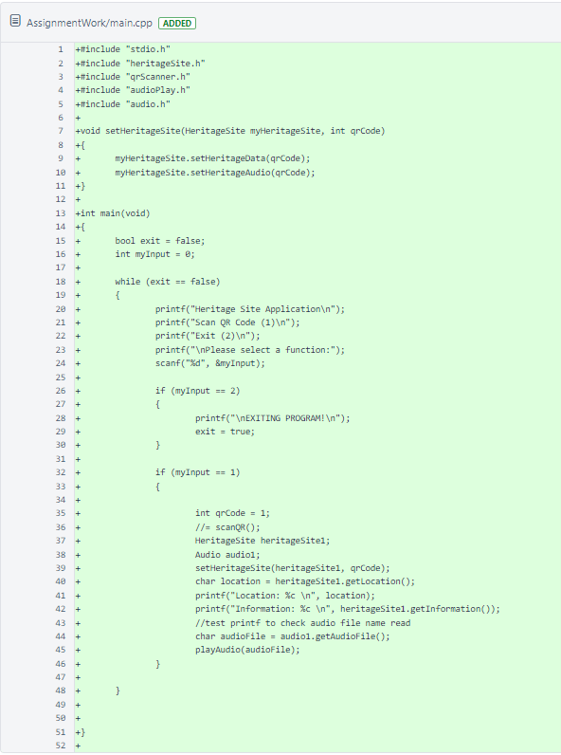

main.cpp

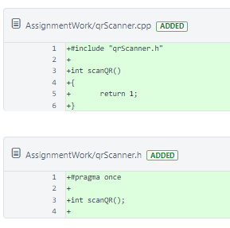

qrScanner.cpp

qrScanner.h

Testing // Rhiannon

Test Number: | Description: | Pass/Fail | Screenshot:
1 | Location | Fail - Reading from the location.txt file does not work | 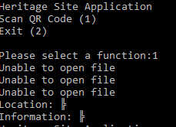
2 | Description | Fail - Reading from the description.txt file does not work
3 | Audio | Fail - Reading from the audio.txt file does not work
4 | Exit | Pass | 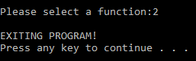

Version Control // Rhiannon, Ethan and Rory
Version Control has been created in Visual Studio. This has been done by looking at changes that has been made and creating new commits. Here are the screenshots of Commits in bitbucket:

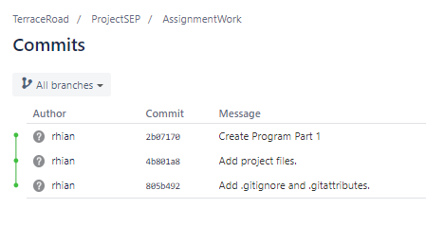
Commit 805b492 is where all the git attributes has been added into the project. Commit 4b801a8 is where all the project files have been added to the project. Lastly, Commit 2b07170 is where the Heritage Site Project has been added into the Assignment Work Project.

Individual contribution and team working discussion // Rhiannon, Ethan and Rory

1. Intro and overview of report // Ethan
2. Key stakeholders identified // Rhiannon
3. Team members/structure and responsibilities // Ethan
4. Functional and Non Function Requirements // Rhiannon
5. Use cases derived from scenario // Ethan
6. Identified requirements for first iteration // Rhiannon
7. identify requirements for 2nd iteration // Ethan
8. Legislation and related ethical and sustainability issues // Individual work
9. Class design (UML) // Ruaidhri
10. Sequence Diagrams // Ruaidhri
11. Collaboration and Responsibilities // Ethan
12. User Interface Design Prototypes // Ruaidhri
13. Code Implementation (1st Iteration) // Rhiannon and Ruaidhri
14. Testing // Rhiannon
15. Version Control // Rhiannon
16. Individual contribution and team working discussion // Ethan and Ruaidhri
17. Design to Requirements matrix // Rhiannon, Ethan and Rory

For the project each member of the group was assign specific tasks to complete, each task was assigned strategically so that each group member would play into their strengths and thus the quality of the work would be higher. This meant that some member were assigned tasks to be completed individually whereas some tasks were a collective effort. This meant that each group member was constantly interacting and liaising with the other group members so that all sections were coherent and worked in tangent.

Design to Requirements matrix // Rhiannon, Ethan and Rory

Requirement | Status | Comment
Barcode Scanner | Achieved | This requirement was achieved by implementing a skeleton function that acted how the barcode scanner would.
Buttons | Not Achieved | The code produced for the application was more of a test harness that tested the functions. With this said it was constructed incorrectly and only allowed for the function of one of the buttons, which was the ‘Press me now and listen’ function. However the project was privoted and the ‘further descriptions’ button was instead used to retrieve text information rather than play audio.
Audio | Not Achieved | This requirement necessitated two parts of the code to work The play audio function skeleton was simple and easy to produce however the other part of the code was the file IO which had to retrieve the name of the audio file so that it could be played. Unfortunately this part of the code was not successfully implemented due to a problem with file IO, however the objects and other functions did work and only failed in the final implementation because of a compound error associated with the file IO function.
Value Added Features | Not Achieved | Although in the requirements Augmented reality, a map and a link to a website were noted and were not achieved due to their complexity, the project pivot in scope did incur some ‘Value added features’. These features were the retrieval of both Location information and of information about each room. Although this also didn’t work because of the shared file IO problems the Objects and their functions did work.

Despite the project not meeting all of the requirements it’s major downfall was the file IO that could not be properly implemented, this meant that many of the other requirements were not met. If the File IO had worked the project would be an effective skeleton that could be used in combination with a UI, moreover the UI that was designed for the project would be arguably better than the original brief whilst meeting the primary function of the application which would be to give an electronic tour, moreover the tour devised by my group would also be more accessible to a larger target audience, this is because it incorporates text and thus would be usable by people who are deaf. This would bring it more in line with the principles outlined in the British Computer Society Code of Conduct, which state there is a duty to act in public interest, specifically in a way that promotes equal use for all. Moreover as a group we stuck to our duty of professional competence and thus used our professional judgement to attempt to create and application that was better than the one outlined in the requirements whilst still keeping the essence of what the application was supposed to do, this would mean the overall usage of the app would be higher which would be pleasing for the stakeholders, such as the taxpayer who are essentially funding the development of the application and thus should she the best return on their money from a government service they are paying into.
Appendices/ Team meeting minutes

Meeting One (Appendix 1):

Meeting One Minutes: 75 Minutes

Rhiannon: Red
Ruaidhri: Blue
Ethan: Green

Agenda:
- Create a Use Case
Starting Use Case

USE CASE # | To develop a digital tour guide app for use with a mobile phone or dedicated hardware device.
Goal in Context | Our goal is to create a system for the Welsh government that will be compatible with mobile devices or other types of hardware e.g. laptop.
Scope & Level | The primary task of the project is to create a digital tour guide application of Welsh heritage sites for the Welsh Government.  We’re not providing the hardware to run the application only the hardware itself the application is only used for Welsh heritage sites.  This application will be created specifically for the Welsh Government.
Preconditions | There is no current application that gives information about Welsh heritage sites, instead information is giving in the form of tours by tour guides.
Success End Condition | The Welsh Government will have a successful running digital tour guide for customers to use on their mobile phones.
Failed End Condition | The Welsh Government will not have an appropriate application that displays information for their public attractions and thus will need to hire tour guides.
Primary,  Secondary Actors | The primary actor is the tourist who will be using the application, they could be of any age and gender as long as they own a device with the application on.  <other systems relied upon to accomplish use case>
Trigger | The trigger is the user opening the application from there mobile device.
DESCRIPTION | Step | Action
 | 1 | - User downloads application to their mobile device  - User opens application  - Once the application is open the user will press the first button where a voice will guide them to a room or sign where the user is required to scan their phone on a barcode or aztec code  - When the application scans the barcode or aztec code a voice will describe the purpose and history of the room and explains that you can press button one again to repeat the last description  - The second button is optional where the user has the option for further descriptions.  - The third button is a next button and will give a description of the next room.  <put here the steps of the scenario  from trigger to goal delivery,and any cleanup afte>
 | 2 | <...>
 | 3
EXTENSIONS | Step | Branching Action
 | 1a | <condition causing branching> :  <action or name of sub.use case>
SUB-VARIATIONS |  | Branching Action
 | 1 | <list of variation s>

RELATED INFORMATION | <Use case name>
Priority: | This application is quite important and critical to the organization because without it tour guides would need to be paid which would be expensive.
Performance | <the amount of time this use case should take>
Frequency | The Use Case will happen on a regular basis everyday. It all differs depending on how many customers visit Welsh Heritage Sites each day.
Channels to actors | <e.g. interactive, static files, database, timeouts>
OPEN ISSUES | <list of issues  awaiting decision  affecting this use case >
Due Date | 9th May 2018
...any other  management  information... | <...as needed>
Superordinates | <optional, name of use case(s) that includes this one>
Subordinates | <optional, depending on tools,  links to sub.use cases>

Meeting Two(Appendix 1):

Meeting 2 Minutes: 20

Rhiannon: Red
Ruaidhri: Blue
Ethan: Green

Agenda:
- Continue with Use Case
Starting Use Case

USE CASE # | To develop a digital tour guide app for use with a mobile phone or dedicated hardware device.
Goal in Context | Our goal is to create a system for the Welsh government that will be compatible with mobile devices or other types of hardware e.g. laptop.
Scope & Level | The primary task of the project is to create a digital tour guide application of Welsh heritage sites for the Welsh Government.  We’re not providing the hardware to run the application only the hardware itself the application is only used for Welsh heritage sites.  This application will be created specifically for the Welsh Government.
Preconditions | There is no current application that gives information about Welsh heritage sites, instead information is giving in the form of tours by tour guides.
Success End Condition | The Welsh Government will have a successful running digital tour guide for customers to use on their mobile phones.
Failed End Condition | The Welsh Government will not have an appropriate application that displays information for their public attractions and thus will need to hire tour guides.
Primary,  Secondary Actors | The primary actor is the tourist who will be using the application, they could be of any age and gender as long as they own a device with the application on.  A secondary actor could be non-affiliated tour guides using the application for reference, these people will be adults of any gender that own a phone.  <other systems relied upon to accomplish use case>
Trigger | The trigger is the user opening the application from there mobile device.
DESCRIPTION | Step | Action
 | 1 | User opens application
 | 2 | FIrst button is pressed labelled“Press me now and listen”
 | 3 | Voice navigates user to room
 | 4 | User scans device on a barcode/aztec code
 | 5 | Voice will describe purpose and history of the location
 | 6 | Voice explaining that user is able to press button again to repeat the description
 | 7 | User presses second button labelled “Further descriptions” (This step is optional)
 | 8 | User presses third button to move onto next room
 | 9 | Use case close at end of tour
EXTENSIONS | Step | Branching Action
 | 1a | GPS Failure (Location of device not found)
 | 2a | Barcode Scanning Problems
 | 3a | User Interaction problems (When button is pressed, the voice may give out wrong details)

RELATED INFORMATION | Mobile Device application sensor
Priority: | This application is quite important and critical to the organization because without it tour guides would need to be paid which would be expensive.
Performance | This use case should be complete by the the due date, this is an estimated time of about 5 months.  <the amount of time this use case should take>
Frequency | The Use Case will happen on a regular basis everyday. It all differs depending on how many customers visit Welsh Heritage Sites each day.
Channels to actors | <e.g. interactive, static files, database, timeouts>
OPEN ISSUES | Development errors  Expensive to create  The development could take longer than the original deadline.  <list of issues  awaiting decision  affecting this use case >
Due Date | 9th May 2018
...any other  management  information... | <...as needed>
Superordinates | <optional, name of use case(s) that includes this one>
Subordinates | <optional, depending on tools,  links to sub.use cases>

Meeting Three(Appendix 2):

Meeting with Stakeholder Minutes: 15 minutes

Attendance:
Rhiannon Thomas
Ethan Randell

Apologies:
Ruaidhri Cook

Attendance:
Rhiannon Thomas
Ethan Randell

Requirements:
- Tour guide app should be suitable for all ages (This may be a problem)
- Augmented Reality
- QR code scanner
- Audio Guide
- Website access
- Make the experience more exciting

Analysis:

There will be problems with these requirements such as:
- The tour guide application will not be suitable for all ages (The context will be the same from a 4 year old to an 80 year old. Elderly people will want facts and figures whereas a younger audience may be bored of that and will want more exciting and fun facts)

