University of Wales Trinity Saint David
Wales Institute of Science and Art

Torsion of Shifts
Motorsport Technology (ACHA4026)
Word Count: 1264

Leah Davies
2500821
January 2026

Contents
Introduction 3
Experimental Procedure 4
Results 7
Analysis 8
Conclusion 9
Evaluation 10
Further work 11
References 12

Figure 1 4
Figure 2 4
Figure 3 4
Figure 4 5
Figure 5 5
Figure 6 5
Figure 7 6
Figure 8 6
Figure 9 6

Table 1 7
Table 2 7
Table 3 7

Introduction
Within this technical report, an explanation of findings from the completion of ‘Torsion of Circular sections; Experiment Procedure 2 – Shaft Modulus’ will be detailed. By using photographs and research, the validity of the experiment will be justified.

Experimental Procedure
This experiment was conducted using three shafts of different materials seen in Figure 1, (brass, aluminium and steel) which were fixed to a panel and a rotating chuck. First, the brass specimen was tested, to do this it was secured between the fixed and rotating chuck, shown in Figure 2. Then the 0 degree mark on Torque Arm scale was aligned with the cursor (Figure 3), for an accurate gathering of data. Once the chuck was again tightened at the 0 Position, a full load of 500g (Figure 4 shows 1 10g weight, which was stacked) was applied onto the cord, to ensure it would hold it’s position.
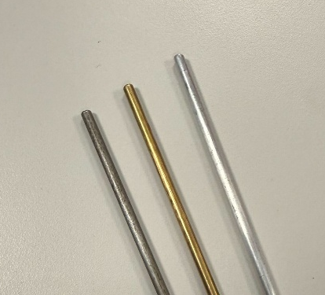
Figure 1
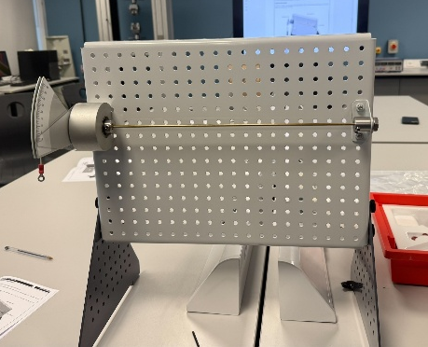
Figure 2
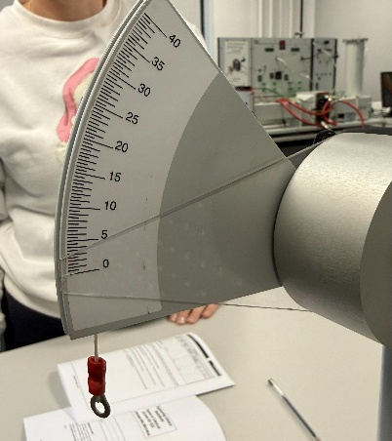
Figure 3

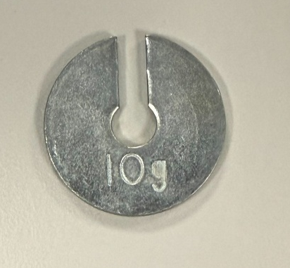
Figure 4
From these steps, the experiment could begin. In 100g increments, the twist angle (degrees) was noted down for each material. The range of weight for brass and steel was 100-500g and for aluminium it was 100-400g. The diameter of each shaft was also measured and written down on a table of results which will be detailed in the section ‘Results’. The process of this experiment can be seen in Figures 1-9.
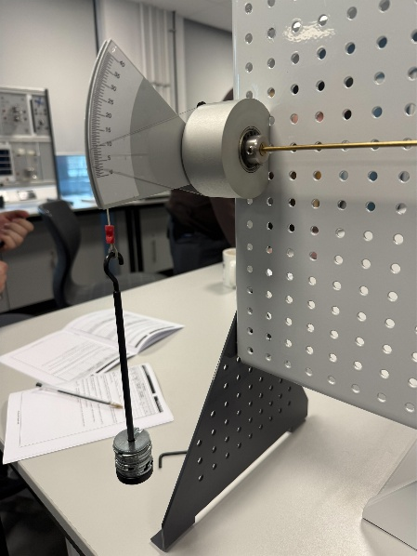
Figure 5
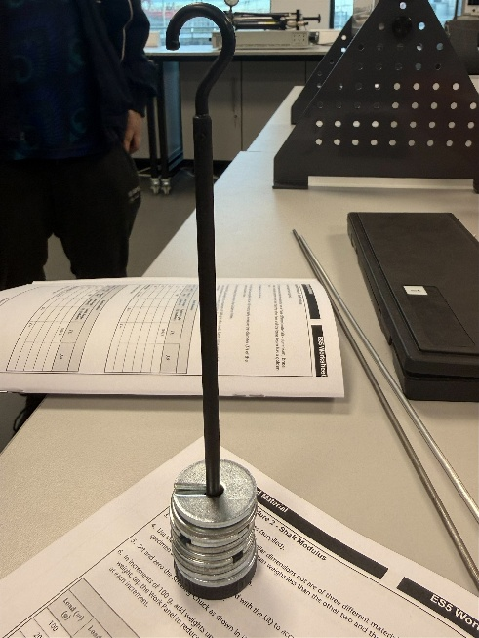
Figure 6
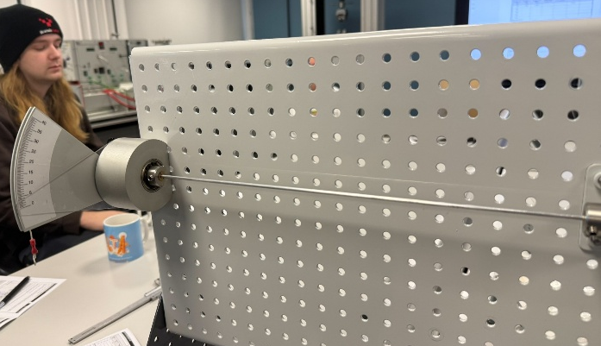
Figure 7
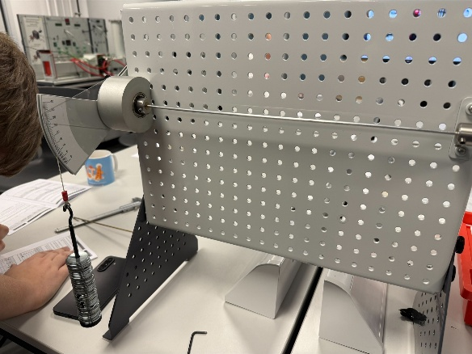
Figure 8
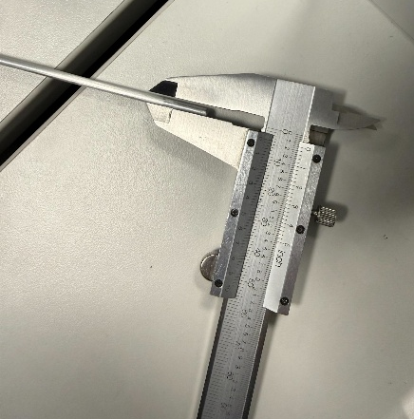
Figure 9

Results
The results gathered and calculated from the experiment are shown in Tables 1, 2 and 3. All results in Bold were raw results gathered in the lab, where the rest have been calculated.
Table 1
Shaft Modulus
Load (m) (g) | Load (w) (N) | Torque (T) (Nm) | Twist Angle (degrees) | Twist Angle (radians) | TL | J * Radians *10⁻¹²
100 | 0.98 | 0.098 | 6.25 | 0.109 | 0.033 | 0.988
200 | 1.962 | 0.196 | 12.25 | 0.214 | 0.066 | 1.940
300 | 2.943 | 0.294 | 18.25 | 0.319 | 0.099 | 2.892
400 | 3.924 | 0.392 | 24.50 | 0.428 | 0.133 | 3.881
500 | 4.905 | 0.491 | 30.00 | 0.524 | 0.167 | 4.751
Material: Brass |  | L = 0.34m | D = 3.1mm, r = 1.55mm |  | J = 9.06646216 *10⁻¹²

Table 2
Shaft Modulus
Load (m) (g) | Load (w) (N) | Torque (T) (Nm) | Twist Angle (degrees) | Twist Angle (radians) | TL | J * Radians *10⁻¹²
100 | 0.98 | 0.098 | 10.50 | 0.183 | 0.033 | 1.659
200 | 1.962 | 0.196 | 16.00 | 0.279 | 0.066 | 2.530
300 | 2.943 | 0.294 | 23.50 | 0.41 | 0.099 | 3.717
400 | 3.924 | 0.392 | 31.50 | 0.55 | 0.133 | 4.989
Material: Aluminium |  | L = 0.34m | D = 3.1mm, r = 1.55mm |  | J = 9.06646216 *10⁻¹²

Table 3
Shaft Modulus
Load (m) (g) | Load (w) (N) | Torque (T) (Nm) | Twist Angle (degrees) | Twist Angle (radians) | TL | J * Radians *10⁻¹²
100 | 0.98 | 0.098 | 2.50 | 0.044 | 0.033 | 0.399
200 | 1.962 | 0.196 | 5.00 | 0.087 | 0.066 | 0.789
300 | 2.943 | 0.294 | 7.50 | 0.131 | 0.099 | 1.188
400 | 3.924 | 0.392 | 10.00 | 0.175 | 0.133 | 1.587
500 | 4.905 | 0.491 | 12.50 | 0.218 | 0.167 | 1.977
Material: Steel |  | L = 0.34m | D = 3.1mm, r = 1.55mm |  | J = 9.06646216 *10⁻¹²

Analysis

As seen in the graphs above, a consistent linearity can be seen across the board. This confirms that all three materials, in their testing, stayed within their elastic limits and followed Hooke’s law in shear. It also shows that the experiment was accurate as the torque was proportionate to the angle of twist.
The gradients of these trendlines represent the Shear Modulus (G) for each material. As expected of steel, as it is the strongest material of the three, has the steepest gradient as more torque is required to produce the same amount of twist compared to other materials. This is followed by brass and then aluminium, showing their relative stiffness. From general knowledge and quick research, it’s evident that these graphs are correct, and the materials responded correctly to these tests, with the graphs reflecting that. The graph representing steel shows a smaller gap from the trendline and the data points, showing that this was the most accurate of the tests, brass also shows a good amount of linearity, however the data points do show more scattering.
Aluminium displays the largest deviations of the three, moreso at lower loads. Furthermore, this material had to be tested with a smaller total weight thanks to its likelihood of exceeding elastic limits at greater loads, minimising our useable data points and thus increased the effect and influence the individual measurements had on the gradient.
All three of the graphs have small negative y-intercepts, which ideally should pass through ‘0,0’. This could be due to slight inaccuracies when zeroing the rotating chuck, or even problems within the system.

Conclusion
When compared to the given textbook G values, from the calculations below, it is shown that the results for brass and steel fall within the +- 10% range, with percentage 6.8% and 6.4% respectively. Aluminium, however, exceeded the acceptable range with a percentage of 16.1%.
The large difference in this number could be due to the fragility of the material and lower stiffness, which makes it more susceptible to measurement errors. With improved zeroing, and more precise measurements, the accuracy of this data set could be improved.
Table 4
Material | Experiment G | Textbook G | % of Error
Brass | 35.4 | 38.0 | 6.8
Aluminium | 29.6 | 25.5 | 16.1
Steel | 84.7 | 79.6 | 6.4

Brass (Expected = 38.0GPa)
$$y=0.0354x-0.0026$$
$$0.0354 ×{10}^{12}Pa=35.4 GPa$$
$$\% of error=\frac{35.4-38.0}{38.0}×100=6.8\%$$

Aluminium (Expected = 25.5GPa)
$$y=0.0296x-0.0127$$
$$0.0296 ×{10}^{12}Pa=29.6 GPa$$
$$\% of error=\frac{29.6-25.5}{25.5}×100=16.1\%$$

Steel (Expected = 79.6GPa)
$$y=0.0847x-0.0011$$
$$0.0847 ×{10}^{12}Pa=84.7 GPa$$
$$\% of error=\frac{84.7-79.6}{79.6}×100=6.4\%$$

Evaluation
During the torsion of circular shafts experiment, several precautions were made to eliminate as many chances of error as to improve the reliability of the results gathered. Before each test, the shaft was carefully placed between the two chucks, to ensure only the torsional forces were being applied so there were minimal bending effects. The rotating chuck was checked every load change, ensuring that it returned to the 0˚ mark once the weight was removed, as there were some issues with slippage. If the torque arm had moved, it was promptly corrected by loosening the grub screws, holding the torque arm at 0 and then re-tightening the screws securely to prevent this from happening and affecting results.
The dimensions, including length and diameter of the shaft, were measured with care and were noted down before any testing started, this is because these values can have a direct impact on the calculated shear modulus. Loads were also gradually applied to the shaft, giving time for the components to settle at that weight before taking an angle reading.
For aluminium, lower maximum loads were also used for aluminium as per the Guidance Notes for the experiment as it’s possible to “twist the rod beyond its elastic limit”. The experiment was conducted the same way for each material in the same conditions, to limit errors and inaccuracies.

Further work
Given unlimited time and resources for this experiment, it would be beneficial to increase the weights by a smaller scale, for example 50g weight increments instead of 100g. This would provide more data points and so the resulting relationship between sheer stress (force applied) and sheer strain (displacement) is more accurate. Main ways of improving this experiment also include reducing possibility of human error and increasing the repeatability of the experiment. As the rotating chuck is currently being zeroed manually by holding the torque arm at 0˚, there is room for mistake by the person conducting the experiment. This can be lessened by introducing a mechanical stop.
Another way of improving accuracy of data could be to have used a micrometer instead of a set of callipers to measure diameter and length, since these two values directly impact the shear modulus calculations.

References
TecQuipment 2012. ‘Torsion of Circular Sections Kit ES5’ Workbook Page 6.

