Marketing plan is written for
_________LUCKNAM PARK HOTEL AND SPA________

Student Name: Romeo Vladut Lila
Student ID number: 2017828

Marketing Essentials BMIH4005
Lecturer
________________________________

Table of Contents
Introduction 3
Marketing Mix 4
Creating Customer Value & Engagement 6
Effective Use of Digital Marketing 7
The Marketing Environment (Micro-SWOT) 8
The Marketing environment (Macro) PESTEL 10
Conclusion – 12
References 12

Introduction
Marketing assists the company in making a profitable relationship with itscustomers. Here I am appointed as a marketing manager of LUCKNAM PARK HOTEL AND SPA. The purpose of this report is to provide a marketing plan for lucknam park hotel and spa, to regain the losses due to the covid 19 pandemic which is situatied in Colerne. The Lucknam Park Hotel and Spa, on an unique 500-acre complex with protected backyard with equiped Equestrian Centre, tennis facilities as well as sports areas, is situated 9,7 kilometers from bath, and offers 43 large rooms including charming cottain houses.Colerne has a good reputation as a tourist attraction, although one that is quite costly to visit. Colerne has several parks, galleries and museums, castles,shopping facilities, and beaches (Pike, 2020). The target audience of this marketing plan is tourists and visitors from all over the world who are looking for quality holiday destinations as well as those potential tourists.

Marketing Mix
A marketing plan assists businesses in achieving, their aims and objectives and thus the marketing mix (4Ps) is a standard structure for defining these strategies (Pike, 2020). Lucknam park hotel and spa's product, price, distribution, and promotion methods are discussed in this section.

(Figure: 4ps of marketing, Source: Self-made)

Products: Currently hotel lucknam park hotel and spa’s main products include food, spa’s and room services(Whitbread PLC, 2021). To increase sales lucknam park hotel and spa can offer combo deals, value-added services, customized room services. As well as to attract corporate customers they can offer business-class service combining meeting, conference facilities. They also can offer hourly workplace reservations for different business events. Again, lucknam park hotel and spa can take bookings for social gatherings and festivals in their venues such as anniversaries, wedding functions,etc (Pike, 2020).
Price:As they are introducing new products in the market they can apply a penetrating pricing strategy where they will charge a minimum price for their new products (Pike, 2015). Once the proper promotions are done and customer demand rises, they can increase their price. However, for the products for the business class, they will need to imply a premium pricing strategy.Accorimg to market research customer wants different types of pricing for different services. Therefore the hotel can introduce variety of pricing point for different types of market segments. For example, the company can introduce premium pricing for the customers who wants to enjoy the premium quality services.

Promotion: The hotel will be promoted through both traditional and digital media. For traditional media the company will use billboard, TV commercials, event sponsorship, radio ads, leaflets and brochure. But for digital media the company will use mobile marketing, email marketing, Facebook instagram and other social medias, their own website (Whitbread PLC, 2021).

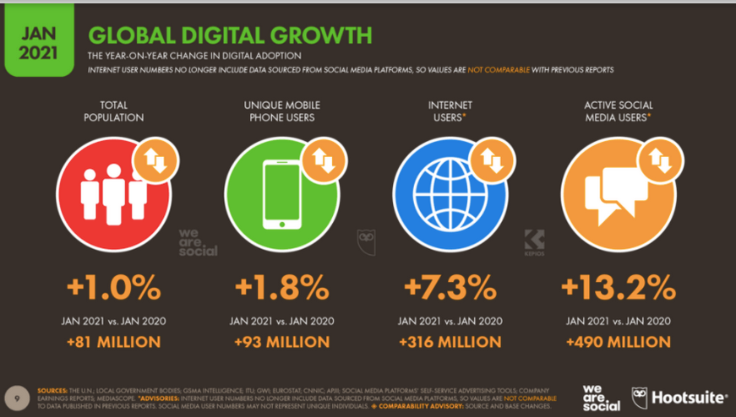
(Figure: statistics of the digital presence of consumers, source: Chaffey and Ellis-Chadwick, 2019).
Place: For this part the company will use their website make the consumers locate their destination. The can also make partnership with other parties by giving franchisee where franchisee can open lobby outlets of the company. This will make it easy for the consumers to locate the company and get their services. Moreover, the Company will use online agents, flash sales sites, mobile platforms, and online networks to distribute itsproducts (Perreault, 2018

Creating Customer Value & Engagement
To comprehend the effectiveness of the marketing plan a survey has been conducted by using a questionnaire where a lot of tourists responded with positive feedbacks. The survey also gave some helpful ideas regarding customer’s demands, requirements, and behaviours regarding the hotel industry during the covid 19 pandemics. The customer value which will be provided by lucknam park hotel and spa are described below:

- The implementation of hygiene protocols will serve the customer a safe travel experience (Kumar and Reinartz, 2016).
- Value-added packages will offer the consumers a lot of service in a combo package which will save consumers money thus providing extra benefits (Blythe, and Martin, 2019).
- The organization should embrace new trends and technology to provide the best service to the consumer which will enhance the visitor engagement.
- The customer should be appreciated constantly. The hotel staffs and employees should practice a warming behaviour with the customers (Kumar and Reinartz, 2016)
- The organization need to appreciate reviews and feedbacks of the consumers and continuously improve themselves.
- Package deals will offer flexible booking systems, car parking, gym facilities, weekend discounts, airport lounges, airport parking are some of the other benefits which will be provided to the consumers. This will ensure that customers get engaged with the organization. (Wirtz, 2012). Such added benefits will increase customer demand and profitability (Kumar and Reinartz, 2016).
- Leveraging social media such as what’s app, Instagram., Twitter, mail can help to connect consumers emphatically.
- Using video content can engage them emotionally.

Effective Use of Digital Marketing
Use of Digital platform for marketing activities can the best purpose to the lucknam park hotel and spa. How lucknam park hotel and spa can use digital marketing are given below:

- Lucknam park hotel and spa will use different social media, websites, email, text messaging services in their marketing activities to attract more and more consumers. In twenty-first-century social media in the biggest platform which enablesthe business to promote their products most effectively with least cost as this is the most used platform by the consumers (Chaffey and Ellis-Chadwick, 2019).
- They may utilize their Instagram, Twitter, and WhatsApp platforms to empathize with consumers and clients (Blythe, and Martin, 2019).
- A website will operate as a reliable resource of information for prospective customers, allowing them to quickly locate the details they require to make a reservation (Ali, 2015). In that way.
- Using Facebook live and posting hotel videos can attract a lot of consumers (Wirtz, 2012). Facebook now allows businesses to accept reservations and sometimes even payments directly from their customers (Chaffey and Ellis-Chadwick, 2019).
- As email marketing is becoming progressively crucial because of its uniqueness lucknam park hotel and spa can also use it effectively.
To attract the customers back to the hotel after the covid 19 pandemic the hotel will need to provide certain message to the consumers regarding the health and safety issue. The company will need to ensure the consumers that they are strictly following healthcare rules and regulations. Providing the sustainable marketing message is another approach to attract consumers in the post covid era. To make people come to the hotel the hotel can deliver message such that they are very customer centric therefore they are adapting their pricing considering the economic conditions of the customers.

The Marketing Environment (Micro-SWOT)
To understand the microenvironment of premier In a SWOT analysis can be efficient (Gürel, and Tat, 2017). This is given below:
Strength  - Brand recognition  - Highly Skilled and dedicated workforce  - Strong networking with their stakeholders (Ali, 2015).  - Various range of services | Weakness  - Low marketing and promotional campaign (Simkin and Dibb, 2013).  - Limited international expansion  - Premium pricing
Opportunities  - Package deals with airlines  - Partnership with various other industrial sectors  - Technological usage  - Customized business product for professionals  - Investments in digital marketing | Threats  - Increasing opportunity cost  - Economic downfall due to covid 19(Simkin and Dibb, 2013).  - High level of competition  - Staff’s shortage due to Brexit issue  - Backpacker hostel

(Figure: SWOT analysis of lucknam park hotel and spa, Source: Self-made)
As lucknam park hotel and spa has good brand recognition, they can utilise it in forming a partnership with other industries. By providing package deals they can attract those customers who have budget issues (Ali, 2015). A highly skilled and dedicated workforce can provide an excellent holiday experience to the customers thus increasing customer engagement(Gürel, and Tat, 2017). As there is increasing competition in the market lucknam park hotel and spa can gain an advantage in this due to their premium services. As there is increasing popularity of backpacker hotels these days lucknam park hotel and spa can address it by providing value-added service and comport to the consumers (Silveret al., 2012). Their premium services can also help them to stand out against the covid 19 pandemic and high competition. The organisation needs to focus their promotional activities where they can work with celebrity personals (Gürel, and Tat, 2017).
Therefore, successful implementation of action can help premier in gaining competitive advantages.

The Marketing environment (Macro) PESTEL
The microenvironment of the lucknam park hotel and spa can be analysed by PESTLE analysis which is given below:
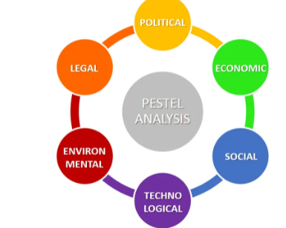
(Figure: PESTLE analysis, source: Rastogi,et al., 2016).
Political: As tourism is the UK’s one of the largest industry and have high growth opportunities UK government provide positive collaboration with the industries thus offering different incentives and subsidies to this sector (Rastogi,et al., 2016). However, Government taxes and VAT have a significant impact on lucknam park hotel and spa especially high taxes on alcohol.
Economical: The economic downfall due to covid 19 has influenced the tourism industry greatly. The hotel industry is suffering huge losses from 2020 and lucknam park hotel and spa is no exception. The spending pattern of the consumer has changed and thus they are forced to lower the price of their products (Perreault, 2018).
Social: Due to covid 19 consumers have become more health-conscious. Their living standards, lifestyle has also changed. They are more reluctant to travelling during covid 19 which influenced the sales of the lucknam park hotel and spa (Ali, 2015).
Technological: Technology has a significant impact on product branding and advertising. The way people communicate is shifting to internet methods. In this way, lucknam park hotel and spa also maintains a well-designed and engaging website. The features of online booking facilitation, client databases that send out information about new item offerings, and advertising campaigns are some of the examples.
Legal: Employment laws, equity laws, Brexit issues are some of the legal factors which have a direct influence on the business functions of the lucknam park hotel and spa (Silveret al., 2012). Lucknam park hotel and spa needs to provide a safe workplace environment for their employees (Rastogi,et al., 2016).
Environmental: By meeting with the legal legislative obligation, the Board has dedicated itself to implementing policies and energy conservation (Simkin and Dibb, 2013). The global weather effects on the hospitality sector, however, the lucknam park hotel and spa is highly cognizant of the environmental perspective. They are trying as much as possible to minimiz
The company can capitalize the positive impact of the macro environment in their marketing activities and it can address the negative impact in its marketing strategies. For example the government patronise towards the tourism sector is huge therefore the subsidiary and incentives gotten from the government can be used to expand their market expansion. The legal environment requires the company to provide an safe working environment for its employees therefore by providing it the company can entice talented employees in their workforce (Perreault, 2018) . The technological usage of the company can be used to provide more customer oriented services to the consumers thee attract more consumers. The company maintain environmental laws which is a good opportunity for the company to create a positive brand image among the consumers.
e environmental damage.

Conclusion –

Covid 19 has drastically impacted the hotel and tourism industry where this industry witnessed a drastic loss of sales from 2020. For recovering the covid 19 losses the hotel industry, therefore,needs to implementinnovative marketing plans. Proper implementation of social media, use of the website, providing package deals, customized services, maintaining strict hygiene protocol, creating emotional engagement with the consumer, value-added services are some of the recommended marketing plans suggested in this report. The lucknam park hotel and spa needs to efficiently implement these plans in their activities.
However, There’s some recommendation for The lucknam park hotel and spa hotel. Though they are a very famous and largest hotel company in the UK their international presence is not sufficient. Therefore, they can implement a market development strategy in their marketing practice (Silveret al., 2012). They can focus on geographical expansion so that they can attract more and more consumers (Blythe, and Martin, 2019). For geographical expansion, they can adopt franchising methods around the world. During the pandemic, they need to concentrate on improving brand loyalty among the consumers.

References

Ali, M.A.B., 2015. Travel and tourism management. PHI Learning Pvt. Ltd.
Blythe, J. and Martin, J., 2019. Essentials of marketing. Pearson UK.
Chaffey, D. and Ellis-Chadwick, F., 2019. Digital marketing. Pearson UK.
Gürel, E. and Tat, M., 2017. SWOT analysis: a theoretical review. Journal of International Social Research, 10(51).
Kumar, V. and Reinartz, W., 2016. Creating enduring customer value. Journal of Marketing, 80(6), pp.36-68.
Perreault, W.D., 2018. Essentials of marketing. New York: Mc Graw Hill.
Pike, S., 2015. Destination marketing: essentials. Routledge.
Pike, S., 2020. Destination MarketingDestination Marketing: Essentials. Routledge.
Rastogi, N.I.T.A.N.K. and Trivedi, M.K., 2016. PESTLE technique–a tool to identify external risks in construction projects. International Research Journal of Engineering and Technology (IRJET), 3(1), pp.384-388.
Silver, L., Stevens, R.E., Wrenn, B. and Loudon, D.L., 2012. The essentials of marketing research. Routledge.
Simkin, L. and Dibb, S., 2013. Marketing essentials. Cengage Learning EMEA.
Wirtz, J., 2012. Essentials of services marketing. FT Press.

