
The marketing plan of FAW-Volkswagen in the Chinese e-mobility market
A comprehensive audit with marketing recommendations
Name:Haomiao Rao
Student No: 2000344
Word count: 2932

Executive summary
Based on the environmental audit, a marketing strategy and practice audit of FAW-VW, a leading automobile company in China, this report finds that the company has established effective marketing strategies and practices in the emerging and rapidly growing e-mobility market in China. This report, however, finds that the company needs to revisit its target customer groups as well as brand and product portfolio design and management. This report finds that the company has established a marketing practice that fits into the external and internal environments in the market yet needs to redesign its brand and product portfolio and targets the young generation customers in China.

Table of contents

Executive summary 2
Table of contents 3
1. Introduction 1
2. Main findings 2
2.1. Marketing concept 2
2.2. Macro & micro environments 2
2.2.1. Macro-environmental analysis 3
2.2.2. Micro-environmental analysis 4
2.3. The target market 5
2.3.1. Segmentation 5
2.3.2. Targeting 5
2.3.3. Positioning 6
2.4. Marketing mix 6
2.4.1. Product 6
2.4.2. Promotion and pricing 7
2.4.3. Place and people 7
2.4.4. Process and physical evidence 7
2.5. Marketing media 8
2.6. Measuring success 8
3. Conclusion 9
4. Recommendations 9
Reference 11
Appendices 14

- Introduction
Since the outbreak of the Covid-19 pandemic, the economic transformation specifically the green transformation has been constantly put to the table of business development and economic policy making. The automobile industry is arguably one of the industries that is critical for the green transformation of the economy by promoting the production and sales of the e-mobility vehicles (Klemeš, Fan and Jiang, 2021). Major automobile production and consumption markets, including EU, UK, US, Japan, South Korea, China, have all announced their roadmaps in abandoning fossil fuel-based combustion engines with electric mobility engines (Bloomberg NetZero Pathfinders, 2022). In China, for example, the year on year sales growth of e-mobility vehicles in the market has reached over 140% while that of the combustion engine passenger vehicles was negative due to the chip shortage and the increase of oil price (Nikkei Asia, 2021; Bloomberg, 2022a; Institute for Energy Economics and Financial Analysis, 2022).
The promising future of the e-mobility market, however, has brought more challenges than opportunities for conventional automobile manufacturers such as FAW-VW (FAW-Volkswagen Automobile Co., Ltd.). FAW-VW was the first passenger car joint-venture in China and has developed to one of the largest passenger vehicle manufacturers in China as well as the world. The revenue and profit of the FAW-VW has long been on the top of the Chinese automobile market. Yet in the e-mobility market, FAW-VW is now challenged by increasingly emerging e-mobility manufacturers from conventional automobile companies such as Toyota, Mercedes-Benz, to entirely e-mobility automobile companies such as Xiaopeng, Wei, Lixiang (Bloomberg, 2022b). To retain the company’s market position in the e-mobility market, it is thus highly necessary to revisit the marketing strategy of FAW-VW in the electric era. Based on the previous report on the environmental scanning, this report is thus produced to provide a comprehensive market audit and marketing plan for the company in the Chinese e-mobility market. This report is to include a macro- and micro-marketing analysis, a STP analysis, a marketing mix analysis, a marketing media analysis, and the measuring approach of the marketing plan established.
- Main findings
  - Marketing concept
Marketing is one of the most important processes of businesses. By delivering value to target customers at a profit, the marketing operations in the organisation provides the understanding and sense-making of target markets and customers, builds the relationship with customers that could sustain the value-creation for customers and profit generation for the organisation (Grönroos, 2006). As a well-established automobile company, the FAW-VW has long been establishing successful marketing strategies for its conventional passenger vehicle products. Vehicle models including Volkswagen Jetta, Volkswagen Santana and Audi A6 & A8 have been some of the most successful passenger models in the Chinese market in terms of sales (Hertrich and Mayrhofer, 2016). The company has developed abundant physical (e.g. 4S stores, car exhibition stands, billboards), financial (e.g. advertisement and marketing investments, sales & revenue for marketing expenditure) and human (e.g. professional sales teams, R&D and technical supporting teams) resources for marketing management in China.
Upon the entry to the e-mobility passenger market in China, the FAW-VW company has been investing in new resources for the marketing of e-passenger cars such as physical stores in major shopping centres and advertisements targeting high-tech savvy customers as attached in appendix 1. It has been reported that the FAW-VW has established a specific marketing team based on social media influencers and digital bloggers for devising marketing strategies for its electric vehicles (Volkswagen Newsroom, 2022). It is thus evident that the company has been investing in key financial, physical, and human resources for the marketing management of e-mobility vehicles.
  - Macro & micro environments
The macro environmental analysis is conducted using the PESTEL model and the micro analysis is conducted using the Porter’s Five Forces model. The full models are appended in the appendix 2 and 3.

    - Macro-environmental analysis
The PESTEL analysis focuses on the external environment of the FAW-VW company in the Chinese e-mobility market. Based on the analysis as exhibited in the appendix 2, the political, economic, technological, and ecological factors favour the FAW-VW company while the social and legal factors are posing complex influence for the company. In the past years especially during the Covid-19 pandemic, the Chinese government has established the green-transformation as one of the key social and economic transformations in the next decade. Massive beneficial policies including taxation reduction, policy incentives for production plant establishments, financial subsidies for e-mobility customers and manufacturers have been rolled out. It has been reported in previous studies that the Chinese government has become of the largest investor in the e-mobility industry worldwide (Ball et al., 2021; Huang et al., 2021; Augurio et al., 2022).
Economically, the low-consumption level due to the impact from the Covid-19 pandemic together with the rising oil price has been driving customers in China to prefer e-mobility vehicles over combustion vehicles. As aforementioned in the introduction, the growth of the sales of e-mobility in China has well-surpassed that of combustion engine-based vehicles. The economic stimulus plans established by the Chinese government have also been focusing on the e-mobility industry to boost the consumption of e-mobility passenger vehicles (Ye et al., 2021). Ecologically, the demand in green transformation especially on the carbon neutrality and carbon peak requirements set by the Chinese government have made the e-mobility passenger vehicle one of the inevitable options for China to promote in the next decade (Guang, 2022). The above factors form the driving force of the market growth of the Chinese e-mobility market.
During the past years, companies including BYD and CATL have become key suppliers in the global e-mobility supply chain in terms of core chip supply, lithium-ion battery module supply and battery management system supply (Bridge and Faigen, 2022). As reported by Graham, Belton and Xia (2021), China is now the largest R&D and patent generation hub in the global e-mobility manufacturing network. The technological factors form the specific advantages of e-mobility companies in China.
While the perception of e-mobility vehicles in China remains to be in the low-to-middle ends as economic and comfort cars while the high-end and luxury cars are still to be combustion engine vehicles. More importantly, the safety concerns of e-mobility vehicles including explosion of lithium-ion batteries and hydrogen-based fuel cells have been further hampering the adoption of e-mobility in China (Higueras-Castillo et al., 2021; Victor Chombo, Laoonual and Wongwises, 2021; Zhang et al., 2022). The legal regulations of e-mobility in China including plate registration, as the national government has issued different plate registration and traffic ban rules for e-mobility across regions, has added the uncertainty in e-mobility development in China (Ling, Cherry and Wen, 2021).
    - Micro-environmental analysis
The full model is attached in appendix 3. Based on the Porter’s Five Forces analysis, the analytical result is shown in the figure below.
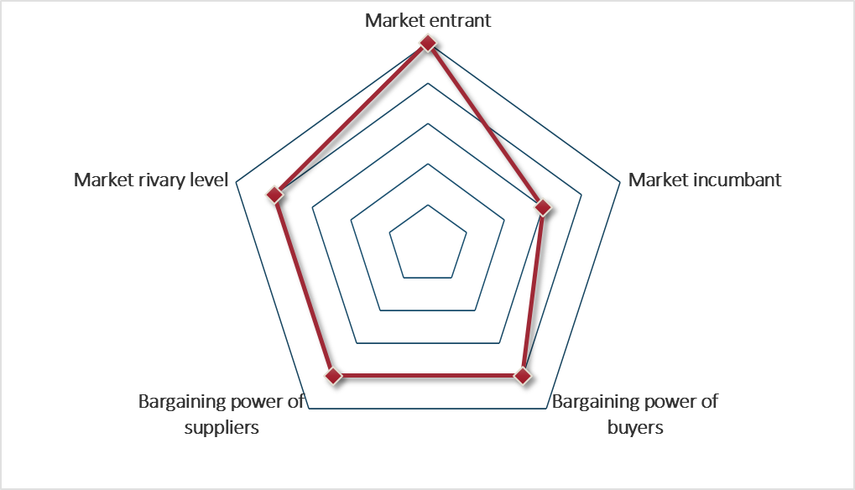
Figure 1. Porter’s Five Forces analysis.
The analysis shows that the e-mobility market in China is highly competition intense. On one hand, market entrants are emerging rapidly in the past years. As found by Statista (2022), over 40 brands have emerged in only two years from 2020 to 2022 in the Chinese e-mobility market. The low-entry barrier in the e-mobility market has attracted entrepreneurs with technologies or capital investment companies with financial resources to enter the market. In the meantime, conventional automobile companies including FAW-VW have been entering the e-mobility market, further pushing the competition level in the market.
As lithium is a rare resource in China, the supply of the lithium element and the lithium-ion battery modules have been limited in some companies in China including CATL and BYD, which increases the bargaining power of suppliers. The abundant options in the market push the bargaining power of buyers. The above factors thus make the e-mobility market in China to be highly competition-intense.
The macro- and micro-environmental analyses show that the Chinese e-mobility market is highly promising while highly competition-intense. In this regard, the FAW-VW company has been investing significantly in terms of physical and financial resources for the marketing of its e-mobility products. By providing promotional offers to customers and using its long-established brand reputation in the Chinese market, FAW-VW has been focusing on the middle-to-high end e-mobility market to avoid the massive competition with market entrants and to establish its supply chain advantage using its conventional automobile production and sales channels (McCaleb, 2015; Volkswagen Newsroom, 2022).
  - The target market
    - Segmentation
The FAW-VW company has been segmenting its market based on the income or consumption levels of its customers. According to the report by McKinsey (2022), the models provided by the FAW-VW in the Chinese e-mobility market is primarily the ID series with the each model of the series targeting one pricing level in the Chinese automobile market. The ID3 and ID4 are for passenger cars ranging in the 30,000 USD price level and the ID Roomzz and the ID Vizzion are targeting the electric SUV in the 40,000 USD price level. The segmentation of the e-mobility products of FAW-VW follows its segmentation strategy in the combustion engine product lines which uses the A, B, C and D-level (based on the pricing of the product) car levelling in the Chinese market (Volkswagen Newsroom, 2022).
    - Targeting
The targeting of the FAW-VW company is now primarily in the middle-range of the passenger cars with its ID3 and ID4 products. The two products are set in the B-level car pricing level in China, the combustion-equivalent of which have been the most welcomed products provided by the FAW-VW company. According to Volkswagen Newsroom (2022), FAW-VW aims to provide high price-performance ratio products that has the Volkswagen quality and edgy design for electric passenger vehicles. The primary target customer group of the company is the customer group that favours the Volkswagen brand and the edge-cutting design of e-mobility vehicles.
    - Positioning
FAW-VW positions itself in the Chinese market as one established automobile provider that has extensive sales and support network in China that could enhance the user experience of customers after purchasing its e-mobility vehicles. The company positions itself as a company that could provide the best price-performance ration in the market with edge-cutting design. To sum up, according to Volkswagen Newsroom (2022), the company provides products, such as ID3 and ID4 with affordable pricing and reliable quality with its extensive post-sales supporting network established in China over the past three decades.
To sum up, the FAW-VW company has been targeting the middle-level, in terms of price and car performance and quality, market segment in the Chinese e-mobility market and positions itself as one reliable e-mobility product and service provider in China.
  - Marketing mix
The marketing mix of the company has been established based on the above factors.
    - Product
The product of the company has thus been focusing on middle-price range, as the B- and C-level cars in China represented by the ID3 and the ID4 models. The company has also announced its development of higher-end models such as the electric luxury SUVs as the Vizzion that could be launched before 2023 (Volkswagen Newsroom, 2022). The product design of the product is also to match the price range as to provide as much reliability and low energy consumption level for its customers. As surveyed by Nie et al. (2020), ID3 and ID4 have been elected as one of the most energy-economic electric vehicles in the Chinese market. Yet it has also been reported that the two models are less competitive in digital hub design and whole car performance (EV Database, 2020).
    - Promotion and pricing
The promotion of FAW-VW’s products has been focusing on the after-sales service. The company provides full quality guarantee and insurance for its e-mobility products in China, which could potentially reinforce the perception of the high-quality and reliability of its products. The company has also been collaborating with local governments in China, using the resources of the state-owned FAW company in China, to provide extra financial incentives for customers purchasing its ID3 and ID4 products (Cabigiosu, 2022). In this regard, the pricing of the product has been positioned in the middle range as aforementioned, yet allowing customers to purchase the product with a lower price.
    - Place and people
To promote its products to those favouring the tech-savvy sense in car design, the FAW-VW has been establishing e-mobility exhibition hubs in major shopping centres across China as exampled in appendix 1. In the meantime, as aforementioned, the FAW-VW company has been actively adopted emerging marketing resources such as influencer on social media platforms in China as its marketing agents to appeal to the tech-savvy customer groups.
    - Process and physical evidence
The FAW-VW company has prioritised the e-mobility marketing as one of the supporting pillars of its marketing management in the next decade. The company has established corporate-level strategic management units supervising the marketing of the e-mobility products in China. The company has been investing resources that have accumulated in the past decade to enhance the physical exhibition of its products by collaborating with automobile bloggers, social media influencers, car exhibitions. The company has been collaborating with large meeting organisers such as the Chinese National Conference Centre to use ID3 and ID4 as official e-mobility solutions (Volkswagen Newsroom, 2022).
To sum up, the above marketing mix strategy adopted by the FAW-VW has been successful as the ID3 and ID4 have become two of the most welcomed e-mobility products in China. Yet it should be pointed out that the use of resources of the FAW-VW established in the combustion engine era has been haunting the company as VW has several issues in car quality in the Chinese market which has been hampering customers from purchasing its products. Moreover, the FAW-VW brand has been viewed as an old brand in China that is not as welcomed by young generation customers as middle-aged customers groups, which suggest that the brand design, management and targeting of the company should be revisited (Wu et al., 2021).
  - Marketing media
The marketing media adopted by the FAW-AW for its e-mobility products has been relying on two channels as one being the conventional marketing media platforms such as newspapers, official websites, 4S stores; and the other being the emerging media platforms such as social media platforms and short video platforms in China (Volkswagen Newsroom, 2022). The conventional marketing channels established by the company have been highly effective. According to McKinsey (2022), over 50% of the FAW-VW e-mobility products are sold in physical stores. While it should be pointed out that the emerging marketing media has also played a vital part. According to Chen and Zhong (2022), the first impressions of FAW-VW’s e-mobility products as ID3 and ID4 are established on social media platforms especially short-video platforms including test-drive videos, assessment videos by actual buyers. It should be pointed out that the attention of customers on FAW-VW’s e-mobility products drawn from emerging channels could be one of the major marketing traffic channel for the company. Yet this needs to be validated in future studies.
  - Measuring success
The marketing promotions and campaigns of the company include primarily financial incentives and bonus packages such as free insurance for the first three years or first 100,000 kilometres (Volkswagen Newsroom, 2022). The measuring of the success of the marketing campaigns, based on the above analysis, should be based on not only the sales but also the marketing coverage and brand image as multiple marketing media platforms have been adopted. As found by Chen and Zhong (2022), the FAW-VW has been establishing a high-coverage marketing campaign in the Chinese market by investing in advertisements in all platforms. The sales of the ID3 and ID4 have also reached the top ranking in the Chinese e-mobility market. It is safe to conclude that the campaigns are successful. Yet it should be pointed out that the coverage, with the cost in marketing, should be further evaluated regarding the sales and profit growth to comprehensively assess the success of the marketing strategy of the company in the Chinese e-mobility market.
- Conclusion
Based on the analysis in this report, it is concluded that the FAW-VW company has established an effective marketing understanding and a marketing mix targeting its ideal customer groups. Yet the analysis in this report shows that the company may have overly invested in marketing due to its multi-channel marketing communication strategy and have focused on the customer group that is less willing to purchase as the middle aged customers in China, who are not the primary customer group for e-mobility purchasing in China (Wu et al., 2014). The company has established a market understanding and a marketing mix as well as a marketing communication strategy that could fit into the competition-intense while promising e-mobility market in China and has achieved sales and marketing coverage success. Yet the further growth of the company requires an adjustment of its marketing strategy.
- Recommendations
Based on the analysis in this report, it is firstly suggested that the company should retain its capability in market sensing and understanding using its current competitive human resources for market probing and forecasting. The company should retain its capability established in the past decades to probe the preferences of Chinese customers. The company is secondly suggested to revisit the design of its product as well as its e-mobility brand, such as to launch independent brands to appeal to young customers that favour new and tech-savvy brands, who are also the primary customers in the market. The company is finally suggested to work with external bodies such as research institutes to further elucidate the consumer preference and purchasing behaviour of customers in China to complement its current marketing strategy.

Reference
Augurio, A. et al. (2022) ‘e-mobility in the Age of COVID-19’, in Business Under Crisis Volume I. Springer, pp. 101–123.
Ball, C. S. et al. (2021) ‘E-mobility from a multi-actor point of view: Uncertainties and their impacts’, Technological Forecasting and Social Change, 170, p. 120925.
Bloomberg (2022a) Chinese Electric Car Maker BYD First-Quarter Income Jumps on Demand for EVs . Available at: https://www.bloomberg.com/news/articles/2022-04-27/byd-first-quarter-income-jumps-on-demand-for-electric-vehicles (Accessed: 27 June 2022).
Bloomberg (2022b) Volkswagen China Plans JVs on Battery Raw Material Supply Chain . Available at: https://www.bloomberg.com/news/articles/2022-03-21/volkswagen-china-plans-jvs-on-battery-raw-material-supply-chain-l10fqg76 (Accessed: 27 June 2022).
Bloomberg NetZero Pathfinders (2022) Phase Out of Internal Combustion Engine Vehicle Sales Policies | . Available at: https://www.bloomberg.com/netzeropathfinders/best-practices/phase-out-of-internal-combustion-engine-vehicle-sales-policies/ (Accessed: 27 June 2022).
Bridge, G. and Faigen, E. (2022) ‘Towards the lithium-ion battery production network: Thinking beyond mineral supply chains’, Energy Research & Social Science, 89, p. 102659.
Cabigiosu, A. (2022) ‘Sustainable development and incumbents’ open innovation strategies for a greener competence‐destroying technology: The case of electric vehicles’, Business Strategy and the Environment.
Chen, J. and Zhong, M. (2022) ‘Research on Volkswagen’s Development Strategy During Covid-19’, in 2022 7th International Conference on Social Sciences and Economic Development (ICSSED 2022). Atlantis Press, pp. 705–710.
Dell’Aquila, M., Atzori, D. and Stroe, O. R. (2020) ‘The Role of Policy Design and Market Forces to Achieve an Effective Energy Transition: A Comparative Analysis Between the UK and Chinese Models’, pp. 227–255. doi: 10.1007/978-3-030-39066-2_10.
EV Database (2020) Compare electric vehicles - EV Database. Available at: https://ev-database.org (Accessed: 27 June 2022).
Gao, Y. (2021) ‘Analysis of BYD’s Business Model and Future Development Prospects’, Advances in Economics, Business and Management Research.
Graham, J. D., Belton, K. B. and Xia, S. (2021) ‘How china beat the US in electric vehicle manufacturing’, Issues in Science and Technology, 37(2), pp. 72–79.
Grönroos, C. (2006) ‘On defining marketing: finding a new roadmap for marketing’, Marketing theory, 6(4), pp. 395–417.
Guang, X. (2022) ‘Carbon Peak and Carbon Neutrality: A Consumption Dimension’, China Economist, 17(2), pp. 93–108.
Hertrich, S. and Mayrhofer, U. (2016) ‘Audi and the Chinese Market: A Success Story’, in Market Entry in China. Springer, pp. 37–44.
Higueras-Castillo, E. et al. (2021) ‘Adoption of electric vehicles: Which factors are really important?’, International Journal of Sustainable Transportation, 15(10), pp. 799–813.
Huang, Y. et al. (2021) ‘On the heterogeneity in consumer preferences for electric vehicles across generations and cities in China’, technological forecasting and social change, 167. doi: 10.1016/J.TECHFORE.2021.120687.
Institute for Energy Economics and Financial Analysis (2022) IEEFA: Skyrocketing EV sales in China spell a no-turning-back step change in global energy landscape . Available at: https://ieefa.org/resources/ieefa-skyrocketing-ev-sales-china-spell-no-turning-back-step-change-global-energy (Accessed: 27 June 2022).
Klemeš, J. J., Fan, Y. Van and Jiang, P. (2021) ‘COVID-19 pandemic facilitating energy transition opportunities’, International Journal of Energy Research, 45(3), pp. 3457–3463. doi: 10.1002/er.6007.
Li, J., Jiao, J. and Tang, Y. (2019) ‘An evolutionary analysis on the effect of government policies on electric vehicle diffusion in complex network’, Energy Policy, 129, pp. 1–12. doi: https://doi.org/10.1016/j.enpol.2019.01.070.
Ling, Z., Cherry, C. R. and Wen, Y. (2021) ‘Determining the Factors That Influence Electric Vehicle Adoption: A Stated Preference Survey Study in Beijing, China’, Sustainability, 13(21), p. 11719.
McCaleb, A. (2015) ‘China’s automobile industry: development, policies, internationalization’, Gdańskie Studia Azji Wschodniej, (08), pp. 163–172.
McKinsey (2022) ‘McKinsey China Auto CEO Quarterly Chief editors’.
Nie, Y. et al. (2020) ‘Examining shanghai consumer preferences for electric vehicles and their attributes’, Sustainability, 10(6), p. 2036.
Nikkei Asia (2021) China plans to phase out conventional gas-burning cars by 2035 . Available at: https://asia.nikkei.com/Business/Automobiles/China-plans-to-phase-out-conventional-gas-burning-cars-by-2035 (Accessed: 27 June 2022).
Omahne, V., Knez, M. and Obrecht, M. (2021) ‘Social Aspects of Electric Vehicles Research—Trends and Relations to Sustainable Development Goals’, world electric vehicle journal, 12(1). doi: 10.3390/WEVJ12010015.
Statista (2022) Electric vehicle market in China - statistics & facts . Available at: https://www.statista.com/topics/5623/electric-vehicle-market-in-china/ (Accessed: 27 June 2022).
Tyfield, D. and Zuev, D. (2018) ‘Stasis, dynamism and emergence of the e-mobility system in China: A power relational perspective’, Technological Forecasting and Social Change, 126, pp. 259–270. doi: 10.1016/j.techfore.2017.09.006.
Victor Chombo, P., Laoonual, Y. and Wongwises, S. (2021) ‘Lessons from the electric vehicle crashworthiness leading to battery fire’, Energies, 14(16), p. 4802.
Volkswagen Newsroom (2022) ID.6 | Volkswagen Newsroom. Available at: https://www.volkswagen-newsroom.com/en/id6-6969 (Accessed: 27 June 2022).
Wu, X. et al. (2014) ‘Research of EV customer acceptance index in China’, in 2013 World Electric Vehicle Symposium and Exhibition, EVS 2014, pp. 1–10. doi: 10.1109/EVS.2013.6914842.
Wu, Y. A. et al. (2021) ‘A review of evolutionary policy incentives for sustainable development of electric vehicles in China: Strategic implications’, Energy Policy, 148, p. 111983.
Ye, R.-K. et al. (2021) ‘Moving from subsidy stimulation to endogenous development: A system dynamics analysis of China’s NEVs in the post-subsidy era’, Technological Forecasting and Social Change, 168, p. 120757.
Zhang, W. et al. (2022) ‘Information perspective for understanding consumers’ perceptions of electric vehicles and adoption intentions’, Transportation Research Part D: Transport and Environment, 102, p. 103157.
Zhao, Q. (2018) ‘Green Innovation Regarding Electromobility in Germany and China: Who and How to Get Involved?’, Journal of Scientometric Research, 7(1), pp. 1–8. doi: 10.5530/jscires.7.1.1.

Appendices

Appendix 1. Marketing resources of FAW-VW in the Chinese e-mobility passenger market
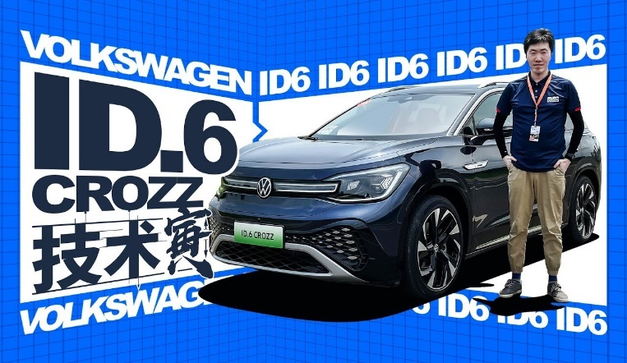
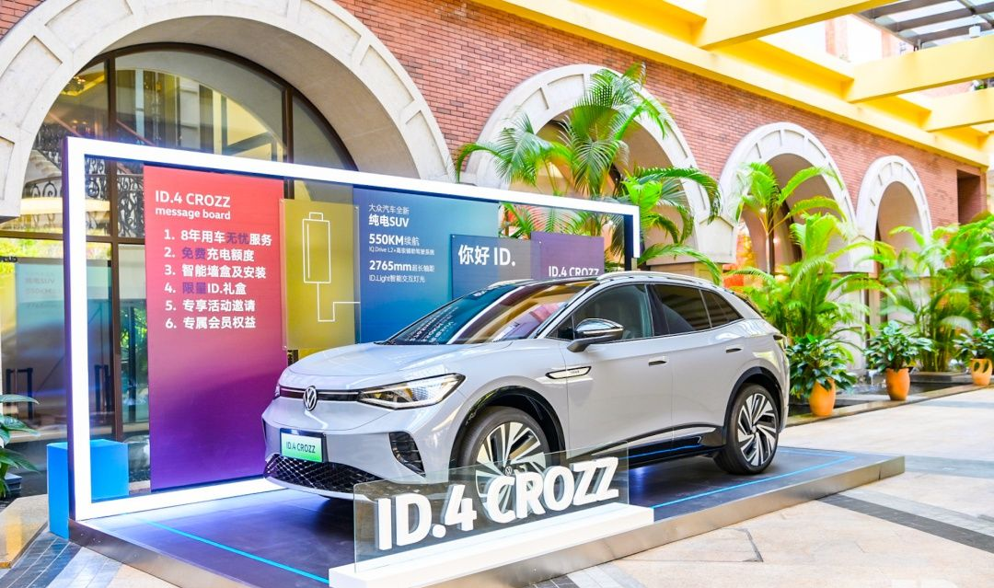
Figure 2. (Left) A e-mobility hub of FAW-VW in one shopping centre. (Right) An advertisement of e-mobility passenger car of FAW-VW. Source: (Volkswagen Newsroom, 2022)

Appendix 2. PESTEL analysis
Political: The Chinese government has launched a carbon peak and carbon neutrality plan for the next two decades and set it as the top priority of the central government. The government has also set the e-mobility industry as its core industry to compete in the global market in the next decade to help China transform from the global factor to the global supply centre. The support on the green transformation is now the priority for both central and local governments in China (Dell’Aquila, Atzori and Stroe, 2020).
Economic: The consumption of the Chinese residents has been decreasing since the pandemic. The stimulus plan provided by the government has been focusing on the green transformation such as to push the purchasing of e-mobility products of business and individual consumers. The rising oil price further pushes the purchasing intention of customers on e-mobility products especially with the subsidy provided by the government on charging station installation (Tyfield and Zuev, 2018; Zhao, 2018).
Social: Chinese customers fear the safety of e-mobility vehicles and their reliability in the long-run. The e-mobility products in China remain to be viewed as economic choices of car purchasing. The acceptance level of e-mobility in China remains to be low (Wu et al., 2014; Omahne, Knez and Obrecht, 2021).
Technological: China is now leading in e-mobility production and design. China is now the largest e-mobility related patent registration country and the largest supplying market of e-mobility. Both factors could offer companies in the market with advantages in establishing cost-competitive supply networks (Li, Jiao and Tang, 2019).
Ecological: The Chinese government has now pushing to reduce the environmental impact of the transportation industry. Customers in the market are also growing increasingly interesting in purchasing products that could be pose less impact to the natural environment (Wu et al., 2014).
Legal: Chinese government has now loosened the regulation on e-mobility from production to car plate registration, which has benefit market entrants. Yet this has caused issues such as that bankruptcy of car makers could harm the confidence of customers of the overall e-mobility market. The uncertainty of the regulatory body could challenge how e-mobility manufacturers design and market their products.

Appendix 3. Porter’s Five Forces analysis
Market entrants: Companies from internet companies, state-owned companies and large automobile companies are entering the market with emerging start-ups. The loosened regulation has lowered the entry barrier to the market especially when the OEM model is adopted in the Chinese e-mobility market (Gao, 2021).
Market incumbents: All major automobile companies in the Chinese market have announced plans or have launched their e-mobility products, which has significantly elevated the competition level in the market.
Power of buyers: The abundant options in the market with the investment from the government and financial institutes have enhanced the power of buyers as they can choose from a wide range of products and brands.
Power of suppliers: Lithium element is rare in China and only several companies in China have maintained a stable output of the lithium ore and lithium battery modules, which has significantly elevated the bargaining power of suppliers.
Market rivalry: The market is thus highly competition intense based on the above analysis.

