

Task 1 – Reading Task Template
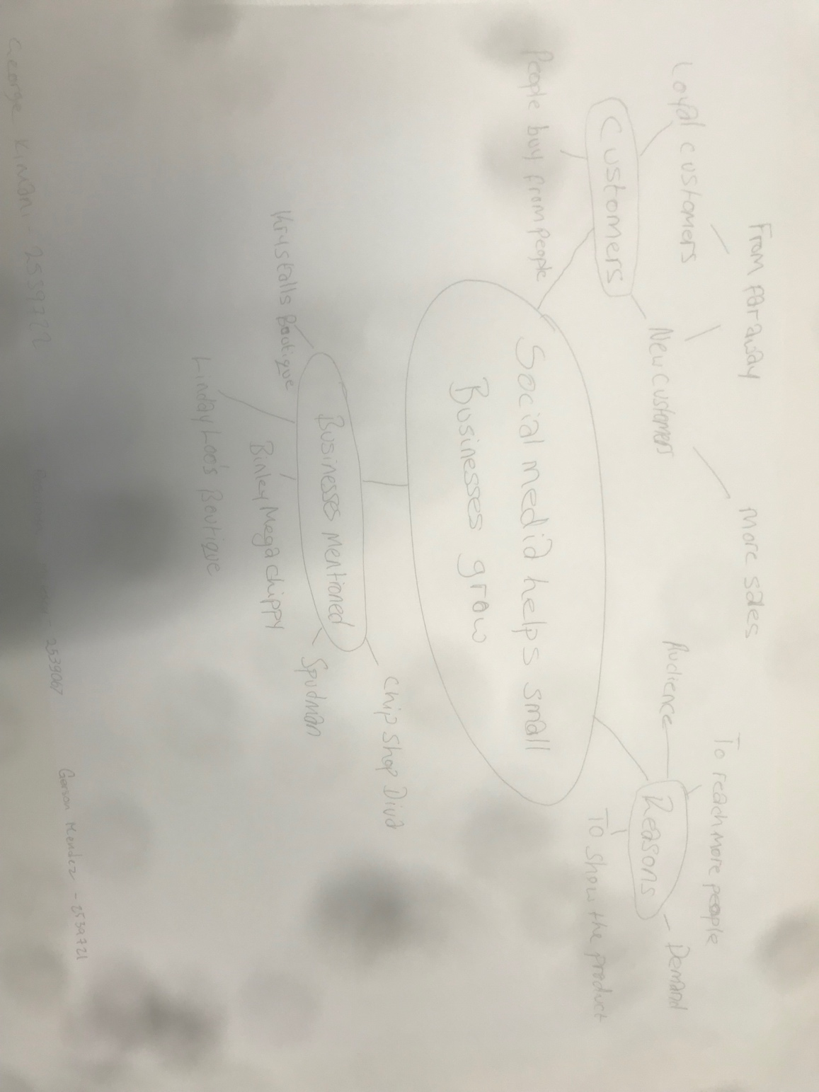
Upload your photo of your A3 in-class notes here:


1. Answer these questions using the sentence starters below
a. What is the main idea of the text?
The main idea is that social media helps small businesses grow
b. What are two key points?
One key point is customers. Loyal customers and new customers come from far away.
Another key point is the businesses mentioned: Binley Mega Chippy, Spudman, Chip Shop Diva
c. What part of the text did you find most important? Why?
The most important part is the first paragraph which explains the article because it gives insight into what is going to be spoken about.
d. Was anything unclear or difficult to understand?
I was not, not sure about anything.
e. How did your group help you understand the text better?
My group helped me by going through the article carefully.
3. One sentence reflection
Question: What did you find challenging about this task?
The hardest part was answering these questions.

