23/05/2024
Current Issues in taxation

Robert Yeo (2000752)
Contents
Introduction 2
Housing Taxation 3
Council Tax 3
Stamp Duty 4
Personal Taxation 5
National Insurance 5
Self-Employed 5
Employed 6
Environmental Taxation 7
Conclusion 10
References 11

Introduction
Taxation is used for raising money for the government for public services, economic growth of a country, and changing social behaviours such as spending, alcohol and fuel services, to name a few (Office for National Statistics, 2022). A good tax system should most of all be fair, it should not unfairly disadvantage anyone, and it should give people equal opportunities, while improving the growth of the country. It should be simple and should not require an army of experts to navigate it, it should minimise bureaucracy and prevent any loopholes that endorse parasitic behaviour (ICAEW, 2023). This is a report that aims to critique the British tax system, with a key focus on housing taxation, personal taxation and environmental taxation.
Housing taxation is split into two key parts, council tax and stamp duty. Council tax is an annual tax that is split into different tax brackets depending on the price of the house; this amount is based on the price of the house if it were sold in 1991 (UK Government, 2024). Stamp duty is the tax on the purchase of the property, which is split into tax bands based on the house price. The Stamp duty’s key aim is to prevent speculation, which will lead to creating housing bubbles. Speculation in the housing market is the acquisition of properties that are not for living purposes. Housing bubbles create inflation on property prices (Seely, 2023).
The areas of personal taxation that this report will delve into, is the difference between taxation of employed and self-employed incomes. In addition, the application of national insurance and whether it truly tackles its targets of healthcare and pensions.
As for environmental taxation, this report will highlight the application of environmental taxation on both businesses and consumers, that drive both changes in behaviour and environmental sustainability.

Housing Taxation

Council Tax
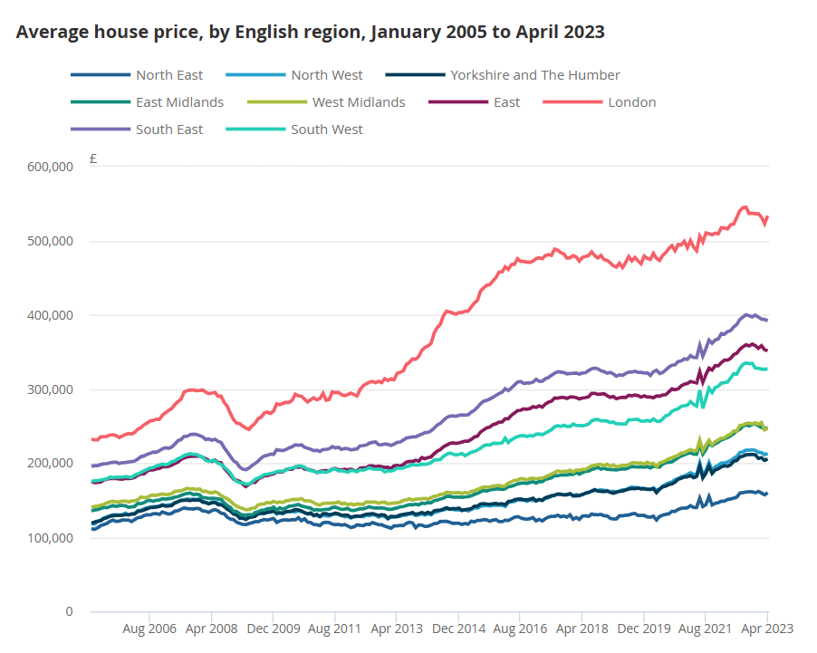
Council Tax is an annual tax for all property owners. It is based upon various tax bands that properties need to pay depending on the property price. “The value is based on the price the property would have sold for on the open market on 1 April 1991 in England and 1 April 2003 in Wales” (UK Government, 2024). This lack of change of valuation for over 33 and 21 years respectively, has created unfairness between places in the UK with exceedingly high property growth areas (London and the South East) and areas with slow growth (like the North East). This means that council tax in areas of rapid property price growth is proportionally less now than areas that experience slow growth. Better off areas are favoured by this tax policy meanwhile places that are worse off are not, which is causing an imbalance for what is deemed to be fair (Office for National Statistics, 2023)
Figure 1 (Office for National Statistics, 2023)
Figure 1 shows the average house price by English region. London and the Southeast house prices are exceedingly high, meanwhile prices in the North are relatively low. When applying council tax to this graph it shows that only the Southern areas benefit from the unfair valuation method of England (Office for National Statistics, 2023).

Stamp Duty
Stamp duty’s original goal was to prevent speculation in housing from investors, causing bubbles in the property market. Speculation in housing reduces property to an investment class, rather than the act of putting a roof over one’s head. Housing bubbles inflate the price of property artificially making them unaffordable for ordinary people. While stamp duty can reduce speculation, it has some negative side effects (Seely, 2023).
Stamp duty is put into place when a new property is purchased, disincentivising people to change house by introducing switching costs. This can result in market inefficiencies resulting in useful property not being available to those who need it (Boait, 2022). For example, disincentivising people to downsize, especially smaller older families. Due to the lack of people downsizing there are fewer large properties for larger families (who need the space) in the market, resulting in higher house prices because of supply limitations of larger properties (Scanlon et al., 2021).
Another problem with stamp duty is its negative impact on the ability of the unemployed to find work. For example, due to the closure of the steelworks in Port Talbot, a large number of people in the town have been left unemployed. The only jobs available to them are outside of the town and this will require moving. Stamp duty leaves them with a significant cost that they are unable to afford. This is an unfair burden on unemployed workers, and by preventing labour mobility, it increases unemployment and reduces the potential growth of the economy (Price et al., 2024).
Lastly if stamp duty is not stable, it can create mini bubbles and penalise people unnecessarily. During the Covid 19 Pandemic the nil rate threshold for stamp duty was temporarily increased from £250,000 to £500,000, which was called a “stamp duty holiday”. People knew the stamp duty holiday was temporary, and there was a frenzy of purchasing activity below £500,000, increasing the price for first time buyers and excluding people from the market. When the stamp duty holiday stopped, the price of houses between £250,000 and £500,000 dropped, leaving some people with losses. This example highlights the importance of stamp duty to maintain a stable housing market. While reducing speculative behaviour on such an important asset class as property has benefits, it also has down sides. Politicians and society should ensure that the right balance is struck (Scanlon et al., 2021).

Personal Taxation
Personal taxation has two components, pay as you earn income tax (PAYE) and national insurance.

National Insurance
National insurance has become a major tax. Adding the employer’s and the employee’s contributions together can amount to more than 21%. It was originally intended to fund national public healthcare (through the NHS), unemployment benefits and national state pensions. Over time, these three benefits are no longer purely funded from national insurance contributions (NIC). Especially in the case of people paying income tax on an employment income, it appears that employees are paying two types of employment tax (UK Government, 2024).
National insurance has become more complex, and there are currently seventeen different categories of national insurance rates. This includes people who work in free ports and those who work in investment zones. In addition, there are different classes of national insurance: class one for employees and employers, class two is a flat rate for self-employed, class three is voluntary contributions and class four is for self-employed people who make profits over a certain level (UK Government, 2024).
For most employees earning above £758 a month, an employer has to pay a marginal rate of 13.8% above their pay in national insurance contributions (NIC) (UK Government, 2024). Some companies could be tempted to cut their labour costs by 13.8% by employing contractors rather than employees, for example self-employed people (Cave, 2023). In some cases, organised crime groups can set up short term umbrella companies, often with foreign directors, to provide short term contract workers, and the firms do not pay national insurance contributions for their employees, before they disappear (Crawford, 2021) (ICAEW, 2023).
A positive point of national insurance is that an individual only receives a state pension after paying NIC for a certain number of years. If someone does not pay it for all the years required, their state pension is reduced pro rata (Northern Irish UK Government, 2024). This means that people who contribute receive the benefits they are entitled to. But, unlike countries such as the Netherlands, where pension tax goes into a savings pot to be used directly by the contributor in retirement and hence is always self-funded, the UK funds its pensions from current taxation. This leaves the UK state pension vulnerable to demographic risks, such as a shrinking younger population, resulting in an unfair tax burden on young taxpayers (The Institute for Fiscal Studies, 2024).

Self-Employed
Self-employed people can pay themselves through income tax or through dividends. The tax rate for dividends is significantly lower than income tax. If self-employed people mainly use dividends to pay themselves, this can significantly reduce their personal taxation. This is meant to incentivise entrepreneurs, investment, creation of new businesses and, in turn, jobs. This is a good way to reward those who take the riskier approach in starting businesses, rather than the far safer, protected world of employment. When applied though, it requires a fine balance. If the self-employed are benefiting too much from a smaller amount of tax, many would deem this to be unfair since they still require healthcare, unemployment benefit, and state pensions (The Resolution Foundation , 2023).

Employed
Income tax is paid at source by the employer based on an employee's tax code, given to them by HMRC. The tax code, if correctly calculated, will result in the employee paying the correct amount of tax, at the end of the UK’s tax year. Income tax is divided up into bands, with the zero rate band, under £12,570, greatly assisting the poorest in society. The other bands consist of basic rate (£12,571 to £50,270) at 20%, higher rate (£50,271 to £125,140) at 40% and an additional rate (over £125,140) at 45% (UK Government, 2024).
Relative to other countries, the UK income tax system is straightforward and unbureaucratic. For example, there are not many deductions such as interest payments for personal debt or state church tax (OECD, 2022; Pew Research Center, 2019). In addition, there are relatively few tax bands compared with other countries of the world (OECD, 2022). Out of thirty eight countries surveyed by the OECD, only nine countries had fewer income tax bands than the UK.

Environmental Taxation
Taxation can be used in both the business world and with consumers to promote a sustainable economy.
In the business world, an environmental tax system should result in a sustainable global economy that includes growth by changing environmental behaviour (Office for National Statistics, 2022). Environmental business taxation is one the most effective ways to deliver this result. Organisations should pay the full cost of any environmental damage they do, but also be credited with any environmental benefits they deliver. In addition taxation can be used to reduce the financial burden of investing in green technology.
Effective environmental business taxation is better referred to as the pricing of the pollutant that is being controlled. A good example of this is carbon pricing which is a combination of a carbon tax and an emission trading system. A carbon tax is price per ton of CO2 emitted paid to the government. An emission trading scheme is known as a ‘cap and trade system’. Governments can agree a certain cap or limit on a certain pollutant like carbon dioxide (South Pole, 2024). Using a trading system, net emitters and net absorbers of the pollutant then can find a market price per unit (such as tons) of the pollutant based upon the annual cap. These units then can be traded in the market so that net emitters and net absorbers can balance each other out under the annual cap. For example, a cement manufacturer will pay for every ton of CO2 emitted, but a forestry firm will get tax credits on the CO2 that their trees absorb every year at the market price. The UK has made big advancements in both carbon taxation and carbon trading in recent years. In 2021 46.7% of carbon dioxide emitted in the UK was covered by a carbon tax or carbon trading scheme. This puts the UK in the top 13% of countries worldwide (Rosado, 2022).
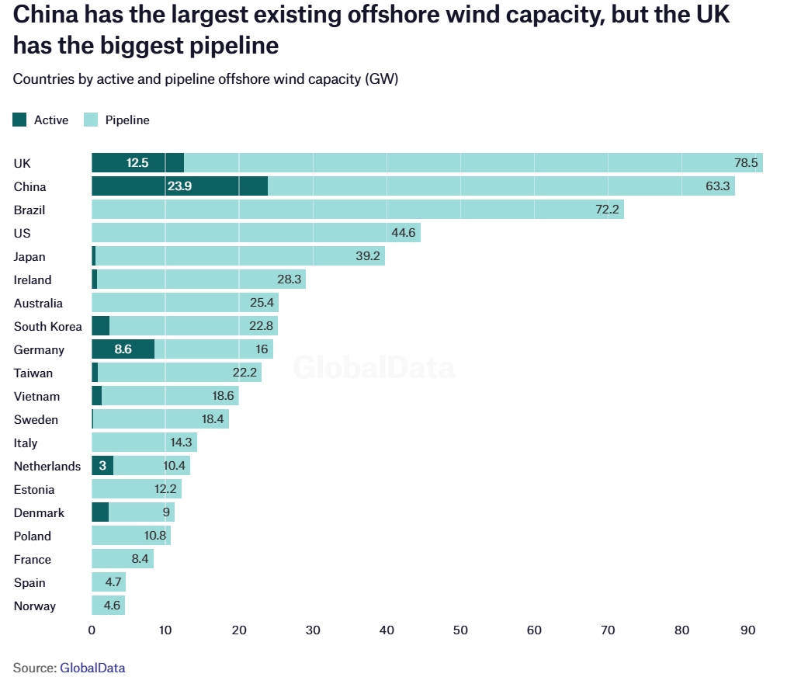
A further important area of environmental taxation is how companies can be helped to invest in green technologies. The UK has made significant changes in capital allowances allowing for major investments in areas such as offshore wind. This taxation policy has led the UK to be the biggest generator of offshore wind power, even before China, if current and plant capacity are combined (Bloomberg, 2023).
Figure 2 (Ferris, 2022)
Capital allowances for environmental investment allow companies to immediately deduct the substantial capital costs against corporation tax. This significantly helps cashflow and reduces total interest paid on loans, since they can be paid back faster (Ferris, 2022).
Consumer taxation can also be used to drive consumption behaviour in different ways, for example pollution zones (like the London ULEZ zone), a reduced rate of VAT for heat pumps, and historically, electric vehicles have had zero road tax that reduced the overall lifetime cost of owning an electric vehicle (RAC, 2024).
Through different environmental taxes there have been significant reductions in CO2 emissions. For example, in figure 3 the amount of CO2 required in the UK to generate one million pounds of GDP has dropped 60% since 1991. While much of this is assisted by technology, environmental taxation has accelerated the adoption of environmental technologies to achieve this (Office for National Statistics, 2022).

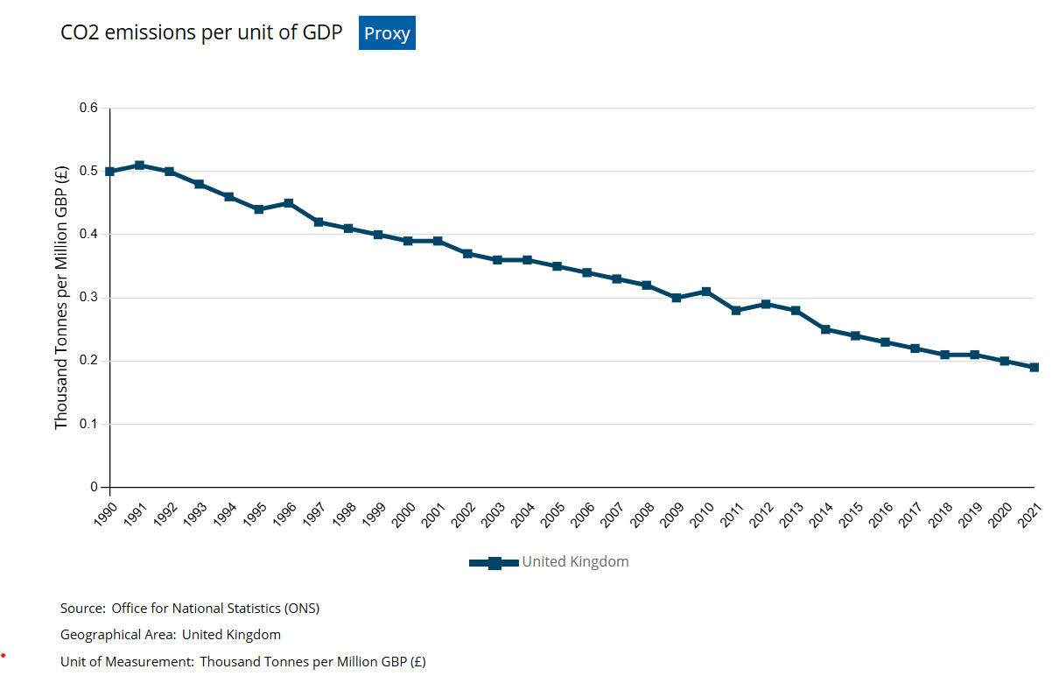
Figure 3 (Office for National Statistics, 2022)

Conclusion
In conclusion, the UK tax system, while complex, has both strengths and weaknesses. The council tax, based on outdated property values, creates discrepancies that favour those in higher-property price growth areas. The stamp duty, while preventing speculation and property bubbles, can disproportionately burden those with lower incomes and hinder housing and labour mobility.
The National Insurance Contributions (NIC) system, despite its complexity and potential for fraud, plays a crucial role in funding state pensions. However, its pay-as-you-go nature raises concerns about future pension sustainability.
The tax system for the self-employed offers lower tax than employees, encouraging entrepreneurship and job creation. For employees the PAYE income tax system, with its few tax brackets and relatively few tax exemptions, offers simplicity compared to other countries.
On the environmental front, the UK’s carbon tax and trading system, which taxes 46.7% of all carbon emissions, promotes carbon capture and is relatively effective. The country’s status as the largest provider of offshore wind power generation, incentivised by capital allowances, further underscores its commitment to environmental sustainability.
Overall, while there are areas for improvement, the UK tax system also has notable strengths, particularly in encouraging entrepreneurship and environmental sustainability.

References
Pew Research Center, 2019. In Western European Countries With Church Taxes, Support for the Tradition Remains Strong. [Online]
Available at: https://www.pewresearch.org/religion/2019/04/30/in-western-european-countries-with-church-taxes-support-for-the-tradition-remains-strong/
[Accessed 03 Junne 2024].
Antony Seely, 2023. Stamp duty land tax on residential property: government policy up to 2021. [Online]
Available at: https://commonslibrary.parliament.uk/research-briefings/sn07050/
[Accessed 30 May 2024].
Bloomberg, 2023. Orsted’s Huge UK Wind Park to Benefit From Tax Relief. [Online]
Available at: https://www.bloomberg.com/news/articles/2023-11-22/orsted-s-huge-uk-wind-park-to-benefit-from-tax-relief-measures
[Accessed 04 June 2024].
Boait, F., 2022. We face peril because the UK economy relies on house prices. Here are three ways to fix that. [Online]
Available at: https://www.theguardian.com/commentisfree/2022/oct/24/uk-economy-house-prices-wealth-financial-sector
[Accessed 30 May 2024].
Cave, R., 2023. How do we solve a problem like national insurance?. [Online]
Available at: https://www.accountingweb.co.uk/community/blogs/rebecca-cave/how-do-we-solve-a-problem-like-national-insurance
[Accessed 03 June 2024].
Crawford, A. M. a. A., 2021. Thousands recruited to front UK firms in 'tax dodge'. [Online]
Available at: https://www.bbc.co.uk/news/uk-57021128
[Accessed 03 June 2024].
Ferris, N., 2022. Weekly data: The number of countries generating offshore wind power is set to double. [Online]
Available at: https://www.energymonitor.ai/sectors/power/weekly-data-the-number-of-countries-generating-offshore-wind-power-is-set-to-double/?cf-view&cf-closed
[Accessed 04 June 2024].
Gov.UK, 2024. How domestic properties are assessed for Council Tax bands. [Online]
Available at: https://www.gov.uk/guidance/understand-how-council-tax-bands-are-assessed
[Accessed 25 May 2024].
ICAEW, 2023. Tackling non-compliance in the umbrella company market. [Online]
Available at: https://www.icaew.com/insights/tax-news/2023/aug-2023/tackling-non-compliance-in-the-umbrella-company-market
[Accessed 03 June 2024].
Kath Scanlon, C. W. a. F. B., 2021. Lessons from the stamp duty holiday, London: London School of Economics.
Northern Irish UK Government, 2024. Qualifying for basic State Pension. [Online]
Available at: https://www.nidirect.gov.uk/articles/qualifying-basic-state-pension#:~:text=To%20get%20the%20full%20basic,you%20were%20born%20before%201945
[Accessed 30 May 2024].
OECD, 2022. PH2.2 TAX RELIEF FOR HOME OWNERSHIP. [Online]
Available at: https://www.oecd.org/els/family/PH2-2-Tax-relief-for-home-ownership.pdf
[Accessed 03 June 2024].
OECD, 2022. Table I.1. Central government personal income tax rates and thresholds. [Online]
Available at: https://stats.oecd.org/index.aspx?DataSetCode=Table_I1
[Accessed 03 June 2024].
Office for National Statistics, 2022. UK environmental taxes: 2022UK environmental taxes: 2022. [Online]
Available at: https://www.ons.gov.uk/economy/environmentalaccounts/bulletins/ukenvironmentaltaxes/2022
[Accessed 05 June 2024].
Office for National Statistics, 2023. UK House Price Index: April 2023. [Online]
Available at: https://www.ons.gov.uk/economy/inflationandpriceindices/bulletins/housepriceindex/april2023
[Accessed 30 May 2024].
Price, P. P. &. B., 2024. Port Talbot: Tata Steel's blast furnaces to close with 3,000 expected job losses. [Online]
Available at: https://www.bbc.co.uk/news/uk-wales-68022901
[Accessed 30 May 2024].
RAC, 2024. Electric car road tax guide – do I need to pay?. [Online]
Available at: https://www.rac.co.uk/drive/electric-cars/running/electric-car-road-tax-guide-do-i-need-to-pay/#:~:text=From%201%20April%202025%2C%20drivers%20of%20electric%20vehicles%20will%20need,Excise%20Duty%20(VED).%E2%80%9D
[Accessed 05 June 2024].
Rosado, H. R. a. P., 2022. Which countries have put a price on carbon?. [Online]
Available at: https://ourworldindata.org/carbon-pricing
[Accessed 05 June 2024].
South Pole, 2024. Carbon Credits Explained. [Online]
Available at: https://www.southpole.com/sustainability-solutions/carbon-credits-frequently-asked-questions
[Accessed 05 June 2024].
The Institute for Fiscal Studies, 2024. National Insurance contributions explained. [Online]
Available at: https://ifs.org.uk/taxlab/taxlab-taxes-explained/national-insurance-contributions-explained
[Accessed 05 June 2024].
The Resolution Foundation , 2023. Britain needs better taxes, rather than just higher ones, to boost fairness and economic growth. [Online]
Available at: https://www.resolutionfoundation.org/press-releases/britain-needs-better-taxes-rather-than-just-higher-ones-to-boost-fairness-and-economic-growth/
[Accessed 30 May 2024].
UK Government, 2024. Income Tax rates and Personal Allowances. [Online]
Available at: https://www.gov.uk/income-tax-rates
[Accessed 03 June 2024].
UK Government, 2024. National Insurance rates and categories. [Online]
Available at: https://www.gov.uk/national-insurance-rates-letters/category-letters
[Accessed 03 June 2024].

