

Changemakers: Building your Personal Brand for Sustainable Employment
BMHP5015_BIRM

Student Name: Gabriela Dinu
Student Number: 2329564
Lecturer Name: Tsiwani Khumalo
Table of Contents
Task 1 - Personal Brand 1
Task 2 - Network Map and Rationale 2
Task 3 - Blog 3
Task 4 - NHS Equality, Diversity, and Inclusion Quiz 4
Task 5 - A letter to Yourself 6
Task 6 - Gantt Chart 7
Task 7 - Making Changes: Report 8
Task 8 - Self-Reflection 9
Reference 11

Task 1 - Personal Brand
My personal brand, Good Samaritan, reflects my professional identity, values and commitment within the health and social care sector. It is grounded in compassion, dignity, and social responsibility, with a clear focus on supporting homeless individuals by providing cooked food and access to essential hygiene facilities, such as toilets and showers. Personal branding is particularly important in health and social care, as it enables individuals to communicate their values, employability, and ethical approach to practice to employers, partners, and service users (Jackson, 2016).
The Good Samaritan brand is rooted in the belief that access to basic human needs is fundamental to health, wellbeing, and social inclusion. Homelessness is strongly associated with poor physical health, mental distress, and barriers to accessing healthcare and employment (Public Health England, 2018). By addressing food insecurity and poor hygiene, Good Samaritan responds to immediate needs while also promoting dignity, self-worth, and social participation. These values align closely with person-centred care principles and the core values of health and social care practice, including respect, equality, and inclusion (NHS England, 2023).
At present, my personal brand is characterised by empathy, reliability, and an initiative-taking approach to tackling social exclusion. However, to strengthen my employability and professional credibility, further development is required. This includes building leadership skills, gaining experience in safeguarding vulnerable adults and improving partnership working with statutory and voluntary organisations. Through reflective practice and continuous professional development, Good Samaritan will continue to evolve as a personal brand that demonstrates both compassion and professional competence within community-based health and social care.

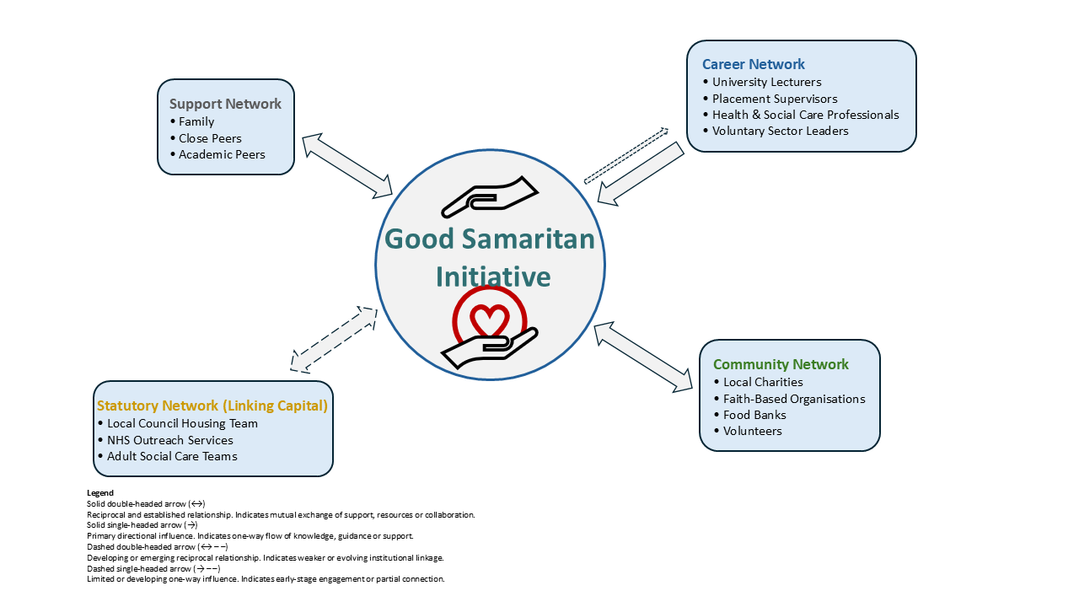
Task 2 - Network Map and Rationale

Figure 1. Network Map Supporting the Good Samaritan Personal Brand.
The network supporting my personal brand, Good Samaritan, can be described as a mixed network comprising career, support, social and community connections. Each element plays a distinct role in enabling the initiative's development and sustainability while also supporting my employability in health and social care.
Career-related connections include lecturers, placement supervisors and professionals working in health, social care, and voluntary sector organisations. These individuals provide guidance, professional insight, and knowledge of sector expectations, helping me to understand pathways into community-based roles and develop relevant employability skills. Such connections support professional learning and career progression.
Support networks consist of family members and close peers who offer emotional encouragement, reassurance, and practical help. These relationships are essential for maintaining resilience and wellbeing, particularly when engaging with complex and emotionally demanding issues such as homelessness. Strong support networks are recognised as protective factors against stress and burnout within caring roles (Skills for Care, 2016).
Community and social networks are central to the Good Samaritan initiative and include local charities, faith-based organisations, food banks, and volunteers. These connections enable collaboration, shared resources, and increased reach within the local community. Granovetter’s (1973) theory of the strength of weak ties highlights the value of such broader connections in accessing new opportunities and information beyond close personal networks.
However, a limitation within my current network is a lack of linking social capital, particularly relationships with statutory services such as local councils, housing teams, and NHS outreach services. Strengthening these links through networking events, partnership meetings and initiative-taking engagement would improve service coordination, enhance sustainability, and further support my long-term employability in health and social care.
This network map illustrates the interaction between bonding, bridging, and linking social capital, demonstrating how professional, community and support networks contribute to employability and initiative sustainability.

Task 3 - Blog
Homelessness and Dignity: Why Access to Food and Hygiene Matters
Homelessness continues to be a significant challenge within the UK, with serious implications for health, wellbeing, and social inclusion. Individuals experiencing homelessness often lack reliable access to nutritious food and basic hygiene facilities such as toilets and showers. These are fundamental human needs, yet their absence can severely impact both physical and mental health.
Access to cooked food is vital for maintaining physical health. Food insecurity is associated with weakened immune systems, increased vulnerability to illness and higher rates of hospital admission (Public Health England, 2018). For individuals who are homeless or in insecure accommodation, poor nutrition can worsen existing health conditions and reduce the ability to recover from illness. Providing regular, cooked meals helps to stabilise health and offers a sense of routine and care.
Equally important is access to hygiene facilities. The inability to shower or use clean toilets increases the risk of infections, skin conditions, and the spread of communicable diseases. Beyond physical health, lack of hygiene has profound psychological and social consequences. Individuals may experience shame, stigma, and social exclusion, which can damage self-esteem and discourage engagement with healthcare, employment, and housing services (Shelter, 2023).
Initiatives such as Good Samaritan aim to address these issues by offering both cooked food and access to toilets and showers in a safe, supportive environment. By meeting immediate needs, such services help to restore dignity and build trust. This can function as a gateway to wider support, encouraging individuals to engage with health services, social care, and community organisations.
Addressing homelessness requires more than temporary solutions. Community-based initiatives that prioritise dignity, compassion and inclusion play a crucial role in supporting recovery and long-term wellbeing. Ensuring access to food and hygiene is not only a matter of health but a fundamental step towards social justice and equality.
Target audience: Members of the public and community volunteers.

Task 4 - NHS Equality, Diversity, and Inclusion Quiz
1. The primary goal of the NHS Equality, Diversity and Inclusion (EDI) Improvement Plan is to create a fair, inclusive, and compassionate working environment in which all staff feel valued, respected, and able to contribute effectively. By promoting inclusion, the NHS aims to improve staff wellbeing, retention and the quality of care delivered to patients and service users (NHS England, 2023).
2. The NHS seeks to address the gender pay gap through transparent pay reporting, equitable recruitment and promotion practices, and targeted leadership development opportunities for women and underrepresented groups, aiming to remove structural barriers and ensure equal access to progression (Government Equalities Office, 2022).
3. Intersectionality refers to the way in which different aspects of identity, such as gender, ethnicity, disability and socioeconomic background, interact to shape individuals’ experiences of inequality and discrimination (Crenshaw, 1989).
4. Creating psychologically safe work environments is essential because it allows staff to raise concerns, report discrimination, and contribute ideas without fear of blame or retaliation, thereby supporting learning cultures, staff engagement, and patient safety (Edmondson, 1999).
5. The NHS EDI Improvement Plan also aims to improve the experience of internationally recruited staff through enhanced induction processes, pastoral support, and fair opportunities for career development (NHS England, 2023). Leadership plays a crucial role in advancing.
6. Leadership is responsible for embedding equality, diversity, and inclusion within organisational culture, modelling inclusive behaviours, and ensuring accountability for progress across teams. Effective leadership promotes fairness in decision-making and supports the implementation of EDI strategies within NHS organisations (West et al., 2015).
7. One key approach is improving career progression opportunities for underrepresented groups by addressing barriers in recruitment, promotion, and leadership development, particularly for staff from ethnic minority backgrounds (NHS England, 2023).
8. Collecting and analysing workforce data on protected characteristics allows organisations to identify patterns of inequality and monitor progress in addressing disparities in recruitment, pay, and career progression (NHS England, 2023).
9. Flexible working supports employees with caring responsibilities, disabilities, or health needs, enabling them to maintain employment and progress in their careers while improving work–life balance and workforce retention (CIPD, 2022).
10. The NHS promotes a zero-tolerance approach to bullying and harassment by strengthening reporting systems, supporting staff who raise concerns, and ensuring organisations take prompt and appropriate action (NHS England, 2023).

Task 5 - A letter to Yourself
18 February 2026
Younger Me
50 Crescent Road
TF14NJ
Newport, UK
Dear younger me,
There was a time when everything felt overwhelming and uncertain. Balancing responsibilities, expectations, and emotional pressure often left you feeling exhausted and doubting your abilities. During that period, you did not yet understand how emotional intelligence and resilience could support your wellbeing or help you manage challenges more effectively, particularly in demanding environments.
Learning about emotional intelligence has shown me how important it is to recognise, understand and regulate emotions rather than ignoring or suppressing them. If you had been able to identify stress earlier and respond with self-awareness and self-compassion, many situations would have felt more manageable. Emotional regulation supports clearer decision-making, healthier relationships and reduces the risk of burnout, which is especially important within health and social care roles that involve emotional labour (Goleman, 1995).
Resilience is not about avoiding difficulty, but about adapting to adversity and learning from challenging experiences. Developing resilience through reflection, problem-solving and strong support networks would have strengthened your confidence and persistence during difficult periods. It would also have helped you view setbacks as opportunities for growth rather than personal failure. Seeking support should never be viewed as a weakness, but as an essential part of maintaining wellbeing and personal development (Herrman et al., 2011).
These lessons are particularly relevant for a future career in health and social care, where professionals regularly encounter distress, uncertainty, and pressure. Developing emotional intelligence and resilience earlier would have supported both your mental health and professional confidence. Carry these lessons forward, as they will guide you in supporting others with compassion while also protecting your own wellbeing.
With love,
The Older Me

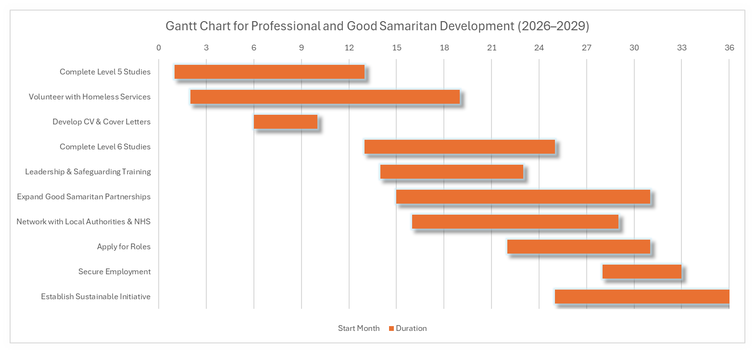
Task 6 - Gantt Chart

Figure 1. Gantt chart illustrating the phased progression of academic development, professional experience, and initiative sustainability over three years.
The Gantt chart provides a structured plan for developing the Good Samaritan initiative alongside achieving my future employment goals within health and social care. It outlines short, medium, and long-term activities, demonstrating effective planning, prioritisation, and time management.
Short-term goals focus on building a strong foundation. These include completing Level 5 academic studies, volunteering with homelessness and community support services, and developing a professional CV and tailored cover letters. These activities support the development of essential knowledge, practical experience, and employability skills relevant to community-based health and social care roles.
Medium-term goals centre on progression and consolidation. These include completing Level 6 studies, expanding the Good Samaritan initiative through partnerships with voluntary organisations, and developing leadership skills through increased responsibility in community settings. During this stage, activities such as attending training workshops, networking with local authorities, and engaging with multidisciplinary professionals may overlap with academic commitments. This overlap highlights the need for effective time management and realistic goal setting.
Long-term goals involve securing employment within community health or social care services and establishing Good Samaritan as a sustainable initiative that continues to support homeless individuals. Clear dependencies within the Gantt chart ensure that academic progression supports professional development and service growth. Regular review points allow progress to be monitored and plans adjusted where necessary.
Overall, the Gantt chart demonstrates planning, organisation, and self-management. These transferable skills are highly valued by employers and are essential for sustainable employment and long-term career development within the health and social care sector.

Task 7 - Making Changes: Report
This report proposes a partnership between a care home and the Good Samaritan initiative to improve support for homeless individuals after discharge. Using Lewin’s Change Model, it outlines how the change could be implemented and embedded into discharge planning to enhance continuity of care and improve health outcomes (Lewin, 1951).
As a care home manager, I would aim to introduce a formal partnership with the Good Samaritan initiative to improve support for homeless individuals following discharge from care services. Individuals who are homeless often experience poor health outcomes after being discharged due to a lack of access to basic needs such as food, hygiene facilities, and community support. This gap can increase the risk of readmission, deterioration in health and social exclusion.
Lewin’s Change Model provides a useful framework for planning and implementing this change. The first stage, unfreezing, would involve recognising the need for change by reviewing discharge outcomes and raising staff awareness of the challenges faced by homeless individuals. Staff engagement sessions and discussions of relevant evidence would help build readiness for change (Lewin, 1951).
The change stage would involve establishing clear referral pathways between the care home and Good Samaritan. This would ensure that individuals are provided with immediate access to cooked food and hygiene facilities upon discharge. Training sessions would be introduced to ensure staff understand the referral process and the benefits of partnership working. Collaboration with voluntary organisations would also support continuity of care beyond the care home setting.
The final stage, refreezing, would embed the partnership into standard discharge planning procedures. Policies and documentation would be updated, and regular reviews would be conducted to monitor effectiveness. Key skills required to support this change include leadership, communication, emotional intelligence, and collaborative working. Potential barriers include limited resources and staff resistance, which could be addressed through phased implementation and ongoing staff support.
Overall, this change would promote dignity, continuity of care and improved outcomes for homeless individuals, while strengthening links between health and social care services and the voluntary sector.

Task 8 - Self-Reflection
Using Gibbs’ Reflective Cycle, this reflection considers my learning and development throughout the module in relation to my personal brand, Good Samaritan. The process of developing this initiative was both motivating and challenging, particularly as it required me to reflect critically on my values, employability skills and professional identity within health and social care (Gibbs, 1988).
Initially, I felt motivated by the opportunity to design a personal brand that aligned closely with my values of compassion and social justice. However, I also felt uncertain about my leadership ability and the sustainability of Good Samaritan. These feelings highlighted a lack of confidence in areas such as networking, partnership working and long-term planning (West et al., 2017).
Evaluating this experience allowed me to identify key strengths, including empathy, commitment, and ethical awareness. At the same time, I recognised areas for improvement, particularly in professional communication and engagement with statutory services. Analysing my learning showed that the module content on personal branding, networking, and change management helped improve my self-awareness and understanding of how personal values can be translated into employability skills. I developed a clearer sense of how my personal brand could support sustainable employment within community-based health and social care (CIPD, 2023).
In conclusion, earlier engagement with professional networks and structured planning would have strengthened my confidence and development sooner. Moving forward, I plan to continue developing leadership skills, reflective practice and partnership working through volunteering, training, and professional networking. This learning will inform my future practice by supporting ethical, compassionate, and sustainable approaches to working with vulnerable populations (Bulman and Schutz, 2023). Overall, the module has strengthened my professional identity and reinforced my commitment to delivering dignity-focused support within health and social care.

Reference
Bulman, C., and Schutz, S. (2023) Reflective practice in nursing. 7th edn. Oxford: Wiley Blackwell.
CIPD (2022) Inclusion and diversity in the workplace. London: Chartered Institute of Personnel and Development.
CIPD (2023) Developing your professional brand. London: Chartered Institute of Personnel and Development.
Crenshaw, K. (1989) ‘Demarginalizing the intersection of race and sex’, University of Chicago Legal Forum, 1989(1), pp. 139–167.
Department of Health and Social Care (2018) Rough sleeping strategy. London: DHSC. Available at: Rough Sleeping Strategy August 2018 (Accessed: 13 February 2026).
Edmondson, A. (1999) ‘Psychological safety and learning behaviour in work teams’, Administrative Science Quarterly, 44(2), pp. 350–383.
Gibbs, G. (1988) Learning by doing: A guide to teaching and learning methods. Oxford: Oxford Polytechnic.
Goleman, D. (1995) Emotional intelligence: Why it can matter more than IQ. London: Bloomsbury.
Government Equalities Office (2022) Gender pay gap reporting: guidance for employers. London: GOV.UK.
Granovetter, M.S. (1973) ‘The strength of weak ties’, American Journal of Sociology, 78(6), pp. 1360–1380.
Herrman, H., Stewart, D.E., Diaz-Granados, N., Berger, E.L., Jackson, B., and Yuen, T. (2011) ‘What is resilience?’, Canadian Journal of Psychiatry, 56(5), pp. 258–265.
Jackson, D. (2016) ‘Re-conceptualising graduate employability: The importance of pre-professional identity’, Higher Education Research & Development, 35(5), pp. 925–939.
Lewin, K. (1951) Field theory in social science. New York: Harper & Row.
NHS England (2023) Equality, diversity, and inclusion improvement plan. Available at: https://www.england.nhs.uk (Accessed: 12 February 2026).
NHS England (2023) Equality, Diversity, and Inclusion Improvement Plan. London: NHS England.
Public Health England (2018) Health matters: Rough sleeping. London: PHE.
Shelter (2023) Health and homelessness. Available at: https://www.shelter.org.uk (Accessed: 17 February 2026).
Skills for Care (2016) Building resilience in the adult social care workforce. Leeds: Skills for Care.
West, M., Eckert, R., Collins, B. and Chowla, R. (2017) Caring to change: How compassionate leadership can stimulate innovation in health care. London: The King’s Fund.
West, M., Eckert, R., Steward, K., and Pasmore, B. (2015) Developing collective leadership for healthcare. London: The King’s Fund.

