University of Wales Trinity Saint David Birmingham
BA Business Management
LCBB5000 Data Handling and Business Intelligence

Coursework (Written Report)
Part 1
GreenMed dataset analysis

Author: Vasile Turcanu, Student nr 2127548
Lecturer: Zahra Mohammadnazari

Introduction:
As an intern at GreenMed Innovations, I've been tasked with analyzing the "GreenMed_Healthcare_2023" dataset, focusing on processing times of major data analytics tools—Hadoop, Spark, R, Python, and Tableau. Our goal is to derive insights that could potentially reshape GreenMed's data processing strategies and improve patient care.
This analysis involves utilizing both Microsoft Excel and SPSS. In the Excel segment, we'll address key questions and showcase data presentation using functions like IF, Pivot Tables, and Charts. In the SPSS segment, we'll explore the correlation between Hadoop and Tableau processing times, followed by the creation and analysis of a scatterplot.
This coursework represents a pivotal exploration into healthcare analytics, aiming to empower GreenMed with actionable insights for more informed decision-making and optimized patient outcomes.

- Descriptive analysis

- Using Microsoft excel, I have found what is the MEAN of Hadoop_Processing_Time
- Open the "GreenMed_Healthcare_2023" dataset in Excel.
- Identify the column that contains the processing times for Hadoop. Let's assume the column name is "Hadoop_Processing_Time."
- To calculate the mean processing time for Hadoop, use the AVERAGE function in Excel. Here's the formula: AVERAGE (Hadoop_Processing_Time)
- After entering the formula in a cell, press Enter. Excel will calculate the mean processing time for Hadoop.

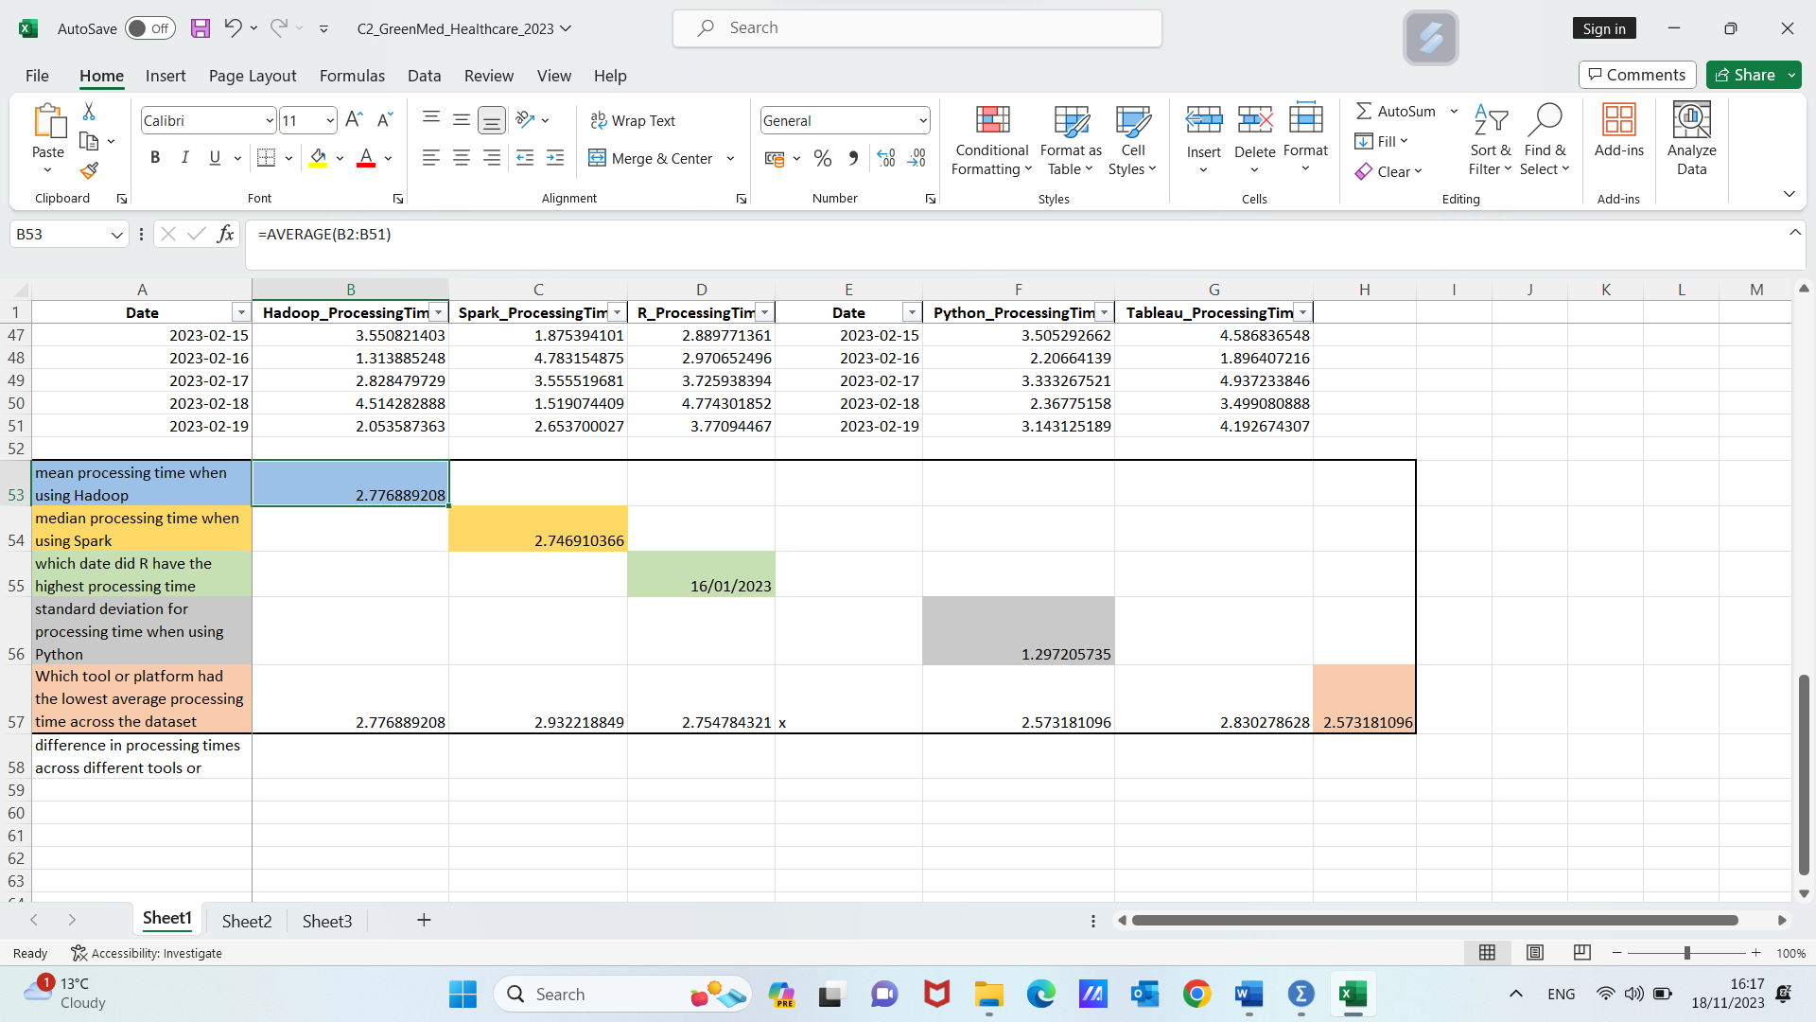

After performing these steps, you will have the mean processing time when using Hadoop. This value (2.7768) represents the average processing time of Hadoop across the dataset and provides an important metric for assessing the performance of Hadoop in your analysis.
2) Also, using Microsoft Excel and right formulas we can find Median for Spark_Processing_Time
- Open the "GreenMed_Healthcare_2023" dataset in Excel.
- Identify the column that contains the processing times for Spark. Let's assume the column name is "Spark_Processing_Time."
- To calculate the median processing time for Spark, use the MEDIAN function in Excel. Here's the formula: =MEDIAN(spark_Processing_Time)
- After entering the formula in a cell, press Enter. Excel will calculate the median processing time for Spark.
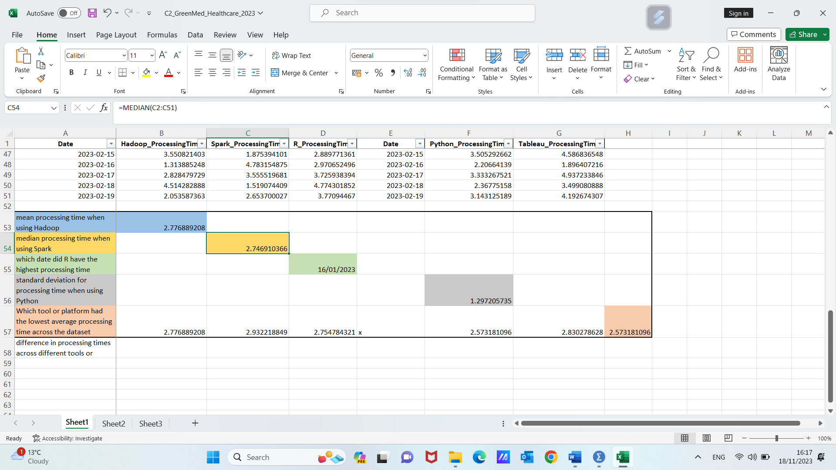
After performing steps, you will have the median processing time 2.7469 when using Spark. This value represents the middle value in the dataset, which is a robust measure of central tendency and provides insights into the typical processing time when using Spark.
3) Using Microsoft Excel, I will determine date when “R” has the highest processing time:
- Open the "GreenMed_Healthcare_2023" dataset in Excel.
- Identify the columns that contain the date and the processing times for "R." Let's assume the date column is "Date" and the processing time column for "R" is "R_Processing_Time."
- In a new column, use the MAX function to find the maximum processing time for "R." Here's the formula:=MAX(R_Processing_Time,R_Processing_Time)
- This formula will return the maximum processing time for "R."
- Now, you need to find the date corresponding to this maximum processing time. You can use the VLOOKUP function. Here's the formula to find the date:=VLOOKUP(MAX(R_Processing_Time,R_Processing_Time))
- After entering the formula in a cell, press Enter. Excel will calculate the date on which "R" had the highest processing time.
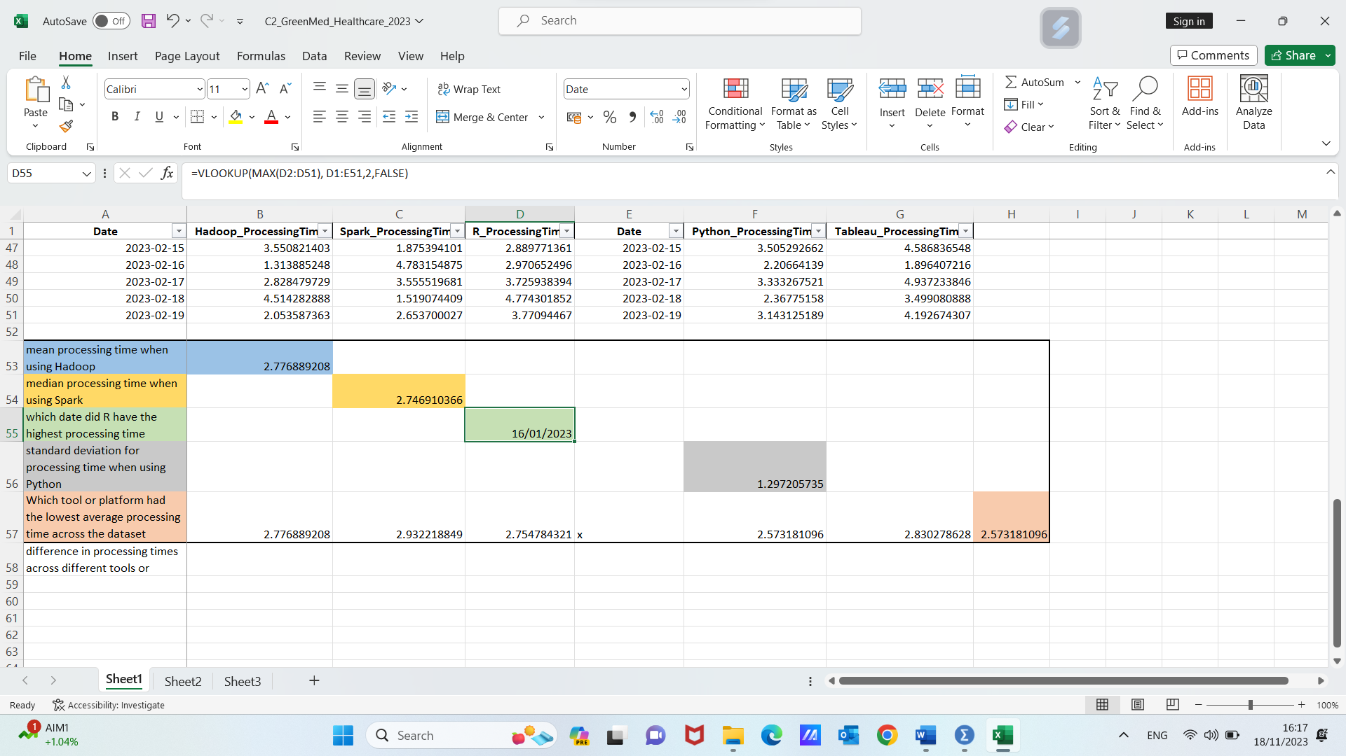
After performing these steps, you will have the date 16/01/2023 on which "R" had the highest processing time, helping you identify when the processing time for "R" peaked in the dataset.
4) Using Microsoft Excel, I will determine what is the standard deviation for Python processing time:
- Open the "GreenMed_Healthcare_2023" dataset in Excel.
- Identify the column that contains the processing times for Python. Let's assume the column name is "Python_Processing_Time."
- To calculate the standard deviation for Python processing times, use the STDEV.P function in Excel. Here's the formula: =STDEV.P(Python_Processing_Time)
- After entering the formula in a cell, press Enter. Excel will calculate the standard deviation for Python processing times.
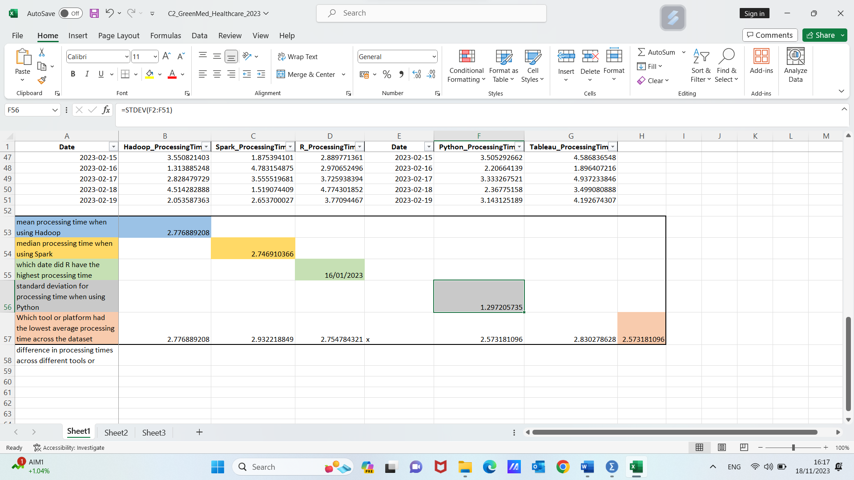
After these steps, you will have the standard deviation for processing time when using Python. This value measures the spread or variability in the processing times, providing insights into the consistency or variability of Python's performance in the dataset.
5) Using Microsoft Excel, I will determine the lowest processing time from the average of all software’s:
- Open the "GreenMed_Healthcare_2023" dataset in Excel.
- Identify the columns that contain the processing times for each tool or platform, such as "Hadoop_Processing_Time," "Spark_Processing_Time," "R_Processing_Time," "Python_Processing_Time," and "Tableau_Processing_Time."
- Calculate the average processing time for each tool using the AVERAGE function in Excel. For instance, for Hadoop:
- =AVERAGE(Hadoop_Processing_Time)
- Repeat this for all the tools.
- Compare the average processing times for each tool and identify the tool with the lowest average processing time using formula =min(average_of_everyone)
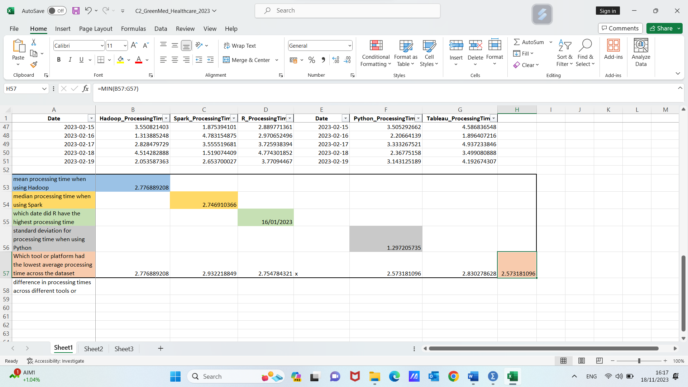
After performing these steps, we will be able to determine which tool or platform had the lowest average processing time across the dataset, which is Phyton with 2.5731 average time of processing. This information can help in assessing the efficiency and performance of the different tools or platforms used in the healthcare organization.
6) Based on the above analysis, we can interpret difference in processing times across different tools or platforms as follows:
- Hadoop_ProcessingTime (2.776): Hadoop seems to have a relatively efficient processing time, indicating its capability to handle and process data effectively.
- Spark_ProcessingTime (2.932): Spark shows a slightly higher average processing time compared to Hadoop. This might suggest that Spark could be processing more complex tasks or larger volumes of data.
- Python_ProcessingTime (2.573): Python demonstrates a lower average processing time, which could imply its efficiency as a programming language for data processing tasks.
- Tableau_ProcessingTime (2.830): Tableau's processing time falls within a moderate range, indicating its capability to handle data visualization tasks reasonably well.
- R_ProcessingTime (2.755): R also shows a relatively efficient processing time, suggesting its effectiveness for statistical computing and data analysis.
In summary, these results provide insights into the performance of each technology in terms of processing time. The choice of the appropriate tool may depend on specific use cases and requirements, such as the scale of data, complexity of tasks, and ease of integration with other systems.
Overall, the choice of tools and platforms should be guided by the specific needs and objectives of GreenMed Innovations. This interpretation can help GreenMed make informed decisions to optimize patient care and healthcare operations based on processing times and tool capabilities.

b. Microsoft Excel offers a powerful set of tools and functions for data analysis and visualization, making it an indispensable tool for professionals seeking to gain insights from their datasets.
Given our dataset with columns "Date," "Hadoop_ProcessingTime," "Spark_ProcessingTime," "R_ProcessingTime," "Python_ProcessingTime," and "Tableau_ProcessingTime," here's how we can create a Pivot Table to present the average processing times for each software in each month:
- Prepare Our Data: Ensure our dataset is well-organized, with columns for "Date," "Hadoop_ProcessingTime," "Spark_ProcessingTime," "R_ProcessingTime," "Python_ProcessingTime," and "Tableau_ProcessingTime."
- Select Our Data: Click on any cell within our dataset.
- Insert Pivot Table: Navigate to the "Insert" tab in the Excel ribbon. Click on "PivotTable."
- Choose Our Data Range: Confirm that Excel has detected the correct range for our data. Select whether we want the Pivot Table to be placed in a new worksheet or an existing worksheet. Click "OK."
- Pivot Table Fields: In the PivotTable Fields pane, drag the "Date" field to the "Columns" area. Drag the software-specific processing time fields ("Hadoop_ProcessingTime," "Spark_ProcessingTime," etc.) to the "Values" area.
- Average Processing Time: For each processing time field in the "Values" area, click on the drop-down arrow, select "Value Field Settings," and choose "Average."
- Format the Pivot Table: We can format the Pivot Table by right-clicking on the cells and selecting format options. Optionally, we can add filters for specific software or date ranges to focus on specific aspects.
- Update the Pivot Table: If our source data changes, right-click on the Pivot Table and select "Refresh" to update the table with the latest data.
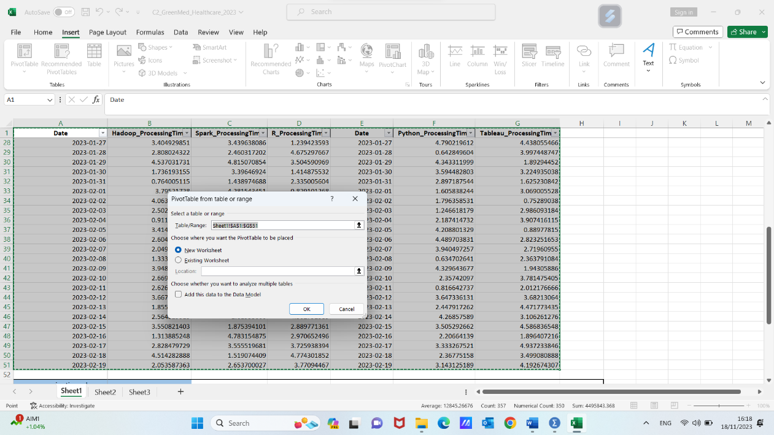

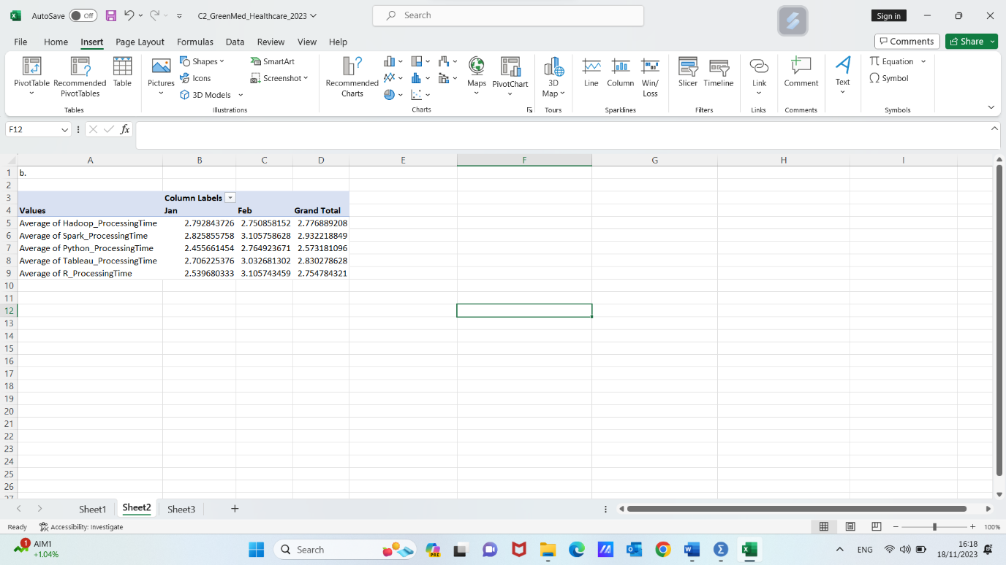
By following these steps, we've created a Pivot Table that presents the average processing times for each software for each month. This dynamic table allows us to quickly analyze trends and variations in processing times across different software tools.

- Using SPSS, we will analyze corelation between Hadoop's processing time and Tableau's processing time.
- In the realm of data processing and analytics, understanding the relationship between different technologies is crucial for optimizing workflows and enhancing overall efficiency. One important aspect of this understanding is the correlation between processing times of different tools. In this analysis, we delve into the correlation between the processing times of two prominent technologies: Hadoop and Tableau.
Processing time is a key metric that reflects the efficiency of data processing tasks. The correlation between Hadoop's processing time and Tableau's processing time provides valuable insights into how these technologies may interact and influence each other in a given analytical context. A positive correlation would suggest that as the processing time of one technology increases, the processing time of the other also tends to increase, while a negative correlation would imply an inverse relationship.
By quantifying the correlation, we gain a numerical measure of the degree to which these processing times are associated. This information is pivotal for organizations and data professionals seeking to optimize their data processing pipelines, ensuring seamless integration and improved performance. Let's proceed with calculating and interpreting the correlation between Hadoop and Tableau processing times.

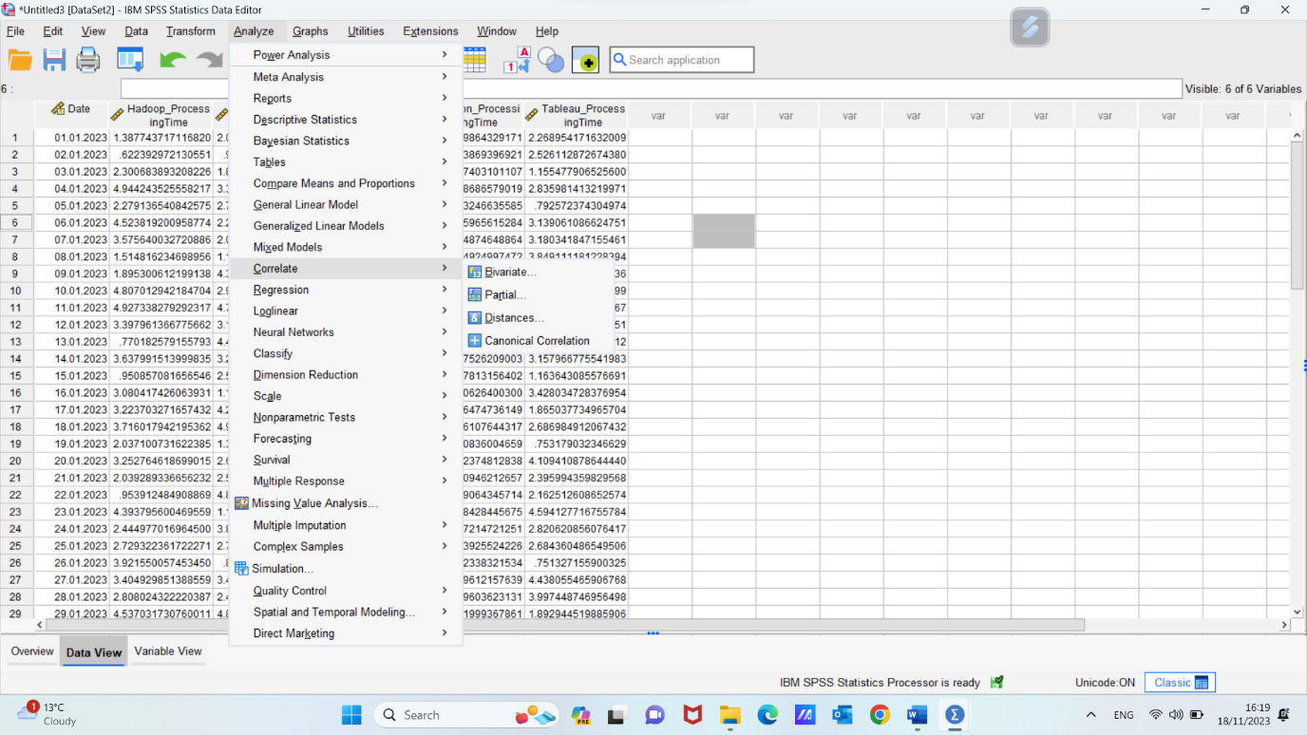

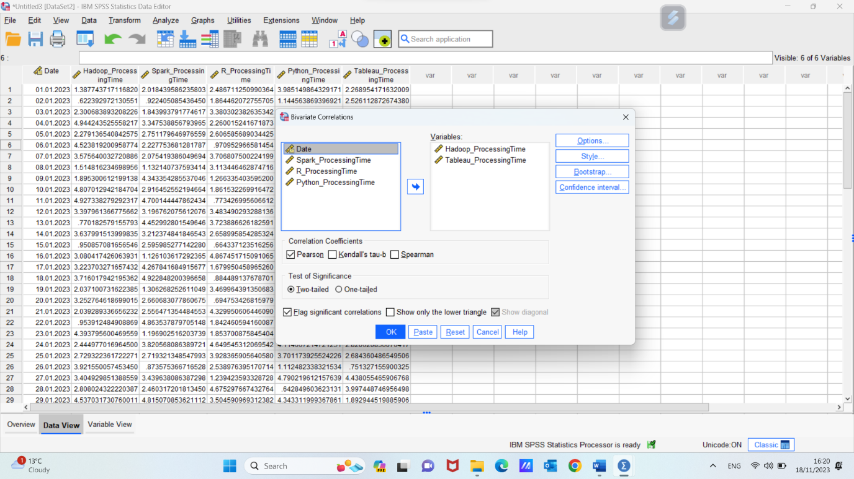
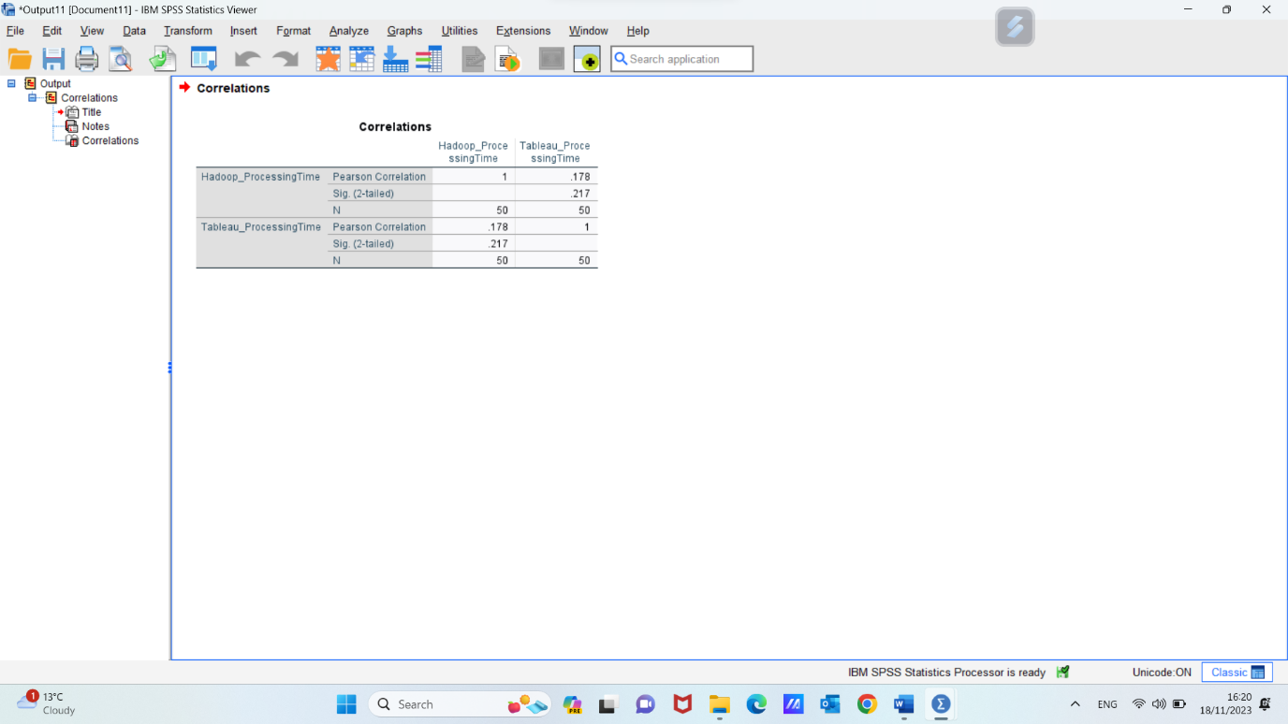

2. In this analysis, we aim to explore the relationship between Hadoop's processing time and Tableau's processing time. The processing time of these two technologies is crucial for understanding the efficiency and performance of data processing workflows. To visually represent this relationship, we will create a scatterplot with Hadoop's processing time on the horizontal axis and Tableau's processing time on the vertical axis.

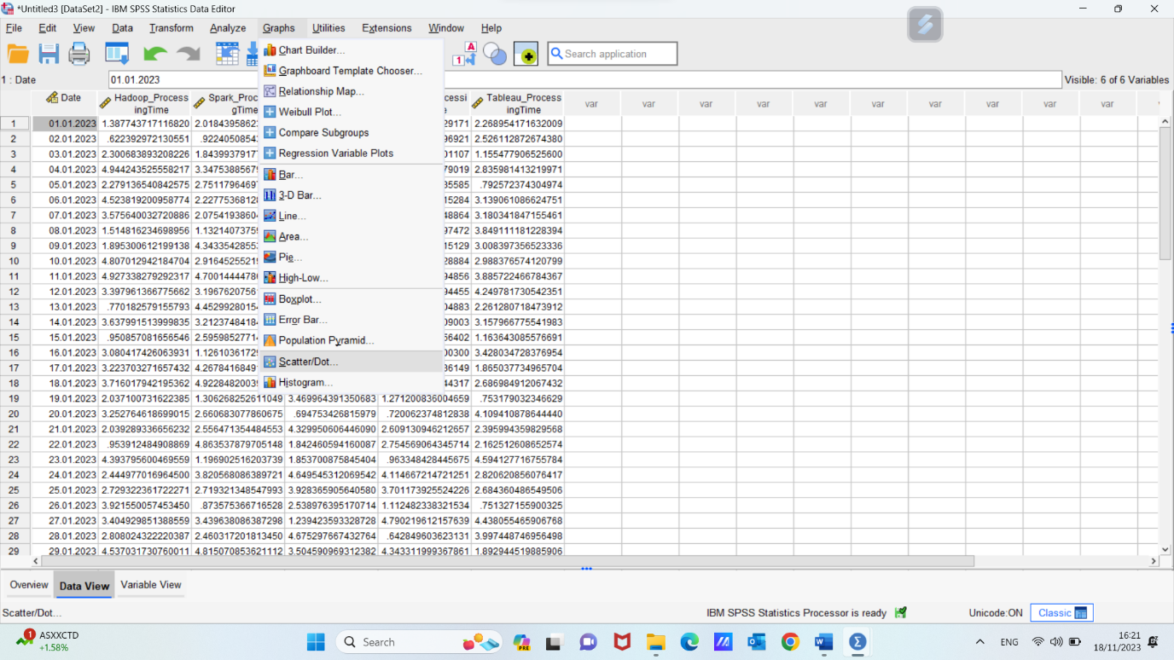

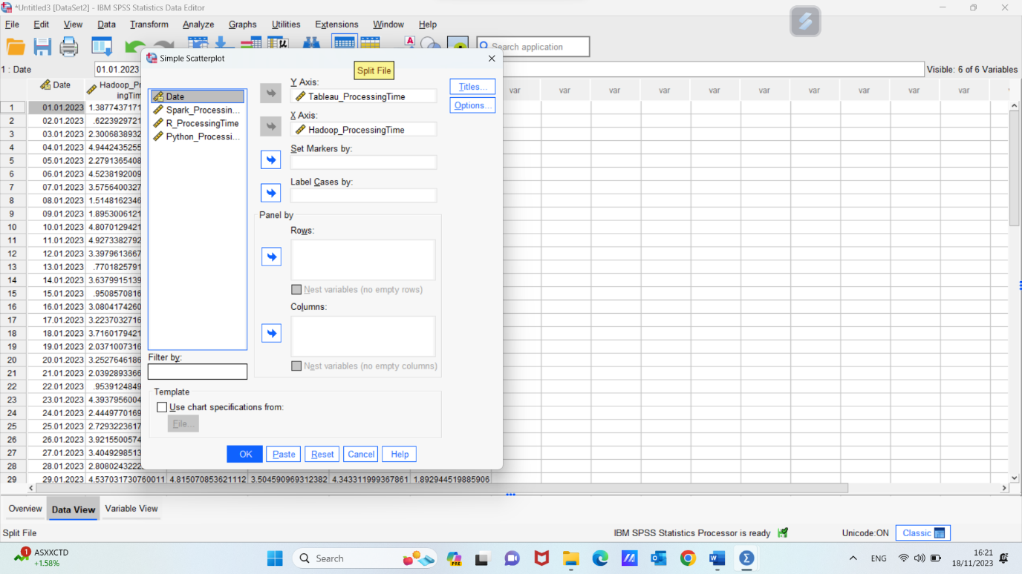

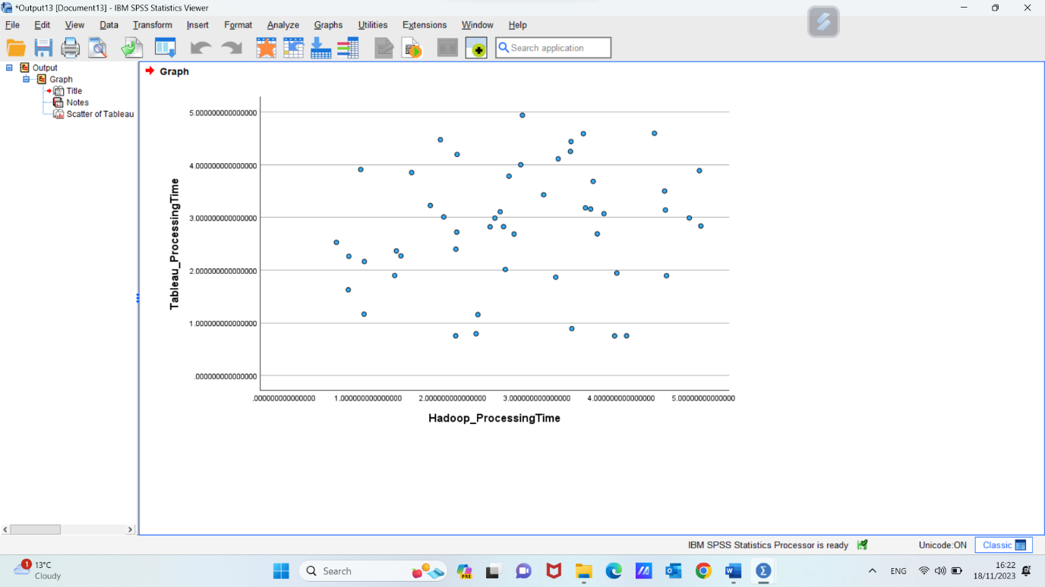

A correlation coefficient of 0.178 between Hadoop's processing time and Tableau's processing time indicates a positive but relatively weak correlation between the two variables. Here's how you can interpret this correlation:
Positive Correlation: The positive sign indicates that as the processing time of Hadoop increases, the processing time of Tableau also tends to increase. In other words, there is a tendency for both processing times to move in the same direction.
Weak Correlation (0.178): The correlation coefficient is relatively low, suggesting that the relationship between Hadoop's processing time and Tableau's processing time is not very strong. Changes in one variable are not strongly predictive of changes in the other variable.
Possible Implications: While there is a positive correlation, it's important to note that correlation does not imply causation. The weak correlation suggests that the processing times of Hadoop and Tableau may not be strongly influenced by each other. Other factors or variables not considered in this analysis could be contributing to their respective processing times.
Consider Additional Factors: To gain a more comprehensive understanding of the relationship, it would be beneficial to consider other factors that may influence processing times in Hadoop and Tableau. Additionally, the nature of the tasks performed by each tool and their specific use cases may contribute to the observed correlation.
In summary, a correlation of 0.178 suggests a positive but weak relationship between Hadoop's processing time and Tableau's processing time. Further investigation into the specific factors influencing processing times in both technologies would provide a more nuanced understanding of their interplay.

Conclusion:
In summary, this coursework delved into the "GreenMed_Healthcare_2023" dataset, exploring processing times of key data analytics tools using Microsoft Excel and SPSS. Our findings, encompassing mean processing times, medians, standard deviations, and correlations, offer valuable insights for optimizing data processing strategies at GreenMed Innovations.
The visual representations provided by scatterplots and charts enhance the communicative impact of our analysis.
This coursework highlights the importance of combining practical tools like Excel with advanced statistical methodologies, providing a comprehensive approach to data analysis. The results underscore the potential for continued innovation and enhancement of healthcare services at GreenMed Innovations through informed data strategies.

References:
- Behl, Sakshi. Top 10 Data Analytics Tools .Tools Used For DataAnalysis. Digital Vidya. N.p., 2018. Web. 28 March 2018.
- R: The R Project For Statistical Computing. http://R-project.org. N.p., 2018. Web. 28 March 2018.
- Anderson, D.R. (2009). Essentials of modern business statistics (4th ed.). Eagan, MN: Cengage South-Western.
- Levesque, R. SPSS Programming and Data Management: A Guide for SPSS and SAS Users, Fourth Edition (2007), SPSS Inc.
- UKEssays. (November 2018). Information on Using SPSS. Retrieved from https://www.ukessays.com/essays/business/information-using-spss-8823.php?vref=1
- Kalwar, M. A., Shahzad, M. F., Wadho, M. H., Khan, M. A., & Shaikh, S. A. (2022). Automation of order costing analysis using Visual Basic for applications in Microsoft Excel. Journal of Applied Research in Technology & Engineering, 3(1), 29-59.
- Mayes, T. R. (2020). Financial analysis with Microsoft Excel. Cengage Learning.

