Fieldwork Journal
Llanllyr, Talsarn

Caitlynn Cendrowski
The University of Wales at Trinity St David
HPAR50004 and Excavation & Fieldwork
Ros Cord & Quentin Drew

Abstract
In this report, we will talk about the rigorous work, plus also the artifacts that were able to be found for the site at Llanllyr. We first will start with the introduction about the site information and what that told us before going to the site, such as predictions I was expecting overall. Then wanting to get into the overall work on the land, plotting on our trench and what work does that take. Then get into the middle of the week and how we obtain all our findings and can have a trench with a lot of findings and how that affects work overall, how does this affect us with the amount of time we are given to get the work done? Then for the last appreciation of the trench and the process of closing a trench on the field. Lastly talk about the ending information on the site and how the predictions came into order, how or what maybe could come from this site as well as possible location of the Cistercian.
Introduction
The Site at Llanllyr in Talsarn, from the Library of Wales there is a known Cistercian nunnery in 1180, then later the land was passed down to a farmhouse with a mansion and gardens on it in 1535. Now the current house dates to the 18th-19th century, the actual location of Cistercian still needs to be discovered due to the high leading factor of the current mansion being possibly on top of it. Then we learned about the period this site has recorded artifacts which showed Mesolithic, Neolithic, Bronze Age, Iron Age, and Holocene. Those having known artifacts in those time periods help us organize a clean time graph for understanding the overall history of the site at Llanllyr. There also has been a known cobblestone garden placement founded in 2015 by the students at UWTSD. That led them to have an idea of what the old house would have looked like back during the 14th-15th century. Records show a great idea of the lush history behind this farmhouse and excavating what we have so far, has already put us in a good direction for locating this said nunnery or maybe a possible settlement movement throughout Talsarn.
Pre-Site Predictions
Before heading on to the site of Llanllyr, my expectations were not the most prospective since I’ve had no experience in excavation work. My first thoughts when arriving on site were based on the land and the ground and dirt placements. How did each one look, what stood out the most such as the mounds and the high-low ground of the land, due to weather conditions, how that affected the overall moisture, or how immense the dirt can hold? Then as well by the old channel near trench 14. Then as well getting to the trench we got assigned to was Trench 10 (N) by the mound. Since hearing that the old Trench 10 plot found a stone fire pit, this indicated to me that either Trench (N) or (S) should be producing materials from the stone fire pit.
On-Site Work
For the predictions on the site on Llanllyr, we decided to open four new trenches, two on mound 2 then one further down mound 2 from the south side. Then the old channel river on the north side goes between the southside channel vertically. Each Trench used the same system where we laid out an 8.52x2.01/1.99 100001 plot for the trench with measuring tapes and level lines. Then we started carefully taking the topsoil layers off and were able to start going in by mattocking the ground to a flat enough level to be able to start troweling and hand shovels. Then start filling up buckets to sift out to gather, small findings or any rocks or quartz. Then on our second day in our Trench, we already found our first piece of flint very small with a brownish color. That was astonishing given we’ve only been on the field for not even 48 hrs.’ and already finding deposits. After that, the rest of the week was troweling down about another 2-3 inches down and sifting with no finding’s figures (4). Next Monday 22/4/24 we were able to identify 10 pieces of flint and flint flakes and the number for the artifacts was recorded as “SF 75 - 3.62 cm/ 56cm (98.83) AOD. These pieces ranged in multiple shapes and colors that would be as red/brown/ gray and would never be bigger than the palm of our hands, or Figure 2. Then going on from that week there were well over 30 pieces found in our trench alone and were being found near the original point as in SE and around NE side and mid down. There were mainly flint or flint flakes; some other findings were glass, charcoal, or even mass amounts of quarts. Now with mass findings in this trench, it became very hard or considerable while troweling around this area shown in Figure 1. Overall, Trench 10 (N) was an amazing first one to have for excavation work with the finds list going from 73 to 130+ findings just in our trench along with all the amazing flint/flint flakes that were found shown in Figure 2 & 3, which seems to have a strange pattern for the deposit layout also shown in Figure 1. This graph shows off this plot deposit, which helped us gain a good understanding of where the settlers may have been throwing off leftover flint pieces around the stone firepit that is there.
Then when moving forward and having enough time to make sure we put it back together, we took a day off due to the mass amount of rainfall at the site which caused intense safety hazards. We were able to gain a better knowledge of doing a context sheet. The description that we could give to Trench 10 (N) was a light brown and a dark brown when wet, lightly compacted with the gremulan ranging from cobble to gravelly silt. Dimensions = 8.54cm x 2.01/1.99 cm, with sifting of 10% quartz and 15% mudstone this will be shown in Figure 5.
After-Site Care & Overall Experience
After doing our context sheets and getting the overall findings all together for this get our measurements. Then for the overall context of the ground which was stated before it was a brownish-light brownish based on moisture within the ground. Also, for sediment layers, we only really had two since in our trench all the findings were near the topsoil, that kind made this easier on us, but the findings overall were interesting to keep up with. Then we went over all our findings with all the flint pieces and went through our artifact record sheets to make sure all our needed information was printed out on the sheet and was able to be seen and understood through and through.
Then once done with the overall work in the trench we decided that the mass amounts of water build-up in the trench would cause more problems while excavating, which caused us to resoil the trench back up with the sifted dirt pile and the topsoil blocks we cut apart to make it easier to put back together. This was good because it shows the aftercare needs of a site when ending an excavation and how this can show people the importance of how we need to be precise and leave the site how we found it in a sense.
My overall experience with the site at Llanllyr was great for beginners; it's not too intense where it’s in unbearable conditions. It’s easy-going work and getting in the field in the mud is one of the biggest problems or the lack of ground stability is a big con. Then as a pro, since we were dived with people who have done this work before it was easy to get a good understanding of what our goal was, or if we had a question on what we were doing it was easy to obtain an answer. Now then with this my experience for my first excavation, this was a great way to learn the basics and be in comfortable weather, with a crew who had also been on site multiple times with breaks.

Figures
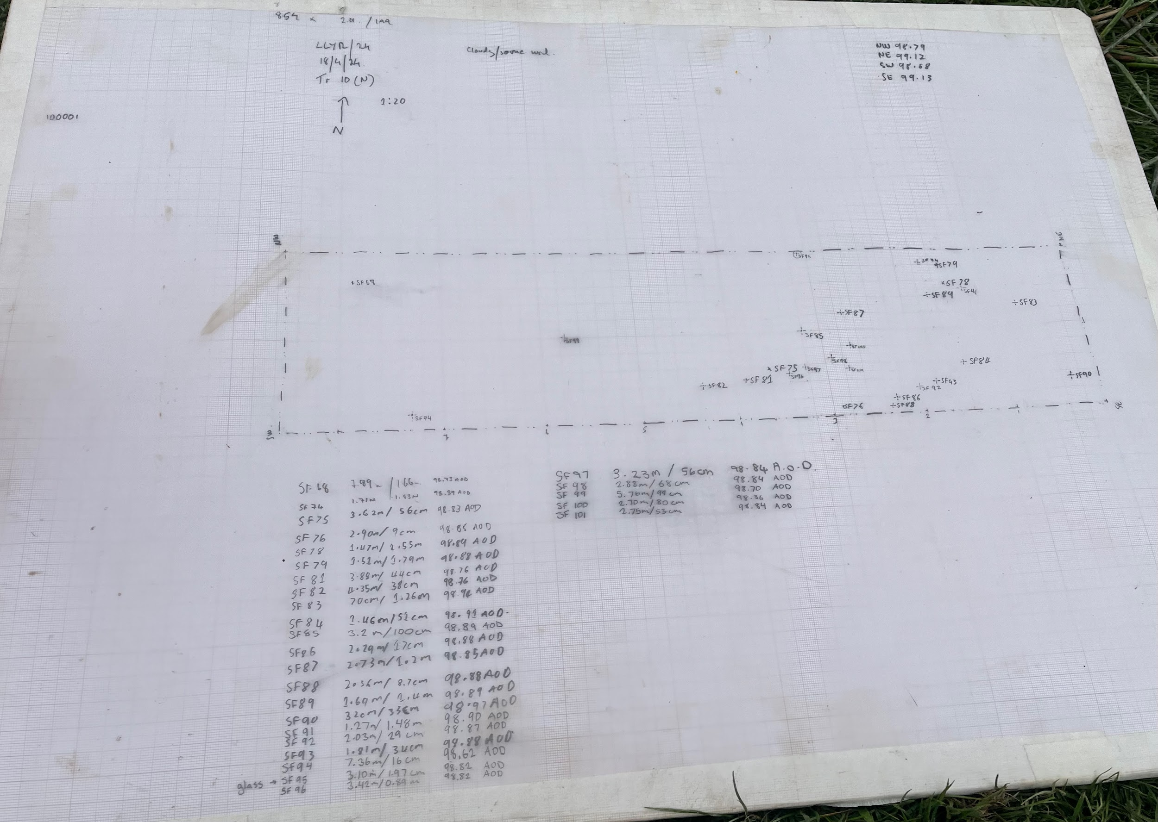
Figure 1: Plot description of Trench 10 (N)

This is a diagram of all of our findings in our trench and this shows off the correlation between where we think had the most known settlement movement. The original Point is the SE side on the right bottom side of the trench.

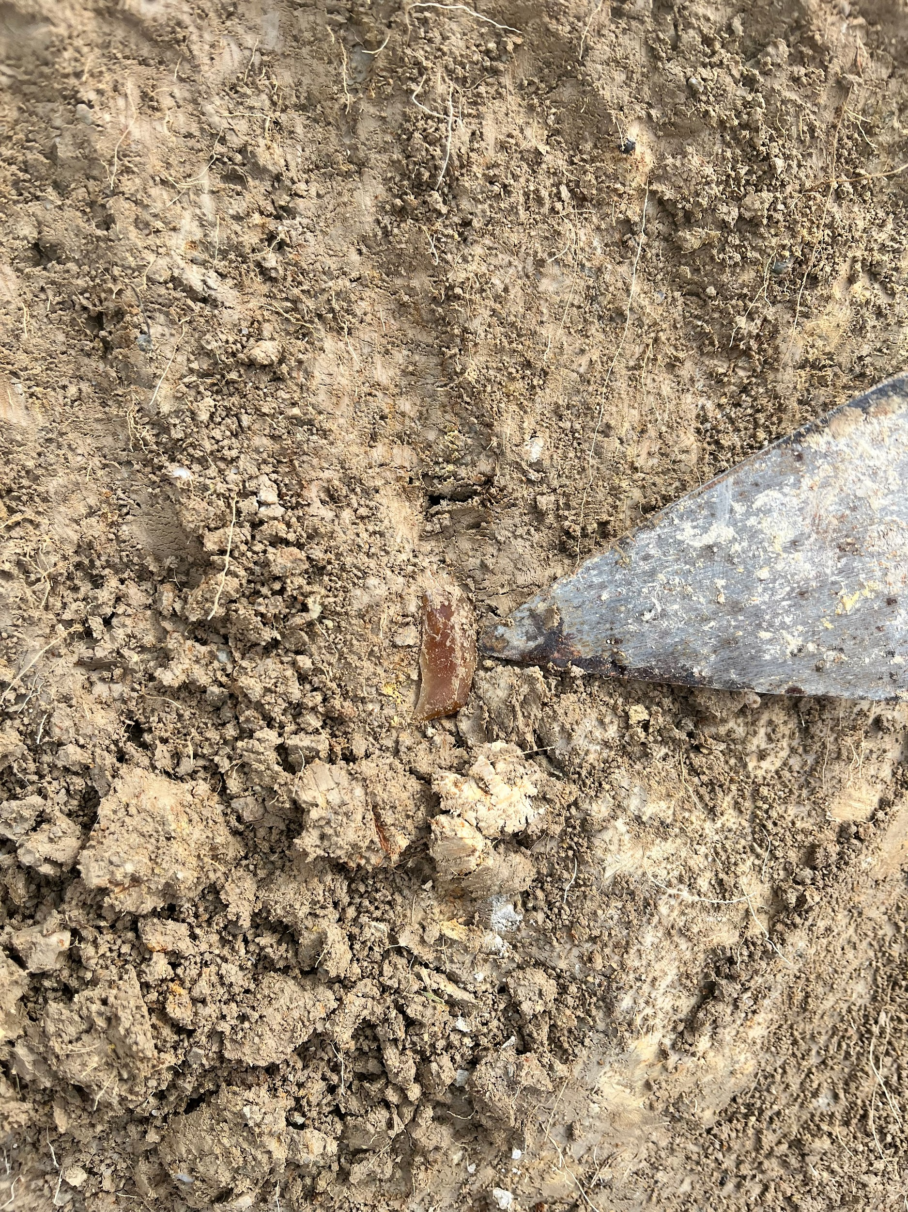
Figures 2 & 3
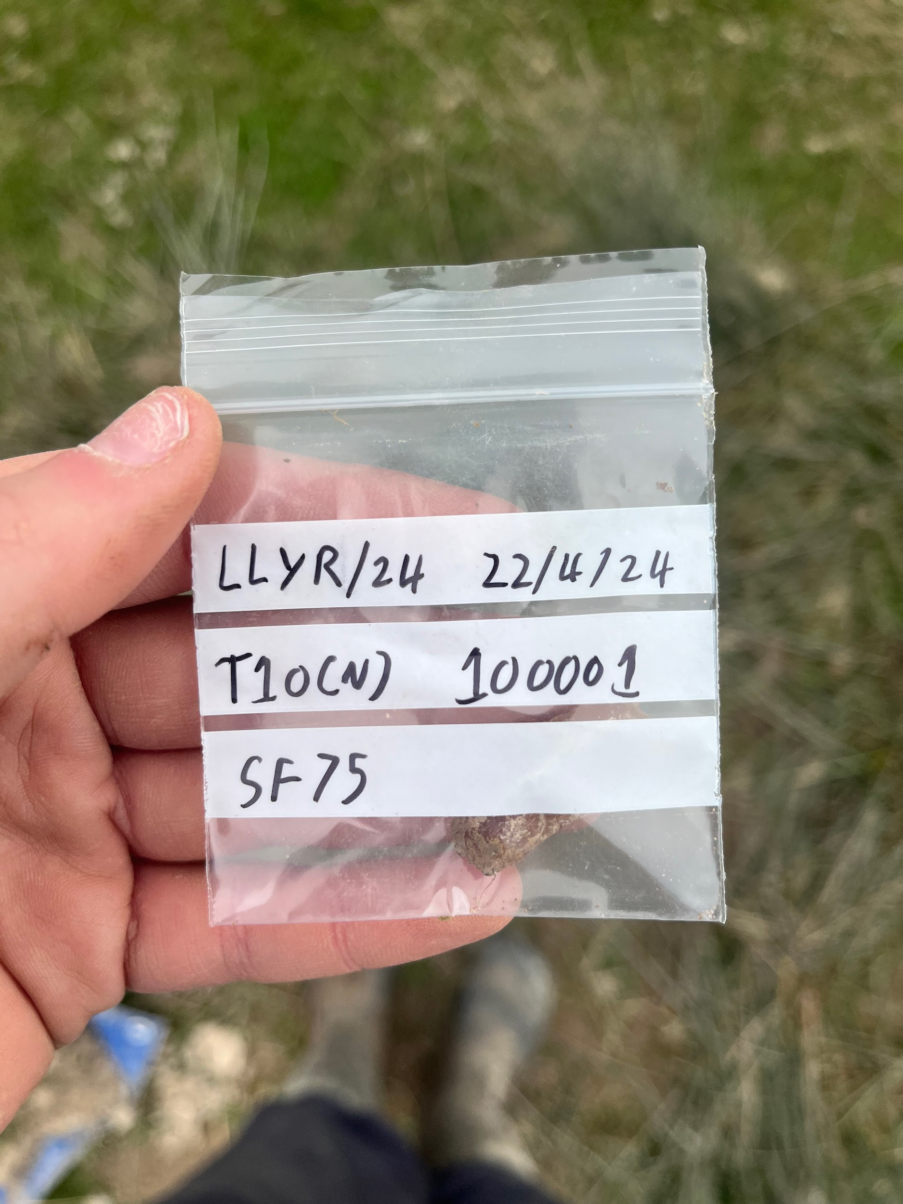

Figure 2: show off and object label of the various flint pieces that were found in Trench 10 (N)
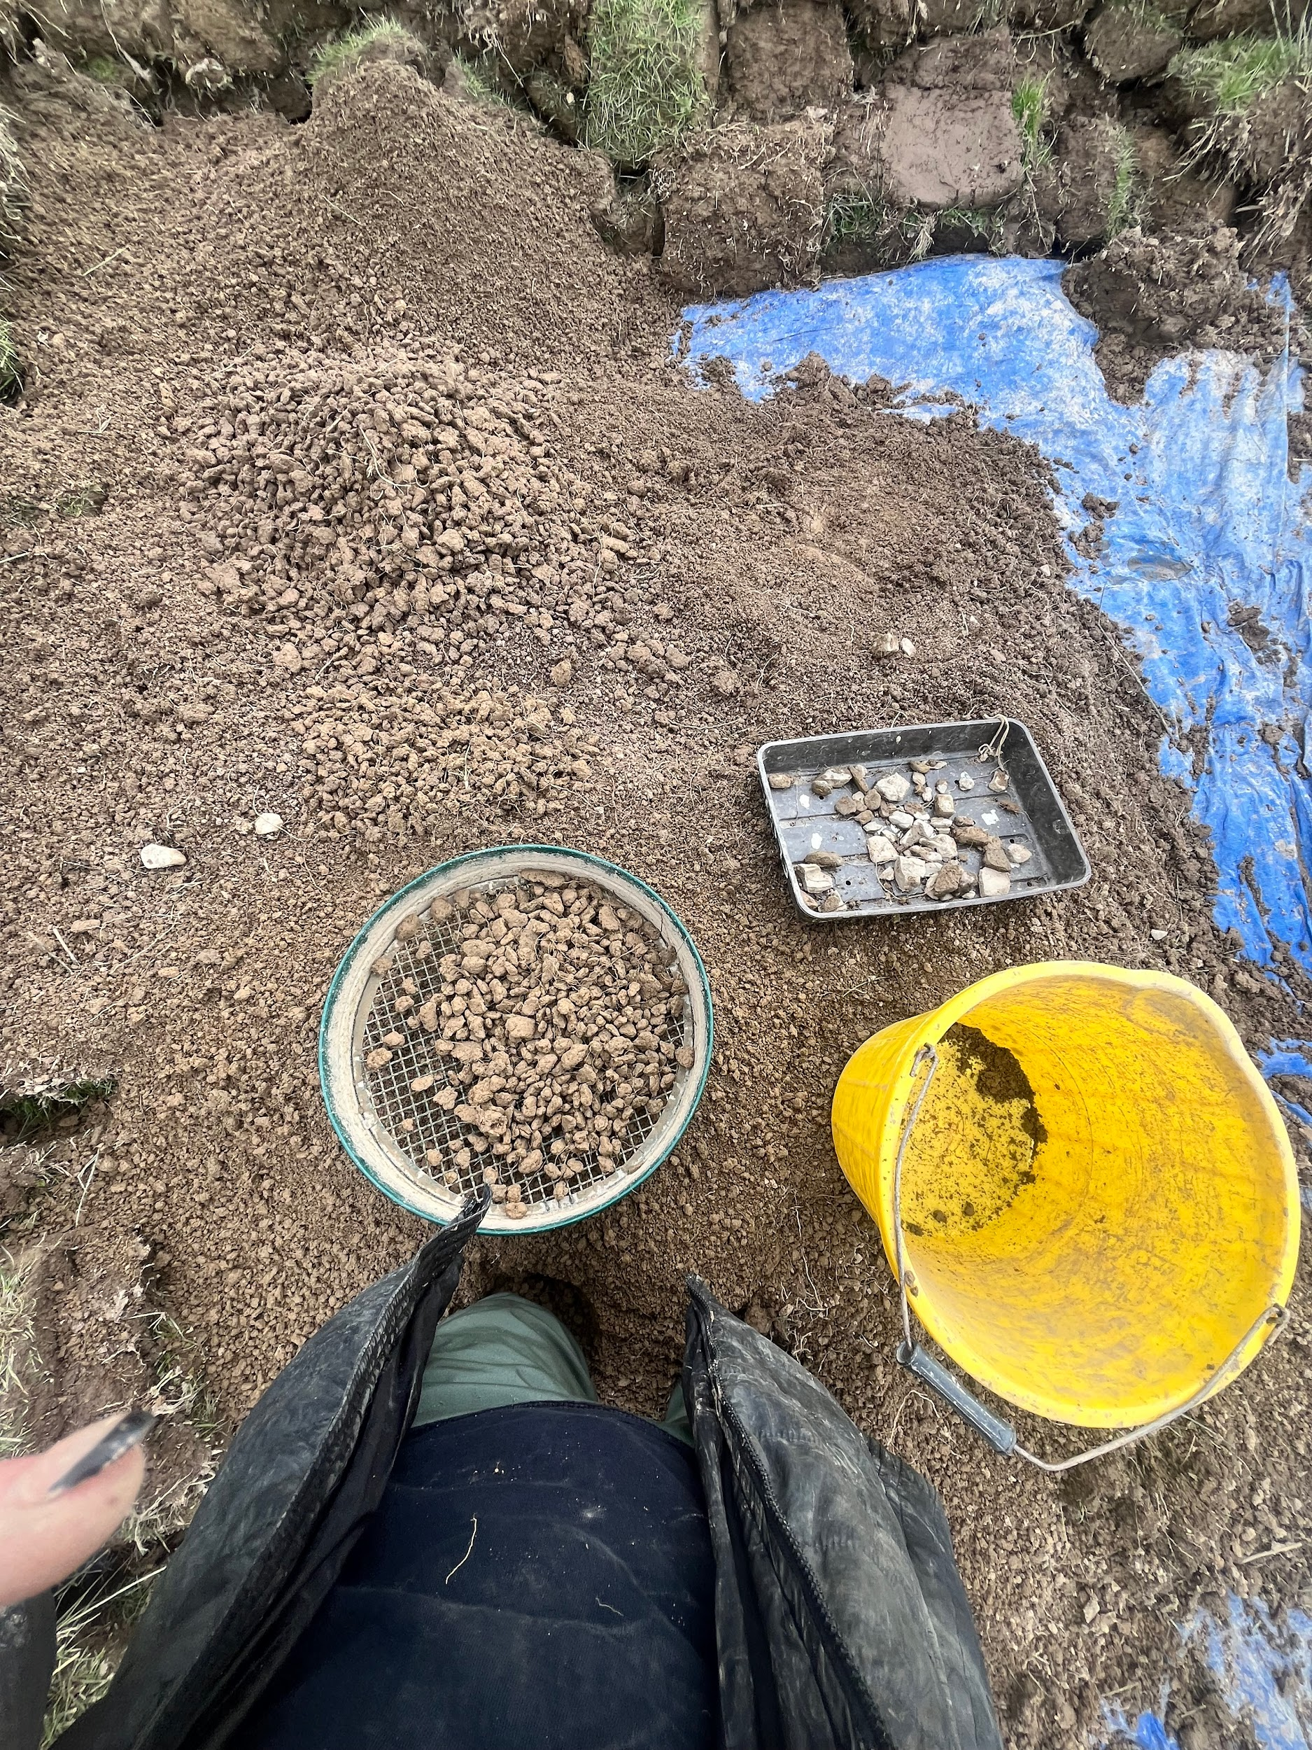
Figure 3: shows off a piece in the Trench from troweling down
Figure 4:

Figure 4: This is a process of us sifting through the
buckets, then go through the sifting process while,
the mud picks through it to look for flint, also
noticed the top-soil level there as well.

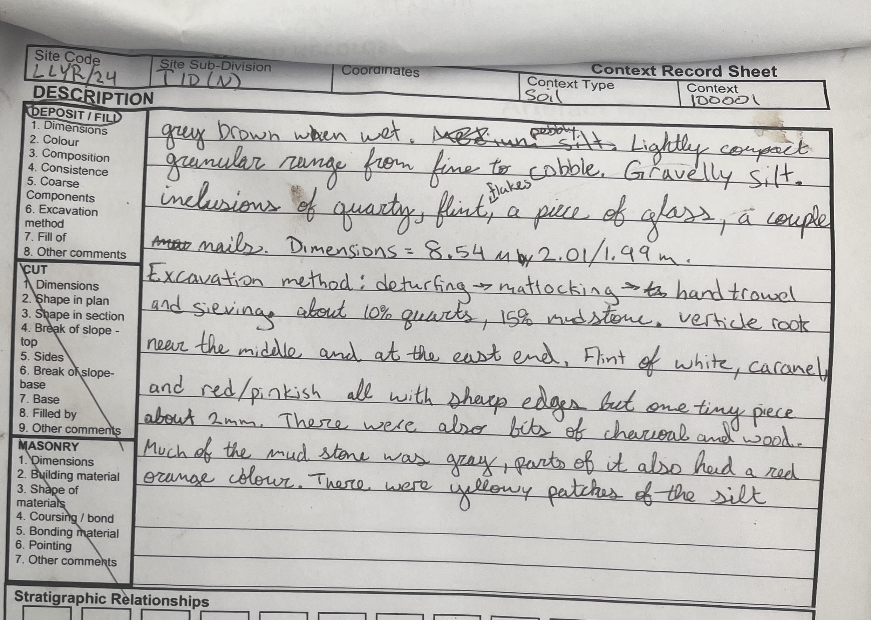
Figure 5:

Context sheet of Trench 10 (N), displaying our sediment layers, also explaining our trench overall and how it looked as we finished our excavation process off.

Referencing

Of Llanllyr , L. family. (1631). Deeds and documents . The National Library Of Wales .
Lewes , H. (2001, November). Lewis family, of Llanllyr. Fonds GB 0210 LLanllry - Llanllyr Estate Records .

