UNIVERSITY OF WALES TRINITY SAINT DAVID
LONDON CAMPUS
Assignment 2
Learning in the Digital Era
Video Link: https://www.youtube.com/watch?v=r-G0n0sCSFA

Module Name: Learning in the Digital Era
Module Code: ACCA 4025

Student Name: Javier Penaloza
Student ID: 2532173
Group: 3

Lecturer’s Name: Anees Baquir

Table of Contents
Introduction 2
Main Body 2
Conclusion 9
References 9

Introduction
This report reflects on my development in learning in the digital age. I will conduct a self-assessment to identify my strengths and weaknesses. It also includes a professional development plan (PDP) with SMART goals to improve my knowledge and skills. Finally, I will explain what I have learnt through attending classes and completing assignments, and how this knowledge can support my studies and participation in class.
Video Link:
https://www.youtube.com/watch?v=r-G0n0sCSFA

Slide 1
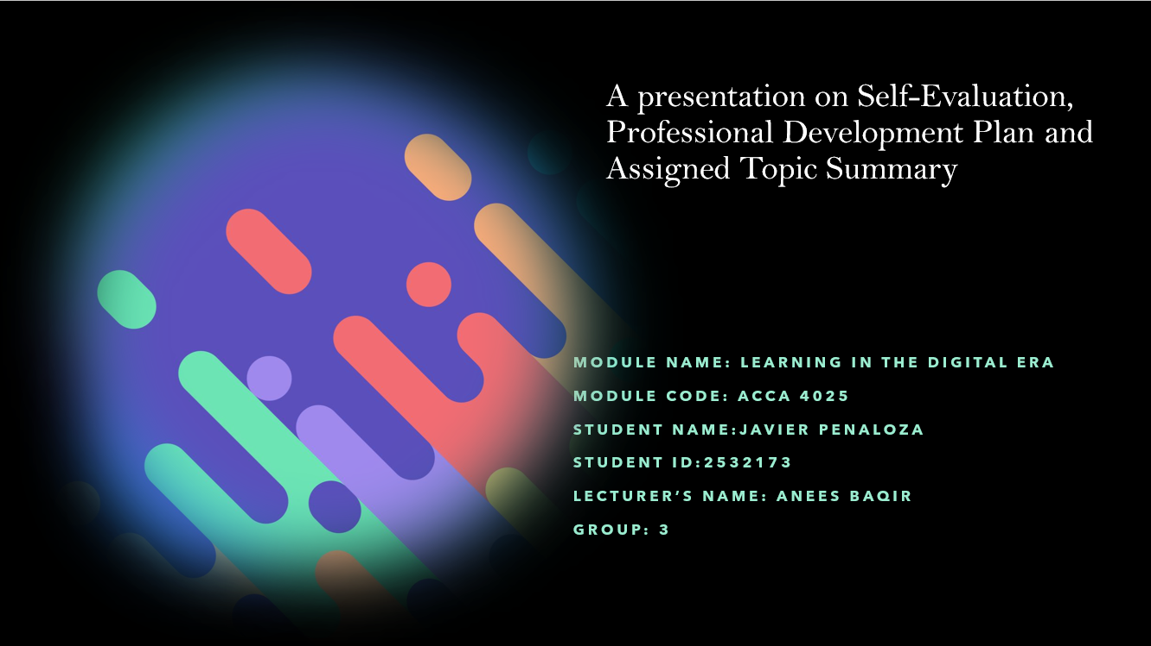

Slide 2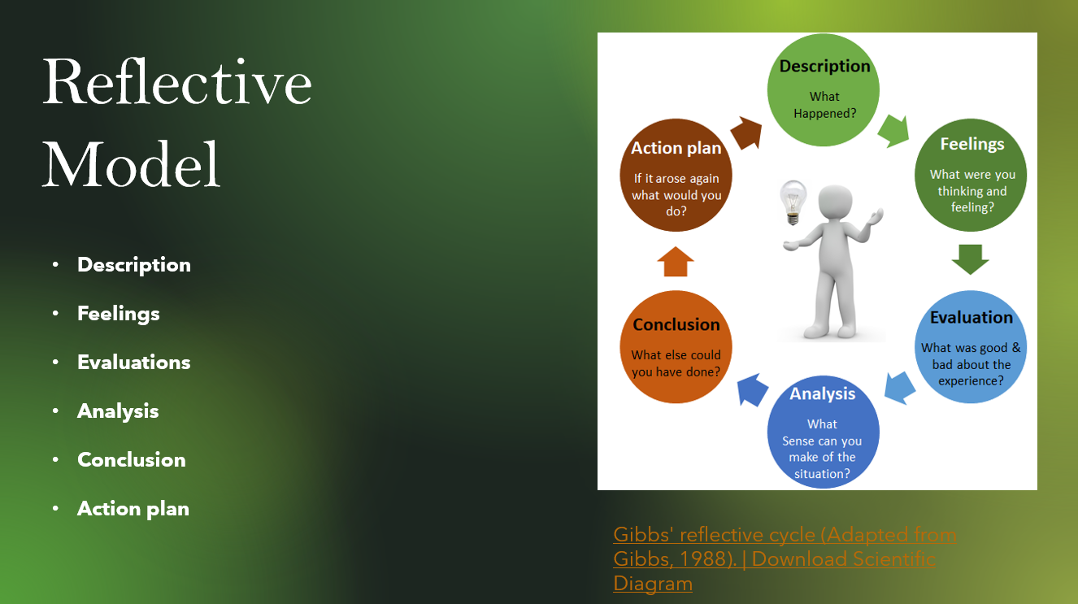
Brief explanation:
A reflective model is a framework that helps people achieve their goals in a structured way [1]. This model has six stages: Descriptions, Feelings, Evaluations, Analysis, Conclusions and Accion Plan (Gibbs, 1988). In my assignment I will use Gibbs’ Model to reflect my experiences and identify my strength and weaknesses [2].

Slide 3

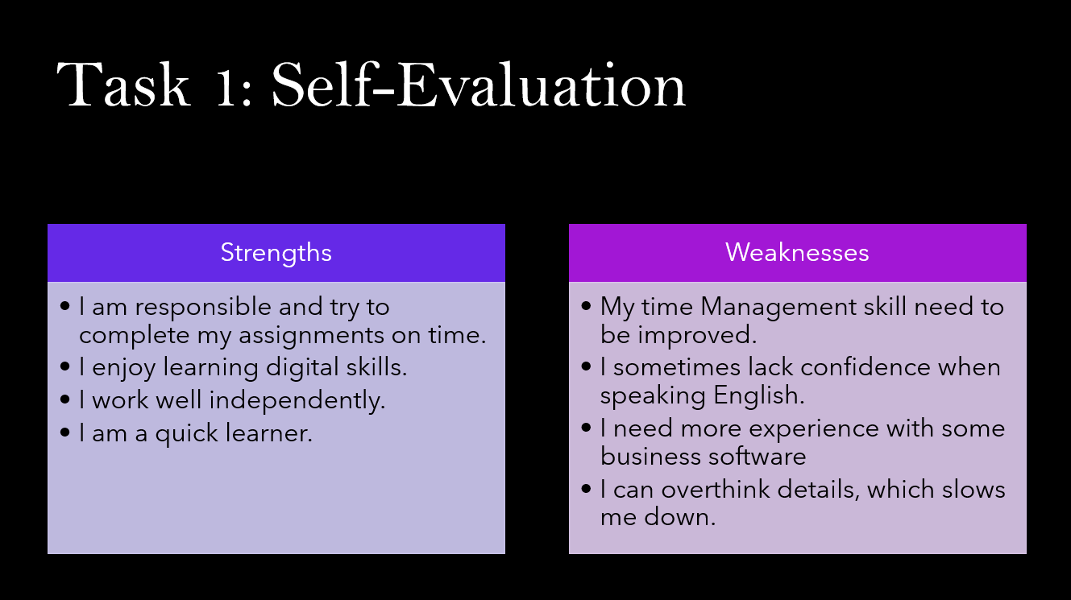
Brief explanation:
Self-evaluation is for a person to identify their strengths and weaknesses. It helps you to understand what you are doing well and what you need to improve.

Slide 4 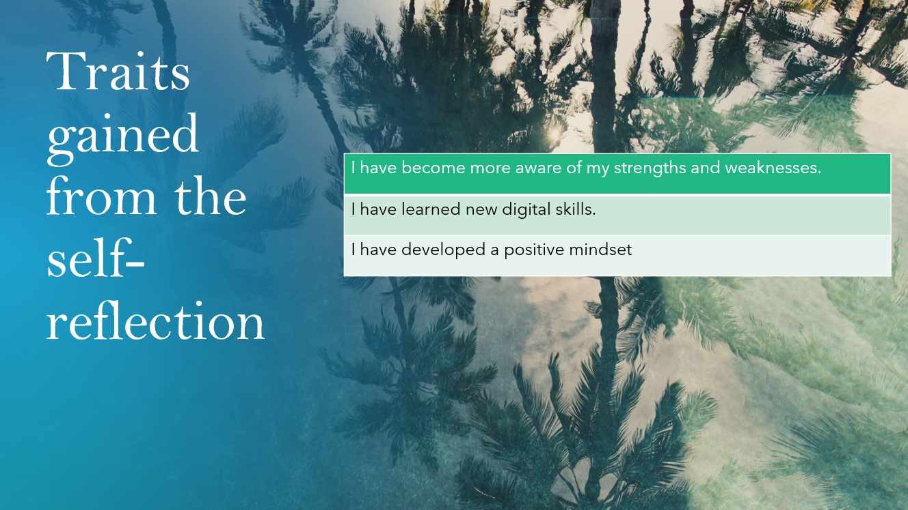
Brief explanation:
Traits gained from the self-reflection are a short summary of what you learn from your reflective model and your action plan [3]. It helps me self-awareness, confidence, and a better understanding of my strengths and weaknesses. It helps learners to identify areas for improvement [4].

Slide 5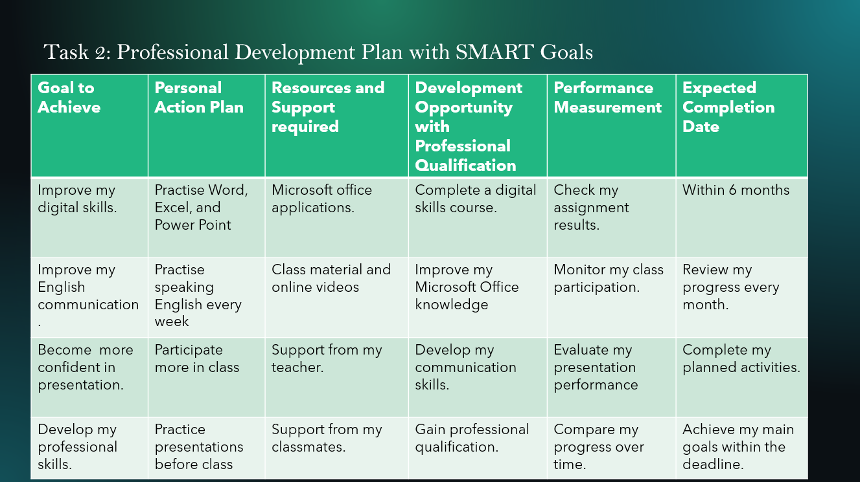Brief explanation:
A Professional Development Plan with SMART goals Is a plan that reflects all the steps you take through to achieve your goals [1].

Slide 6 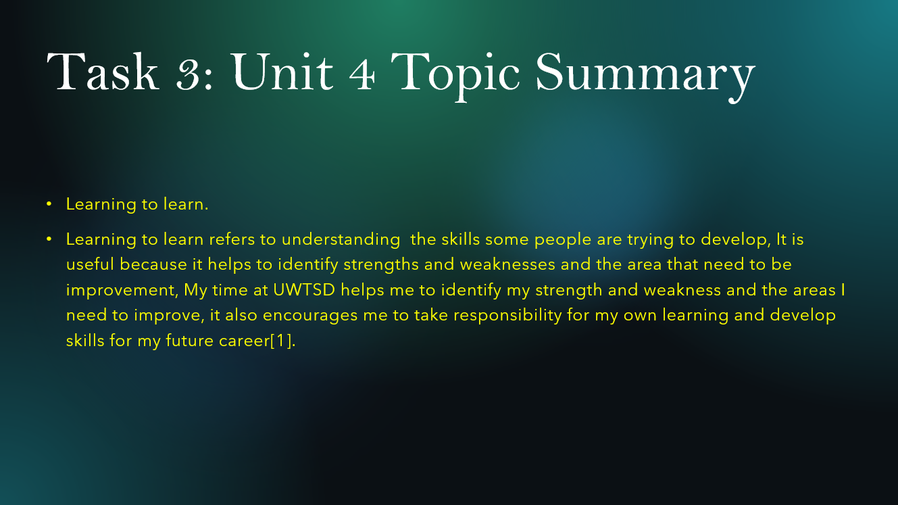
Brief explanation:
Through learning to learn, it is useful to identify the strengths and weaknesses in a person [6]. In my case I learnt to manage my time, reflect on my experiences and look for ways to improve them. I also learnt to be more conscience of my learning and establish objectives for my personal developments and professional.

Slide 7

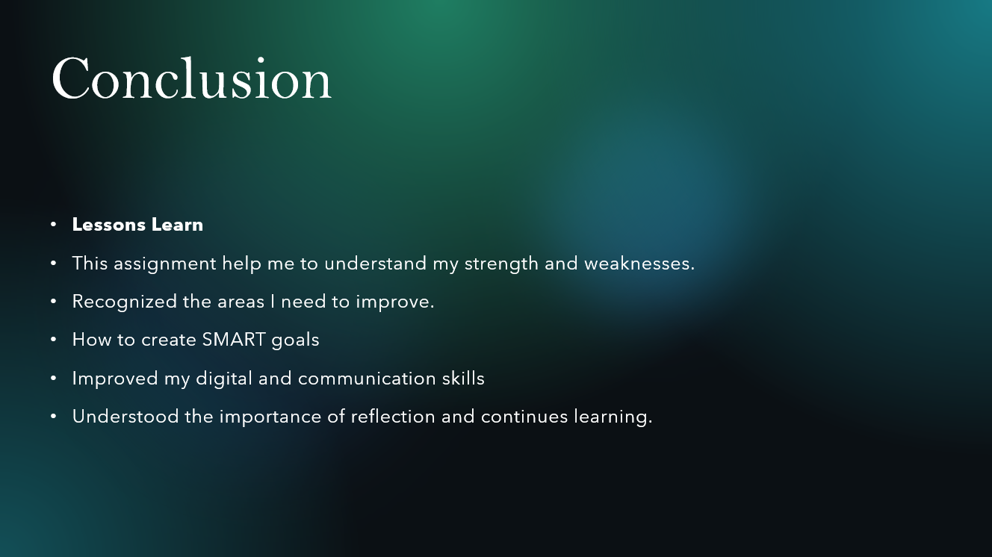
Brief explanation:
In conclusion, self- reflection has help me to identify the areas where I need to improve, it also helps to understand better my strength and weaknesses and the areas for improvement. Self-Reflections is important because it helps individuals learn from their experience and plan for future development [7].
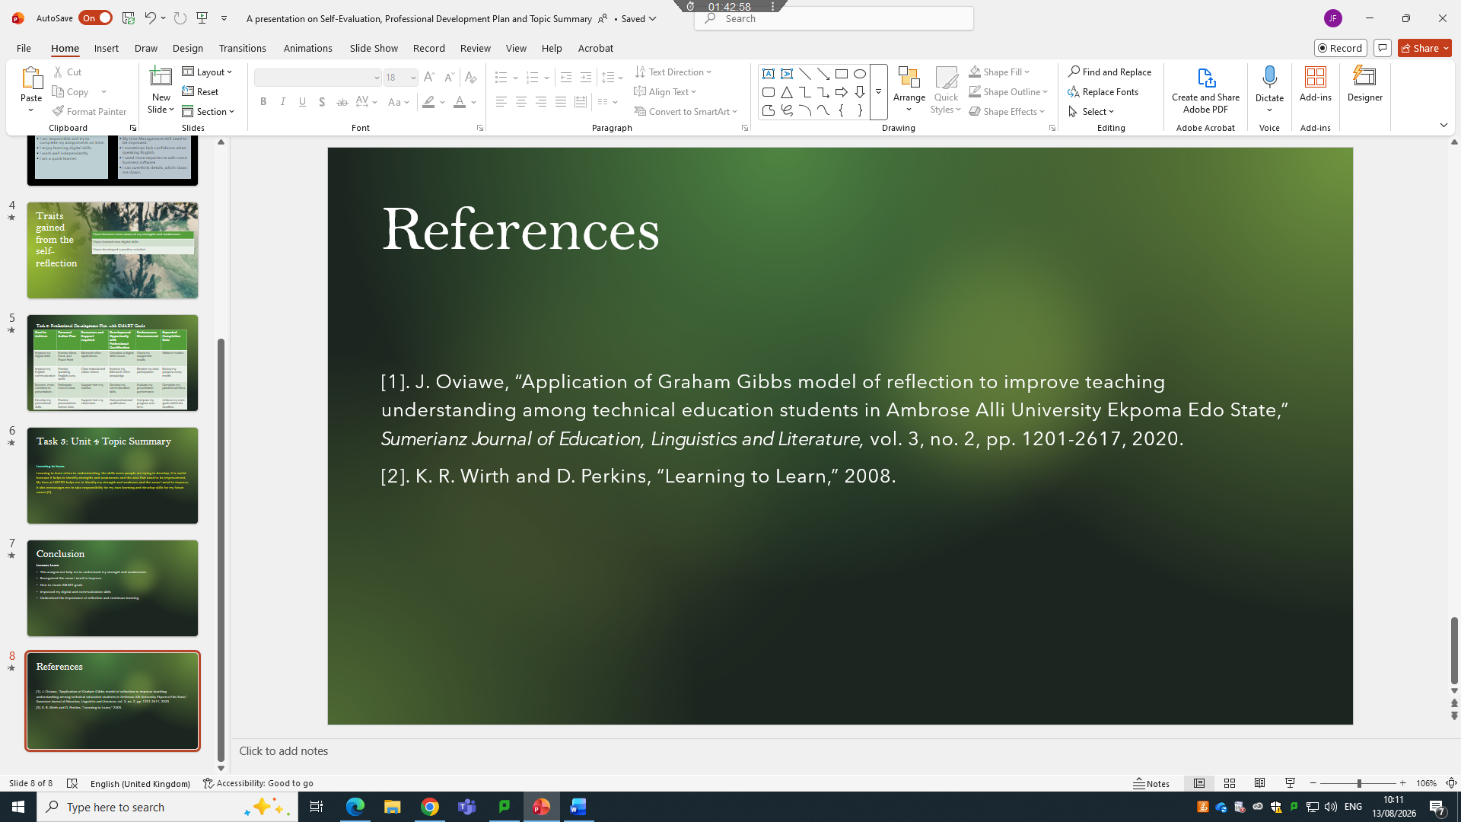
Slide 8

Conclusion
To conclude, Self-Reflective Model has helped me to identify my strength and weaknesses. It allows me to work the areas where I need to improve such as, speaking English confidently and use Digital tools. Furthermore, it encourages me to continuing learning and improve every day. It also will help me in my future, personally and professionally.

References

[1] | J. Oviawe, “Application of Graham Gibbs model of reflection to improve teaching understanding among technical education students in Ambrose Alli University Ekpoma Edo State,” Sumerianz Journal of Education, Linguistics and Literature, vol. 3, no. 2, pp. 1201-2617, 2020.
[2] | S. N. Aneeis Hashim, A. Yaacob, I. Suryani, R. Mohd Asraf, Z. Bahador and N. Supian, “Exploring the use of Gibbs’ reflective model in enhancing in-service ESL teachers’ reflective writing,” vol. 14, 2023.
[3] | C. J. Travers, D. Morisano and E. A. Locke, “Self‐reflection, growth goals, and academic outcomes: A qualitative study,” British journal of educational psychology, vol. 85, no. 2, pp. 224-241, 2015.
[4] | S. J. Donovan, C. D. Güss and D. Naslund, “Improving dynamic decision making through training and self-reflection,” Judgment and Decision making, vol. 10, no. 4, pp. 284-295, 2015.
[5] | S. S. Yates, The SMART goal framework: Teacher perceptions of professional learning and teacher practice, Northcentral University, 2014.
[6] | C. Stringher, R. D. Crick and K. Ren, “Learning to learn,” Routledge, 2013.
[7] | M. H. Van Loon, “Self-assessment and self-reflection to measure and improve self-regulated learning in the workplace,” Handbook of vocational education and training.Developments in a changing world of work, pp. 1-34, 2019.

