

Thomas Greenwood

Direct Stress Strain Investigation

HNC Level 4

UWTSD

Abstract
This report looks at a Projectile hitting two different Material armour plates at an oblique angle of 45 degrees and at the same velocity of 1200m/s. The findings of the report show that the second Material was better at slowing down the Projectile and this is put down to properties of the Material itself. Compression stress waves in the second Material were not as high as the first Material either. The velocity of the Projectile hitting the second type of Titanium lost a greater velocity than the Projectile hitting Titanium type One.

Contents
1.0 Introduction/Overview (4)
2.0 Materials (5)
2.1 Material for Armour Plate 1 (5)
2.2 Material for Armour Plate 2 and Projectile(6)
2.3 Material justifications and overview (7)
3.0 Hypothesis (8)
4.0 Johnson Cook model (9)
5.0 Overview of parts (10)
6.0 Impact shots (11)
6.1 Titanium Plate 1 Impact shots (11 – 13)
6.2 Titanium Plate 2 impact shots (14 – 16)
6.3 Probe analysis (17)
6.4 Titanium 1 Probe analysis (17)
6.4.1 Comparison of Max principle and Shear stress in Titanium 1 (18)
6.5 Titanium 2 Probe Analysis (19)
6.5.1 Comparison of Max principle and Shear stress in Titanium 2 (20)
6.6 Overall comparison of all probe figures (20)
7.0 Plotting velocities (21)
7.1 Titanium 1 Projectile Impact velocity graphs (magnitude) (21)
7.1.1 Discussion of Titanium 1 velocity chart (22)
7.2 Titanium 2, Projectile Impact velocity graphs (magnitude) (22)
7.2.1 Discussion of Titanium 2 velocity chart (23)
7.3 Magnitude Velocity plot Conclusion (23)
7.4 Plotting of V1 and V2 (24)
7.4.1 Titanium 1 V1, V2 (24)
7.4.2 Titanium 2 V1, V2 (25)
7.5 Conclusion of V1 and V2 results (25)
8.0 Improvements and Limitations (26)
9.0 Final Conclusions (26)

1.0 Introduction/Overview
This report details the behaviours of a Projectile hitting two different Material armoured plates at an oblique angle. Throughout the report certain areas will be discussed such as Material properties, Johnson cook formula, compression/shear stresses, plotting velocities etc. The models in this report were made in ABAQUS which is an industry standard modelling software.
To give a brief overview of the simulations, two Materials were chosen and modelled into two Armoured Plates of the same size in the ABAQUS software along with a Projectile of one material, multiple simulations were run, and the results were noted.

2.0 Materials
2.1 Material for Armour Plate 1
Ti-6Al-4V (First type)
Johnson Cook Damage Parameters [1]
D¹ = -0.09
D² = 0.25
D³ = - 0.5
D⁴ = 0.014
D⁵ = 3.87

Johnson Cook Plastic Model [2]
A = 236 MPa
B = 245 MPa
n = 0.539
C = 0.0125
m = 1

Elastic Parameters [2]
Young’s Modulus = 116000000000
Poisson’s Ratio = 0.34

Other Parameters [2]
Melting Temperature = 1941.15 K
Transition Temperature = 295 K
Reference Strain Rate = 1
Fracture Energy = 0
Mass Density = 4520
Epsilon dot zero = 1
Figure 1

2.2 Material for Armour Plate 2 and Projectile
Ti-6Al-4V (Second type with higher initial yield strength and other parameters)
Figure 2
Johnson Cook Damage Parameters [3]
D¹ = -0.09
D² = 0.25
D³ = - 0.5
D⁴ = 0.014
D⁵ = 3.87

Johnson Cook Plastic Model [3]
A = 870 MPA
B = 990 MPA
n = 0.25
C = 0.011
m = 1

Elastic Parameters
Youngs modulus = 116000000000
Poisson’s Ratio = 0.34

Other Parameters [3]
Melting Temperature = 1933 K
Transition Temperature = 298 K
Reference Strain Rate = 1
Fracture Energy = 20
Mass Density = 4520
Epsilon dot zero = 1

2.3 Material justifications and overview

Titanium and ones like these are used in modern armour plating and is applied around the world mostly on vehicle platforms due to its light weight, ease of manufacture and highly capable ballistic properties [4]. Both have the same density to create a fairer test however, there are slight differences in their Material properties which this report will show and then discuss how said differences may have affected their performance in the oblique impact simulation. Both the armour plates have been modelled to the same sizes and the same for the projectile.
Unlike the armour plates, projectiles are not commonly made from Titanium this is due to how lightweight Titanium can be. In the simulation a Titanium Projectile was used to create an unconventional impact of two similar materials and as this report is about looking in depth into how well each plate reacted to the Projectile therefore Material of said Projectile is not as relevant. Furthermore, by keeping the Material of the Projectile the same in both tests allows for a fair assessment on how it reacted to the armour plate and how the armour plate reacted to the stimulation of the projectile.

3.0 Hypothesis

When comparing both materials it makes sense to hypothesise that the Titanium plate One will not slow down the bullet as greatly as Titanium two. While the differences may be marginal, this should be apparent when looking at the plotting of velocities and how certain nodes of the Projectile hitting armour plate 1 in the first test lost a greater velocity than the armour plate Two test. Titanium two had a greater yield strength therefore it is determined to perform better [5]. However, this report will investigate how the Projectile slowed down, and it would be apparent that oscillation may be found in the graphs too.
During the simulations probing was used to investigate the compressive and shear stresses on the armour plates. The compressive stress for the second Titanium plate may be less than the first and the same could be said for the shear stresses as well.

4.0 Johnson Cook model

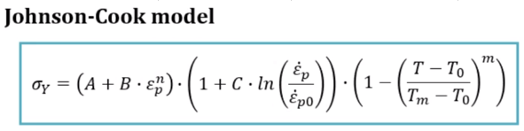

Figure 3

Figure 3 shows the Johnson cook model formula used in the simulations to model the materials. Refer to the materials section of the report to view the individual parameters.

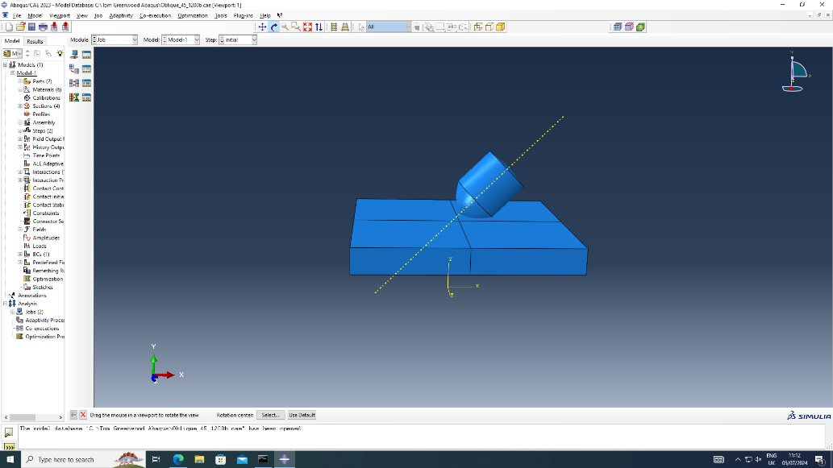
5.0 – Overview of parts
Figure 4 Overview of both Armoured Plate and Projectile at a 45-degree oblique angle

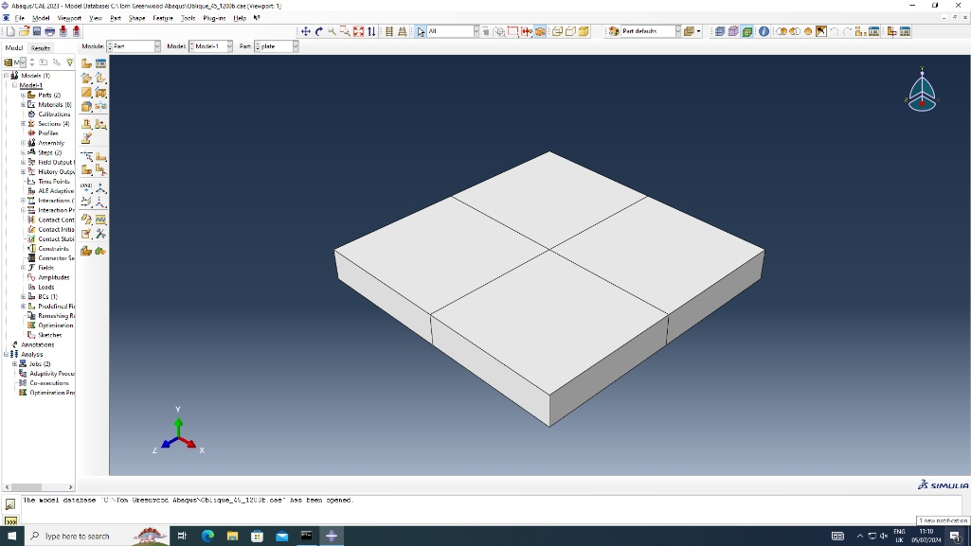
Figure 5 Armoured Plate

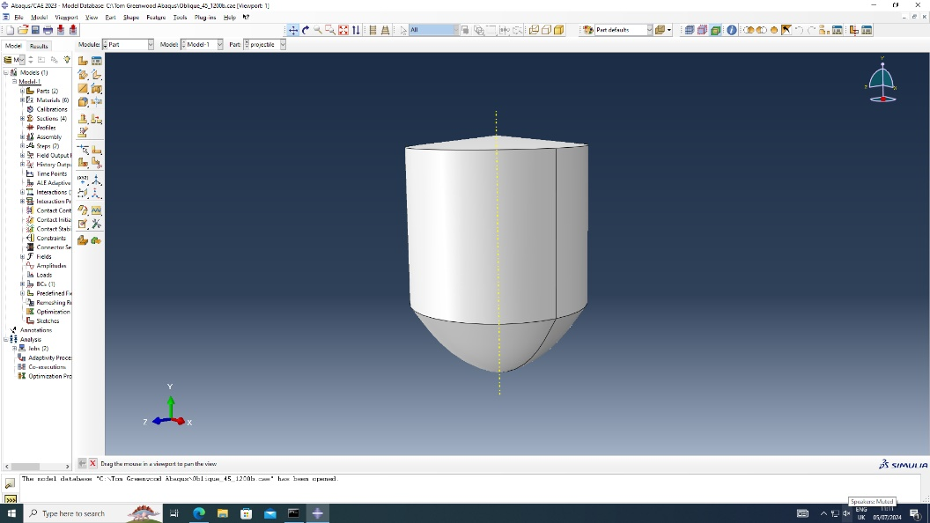
Figure 6 Projectile

6.0 Impact shots
6.1 Titanium Plate 1 Impact shots
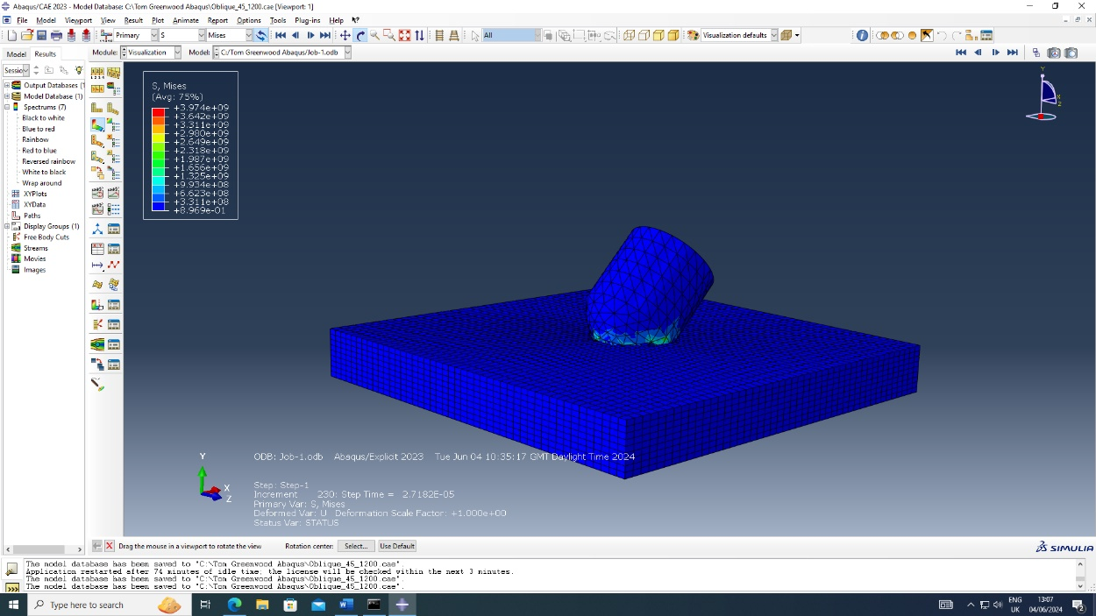
Figure 7 Overall shot of impact 1

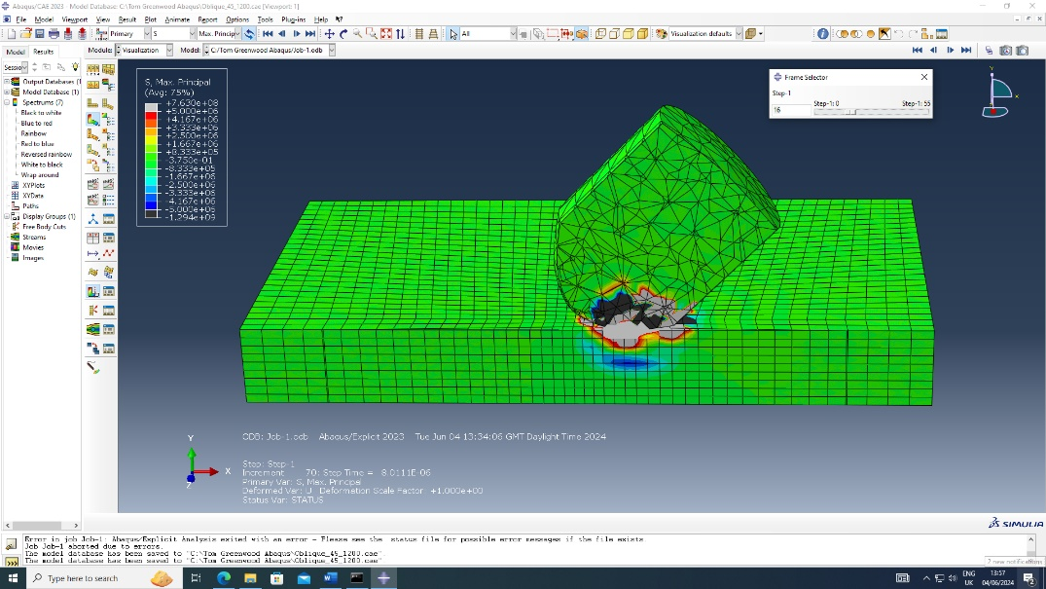

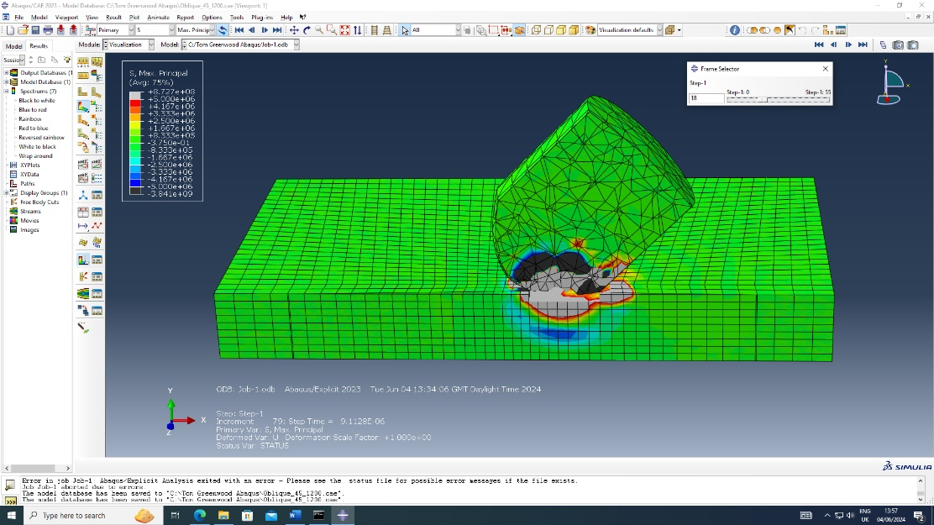

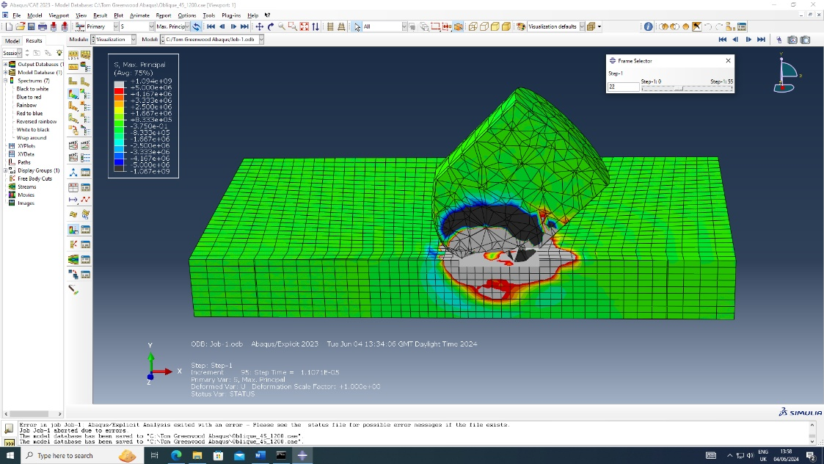

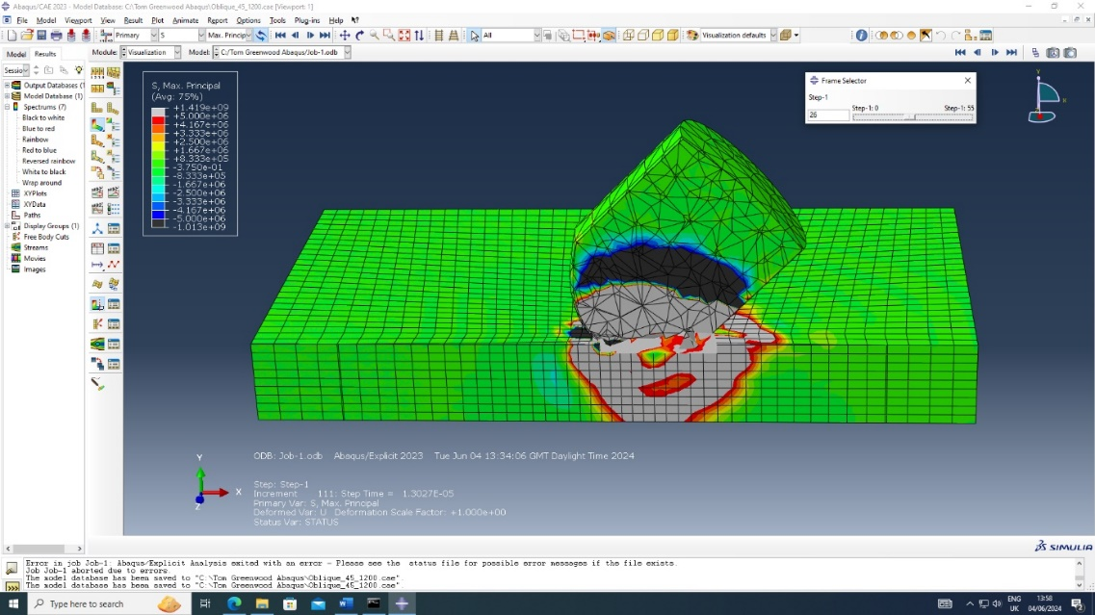
Figure 8 Four images above show the impact on Titanium 1 plate at different intervals

From the figure above the assessment was made that there is a high level of damage as the grey areas show tension which ultimately would be the pulling apart of the Material if this was replicated on a physical piece of Titanium. It is also clear that a blue wave passes through the armour plate in front of the tension waves. This blue wave is compression and shows the Material compressing together, hence the tension following and pulling apart the plate and causing damage.
These shots are only an overview of the impact with basic analysis, further in this report nodes will be probed to investigate more detail about the behaviour of the armour plates.

6.2 Titanium Plate 2 impact shots

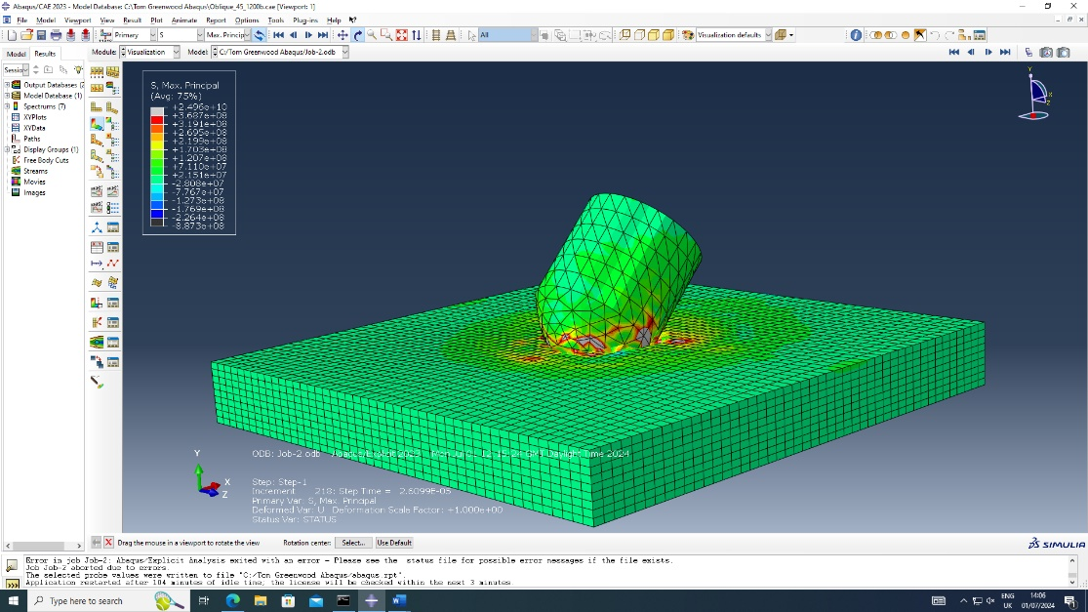
Figure 9 Overall shot of impact 2

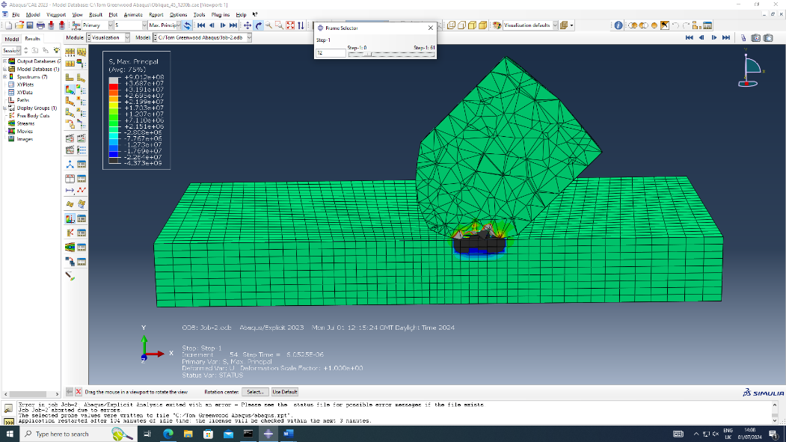

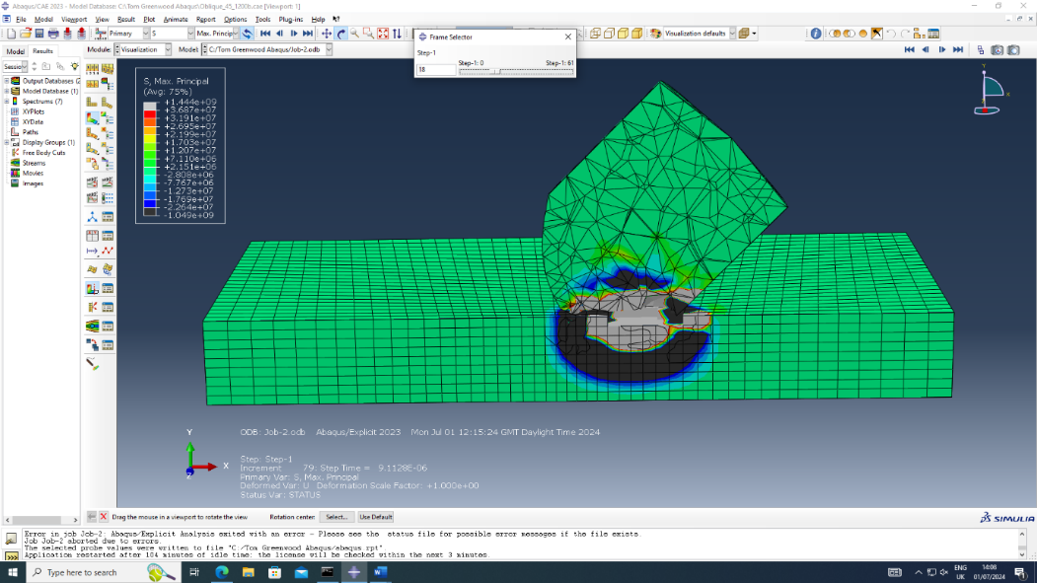

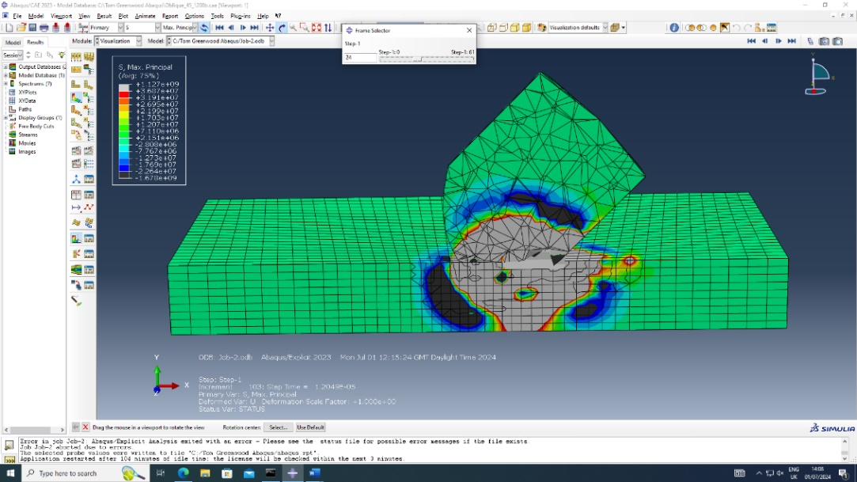

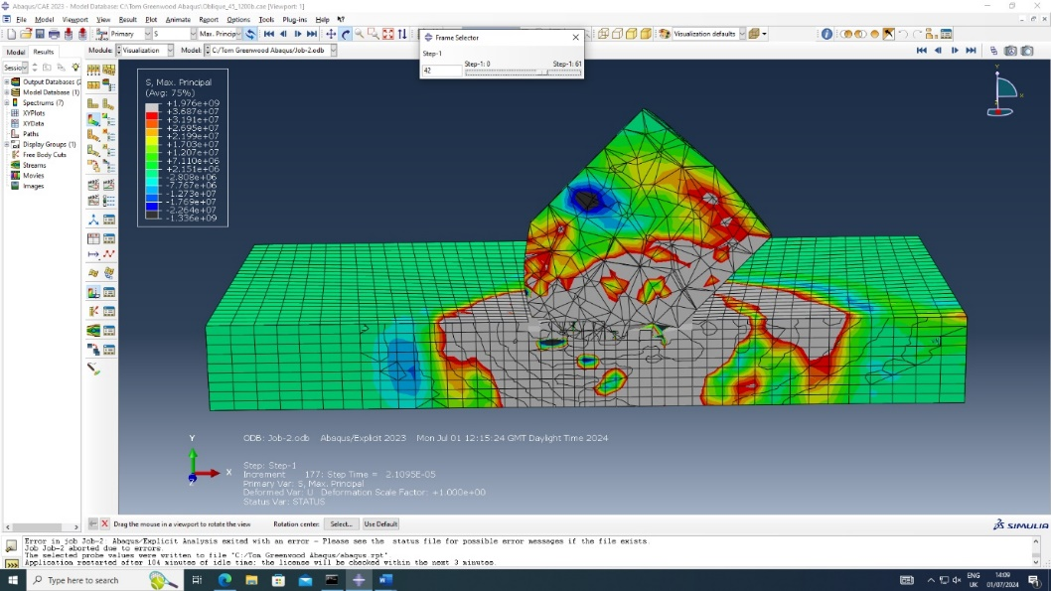
Figure 10 Four images above show the impact on Titanium 2 plate at different intervals

The figure above paints a similar picture when compared to the Titanium One plate impact shots. At a first glance a higher level of damage is depicted which may lead someone to believe that this plate was less effective however the being only an overview and not an analysis of other factors such as velocity this assumption cannot be made.
Once again, a high energy compression wave is noted at the point of impact with tension and damage behind it, furthermore the parameters have been slightly altered in Titanium 2 for the results as the parameters used for Titanium 1 results could not show enough detail to make any observations in this impact.
As a final point to touch on regarding the impact, a compression wave can be seen travelling up the Projectile which shows the armour plate slowing down the projectile. In real life bullets recovered from armour plate impacts are generally compressed and deformed. This shows that the armour plate in this impact is doing a better job at slowing down the Projectile as a higher compression wave and resultant damage can be noted in said Projectile in this example.

6.3 Probe Analysis
This section of the report will investigate the shear and compressive stresses in detail for both Titanium plates and analyse the findings of the ABAQUS probe tool.
Each plate has been probed in roughly the same area and by using a split view both the figures for max principle which investigates compressive stresses and shear 12 which shows shear stresses can be probed. The probing tool allows the selection of individual nodes, the compression and shear stress figures can then be observed at an intricate level.
6.4 Titanium 1 Probe analysis
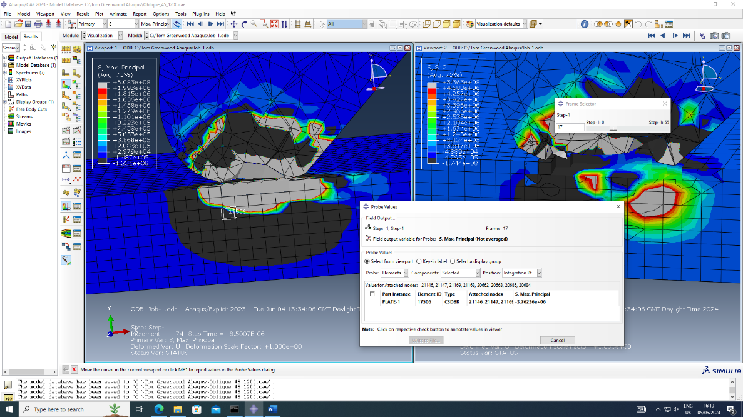
Figure 11 Image above shows the max principal figure for an individual node (Titanium 1)

As a concept max principle is used to evaluate the behaviours of materials when under extreme load conditions such as this example, it can be used to investigate how much stress a Material is under and when it may fail etc [6]. The image above shows a node on the compression wave being picked by the probe tool.

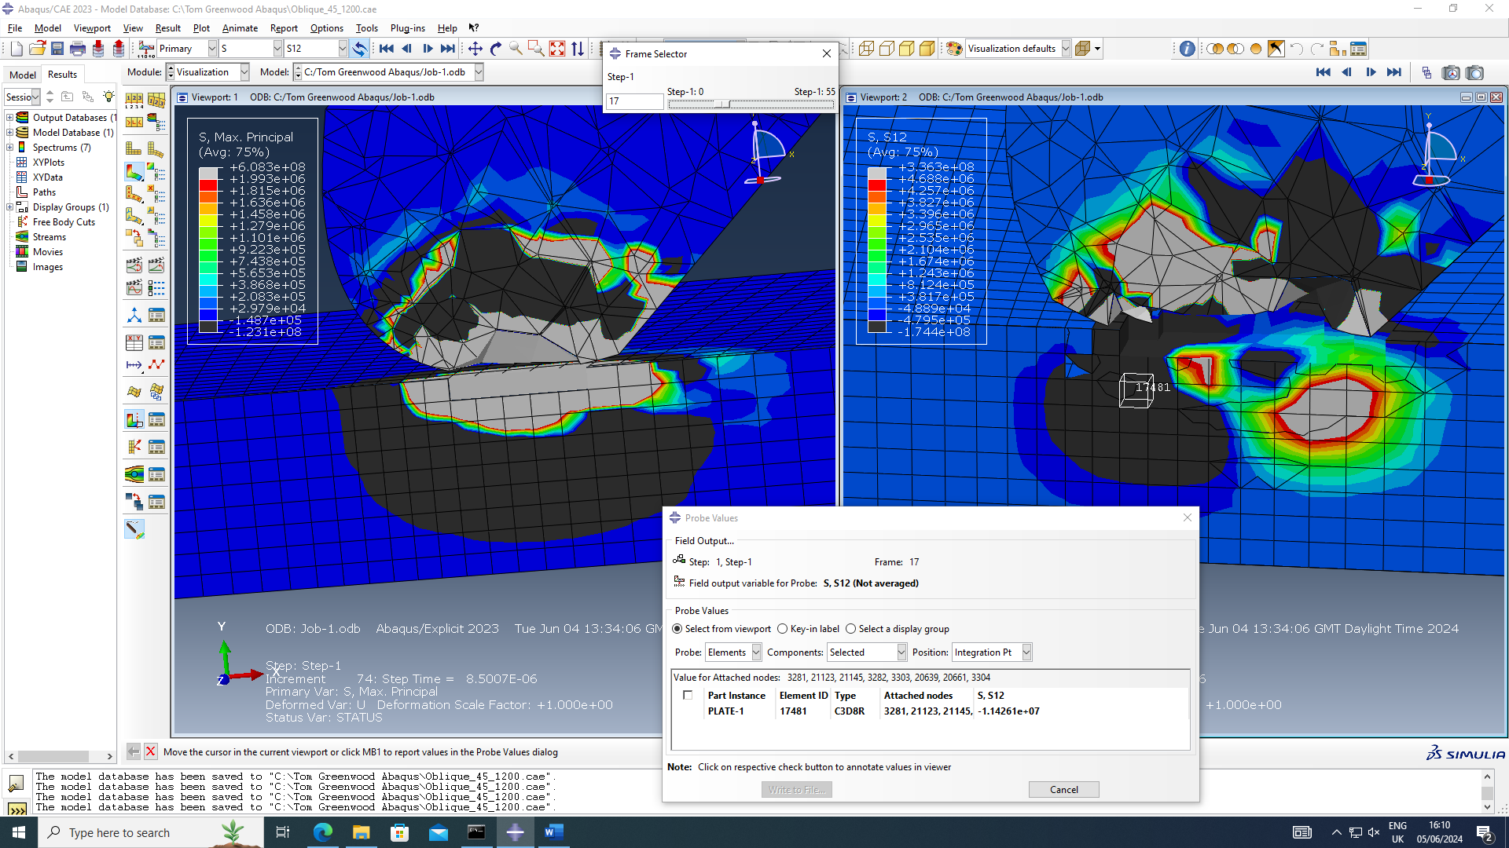
Figure 12 Image above shows shear stress of an individual node (Titanium 1)

Shear stress can be described as a materials resistance to deformation when under a force or load that is acting parallel to the selected plane of reference [7]. This is important when it comes to studying the behaviours of armour plates as it can help when looking into the damage caused by a projectile. It may also be noted that shear stresses in this instance are the positive and negative values sliding in opposite senses.
6.4.1 Comparison of Max principle and Shear stress in Titanium 1
As an overview the value Max principle was -3.8E6 and the value for S12 was -1.1E7, which means the S12 figure was around 2.8 times bigger than Max principle. This means the force of the damage was greater than the compression wave.

6.5 Titanium 2 Probe Analysis
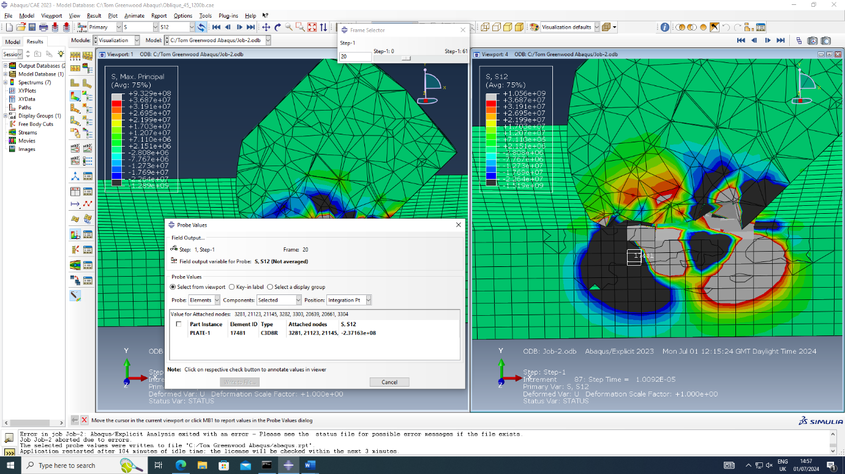
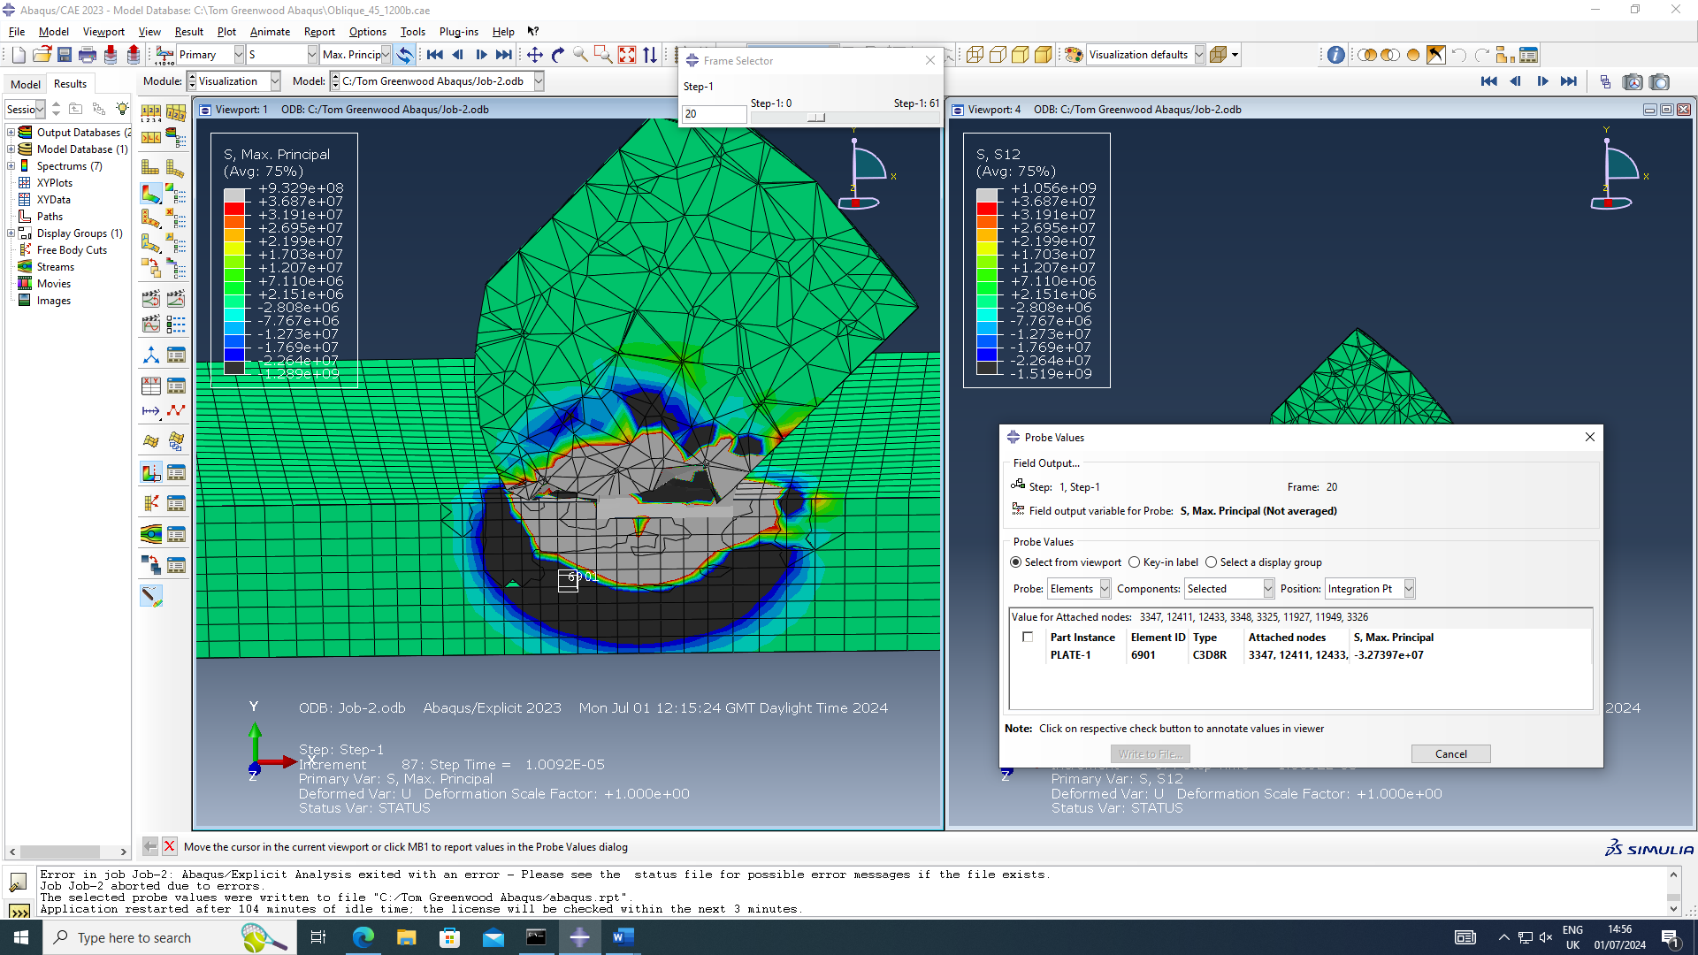
Figure 13 Image above shows shear stress of an individual node (Titanium 2)
Figure 14 Figure 13 Image above shows the max principal figure for an individual node (Titanium 2)

6.5.1 Comparison of Max principle and Shear stress in Titanium 2

The Max principal figure for Titanium 2 was -3.3E7 and the value for S12 was -2.4E8 therefore the shear stress was around 7 times bigger than the Max principal figure. This once again shows evidence that the shear stress was greater than the Max principal compression wave.

6.6 Overall comparison of all probe figures
To compare the Max principal figures for Titanium 1 and 2, Titanium 1 had a lower compressive stress which at face value was not something hypothesised however by delving deeper into the findings it is apparent that Titanium 2 had a higher shear stress. Usually this would not be ideal however armoured plates are designed to deform to help slow projectiles down therefore it can be interpreted in these findings that Titanium 2 took on more damage while also creating more damage to the Projectile and ultimately slowing it down. It should be noted that velocities are investigated in this part of the report so it can be hard to determine which plate is more effective at this stage,

7.0 – Plotting Velocities
This section of the report it arguably the most important as it looks at the velocities of the Projectile upon impact. This will show how the Projectile behaved and lost velocity which will aid the conclusion on which Material was most effective. As previous areas of the report show that Titanium 2 had taken on more damage than Titanium 1 the velocity graphs may evidence that the damage is not necessarily relevant when deciding on what stopped the Projectile most effectively.
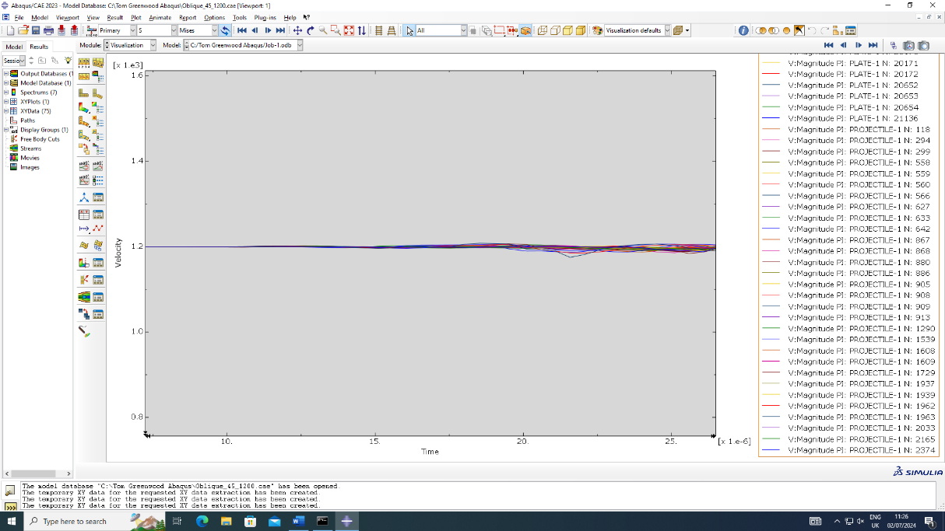
7.1 Titanium 1 Projectile Impact velocity graphs (magnitude)
Figure 15 Image of a velocity graph showing the initial impact with Titanium 1
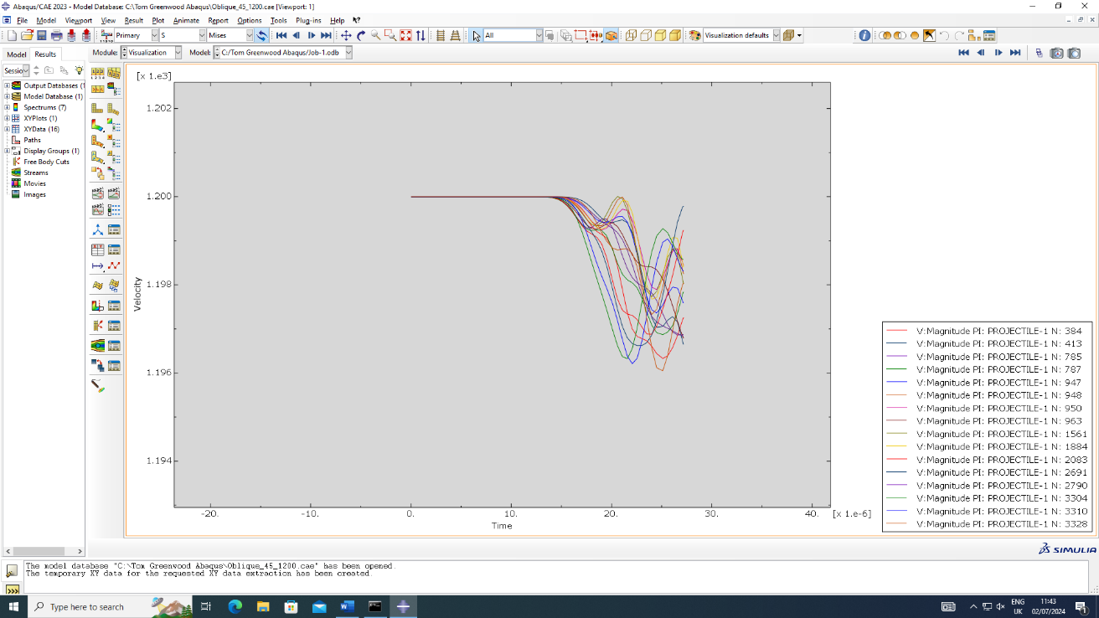
Figure 16 Image of a velocity graph showing Projectile mid impact with Titanium 1

7.1.1 Discussion of Titanium 1 velocity chart
In the graphs above it can be noted that the Projectile lost velocity initially then gained some back. This may be due to ricocheting after impact with the armour plate however this is not ideal as an armour plate needs to slow the overall velocity of a Projectile down to be effective.

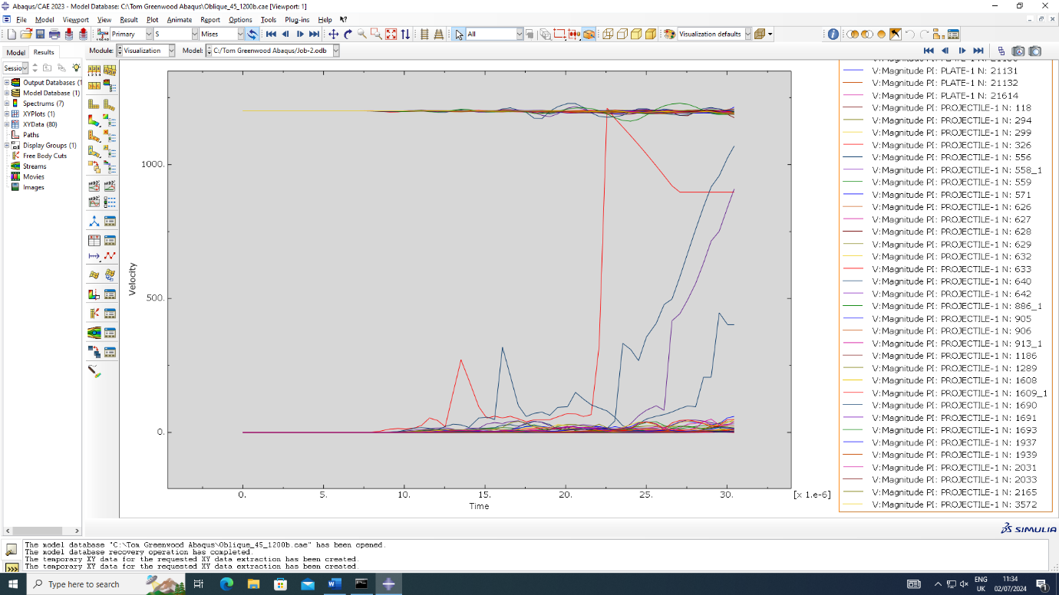
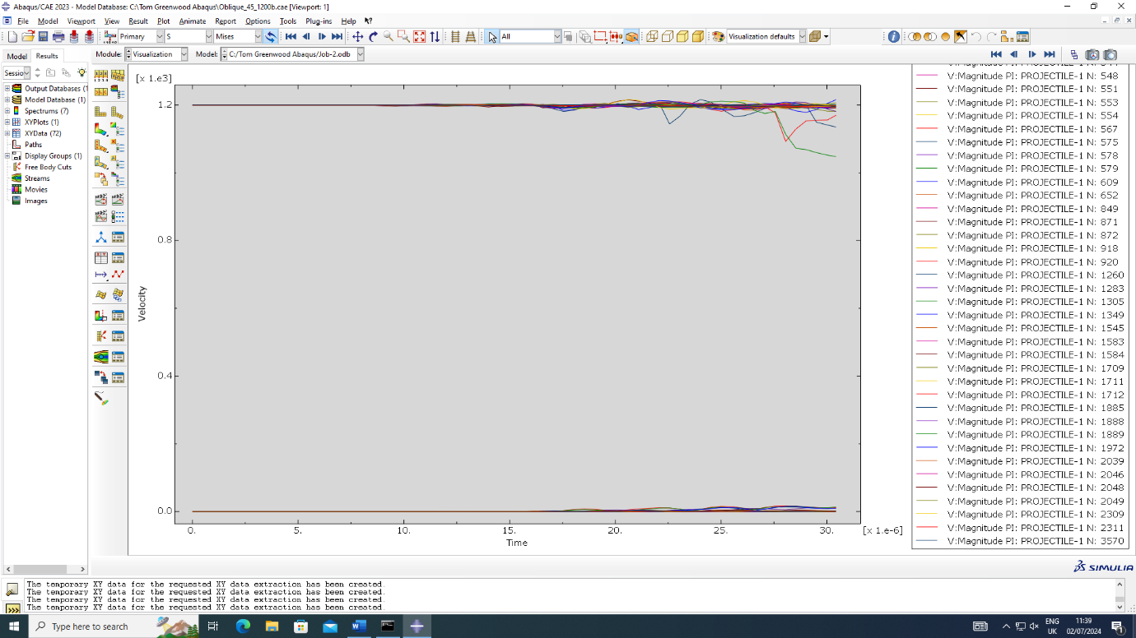
7.2 Titanium 2, Projectile Impact velocity graphs (magnitude)
Figure 17 Image of a velocity graph showing Projectile mid impact with Titanium 2
Figure 18 Image of a velocity graph showing the initial impact with Titanium 2

7.2.1 Discussion of Titanium 2 velocity chart
In the figures above there is certainly more fluctuation amongst the nodes of the Projectile in terms of velocity. At initial impact some of the nodes have lost their velocity altogether suggesting that they have stopped. In the mid impact figure, most of the Projectile has stopped and a large majority of the nodes are moving extremely slowly there it would be easy to conclude that Titanium 2 has done a better job at slowing down the projectile.

7.3 Magnitude Velocity plot Conclusion
To conclude the findings in this section, it must firstly be noted that the overall magnitude has been investigated for a bunch of nodes, this means that this is essentially an overview of how the whole Projectile acted in all vectors. From the findings above Titanium 2 was more effective which also adds evidence to the hypothesis.

7.4 Plotting of V1 and V2
This area of the report looks at the plotting of the V1 (X axis) and V2 (Y axis) velocities. As this is an oblique impact these are important areas to plot. Singular nodes were chosen for both impacts and the behaviours will be discussed below.

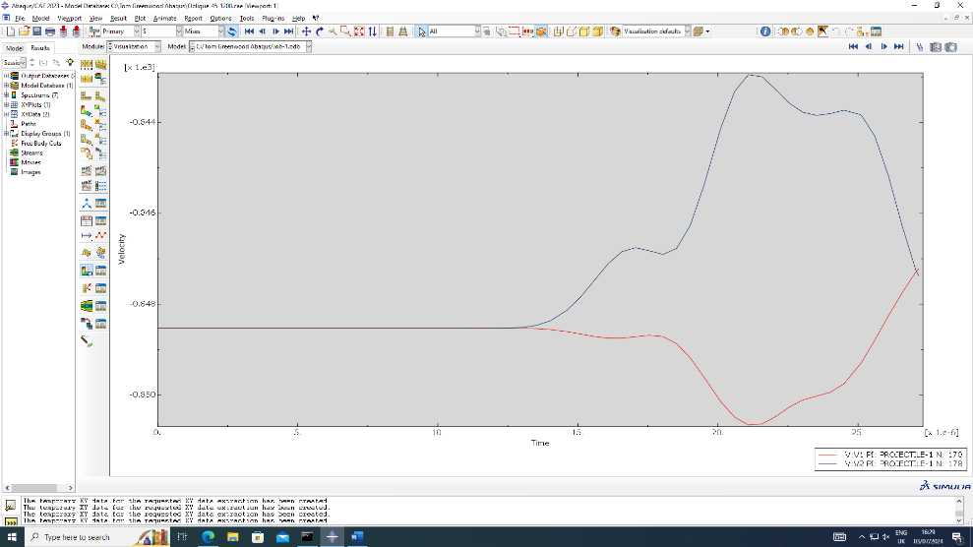
7.4.1 Titanium 1 V1, V2
Figure 19 Graph of V1, V2 velocities for Projectile hitting the Titanium 1 plate

In the figure above it is shown that upon impact the Projectile gains velocity in the X direction momentarily then starts to slow down as it progresses through the armour plate. As for the V2 figure, it slows down with a small amount of oscillation then speeds back up and ends up meeting the V1 figure around 847 m/s mark.

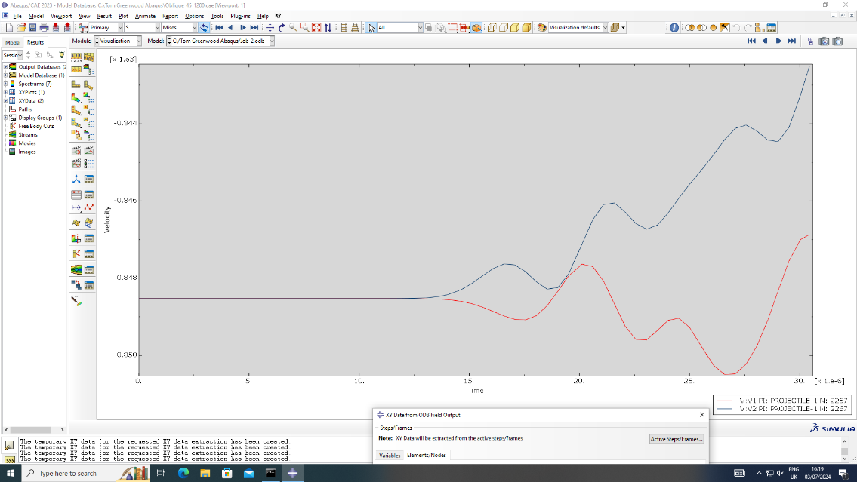
7.4.2 Titanium 2 V1, V2
Figure 20 Graph of V1, V2 velocities for Projectile hitting the Titanium 2 plate

The results for the Projectile hitting the Titanium 2 plate are drastically different to the previous result. Upon impact the Projectile slows down both in the V1 and V2 direction which is ideal in armour plating. A high amount of oscillation is then seen which may be due to fragmentation or stress waves passing through the Projectile at intervals and providing oscillation. Near the end of the graph the final velocity is lower than the final velocity for Titanium 1.

7.5 Conclusion of V1 and V2 results
To conclude these results, the data shows the Projectile hitting the Titanium 2 plate lost a greater velocity and therefore is more effective than Titanium plate 1. These results are also seen in the magnitude velocity results and provide hard evidence for the hypothesis. As a counter point it should be noted that this test was only repeated a small number of times and the results may vary if done in more detail.

8.0 Improvements and Limitations
During the modelling process, it was clear that there were certain areas that could be improved. In terms of proving if the parameters of the Johnson cook formula had a direct impact on effectiveness of the armour plate, a larger number of materials could be tested in the future with a wider range of damage and plastic parameters. This may aid a more accurate result. To add another point, the dimensions of the Projectile and armour plate could be modified to assess whether factors such as surface areas play a role in stopping the Projectile more effectively.

9.0 Final Conclusion
Throughout the report there has been multiple cases of conflicting evidence that goes against the original hypothesis of the second kind of Titanium would perform better as an armour plate than Titanium one. Overall, however the Projectile lost the most amount of velocity after hitting Titanium two, it also had a high fluctuation in velocity which could point to the notion that it may have broken up and ricocheted in another direction [8].

References

[1] | M. Sbayti, “Finite Element Analysis of hot Single Point Incremental forming of hip prostheses - Johnson-Cook failure parameters for Ti-6Al-4V,” Research Gate, Jan 2016. [Online]. Available: https://www.researchgate.net/figure/Johnson-Cook-failure-parameters-for-Ti-6Al-4V_tbl1_309439102. [Accessed 1st June 2024].
[2] | A. Manes, “Microstructural numerical modeling of Al 2 O 3 /Ti composite - Parameters for the Johnson-Cook model for titanium,” Research Gate, Jan 2018. [Online]. Available: https://www.researchgate.net/figure/Parameters-for-the-Johnson-Cook-model-for-titanium_tbl1_322911091. [Accessed 1st June 2024].
[3] | C. A. T. S. D. Bermudo Gamboa, “Modeling of the fracture energy on the finite element simulation in Ti6Al4V alloy machining,” Nature, 16th September 2021. [Online]. Available: https://www.nature.com/articles/s41598-021-98041-5. [Accessed 2nd June 2024].
[4] | M. G. W. B. R. J. W. O. Jonathan S. Montgomery, “Low-Cost Titanium Armors for Combat Vehicles,” JOM [Google Scholar] , 1997. [Online]. Available: https://www.tms.org/pubs/journals/JOM/9705/Montgomery-9705.html. [Accessed 4th July 2024].
[5] | Masteel, “The History Of Armour Plate Steel,” Masteel, 2nd Febuary 2018. [Online]. Available: https://masteel.co.uk/news/history-armour-plate-steel/#:~:text=Armour%20Plate%20Steel%20Properties&text=The%20combination%20of%20both%20properties,MPa%20and%201250%20MPa%2C%20respectively.. [Accessed 4th July 2024].
[6] | Simscale, “Principal Stress and Principal Strain: An Overview,” Simscale, 13th September 2023. [Online]. Available: https://www.simscale.com/docs/simwiki/fea-finite-element-analysis/principal-stress-and-principal-strain/#:~:text=The%20concept%20of%20maximum%20principal%20strain%20is%20pivotal,serving%20as%20an%20indicator%20of%20potential%20material%20failure.. [Accessed 15th July 2024].
[7] | T. Xometry, “Shear Stress: Definition, How it Works, Example, and Advantages,” Xometry , 20th September 2023. [Online]. Available: https://www.xometry.com/resources/materials/shear-stress/. [Accessed 15th July 2024].
[8] | M. Jauhari, “ Mathematical Model for Bullet Ricochet,” ScholarlyCommons, 1971. [Online]. Available: https://scholarlycommons.law.northwestern.edu/cgi/viewcontent.cgi?article=5678&context=jclc. [Accessed 16th July 2024].

