Ana-Maria Ifrim
2412153
Module name:
Problem Solving and Innovation (BMSW4014)
Lecturer: Tristan Hawkins
The rise of shoplifting in retail
Supporting Document

The rise of shoplifting in Co-Operative stores

Introduction
Shoplifting in UK retail shops has known a remarkable rise in the past 20 years with significant impact over store revenues, operational costs and the safety of both employees and customers (Syal, 2024).
Throughout the current presentation we are addressing this problem, analysing the root cause and exploring some possible solutions.
Summary
According to the Office for National Statistics [hereafter ONS], (2025), in 2024 was the higher rate of shoplifting offences recorded by police since 2002, as follows:

Figure 1. Police recorded shoplifting crime, year ending March 2003 to year ending September 2024
There were 49,2914 shoplifting offences recorded from October 2023 to September 2024, with 23% more then the previous year.
From April 2002 to March 2015 the incidents fluctuated between 31,0881 and 32,6053. From 2015 onwards shoplifting begun to rise and reached a peak of 37,9758 in March 2018. Then it started a decline until March 2021, when 22,8128 incidents were recorded. Starting 2021 the shoplifting cases started to rise again until 2024 when the latest data shows 49,2914 incidents recorded by police. The lowest number of shoplifting incidents were recorded between 2019 and 2021 during the pandemic.
Co-Operative store has recorded a 44% increase in retail crime in 2023, with over 1000 incidents a day and a rise of 35% in violence and abuse, about 4 colleagues attacked every day (Houlton, 2024). This despite Co-Op investing over £200M in prevention measure during de recent years (Co-Op, 2024).

Fishbone Diagram
To have an overview of the grounds of shoplifting in Co-Op stores, Fishbone Diagram will help identify potential causes that can be displayed into 5 categories as fallows (Kajal, 2022):
- Methods
The processes that can lead to the rise of shoplifting are:
- Poorly designed layout with blind spots.
- Inaccurate inventory that can mask theft.
- Inadequate training of the staff.
- Inefficient processes for reporting theft.

- Machines
The equipment can be a cause of shoplifting such as:
- Faulty self-service checkout that makes shoplifter think it is not their fault (Wildman, 2024).

- Materials
The type of products targeted by thieves are mostly (T-Class UK, 2024):
- High value products such as meat, alcohol and confectionary.
- Easy concealable items.
- Easily removable tags items.

- People
There are three categories of theft (Wildman, 2024):
- Customer stealing: either intentional (by impulse) or unintentional (they forget to scan products or the self-service is faulty).
- Professional shoplifters: who steal large quantities of products with the intend of reselling.
- Employee: who steals either due to accessibility of the merchandise or the financial pressure.

- Environment
  - Economic Environment
- Cost of living crisis with rising inflation, stagnant wages and employment shortage (Sualeh, 2024).
  - Social environment
- Growing level of drug and alcohol addiction determine people to steal goods and sell them to procure drugs (Connolly et al, 2024).
- Decline in respect for authorities (Wildman, 2024).
- Normalisation of small-scale theft (Sualeh, 2024).
- Act of rebellion of the youth (Wildman, 2024).
  - Law enforcement
- Ineffective police response to shoplifting incidents (Wildman, 2024).
- Young persons consider it easy and think they will not be prosecuted (Wildman, 2024).
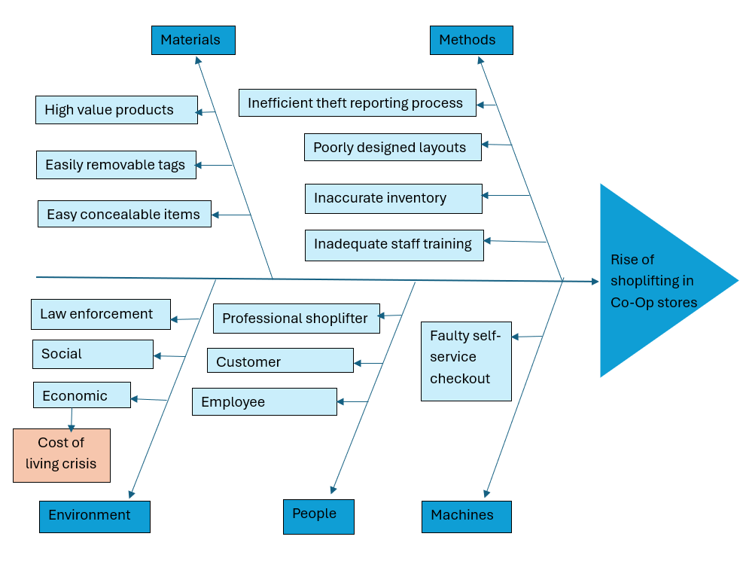
Figure 2. Fishbone Diagram

Therefore, the factor that has the biggest impact over the rise of shoplifting in Co-Op stores is financial difficulties.

REFERENCES

Connolly, J., Convery, NJ., Jones, S., Shoulde, G. , (2024) 'I stole to order' says prolific ex-shoplifter, Available at: https://www.bbc.co.uk/news/articles/czdpvd41z7mo.amp (Accessed 10 February 2025).
Co-Operative (2024) Stealing with Impunity – new report sets out ten-point plan to curb career criminals and prolific offenders as Co-op reveals record levels of theft and violence, Available at: https://www.co-operative.coop/media/news-releases/stealing-with-impunity-new-report-sets-out-ten-point-plan-to-curb-career (Accessed 13 February 2025).
Houlton, C. Co-op: ‘Levels of crime and abuse at highest ever seen’ in stores. Available at: https://www.grocerygazette.co.uk/2024/09/03/co-op-crime-abuse-stores/#:~:text=%E2%80%9CWhat%20is%20driving%20a%2044,meat%20section%2C%E2%80%9D%20he%20said (Accessed 08 February 2025).
Kajal, (2022) Fishbone Diagram – How to Use it for Root Cause Analysis, Available at: https://unichrone.com/blog/quality-management/fishbone-root-cause-analysis/ (Accessed 10 February 2025).
Office for National Statistics [ONS] (2025), Crime in England and Wales: Appendix tables, Available at: https://www.ons.gov.uk/peoplepopulationandcommunity/crimeandjustice/datasets/crimeinenglandandwalesappendixtables , p1, Table A5a, Summary Table A6 (Accessed 13 February 2024).
Sualeh, H. (2024) Shoplifting Reaches 20-Year High in England and Wales: Causes, Impacts, and Security Solutions, Available at: https://www.get-licensed.co.uk/get-daily/shoplifting-reaches-20-year-high-in-england-and-wales/ (Accessed 13 February 2025).
Syal, R. (2024) Shoplifting in England and Wales rises to new 20-year high, The Guardian, Available at: https://www.theguardian.com/uk-news/article/2024/jul/24/shoplifting-rate-england-wales-rises-new-20-year-high. (Accessed 06 February 2025).
T-Class UK (2024) How To Spot & Prevent Shoplifting In Your Store?, Available at: https://t-class.co.uk/how-to-spot-prevent-shoplifting-in-your-store/#:~:text=Concealing%20items%20in%20pockets%2C%20bags,other%20stores%20to%20avoid%20suspicion (Accessed 10 February 2025).
Wildman, C. (2024) Shoplifting is now at record levels. Here’s how it went from a crime punishable by death to police ‘turning a blind eye’, Available at: https://theconversation.com/shoplifting-is-now-at-record-levels-heres-how-it-went-from-a-crime-punishable-by-death-to-police-turning-a-blind-eye-237704#:~:text=Wherever%20you%20are%20on%20the,of%20drug%20and%20alcohol%20addiction (Accessed 10 February 2025).

LIST OF FIGURES

Figure 1. Police recorded shoplifting crime, year ending March 2003 to year ending September 2024

Figure 2. Fishbone Diagram

