Utilizing the Entrecomp framework, critically evaluating your own creativity and enterprise skills. Consider how you might be able to develop the creativity and enterprising skills of primary learners through your own pedagogy.

‘In a world dominated by technological innovations, creativity is a critical component; human skills and people’s powers of creativity and imagination are key resources in a knowledge driven economy (Robinson, 2000, as cited in Grainger, Barnes, 2006).

Within this document, the writer will be evaluating the creativity and enterprise skills of oneself as an educator within the primary sector. Within doing so the writer will be utilising the Entrecomp framework for analysis of personal creative and enterprise skills. The writer will then use personal analysis to then analyse how to adapt and innovate self-pedagogy in order to further foster creative and enterprise skills of primary learners.

So what is creativity?
‘Creativity is defined as “imaginative activity fashioned so as to produce outcomes that are both original and of value” (NACCCE, 1999:30). It involves fresh thinking, looking at problems and issues from a different angle and making connections.’ Grigg (2014 P103)

Sharp (2004, p.5) stated that ‘Most theorists agree that the creative process involves a number of components.’ Sharp recognised and identified that there are five more commonly used components. These are:
- Imagination
- Originality
- Productivity
- Problem solving
- The ability to produce an outcome of value and worth.

On the contrary, someone who does not show any of the above components can still be creative and have a creative way of looking and solving problems.

Creativity can mean many different things to individual people, “in terms of the primary classroom, teachers can often find it hard to envisage what it actually looks like, let alone plan to encourage or foster it.” Desailly (2015)

Gardner (1999) suggested that people and children can develop multiple intelligences or potentials for further learning. Someone who is good or talented with the arts are not necessarily creative. As Sharp (2004) suggested that talent differs from creative ability. Sharp states that ‘‘Talent usually refers to the possession of a high degree of aptitude and skill in a given area (such as music or mathematics), but would not necessarily imply either a high degree of originality or an ability to demonstrate creative abilities outside the specific area.’
During one of the most watched TED talks conferences, ‘Do schools kill creativity’ (Astle, 2018), Ken Robinson, chairman of the NACCCE (National Advisory Committee on Creative and Cultural Education) suggested that, as an education system, schools teach children out of creativity instead of fostering the creative side and encouraging children to become creative through every day activities.
Astle (2018) responded to the TED talks conference and answered the proposed question of ‘Do schools kill creativity?’. Astle responded with “no, although they certainly can if they forget two important lessons” in brief the two important lessons are:
First, the curriculum needs to provide rich and broad activities that do not encumber the potential for raising and developing creativity through every day activities.
Secondly, people need to understand the disciplines and central place for creativity within education and ‘take them as a starting point in curriculum designs.’
To conclude Astle’s response, the education board and curriculum writers need to understand how to foster creativity and write a curriculum that allows creativity to flow through the disciplines and skills that the curriculum provide.
Craft (2000, as cited in Grigg, 2014. P103) ‘uses the term ‘Possibility thinking’ to describe creativity that guides decision making in everyday life.’ Craft then leads on to suggest that possibility thinking, ‘represents a shift from asking ‘what is this and what can it do?’ to ‘what can I do with this?’ and ‘what if…?’. Thus, if the core curriculum presented opportunities to overcome functional fixedness of objects and allow the children to pose such questions, would the education system be allowing itself to foster creativity as Astle briefly suggested.
In Graham Donaldson’s report (2015) ‘Successful futures’. Donaldson recommended four key purposes and the key characteristics of the upcoming revised curriculum. One of these purposes being;
‘All our children and young people will be: enterprising, creative contributors who:
- Connect and apply their knowledge and skills to create ideas and products,
- Think creatively to reframe and solve problems,
- Identify and grasp opportunities,
- Take measured risks,
- Lead and play in different roles effectively and responsible,
- Express ideas and emotions through different media,
- Give off their energy and skills so that other people will benefit.
And are ready to play a full part in life and work.’ Donaldson (2015. P29)
Donaldson also recognised the need for the change in the curriculum in order to foster and enhance creativity within the primary sector. The recommended changes will allow the children of Wales to develop in to enterprising and creative contributors to society.

When posed the question “Are you a creative person?” the writer was sceptical weather they were creative or not and the British as a nation are considered negative and pessimistic when posed a question about themselves.
The writer believes that the feeling of being creative can be seen as challenging or complex due to the various different parameters, traits and dimensions that define creativity within a person.
In regards to the proposed question, the writer does not believe they are not creative academically but through everyday problem solving the writer is able to improvise and to adapt to overcome problems and scenarios. The writer has deduced the reasoning for the above hypothesis as their personal experience through the education system. ‘Robinson describes creativity as the ‘generic code’ of education, which is essential for the economic circumstances of the twenty-first century’ (Buie, 2005). Coincidentally, during the process of the writer’s educational journey through the school system, the writer has been navigated towards what Guilford (1967) “Convergent thinking” with focusing on what is fact and correct in order to succeed in standardised testing. As opposed to being guided too foster “Divergent thinking” where any idea is accepted regardless of Dunker’s functional fixedness and obstacles that can block creativity, Oelze (2018).

As a trainee teacher within the primary sector, the writer believes that they have overcome the feeling of not being a creative person and allowed oneself to aim towards becoming confident in teaching creatively and teaching for creativity. ‘As primary professionals, we need to recognise that it is our responsibility to foster the creative development of the young.’ Barnes and Cremin (as cited in Arthur, Cremin, 2010. P357)
For example, during PTE (Professional Teaching Experience), the writer decided to teach a mathematics lesson based on symmetry without the use of text books, writing and even shapes. (See appendix one)
During this session the children had prior input of symmetry using regular two-dimensional shapes and textbooks. The writer took the initiative to reinforce their knowledge, giving concrete experience, by allowing the children in pairs to explore the natural environment, within the school premises, and photograph any shape, object or anything else they may see that is or can be symmetrical. Petty (2009, P322) suggested that ‘Creativity is often seen as the exclusive territory of the creative arts,’ but ‘in the ‘real world’, creative skills are vital.’ Hence, the reasoning behind the writer using the opportunity to allow children to be creative within a core curriculum orientated mathematics lesson.
After the lesson activity in which the children identify and photograph the symmetrical objects, patterns etc. The pairs of children will then present their photographs to the rest of the class justifying the symmetrical reasoning. One child in the class took the initiative to use photo editing software on the IPad to create an original symmetrical pattern using natural objects.
Upon reflection of this lesson activity, the writer thought it would be more beneficial if all the children still identified symmetrical objects, pattern etc. within the natural environment to refine their ability to identify symmetrical properties. Also, the children could create their own symmetrical imagine using natural objects, shapes or patterns to ensure good understanding of the concept of creating symmetrical outcomes and what makes something symmetrical. Thus, developing and exercising the skills and components that Sharp (2004) recognised to be involved within the creative process i.e. Imagination, originality, productivity, and the ability to produce an outcome for a purpose.

​ ‘Enterprise in education is about taking an enterprising approach to teaching and learning. Enterprise encourages all young people to learn and develop in a way that meets their needs and develops skills for learning, skills for life and skills for work.’ EducationScotland (2018)
Arguably, the entire purpose of the education system and Primary school is to prepare children for the future. With this in mind, the writer proposed that the education system work with the Young Enterprise charity in order to ‘make the connection between school and the world of work, enabling young people to develop the knowledge and attitudes they need to succeed.’ YoungEnterprise (Date unknown)
The writer believes that the main limitation to their own creative teaching is down to the questions of: How do we assess creativity? Can we give children a grade for their creative or enterprising abilities? How can we foster creative ability if we do not feel creative in ourselves?
Kevinhigonia (2016) shared ‘Eight disadvantages of being creative’ within schools. One of the disadvantages in particular caught the attention of the writer. This disadvantage was ‘Saturation’. In which Kevinhigonia suggested that sometimes he feels overwhelmed with thinking of large quantities of ideas for a topic or brief. From a personal point of view, Kevinhigonia stated:
‘If I have plenty of ideas I assume that a number of them simply cannot be original. Nothing worthwhile should come easily, so I usually dismiss the first few rounds of brainstorming’. Although the above statement can be seen as reasonable or just to some readers, the writer feels that if Kevinhigonia had be taught to adopt Guilford’s:
‘Divergent thinking’ with the brainstorming activity allowing multiple idea to flow without thought of practicality or possibility.
‘Convergent thinking’ to then go through the brainstorming ideas, narrowing down what is possible or more suitable to the desired outcome to come to a consensus of the best outcome.
Or alternatively, ‘Lateral thinking’ in which Divergent and convergent thinking are combined through-out the brainstorming activity. i.e. as the idea arises, think of potential benefits, limitations and plausibility of the idea.
The writer is inspirited with the opportunity to use the revised curriculum, following Donaldson’s recommendations in order to instil and foster the creative and enterprise skills of the future generations.
‘The 2008 Small Business Act for Europe, the 2012 Communication on Rethinking Education, the 2013 Entrepreneurship Action Plan 2020, and more recently the New Skills Agenda for Europe, have kept the need to promote entrepreneurship education and entrepreneurial learning under the spotlight. This has led to a wealth of initiatives across Europe.’ (Bacigalupo et al, 2016. P5)
Sharing the same aim as the Young Enterprise (Date unknown),
‘We make the connection between school and the world of work, enabling young people to develop the knowledge and attitudes they need to succeed, building on 8 key skills: Communication, Confidence, Financial Capability, Initiative, Organisation, Problem-solving, Teamwork and Resilience.’
The Joint Researched Centre (JRC) of the European Commission developed The Entrepreneurship Competence Framework, also known as the EntreComp, on behalf of the Directorate General for Employment, Social Affairs and Inclusion (DG EMPL). Eckert (as cited in Bacigalupo et al, 2016) ‘The framework aims to establish a bridge between the worlds of education and work’
The EntreComp framework consists of three key competence areas (See appendix Two); ‘Into action’, ‘Resources’ and ‘Ideas and opportunities’. The three key competence areas consist of fifth-teen competences and descriptors, five for each competence area, and eight different proficiency levels and 442 learning outcomes. (Bacigalupo et al, 2016. P14)
The framework and competences have been designed to benefit creativity and entrepreneurship within education but is also versatile in corresponding to the development and reinforcement of entrepreneurial skills within a place of work.
The writer believes that the most important competence that the education system need to make the focal point is the competence ‘Creativity’ which in itself is split up in to five separate threads that combine to compose the competence. These are:
- Be curious and open,
- Develop ideas,
- Define problems,
- Design value,
- Be innovative.
(Bacigalupo et al, 2016. P24-25)
In regards to the Entrecomp competence of creativity, the writer finds oneself comparing and self-evaluating themselves against the level descriptors. Interestingly, although the writer does not feel that they have a high capacity for creativity; with self-assessing, utilising the level descriptors of the Entrecomp framework, the writer finds themselves attaining the best fit for level five - six of the descriptors. With this in mind the writer is but to question; is the EntreComp framework a true assessment when measuring for creativity and creative ability? Or is the writer too strict or just under knowledgeable of how to access creativity?
The JRC have identified the need to educate children into becoming more financial literate during the ‘Resources’ competence area. With adding the ‘financial and economic literacy’ competence, the Entrecomp framework is allowing the same opportunity to children in Wales as schools in places such as Singapore. ‘Singapore’s Ministry of Education promotes financial literacy among students through infusing key concepts in the curriculum.’ Hartung (2017). The writer is encouraged by the advancement of the wanting to educate children into financial literate young people. As a practitioner with a passion for mathematics, the writer feels enthusiastic to be giving the opportunity to teach ‘real-world’ mathematical problems preparing children for the real world beyond the education system.
Utilising the full Entrecomp framework (see appendix three), stakeholders within the primary sector would only focus on the ‘foundation’, ‘intermediate’ and ‘advanced’ levels of proficiency covering level one – level six. Levels seven and eight are referred to as the ‘expert’ levels of proficiency that are mainly utilised within the business sector and typically out of reach during the educational system.
The JRC in 2016 identified the main limitation as, ‘the framework has not yet been adapted to, or tested in real setting.’ (Bacigalupo et al, 2016. P9) Although the writer does not doubt the extensive research and experiences of each of the experts involved with the creating of the EntreComp framework. The writer would question the integrity of an entire framework that has never been tested by current practitioners within the sectors in which the framework will be implemented.
On the contrary, the JRC (2016. P9) identified this limitation themselves and stated,
‘A subsequent step will be to try the EntreComp Framework out in practice, by implementing and evaluating it in a specific context and, eventually, if necessary, to amend and refine it according to feedback from practitioners and end-users.’

Tina Seelig (2012) created the ‘innovation engine’ in which she identified six of the key aspects that interlink in order to ‘unleash creativity’ and cultivate the transformation of knowledge into ideas and ‘innovate’.
‘In Seelig’s Innovation Engine model, attitude, knowledge, and imagination overlap and are internal because they reside in the mind.’ Frenkel (2012).
The writer noticed that within the ‘Creativity’ competence of the Entrecomp framework, one of the descriptor threads is “be innovative”. The writer is intrigued that through the full thread for ‘be innovative’, through all of the levels, that the Entrecomp framework only concentrates on identifying innovation as opposed to teaching and allowing prospectors to become innovative. For example, the level one descriptor reads, ‘I can find examples of innovative products, services and solutions’ (Bacigalupo et al, 2016. P25). The writer proposes that instead of ‘finding examples of innovation’, the JRC adopt, adapt and embrace Seelig’s Innovation engine and encompass the ‘Be innovative’ strand with the key aspects that enhance innovative ideas.
Another tool for encouraging innovation and in turn creativity is Bob Eberle’s SCAMPER (Substitute, Combine, Adapt, Modify, put to other Purposes, Eliminate, Rearrange/ reverse), a mnemonic for a process that can encourage the creative process and allow innovation.
Eberle (1996) suggested that SCAMPER is more accurately described as a mnemonic for a collection of techniques rather than technique on its own. Mulder (2018) described SCAMPER as a ‘creative brainstorming technique’. The writer is fascinated with the fact that Eberle suggested that SCAMPER is but a collection of techniques when it alludes itself to being a techniques used in itself.

To conclude with a reflection of the teaching pedagogies that the writer has used and discussed in this text. The writer is going to reconsider how they have previously fostered creativity and innovation within their classrooms to allow the children the opportunity to become “enterprising, creative contributors” to the society to come. As a teaching practitioner, the writer intends to exercise the EntreComp framework but apply other pedagogies, heutagogies or techniques to further enhance the entrepreneurship and teaching for creativity of the children as opposed to the current attempts of teaching creatively.

Recommendations

- The EntreComp framework to be trialled and implemented by professionals in their field in order to refine the framework before it becomes initiated into the education system.

- The EntreComp framework to be adapted or advised to be use alongside suggested strategies that have been tried and tested by current practitioners in their field of expertise.

- Optional training should be provided for practitioners to best deliver and develop the creativity and enterprise skills within the EntreComp framework.

Reference list

Arthur, J. and Cremin, T. (2010) Learning to teach in the primary school. 2nd Ed. New York: Routledge.

Astle, J. (2018) Do schools really “Kill creativity”? Available at: https://www.thersa.org/discover/publications-and-articles/rsa-blogs/2018/04/do-schools-kill-creativity [Accessed: 27.01.19]

Bacigalupo, M., Kampylis, P., Punie, Y., Van den Brande, G. (2016). EntreComp: The Entrepreneur- ship Competence Framework. Luxembourg: Publication Office of the European Union; EUR 27939 EN; doi:10.2791/593884

Buie, E. (2005) Creative thinkers wither in age. Times education supplement.

Desailly, J. (2015) Creativity in the primary classroom. 2nd ed. London: Sage publishing.

Donaldson, G (2015) Successful Futures. Cardiff. WAG.

Eberle, B. (1996). Scamper: Games for Imagination Development. Prufrock Press Inc.

EducatingScotland (2018) Enterprise in education. Available at: https://education.gov.scot/improvement/learning-resources/Enterprise%20in%20Education [Accessed: 25.01.19]

Frenkel. K. A, (2012) Tina Seelig’s insights on creativity. Available at: http://www.creativitypost.com/create/tina_seeligs_insights_on_creativity [Accessed: 27.01.19]

Gardner, H. (1999) Intelligence reframed: multiple intelligence for the 21st century, New York: Basic Books.

Grainger, T., Barnes, J. (2006) Creativity in the primary curriculum. London, UK: Routledge

Grigg, R, (2014). Becoming an Outstanding Primary School Teacher. 2nd ed New York: Routledge.

Guilford, J. P. (1967). The nature of human intelligence. New York: McGraw-Hill.

Hartung. R, (2017) Developing money-confident children. Available at: https://www.todayonline.com/singapore/developing-money-confident-children [Accessed: 26.01.19]

Kevinhigonia (2016) The advantages and disadvantages of being creative and what if schools kill creativity. Available at: https://httpschoolskillscreativitykevinhigonia.wordpress.com/2016/08/12/the-advantages-and-disadvantages-of-being-creative-and-what-if-schools-kills-creativity/ [Accessed: 28.01.19]

Mulder, P. (2018) SCAMPER Technique by Bob Eberle. Available at: https://www.toolshero.com/creativity/scamper-technique-bob-eberle/ [Accessed: 24.01.19]

NACCCE (1999) All our futures: Creativity, culture and education. London: Dfee

Obelze. P, (2018) Understanding Functional Fixedness and How It Influences Behaviour. Available at: https://www.betterhelp.com/advice/psychologists/understanding-functional-fixedness-and-how-it-influences-behavior/ [Accessed: 28.01.19]

Petty, J. (2009) Teaching today: a practical guide. 4th Ed. Cheltenham: Nelson Thorne.

Seelig. T, (2012) InGenius: A crash course on creativity. New York: Harpercollins

Sharp, C. (2004) Developing young children’s creativity: what can we learn from research. Available at: https://www.nfer.ac.uk/publications/55502/55502.pdf [Accessed: 24.01.19]

Youngenterprise (date unknown) What we do. Available at: https://www.young-enterprise.org.uk/what-we-do/overview-new/ [Accessed: 27.01.19]

Appendix one
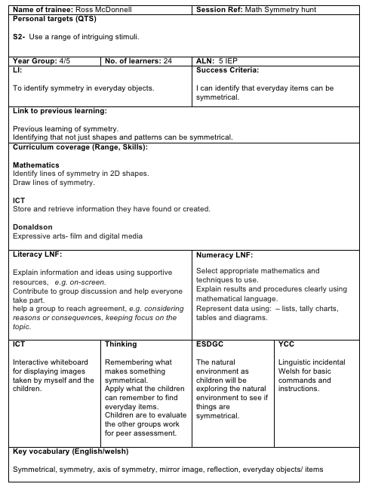
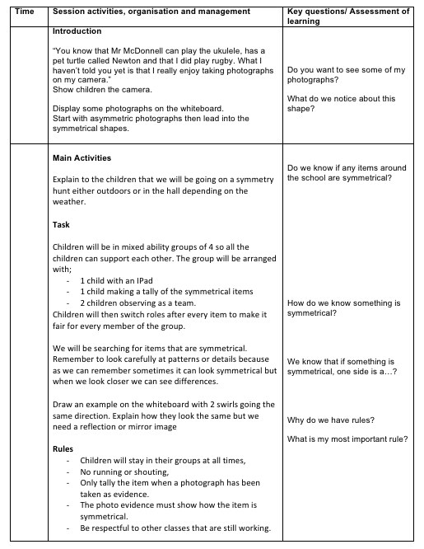

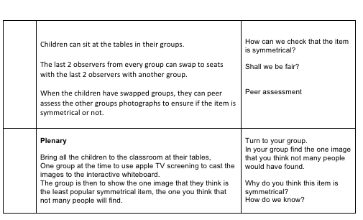

Appendix two

Bacigalupo, M., Kampylis, P., Punie, Y., Van den Brande, G. (2016). EntreComp: The Entrepreneur- ship Competence Framework. Luxembourg: Publication Office of the European Union; EUR 27939 EN; doi:10.2791/593884

Appendix three

